
SOFTWARE REQUIREMENTS SPECIFICATION
(SRS)
EstateX Mobile Application
Real Estate Management and Listing Platform

Hiren Makvana (25SOECE13036)
Dhruval Limbad (25SOECE13035)
Bhargav Dudhagra (25SOECE13027)



Department of Computer Engineering
RK University, Rajkot - Gujarat
Academic Year: 2026

Description
EstateX is a Flutter-based real estate management and listing mobile application that connects buyers/tenants, owners/sellers and brokers. Users can discover properties, view details, search and filter listings, save favourites, compare properties, book visits and contact brokers.
The application also includes an Admin Panel for managing users, brokers, properties, verification, reports and platform statistics.

Team & Project Information
- Project: EstateX Mobile Application
- Technology: Flutter / Dart
- Department: Computer Engineering, RK University
- Academic Year: 2026

Document Revision
Version 1.0 – Revised SRS. The document is shortened and arranged in a compact format similar to the provided Flutter SRS, while retaining the original EstateX screen photos.

1. Introduction

1.1 Purpose
This SRS defines the main functional and non-functional requirements of EstateX. It is intended for developers, testers, project guides and future maintainers.

1.2 Scope
- User authentication and profile management.
- Property listing, discovery and verification.
- Search, filtering, sorting and nearby-property search.
- Wishlist, property comparison and EMI/mortgage calculation.
- Site-visit scheduling, broker assignment and communication.
- Admin management of users, brokers, properties, reports and analytics.

1.3 Technology & Environment
- Flutter and Dart client for Android 8+ and iOS 13+.
- REST backend with database and cloud file storage.
- Internet connection and GPS are required for online and nearby features.
- HTTPS and token-based authentication are used for communication.

1.4 Definitions
Buyer/Tenant: searches or visits properties. Owner/Seller: provides property listings. Broker: supports property deals and visits. Admin: manages verification and platform operations.

2. Functional Requirement Summary

User Side
- Splash, registration, login/logout and password recovery.
- Home dashboard, recommendations, brokers and EstateX services.
- Property details, listing, search, sort, filters and nearby finder.
- Wishlist, comparison, site visits, broker details and communication.
- EMI/mortgage calculator, profile, notifications and support.

Admin Side
- Admin login and dashboard statistics.
- Manage users: search, filter, activate, deactivate and block.
- Manage brokers: review documents, approve or request changes.
- Manage properties: review documents, approve/reject and activate/deactivate.
- Reports, complaints, analytics, profile and password management.

Key Constraints
- Only admin-approved properties are visible to buyers.
- Prices are shown in Indian Rupees using Lakh/Crore notation.
- Location services depend on GPS permission and third-party map services.
- Online payment, e-signing and web clients are outside the current release.

3. App UI – Screens 1 & 2
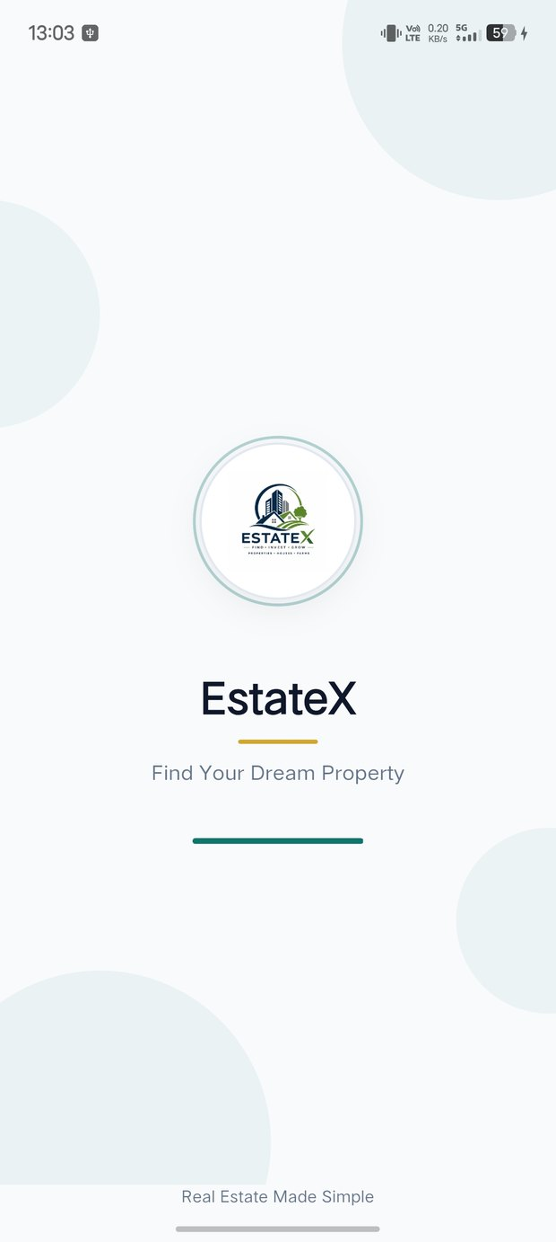  Figure 1: Splash Screen  First screen shown at launch. It displays the EstateX identity while the app initializes and routes the user. | 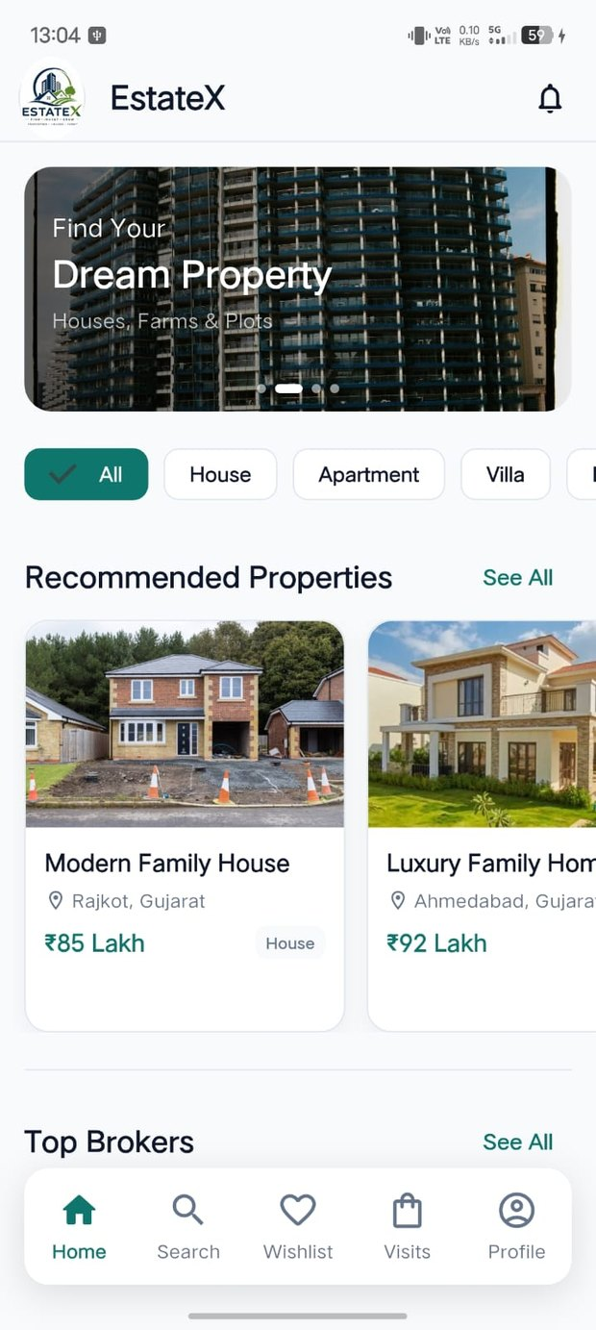  Figure 2: Home Screen  Main buyer/tenant dashboard with property discovery, recommendations and bottom navigation.

3. App UI – Screens 3 & 4
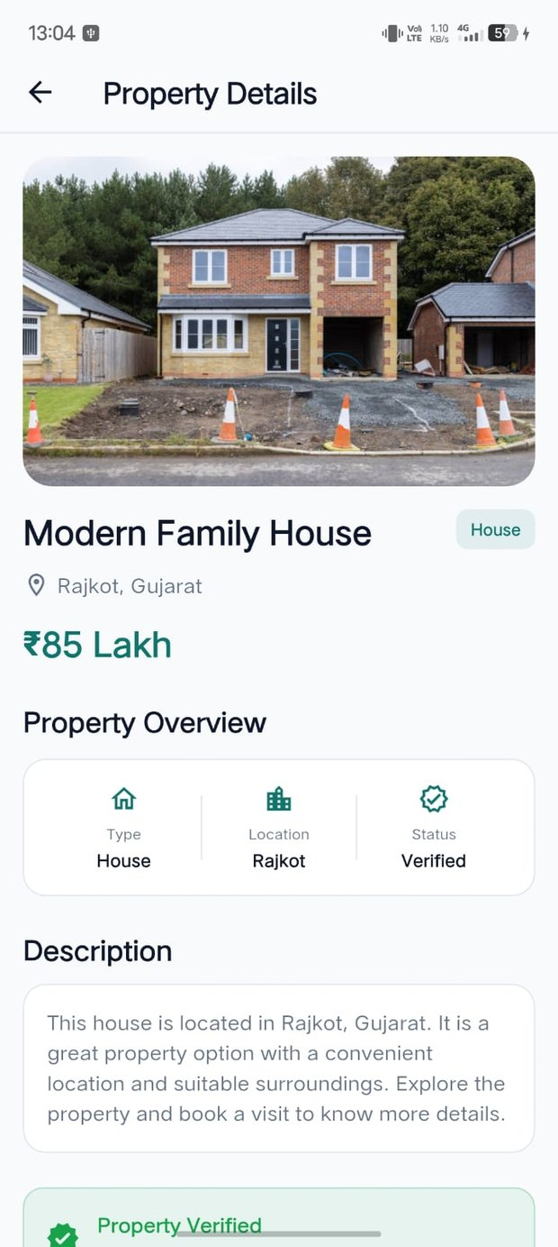  Figure 3: Property Details  Shows property photo, title, type, location, price, overview and verification status. | 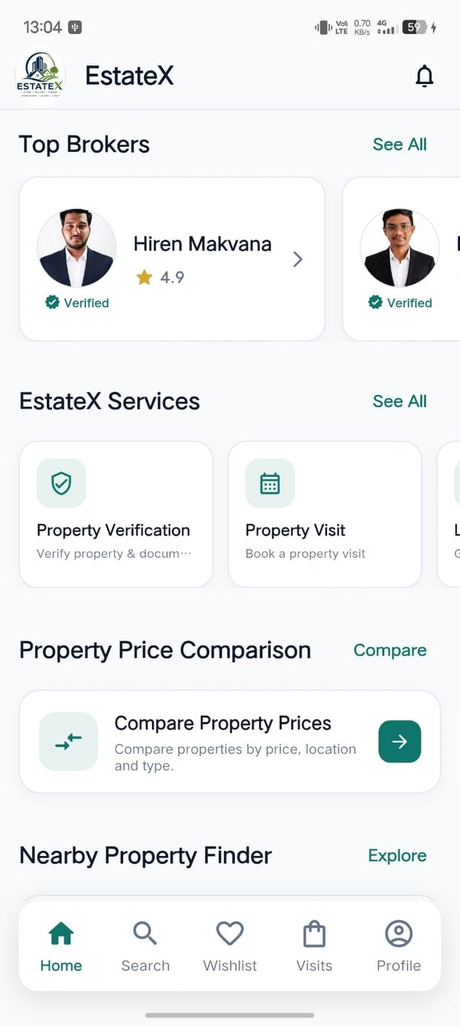  Figure 4: Brokers, Services & Tools  Provides quick access to top brokers, property services, comparison and nearby-property tools.

3. App UI – Screens 5 & 6
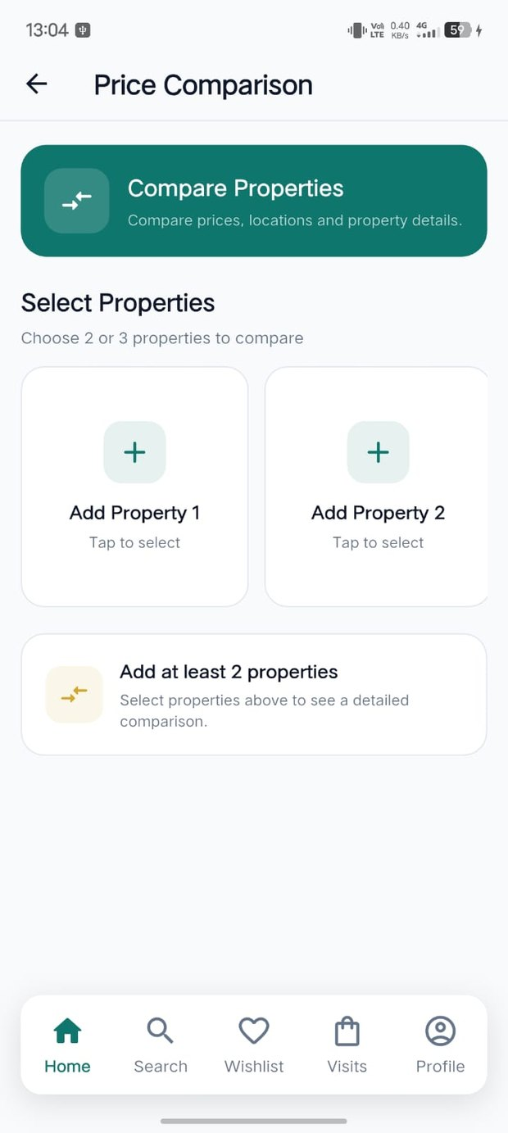  Figure 5: Price Comparison  Lets users select two or three properties and compare key information such as price, location and type. | 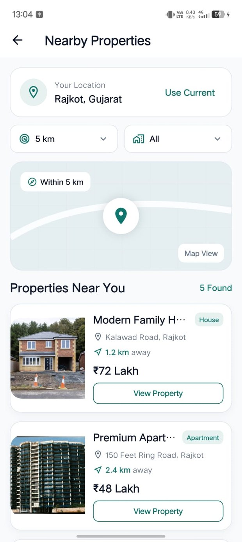  Figure 6: Nearby Properties  Uses current location and a selected radius to display nearby property results.

3. App UI – Screens 7 & 8
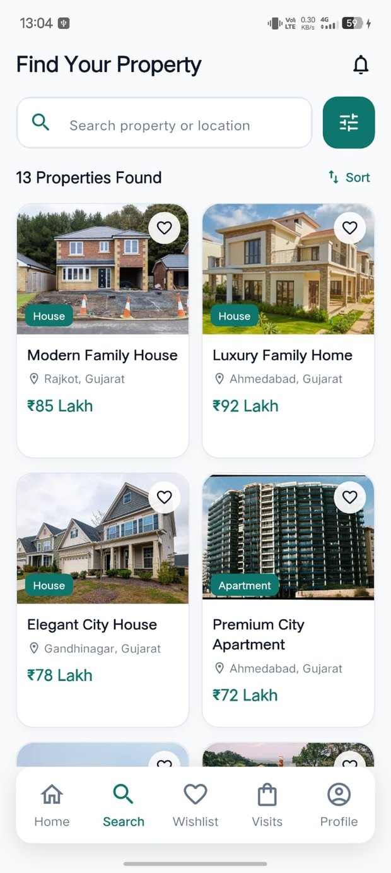  Figure 7: Search Screen  Searches properties by name or location and displays matching results with quick actions. | 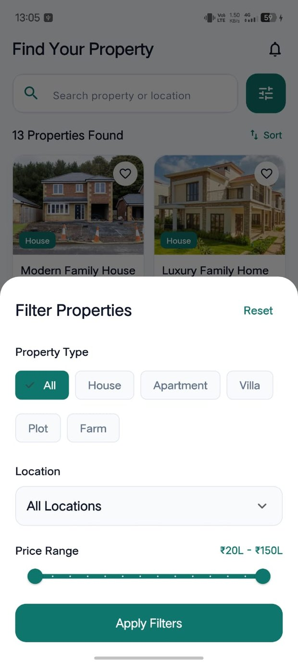  Figure 8: Filter Properties  Provides property type, location and price filters to narrow the search results.

3. App UI – Screens 9 & 10
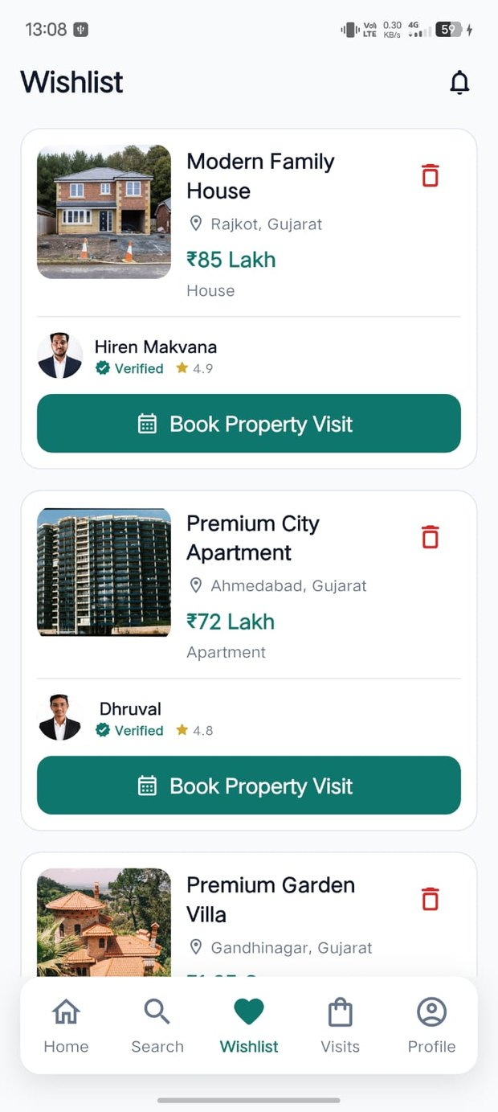  Figure 9: Wishlist  Lists properties saved by the user for later review and visit booking. | 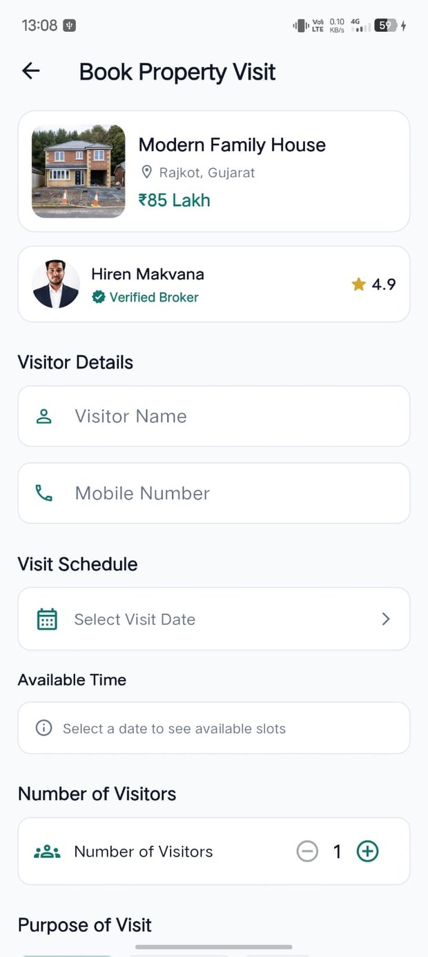  Figure 10: Book Property Visit  Collects visitor details, date, time and visit information for a selected property.

3. App UI – Screens 11 & 12
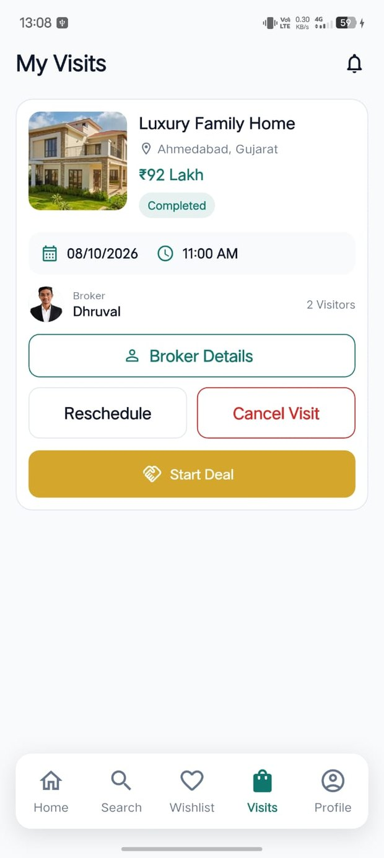  Figure 11: My Visits  Displays booked visits with status and actions such as reschedule or cancel. | 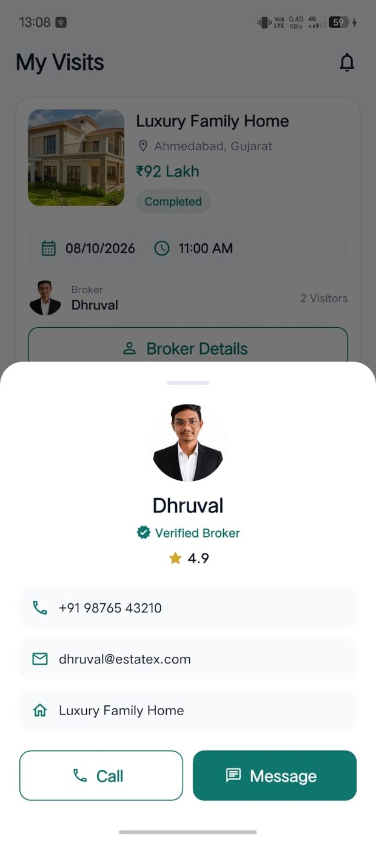  Figure 12: Broker Details  Shows the assigned verified broker with rating, contact information, Call and Message actions.

3. App UI – Screens 13 & 14
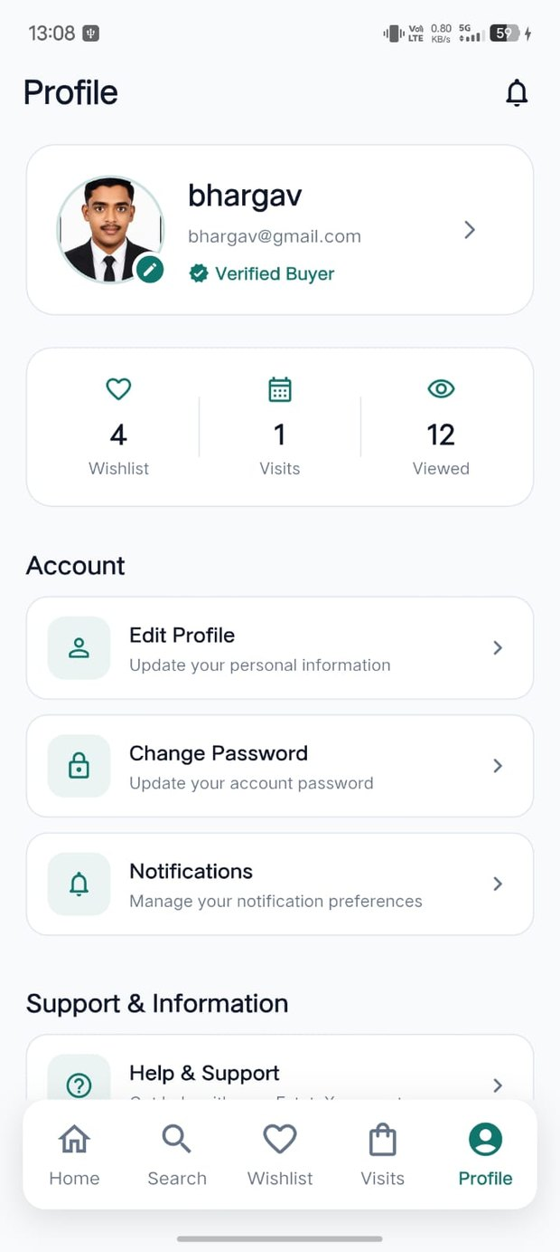  Figure 13: User Profile  Shows user identity, verification badge, activity counters and account options. | 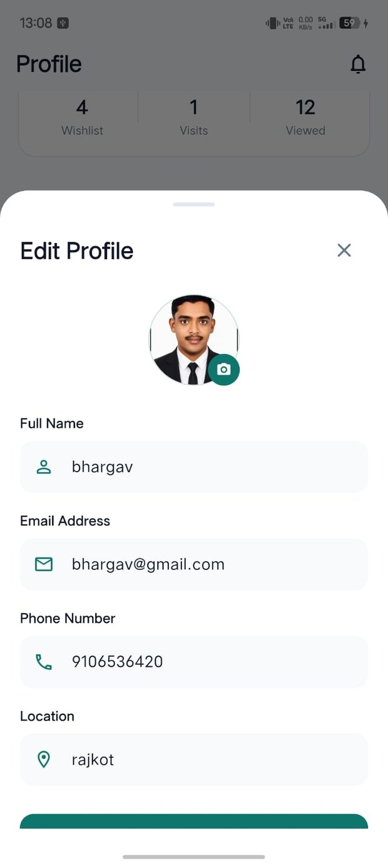  Figure 14: Edit Profile  Allows changes to profile photo, name, email, phone and location with validation.

3. App UI – Screens 15 & 16
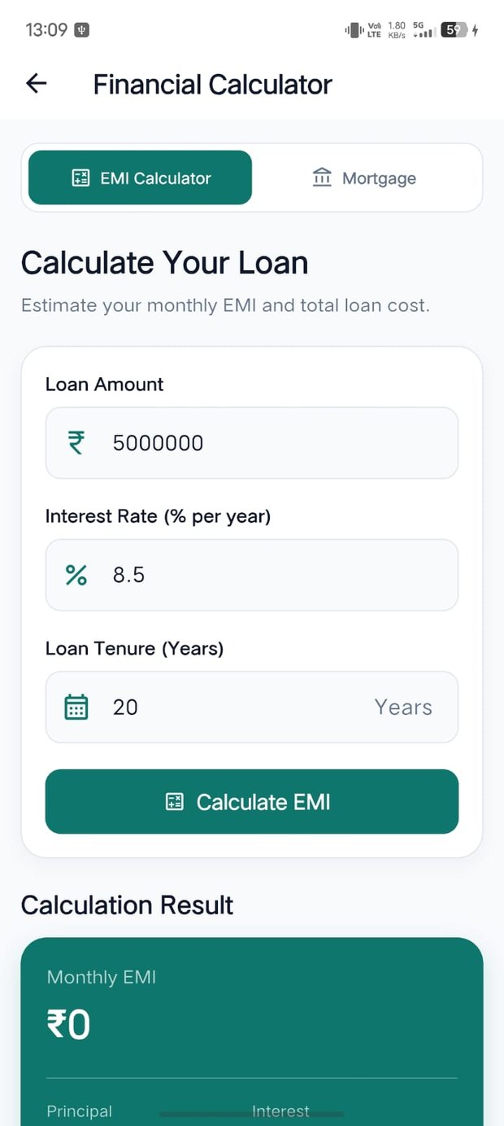  Figure 15: Financial Calculator  Provides EMI and mortgage calculations using loan amount, interest rate and tenure. | 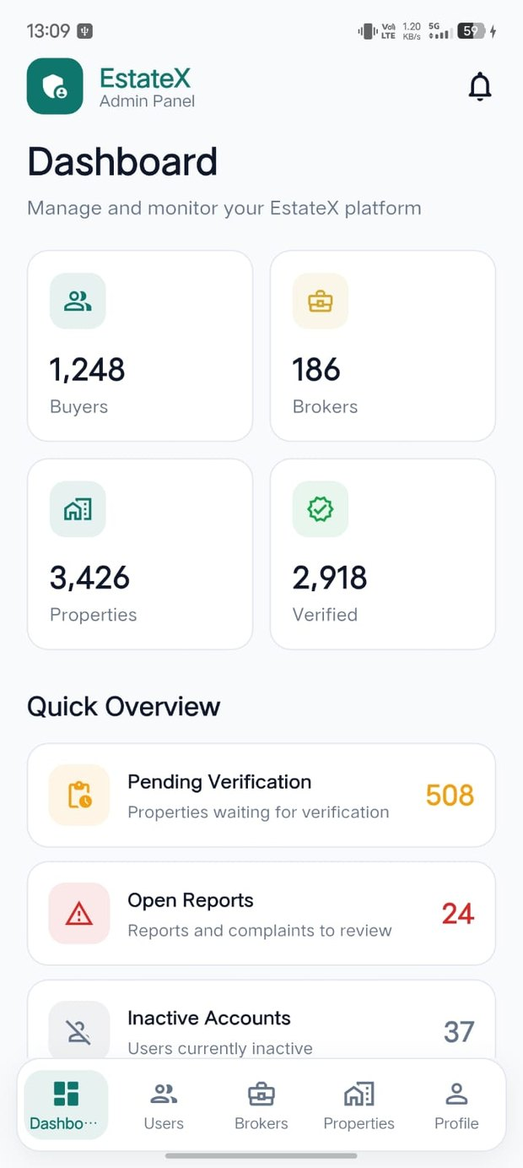  Figure 16: Admin Dashboard  Summarizes buyers, brokers, properties, verification items and quick platform alerts.

3. App UI – Screens 17 & 18
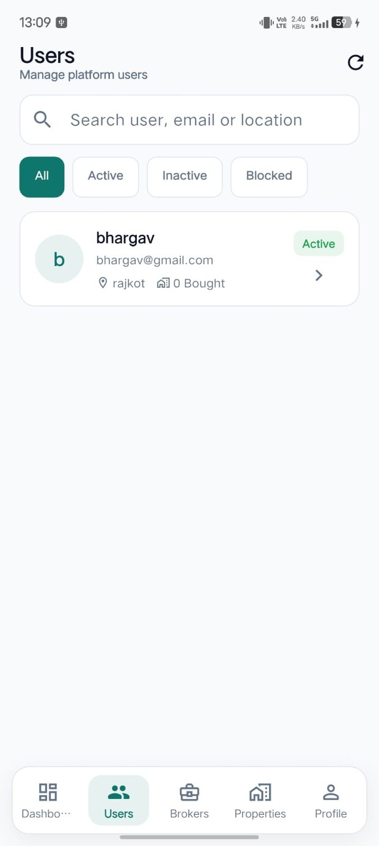  Figure 17: Manage Users  Allows admin search/filter of users and account actions such as activation or blocking. | 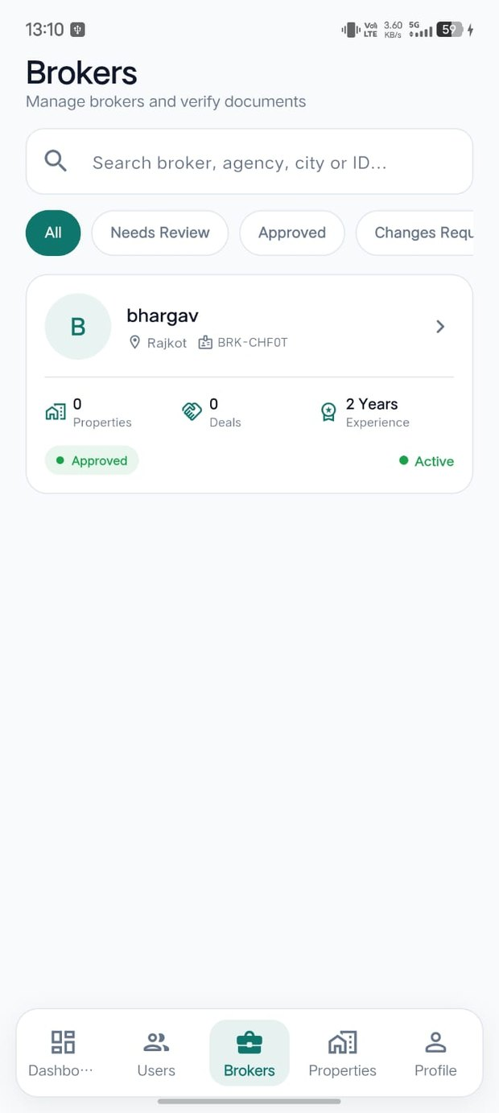  Figure 18: Manage Brokers  Supports broker search, status filtering and document verification/approval.

3. App UI – Screens 19 & 20
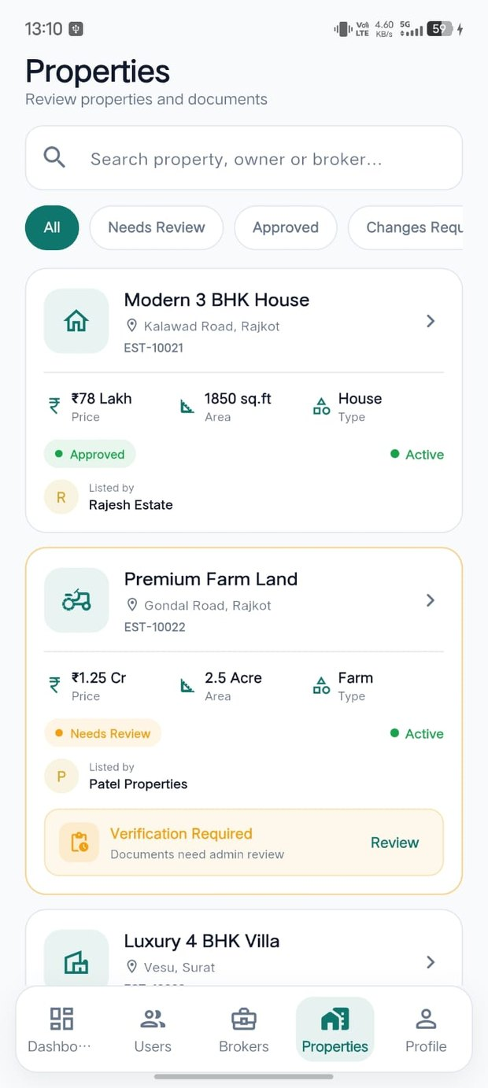  Figure 19: Manage Properties  Allows admin to review property listings, verification status and submitted documents. | 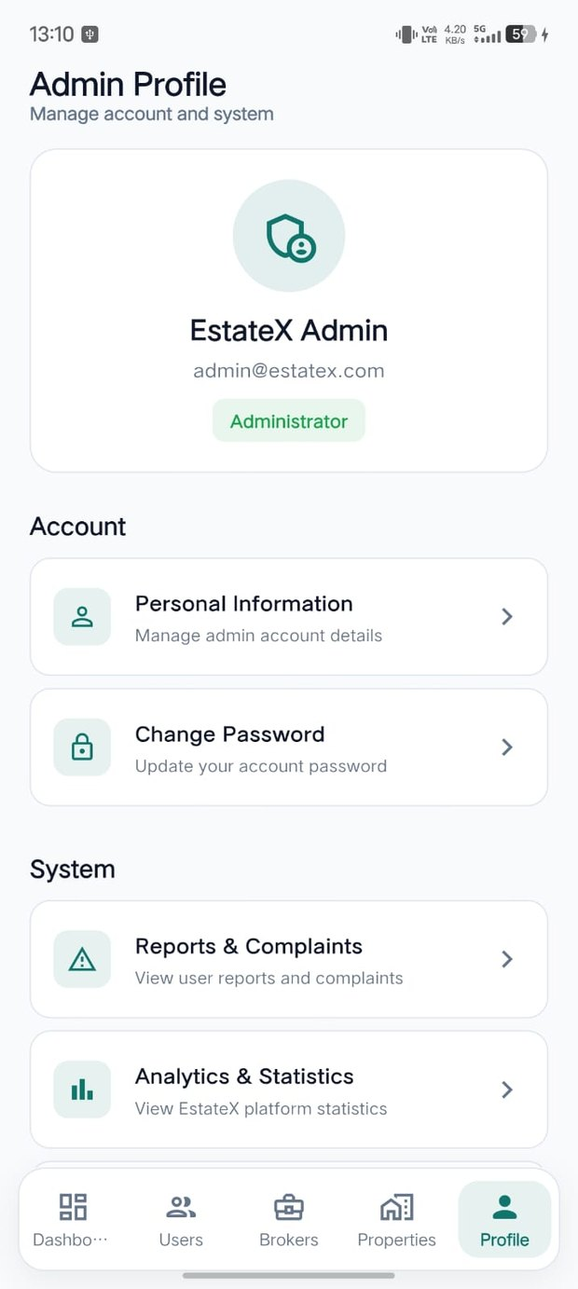  Figure 20: Admin Profile  Provides administrator identity, account security, reports and analytics access.

4. External Interface Requirements

4.1 Hardware Interfaces
- Touch screen for application interaction.
- GPS/location sensor for nearby-property features.
- Camera and device storage for profile photos, property images and documents.
- Telephony application for calling a broker.

4.2 Software Interfaces
- Flutter/Dart mobile client.
- RESTful backend service.
- Relational or NoSQL database.
- Cloud file storage for images/documents.
- Map, location and notification services.

4.3 Communication Interfaces
- HTTPS/TLS communication between app and server.
- JSON for data exchange.
- Android and iOS push-notification channels.

4.4 UI Pattern
The application follows a Material Design approach with a consistent EstateX visual theme and bottom-navigation pattern.

5. System Features
5.1 Authentication & Roles: Register, sign in, logout, password recovery and role-based access.
5.2 Profile Management: View and update personal information and account settings.
5.3 Home & Navigation: Provide discovery, recommendations, services and module navigation.
5.4 Property Listing & Details: Create/manage listings and show approved property information.
5.5 Search & Filters: Search by name/location and filter by property type, price, BHK, amenities and listing type.
5.6 Nearby Finder: Locate properties around the user's current location.
5.7 Wishlist & Comparison: Save properties and compare two or three selected options.
5.8 Site Visits & Inquiry: Book, reschedule and cancel visits and start a deal after a completed visit.
5.9 Broker Communication: Assign a verified broker and provide call/message actions.
5.10 Financial Calculator: Estimate EMI and mortgage information.
5.11 Notifications: Inform users about important application events.
5.12 Admin Management: Manage users, brokers, properties, verification, reports and analytics.

6. Non-Functional Requirements
Performance
The application should provide responsive navigation and reasonable loading time for property lists and details.
Security
Use HTTPS, token-based authentication and role-based access. Admin-approved property visibility is required.
Reliability & Availability
The system should handle normal failures gracefully and preserve important visit and listing information.
Usability
Screens should be simple, consistent and suitable for mobile users. Important actions should be easy to locate.
Portability
The Flutter client targets Android 8+ and iOS 13+ from a common codebase.
Maintainability & Scalability
Modules should remain separated so features such as listings, brokers, visits and admin functions can be maintained independently.
Privacy & Legal
User and property information should be handled securely, with ownership and broker documents reviewed through the verification process.

7. Assumptions, Dependencies & Constraints
- Users have smartphones with internet access and provide location permission when required.
- Map, geolocation, notification and SMS/email services depend on third-party providers.
- Property owners are expected to provide genuine ownership documents for admin verification.
- Broker availability for a time slot is maintained through the application.
- The current release does not include online token/rent payment, e-signing or a web client.

8. Future Enhancements
- In-app chat and video tours.
- Online token/rent payment and e-agreement signing.
- AI-based price estimation and personalized recommendations.
- Multi-language support including English, Hindi and Gujarati.
- Web portal for owners and brokers.
- Virtual 360-degree property tours.

References
- IEEE Std 830-1998 – Recommended Practice for Software Requirements Specifications.
- ISO/IEC/IEEE 29148:2018 – Requirements Engineering.
- Flutter Documentation.
- Material Design Guidelines.
- Life-Link Mobile Application SRS – department reference format.

9. Screen & Module Summary

User Application
- Splash → Home → Property Details
- Search → Filters → Wishlist → Comparison
- Nearby Properties → Book Visit → My Visits
- Broker Details → Profile → Edit Profile
- Financial Calculator → Notifications / Support

Admin Panel
- Admin Dashboard → Users → Brokers → Properties → Admin Profile
- Verification workflows support broker and property approval.
- Dashboard provides platform statistics and quick overview of pending work.

Main Data Handled
- User profile and role information.
- Property details, images, price, area, location and verification status.
- Visit date/time, visitor details and visit status.
- Broker information, rating and verification documents.
- Administrative status, reports and analytics.

10. Conclusion
EstateX is designed as a compact mobile platform for real-estate discovery and management. The requirements cover the main buyer/tenant, owner/seller, broker and administrator workflows described in the original project SRS.
The application combines property search and listing functions with wishlist, comparison, nearby search, visit scheduling, broker communication, financial calculation and administration. The included screen photos document the planned user interface for the major modules.

Project Team
- Hiren Makvana (25SOECE13036)
- Dhruval Limbad (25SOECE13035)
- Bhargav Dudhagra (25SOECE13027)
--- End of Software Requirements Specification ---

