MTA CCTV System Deployment Report

# Introduction

This report presents an analysis of the NYC Transit Subway Entrance and Exit Data to develop an efficient CCTV deployment system. The objective is to ensure high-security coverage, especially at critical and high-traffic stations, while considering network communication reliability.

# Data Analysis

The analysis was performed using Microsoft Excel and Python to process the dataset and generate relevant insights. The key findings are summarized below:

## Top 10 Stations by Number of Entrances

This chart shows the stations with the highest number of entrances which require enhanced CCTV coverage.

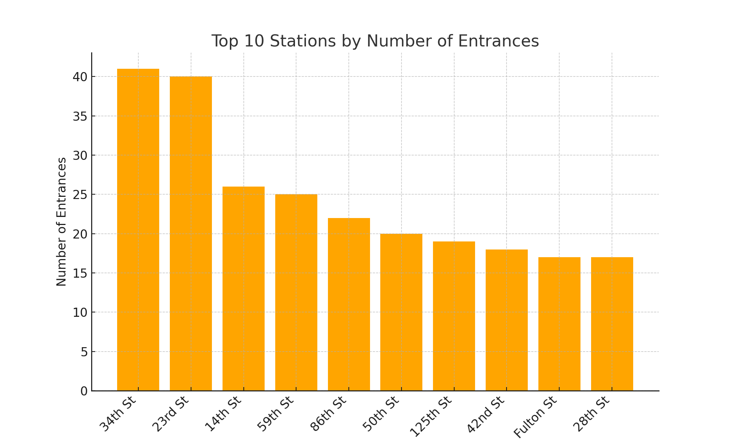

## ADA Accessibility Coverage by Division

This chart shows the proportion of accessible entrances across different divisions, which is crucial for ensuring safety and coverage for all passengers.

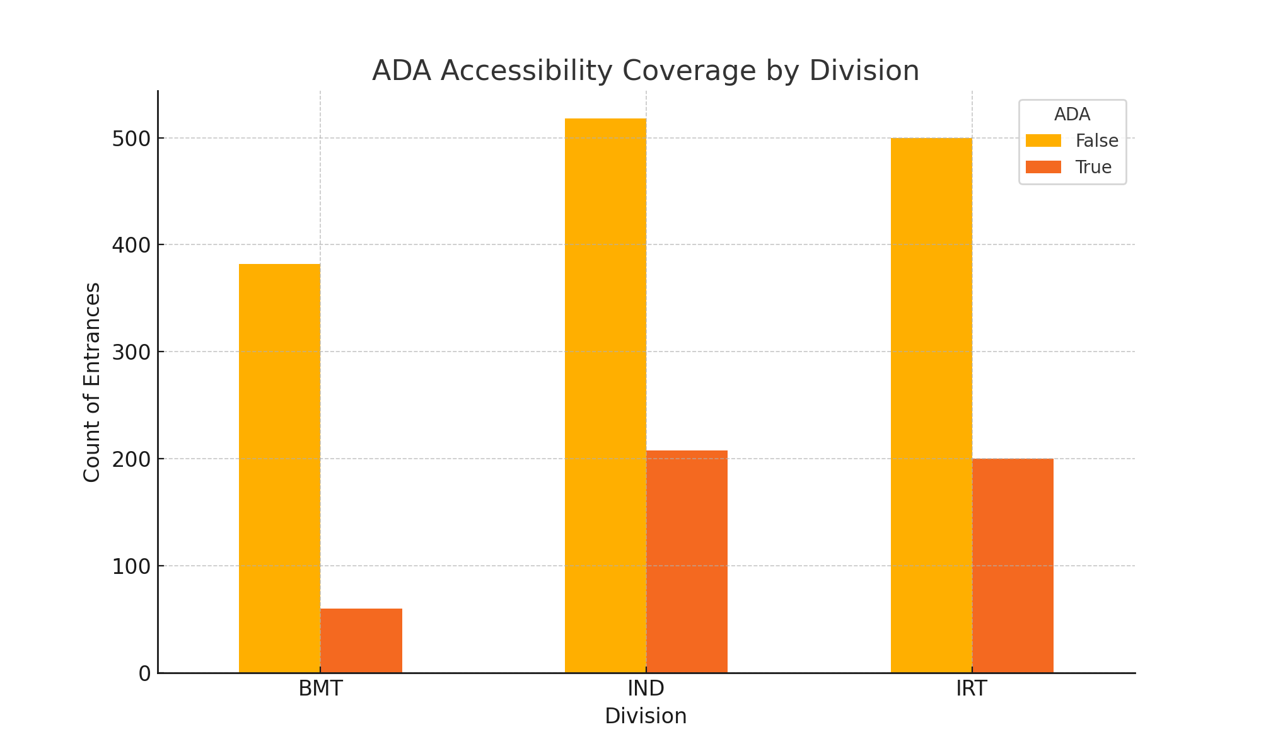

# Recommendations

Based on the analysis, the following recommendations are made:  
  
- Install CCTV cameras at all major entrances and high-traffic stations.  
- Ensure ADA compliance by providing adequate coverage at accessible entrances.  
- Utilize fiber connections for high-traffic stations to maintain reliable network communication.  
- Implement wireless connections for remote or low-traffic areas.

# Conclusion

The analysis provides a foundation for developing a comprehensive CCTV system deployment plan for the NYC subway system. Further testing and optimization may be required to enhance network reliability and security coverage.