# Business Requirement

1. This program is intended to provide functionality of creating/updating/disabling items.
2. Source system provides the data in csv format
3. Source system csv file has a column : ITEM_UPDATE will have values : Create/Update/Disable
4. Data will be uploaded from csv to staging table
5. Validation program will validate data in the staging table and loads into Oracle Item Interface table
6. Standard Import program to be run to load the data from staging table to base table for different modes : Create/Update(Disable)

List of files considered in this conversion program

|  |  |  |  |
| --- | --- | --- | --- |
| **SNO** | **File Name** | **Program Type** | **Purpose** |
| 1 | XXAK_INV_MTL_ITEM_STG_T_DDL.sql | SQL | DDL Script for Staging Table |
| 2 | XXAK_COMMON_ERROR_LOG_T_DDL | SQL | DDL Script for Error Log |
| 3 | XXAK_COMMON_ERR_PKG_SPEC.sql | PLSQL Spec | Package spec |
| 4 | XXAK_COMMON_ERR_PKG_BODY.sql | PLSQL Body | Package Body-Contains the business logic to insert error/debug log into custom table |
| 5 | XXAK_INV_ITEM_IMPORT_PKG_SPEC.sql | PLSQL Spec | Package Spec |
| 6 | XXAK_INV_ITEM_IMPORT_PKG_BODY.sql | PLSQL Body | Package Body, Concurrent program to validate data in staging table and upload to base table |
| 7 | ItemData.csv | CSV | Data File |
| 8 | XXAK_ITEM_CONV_CTL.ctl | SQL Loader CTL File | To Load data from CSV to staging table |
| 9 | XXAK_DATA_LOADER.prog | Shell Script | To Load the data from CSV to Staging table , using control file approach and archive the file |
| 10 | XXAK_DATA_LOADER_CP.ldt | LDT | Conc Program definition for Shell Script |
| 11 | XXAK_INV_ITEM_IMPORT.ldt | LDT | Conc program definition for PLSQL |

**Migration Steps**

Compile DDL files - 2

Compile PLSQL Spec/Body - 4

Move the CTL file to $FND_TOP/bin folder - 1

Move the prog file to $FND_TOP/bin folder - 1

Create symbolic using : ln -s $FND_TOP/bin/fndcpesr XXAK_DATA_LOADER.prog

**Upload LDT's**

**FNDLOAD apps/apps 0 Y UPLOAD $FND_TOP/patch/115/import/afcpprog.lct XXAK_DATA_LOADER_CP.ldt - WARNING=YES UPLOAD_MODE=REPLACE CUSTOM_MODE=FORCE**

**FNDLOAD apps/apps 0 Y UPLOAD $FND_TOP/patch/115/import/afcpprog.lct XXAK_INV_ITEM_IMPORT.ldt - WARNING=YES UPLOAD_MODE=REPLACE CUSTOM_MODE=FORCE**

**Copy the data file to below location : $FND_TOP/bin/ItemData/inbound**

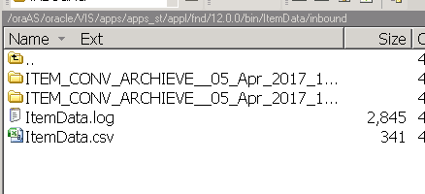

Validate the below concurrent programs : Below Shell Script to call the control file --> to load data from csv to staging table and also archive the data file .

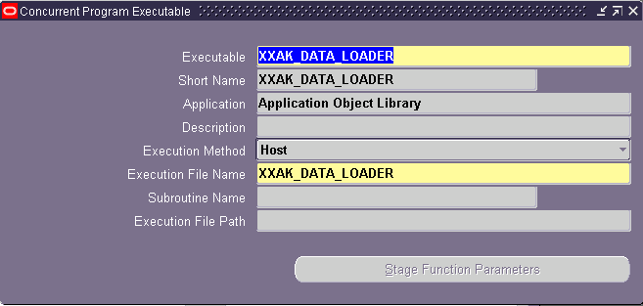

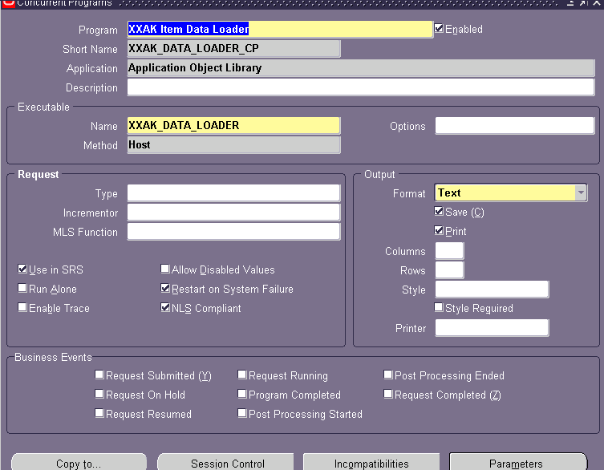

PLSQL based concurrent program to validate data in staging table, load data into interface table and invoke Open Interface Concurrent Program for each operation

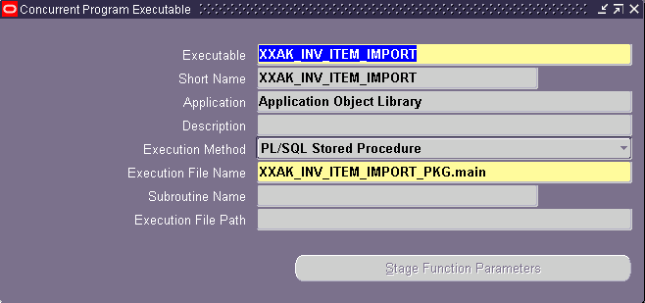

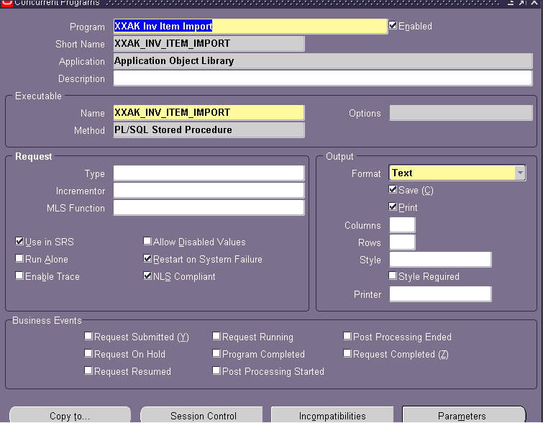

**Test data**

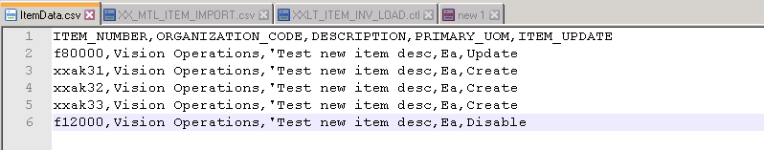

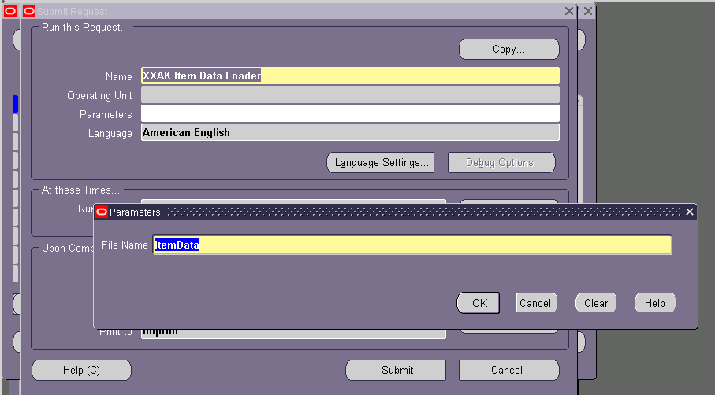

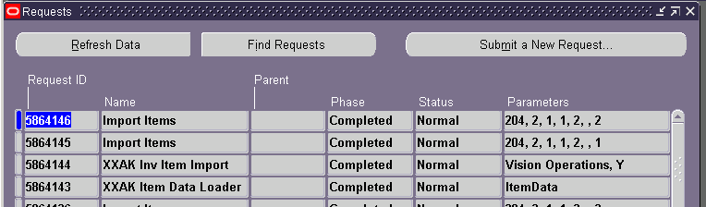

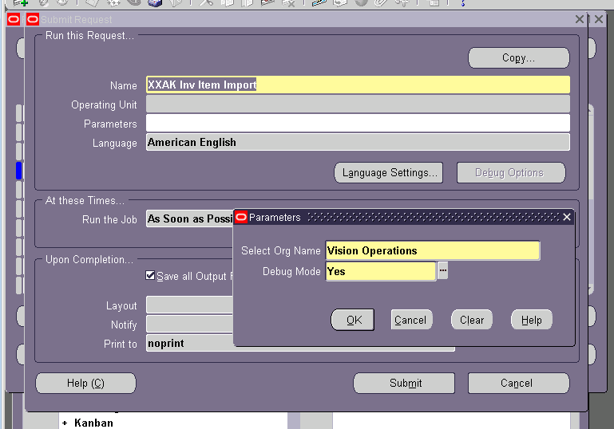

**Validating data in item master tables.**

