AquaSence AI
FULL PRODUCT REQUIREMENTS DOCUMENT + SYSTEM IMPLEMENTATION SPECIFICATION
Smart India Hackathon 2026 • SIH260220 • Team Rocket

Document purpose
This is the master implementation specification for the current prototype blueprint. It combines the locked problem interpretation, product requirements, hardware/software architecture, Layer 1 agronomic engine, Layer 2 XGBoost residual forecasting, feedback/retraining loop, interfaces, data contracts, validation, risks, and implementation sequence. It is the source-of-truth document for prototype development unless the team explicitly records a later change.

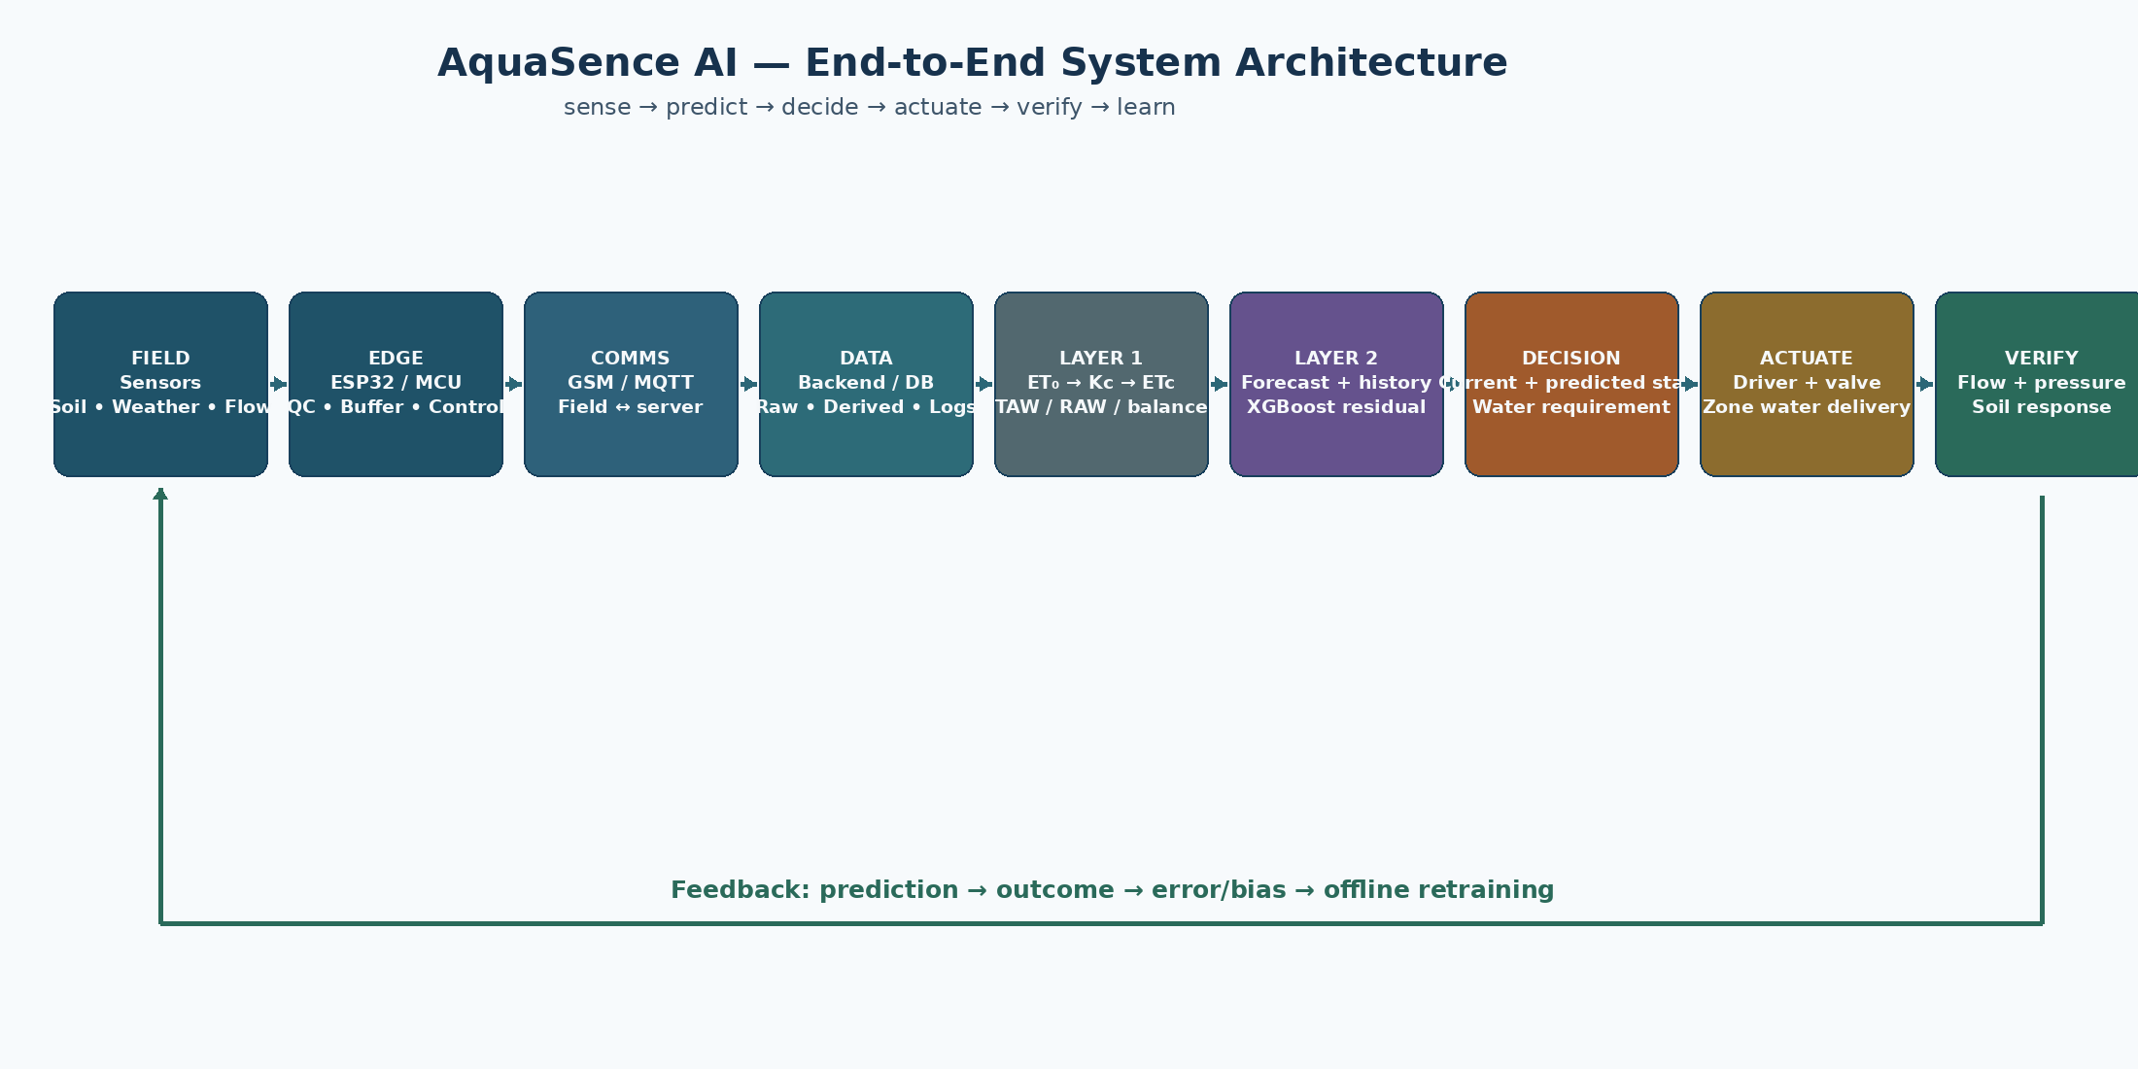
Figure 0. Master end-to-end architecture.

Document Control and Change Policy
Item | Value
Project | AquaSence AI
Team | Team Rocket
Hackathon | Smart India Hackathon 2026
Problem ID | SIH260220
Domain | Agriculture, FoodTech & Rural Development
PS Category | Hardware
Document status | Locked prototype blueprint / implementation PRD
Primary rule | Do not add architecture merely for novelty; implement and validate the frozen loop first.

Change control
Changes to the locked architecture should be made only after (a) identifying a demonstrated failure or requirement gap, (b) documenting the reason, (c) specifying the impact on hardware, data, model and validation, and (d) updating this master document. This prevents architecture drift during the build.

Contents
1. Problem Statement and Problem Interpretation | 10. Layer 2 — XGBoost Residual Forecasting
2. Product Vision, Goals and Non-Goals | 11. Feedback and Recalibration
3. Users, Use Cases and Success Criteria | 12. Decision and Valve-Control Logic
4. System Concept and End-to-End Flow | 13. Farmer Dashboard and Human Override
5. Requirements (PRD) | 14. Failure Modes, Safety and Fallbacks
6. Hardware Architecture | 15. Validation and Test Strategy
7. Connectivity and Messaging | 16. Prototype Build Plan and Team Interfaces
8. Data Architecture and Database | 17. Acceptance Criteria
9. Layer 1 — Agronomic Engine | 18. Future Enhancements and Explicit Non-Goals
Appendix A — Equation Reference | Appendix C — Example End-to-End Trace
Appendix B — Crop p-Table / RAW Reference | Appendix D — Source and Research References

1. Problem Statement and Problem Interpretation

1.1 Official problem statement
The following is reproduced from the team’s uploaded SIH solution PDF, page 1:
SIH260220
“Automatic regulation of valves for release of water based upon soil moisture availability in the root zone of the crop, using artificial intelligence, in a piped and micro irrigation network of irrigation system.”

PS field | Value
Problem Statement ID | SIH260220
Problem Statement Title | Automatic regulation of valves for release of water based upon soil moisture availability in the root zone of the crop, using artificial intelligence, in a piped and micro irrigation network of irrigation system.
Ministry | Ministry of Jal Shakti
Theme | Agriculture, FoodTech & Rural Development
Category | Hardware

The uploaded PS description identifies dynamic water demand, real-time soil-moisture integration, algorithmic precision, automated valve control, adaptability, user-friendliness, and economic viability as key challenges. Source: Team Rocket SIH submission PDF, page 1.

1.2 What the PS actually requires
- Not just sensor monitoring: the system must translate field conditions into a water-release action.
- Not just AI: the output must physically regulate irrigation valves in a piped/micro-irrigation network.
- Not just a valve controller: the irrigation quantity must be tied to root-zone water availability and crop demand.
- Not just an open-loop prediction: the system should observe actual field/system response and record the outcome.
- Not just a prototype dashboard: the solution must remain practical for field connectivity, hardware reliability and farmer intervention.

2. Product Vision, Goals and Non-Goals

2.1 Product vision
AquaSence AI is a closed-loop precision irrigation platform that combines a deterministic agronomic water-balance engine with a data-driven residual forecasting model to predict future root-zone moisture, determine irrigation needs, automatically operate zone-wise valves, and verify actual field response.

2.2 Core design principle
Sense → predict → decide → actuate → verify → learn
Layer 1 remains the transparent agronomic authority for current water status and irrigation quantity. Layer 2 predicts the field-specific deviation from the physics forecast. Feedback improves the residual model over time without turning V1 into a production MLOps system.

2.3 Goals
1. Deliver zone-wise irrigation based on root-zone water availability rather than fixed schedules alone.
2. Use live soil/weather observations plus short-horizon forecast weather.
3. Calculate a scientifically grounded irrigation baseline using FAO-56-compatible equations and root-zone water balance.
4. Use XGBoost to learn field-specific residual corrections to the 24-hour physics forecast.
5. Convert irrigation depth into physical water volume and valve runtime using area, flow and efficiency.
6. Log every prediction and eventual observed outcome so the model can be retrained offline after sufficient real data accumulates.
7. Keep the architecture modular enough to scale from a multi-zone prototype to larger installations.

2.4 Non-goals for Prototype V1
- No reinforcement learning controller.
- No Kalman/EnKF state-assimilation subsystem.
- No automatic real-time optimization of Kc or soil parameters.
- No automated model-drift detection framework.
- No champion/challenger production deployment system.
- No uncertainty/conformal-prediction subsystem.
- No claim of real-field ML accuracy until genuine field-labelled data exists.

3. Users, Use Cases and Success Criteria
Actor | Primary needs | System response
Farmer / irrigation manager | Know field status; reduce unnecessary watering; intervene when needed | Dashboard, alerts, zone state, manual override
Prototype operator | Run experiments; inspect raw/cleaned data; compare prediction with outcome | Engineering mode, logs, exports, test controls
Hardware subsystem | Sense, transmit, actuate, verify | Sensor nodes, GSM/MQTT, valve driver, flow/pressure feedback
ML subsystem | Build auditable training data and improve prediction | Feature pipeline, residual dataset, validation reports
Agronomic engine | Maintain physical plausibility and transparent decisions | ET0/Kc/ETc/TAW/RAW/water balance calculations

3.1 Core use cases
1. Normal monitoring: sensors update the current state; no irrigation is triggered if depletion remains below RAW.
2. Current irrigation: current depletion reaches RAW; Layer 1 computes replenishment and the actuator opens the relevant valve.
3. Predictive warning: XGBoost predicts that the root zone will cross the critical state within 24 h; the system can prepare/schedule action subject to forecast and Layer-1 checks.
4. Rain event: forecast rainfall reduces predicted depletion; the physics-forward run reflects this before scheduling irrigation.
5. Actuation verification: command is sent; flow/pressure and soil response are logged to verify the outcome.
6. Farmer override: authorized user can cancel, delay or manually trigger an approved zone action within safety limits.

4. System Concept and End-to-End Flow

Figure 1. Locked end-to-end architecture.

4.1 End-to-end sequence
1. Field sensing: distributed nodes collect soil moisture, weather/environment variables, rainfall and irrigation-network measurements.
2. Edge processing: the MCU validates basic ranges, timestamps samples, performs local buffering and prepares data for transport.
3. Communication: GSM provides field connectivity; MQTT carries telemetry and control messages.
4. Data platform: raw readings, cleaned values, derived variables, predictions and outcomes are stored with zone/timestamp identifiers.
5. Layer 1: weather is transformed into ET0; crop/growth stage provides Kc; ETc and root-zone water balance determine present irrigation status and quantity.
6. Forecast forward run: Layer 1 runs 24 h ahead using the current state and forecast weather.
7. Layer 2: XGBoost predicts the residual between the physics forecast and the eventual observed root-zone moisture.
8. Final forecast: physics forecast plus predicted residual gives the 24 h corrected root-zone moisture estimate.
9. Decision: the current Layer-1 state remains the immediate irrigation authority; the predicted state supplies early warning/planning context.
10. Actuation: the decision is converted to a valve command and then to physical water delivery.
11. Verification: flow, pressure and subsequent soil response are logged.
12. Feedback: once the forecast horizon has elapsed, predicted and actual values are compared; residual examples are accumulated for offline retraining.

5. Product Requirements Document (PRD)

5.1 Functional requirements
ID | Requirement | Acceptance intent
FR-01 | Sensor acquisition | System shall acquire timestamped soil moisture and required weather/environment variables per zone.
FR-02 | Root-zone state | System shall convert sensor readings into a configured root-zone moisture/depletion state.
FR-03 | Weather forecast | System shall retrieve and timestamp short-horizon forecast weather required by Layer 1 and Layer 2.
FR-04 | Layer 1 ET | System shall compute ET0 and ETc using the locked equations and configured crop parameters.
FR-05 | Root-zone balance | System shall maintain water-balance state including effective precipitation, ETc, irrigation and losses.
FR-06 | Irrigation trigger | System shall determine whether current depletion has reached RAW.
FR-07 | Irrigation sizing | System shall convert the net replenishment need to gross applied depth, volume and valve runtime.
FR-08 | Layer 1 forecast | System shall run the Layer-1 state forward for 24 h using forecast weather.
FR-09 | Layer 2 residual | System shall predict the 24 h residual using XGBoost and only information available at prediction time.
FR-10 | Final forecast | System shall combine physics forecast and predicted residual.
FR-11 | Actuation | System shall send zone-specific valve commands subject to safety checks.
FR-12 | Verification | System shall record actual flow/pressure and post-event soil response.
FR-13 | Logging | System shall store prediction, outcome, error, context and control information.
FR-14 | Feedback retraining | System shall support offline retraining after sufficient labelled residual observations exist.
FR-15 | Manual override | System shall provide a farmer/operator override path with logged reason and timestamp.

5.2 Non-functional requirements
NFR | Requirement
NFR-01 | Safety: ML output must not bypass deterministic irrigation and actuator safety constraints.
NFR-02 | Auditability: every prediction and control event must be traceable to source inputs and timestamps.
NFR-03 | Data integrity: raw sensor readings must be retained separately from filtered/derived values.
NFR-04 | Connectivity resilience: temporary network loss must not corrupt the local state or generate stale commands.
NFR-05 | Latency: telemetry and control should meet the prototype zone-cycle needs; exact limits to be benchmarked during integration.
NFR-06 | Scalability: zones are addressable independently.
NFR-07 | Maintainability: hardware and software modules can be tested independently.
NFR-08 | Explainability: the system can show current agronomic state, forecast and reason for an irrigation decision.

5.3 Success metrics
- Physics baseline produces numerically valid ET0/ETc/TAW/RAW results on known test cases.
- XGBoost residual model beats the persistence baseline on held-out temporal data before it is allowed into the final demo loop.
- Physics+XGBoost does not degrade irrigation-trigger safety compared with physics-only decisions.
- Actual delivered water can be independently verified using flow/pressure measurements.
- Every prediction has a later outcome record so MAE and bias can be computed.
- Prototype can demonstrate at least one complete zone cycle from sensor input to valve actuation and feedback.

6. Hardware Architecture

6.1 Field sensing node
Component class | Role | Implementation note
Capacitive soil-moisture sensor | Measure volumetric soil moisture | Prefer calibrated capacitive sensors; depth placement must reflect crop root zone.
Temperature / RH sensor | Atmospheric context | DHT22-class sensor acceptable for prototype; weather-station grade sensor is a future upgrade.
Rain gauge / rainfall input | Precipitation | Prefer event/amount measurement; external weather forecast can supplement but not replace local observation.
Flow sensor | Actual water delivery | Measures delivered volume/rate; important for verifying valve action.
Pressure sensor | Hydraulic state | Detects low pressure, restrictions or abnormal network behavior.
ESP32-class MCU | Edge brain | Acquire, validate, buffer, transmit, and interface with driver hardware.
Valve + driver | Physical actuation | Motorized/solenoid valve with appropriate driver/relay/H-bridge depending on actuator.

6.2 Why hardware is split into sensing, edge and actuation
- Sensing should not depend on a cloud connection to maintain safe local state.
- Edge logic reduces unnecessary network traffic and provides local buffering.
- The microcontroller cannot usually power an actuator directly; driver circuitry provides the required electrical interface.
- Flow/pressure feedback makes the physical irrigation action observable rather than assumed.

6.3 Valve actuation concept
The controller sends a low-power command to the driver. The driver provides the required actuator power. A directional motorized valve may require an H-bridge or equivalent reversible driver; a solenoid valve may use a relay/MOSFET driver as appropriate to the selected hardware. The exact actuator electrical interface must be confirmed against the chosen valve datasheet before fabrication.
Hardware safety
Never allow a software GPIO directly to power a motor/solenoid unless the component is explicitly designed for it. The driver, flyback protection, supply sizing, fuse/protection, common-ground strategy and emergency shutoff are hardware design items, not software assumptions.

7. Connectivity and Messaging

7.1 GSM + MQTT
The prototype communication direction is GSM cellular connectivity using a SIM800-class modem with MQTT as the lightweight message transport. GSM is the field communication road; MQTT is the message-routing protocol.
Message direction | Topic pattern (conceptual) | Payload examples
Telemetry → server | {zone_id}/telemetry | timestamp, soil moisture, temp, RH, rainfall, flow, pressure
Valve command → field | {zone_id}/valve | command, volume, runtime, request ID
Status → server | {zone_id}/status | online/offline, battery, modem status, last-command state
Prediction log → server | {zone_id}/prediction | physics forecast, residual, corrected forecast, horizon

7.2 Connectivity rules
- Every message must carry a timestamp and zone/device identifier.
- Commands must have a request/command ID so actuation can be audited.
- Stale commands must be rejected based on a defined maximum age.
- Local buffering should preserve sensor records during short connectivity outages.
- An outage must not cause the system to replay obsolete irrigation commands blindly.

8. Data Architecture and Database

8.1 Data classes
Data class | Examples | Retention role
Raw telemetry | ADC/raw soil reading, raw T/RH, raw flow | Audit / recalibration
Cleaned telemetry | Validated soil moisture, filtered weather | Model input
Derived agronomic | ET0, Kc, ETc, TAW, RAW, Dr | Decision trace
Forecast | Forecast rainfall/T/RH/wind/radiation/ET0 | Layer-2 input audit
Prediction | physics forecast, XGB residual, final forecast | Evaluation
Outcome | actual future soil moisture, actual water delivered | Feedback/training
Control event | command, start, stop, valve state | Safety/audit
Configuration | crop, stage, soil, Zr, θFC, θWP, efficiency | Reproducibility

8.2 Canonical prediction row
Field | Example | Notes
timestamp_t | 2026-08-20T10:00:00 | Prediction origin time
zone_id | Z01 | Primary key component
theta_rz_t | 0.274 | Current root-zone volumetric moisture
theta_phys_t24 | 0.242 | Layer-1 forward forecast
forecast_rain_24h | 2.5 mm | Only forecast available at t
forecast_et0_24h | 4.9 mm | Aggregated/derived
residual_target | 0.006 | Only populated after t+24 actual exists
xgb_residual_hat | 0.004 | Prediction from deployed model
theta_final_hat | 0.246 | physics + residual
theta_actual_t24 | 0.248 | Later observed value
error | 0.002 | actual − final forecast
abs_error | 0.002 | absolute error
bias_sign | positive | signed direction

9. Layer 1 — Agronomic Engine
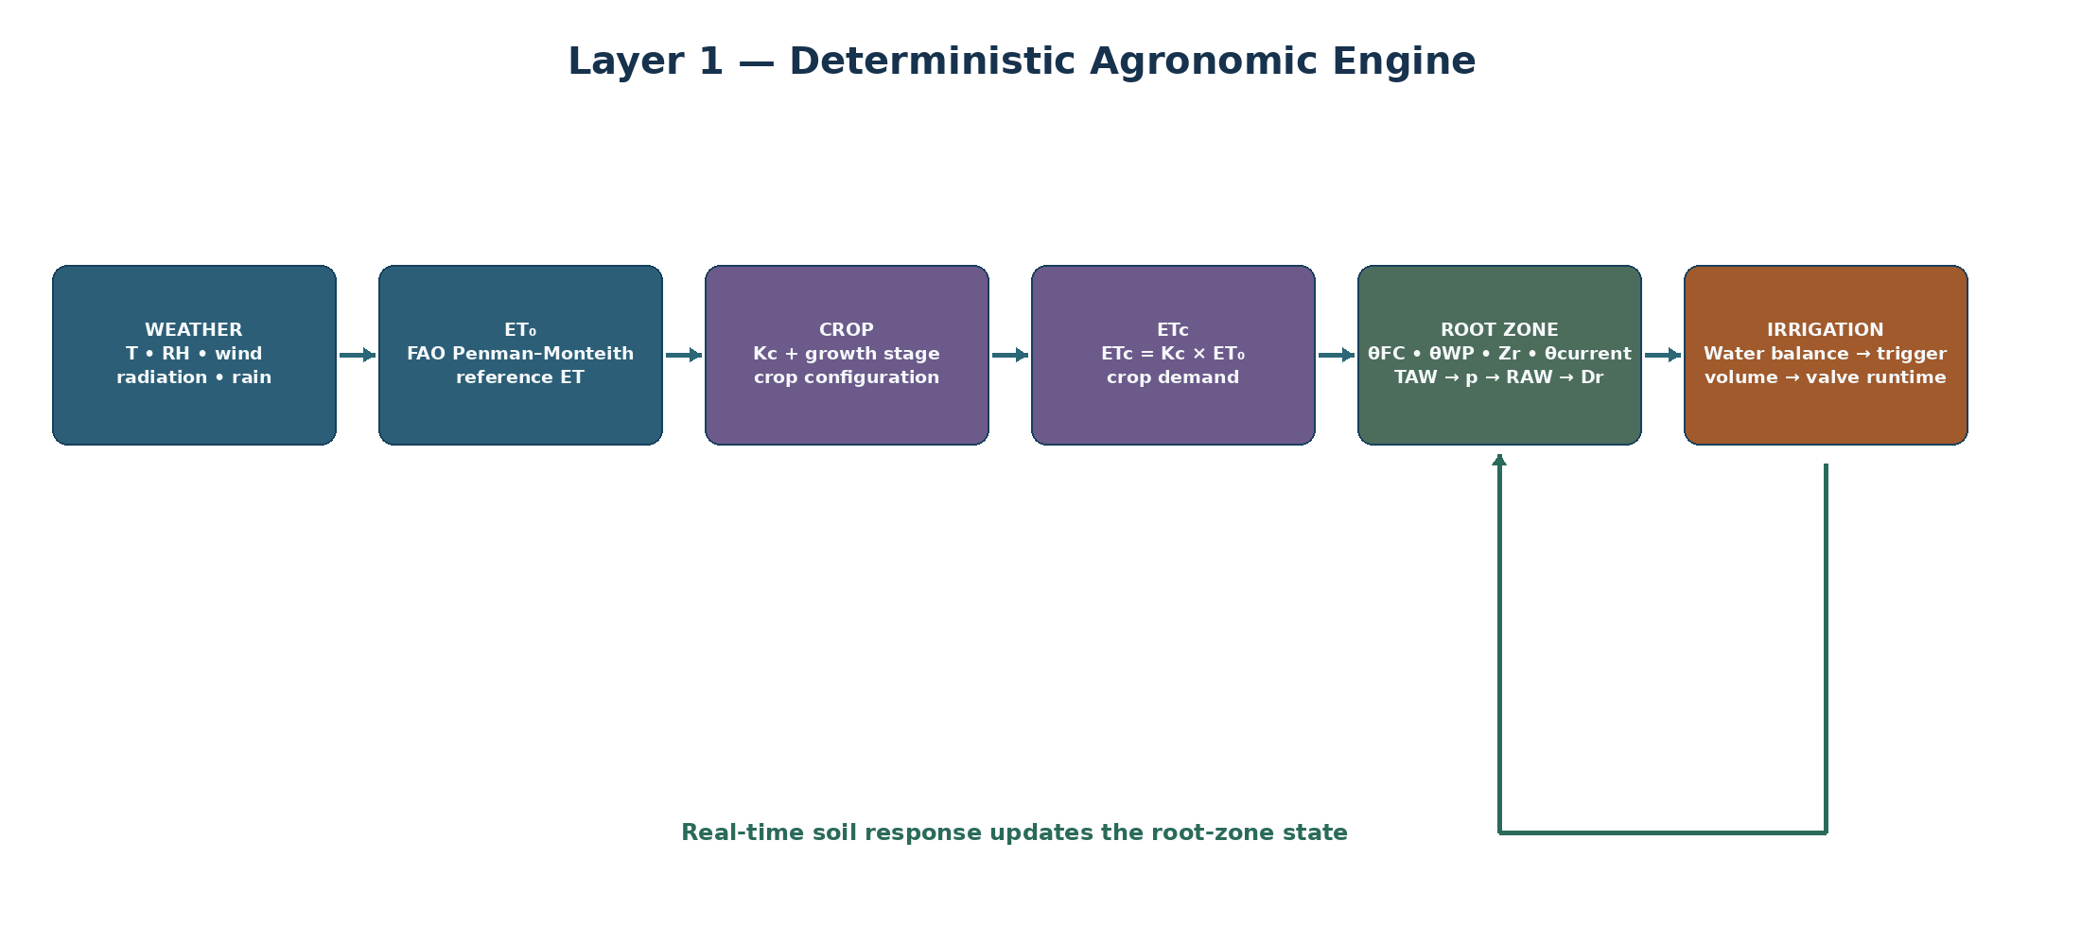
Figure 2. Layer 1 locked architecture.

9.1 Role
Layer 1 is deterministic. It is not trained as an ML model. It uses weather inputs, crop coefficients, soil/root-zone parameters and real-time soil moisture to estimate crop water demand, root-zone storage/depletion and irrigation need.

9.2 Required dynamic inputs
Input | Symbol | Unit / format | Used by
Air temperature | T | °C | ET0
Relative humidity | RH | % | ET0
Wind speed at 2 m | u2 | m/s | ET0
Solar/net radiation inputs | Rs / Rn | MJ/m²/day | ET0
Rainfall | P | mm | Water balance
Root-zone soil moisture | θcurrent | m³/m³ | Root-zone state / depletion

9.3 Configuration parameters
Parameter | Meaning
Crop type | Selects crop coefficients and crop configuration
Growth stage | Determines stage-specific Kc
Kc | Crop coefficient / stage value
θFC | Volumetric moisture at field capacity
θWP | Volumetric moisture at wilting point
Zr | Effective root-zone depth
p_table | Baseline depletion fraction from crop reference
p | ETc-adjusted depletion fraction
Ea | Application/irrigation efficiency
Area | Zone area in m²

9.4 Locked equation set
es = 0.6108 × exp(17.27T / (T + 237.3))
Saturation vapour pressure, kPa.
ea = es × RH / 100
Actual vapour pressure, kPa.
VPD = es − ea
Vapour-pressure deficit, kPa.
Δ = 4098 × es / (T + 237.3)²
Slope of saturation vapour-pressure curve, kPa/°C.
P = 101.3 × ((293 − 0.0065z) / 293)^5.26
Atmospheric pressure estimate from elevation z (m).
γ = 0.000665 × P
Psychrometric constant, kPa/°C.
ET0 = [0.408Δ(Rn−G) + γ×900/(T+273)×u2×(es−ea)] / [Δ + γ(1+0.34u2)]
Daily FAO Penman–Monteith reference ET, mm/day.
ETc = Kc × ET0
Single-Kc crop evapotranspiration baseline, mm/day.
TAW = 1000 × (θFC − θWP) × Zr
Total available water in root zone, mm.
p = clip[p_table + 0.04 × (5 − ETc), 0.1, 0.8]
ETc-adjusted allowable depletion fraction.
RAW = p × TAW
Readily available water / irrigation trigger depletion, mm.
S = 1000 × (θcurrent − θWP) × Zr
Current plant-available storage, clipped to [0, TAW].
Dr = TAW − S
Current root-zone depletion, mm.
Dr = clip[1000 × (θFC − θcurrent) × Zr, 0, TAW]
Equivalent direct depletion calculation.
θcrit = θFC − p(θFC − θWP)
Critical volumetric moisture corresponding to RAW.
Dr,t = Dr,t−1 + ETc,t − Pe,t − Inet,t + DPt + ROt
Daily depletion-form water balance.
Igross = Inet / Ea
Gross irrigation depth, mm.
V(L) = Igross(mm) × Area(m²)
Water volume, litres.
t_valve(min) = V(L) / Q(L/min)
Valve runtime using confirmed flow rate.

9.5 Trigger vs quantity
Critical distinction
RAW is primarily a trigger/scheduling threshold. The final irrigation quantity is a separate water-balance and replenishment calculation. The system must not compare a percentage moisture reading directly with TAW, because TAW is a root-zone water-depth quantity in mm.

9.6 Crop p-table and root-depth reference
The following reference table is carried forward from the team’s Layer 1 implementation specification. p_table values are referenced at approximately ETc = 5 mm/day and require the documented ETc adjustment before use. The table is a configuration/reference source, not a substitute for local agronomic validation.
Crop group | Crop / variant | Max effective Zr (m) | p_table
Small vegetables | Broccoli | 0.4–0.6 | 0.45
Small vegetables | Brussel Sprouts | 0.4–0.6 | 0.45
Small vegetables | Cabbage | 0.5–0.8 | 0.45
Small vegetables | Carrots | 0.5–1.0 | 0.35
Small vegetables | Cauliflower | 0.4–0.7 | 0.45
Small vegetables | Celery | 0.3–0.5 | 0.20
Small vegetables | Garlic | 0.3–0.5 | 0.30
Small vegetables | Lettuce | 0.3–0.5 | 0.30
Small vegetables | Onions – dry | 0.3–0.6 | 0.30
Small vegetables | Onions – green | 0.3–0.6 | 0.30
Small vegetables | Onions – seed | 0.3–0.6 | 0.35
Small vegetables | Spinach | 0.3–0.5 | 0.20
Small vegetables | Radishes | 0.3–0.5 | 0.30
Solanaceae | Egg Plant | 0.7–1.2 | 0.45
Solanaceae | Sweet Peppers (bell) | 0.5–1.0 | 0.30
Solanaceae | Tomato | 0.7–1.5 | 0.40
Cucurbitaceae | Cantaloupe | 0.9–1.5 | 0.45
Cucurbitaceae | Cucumber – Fresh Market | 0.7–1.2 | 0.50
Cucurbitaceae | Cucumber – Machine harvest | 0.7–1.2 | 0.50
Cucurbitaceae | Pumpkin, Winter Squash | 1.0–1.5 | 0.35
Cucurbitaceae | Squash, Zucchini | 0.6–1.0 | 0.50
Cucurbitaceae | Sweet Melons | 0.8–1.5 | 0.40
Cucurbitaceae | Watermelon | 0.8–1.5 | 0.40
Roots and tubers | Beets, table | 0.6–1.0 | 0.50
Roots and tubers | Cassava – year 1 | 0.5–0.8 | 0.35
Roots and tubers | Cassava – year 2 | 0.7–1.0 | 0.40
Roots and tubers | Parsnip | 0.5–1.0 | 0.40
Roots and tubers | Potato | 0.4–0.6 | 0.35
Roots and tubers | Sweet Potato | 1.0–1.5 | 0.65
Roots and tubers | Turnip (and Rutabaga) | 0.5–1.0 | 0.50
Roots and tubers | Sugar Beet | 0.7–1.2 | 0.55
Legumes | Beans, green | 0.5–0.7 | 0.45
Legumes | Beans, dry and Pulses | 0.6–0.9 | 0.45
Legumes | Beans, lima, large vines | 0.8–1.2 | 0.45
Legumes | Chick pea | 0.6–1.0 | 0.50
Legumes | Fababean (broad bean) – Fresh | 0.5–0.7 | 0.45
Legumes | Fababean (broad bean) – Dry/Seed | 0.5–0.7 | 0.45
Legumes | Grabanzo | 0.6–1.0 | 0.45
Legumes | Green Gram and Cowpeas | 0.6–1.0 | 0.45
Legumes | Groundnut (Peanut) | 0.5–1.0 | 0.50
Legumes | Lentil | 0.6–0.8 | 0.50
Legumes | Peas – Fresh | 0.6–1.0 | 0.35
Legumes | Peas – Dry/Seed | 0.6–1.0 | 0.40
Legumes | Soybeans | 0.6–1.3 | 0.50
Perennial vegetables | Artichokes | 0.6–0.9 | 0.45
Perennial vegetables | Asparagus | 1.2–1.8 | 0.45
Perennial vegetables | Mint | 0.4–0.8 | 0.40
Perennial vegetables | Strawberries | 0.2–0.3 | 0.20
Fibre crops | Cotton | 1.0–1.7 | 0.65
Fibre crops | Flax | 1.0–1.5 | 0.50
Fibre crops | Sisal | 0.5–1.0 | 0.80
Oil crops | Castorbean (Ricinus) | 1.0–2.0 | 0.50
Oil crops | Rapeseed, Canola | 1.0–1.5 | 0.60
Oil crops | Safflower | 1.0–2.0 | 0.60
Oil crops | Sesame | 1.0–1.5 | 0.60
Oil crops | Sunflower | 0.8–1.5 | 0.45
Cereals | Barley | 1.0–1.5 | 0.55
Cereals | Oats | 1.0–1.5 | 0.55
Cereals | Spring Wheat | 1.0–1.5 | 0.55
Cereals | Winter Wheat | 1.5–1.8 | 0.55
Cereals | Maize, Field (grain) (field corn) | 1.0–1.7 | 0.55
Cereals | Maize, Sweet (sweet corn) | 0.8–1.2 | 0.50
Cereals | Millet | 1.0–2.0 | 0.55
Cereals | Sorghum – grain | 1.0–2.0 | 0.55
Cereals | Sorghum – sweet | 1.0–2.0 | 0.50
Cereals | Rice | 0.5–1.0 | 0.20
Forages | Alfalfa – for hay | 1.0–2.0 | 0.55
Forages | Alfalfa – for seed | 1.0–3.0 | 0.60
Forages | Bermuda – for hay | 1.0–1.5 | 0.55
Forages | Bermuda – spring crop for seed | 1.0–1.5 | 0.60
Forages | Clover hay, Berseem | 0.6–0.9 | 0.50
Forages | Rye Grass hay | 0.6–1.0 | 0.60
Forages | Sudan Grass hay (annual) | 1.0–1.5 | 0.55
Forages | Grazing Pasture – Rotated Grazing | 0.5–1.5 | 0.60
Forages | Grazing Pasture – Extensive Grazing | 0.5–1.5 | 0.60
Forages | Turf grass – cool season | 0.5–1.0 | 0.40
Forages | Turf grass – warm season | 0.5–1.0 | 0.50
Sugar cane | Sugar Cane | 1.2–2.0 | 0.65
Tropical fruits and trees | Banana – 1st year | 0.5–0.9 | 0.35
Tropical fruits and trees | Banana – 2nd year | 0.5–0.9 | 0.35
Tropical fruits and trees | Cacao | 0.7–1.0 | 0.30
Tropical fruits and trees | Coffee | 0.9–1.5 | 0.40
Tropical fruits and trees | Date Palms | 1.5–2.5 | 0.50
Tropical fruits and trees | Palm Trees | 0.7–1.1 | 0.65
Tropical fruits and trees | Pineapple | 0.3–0.6 | 0.50
Tropical fruits and trees | Rubber Trees | 1.0–1.5 | 0.40
Tropical fruits and trees | Tea – non-shaded | 0.9–1.5 | 0.40
Tropical fruits and trees | Tea – shaded | 0.9–1.5 | 0.45
Grapes and berries | Berries (bushes) | 0.6–1.2 | 0.50
Grapes and berries | Grapes – Table or Raisin | 1.0–2.0 | 0.35
Grapes and berries | Grapes – Wine | 1.0–2.0 | 0.45
Grapes and berries | Hops | 1.0–1.2 | 0.50
Fruit trees | Almonds | 1.0–2.0 | 0.40
Fruit trees | Apples, Cherries, Pears | 1.0–2.0 | 0.50
Fruit trees | Apricots, Peaches, Stone Fruit | 1.0–2.0 | 0.50
Fruit trees | Avocado | 0.5–1.0 | 0.70
Fruit trees | Citrus – 70% canopy | 1.2–1.5 | 0.50
Fruit trees | Citrus – 50% canopy | 1.1–1.5 | 0.50
Fruit trees | Citrus – 20% canopy | 0.8–1.1 | 0.50
Fruit trees | Conifer Trees | 1.0–1.5 | 0.70
Fruit trees | Kiwi | 0.7–1.3 | 0.35
Fruit trees | Olives (40–60% ground coverage by canopy) | 1.2–1.7 | 0.65
Fruit trees | Pistachios | 1.0–1.5 | 0.40
Fruit trees | Walnut Orchard | 1.7–2.4 | 0.50

9.7 Kc policy
- Use stage-specific Kc values from a validated agronomic source; do not use one permanent Kc for an entire crop.
- Interpolate Kc across stage transitions when the configured stage boundaries support a linear approximation.
- Keep Kc configuration versioned so every prediction can be reproduced.
- Do not automatically optimize Kc in V1; collect evidence first and treat future Kc calibration as a controlled research/field-validation task.

10. Layer 2 — XGBoost Residual Forecasting
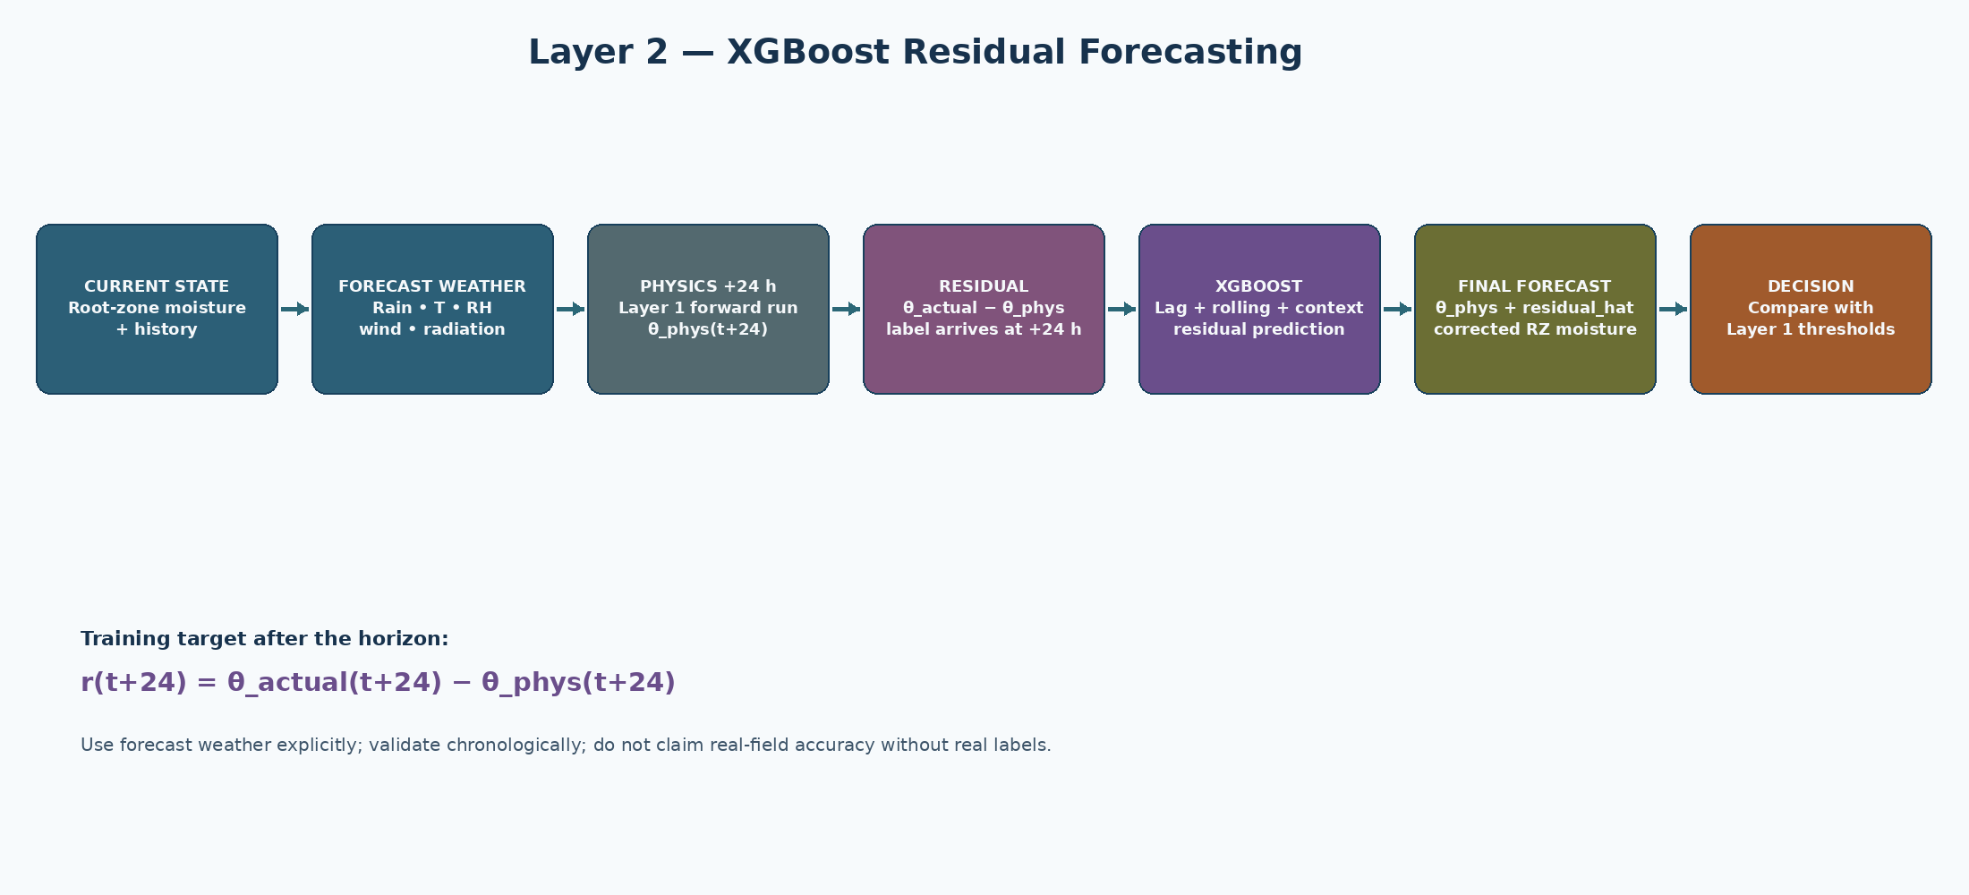
Figure 3. Layer 2 locked architecture.

10.1 Role
Layer 2 predicts the field-specific residual of the physics-forward 24-hour root-zone moisture forecast. It does not directly choose valve GPIO state and it does not replace Layer 1.
theta_phys(t+24) = Layer1(current corrected state, forecast weather)
Physics-only 24-hour forecast.
r(t+24) = theta_actual(t+24) − theta_phys(t+24)
Residual target; it is only known after the horizon elapses.
r_hat(t+24) = XGBoost(features available at t)
Predicted field-specific correction.
theta_hat(t+24) = theta_phys(t+24) + r_hat(t+24)
Final corrected 24-hour forecast.

10.2 Mandatory forecast dependency
Forecast weather is not optional in the Layer-2 design
The model must receive future weather information available at prediction time. Without forecast rainfall/temperature/etc., the model becomes mostly a trend extrapolator and loses the ability to anticipate a rain event or heat-driven demand change.

The forecast service should be wrapped behind a provider interface so the model pipeline does not depend on one vendor. For the prototype, a weather API such as Open-Meteo may be used; the provider must supply the variables needed for the physics forward run and XGBoost forecast features.

10.3 Feature groups
Group | Features
Current field state | Root-zone moisture; depth-wise moisture if available; soil temperature if available
Historical dynamics | SM lags 1/3/6/12/24 h; moisture changes; rolling mean/std; rainfall sums 6/24/72 h; irrigation sums 6/24/72 h; time since irrigation
Observed weather | T, RH, wind, radiation, recent rainfall
Agronomic context | ET0, ETc, Kc, crop, growth stage, Zr, soil parameters
Forecast weather | Forecast rainfall by time bucket; forecast temperature mean/max; forecast RH; forecast wind; forecast radiation; forecast ET0
Calendar features | Hour-of-day, day-of-year / growth-stage indicator

10.4 Target and sampling
- Canonical row frequency: one row per zone per hour.
- Prediction horizon: +24 h for prototype V1.
- Target: residual in root-zone volumetric moisture units (m³/m³).
- Root-zone target should be computed from the selected sensor depths using a depth-weighted average when multiple sensors are available.
theta_RZ = Σ(theta_i × Δz_i) / Zr
Depth-weighted root-zone moisture when multiple instrumented layers are used.

10.5 Model objective and training discipline
- Primary model: XGBoost regression.
- Initial objective: reg:squarederror.
- Validation: chronological split; never randomly shuffle time series into train/test.
- Use early stopping against a chronological validation set once the baseline pipeline is stable.
- Benchmark before declaring XGBoost successful: persistence, physics-forward baseline, Ridge, Random Forest, LightGBM and later LSTM/GRU if data supports it.
- Choose by held-out performance and irrigation-relevant metrics, not by generic R² alone.
MAE = (1/n) Σ |y − y_hat|
Primary absolute error metric.
RMSE = sqrt[(1/n) Σ (y − y_hat)²]
Penalizes large forecast errors.
Bias = (1/n) Σ (y − y_hat)
Signed systematic error.
NMAE = MAE / (θFC − θWP)
Normalizes moisture error to the soil’s available-water range.

11. Feedback and Recalibration — V1
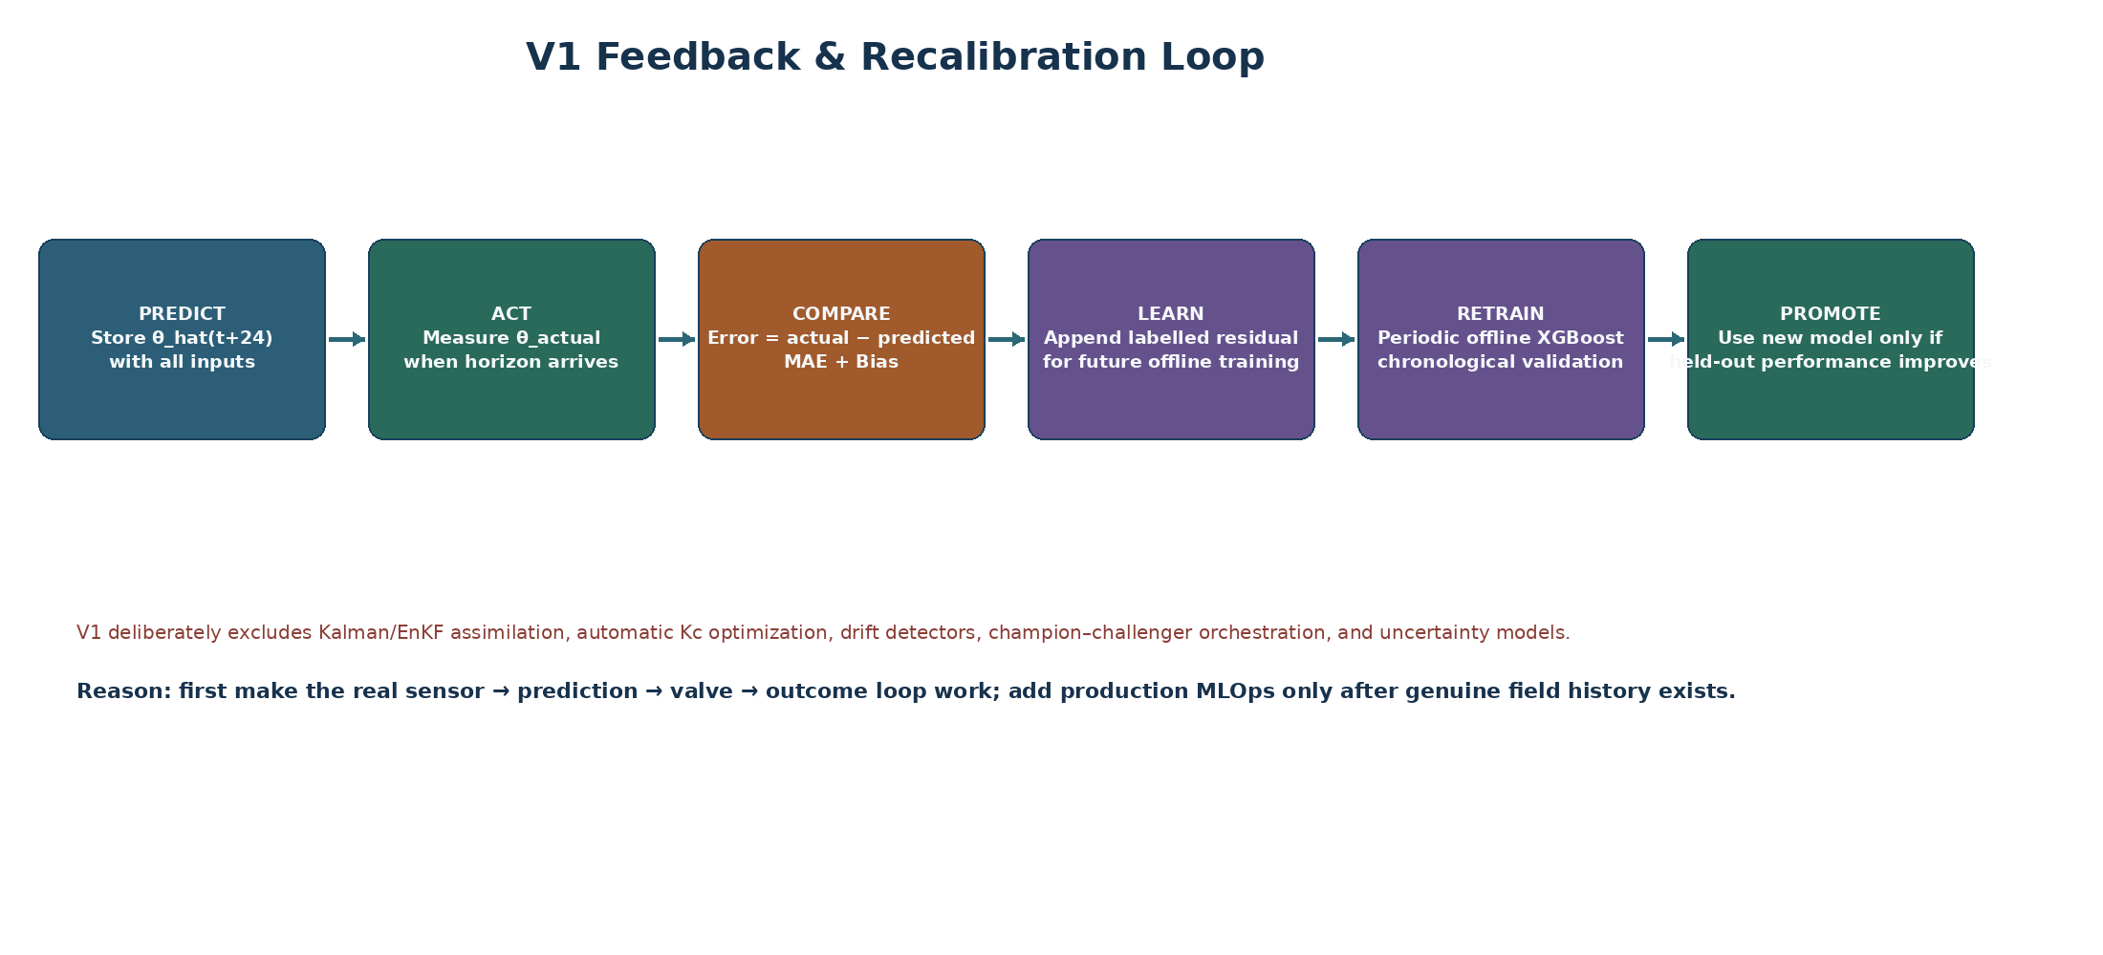
Figure 4. V1 feedback and offline retraining loop.

11.1 What is actually built in V1
- Basic sensor quality control: hard range checks and rolling median/spike filtering.
- Prediction logging: store forecast context, model output and eventual measured outcome.
- Error tracking: rolling MAE, RMSE and bias.
- Offline retraining: accumulate real labelled residual examples and periodically retrain XGBoost.
- Chronological validation: only promote a retrained model when it improves the frozen evaluation criteria.
- No automatic live recalibration of agronomic parameters during every sensor cycle.

11.2 Error taxonomy
Error type | Example | V1 handling
Sensor spike | 25% → 92% → 26% | Reject/flag via range and spike filter; keep raw for audit.
Forecast error | Weather forecast misses a rain event | Log as prediction error; do not rewrite Layer 1 instantly.
Systematic physics bias | Physics underestimates moisture for a crop/soil condition | Observe in residual statistics; future controlled calibration work.
ML residual error | XGBoost correction moves forecast farther from outcome | Log, evaluate, and retrain only offline after enough data.

11.3 Retraining rule
V1 retraining is periodic and offline. The model is not retrained after every sample. New real-field residual examples are accumulated; a training job is run on the updated dataset; the candidate is evaluated on a frozen chronological holdout; only a candidate that passes the acceptance criteria is eligible for future deployment.
Judge-facing explanation: “We log every prediction against the actual outcome, track rolling error and bias, and periodically retrain the residual model on accumulated field data, validating the new model against a frozen holdout before deployment.”

11.4 V1 explicitly excludes
- Kalman/EnKF state assimilation
- Automatic bounded Kc optimization
- Online/streaming XGBoost adaptation
- ADWIN or other formal drift detectors
- Champion/challenger orchestration
- Conformal uncertainty prediction

12. Decision and Valve-Control Logic

12.1 Current state decision
Layer 1 remains the immediate irrigation authority. If current root-zone depletion reaches RAW, the system may trigger replenishment, subject to safety and actuator conditions.
Dr_current ≥ RAW → irrigation trigger
Current root-zone depletion reaches the allowable depletion threshold.

12.2 Predictive decision
Layer 2 supplies a 24-hour forecast. If the predicted root-zone state is expected to cross the critical condition, the system can flag or schedule a likely irrigation need, subject to forecast quality and Layer-1 constraints. Predictive logic must not silently bypass current-state safety checks.

12.3 Water volume and runtime
Once net replenishment depth is determined, convert depth to gross applied depth using application efficiency; convert depth to litres using zone area; then convert litres to runtime using measured flow. Flow-confirmed delivery is preferred over a purely assumed flow rate.
V(L) = I_gross(mm) × Area(m²)
1 mm over 1 m² equals 1 litre.
runtime(min) = V(L) / Q(L/min)
Q should come from calibrated/measured zone flow where possible.

12.4 Safety rules
- If pressure is below the safe operating range, do not execute a new valve command unless the safety policy explicitly allows it.
- If flow remains zero/abnormal after valve opening, stop or flag the zone instead of assuming water was delivered.
- If a command is stale, reject it.
- If required sensor state is invalid, fall back to a documented safe state and alert the operator.
- An ML prediction cannot override configured maximum runtime, maximum volume, pressure limits or emergency stop.

13. Farmer Dashboard and Human Override
View | Display | Purpose
Zone overview | Current soil moisture, depletion, RAW status, valve state | Fast operational status
Prediction | 24 h physics forecast, XGB correction, final moisture forecast | Explain predictive layer
Decision trace | ET0, Kc, ETc, current Dr, RAW, irrigation need | Explain agronomic decision
Actuation | Commanded volume, runtime, measured flow/pressure | Verify delivery
Alerts | Sensor fault, connectivity, abnormal flow, predicted depletion | Prompt intervention
History | Prediction vs actual, MAE/bias, irrigation events | Show learning over time
Override | Start/stop/hold zone with safety constraints | Farmer authority

14. Failure Modes, Safety and Fallbacks
Failure | Detection | V1 response
Soil sensor invalid | Range/spike filter | Flag reading; use last valid state only within documented freshness window; otherwise inhibit automatic action.
Forecast API unavailable | Missing/stale forecast timestamp | Mark forecast degraded; do not fabricate future weather. Use current-state Layer 1 path only if the safety policy allows.
GSM disconnected | Heartbeat/connection timeout | Buffer telemetry locally; reject stale control commands.
MQTT broker unavailable | Publish/subscribe timeout | Buffer data; retry; no uncontrolled actuator behavior.
Valve command issued but no flow | Flow=0 or abnormal profile | Stop/flag zone; require operator inspection.
Pressure abnormal | Pressure outside configured range | Inhibit or stop actuation according to safety policy.
Database unavailable | Connection failure | Local queue/buffer; reconcile once storage returns.
XGB unavailable or degraded | Model file missing/stale/error | Use Layer 1 only; continue logging the reason for degraded mode.
Unexpected model output | Value outside physical moisture bounds | Clamp/flag or reject; never bypass Layer 1 safety constraints.

15. Validation and Test Strategy

15.1 Unit tests — Layer 1
- Validate each atmospheric equation against known cases.
- Validate ET0 units and sign/range.
- Validate Kc lookup and stage transitions.
- Validate TAW/RAW calculations against hand-calculated examples.
- Validate θcurrent → Dr conversion including FC/WP bounds.
- Validate trigger logic around Dr = RAW.
- Validate mm → litres → runtime conversions.

15.2 Layer 2 tests
- Verify no feature uses data after timestamp t unless it is explicitly forecast data available at t.
- Verify target uses t+24 observed value only after the horizon elapses.
- Compare persistence and physics-forward baselines before training ML.
- Train XGBoost with chronological validation.
- Evaluate residual distribution and bias by crop/stage/weather regime.
- Run at least one dry period, one rainfall transition and one irrigation event through the evaluation set.

15.3 Hardware-in-the-loop tests
1. Force a dry-zone condition and verify the expected valve action.
2. Force a wet-zone condition and verify valve remains closed.
3. Simulate a pressure drop and verify safe response.
4. Simulate zero flow after valve opening and verify fault handling.
5. Disconnect GSM and verify buffering/retry behavior.
6. Send stale command and verify rejection.
7. Log prediction and eventual outcome through the complete 24-hour feedback cycle.

16. Prototype Build Plan and Team Interfaces
Workstream | Primary deliverable | Dependency
Hardware — sensing | ESP32 + moisture + T/RH + rain inputs | Component selection/calibration
Hardware — hydraulic | Valve + driver + flow + pressure | Valve datasheet + power design
Hardware — comms | GSM modem + MQTT connectivity | SIM/network + broker
Software — Layer 1 | Python agronomic engine + unit tests | Weather input contract + crop config
Software — forecast | Forecast API adapter + cache | Location + provider
Software — data | Canonical DB schema + ingestion | MQTT/API payload contract
ML — data | Feature generator + synthetic structured-bias generator | Layer 1 forward run
ML — XGB | Residual training + validation | Dataset + physics baseline
Integration | End-to-end loop | All prior components
Dashboard | Operational view + manual override | Backend data contract

16.1 Recommended execution order
1. Prove weather forecast API call and payload parsing for the prototype location.
2. Implement and unit-test Layer 1 with deterministic known inputs.
3. Build a canonical synthetic weather/soil trajectory generator using Layer 1.
4. Inject structured feature-correlated biases; generate residual labels.
5. Build physics-forward + residual dataset and train XGBoost V1.
6. Validate against persistence and physics-only baselines.
7. Bring one real sensor into storage and calibrate the measurement path.
8. Integrate real sensor data into Layer 1.
9. Add valve + flow/pressure verification.
10. Run one end-to-end closed-loop demo zone.
11. Accumulate real outcomes and begin offline residual retraining only after sufficient labels exist.

17. Acceptance Criteria
Area | Must pass before “prototype works” claim
Layer 1 | Known test vectors produce valid ET0/ETc/TAW/RAW and irrigation outputs; no unit/sign errors.
Forecast | Forecast feed is live and timestamped; stale/missing forecast is handled safely.
Layer 2 | XGBoost residual model beats the physics baseline on a held-out temporal evaluation or the team documents why it is not yet ready.
Hardware | At least one real zone can read sensors and operate a valve through the control path.
Verification | Measured flow/pressure and later soil response are logged for an irrigation event.
Feedback | At least one prediction-outcome pair is stored and error metrics can be computed.
Safety | Invalid sensor, forecast failure, communication loss and valve/flow fault each have tested behavior.
Demo | A complete sequence can be demonstrated: field state → prediction → decision → valve → measured response → log.

18. Future Enhancements and Explicit Non-Goals
These are intentionally outside Prototype V1 unless a demonstrated need arises:
- Dual-Kc / more detailed soil evaporation modelling.
- Revised 2025 FAO crop-evapotranspiration methods beyond the compatibility baseline after a controlled audit.
- Local automated Kc/soil-parameter calibration after multi-week/month field history.
- Formal concept-drift detection and online adaptive XGBoost.
- Uncertainty-aware prediction intervals and risk-aware scheduling.
- MPC or reinforcement-learning control of multiple interacting hydraulic zones.
- Multi-season transfer learning and model personalization by farm/soil/crop.
- Large-scale device provisioning, stronger security hardening and production MLOps.

Appendix A — Equation Reference (Quick Implementation Sheet)
# | Equation
1 | es = 0.6108 exp(17.27T/(T+237.3))
2 | ea = es × RH / 100
3 | VPD = es − ea
4 | Δ = 4098 es / (T+237.3)^2
5 | P = 101.3 × ((293−0.0065z)/293)^5.26
6 | γ = 0.000665P
7 | ET0 = [0.408Δ(Rn−G) + γ×900/(T+273)×u2×(es−ea)] / [Δ + γ(1+0.34u2)]
8 | ETc = Kc × ET0
9 | TAW = 1000(θFC−θWP)Zr
10 | p = clip[p_table + 0.04(5−ETc), 0.1, 0.8]
11 | RAW = p × TAW
12 | S = clip[1000(θcurrent−θWP)Zr, 0, TAW]
13 | Dr = TAW − S
14 | Dr = clip[1000(θFC−θcurrent)Zr, 0, TAW]
15 | θcrit = θFC − p(θFC−θWP)
16 | Dr,t = Dr,t−1 + ETc,t − Pe,t − Inet,t + DPt + ROt
17 | Igross = Inet/Ea
18 | V(L) = Igross(mm)×Area(m²)
19 | runtime(min) = V(L)/Q(L/min)
20 | r(t+24)=θactual(t+24)−θphys(t+24)
21 | r_hat=XGBoost(features at t)
22 | θ_hat(t+24)=θphys(t+24)+r_hat

Appendix B — p-table / root-depth reference
Reference table carried into the master document from the locked Layer 1 specification. Values are configuration/reference values and must be validated for the selected crop/condition before deployment.
Crop group | Crop / variant | Max effective Zr (m) | p_table
Small vegetables | Broccoli | 0.4–0.6 | 0.45
Small vegetables | Brussel Sprouts | 0.4–0.6 | 0.45
Small vegetables | Cabbage | 0.5–0.8 | 0.45
Small vegetables | Carrots | 0.5–1.0 | 0.35
Small vegetables | Cauliflower | 0.4–0.7 | 0.45
Small vegetables | Celery | 0.3–0.5 | 0.20
Small vegetables | Garlic | 0.3–0.5 | 0.30
Small vegetables | Lettuce | 0.3–0.5 | 0.30
Small vegetables | Onions – dry | 0.3–0.6 | 0.30
Small vegetables | Onions – green | 0.3–0.6 | 0.30
Small vegetables | Onions – seed | 0.3–0.6 | 0.35
Small vegetables | Spinach | 0.3–0.5 | 0.20
Small vegetables | Radishes | 0.3–0.5 | 0.30
Solanaceae | Egg Plant | 0.7–1.2 | 0.45
Solanaceae | Sweet Peppers (bell) | 0.5–1.0 | 0.30
Solanaceae | Tomato | 0.7–1.5 | 0.40
Cucurbitaceae | Cantaloupe | 0.9–1.5 | 0.45
Cucurbitaceae | Cucumber – Fresh Market | 0.7–1.2 | 0.50
Cucurbitaceae | Cucumber – Machine harvest | 0.7–1.2 | 0.50
Cucurbitaceae | Pumpkin, Winter Squash | 1.0–1.5 | 0.35
Cucurbitaceae | Squash, Zucchini | 0.6–1.0 | 0.50
Cucurbitaceae | Sweet Melons | 0.8–1.5 | 0.40
Cucurbitaceae | Watermelon | 0.8–1.5 | 0.40
Roots and tubers | Beets, table | 0.6–1.0 | 0.50
Roots and tubers | Cassava – year 1 | 0.5–0.8 | 0.35
Roots and tubers | Cassava – year 2 | 0.7–1.0 | 0.40
Roots and tubers | Parsnip | 0.5–1.0 | 0.40
Roots and tubers | Potato | 0.4–0.6 | 0.35
Roots and tubers | Sweet Potato | 1.0–1.5 | 0.65
Roots and tubers | Turnip (and Rutabaga) | 0.5–1.0 | 0.50
Roots and tubers | Sugar Beet | 0.7–1.2 | 0.55
Legumes | Beans, green | 0.5–0.7 | 0.45
Legumes | Beans, dry and Pulses | 0.6–0.9 | 0.45
Legumes | Beans, lima, large vines | 0.8–1.2 | 0.45
Legumes | Chick pea | 0.6–1.0 | 0.50
Legumes | Fababean (broad bean) – Fresh | 0.5–0.7 | 0.45
Legumes | Fababean (broad bean) – Dry/Seed | 0.5–0.7 | 0.45
Legumes | Grabanzo | 0.6–1.0 | 0.45
Legumes | Green Gram and Cowpeas | 0.6–1.0 | 0.45
Legumes | Groundnut (Peanut) | 0.5–1.0 | 0.50
Legumes | Lentil | 0.6–0.8 | 0.50
Legumes | Peas – Fresh | 0.6–1.0 | 0.35
Legumes | Peas – Dry/Seed | 0.6–1.0 | 0.40
Legumes | Soybeans | 0.6–1.3 | 0.50
Perennial vegetables | Artichokes | 0.6–0.9 | 0.45
Perennial vegetables | Asparagus | 1.2–1.8 | 0.45
Perennial vegetables | Mint | 0.4–0.8 | 0.40
Perennial vegetables | Strawberries | 0.2–0.3 | 0.20
Fibre crops | Cotton | 1.0–1.7 | 0.65
Fibre crops | Flax | 1.0–1.5 | 0.50
Fibre crops | Sisal | 0.5–1.0 | 0.80
Oil crops | Castorbean (Ricinus) | 1.0–2.0 | 0.50
Oil crops | Rapeseed, Canola | 1.0–1.5 | 0.60
Oil crops | Safflower | 1.0–2.0 | 0.60
Oil crops | Sesame | 1.0–1.5 | 0.60
Oil crops | Sunflower | 0.8–1.5 | 0.45
Cereals | Barley | 1.0–1.5 | 0.55
Cereals | Oats | 1.0–1.5 | 0.55
Cereals | Spring Wheat | 1.0–1.5 | 0.55
Cereals | Winter Wheat | 1.5–1.8 | 0.55
Cereals | Maize, Field (grain) (field corn) | 1.0–1.7 | 0.55
Cereals | Maize, Sweet (sweet corn) | 0.8–1.2 | 0.50
Cereals | Millet | 1.0–2.0 | 0.55
Cereals | Sorghum – grain | 1.0–2.0 | 0.55
Cereals | Sorghum – sweet | 1.0–2.0 | 0.50
Cereals | Rice | 0.5–1.0 | 0.20
Forages | Alfalfa – for hay | 1.0–2.0 | 0.55
Forages | Alfalfa – for seed | 1.0–3.0 | 0.60
Forages | Bermuda – for hay | 1.0–1.5 | 0.55
Forages | Bermuda – spring crop for seed | 1.0–1.5 | 0.60
Forages | Clover hay, Berseem | 0.6–0.9 | 0.50
Forages | Rye Grass hay | 0.6–1.0 | 0.60
Forages | Sudan Grass hay (annual) | 1.0–1.5 | 0.55
Forages | Grazing Pasture – Rotated Grazing | 0.5–1.5 | 0.60
Forages | Grazing Pasture – Extensive Grazing | 0.5–1.5 | 0.60
Forages | Turf grass – cool season | 0.5–1.0 | 0.40
Forages | Turf grass – warm season | 0.5–1.0 | 0.50
Sugar cane | Sugar Cane | 1.2–2.0 | 0.65
Tropical fruits and trees | Banana – 1st year | 0.5–0.9 | 0.35
Tropical fruits and trees | Banana – 2nd year | 0.5–0.9 | 0.35
Tropical fruits and trees | Cacao | 0.7–1.0 | 0.30
Tropical fruits and trees | Coffee | 0.9–1.5 | 0.40
Tropical fruits and trees | Date Palms | 1.5–2.5 | 0.50
Tropical fruits and trees | Palm Trees | 0.7–1.1 | 0.65
Tropical fruits and trees | Pineapple | 0.3–0.6 | 0.50
Tropical fruits and trees | Rubber Trees | 1.0–1.5 | 0.40
Tropical fruits and trees | Tea – non-shaded | 0.9–1.5 | 0.40
Tropical fruits and trees | Tea – shaded | 0.9–1.5 | 0.45
Grapes and berries | Berries (bushes) | 0.6–1.2 | 0.50
Grapes and berries | Grapes – Table or Raisin | 1.0–2.0 | 0.35
Grapes and berries | Grapes – Wine | 1.0–2.0 | 0.45
Grapes and berries | Hops | 1.0–1.2 | 0.50
Fruit trees | Almonds | 1.0–2.0 | 0.40
Fruit trees | Apples, Cherries, Pears | 1.0–2.0 | 0.50
Fruit trees | Apricots, Peaches, Stone Fruit | 1.0–2.0 | 0.50
Fruit trees | Avocado | 0.5–1.0 | 0.70
Fruit trees | Citrus – 70% canopy | 1.2–1.5 | 0.50
Fruit trees | Citrus – 50% canopy | 1.1–1.5 | 0.50
Fruit trees | Citrus – 20% canopy | 0.8–1.1 | 0.50
Fruit trees | Conifer Trees | 1.0–1.5 | 0.70
Fruit trees | Kiwi | 0.7–1.3 | 0.35
Fruit trees | Olives (40–60% ground coverage by canopy) | 1.2–1.7 | 0.65
Fruit trees | Pistachios | 1.0–1.5 | 0.40
Fruit trees | Walnut Orchard | 1.7–2.4 | 0.50

Appendix C — Example End-to-End Trace

C.1 Example (illustrative only)
The following is an illustrative calculation to explain the software flow. It is not a field claim and the numbers are placeholders until the team selects a real crop, soil and calibrated sensor configuration.
Stage | Example value | Interpretation
Weather | T=32°C, RH=45%, wind=3 m/s, radiation inputs available | Input to ET0
ET0 | 5.2 mm/day | Atmospheric reference demand
Kc | 1.05 | Configured crop/stage coefficient
ETc | 5.46 mm/day | Crop evapotranspiration baseline
θFC / θWP | 0.30 / 0.15 m³/m³ | Soil hydraulic parameters
Zr | 0.60 m | Effective root zone
TAW | 90 mm | Total available water
p | ETc-adjusted fraction | Allowable depletion fraction
RAW | p×TAW | Trigger threshold
θcurrent | 0.245 m³/m³ | Live root-zone sensor state
Dr | Calculated from θcurrent | Current depletion
Trigger | Dr ≥ RAW? | Determines whether replenishment is due
Gross volume | Derived from net depth, efficiency and zone area | Physical water command
Valve runtime | Volume / measured flow | Actuator command
Feedback | Later actual θ + flow + pressure | Prediction/outcome log

Appendix D — Source and Research References
- Team Rocket uploaded SIH solution PDF / deck — source for PS ID, title, theme, category and the team’s proposed solution architecture (page 1 onward).
- FAO Irrigation and Drainage Paper 56 — Crop Evapotranspiration: Guidelines for Computing Crop Water Requirements (classic FAO-56 baseline used for the deterministic Layer 1 design).
- FAO 2025 Revised Edition of Crop Evapotranspiration — current revision of the FAO56 guidelines; the prototype uses a FAO-56-compatible baseline and should audit the revised guidance before production. Official current source: https://agris.fao.org/search/en/providers/124943/records/6a32b9d6b9a0a56f302a5e20
- XGBoost documentation — regression objectives and training/evaluation capabilities. Official current documentation: https://xgboost.readthedocs.io/
- Team Rocket Layer 1 — Agronomic Engine Final Implementation Specification v2 (internal working specification; incorporated into this master document).
- Team Rocket Layer 2 — XGBoost Residual Forecasting Engine Implementation Specification (internal working specification; incorporated into this master document).
- Team Rocket Feedback & Recalibration Implementation Specification V1 (internal working specification; incorporated into this master document).
- Research context considered during brainstorming: soil-moisture forecasting, irrigation scheduling, LSTM/XGBoost comparisons, physics-informed/residual modelling and sensor-feedback approaches.

Master Implementation Checklist — Freeze Point
Frozen architecture
Field sensing → edge controller → GSM/MQTT → data platform → Layer 1 deterministic agronomic engine → 24 h physics forward run using forecast weather → Layer 2 XGBoost residual correction → corrected 24 h root-zone forecast → Layer-1 irrigation decision → valve/driver → flow/pressure + soil response → database → periodic offline retraining.

Before coding
1. Confirm weather forecast provider and variables.
2. Confirm exact soil sensor type and calibration method.
3. Confirm soil θFC, θWP and effective Zr assumptions for the prototype crop.
4. Confirm crop Kc source and growth-stage schedule.
5. Confirm valve/driver electrical interface and safe flow/pressure ranges.

Before internal demo
1. Layer 1 unit tests pass.
2. Forecast API call works.
3. Synthetic structured-residual dataset generated.
4. XGBoost residual model trained and evaluated against persistence and physics-only baseline.
5. At least one real sensor path works.
6. At least one valve command can be executed safely.
7. One prediction-outcome record can be shown in the database.
End of master PRD / system implementation specification.

