AquaSence AI
Simulation Prototype Specification
SIH260220 | Team Rocket | Internal Prototype / Judge Demo
Prototype principle
Tomorrow's prototype is a live simulation of the real cyber-physical system. Sensor, weather and actuator values are generated or manually controlled using realistic ranges; the same Layer 1, Layer 2, decision and feedback logic is executed live. The demo must never present synthetic values as real field measurements.

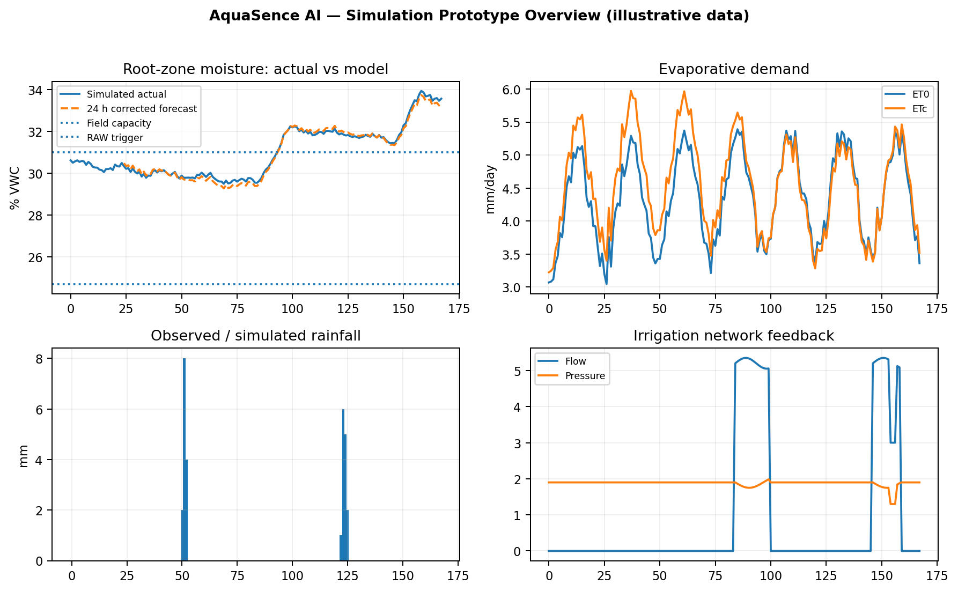
Illustrative prototype dashboard / monitoring view. All values must be driven by the simulation engine at runtime.

1. Purpose and Scope
This specification defines the implementation requirements for the AquaSence AI simulation prototype. It is an execution document for the internal SIH prototype, not a replacement for the master PRD. It translates the locked architecture into a demonstrable simulation with controllable field inputs, live calculations, realistic system response, measurable prediction error, and visible feedback.
- Demonstrate the complete end-to-end decision path without requiring physical field hardware to be available in the demo room.
- Use realistic, reproducible simulated measurements for soil, weather, rainfall, irrigation flow, pressure and forecast conditions.
- Execute the actual Layer 1 agronomic engine, the Layer 2 physics-forward + XGBoost residual forecasting path, the irrigation decision logic, and the V1 feedback/logging loop.
- Provide judge-facing graphs and KPI cards that explain both the agricultural reasoning and the machine-learning behaviour.
- Make every number traceable to an input, equation, model output, or simulated actuator response.

2. Non-Goals for the Prototype
- No claim that simulated accuracy equals field accuracy.
- No production-grade autonomous retraining, drift detection, Kalman filtering, uncertainty modelling, or online model deployment.
- No need to prove long-term agricultural yield improvement in a one-day prototype.
- No hidden hard-coded “correct answer” after the input is changed; the outputs must be recomputed by the pipeline.

3. Prototype Architecture
The prototype reproduces the same logical layers planned for deployment. Only the physical source of observations is substituted by a simulation engine.
SIMULATED FIELD → SENSOR/WEATHER STREAM → QC/FILTER → LAYER 1 → PHYSICS FORWARD FORECAST → XGBOOST RESIDUAL → PREDICTED FUTURE RZ MOISTURE → DECISION ENGINE → SIMULATED VALVE → SIMULATED FIELD RESPONSE → DATABASE/LOGS → METRICS
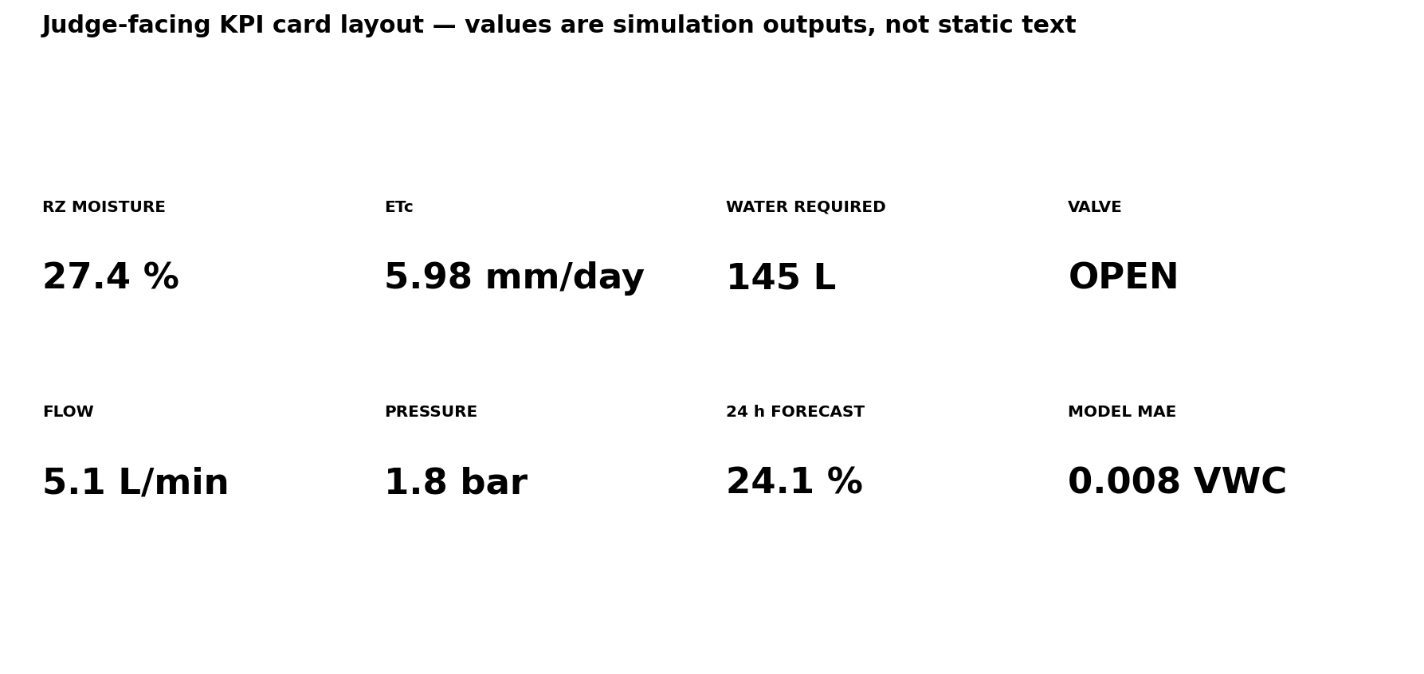
Judge-facing KPI panel concept.

4. Simulation Input Model

4.1 Environment controls
Input | Unit | Prototype range | Purpose
Air temperature | °C | 10–45 | ET0 / weather state
Relative humidity | % | 20–95 | Vapour pressure / dryness
Wind speed at 2 m | m/s | 0–12 | ET0
Solar / net radiation | MJ/m²/day | 0–30 | ET0
Rainfall | mm | 0–50/event | Water input
Forecast rainfall | mm next 24 h | 0–50 | Forward weather input
Forecast temperature | °C next 24 h | 10–45 | Forward ET demand
Forecast humidity | % next 24 h | 20–95 | Forward ET demand
Forecast wind | m/s next 24 h | 0–12 | Forward ET demand
Forecast radiation | MJ/m²/day | 0–30 | Forward ET demand

4.2 Field / agronomic controls
Input | Unit / type | Example | Purpose
Crop | categorical | Tomato | Kc/p/root-zone settings
Growth stage | categorical | Flowering | Kc and p
Soil texture | categorical | Loam | FC/WP/soil parameters
Root-zone depth | m | 0.60 | TAW / storage
Soil moisture current | m³/m³ | 0.274 | Current state
Flow rate | L/min | 5.1 | Valve runtime / verification
Pressure | bar | 1.8 | Hydraulic verification
Zone area | m² | 100 | mm to litres conversion
Irrigation efficiency | 0–1 | 0.90 | Gross irrigation
Forecast confidence flag | boolean | TRUE | Simulation health

5. Simulation Engine

5.1 Simulation clock
- Internal simulation time advances in 1-hour steps for the V1 demo.
- Each step updates the field state, recalculates Layer 1, generates the physics forecast, runs XGBoost, updates the dashboard, and appends an observation log.
- The UI must support PLAY, PAUSE, STEP +1h, RESET and scenario restart.
- The demo may accelerate simulation time (for example, one simulated hour every 1–2 seconds), but timestamps shown to the judge must remain simulation timestamps.

5.2 Realistic state transitions
- Soil moisture must change continuously; it should not jump arbitrarily except for rainfall, irrigation, or a deliberately injected anomaly scenario.
- Temperature and radiation should follow a diurnal pattern with configurable weather perturbations.
- Humidity should generally respond inversely to temperature/radiation during daytime unless rainfall or a cloud event is simulated.
- Rainfall should produce a rapid increase in root-zone moisture only after applying the configured effective-rainfall/infiltration behaviour.
- Irrigation should increase moisture progressively across the simulated valve runtime rather than instantly setting the target moisture.
- Flow and pressure should respond to valve state and may include controlled noise or a deliberate hydraulic deviation event.

6. Demo Scenario Library
Scenario | Input state | Expected system behaviour | Judge purpose
01 — Dry field | Low SM, high ETc, no useful rain | Trigger/prepare irrigation; show water requirement and valve action | Core problem
02 — Rain ahead | Moderate SM, positive 24 h rain forecast | Reduce/delay irrigation; show forecast value | Why forecast matters
03 — Heat wave | High temperature, low humidity, high ETc | Higher depletion rate / earlier trigger | Shows ET-driven behaviour
04 — Wet field | SM near FC, low ET demand | No irrigation; continue monitoring | Shows water conservation
05 — Valve deviation | Commanded flow differs from measured flow | Stop/flag event, log deviation | Shows closed-loop feedback
06 — Model correction | Physics forecast has structured bias | XGBoost residual reduces held-out error in simulation | Shows ML purpose
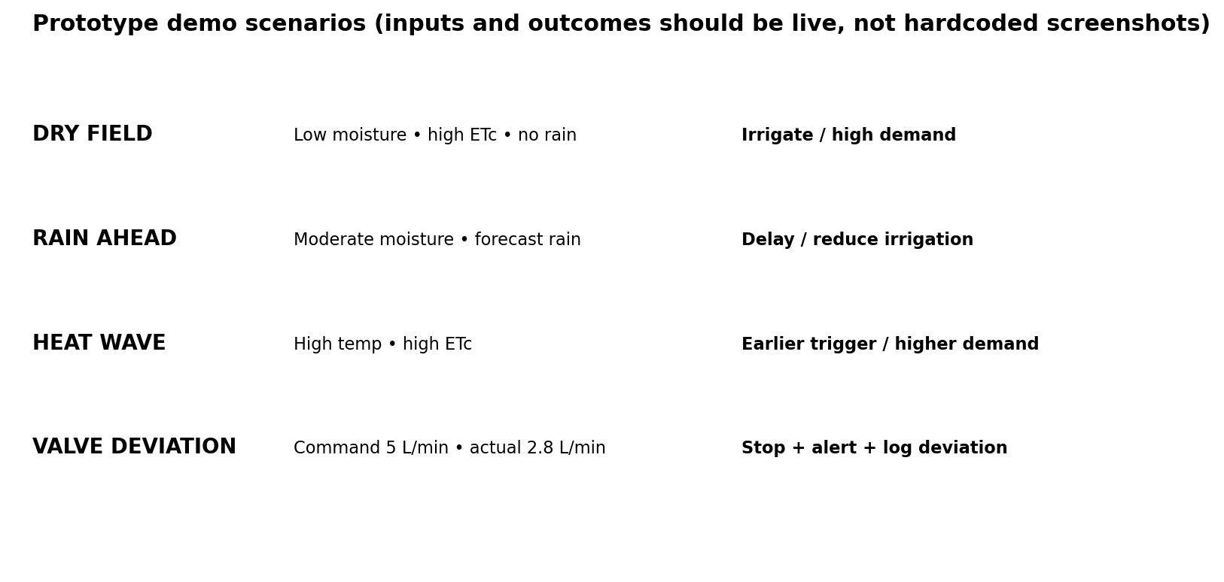
Scenario matrix for the live demonstration. The UI should expose these as scenario presets, not static slides.

7. Layer 1 Live Outputs
Layer 1 remains the deterministic agronomic and root-zone water-balance engine. In the simulation, every output is computed live from the current simulated weather, crop, soil and moisture state.
- ET0 (mm/day)
- Kc (dimensionless) selected from crop + growth-stage configuration
- ETc (mm/day)
- TAW (mm)
- p and RAW (mm)
- Current root-zone depletion Dr (mm)
- Critical moisture threshold θcrit
- Effective rainfall contribution
- Net irrigation requirement (mm)
- Gross irrigation requirement (mm)
- Required water volume (L)
- Valve runtime (min) based on simulated/measured flow rate
UI rule
Every “water required” card must be traceable to the Layer 1 calculation chain. The UI should provide a compact “Why?” panel that explains the trigger in plain language, for example: “Root-zone depletion reached RAW; no useful rainfall is forecast; gross irrigation = 145 L.”

8. Layer 2 Live Outputs
Layer 2 is the physics-forward forecast plus XGBoost residual correction. The simulation must show the two forecasts separately so the judge can see exactly where the machine-learning component adds value.
Output | Example | Refresh | Display
Physics-only 24 h RZ moisture | 0.218 m³/m³ | Every simulated hour | Forecast card + graph
XGBoost residual | +0.006 m³/m³ | Every simulated hour | Model insight
Corrected 24 h RZ moisture | 0.224 m³/m³ | Every simulated hour | Primary prediction card
Prediction error | Actual − predicted | Available after target time | Metric/history
Rolling MAE | 0.008 m³/m³ (illustrative) | After enough outcomes | Model health
Bias | +0.0014 m³/m³ (illustrative) | After enough outcomes | Model health
R² | 0.925 (illustrative) | Validation window | Model health

9. Forecast Weather Dependency
The 24-hour prediction must use explicit forecast weather inputs. If the forecast feed is unavailable, the UI must show a degraded-state flag; the system must not silently substitute stale or future observed values.
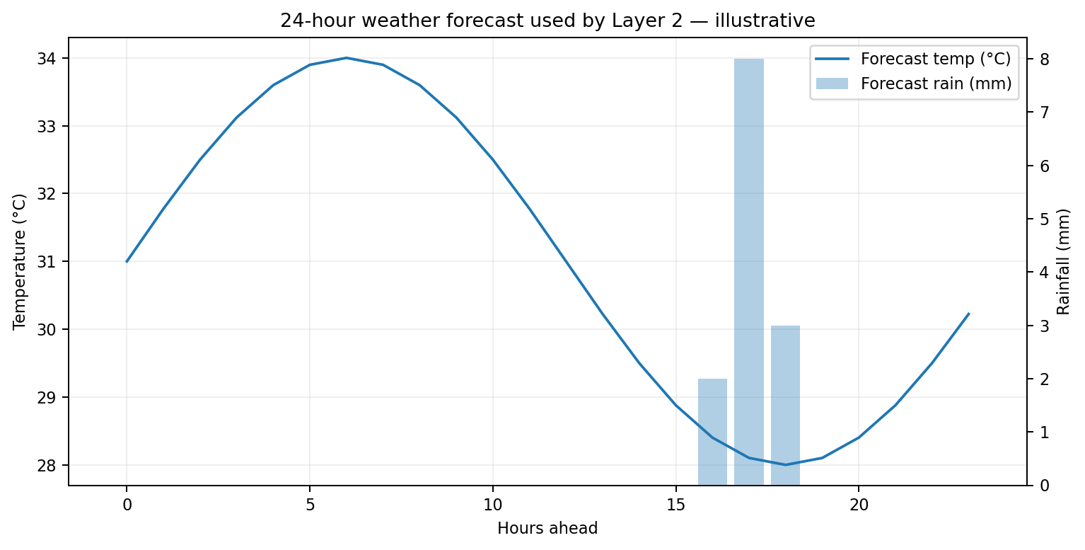
Required forecast visualization: temperature trajectory plus rainfall forecast over the next 24 hours (illustrative).
- Forecast features: rainfall, temperature, humidity, wind, radiation and/or forecast ET0 where available.
- Feature windows: 0–6 h, 6–12 h and 12–24 h aggregation for rainfall and ET-related demand are recommended for the V1 simulation.
- No data leakage: future observed soil moisture, future observed rainfall, or future actual irrigation may never be passed into the prediction at the time the forecast is generated.
- Simulation mode may provide a deterministic future weather timeline so the forecast API is not required to be online during the judge demo; the dashboard must label the source as “simulated forecast”.

10. Judge-Facing Dashboard — Real-Time Cards
The top of the dashboard should contain high-signal cards that answer: What is happening now? What does the model expect? How much water will be used? Did the actuation work?

KPI card layout. Values are illustrative; the live prototype must populate them from the simulation state.
Card | What it shows | Update trigger | Alert state
Root-zone moisture | Current θRZ + % VWC | Every simulated hour | Normal / Near RAW / Below threshold
ETc | Current crop water demand | Every hour | Normal / High demand
Water required | Gross litres for current decision | On decision | 0 L / Calculated / Scheduled
Valve state | Open/Closed + current runtime | Actuation events | Open / Closed / Fault
Flow | Measured/simulated L/min | During irrigation | Normal / Deviation
Pressure | Measured/simulated bar | During irrigation | Normal / Low / High
24 h forecast | Corrected future θRZ | Every hour | Safe / Near trigger / Trigger likely
Model health | Rolling MAE / Bias | After outcomes | Healthy / Needs review

11. Required Graphs and Visual Analytics
The prototype should prioritize graphs that explain system cause → prediction → action → response. Do not add charts merely because the dashboard has space.

11.1 Root-zone moisture graph
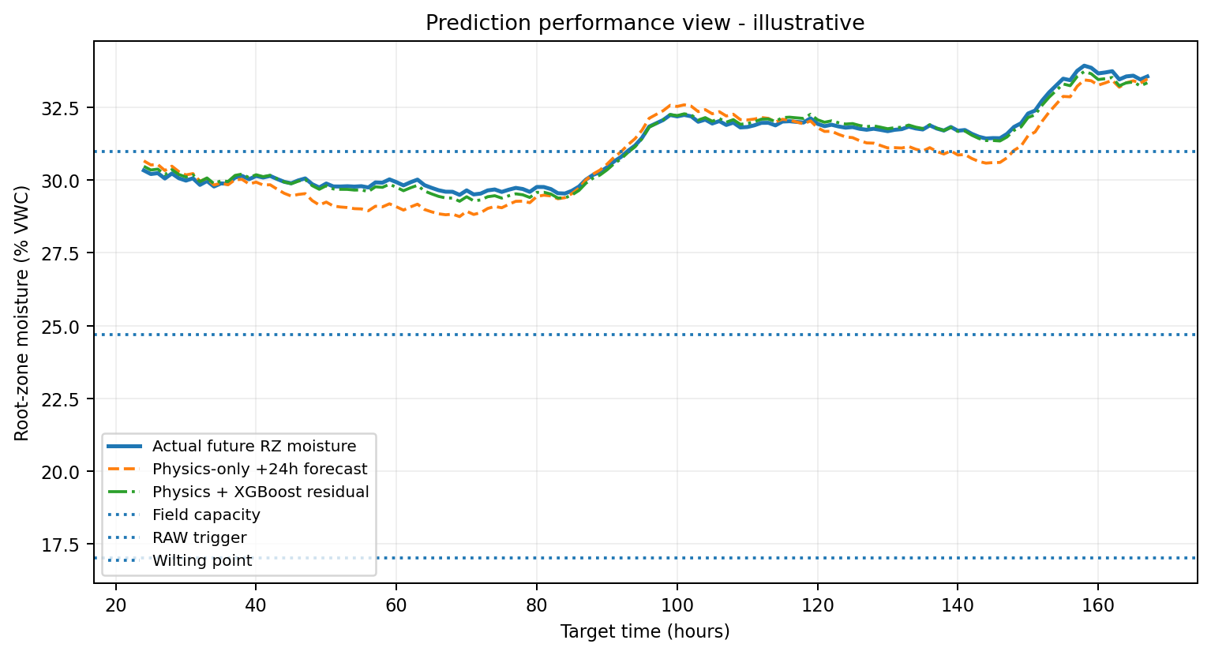
Show actual simulated soil moisture, physics-only +24h forecast, corrected XGBoost forecast, field capacity, RAW trigger threshold and wilting point. This is the primary graph.

11.2 ET0 / ETc graph

Show ET0 and ETc over the simulation timeline. Use to explain why demand changes across the day or weather scenario.

11.3 Forecast weather graph

Show next 24 h temperature and forecast rainfall. This proves that Layer 2 receives future weather context.

11.4 Water requirement vs delivered
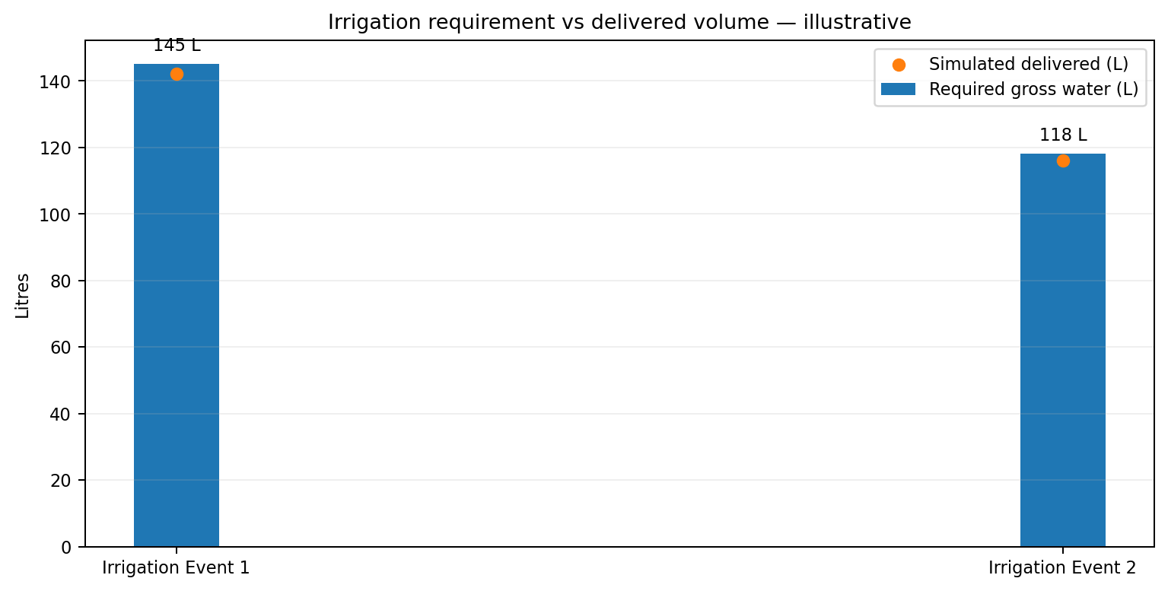
Show required gross water and actual delivered water for each irrigation event. Include deviation percentage.

11.5 Physics vs corrected forecast

Overlay actual RZ moisture, physics-only forecast and physics+XGBoost forecast. Judge should see ML reducing the physics residual.

11.6 Residual error trend
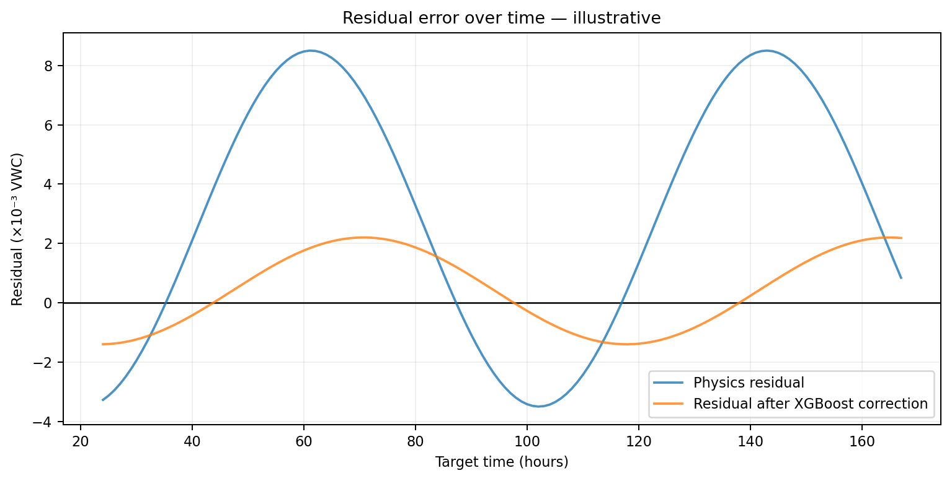
Show signed residual before and after XGBoost correction. The purpose is to demonstrate bias correction, not to present decorative analytics.

11.7 Model score over time
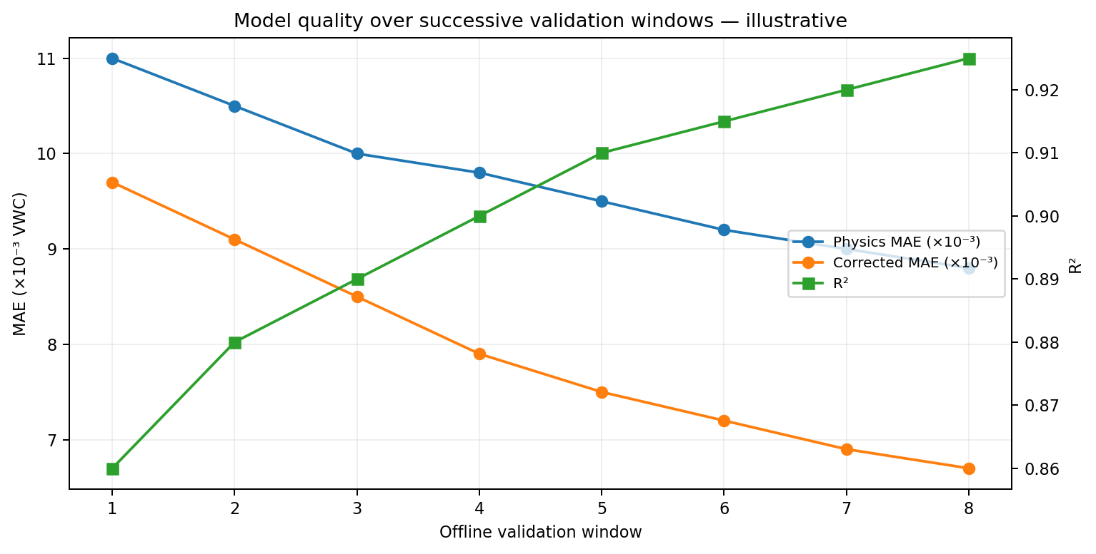
Plot MAE for physics-only vs corrected model and R² over successive offline validation windows. Values must be computed from the validation dataset.

11.8 Recalibration improvement
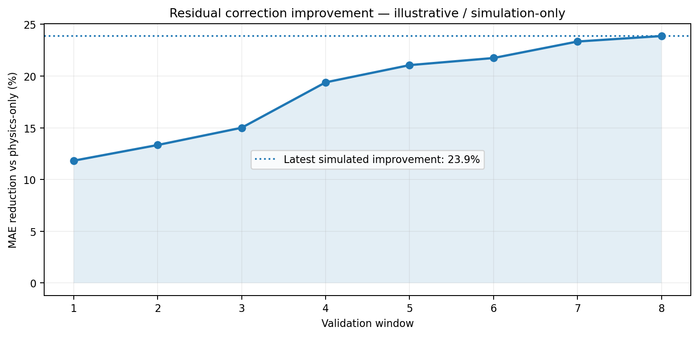
Show percentage reduction in MAE versus physics-only. In a real demo this must be calculated live from the simulated validation set; the graph is illustrative.

11.9 Flow + pressure feedback
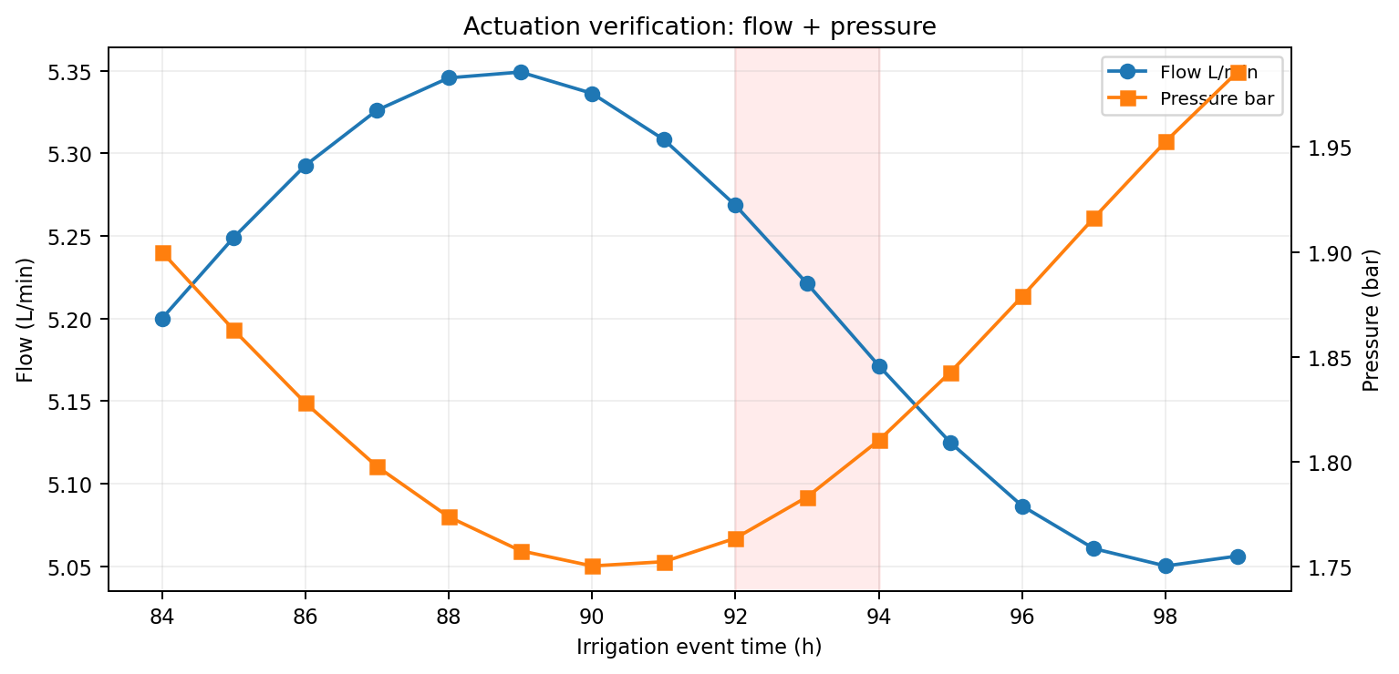
Show measured flow and pressure during valve operation and clearly mark any simulated deviation event.

11.10 Event timeline
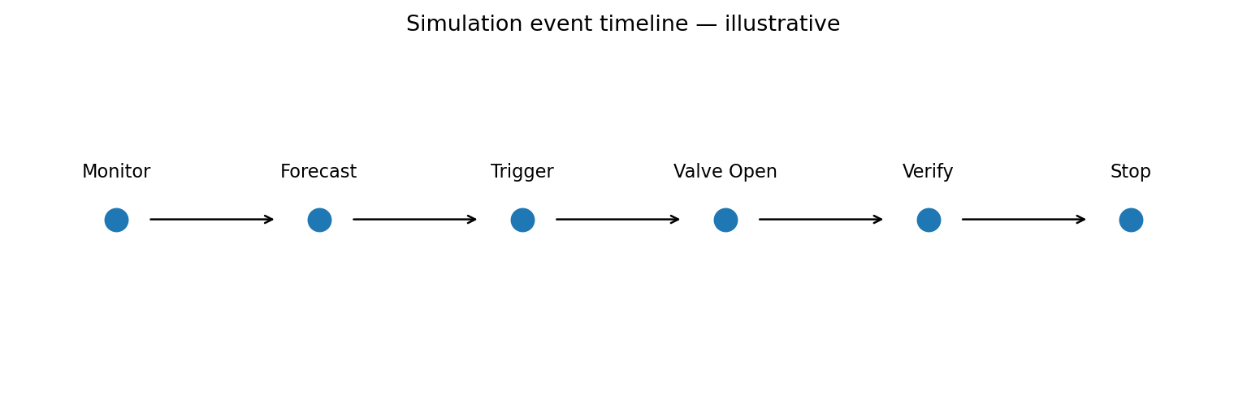
Show Monitor → Forecast → Trigger → Valve Open → Verify → Stop for each selected irrigation event.

12. Error, Recalibration and Model Health
The simulation must not invent claims of field accuracy. It may compute objective metrics on the simulated/public validation dataset and label them as such. The UI should distinguish: “Simulation validation” versus “Real field validation”.
- MAE = mean absolute root-zone moisture prediction error.
- RMSE = root-mean-square prediction error.
- R² = coefficient of determination.
- Bias = mean signed prediction error.
- NRMSE = RMSE / (θFC − θWP), for soil-normalized error reporting.
- Irrigation trigger precision/recall: whether the model correctly anticipates a Layer-1 RAW trigger in the simulated dataset.
- Water delivery deviation = (actual delivered − commanded volume) / commanded volume.
- Recalibration improvement = (MAE_physics − MAE_corrected) / MAE_physics × 100.

Illustrative validation trend. The real dashboard must compute metrics from the active validation dataset, not use these placeholder values.

Illustrative simulated MAE improvement after residual correction. Do not present this number as real-world field performance.
Strict reporting rule
For tomorrow's demo, a statement such as “MAE improved by 28%” is valid only if the software computed that value from a clearly defined held-out simulation/public validation set. Never label synthetic performance as field accuracy.

13. Feedback and Learning Loop — V1
PREDICTION → LOG → WAIT FOR ACTUAL OUTCOME → ERROR = ACTUAL - PREDICTED → UPDATE ROLLING MAE/BIAS → PERIODIC OFFLINE RETRAIN
- Every prediction receives a prediction ID and timestamp.
- The actual simulated soil-moisture outcome at t+24 h is stored against the prediction ID.
- Residual = actual future root-zone moisture − corrected predicted root-zone moisture.
- Rolling MAE and bias are recomputed whenever enough resolved predictions exist.
- V1 retraining is offline and periodic; there is no online retraining in the live loop.
- Any retrained model must be validated against a frozen holdout before being marked as the next candidate model.
- The demo should include a “feedback log” or “model history” view where the judge can see predictions turning into resolved outcomes.

Residual trend visualization for feedback and learning. The corrected residual should generally become smaller after the residual model has learned the structured bias in the simulation dataset.

14. Synthetic Data Generation — Critical Rules
Because this prototype is simulation-based, the generator must create physically plausible trajectories and a validation truth that is distinct from the exact physics assumptions used for the prediction model.
- Start with Layer 1 to generate a physically plausible baseline trajectory.
- Generate a hidden “actual” trajectory by injecting structured, feature-correlated deviations, not independent white noise alone.
- Example structured deviations: stage-dependent ET bias, soil-texture-dependent infiltration offset, forecast-vs-actual rainfall mismatch, mild sensor drift, or systematic effective-rainfall error.
- Expose the causal variables responsible for the structured deviation to XGBoost so that residual learning is possible.
- Keep the hidden parameters fixed for a scenario so the model has a learnable relationship.
- Reserve a held-out set with different timestamps and at least one different scenario configuration to test generalization.
- Clearly label synthetic truth as “simulated actual”.
Recommended demo bias example
During flowering, set the simulated actual crop-water response to be systematically 5–8% higher than the baseline ETc assumption. In loamy soil, keep the bias small; in sandy soil, simulate a modest faster-drainage effect. XGBoost then receives crop stage, ETc, soil context and weather features and has a real structured residual pattern to learn.

15. Decision and Actuation Simulation
- Layer 1 determines whether current root-zone depletion has reached RAW and calculates required irrigation volume.
- If irrigation is not required, valve remains CLOSED and the dashboard shows “Monitoring”.
- If irrigation is required, the decision engine produces required litres and target runtime based on the current measured/simulated flow rate.
- Valve state changes from CLOSED → OPEN and the simulated field engine increases root-zone moisture gradually.
- Flow and pressure values are updated every simulation step while the valve is open.
- If a deliberate deviation scenario is active, the measured flow may fall below commanded flow and the system should stop/flag the event according to the V1 safety rule.
- Valve stops when the target runtime is reached or the simulation detects a delivery fault.

Actuation verification graph. The red shaded region is a deliberate simulated deviation for the demo.

16. Required Simulation Screens
Screen | Must show | Key interactions | Judge value
Live Dashboard | KPI cards, main moisture graph, system status | Pause/play/reset, scenario selector | Main demo screen
Simulation Controls | All environmental and field inputs + forecast controls | Edit, randomize within safe ranges, run | Shows controllability
Prediction & Decision | Physics forecast, XGB residual, corrected forecast, Layer-1 trigger | Expand “Why?” details | Explains AI + agronomy
Irrigation Event | Valve state, water required, runtime, flow, pressure | Start/stop simulation event | Shows hardware logic
Feedback & Model | Actual vs predicted, MAE/RMSE/R²/bias, residual trend | Select validation window | Shows learning/accuracy honestly
History | Resolved predictions and irrigation events | Filter by zone/scenario | Traceability
System Health | Forecast availability, data freshness, sensor status | View degraded state | Demonstrates robustness

17. Exact Judge Demo Sequence
1. Open Live Dashboard on a normal/wet field state. Point out current root-zone moisture, ETc, forecast, and valve status.
2. Switch to “Dry Field” scenario. Advance the simulation several steps and show moisture falling while ETc remains elevated.
3. Open the prediction view and show the 24-hour physics forecast plus XGBoost residual correction.
4. Show the RAW trigger line crossing. Explain: “Layer 1 says the current depletion has reached the allowable threshold; Layer 2 says the trend is likely to remain dry over the next 24 hours.”
5. Let the decision engine calculate gross water required. Show litres, flow rate and valve runtime.
6. Start irrigation. Show valve OPEN, flow, pressure and increasing soil moisture in real time.
7. Stop automatically when the configured target is reached. Show valve CLOSED and the updated root-zone moisture.
8. Run the “Rain Ahead” scenario. Show forecast rainfall changing the forward prediction and the resulting irrigation recommendation.
9. Run the “Valve Deviation” scenario. Show commanded flow vs actual flow and the alert/stop logic.
10. Open the model/feedback screen. Show resolved predictions, rolling error, bias, and the simulated reduction in residual MAE. State clearly that these are simulation/public-data validation metrics, not field accuracy.

18. Judge Questions — Required Answers
Q: Why simulate instead of use physical sensors?
A: This prototype validates the complete computational and control pipeline. The simulated input stream uses the same schema intended for physical sensors, allowing repeatable tests of dry, rain, heat and failure scenarios. Physical sensing is the next integration step.
Q: What exactly does XGBoost do?
A: It learns a residual correction to the 24-hour physics-based root-zone moisture forecast. It does not directly open the valve.
Q: Why not let ML directly decide irrigation?
A: Layer 1 remains the agronomic and safety authority. ML adds field-specific predictive correction; the physical control remains deterministic and explainable.
Q: Where does the 24-hour forecast come from?
A: The prototype uses a forecast weather stream. In demo mode this can be simulated deterministically so the complete system remains reproducible.
Q: How does the system learn?
A: Every prediction is logged against the eventual outcome; rolling MAE and bias are tracked; after enough real observations accumulate, the residual model can be retrained offline and validated against a frozen holdout.
Q: Is the reported accuracy real field accuracy?
A: No. Prototype metrics are clearly labelled simulation/public-data validation. Field accuracy is claimed only after real sensor data is collected and evaluated.
Q: What happens if the valve command does not produce the expected flow?
A: Flow/pressure feedback detects the deviation; the system can stop/flag the event according to the configured safety rule and logs the anomaly.

19. Prototype Acceptance Criteria
Area | Acceptance criterion | Evidence on screen
Simulation inputs | Changing any major input produces a downstream change within the next update cycle. | Simulation Controls + KPI updates
Layer 1 | ET0, Kc, ETc, TAW, RAW, depletion and water requirement are computed from inputs. | Prediction/Decision “Why?” panel
Forecast | 24 h forecast variables are explicit inputs; unavailable forecast produces degraded-state indication. | Forecast card / status
XGBoost | Produces a residual prediction and corrected 24 h RZ moisture. | Prediction screen
Decision | Water requirement comes from Layer 1 after state/prediction context, not hard-coded UI text. | Decision trace
Actuation | Valve runtime and delivered water update soil/flow/pressure simulation. | Irrigation Event screen
Feedback | Predictions are stored and later compared to actual simulated outcomes. | Feedback screen
Metrics | MAE, RMSE, R² and bias are computed from the validation dataset. | Model health cards/graph
Recalibration demo | If structured simulation bias is injected, residual correction shows measurable reduction on held-out simulated data. | Recalibration improvement graph
Honest reporting | All synthetic/public-data metrics are labelled as such. | Footer / methodology note

20. Build Order for Tomorrow
1. Implement simulation state object and time-step engine.
2. Implement the Layer 1 calculation functions from the locked agronomic specification.
3. Implement deterministic simulated weather and rainfall generators plus 24 h forecast arrays.
4. Implement physics-forward 24 h soil-moisture forecast using the same Layer 1 water balance.
5. Generate structured-bias synthetic trajectories and a held-out validation dataset.
6. Train the first XGBoost residual model offline.
7. Build the live prediction endpoint/function that returns physics forecast, residual and corrected forecast.
8. Implement the decision engine and water/valve runtime calculation.
9. Implement simulated actuator response, flow and pressure signals.
10. Implement logging and prediction-to-outcome linkage.
11. Build the dashboard KPI cards and the primary moisture / forecast graph first.
12. Add the remaining graphs only after the core end-to-end loop runs without manual intervention.
13. Run the exact judge demo sequence twice end-to-end before presentation.

21. Final One-Page Mental Model
INPUT → UNDERSTAND → PREDICT → DECIDE → ACT → VERIFY → LEARN
- INPUT: simulated soil, weather, rainfall, crop and irrigation-network state.
- UNDERSTAND: Layer 1 converts the inputs into ET0, ETc, TAW, RAW, depletion and current irrigation need.
- PREDICT: the physics engine runs forward using forecast weather; XGBoost predicts the residual and produces the corrected 24 h root-zone moisture forecast.
- DECIDE: the system determines whether irrigation is needed and how much water should be applied.
- ACT: the simulated valve opens for the calculated runtime.
- VERIFY: simulated flow, pressure and soil moisture show whether the commanded action produced the expected response.
- LEARN: predictions are logged, compared to eventual outcomes, and used for periodic offline residual-model retraining.
Prototype definition
If the simulation is executed correctly, every graph, card, decision and valve event is an output of the same logic intended for real deployment. The only substituted component is the physical data/actuator source.

