AquaSence AI — Backend Schema & API Specification
V1 Simulation Prototype | Team Rocket | Smart India Hackathon 2026
Purpose
This document is the backend data-contract and API source of truth for the frozen AquaSence V1 architecture. It translates the TRD, PRD, Layer 1, Layer 2 and Simulation Prototype Specification into implementable relational tables, Pydantic contracts, REST endpoints, WebSocket events, repository boundaries, validation rules and seed data.

0. Freeze Point
Decision | V1 locked choice
Architecture | Single-repository, two-process local prototype: React + TypeScript + Vite frontend; FastAPI + Python backend.
Persistence | SQLite through SQLAlchemy 2.0.
API contract | Pydantic v2 models are the runtime source of truth.
Realtime | WebSocket for simulation controls and live telemetry.
Weather | Open-Meteo via HTTPX adapter.
ML | XGBoost residual model; model artifacts on filesystem.
Simulation | Deterministic named scenarios with fixed seeds.
Business logic boundary | Backend/domain modules own all agronomic, prediction, decision and simulation decisions.
V1 non-goals | No MQTT runtime, Redis, Kafka, Celery/RQ, microservices, GraphQL, full authentication, PostgreSQL or Kubernetes.

1. Backend Responsibilities
- Expose REST endpoints for zone state, simulation control, history, model metrics, feature importance and health.
- Expose a WebSocket stream for simulation ticks, telemetry, predictions, decisions, actuation and alert events.
- Persist every traceable input/output needed to reproduce and explain a demo decision.
- Own Layer 1 execution; the frontend must never reimplement ET0, Kc, TAW, RAW, depletion or irrigation sizing.
- Own Layer 2 feature engineering, physics-forward forecast invocation and XGBoost residual inference.
- Own current-state and predictive decision logic plus safety gates.
- Provide an adapter boundary so simulated telemetry can later be replaced by real hardware/MQTT without changing the domain schema.
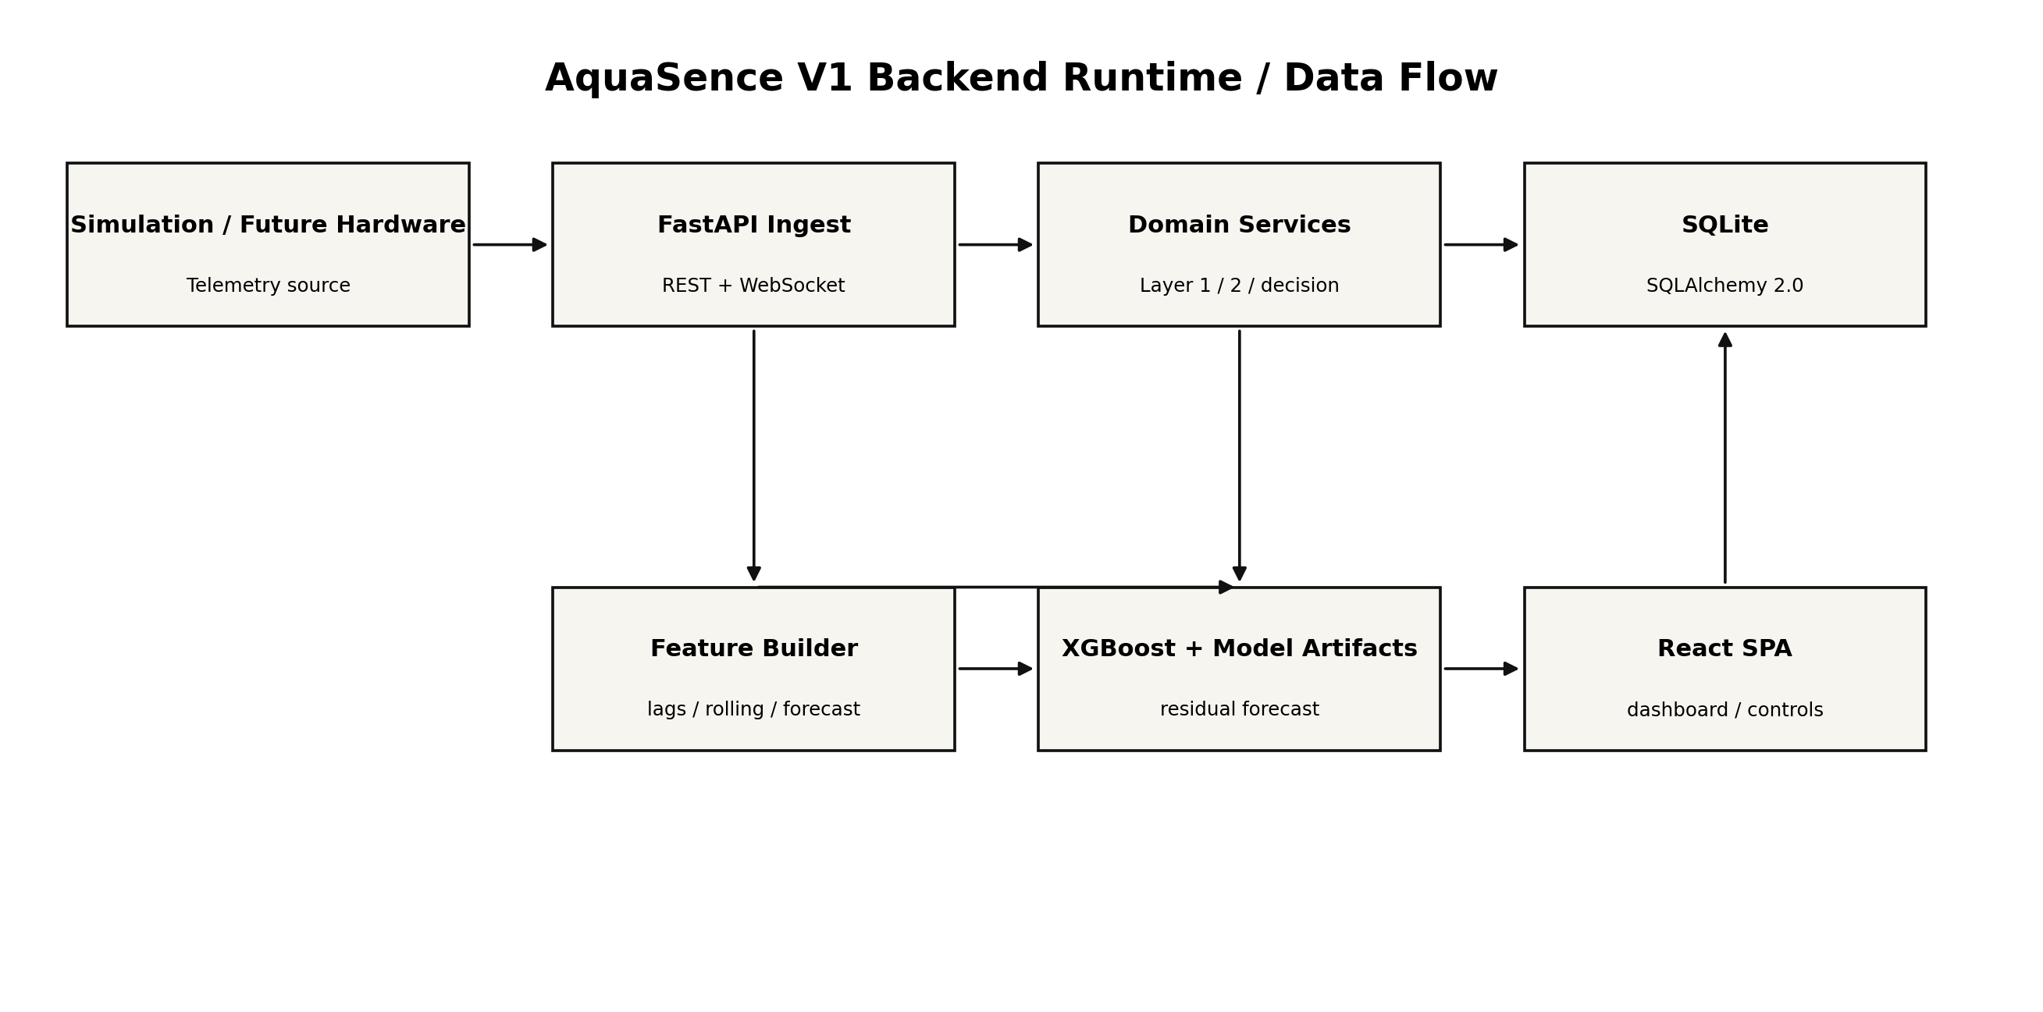

2. Source-of-Truth Rules
Rule | Implementation requirement
Single source of truth | Pydantic contracts define external payloads; SQLAlchemy models define persistence; domain dataclasses/functions define calculations.
No UI decisions | React only renders server outputs and sends user actions.
No route logic | FastAPI routes call application/domain services; routes do not contain business calculations.
Traceability | Every dashboard value must be recoverable from a persisted input, equation output, model output or simulation response.
Determinism | Scenario runs accept a seed and a scenario configuration version.
Explicit provenance | Telemetry rows carry source and quality fields; forecasts carry provider and issued_at/valid_at.
Time semantics | All persisted timestamps are UTC ISO-8601; UI converts to local display time.
Units are canonical | The API never exposes ambiguous unit-less engineering values.

3. Relational Data Model
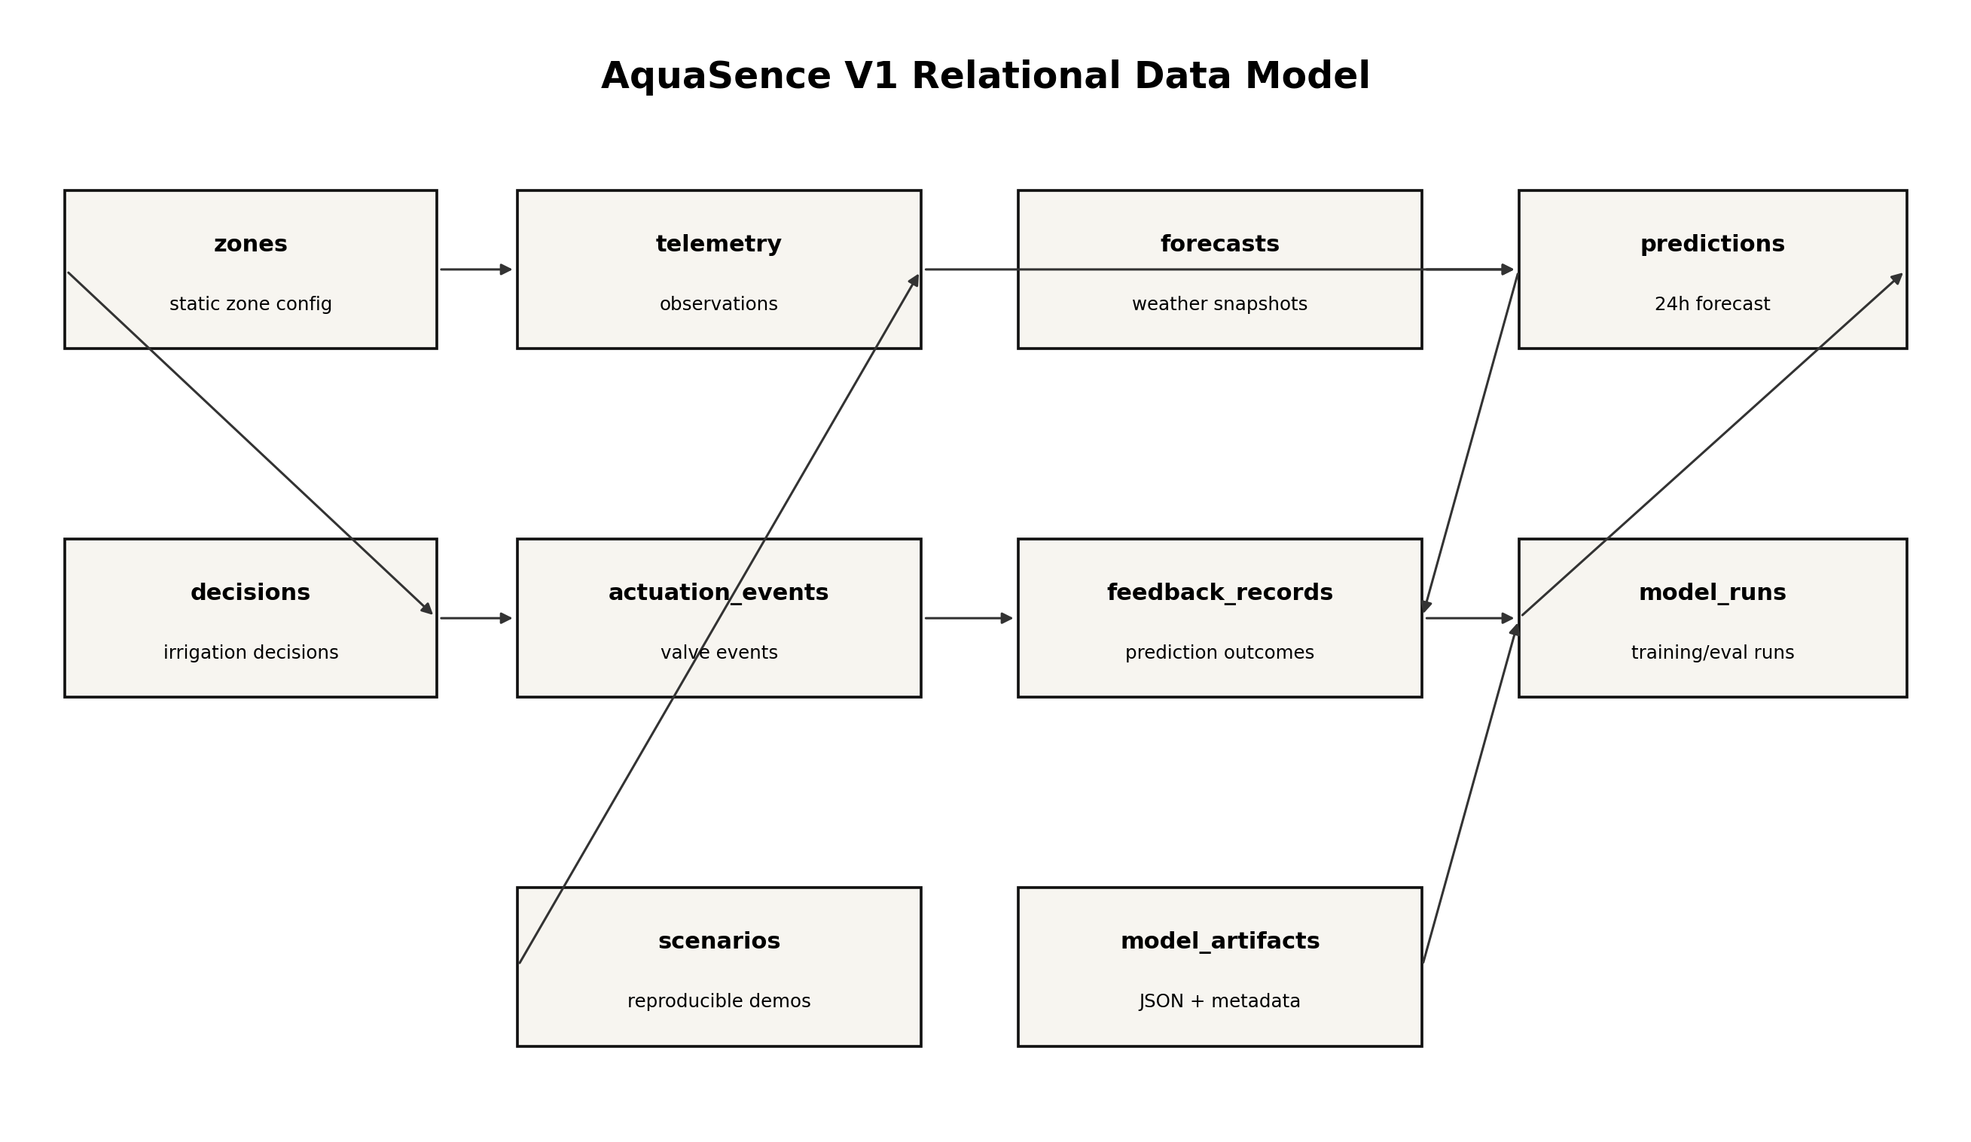

3.1 Table: zones
Static configuration for each irrigation zone. One row represents one simulated field zone and is the parent for telemetry, decisions and actuation events.
Column | Type | Null | Rule / meaning
id | TEXT | No | Stable zone identifier, e.g. Z01. Primary key.
name | TEXT | No | Human-readable name.
crop | TEXT | No | Crop identity used by Layer 1 Kc/p-table selection.
growth_stage | TEXT | No | Current crop stage.
soil_type | TEXT | No | Configured soil texture/class.
area_m2 | REAL | No | Zone area; > 0.
root_depth_m | REAL | No | Effective root-zone depth; > 0.
theta_fc | REAL | No | Field capacity, m3/m3.
theta_wp | REAL | No | Wilting point, m3/m3; must be < theta_fc.
irrigation_efficiency | REAL | No | 0 < efficiency <= 1.
p_table | REAL | No | Baseline depletion fraction from crop reference table.
enabled | INTEGER | No | 0/1. Disabled zones do not receive automatic simulated actions.
created_at | DATETIME | No | UTC creation timestamp.
updated_at | DATETIME | No | UTC last update timestamp.

3.2 Table: telemetry
Observed or simulated sensor/environment records. Append-only for V1; never update an old measurement in place.
Column | Type | Rule / meaning
id | INTEGER PK | Auto-increment.
zone_id | TEXT FK | References zones.id.
timestamp | DATETIME | UTC event time.
source | TEXT | simulation_v1 or hardware_mqtt_future.
quality | TEXT | valid, filtered, rejected, stale.
temperature_c | REAL | Air temperature.
relative_humidity_pct | REAL | 0-100.
wind_speed_mps | REAL | Canonical wind speed.
solar_radiation_mj_m2_day | REAL | Radiation value used by Layer 1 where available.
rainfall_mm | REAL | Observed precipitation for the timestep.
soil_moisture_rz | REAL | Root-zone volumetric water content, m3/m3.
flow_l_min | REAL | Observed/simulated flow at the zone.
pressure_bar | REAL | Observed/simulated pressure.
irrigation_volume_l | REAL | Water applied during the timestep.
metadata_json | TEXT | Optional source/sensor metadata.

3.3 Table: forecasts
Column | Type | Rule / meaning
id | INTEGER PK | Auto-increment.
issued_at | DATETIME | When provider forecast was fetched.
valid_at | DATETIME | Hour/period the forecast applies to.
latitude | REAL | Forecast location.
longitude | REAL | Forecast location.
provider | TEXT | open_meteo_v1.
temperature_c | REAL | Forecast 2m temperature.
relative_humidity_pct | REAL | Forecast relative humidity.
wind_speed_mps | REAL | Forecast wind.
precipitation_mm | REAL | Forecast precipitation.
solar_radiation_mj_m2_day | REAL | Forecast solar/radiation representation.
et0_mm_day | REAL | Provider ET0 if available/used.
raw_json | TEXT | Optional archived provider response for debugging.

3.4 Table: predictions
Column | Type | Rule / meaning
id | INTEGER PK | Auto-increment.
zone_id | TEXT FK | References zones.id.
created_at | DATETIME | Prediction creation time.
target_time | DATETIME | Future target time, V1 +24h.
model_version | TEXT | Artifact/model version identifier.
physics_prediction | REAL | Layer 1 physics-forward predicted root-zone moisture.
predicted_residual | REAL | XGBoost residual correction.
final_prediction | REAL | physics_prediction + predicted_residual.
feature_snapshot_json | TEXT | Exact feature values used for this inference.
forecast_snapshot_id | INTEGER FK | Forecast record set/version used.
quality | TEXT | ok, degraded, physics_only.
notes | TEXT | Optional trace/debug.

3.5 Table: decisions
Column | Type | Rule / meaning
id | INTEGER PK | Auto-increment.
zone_id | TEXT FK | References zones.id.
timestamp | DATETIME | Decision creation time.
triggered | INTEGER | 0/1 current-state irrigation trigger.
predictive_warning | INTEGER | 0/1 forecast-based warning.
reason_code | TEXT | Structured reason, e.g. RAW_THRESHOLD_REACHED, PREDICTED_DEPLETION.
net_irrigation_mm | REAL | Net root-zone replenishment.
gross_irrigation_mm | REAL | After efficiency adjustment.
volume_l | REAL | Zone water volume.
runtime_min | REAL | Valve runtime based on flow.
safety_status | TEXT | allowed, blocked, degraded.
manual_override | INTEGER | 0/1.
prediction_id | INTEGER FK | Optional source prediction.

4. Remaining Tables

4.1 actuation_events
Column | Type | Rule / meaning
id | INTEGER PK | Auto-increment.
zone_id | TEXT FK | Zone.
decision_id | INTEGER FK | Decision that created the event.
started_at | DATETIME | Valve-open time.
ended_at | DATETIME | Valve-close time.
commanded_state | TEXT | OPEN/CLOSE.
expected_flow_l_min | REAL | Expected flow from simulation/config.
actual_flow_l_min | REAL | Observed/simulated flow.
pressure_bar | REAL | Pressure during event.
delivered_l | REAL | Actual delivered volume.
status | TEXT | completed, aborted, anomaly.
anomaly_code | TEXT | Optional delivery deviation code.

4.2 feedback_records
Column | Type | Rule / meaning
id | INTEGER PK | Auto-increment.
prediction_id | INTEGER FK | Linked prediction.
zone_id | TEXT FK | Zone.
target_time | DATETIME | When the prediction was supposed to be evaluated.
predicted | REAL | Final predicted root-zone moisture.
actual | REAL | Measured/simulated actual at target_time.
error | REAL | actual - predicted.
abs_error | REAL | Absolute error.
squared_error | REAL | Squared error.
source | TEXT | simulation or real_field.
evaluated_at | DATETIME | When outcome became available.

4.3 model_runs
Column | Type | Rule / meaning
id | INTEGER PK | Auto-increment.
model_version | TEXT | Unique version identifier.
run_type | TEXT | train, evaluate, backtest, baseline.
created_at | DATETIME | UTC.
dataset_hash | TEXT | Hash of dataset/features used.
train_start | DATETIME | Training window.
train_end | DATETIME | Training window.
val_start | DATETIME | Validation window.
val_end | DATETIME | Validation window.
test_start | DATETIME | Test window.
test_end | DATETIME | Test window.
mae | REAL | Validation/test metric.
rmse | REAL | Validation/test metric.
bias | REAL | Signed mean error.
r2 | REAL | R2.
nrmse | REAL | Normalized RMSE.
notes | TEXT | Run summary.

4.4 scenarios
Column | Type | Rule / meaning
id | INTEGER PK | Auto-increment.
name | TEXT | Unique scenario name.
description | TEXT | Purpose and expected behavior.
seed | INTEGER | Fixed seed for deterministic run.
config_json | TEXT | Scenario parameters.
created_at | DATETIME | UTC.
enabled | INTEGER | 0/1.

4.5 model_artifacts (filesystem, not required as SQL table)
models/xgb/<model_version>/model.json
models/xgb/<model_version>/metadata.json
models/xgb/<model_version>/metrics.json
The database stores metadata and provenance; the trained booster remains a versioned file artifact. This avoids storing binary model payloads in SQLite.

5. Constraints and Indexes
Table | Index / constraint | Reason
zones | PRIMARY KEY (id) | Stable zone identity.
zones | CHECK(theta_wp < theta_fc) | Prevent invalid soil state.
telemetry | INDEX(zone_id, timestamp) | Fast chart/history queries.
telemetry | INDEX(source, timestamp) | Filter simulation vs hardware later.
forecasts | INDEX(valid_at, issued_at) | Fast forecast alignment.
predictions | INDEX(zone_id, target_time) | Prediction trace and outcome lookup.
predictions | UNIQUE(zone_id, target_time, model_version) | Avoid duplicate inference records.
decisions | INDEX(zone_id, timestamp) | Timeline queries.
actuation_events | INDEX(zone_id, started_at) | Valve history.
feedback_records | INDEX(zone_id, target_time) | Rolling error metrics.
model_runs | INDEX(created_at) | Latest model run lookup.

6. Pydantic API Contracts
Pydantic v2 is the canonical API validation layer. Request/response models should be defined in one module and reused by route handlers and tests. The frontend should derive TypeScript types from OpenAPI or a generated client; do not manually maintain parallel JSON schemas.

6.1 Common response envelope
{
"data": { ... },
"meta": {
"request_id": "uuid",
"timestamp": "2026-08-21T10:30:00Z"
}
}

6.2 Error envelope
{
"error": {
"code": "FORECAST_UNAVAILABLE",
"message": "No fresh weather forecast is available.",
"details": {"zone_id": "Z01"}
},
"meta": {"request_id": "uuid"}
}
HTTP | Error code examples | Meaning
400 | INVALID_REQUEST | Validation or malformed request.
404 | ZONE_NOT_FOUND, SCENARIO_NOT_FOUND | Referenced resource does not exist.
409 | SIMULATION_STATE_CONFLICT | Operation conflicts with current state.
422 | INVALID_DOMAIN_STATE | Payload syntactically valid but domain-invalid.
503 | FORECAST_UNAVAILABLE, MODEL_UNAVAILABLE | Required dependency unavailable; safe fallback applies.
500 | INTERNAL_ERROR | Unexpected failure; log request_id.

6.3 Canonical telemetry request
{
"zone_id": "Z01",
"timestamp": "2026-08-21T10:00:00Z",
"temperature_c": 31.8,
"relative_humidity_pct": 48.0,
"wind_speed_mps": 3.1,
"solar_radiation_mj_m2_day": 18.2,
"rainfall_mm": 0.0,
"soil_moisture_rz": 0.267,
"flow_l_min": 0.0,
"pressure_bar": 1.7,
"irrigation_volume_l": 0.0,
"source": "simulation_v1",
"quality": "valid"
}

6.4 Zone summary response
{
"zone_id": "Z01",
"crop": "Tomato",
"growth_stage": "Flowering",
"current": {
"soil_moisture_rz": 0.267,
"temperature_c": 31.8,
"relative_humidity_pct": 48.0,
"rainfall_mm": 0.0
},
"agronomic": {
"et0_mm_day": 5.2,
"kc": 1.15,
"etc_mm_day": 5.98,
"taw_mm": 92.0,
"raw_mm": 41.4,
"depletion_mm": 39.8
},
"prediction": {
"target_time": "2026-08-22T10:00:00Z",
"physics_prediction": 0.240,
"predicted_residual": 0.004,
"final_prediction": 0.244
},
"decision": {
"triggered": false,
"predictive_warning": true,
"status": "MONITOR"
}
}

7. REST API Surface
Endpoint | Method | Request | Response / purpose
/api/v1/health | GET | None | Health status, DB status, model status, forecast freshness.
/api/v1/zones | GET | Query filters optional | List zones with compact current state.
/api/v1/zones/{id} | GET | Path id | Full zone snapshot including Layer 1, Layer 2 and decision trace.
/api/v1/simulation/start | POST | StartSimulationRequest | Start named scenario; returns run id and initial snapshot.
/api/v1/simulation/pause | POST | None | Pause simulation clock.
/api/v1/simulation/step | POST | StepRequest(optional hours=1) | Advance simulated clock; returns snapshot + events.
/api/v1/simulation/reset | POST | ResetRequest | Reset current scenario to seed state.
/api/v1/simulation/scenario | POST | ScenarioLoadRequest | Load a named scenario.
/api/v1/history | GET | zone_id, start, end, resolution | Historical telemetry/predictions/decisions series.
/api/v1/model/metrics | GET | window optional | Latest model run + rolling feedback metrics.
/api/v1/model/feature-importance | GET | model_version optional | XGBoost feature importance.
/api/v1/decisions/{id} | GET | Path id | Full decision explanation and calculation trace.
/api/v1/actuation/events | GET | zone/time filters | Valve event history.
/api/v1/feedback/summary | GET | zone/window filters | MAE, RMSE, bias, normalized error and count.
/api/v1/config/zones/{id} | GET | Path id | Zone configuration for engineering UI.

8. Detailed Endpoint Contracts

8.1 GET /api/v1/health
200 OK
{
"status": "ok",
"database": "ok",
"model": {"available": true, "version": "xgb-v1"},
"forecast": {"available": true, "issued_at": "...", "age_minutes": 4}
}

8.2 POST /api/v1/simulation/start
Request
{
"scenario_name": "drying_tomato",
"seed": 42,
"speed_multiplier": 1.0
}
Response
{
"run_id": "sim-20260821-001",
"scenario": "drying_tomato",
"sim_time": "2026-08-21T06:00:00Z",
"status": "running"
}

8.3 POST /api/v1/simulation/step
Request
{"hours": 1}
Response
{
"sim_time": "2026-08-21T07:00:00Z",
"zone_updates": [ ... ],
"events": [ ... ]
}

8.4 GET /api/v1/zones/{id}
The zone detail endpoint is the primary dashboard trace endpoint. It should provide a single coherent snapshot rather than forcing the frontend to orchestrate multiple domain calls.
Response section | Must contain
identity | zone_id, name, crop, growth_stage, soil_type, area, root_depth
current_state | latest telemetry + quality/source
layer1 | ET0, Kc, ETc, FC, WP, TAW, p, RAW, depletion, critical moisture, irrigation sizing
layer2 | forecast freshness, physics prediction, residual, final prediction, model version
decision | trigger, predictive warning, water volume, runtime, safety status, reason code
actuation | current valve state, flow, pressure, delivered volume
feedback | latest evaluated prediction, error, rolling MAE/bias

9. WebSocket Contract
Endpoint: GET/WS `/ws` or `/api/v1/ws` depending on final routing convention. Use a single WebSocket connection per browser session. The server broadcasts normalized domain events, not database rows.
Event | When | Payload keys
simulation.status | start/pause/reset | run_id, status, sim_time, scenario
telemetry.updated | new simulation/hardware telemetry | zone_id, timestamp, values, quality
forecast.updated | forecast fetched/refreshed | issued_at, provider, horizon, variables
prediction.updated | Layer 2 inference completed | prediction_id, zone_id, target_time, physics, residual, final, model_version
decision.updated | decision recomputed | decision_id, triggered, predictive_warning, reason_code, volume_l, runtime_min, safety_status
actuation.updated | valve opens/closes/updates | event_id, zone_id, state, flow, pressure, delivered_l, status
feedback.updated | outcome becomes available | feedback_id, prediction_id, actual, error, abs_error
alert.created | safety/degraded condition | alert_id, severity, code, message, zone_id

9.1 Event example
{
"type": "prediction.updated",
"payload": {
"prediction_id": 128,
"zone_id": "Z01",
"target_time": "2026-08-22T10:00:00Z",
"physics_prediction": 0.240,
"predicted_residual": 0.004,
"final_prediction": 0.244,
"model_version": "xgb-v1"
}
}

10. Repository / Service Boundaries
Module | Owns | Must not import
layer1/ | Equations, water balance, irrigation sizing. | FastAPI, SQLAlchemy, React.
layer2/ | Forecast wrapper, feature engineering, residual inference. | FastAPI route objects, React.
decision/ | Trigger, predictive warning, safety gates, runtime command. | React, direct SQL.
simulation/ | Scenario state, clock, deterministic transitions, simulated response. | React.
feedback/ | Feedback metric computation and offline retrain metadata. | FastAPI route objects.
adapters/ | Open-Meteo, simulation source, future hardware seam. | UI components.
api/ | Routes, dependency wiring, serialization. | Domain calculations.
db/ | SQLAlchemy models, repositories, session handling. | ML/business logic.

10.1 Repository pattern
class TelemetryRepository:
add(sample) -> TelemetryRecord
latest_for_zone(zone_id) -> TelemetryRecord | None
range_for_zone(zone_id, start, end) -> list[TelemetryRecord]
class PredictionRepository:
add(prediction) -> PredictionRecord
by_target(zone_id, target_time) -> PredictionRecord | None
recent(zone_id, limit=100) -> list[PredictionRecord]
class FeedbackRepository:
add(record) -> FeedbackRecord
rolling_metrics(zone_id, window) -> MetricsSummary

11. Transaction Boundaries
- One simulation step should execute inside one application-level orchestration transaction: generate/ingest telemetry -> compute Layer 1 -> compute forecast + Layer 2 -> decision -> actuation -> persist all outputs.
- If database persistence fails, the UI must not claim that feedback was logged. The step may still produce in-memory state for demo continuity, but the response must include persistence_status=failed.
- Prediction and decision rows should reference one another by foreign keys so a judge-facing trace can be reconstructed later.
- Actuation events should be written even when aborted for safety; status=aborted/anomaly preserves evidence of failure.

12. Simulation Backend State Machine
IDLE -> RUNNING -> PAUSED -> RUNNING -> RESET -> IDLE
Within RUNNING step:
telemetry -> forecast -> layer1 -> layer2 -> decision -> actuation -> response -> feedback-ready
State | Allowed actions
IDLE | load scenario, start, reset
RUNNING | pause, step, reset
PAUSED | resume/start, step once, reset
ERROR | reset; never auto-actuate
DEGRADED | continue only in safe mode; physics-only if ML unavailable; no auto-action if required forecast unavailable

13. Backend Calculation Trace Contract
Every decision should optionally expose a trace object for the dashboard and debugging. This is the main defense against “black box” claims.
{
"zone_id": "Z01",
"timestamp": "...",
"inputs": { ... },
"layer1": {
"et0": 5.2,
"kc": 1.15,
"etc": 5.98,
"taw": 92.0,
"p": 0.50,
"raw": 46.0,
"depletion": 41.0,
"theta_critical": 0.225,
"net_irrigation_mm": 12.4,
"gross_irrigation_mm": 13.8,
"volume_l": 1380
},
"layer2": {
"physics_prediction": 0.244,
"predicted_residual": 0.003,
"final_prediction": 0.247,
"model_version": "xgb-v1"
},
"decision": {
"triggered": false,
"predictive_warning": true,
"reason_code": "PREDICTED_RAW_CROSSING"
}
}

14. API Validation Rules
Object | Validation rules
Zone | area_m2 > 0; root_depth_m > 0; 0 < irrigation_efficiency <= 1; theta_wp < theta_fc; p_table between 0.1 and 0.8.
Telemetry | RH 0-100; flow >= 0; pressure >= 0; soil moisture must be within configured plausibility band or be marked rejected/filtered.
Forecast | valid_at > issued_at; provider required; forecast freshness checked before predictive auto-action.
Prediction | target_time > created_at; model_version required; final_prediction = physics_prediction + predicted_residual.
Decision | volume_l >= 0; runtime_min >= 0; safety_status must be known enum.
Actuation | ended_at >= started_at; delivered_l >= 0; anomaly status must carry anomaly_code.
Feedback | actual/predicted present; error = actual - predicted; evaluated_at >= target_time.

15. Data Retention — V1
- Keep all simulation telemetry, predictions, decisions and actuation events for the duration of the demo project; do not implement automatic deletion in V1.
- Keep only the minimum raw weather response needed for reproducibility/debugging; store canonical forecast rows as the primary source for model features.
- Keep model artifacts and metadata in Git-ignored model storage with version names recorded in model_runs.
- If the dataset becomes large, export a CSV/Parquet snapshot before cleanup; do not silently delete source data.

16. Seed Scenarios and Required Data
Scenario | Purpose | Key changes
drying_tomato | Baseline dry-down and irrigation trigger | High ETc, no rain, declining moisture.
rain_incoming | Demonstrate forecast dependency | Moderate current depletion, forecast rainfall reduces/avoids irrigation.
heatwave | Demonstrate atmospheric demand | Higher temp/radiation, lower RH.
valve_deviation | Demonstrate flow/pressure feedback | Commanded flow > actual flow; anomaly generated.
sensor_spike | Demonstrate QC | One impossible moisture spike; filtered/rejected without corrupting state.
ml_unavailable | Demonstrate safe fallback | Physics-only forecast; predictive ML unavailable; no unsafe auto-action.

17. Query Shapes for UI
UI need | Preferred backend query
Zone cards | latest telemetry + latest prediction + latest decision for all enabled zones.
24h moisture graph | telemetry + prediction series at chosen zone.
Water requirement card | latest decision with Layer 1 trace.
Flow/pressure chart | actuation_events + telemetry in event window.
Prediction-vs-actual chart | predictions JOIN feedback_records by prediction_id.
Model metrics | latest model_runs + rolling feedback metrics.
Feature importance | artifact metadata or precomputed persisted JSON keyed by model_version.
Scenario control | scenarios list + current simulation status.

18. API-to-UI Example: Zone Snapshot
GET /api/v1/zones/Z01
The backend returns one server-computed snapshot.
React should render:
- current moisture card
- ETc card
- water requirement card
- valve card
- prediction chart
- decision explanation
- feedback/accuracy card
React should NOT call Layer 1 equations, calculate RAW or decide valve state.

19. API-to-Database Traceability
Action | Tables written/read
Start scenario | scenarios READ; telemetry WRITE; optionally model/forecast snapshots READ.
Simulation step | telemetry WRITE; forecasts READ/WRITE; predictions WRITE; decisions WRITE; actuation_events WRITE; WebSocket events.
Outcome becomes available | feedback_records WRITE.
Model metrics | feedback_records READ + model_runs READ.
History | telemetry/predictions/decisions/actuation_events READ.
Zone snapshot | zones + latest telemetry + latest forecast + latest prediction + latest decision + latest feedback READ.

20. Offline Training Job Contract
python -m app.feedback.train_xgb \
--zone Z01 \
--train-start 2026-01-01T00:00:00Z \
--train-end 2026-08-01T00:00:00Z \
--val-start 2026-08-01T00:00:00Z \
--val-end 2026-08-10T00:00:00Z \
--test-start 2026-08-10T00:00:00Z \
--test-end 2026-08-20T00:00:00Z
- Build feature matrix from canonical telemetry + aligned forecasts + Layer 1 forward baseline.
- Construct residual target: actual_root_moisture_at_target - physics_prediction_at_target.
- Fit XGBRegressor with chronological validation and early stopping.
- Write model.json, metrics.json and metadata.json under a versioned directory.
- Insert a model_runs row with dataset hash and time windows.
- Never replace an existing model artifact during the training command; write a new version. Deployment/promotion is a separate explicit operation.

21. Testing Requirements
Test group | Minimum tests
Schema | Migrations create all tables; invalid FK/constraints fail.
Pydantic | Valid and invalid payload cases for every public request model.
Repositories | CRUD + range queries + ordering + duplicate constraints.
Endpoints | Health, zones, scenario controls, history, model metrics, feature importance.
WebSocket | Event ordering and reconnect-safe snapshots.
Simulation | Deterministic seed produces identical telemetry and outputs.
Traceability | One simulation step creates linked telemetry -> prediction -> decision -> actuation rows.
Failure | Forecast unavailable, model unavailable, DB failure, flow mismatch, invalid sensor.

22. Security / Safety Notes — V1
- No public deployment or user authentication is required for the local prototype.
- Never expose an endpoint that lets the frontend set an arbitrary valve state without passing through the decision/safety service.
- Manual override requests must carry zone_id, requested state, confirmation flag and reason text; backend rechecks safety constraints.
- Log every manual override as a decision/actuation event with a source marker such as MANUAL_UI.
- External provider failures must degrade explicitly; never fabricate fresh forecast data.

23. Backend Implementation Order
- Create project package structure and dependency lockfiles.
- Create SQLAlchemy engine, session management and migrations/schema initialization.
- Implement tables + repositories + seed scenario records.
- Implement Pydantic schemas and API response envelopes.
- Implement zone and history query services.
- Implement simulation orchestration and deterministic scenario source.
- Implement Layer 1 domain service integration.
- Implement weather adapter and forecast cache table.
- Implement Layer 2 feature builder and model artifact loader.
- Implement prediction/decision persistence and trace endpoint.
- Implement WebSocket event broadcaster.
- Implement feedback metrics and offline training command.
- Add tests for each completed module before adding the next.
- Only then connect the React screens to the finished contracts.

24. Cursor Agent Rules for Backend
- Before editing schema or API contracts, read this document and the TRD. Do not infer new tables casually.
- One change per task: schema migration, endpoint, repository, service, or UI contract should be separate and testable.
- Never move equations into routes or React components.
- Never invent fields on API payloads without updating Pydantic, SQLAlchemy/repository usage and tests together.
- Prefer explicit service functions over generic “engine” abstractions.
- When introducing a new dependency, state which concrete TRD requirement needs it. If none, do not add it.
- Every backend change must include at least one test or fixture update where behavior changes.

25. Acceptance Criteria
Criterion | Pass condition
Schema | All locked tables exist with stated keys, checks and indexes.
API | All core endpoints respond with validated payloads and stable error envelopes.
Trace | A single simulated hour can be traced from telemetry to prediction to decision to actuation to feedback-ready record.
Realtime | WebSocket events mirror each simulation step without duplicated or out-of-order domain state.
Determinism | Same scenario + same seed produces the same backend outputs.
Failure safety | Missing forecast/model/invalid telemetry cannot cause an unsafe automatic action.
ML provenance | Every prediction identifies model_version and forecast source.
Retraining provenance | Every model run stores dataset hash, windows and metrics.
Frontend readiness | Frontend can render its approved screens from the backend contracts without business calculations.

Appendix A — Canonical Enums
Enum | Allowed values
telemetry.source | simulation_v1, hardware_mqtt_future
telemetry.quality | valid, filtered, rejected, stale
decision.safety_status | allowed, blocked, degraded
actuation.state | OPEN, CLOSE
actuation.status | completed, aborted, anomaly
model_run.run_type | train, evaluate, backtest, baseline
prediction.quality | ok, degraded, physics_only

Appendix B — Example End-to-End Record Chain
zones.id = Z01
telemetry.id = 1001
forecast_snapshot = issued_at 10:00, valid_at 11:00..10:00+24h
predictions.id = 2001 -> zone Z01 -> forecast_snapshot -> model xgb-v1
decisions.id = 3001 -> prediction_id 2001
actuation_events.id = 4001 -> decision_id 3001
feedback_records.id = 5001 -> prediction_id 2001
model_runs.id = 7 -> produced model_version xgb-v2

Appendix C — Final Backend Checklist
- [ ] SQLite database file created and schema initialized.
- [ ] All repositories have typed return values.
- [ ] Pydantic models cover every REST request/response and WebSocket event.
- [ ] Open-Meteo adapter normalizes provider fields into canonical variables.
- [ ] Forecast freshness is persisted and checked before predictive decisions.
- [ ] Simulation step creates linked data records in one orchestrated operation.
- [ ] XGBoost model version is recorded on every prediction.
- [ ] Feedback row can be resolved after the target timestamp is reached.
- [ ] Rolling MAE/bias query works against feedback_records.
- [ ] Frontend can render dashboard from zone snapshot and history endpoints alone.
- [ ] Backend passes unit/API/simulation smoke tests.
- [ ] No business calculations exist in FastAPI routes or React components.

