TEAM ROCKET
LAYER 1 — AGRONOMIC ENGINE
Final Implementation Specification
FAO-56-compatible reference ET + crop coefficient + root-zone water balance + irrigation trigger and sizing

Purpose | Implementation-ready specification for the deterministic agronomic layer of AquaSense AI.
Status | LOCKED BASELINE — use this as the reference design for prototype implementation.
Scope | Layer 1 only. ML prediction / Layer 2 and fusion are intentionally outside this document.
Primary principle | Use agricultural science to compute a transparent baseline; use real-time soil sensing to update and verify root-zone state.

Important implementation rule
Layer 1 is deterministic. It is not trained like an ML model. Crop coefficients, soil hydraulic parameters, root-zone depth and management parameters are configured/calibrated from agronomic sources and field measurements. The real-time sensor measurement is used to update the root-zone state.

1. Locked Layer-1 architecture
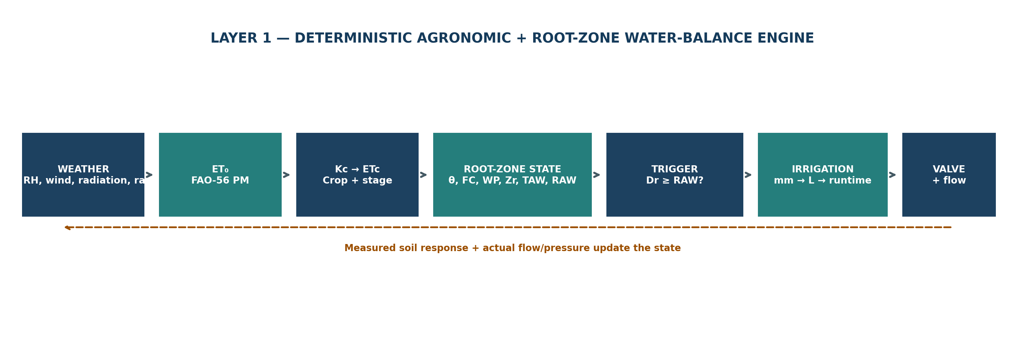
Figure 1. Locked Layer-1 architecture (deterministic agronomic + root-zone water-balance engine).
- ET0 is computed from climate/weather data using the FAO Penman-Monteith reference method.
- ETc is computed from ET0 and stage-specific crop coefficient Kc.
- The root-zone state is represented using field capacity, wilting point, rooting depth, total available water (TAW), readily available water (RAW), and live volumetric soil-water content.
- Irrigation is triggered when current root-zone depletion reaches the RAW threshold.
- The irrigation amount is calculated from the current root-zone deficit and converted to gross applied depth, volume and valve runtime.
- Flow/pressure and post-irrigation soil response are used to verify actual delivery and update the root-zone state.

2. Inputs and configuration
Category | Variable | Symbol | Unit | Source / role
Weather | Air temperature | T | °C | Weather station / API
Weather | Relative humidity | RH | % | Weather station / API
Weather | Wind speed at 2 m | u2 | m/s | Anemometer / weather API
Weather | Solar / net radiation | Rs / Rn | MJ/m²/day | Radiometer or derived from weather data
Weather | Rainfall | P | mm | Rain gauge / weather API
Location | Elevation | z | m | Static site metadata; used for pressure if not measured
Soil | Current root-zone volumetric water content | θcurrent | m³/m³ | Live soil-moisture sensor
Soil | Field capacity | θFC | m³/m³ | Soil characterization / lookup + calibration
Soil | Wilting point | θWP | m³/m³ | Soil characterization / lookup + calibration
Soil | Effective root-zone depth | Zr | m | Crop + local root profile
Crop | Crop type | crop | — | Configuration
Crop | Growth stage | stage | — | Configuration / phenology tracking
Crop | Crop coefficient | Kc | dimensionless | FAO stage table + interpolation
Crop | Baseline depletion fraction | ptable | 0–1 | FAO crop/depletion table
Management | Irrigation efficiency | Ea | 0–1 | System calibration
Hydraulics | Zone area | A | m² | Field/network configuration
Hydraulics | Measured flow rate | Q | L/min | Flow sensor; used for runtime
Prototype sensor minimum
For a complete ET0 calculation, the weather input set must provide air temperature, humidity, wind speed and radiation (or enough information to derive radiation), with site elevation/location as configuration. Soil moisture is required for real-time root-zone state. Rainfall, flow and pressure are supporting inputs for the closed-loop irrigation system.

3. Equation set — final baseline
All equations below are written so the implementation can use daily time steps as the primary decision interval. Sub-daily calculations can be added later without changing the architecture.

3.1 Atmospheric variables
es = 0.6108 × exp(17.27T / (T + 237.3))
Saturation vapour pressure, es in kPa; T in °C.

ea = es × RH / 100
Actual vapour pressure, ea in kPa.

VPD = es − ea
Vapour-pressure deficit, kPa.

Δ = 4098 × es / (T + 237.3)²
Slope of saturation vapour-pressure curve, kPa/°C.

P = 101.3 × ((293 − 0.0065z) / 293)^5.26
Atmospheric pressure estimate when pressure is not measured; P in kPa, z in m.

γ = 0.000665 × P
Psychrometric constant, kPa/°C.

3.2 Reference evapotranspiration — ET0
ET0 = [0.408Δ(Rn − G) + γ × 900/(T+273) × u2 × (es−ea)] / [Δ + γ(1 + 0.34u2)]
FAO Penman-Monteith daily reference ET. ET0 in mm/day; Rn and G in MJ/m²/day; u2 in m/s.

Prototype convention: for a daily timestep, G is initially approximated as 0 unless the implementation explicitly models daily soil heat flux.

3.3 Crop evapotranspiration — ETc
ETc = Kc × ET0
Single-Kc approach is the locked Layer-1 baseline.

Kc is selected by crop and growth stage. During transition stages, Kc is linearly interpolated between stage values.
Kc(t) = Kc,start + ((t − t0)/duration) × (Kc,end − Kc,start)
Use only for stage transitions where a linear change is a reasonable approximation.

3.4 Root-zone capacity
TAW = 1000 × (θFC − θWP) × Zr
TAW in mm; θFC and θWP are volumetric fractions; Zr in m.

p = clip[ptable + 0.04 × (5 − ETc), 0.1, 0.8]
ETc in mm/day; p is the allowable depletion fraction.

RAW = p × TAW
RAW in mm.

3.5 Real-time soil state
S = 1000 × (θcurrent − θWP) × Zr
Current root-zone plant-available water storage, S in mm, clipped to [0, TAW].

Dr = TAW − S
Current root-zone depletion, Dr in mm.

Dr = clip[1000 × (θFC − θcurrent) × Zr, 0, TAW]
Equivalent direct formula for current depletion.

θcrit = θFC − p × (θFC − θWP)
Critical volumetric moisture corresponding to RAW threshold.

3.6 Trigger logic
If Dr ≥ RAW → irrigation trigger; otherwise → continue monitoring
The trigger decision is distinct from the irrigation amount calculation.

3.7 Root-zone water balance / state update
Dr,t = Dr,t−1 + ETc,t − Pe,t − Inet,t + DPt + ROt
Depletion-form water balance. Dr in mm; Pe = effective precipitation; Inet = net irrigation entering root zone; DP = deep percolation; RO = runoff.

For the prototype, live soil-moisture measurements are the authoritative state correction. The water-balance equation is used to propagate the state between sensor observations and to reason about rainfall/irrigation contributions. Do not double-count rainfall or ETc when a measured post-event soil state is available.

3.8 Irrigation amount
Inet = Dtarget
Use Dtarget as the planned reduction in root-zone depletion. Prototype baseline: refill toward field capacity, so Dtarget = Dr when a trigger occurs.

Igross = Inet / Ea
Gross applied irrigation depth, mm. Ea is system/application efficiency 0–1.

V(L) = Igross(mm) × A(m²)
Water volume. 1 mm over 1 m² equals 1 litre.

tvalve(min) = V(L) / Q(L/min)
Valve runtime using measured/estimated zone flow rate.

For variable flow, replace the simple runtime formula with volume integration: V = ∫Q(t)dt, and stop when cumulative delivered volume reaches the target.

4. Decision logic and state machine
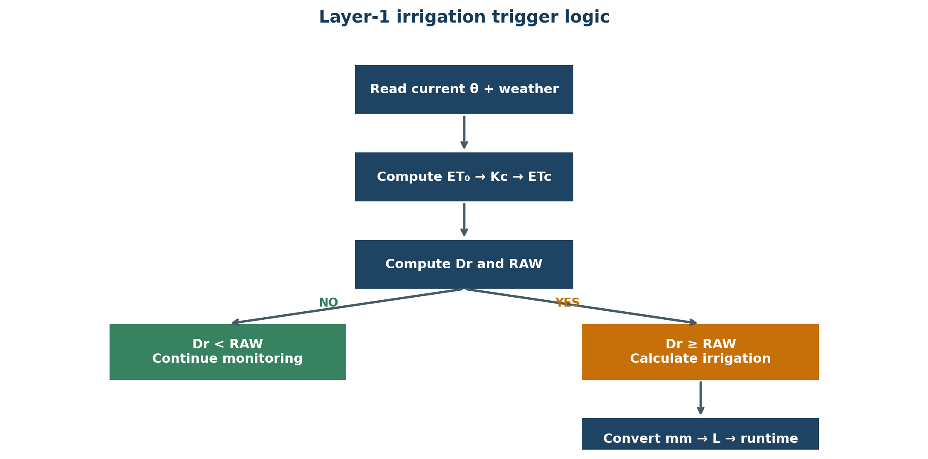
Figure 2. Layer-1 irrigation trigger state machine.

5. Implementation sequence
1. Ingest the daily weather inputs and live root-zone soil moisture.
2. Validate units, timestamps, sensor ranges and missing values.
3. Calculate es, ea, VPD, Δ and γ.
4. Calculate ET0 using FAO Penman-Monteith.
5. Retrieve/interpolate Kc from the crop × growth-stage configuration.
6. Calculate ETc = Kc × ET0.
7. Calculate TAW from θFC, θWP and Zr.
8. Retrieve ptable and apply the ETc adjustment to obtain p; calculate RAW.
9. Convert the live soil-moisture reading to root-zone storage S and depletion Dr.
10. Update the root-zone state using the water-balance logic; use the live sensor to correct drift in the state estimate.
11. If Dr < RAW, keep the zone in monitoring state.
12. If Dr ≥ RAW, calculate the planned net irrigation depth, then gross depth, volume and valve runtime.
13. Issue the valve command subject to safety constraints (maximum runtime, tank status, pressure limits, connectivity state).
14. Track actual flow/pressure during the irrigation event and stop when the target cumulative volume is reached or a safety fault occurs.
15. Log predicted quantities, actual delivery and post-irrigation soil state for later analysis and for Layer 2 data generation.

6. Diagnostic graphs / expected behavior
The following figures are illustrative diagnostics for implementation and testing. They are not field measurements and must not be presented as measured prototype performance.
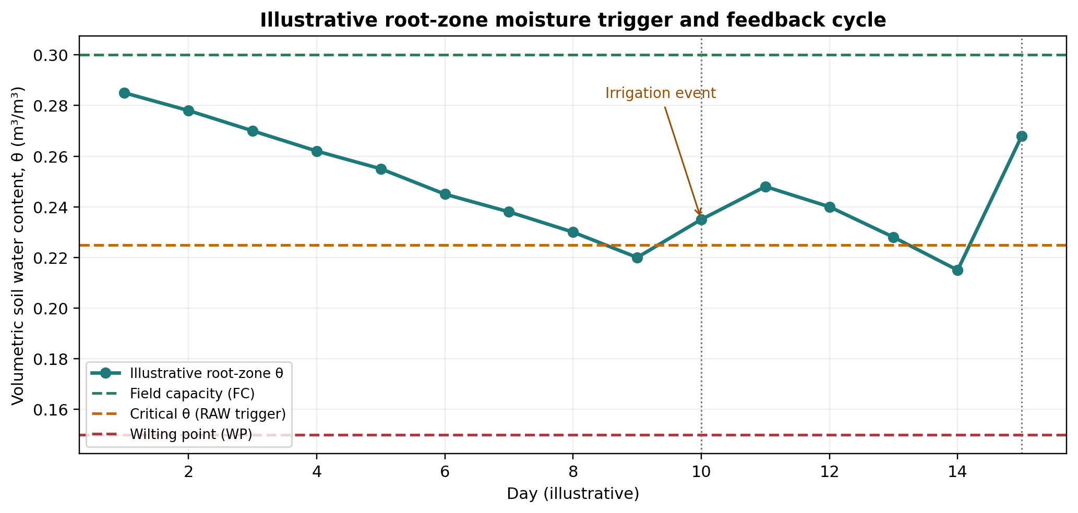
Figure 3. Illustrative soil-moisture trajectory showing FC, RAW trigger threshold and WP.
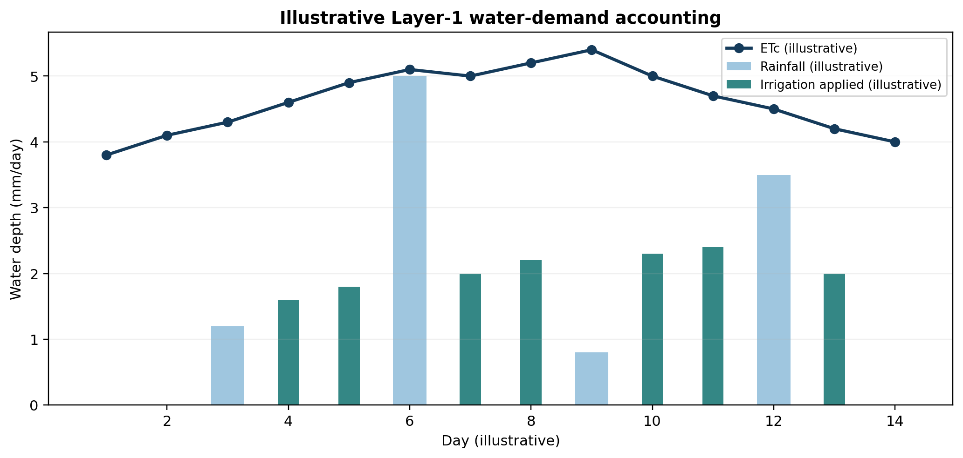
Figure 4. Illustrative daily ETc, rainfall and irrigation accounting.

7. Configuration tables required by the implementation

7.1 Crop configuration
Field | Example / description
crop_id | Unique crop identifier
crop_name | Human-readable crop name
stage_sequence | Initial / development / mid / late
Kc_initial | FAO/reference value
Kc_mid | FAO/reference value
Kc_end | FAO/reference value
stage_durations | Days or phenology-derived stage lengths
p_table | Baseline allowable depletion fraction
root_depth | Effective rooting depth by stage or crop profile

7.2 Soil / zone configuration
Field | Example / description
zone_id | Unique irrigation zone
soil_texture | Configured soil class / lab characterization
theta_FC | Field-capacity volumetric water content
theta_WP | Wilting-point volumetric water content
Zr | Effective root-zone depth
zone_area_m2 | Irrigated zone area
Ea | Application/system efficiency
Q_expected | Nominal flow rate; overwritten by measured flow when available
pressure_limits | Safe operating pressure limits

8. Required database/logging schema
Every irrigation event should create a complete, auditable record. The same log will later form the local field dataset for Layer 2.
Timestamp / ID | Field / variable | Purpose
timestamp | Event / sensor time | Sequence ordering
zone_id | Irrigation zone | Spatial identity
crop_id / stage | Crop context | Kc/p selection
T / RH / u2 / Rn | Weather inputs | ET0 calculation
rainfall | Rain event | Water-balance accounting
theta_current | Live soil moisture | Root-zone state
theta_FC / theta_WP / Zr | Soil parameters | TAW / depletion
Kc / ET0 / ETc | Calculated agronomic variables | Model traceability
TAW / p / RAW | Calculated thresholds | Trigger traceability
Dr_before | Pre-event depletion | Trigger state
Inet / Igross / V_target | Irrigation target | Decision output
Q(t) / pressure(t) | Actual hydraulic response | Delivery verification
V_delivered | Integrated actual volume | Closed-loop verification
theta_after | Post-event soil state | State correction / calibration
fault_code / override | Exceptions / human intervention | Safety + auditability

9. Validation and acceptance criteria
- Unit validation: every equation must be unit-consistent and produce physically plausible ranges.
- Sensor validation: θ must remain within plausible [0, 1] volumetric bounds; outliers must be flagged before use.
- ET0 validation: compare calculated ET0 against an independent reference/source for selected periods.
- Kc validation: verify crop/stage tables and interpolation against the chosen agronomic reference.
- Water-balance conservation check: for controlled experiments, cumulative inputs − outputs must approximately match measured soil-storage changes within measurement uncertainty.
- Trigger validation: verify that irrigation is not triggered while depletion remains below RAW and is triggered when depletion reaches RAW.
- Delivery validation: commanded volume must be compared with measured cumulative flow; define a maximum allowed delivery error during prototype testing.
- Post-event validation: after irrigation, the measured root-zone state should move toward the target state without exceeding safety limits.
- Failure-mode validation: test missing weather data, bad soil sensor, GSM outage, low pressure, blocked flow and manual override.

10. Locked design decisions for prototype V1
Decision | Locked choice | Reason
ET method | FAO Penman-Monteith reference ET0 | Transparent, standard agronomic baseline
Crop ET | Single-Kc ETc = Kc × ET0 | Simpler to validate first; stage-specific Kc retained
Root-zone state | Live θ + FC/WP/Zr | Direct field observability
Depletion threshold | RAW = p × TAW | Directly connected to crop stress threshold
p adjustment | FAO-style ETc adjustment with bounds | Captures demand-dependent allowable depletion
Trigger | Dr ≥ RAW | Clear, auditable scheduling rule
Irrigation sizing | Refill toward field capacity for prototype baseline | Simple deterministic target for initial hardware validation
Water volume | Depth × zone area | Simple physical conversion
Valve runtime | Target volume ÷ measured flow; integrate Q(t) when variable | Connects agronomic requirement to hardware
State feedback | Live soil moisture is authoritative correction after events | Prevents model drift / double-counting
Layer 1 learning | None | All parameters are configured/calibrated, not ML-trained
What Layer 1 is not
Layer 1 does not choose between LSTM, XGBoost or another ML model. Layer 2 will do that. Layer 1 provides a transparent, scientifically grounded baseline and a real-time root-zone state against which Layer 2 can later be evaluated.

11. Known refinements reserved for later
- Dual crop coefficient (Kcb + Ke) for separating transpiration and soil evaporation.
- Explicit soil hydraulic functions / moisture-release curves instead of lookup-based θFC and θWP.
- Detailed infiltration/runoff/deep-percolation models for rainfall events.
- Dynamic water-stress coefficient Ks where the crop is already stressed.
- Remote-sensing assimilation / spatialized ET or soil moisture.
- Sub-daily ET0 and high-frequency control if the final field hardware supports it.
- Irrigation strategy optimization beyond full-replenishment-to-FC, once prototype evidence and water-use objectives are established.

12. Reference basis
[1] FAO — Chapter 1: Introduction to evapotranspiration. — Reference ET0 is a climatic parameter; FAO Penman-Monteith is the standard method; crop coefficients relate ETc to ET0.
https://www.fao.org/4/X0490E/x0490e04.htm
[2] FAO — FAO Irrigation and Drainage Paper 56: Crop evapotranspiration. — Core equations for ET0, Kc, TAW and RAW; stage-dependent crop coefficients and soil-water stress framework.
https://www.fao.org/4/X0490E/x0490e00.htm
[3] FAO — Chapter 8: ETc under soil water stress conditions. — TAW, RAW, p and crop-water stress logic.
https://www.fao.org/4/X0490E/x0490e0e.htm
[4] FAO AQUASTAT — Irrigation water requirement. — Relationship among ETc, effective precipitation and soil-water storage.
https://www.fao.org/aquastat/en/data-analysis/irrig-water-use/irrig-water-requirement/index.html
[5] FAO — Chapter 4: Irrigation water needs. — Crop water need, effective rainfall and irrigation water need.
https://www.fao.org/4/s2022e/s2022e04.htm
[6] FAO — 2025 Revised Edition: Crop evapotranspiration — Guidelines for computing crop water requirements. — Major update to FAO Irrigation and Drainage Paper 56; foundational concepts retained with enhanced methods.
https://agris.fao.org/search/es/records/6a32b9d6b9a0a56f302a5e20

13. Implementation handoff checklist
- Create crop table with Kc by stage and p_table values from the selected agronomic reference.
- Create soil/zone table with θFC, θWP, Zr, zone area and application efficiency.
- Implement unit-tested functions for each equation before integrating sensors.
- Implement a root-zone state object containing S, Dr, TAW, RAW and timestamp.
- Implement sensor-state correction so measured θ can reset/correct propagated water-balance state.
- Implement trigger and irrigation-volume calculation as deterministic, auditable code.
- Implement flow-based closed-loop valve stopping logic.
- Log every intermediate calculation, not just final valve commands.
- Run a controlled single-zone bench experiment before adding Layer 2.
- After Layer 1 passes validation, begin Layer 2 model selection and training.
END OF LAYER 1 LOCK — TEAM ROCKET

