TEAM ROCKET
FEEDBACK & RECALIBRATION SYSTEM
Implementation Specification — V1 Prototype
Scope lock
This document covers only the V1 feedback/recalibration subsystem for the frozen Layer 1 + Layer 2 architecture. V1 intentionally excludes Kalman/EnKF state assimilation, automatic Kc optimization, ADWIN drift detection, champion/challenger deployment, online retraining, and uncertainty/conformal prediction. Those are future-production options, not prototype requirements.

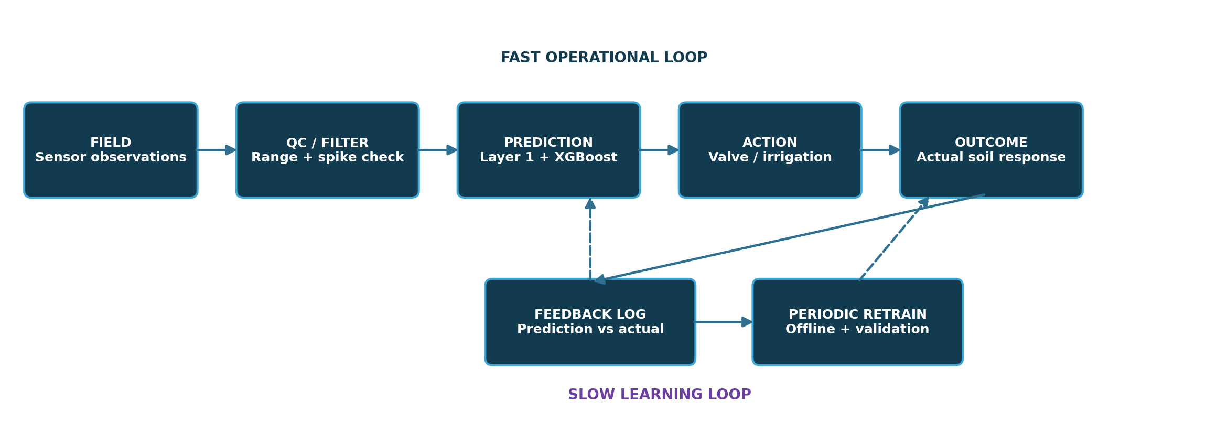

1. Purpose and design principle
The feedback subsystem converts the irrigation prototype from a one-shot predictor into an evidence-based learning loop. Every prediction is logged against the eventual measured root-zone outcome. The system uses that history to quantify prediction error and to periodically retrain the residual XGBoost model offline. The feedback loop must improve the model without compromising the deterministic agronomic safety logic in Layer 1.
- Layer 1 remains the deterministic agronomic authority for current soil-water status, irrigation trigger and irrigation quantity.
- Layer 2 (XGBoost residual model) provides a 24-hour-ahead correction to the Layer 1 physics-forward moisture forecast.
- Feedback is primarily for measurement, learning and later offline model improvement; it does not directly rewrite control parameters during every sensor cycle.
- No new architecture is introduced in V1 beyond logging, error tracking and periodic offline retraining.

2. Frozen V1 architecture
- Sensor data → hard range check → rolling median/spike filter → Layer 1 + forecast weather → physics-forward 24 h forecast → XGBoost residual correction → final 24 h root-zone moisture prediction → Layer 1 decision logic → valve → measured response.
- The feedback loop stores prediction, outcome and context in the database.
- When enough new real-field labels accumulate, the XGBoost residual model is retrained offline, evaluated chronologically, and only then considered for future deployment.

3. Error taxonomy: what V1 handles vs. what it only observes
Error type | V1 response | Future / not V1
Single sensor spike / impossible reading | Range check + rolling median filter; reject/flag the reading | State-space filters such as Kalman/EnKF
One-off forecast/model error | Log the error; do not automatically change the model | Online parameter changes
Persistent systematic forecast bias | Track rolling MAE and bias; include validated observations in future offline retraining | Automatic Kc/parameter optimizer
Model performance degradation over time | Observe via recent error metrics; retrain offline when enough data exist | Automated concept-drift detectors / streaming retraining
Model update safety | Validate new model on a chronological holdout before using it later | Production champion/challenger infrastructure
Prediction uncertainty | Not a V1 feature; keep safety rules deterministic | Conformal prediction / prediction intervals

4. Sensor quality control (V1)
Goal: prevent obvious sensor faults from contaminating the physical model or residual-training dataset.

4.1 Hard range checks
- Soil moisture must be physically plausible for the configured sensor and soil layer. Values far outside calibrated bounds are rejected/flagged.
- Temperature, humidity, wind, rainfall, flow and pressure each receive basic configured min/max bounds.
- Do not silently replace invalid data with a fabricated value. Mark the sample as invalid and carry the missing-data status downstream.

4.2 Spike / jump filter
- Use a rolling median or median-based spike detector to identify isolated jumps that are physically implausible over the sampling interval.
- Keep the raw reading for auditability; create a separate cleaned value used by the model.
- Do not use aggressive smoothing that erases real rainfall/infiltration events.

4.3 Data status flag
status | meaning | used in Layer 1? | used for XGBoost training?
VALID | passes range and spike checks | Yes | Yes
FLAGGED | suspicious but retained for inspection | Prefer not | Not in first V1 model
INVALID | physically impossible / missing | No | No
MISSING | no reading available | Use model fallback rules | No label row

5. Prediction-to-outcome logging
Every 24-hour prediction creates a supervised feedback record. Because the target is future root-zone moisture, the prediction cannot be scored until the corresponding future observation is available.
Field | Type | Example | Why stored
prediction_id | string | UUID | Unique record
timestamp_predicted | datetime | 2026-08-20 14:00 | Prediction time
timestamp_target | datetime | 2026-08-21 14:00 | 24 h target time
zone_id | string | Z01 | Spatial context
model_version | string | xgb_residual_v1 | Traceability
physics_pred_theta | float | 0.218 | Layer 1 forward prediction
xgb_residual_pred | float | +0.006 | Model correction
final_theta_pred | float | 0.224 | Final forecast
actual_theta_rz | float | 0.221 | Measured outcome
error | float | -0.003 | Signed error = actual - predicted
abs_error | float | 0.003 | MAE accumulation
irrigation_decision | enum | NONE | Decision context
irrigation_volume | float | 0 | Action context
weather_features | JSON | ... | Reproducibility
forecast_features | JSON | ... | Forecast dependence
data_quality | enum | VALID | Input quality

6. Core feedback calculations

6.1 Signed prediction error
e_t = y_t − ŷ_t
where y_t is the actual 24-hour-ahead root-zone moisture and ŷ_t is the final Layer 1 + XGBoost prediction.

6.2 Absolute error
AE_t = |e_t|

6.3 Rolling MAE
MAE_W = (1 / W) Σ |e_i|
Use a fixed recent evaluation window W for operational reporting. The exact window can be chosen after the prototype sampling frequency and data volume are known; do not claim a final window size until tested.

6.4 Rolling bias
Bias_W = (1 / W) Σ e_i
Positive bias means the system is systematically predicting lower moisture than observed (it is too pessimistic about drying). Negative bias means it is predicting higher moisture than observed (it is too optimistic about wetness).

6.5 Normalized moisture error
NMAE = MAE / (θFC − θWP)
NRMSE = RMSE / (θFC − θWP)
Normalize by the available volumetric water range for the relevant soil layer so errors are interpretable across different soils. Keep the raw MAE/RMSE as the primary absolute metrics too.

7. V1 recalibration / retraining strategy
Key rule
V1 does not retrain online. The system collects real observations continuously, then retrains XGBoost offline only after enough new labelled residual samples exist.

- Accumulate prediction records until a meaningful new labelled set exists.
- Recompute the residual target for each completed 24-hour prediction: residual = actual_root_zone_moisture − physics_forward_prediction.
- Append only quality-controlled rows to the training dataset.
- Keep the latest chronological segment as a validation/test holdout; never train on future outcomes.
- Retrain XGBoost offline with the same feature contract and data-quality rules.
- Evaluate the new model on an unseen chronological holdout using MAE, RMSE, bias, NMAE/NRMSE and irrigation-relevant errors.
- Retain the new model only if it improves the predefined acceptance criteria; otherwise keep the prior model and continue collecting data.

8. Residual-learning target
Layer 2 does not learn the raw future soil moisture in the chosen V1 architecture. It learns the residual correction to the deterministic physics-forward forecast.
r_{t+24} = θ_actual,t+24 − θ_physics,t+24
r̂_{t+24} = XGBoost(X_t)
θ̂_final,t+24 = θ_physics,t+24 + r̂_{t+24}
This makes the physics model the structured baseline and gives XGBoost the narrower task of learning field-specific systematic deviation.

9. What counts as a successful feedback cycle?
- Prediction is created using only information available at prediction time, including the valid next-24-hour forecast inputs.
- The prediction is logged with a model version and complete feature context.
- The future root-zone measurement is collected and passes quality checks.
- The residual and error metrics are computed automatically.
- The result contributes to rolling MAE and bias dashboards/analysis.
- After enough real field data exist, the record becomes eligible for the next offline training run.

10. Periodic offline retraining flow
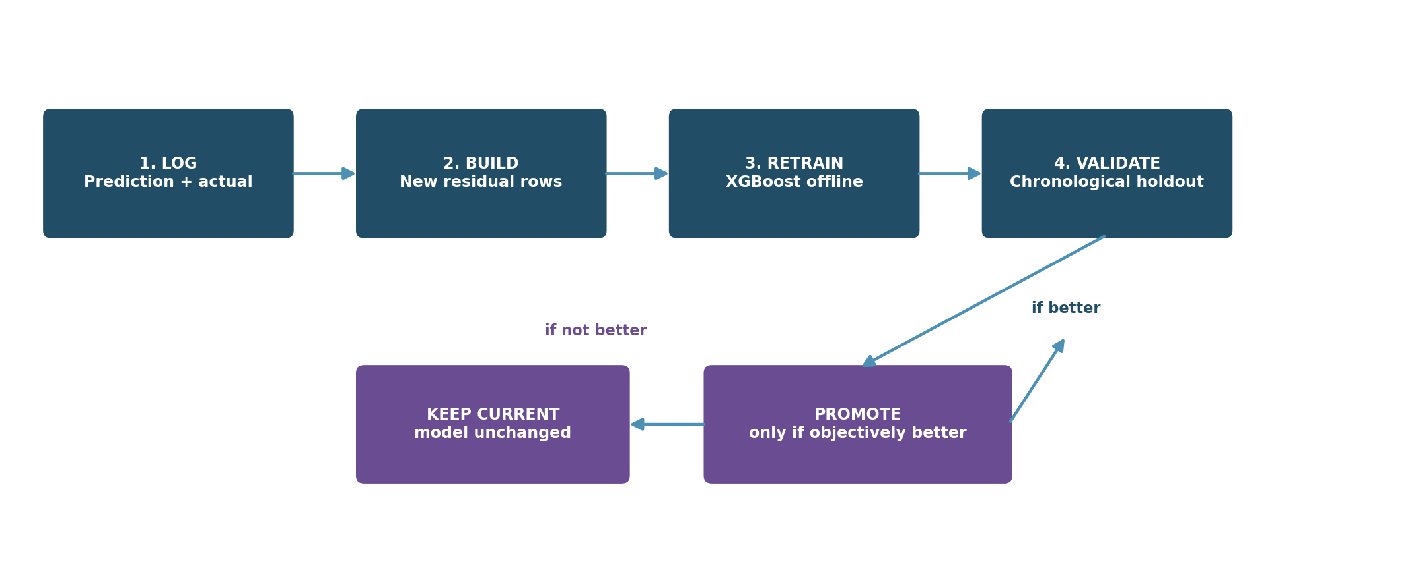

10.1 Retraining pseudocode
for prediction in completed_predictions:
if prediction.target_is_valid and prediction.input_quality == "VALID":
residual = prediction.actual_rz_moisture - prediction.physics_prediction
append_to_training_set(prediction.features, residual)
if enough_new_samples():
train_set, val_set, test_set = chronological_split(dataset)
model = fit_xgboost(train_set, eval_set=val_set, early_stopping=True)
metrics = evaluate(model, test_set)
if passes_acceptance_criteria(metrics):
save_model(model, metrics, version=new_version)
else:
keep_current_model()

11. V1 acceptance criteria
Do not define a single universal numerical pass/fail threshold before baseline data exist. First establish the baseline distribution, then set thresholds from measured performance and prototype requirements.
Metric / test | Why it matters | V1 rule
MAE / RMSE | Overall forecast magnitude | Report absolute values
Bias | Detect systematic dry/wet tendency | Track sign and magnitude
NMAE / NRMSE | Compare across soil water ranges | Report normalized values
Threshold error near RAW | Controls irrigation safety | Must not show unacceptable missed/false triggers
Post-rain performance | Captures hard weather transitions | Report separately
Extreme-dry performance | Important for crop-stress prevention | Report separately
Data leakage check | Prevents inflated performance | Chronological split only

12. What is intentionally NOT in V1
- Kalman filter / Extended Kalman Filter / Ensemble Kalman Filter state assimilation.
- Automatic bounded optimization of Kc, rainfall-efficiency or other Layer-1 parameters.
- Online or per-hour model retraining.
- ADWIN or other formal concept-drift detectors.
- Production champion/challenger deployment infrastructure.
- Conformal prediction or probabilistic uncertainty intervals.
- Complex ensemble stacking unless a later experiment proves a material benefit.
Future-work note
These techniques may become useful after the prototype has accumulated weeks/months of real field residuals and sensor-quality statistics. They should not be implemented merely to make the architecture look more advanced.

13. Failure and safety behavior
Condition | V1 response | Reason
Sensor reading invalid | Reject/flag; do not train on it; use safe Layer-1 fallback behavior | Protect model and control loop from bad data
Forecast API unavailable | Flag forecast as unavailable; do not pretend stale values are current | Forecast is a required Layer-2 input
XGBoost model unavailable | Use Layer 1 only | Deterministic safety path remains available
Residual model performs poorly | Continue logging; do not deploy a new model until validated | Avoid degrading a working baseline
Flow/pressure indicates delivery problem | Raise alert / stop or safe-control according to hardware safety logic | Commanded volume may differ from actual delivery

14. Database implementation notes
- Store raw sensor values and cleaned values separately where practical; this preserves auditability.
- Persist model version, feature-generation version and forecast source/timestamp with every prediction.
- Store the target outcome only after its 24-hour observation becomes available.
- Never overwrite historical prediction records; append corrections as new records or quality flags.
- Keep a clear distinction between synthetic/public-data experiments and real field observations.

15. Implementation checklist
- ☐ Forecast API call works for prototype coordinates and returns required next-24-hour variables.
- ☐ Layer 1 produces a physics-forward 24-hour root-zone moisture forecast.
- ☐ Raw sensor values are stored with timestamps and zone IDs.
- ☐ Range and spike filters are implemented and unit-tested.
- ☐ Prediction records are logged before future target is known.
- ☐ Future target is joined after 24 hours without timestamp leakage.
- ☐ Residual target is calculated correctly.
- ☐ First XGBoost model trains on a chronological split.
- ☐ MAE/RMSE/bias/NMAE/NRMSE are computed.
- ☐ Post-rain and dry-period error slices are computed.
- ☐ Periodic offline retraining script can run end-to-end.
- ☐ New model is validated on an unseen chronological holdout before use.
- ☐ Layer 1-only fallback works if Layer 2 is unavailable.

16. Minimal code modules
Module | Responsibility | V1
sensor_qc.py | Range checks + spike filter | Build first
forecast_client.py | Fetch/store next-24-hour weather forecast | Build first
layer1_forward.py | Run Layer 1 forward to t+24 h | Build first
feature_builder.py | Lag/rolling/forecast/agronomic features | Build second
residual_dataset.py | Join prediction with future actual and compute residual | Build second
xgb_train.py | Train/evaluate XGBoost residual model | Build third
prediction_logger.py | Persist prediction + context + version | Build with model
metrics.py | MAE/RMSE/bias/normalized error + slices | Build with model
offline_retrain.py | Periodic retraining and validation | Build after first model works

17. Judge-facing explanation
One-sentence answer
“We log every prediction against the actual future root-zone measurement, track rolling error and bias, and periodically retrain the residual XGBoost model on accumulated real-field data, validating it chronologically before using the updated model.”

If asked how the system handles an isolated bad sensor reading: “We use simple physical range checks and a rolling median/spike filter in V1; we do not allow obvious bad measurements to enter the prediction-training loop.”
If asked how the system handles persistent bias: “We first quantify the bias. The prototype logs it and uses it in the next offline retraining cycle; automatic agronomic-parameter recalibration is future work once we have sufficient field history.”

18. V1 frozen specification summary
Item | Locked V1 decision
Fast loop | Sensor QC → Layer 1 + XGBoost prediction → irrigation action → response measurement
Learning loop | Log prediction → wait for future target → calculate residual/error → periodic offline retrain
ML target | 24-hour residual in root-zone volumetric moisture
Physics baseline | Layer 1 forward simulation using forecast weather
Primary ML model | XGBoost regression
Metrics | MAE, RMSE, bias, NMAE/NRMSE, threshold errors
Retraining | Offline, periodic, chronological validation
V1 exclusions | Kalman/EnKF, automatic parameter optimization, ADWIN, online retraining, champion/challenger, uncertainty models

19. Implementation handoff — build order
- 1. Forecast and timebase: Make the weather-forecast client reliable first. Store forecast issuance time, valid time, source and variables.
- 2. Sensor QC: Implement raw logging, hard bounds, rolling median/spike filter, and VALID/FLAGGED/INVALID status.
- 3. Layer-1 forward run: Given current root-zone state + next-24h forecast, produce the physics moisture forecast that becomes the XGBoost baseline.
- 4. Prediction logging: Write one prediction record before the future target exists. Keep all feature context and model version.
- 5. Target join: After 24 h, join the quality-controlled measured root-zone moisture and compute the residual.
- 6. First XGBoost: Train the residual model on the first clean dataset using chronological train/validation/test splits.
- 7. Feedback metrics: Compute MAE, RMSE, bias, NMAE/NRMSE and threshold-related errors; save metrics with the model version.
- 8. Offline update: Only after enough real labelled rows exist, retrain offline and validate before using the updated model.

19.1 V1 rule to keep in the codebase
Do not let the feedback loop silently change agronomic parameters or retrain the model online. The prototype observes, logs, evaluates and periodically retrains offline. Layer 1 remains the deterministic fallback whenever Layer 2 is unavailable or its inputs are invalid.

