AquaSence AI
APP FLOW & INTERACTION SPECIFICATION
Smart India Hackathon 2026 • SIH260220 • Team Rocket
Document purpose: Define every application screen, state, navigation path and user interaction required by the locked PRD. This document is the UI/UX implementation reference for the prototype. Where the PRD does not dictate visual styling, this specification defines behavior without changing the system architecture.

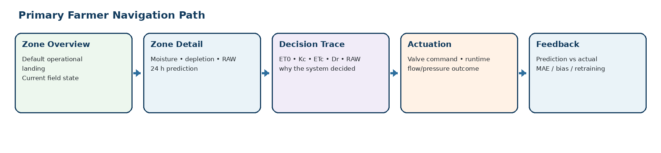
Figure 1. Primary farmer navigation path.

1. Scope and Product Boundary
This app is the human-facing control and observability layer for AquaSence AI. It does not replace the deterministic Layer 1 agronomic engine, the XGBoost residual model, or hardware safety logic. The app visualizes state, explains decisions, surfaces predictive warnings, provides authorized manual override, and exposes prototype engineering diagnostics.
In scope for V1 | Explicitly out of scope for V1
Zone monitoring and health | Formal production MLOps orchestration
24 h prediction view | Automatic Kc/soil-parameter optimization
Agronomic decision trace | Kalman/EnKF configuration UI
Irrigation event / valve status | ADWIN / automated drift management
Flow/pressure verification | Champion/challenger deployment console
Alerts and manual override | Uncertainty/conformal-prediction UI
Prediction-vs-actual logging and model metrics | Reinforcement-learning control
Prototype operator diagnostics | Production device provisioning / fleet management

2. Users and Access Modes
Role | Primary goals | Screens / capabilities
Farmer / Irrigation Manager | Know field state; understand whether water is needed; intervene safely | Zone Overview, Zone Detail, Prediction, Decision Trace, Irrigation/Actuation, Alerts, Manual Override, History
Prototype Operator / Engineering User | Run experiments; inspect raw/cleaned data; compare prediction with outcome | All farmer views + Engineering Mode, Data Inspector, Prediction Evaluation, System Health, Export
Hardware subsystem (non-human actor) | Sense, transmit, actuate, verify | Appears through system status, device status, telemetry and actuation events

Access principle: The PRD requires authorized manual intervention. The exact identity provider is not locked; the UI should therefore implement role-based access without hard-coding a vendor-specific authentication mechanism in V1.

3. Global Navigation Model

Figure 2. Recommended primary navigation sequence.
Navigation item | Default route | Purpose
Dashboard / Zones | /zones | Fast operational overview across all zones
Zone detail | /zones/:zoneId | Deep dive into one irrigation zone
Prediction | /zones/:zoneId/prediction | 24 h physics forecast + XGBoost correction
Decision Trace | /zones/:zoneId/decision | Show how ET0/Kc/ETc/TAW/RAW and current state lead to the irrigation status
Irrigation / Actuation | /zones/:zoneId/irrigation | Show active/completed valve events and verified delivery
Alerts | /alerts | Faults, degraded forecast, sensor issues, abnormal flow/pressure
History | /zones/:zoneId/history | Past moisture, irrigation, weather and prediction outcomes
Engineering Mode | /engineering | Prototype-only diagnostics, raw/cleaned data and model evaluation

4. Global UI Components and Interaction Rules
Component | Behavior
Zone status chip | Always show one primary state: Normal, Irrigation Required, Predicted Irrigation, Irrigating, Verification, Warning, Fault, or Data Stale.
Last updated | Display source timestamp and freshness; never imply that stale data is real-time.
Forecast freshness | Show forecast issue time / age whenever a predictive view is displayed.
Manual action confirmation | Any manual OPEN/CLOSE/TRIGGER action requires a confirmation surface with zone, requested action, expected runtime/volume and safety status.
Safety block | When pressure is unsafe, flow is abnormal, required sensor state is invalid or command is stale, disable the unsafe action and explain why.
Traceability link | From any prediction or irrigation event, the user can open the associated Decision Trace and event record.
Error banner | Persistent, specific and actionable. Example: “Forecast unavailable — predictive planning degraded; current-state controls remain available if safety policy permits.”

5. Screen Inventory
# | Screen | Actor | Priority | Primary interaction
01 | Access / session entry | All | P0 | Enter authorized session; load correct role
02 | Zone Overview Dashboard | Farmer | P0 | Scan status; open zone
03 | Zone Detail / Live State | Farmer | P0 | Inspect moisture, depletion, RAW, valve and network state
04 | 24 h Prediction | Farmer | P0 | Inspect physics forecast, residual correction and final forecast
05 | Decision Trace | Farmer | P0 | Understand why system says monitor / irrigate / plan
06 | Irrigation / Actuation | Farmer + Operator | P0 | Observe and authorize safe valve actions
07 | Actuation Verification | Farmer + Operator | P0 | Confirm flow, pressure and soil response
08 | Alerts & Incidents | Farmer + Operator | P0 | Acknowledge, inspect and act
09 | Manual Override | Authorized Farmer + Operator | P0 | Cancel, delay or manually trigger an approved zone action
10 | History & Trends | Farmer + Operator | P1 | Review moisture, irrigation, forecast outcomes
11 | Engineering / Data Inspector | Operator | P1 | Inspect raw/cleaned data and derived agronomic variables
12 | Model Evaluation | Operator | P1 | Inspect prediction vs actual, MAE, RMSE, bias
13 | System / Device Health | Operator | P1 | Inspect sensor/GSM/MQTT/valve health
14 | Settings / Configuration | Operator | P1 | View versioned crop/soil/zone configuration; edit only approved prototype settings

Screen 1 — Access / Session Entry
Actor / Access | Primary Purpose | Source of Truth
Farmer / Operator | Establish the authorized session required for farmer override and engineering functions. | Not specified in PRD beyond authorized user requirement; authentication mechanism remains an implementation choice.

Content and data
- User credentials/session state
- role mapping
- system availability.

Interactions
- A. Open app → session check → route to role-appropriate landing screen.
- B. Unauthorized user sees access denied; no control surfaces are exposed.
- C. Session timeout returns user to entry.

Validation / safety behavior
Do not hard-code a specific identity provider; implement an application-level role boundary.

Screen 2 — Zone Overview Dashboard
Actor / Access | Primary Purpose | Source of Truth
Farmer / Irrigation Manager | Provide the fastest operational view of all irrigation zones. | Source: PRD View “Zone overview” — current soil moisture, depletion, RAW status, valve state.

Content and data
- Zone ID, current root-zone moisture, depletion Dr, RAW status, valve state, flow/pressure status, data freshness, 24 h predicted state/flag, active alert count.

Interactions
- A. Default screen after entry.
- B. Tap zone → Zone Detail.
- C. Tap alert → Alert detail.
- D. Active irrigation shows live progress.
- E. Stale data is visually distinct.

Validation / safety behavior
If telemetry is stale, do not display it as live. Surface freshness. If zone fault exists, prioritize the fault state.

Screen 3 — Zone Detail / Live State
Actor / Access | Primary Purpose | Source of Truth
Farmer / Operator | Provide one-zone situational awareness. | PRD says root-zone state, current irrigation, predictive warning and actuation verification are core use cases.

Content and data
- Current moisture by depth if available, root-zone moisture, θFC/θWP context, Dr, RAW, θcrit, ET0, ETc, rainfall, forecast freshness, valve state, flow, pressure.

Interactions
- A. Switch depth view if multiple sensors exist.
- B. Open Prediction.
- C. Open Decision Trace.
- D. Open current irrigation event.
- E. Manual Override entry requires authorization.

Validation / safety behavior
Use simple state labels plus numbers. Keep “current state” separate from “predicted state.”

Screen 4 — 24 h Prediction
Actor / Access | Primary Purpose | Source of Truth
Farmer / Operator | Explain the short-horizon predictive state. | PRD: Layer 2 predicts residual; final forecast = physics forecast + predicted residual.

Content and data
- Physics-only 24 h forecast, XGBoost residual correction, final corrected forecast, forecast weather summary, model timestamp, model version, prediction status.

Interactions
- A. View forecast components separately.
- B. Toggle physics vs corrected forecast.
- C. Open feature/context summary.
- D. If forecast API is stale/missing, show degraded mode and suppress misleading future claims.

Validation / safety behavior
Never show a corrected forecast without showing its source timestamp and that forecast weather was available.

Screen 5 — Decision Trace
Actor / Access | Primary Purpose | Source of Truth
Farmer / Operator | Answer “Why is the system recommending this status?” | PRD View “Decision trace” explicitly lists ET0, Kc, ETc, current Dr, RAW, irrigation need.

Content and data
- ET0, Kc, ETc, θFC, θWP, Zr, TAW, p, RAW, current θ/Dr, effective rainfall contribution, net/gross irrigation requirement, zone area, flow, runtime.

Interactions
- A. Expand each calculation stage.
- B. Jump to source data timestamp.
- C. Compare current vs threshold.
- D. If triggered, show resulting water volume/runtime.

Validation / safety behavior
The page explains, not edits, the locked Layer 1 calculations.

Screen 6 — Irrigation / Actuation
Actor / Access | Primary Purpose | Source of Truth
Farmer / Operator | Show active and recent valve commands and the physical delivery process. | PRD: decision converts into valve command; water volume uses area and measured/calibrated flow.

Content and data
- Command ID, zone, command type, requested volume, requested runtime, valve state, start time, expected end time, measured flow, pressure.

Interactions
- A. Open a safe approved action.
- B. Confirmation before manual commands.
- C. During irrigation show progress.
- D. Allow stop/emergency action where hardware policy permits.

Validation / safety behavior
The UI cannot bypass maximum runtime, maximum volume, pressure limits or emergency stop.

Screen 7 — Actuation Verification
Actor / Access | Primary Purpose | Source of Truth
Operator / Farmer | Prove that commanded irrigation actually happened. | PRD: flow/pressure and subsequent soil response are logged; actual delivered water independently verified.

Content and data
- Expected flow/volume vs measured flow/volume, pressure timeline/summary, soil moisture before/after, verification result, anomaly/fault.

Interactions
- A. “Verified” when flow/pressure are within configured limits and outcome is plausible.
- B. “Mismatch” if zero/abnormal flow after opening.
- C. Link to alert and event log.

Validation / safety behavior
Never display “delivered successfully” solely because a command was acknowledged. Delivery must be supported by measurements.

Screen 8 — Alerts & Incidents
Actor / Access | Primary Purpose | Source of Truth
Farmer / Operator | Centralize problems requiring attention. | Failure modes and safety table in PRD.

Content and data
- Alert type, zone, timestamp, severity, current value, expected range/state, recommended operator action, related command/prediction.

Interactions
- A. Filter by zone/severity/type.
- B. Open source event.
- C. Acknowledge.
- D. Resolve only when condition clears or operator marks as handled.

Validation / safety behavior
Examples: sensor invalid, forecast unavailable/stale, GSM disconnected, zero flow after valve opening, low pressure, stale command rejected.

Screen 9 — Manual Override
Actor / Access | Primary Purpose | Source of Truth
Authorized Farmer / Operator | Allow safe human intervention without bypassing deterministic safety. | PRD: authorized user can cancel, delay or manually trigger an approved zone action within safety limits.

Content and data
- Zone, current state, proposed action, current pressure, flow status, sensor freshness, requested volume/runtime, reason/optional note.

Interactions
- A. Choose Cancel / Delay / Trigger.
- B. Review safety summary.
- C. Confirm.
- D. Generate request ID.
- E. Show command status and result.

Validation / safety behavior
Disable action if sensor state invalid beyond allowed freshness, pressure unsafe, command would exceed limits or emergency stop active.

Screen 10 — History & Trends
Actor / Access | Primary Purpose | Source of Truth
Farmer / Operator | Review field behavior and irrigation history. | PRD requires raw, cleaned, derived, predictions and outcomes to be stored; history is implied by logging and auditability.

Content and data
- Time-series: soil moisture, depletion, rainfall, ET0/ETc, irrigation volume, flow, pressure, predicted vs actual moisture.

Interactions
- A. Time range selector.
- B. Zone selector.
- C. Tap a point → event detail.
- D. Export for engineering use if permitted.

Validation / safety behavior
Keep raw vs cleaned vs derived data distinct in engineering export.

Screen 11 — Engineering / Data Inspector
Actor / Access | Primary Purpose | Source of Truth
Prototype Operator | Inspect the data pipeline end-to-end. | PRD actor table explicitly gives the prototype operator raw/cleaned inspection and exports.

Content and data
- Raw telemetry, cleaned telemetry, derived agronomic variables, forecast payload metadata, prediction row, outcome row, quality flags.

Interactions
- A. Filter by timestamp/zone/device.
- B. Compare raw vs cleaned.
- C. Open the exact row used for prediction.
- D. Export data.

Validation / safety behavior
Engineering-only. Never present raw diagnostic fields as farmer controls.

Screen 12 — Model Evaluation
Actor / Access | Primary Purpose | Source of Truth
Prototype Operator | Evaluate whether the residual model is earning its place. | PRD: every prediction gets eventual outcome; XGBoost must beat physics baseline before final demo loop.

Content and data
- Prediction origin time, physics forecast, residual prediction, final forecast, actual, error, absolute error, rolling MAE/RMSE/bias, model version, validation status.

Interactions
- A. Filter by crop/stage/weather regime.
- B. Compare physics-only vs XGBoost.
- C. View frozen evaluation results.
- D. Mark candidate retraining as ready/not ready.

Validation / safety behavior
Do not expose “accuracy” claims without test-set context; V1 reports held-out temporal metrics.

Screen 13 — System / Device Health
Actor / Access | Primary Purpose | Source of Truth
Prototype Operator | Verify hardware and connectivity conditions. | PRD: GSM/MQTT connectivity rules and hardware reliability requirements.

Content and data
- Sensor freshness, device online/offline, battery/power status if available, GSM state, MQTT heartbeat, last telemetry, valve status, flow/pressure health.

Interactions
- A. Inspect a device.
- B. See last contact.
- C. Open failure incident.
- D. View buffer/reconnect indicators.

Validation / safety behavior
A communications outage must not replay stale irrigation commands blindly.

Screen 14 — Settings / Configuration
Actor / Access | Primary Purpose | Source of Truth
Prototype Operator | View and manage approved prototype configuration. | PRD explicitly requires versioned Kc and excludes automatic Kc/soil-parameter optimization in V1.

Content and data
- Crop, growth-stage schedule, Kc values, θFC, θWP, Zr, p_table, application efficiency, zone area, flow calibration, pressure limits, forecast provider status.

Interactions
- A. View current version.
- B. Edit only approved fields.
- C. Save creates version/change record.
- D. Revert if supported by implementation.

Validation / safety behavior
Do not expose automatic Kc/soil calibration in V1. Configuration is versioned and reproducible.

20. End-to-End App Interaction Flows
Flow rule: The app is observational and supervisory. The immediate irrigation authority remains deterministic Layer 1; prediction supplies early-warning context; safety constraints always remain stronger than UI intent.

Flow A — Normal monitoring
- Zone telemetry arrives with valid freshness.
- Dashboard updates current moisture, depletion, RAW status and valve state.
- If depletion is below RAW, zone remains in Normal / Monitoring state.
- User can inspect Prediction and Decision Trace without triggering irrigation.

Flow B — Current irrigation trigger
- Current root-zone depletion reaches RAW.
- Layer 1 computes replenishment quantity and runtime from area, efficiency and confirmed flow.
- Dashboard shows Irrigation Required and exposes the approved action.
- Valve command is issued with request ID and safety checks.
- Actuation view shows progress; verification page compares expected vs actual delivery.

Flow C — Predictive warning
- Forecast weather is available and fresh.
- Layer 1 performs a 24 h physics forward run.
- XGBoost predicts field-specific residual; final forecast is produced.
- If the predicted root-zone state is expected to cross the critical condition, dashboard shows Predicted Irrigation / Planning state.
- No predictive state bypasses current-state safety checks.

Flow D — Rain event changes plan
- Forecast rainfall enters the 24 h forward run.
- Physics forecast reflects expected rainfall contribution.
- If predicted depletion no longer crosses the critical condition, predictive irrigation warning may clear.
- The UI explicitly shows forecast rainfall so the user can understand why the plan changed.

Flow E — Actuation mismatch
- Valve command is sent.
- Flow remains zero or pressure becomes abnormal.
- System stops / inhibits further action according to the configured safety policy.
- Alert is created and the event is marked unverified or faulted.
- Farmer/operator sees the reason rather than a false success state.

Flow F — Forecast unavailable
- Forecast provider fails or forecast timestamp becomes stale.
- Prediction page enters degraded state and identifies the missing dependency.
- No future weather is fabricated.
- Current-state Layer 1 path may continue only if the documented safety policy allows it.

Flow G — Farmer override
- Authorized user opens Manual Override from the zone context.
- UI shows current moisture/depletion, pressure, flow state, requested action and limits.
- User chooses Cancel / Delay / Trigger and confirms.
- Command receives request ID and is audited.
- Result returns to Actuation Verification.

Flow H — Prediction feedback
- At t+24 h, actual root-zone moisture becomes available.
- Prediction record is matched by zone/timestamp/model version.
- Residual, absolute error and bias contribution are calculated.
- Rolling MAE/RMSE/bias update in Engineering Mode.
- Samples accumulate for periodic offline XGBoost retraining.

21. Prediction → Decision UI Interaction
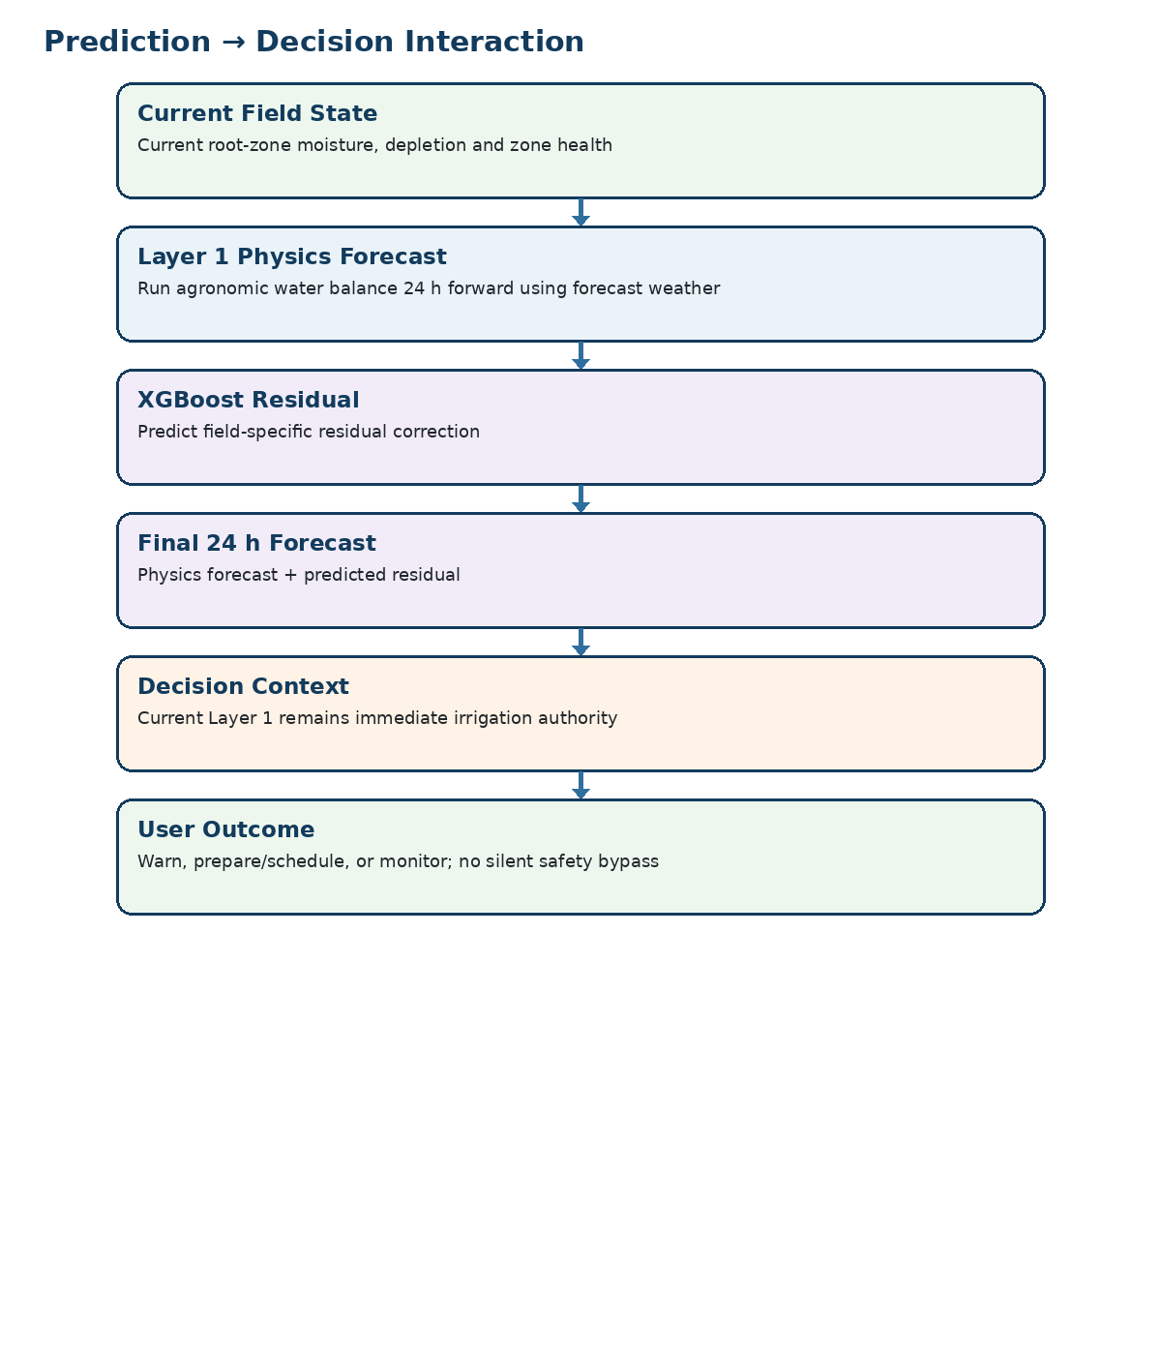
Figure 3. Prediction-to-decision interaction.

22. Zone State Model
State | Entry condition | Primary UI | Allowed user actions | Exit condition
Normal / Monitoring | Dr < RAW; valid telemetry | Green/neutral status | View details; no immediate irrigation action | Dr reaches RAW, or predictive warning
Predicted Irrigation | 24 h forecast expected to cross critical state | Prediction warning | Open prediction/trace; review planning context | Forecast changes or irrigation planned/current trigger
Irrigation Required | Current Dr ≥ RAW | High-priority zone state | Review/approve safe action | Valve starts or condition resolves
Irrigating | Approved command active | Live actuation progress | Stop/emergency action if allowed | Runtime complete / manual stop
Verification | Actuation complete; measurements being checked | Verified/pending/mismatch indicator | Inspect outcome | Verified, faulted or data timeout
Warning / Degraded | Forecast/sensor/communication issue | Amber banner + alert | Inspect; safe fallback only | Condition clears
Fault | Unsafe flow/pressure, invalid critical sensor, stale command rejection | Red fault state | Acknowledge / resolve / maintenance | Fault condition resolved

23. Interaction Matrix
Interaction | Expected result | Audit record
Tap zone card | Open Zone Detail for selected zone | Navigation event optional; no control command
Open Prediction | Load physics, residual and final forecast with timestamps | Prediction view access; prediction record already persisted
Open Decision Trace | Show ET0/Kc/ETc/TAW/RAW/Dr and irrigation quantity path | Traceable to data timestamps and configuration version
Manual Trigger | Safety checks → confirmation → command | Request ID + user + timestamp + command
Cancel/Delay | Validate command state; issue supported control action | Request ID + user + timestamp + reason
Acknowledge alert | Mark operator awareness; does not erase underlying telemetry | Alert status history
Export data | Export permitted raw/cleaned/derived/prediction fields | Export event + filters used
Open prediction outcome | Show predicted vs actual and error | Outcome matched to original prediction ID
Retrain candidate | Operator reviews metrics; separate backend job handles training | Model version, training window, validation result

24. Screen-Level Data Contracts
Object | Minimum fields used by UI
ZoneState | zone_id, timestamp, theta_rz, Dr, RAW, theta_crit, valve_state, flow, pressure, freshness, state
Prediction | prediction_id, origin_timestamp, horizon, theta_phys, residual_hat, theta_final, forecast_timestamp, model_version, status
DecisionTrace | ET0, Kc, ETc, thetaFC, thetaWP, Zr, TAW, p, RAW, Dr, rainfall/effective rainfall, Inet, Igross, volume_l, runtime_min, config_version
IrrigationEvent | request_id, zone_id, command, requested_volume_l, requested_runtime_min, start/end, flow, pressure, delivered_volume_l, verification_status
Alert | alert_id, zone_id, type, severity, timestamp, current_value, expected_condition, state, acknowledgement
Outcome | prediction_id, outcome_timestamp, theta_actual, error, abs_error, model_version

25. Failure and Degraded-State UX
Failure / degraded condition | UI response | Control implication
Soil sensor invalid | Show stale/invalid badge; show last valid timestamp | Automatic action inhibited if freshness window exceeded
Forecast API unavailable | Prediction page shows “Forecast unavailable”; keep last successful forecast timestamp visible | Do not fabricate future weather; predictive planning degraded
GSM disconnected | Show offline/connection state and last contact time | Telemetry can buffer locally; stale commands must be rejected
MQTT / message transport failure | Show communication alert; preserve unsent telemetry if buffer exists | No assumption of command delivery
Low pressure | Show pressure fault at zone and actuation screen | Block new valve action unless policy explicitly permits
Zero/abnormal flow after opening | Show actuation mismatch and fault | Stop/flag according to safety policy
Stale command | Show rejected command with age | No valve actuation

26. Prototype Operator / Engineering Mode
The PRD explicitly gives the prototype operator responsibilities that are different from a farmer: run experiments, inspect raw/cleaned data, compare prediction with outcome, and export data. Engineering Mode should therefore be clearly separated from the farmer-facing experience.
- Raw TelemetryRead-only table of the exact samples received from hardware. Never overwrite raw values with filtered values.
- Cleaned TelemetryShow validation flags, filtered values and the reason a reading was rejected or transformed.
- Derived AgronomicShow ET0, Kc, ETc, TAW, RAW, Dr and configuration version.
- Forecast ContextShow provider name, forecast issuance time, variables received and freshness.
- Prediction EvaluationShow physics forecast, residual prediction, final forecast, actual outcome and rolling metrics.
- Hardware Test ViewShow current sensor health, valve state, flow and pressure for hardware-in-the-loop tests.

27. App Acceptance Criteria
Area | Acceptance test
Zone Overview | A zone card correctly reflects current moisture, depletion, RAW state, valve state, freshness and active alerts.
Decision Trace | Given known test values, the UI reproduces the stored Layer 1 decision values and units without recalculation drift.
Prediction | A prediction record shows physics forecast, residual correction, final forecast, forecast timestamp and model version.
Current irrigation | When Dr ≥ RAW in a controlled test, the UI exposes the expected irrigation state and the approved safe action.
Override | Authorized user can submit an approved manual command; unauthorized user cannot.
Safety | Low pressure, invalid critical sensor or stale command prevents unsafe actuation and produces a visible reason.
Verification | After an irrigation event, the UI distinguishes command acknowledgement from actual delivery verification.
Feedback | After the forecast horizon, predicted vs actual values appear in the outcome record and contribute to MAE/RMSE/bias.
Degraded forecast | If forecast API is stale/unavailable, the prediction surface clearly shows degraded mode and never presents fabricated future weather.
Engineering mode | Operator can inspect raw/cleaned/derived/prediction/outcome records for one zone and one time interval.

28. Recommended Screen Build Order
- Build Zone Overview with live/stale state and zone navigation.
- Build Zone Detail and current-state Decision Trace.
- Integrate Prediction screen once the forecast payload and XGBoost record schema are stable.
- Build Irrigation/Actuation and Verification as the first control-critical surface.
- Build Alerts and Manual Override with safety gating.
- Add History/Trends.
- Add Engineering/Data Inspector and Model Evaluation.
- Add System/Device Health.
- Add configuration/version views only after the core closed loop is stable.

29. V1 Product Discipline
Implementation rule: Do not create UI controls for architecture that the PRD explicitly excludes from V1. If a future feature is not implemented, it should appear as a read-only research note or be absent, not as a misleading button.

- No UI control for live Kc optimization.
- No UI for automatic drift detection.
- No UI for Kalman/EnKF configuration.
- No UI for champion/challenger production deployment.
- No UI claiming real-field ML accuracy until genuine field-labelled data exists.
- No manual command path that bypasses pressure, flow, stale-command, runtime, volume or emergency-stop rules.

30. Source Basis and Interpretation Notes
This App Flow specification is derived from the locked AquaSence AI master PRD supplied by Team Rocket. The master PRD defines the actors, use cases, dashboard views, engineering mode needs, control safety rules, data classes, prediction/feedback architecture and prototype non-goals. Where the PRD names a required screen behavior but does not prescribe a visual layout, this document supplies an implementation-oriented UI interpretation while preserving the locked system logic.
PRD anchor | Used in this App Flow specification
Section 3 — Users, Use Cases and Success Criteria | Roles, dashboard needs, normal/current/predictive/rain/verification/override flows
Section 4 — System Concept and End-to-End Flow | Navigation story from sensing through feedback
Section 8 — Data Architecture | Screen-level data contracts and engineering mode data separation
Section 9 — Layer 1 | Decision Trace, current state and irrigation calculations
Section 10 — Layer 2 | Prediction screen, forecast dependency, residual correction display
Section 11 — Feedback | Outcome history, error metrics and offline retrain view
Section 12 — Decision and Valve Control | Actuation screen, safety state, runtime/flow verification
Section 13 — Farmer Dashboard and Human Override | Farmer-facing dashboard and manual override behavior
Sections 14–15 — Failure / Validation | Alert, degraded state and acceptance criteria

31. UI Implementation Freeze Checklist
- All P0 screens exist: Zone Overview, Zone Detail, Prediction, Decision Trace, Irrigation/Actuation, Verification, Alerts, Manual Override.
- Every control-critical screen displays data freshness and zone identity.
- Prediction screen distinguishes physics forecast, XGBoost correction and final forecast.
- Decision Trace exposes the exact Layer 1 variables used for the stored decision.
- Actuation UI distinguishes command acknowledgement from verified delivery.
- All manual actions have confirmation + safety summary + request ID.
- Forecast degradation is visible and never silently replaced with fabricated data.
- Engineering Mode exposes raw vs cleaned vs derived vs prediction/outcome records.
- No V1 screen exposes excluded production MLOps features as if they are implemented.

