Dissertation Title

Predicting Gold price variations using Machine Learning Techniques

Final Thesis

In Partial Fulfillment
of the Requirements for the Degree of
Master in Computer Science

Student Name | : | Bhargava Billu
Student ID | : | 2815493
Supervisor | : | Lucian Duta

Abstract
Accurate prediction of gold prices is an important problem in financial markets due to the high volatility and economic significance of gold as a safe-haven asset. This study investigates and compares the performance of five different machine learning and deep learning models for forecasting gold price movements using historical time-series data. The models evaluated include Random Forest Regressor, Artificial Neural Network (ANN), Simple Recurrent Neural Network (RNN), Long Short-Term Memory (LSTM), and Gated Recurrent Unit (GRU). The dataset used in this research consists of ten years of historical gold price data (GC=F), with the most recent 20% reserved for testing. All models were trained using a consistent preprocessing pipeline, including MinMax scaling and a sliding window approach for sequence generation. Performance was evaluated using Mean Absolute Error (MAE), Mean Squared Error (MSE), Root Mean Squared Error (RMSE), and the coefficient of determination (R²). The results show a clear difference in performance among the models. The GRU model achieved the best performance with an MAE of 118.20 USD and an R² of 0.88, demonstrating strong predictive capability. The LSTM model also performed well, while the ANN showed moderate performance. In contrast, the Random Forest and Simple RNN models performed poorly, with negative R² values indicating weak or unreliable predictions. Overall, the findings highlight that gated recurrent neural network architectures, particularly GRU, are more effective for gold price forecasting due to their ability to capture temporal dependencies in financial time-series data. The study concludes that model selection plays a critical role in prediction accuracy and suggests that GRU-based approaches are highly suitable for financial forecasting applications.

Keywords: Gold price prediction, Machine learning, Deep learning, GRU, LSTM, Artificial Neural Network, Random Forest, Time series forecasting, Financial forecasting, Recurrent neural networks.

Acknowledgements

I would like to express my sincere gratitude to the University of East London for providing me with the opportunity and academic environment to complete this research successfully. The guidance, resources, and support offered throughout my MSc Computing with Industrial Placement programme have been invaluable in shaping my understanding and skills in the field of machine learning and data science.

I am especially grateful to my supervisor, Lucian Duta, for his continuous support, encouragement, and constructive feedback throughout the development of this dissertation. His guidance helped me to refine my research direction, improve the technical quality of my work, and stay focused on the key objectives of the study. I deeply appreciate the time and effort he dedicated to reviewing my progress and providing insightful suggestions at every stage of the project.

I would also like to thank my lecturers and academic staff at the University of East London for their teaching and support during my course, which helped build the foundation required to complete this research.

Finally, I would like to acknowledge my family and friends for their constant encouragement, motivation, and understanding throughout this academic journey. Their support has been a source of strength and inspiration.

Table of Contents
Abstract ii
List of Tables vi
List of Figures vii
List of Acronyms viii
Chapter 1 Introduction 9
1.1 Background 12
1.2 Problem Statement 15
1.3 Research Question and Objectives 16
1.4 Expected Outcomes 17
Chapter 2 Literature Review 18
2.7 Literature Review Summary 23
Chapter 3 Methodology 28
4.1 Research Design 28
4.2 Data Acquisition 29
4.3 Data Cleaning 30
4.4 Exploratory Data Analysis and Visualisation 32
4.4 Feature Engineering 32
4.5 Data Preprocessing Sequence Construction & Splitting 33
4.6.1 Random Forest 34
4.6.2 ANN Model 34
4.6.3 RNN Model 35
4.6.4 LSTM Model 35
4.6.5 GRU Model 36
4.7 Model Evaluation Framework 37
4.8 Limitations & Delimitations 37
4.8.1 Limitations 37
4.8.2 Delimitations 38
Chapter 4 Results & Findings 40
4.1 Random Forest Performance 40
4.2 Artificial Neural Network (ANN) Performance 41
4.3 Simple RNN Performance 41
4.4 Long Short-Term Memory (LSTM) Performance 42
4.5 Gated Recurrent Unit (GRU) Performance 42
4.6 Comparison of All Model Results 43
4.6.1 Mean Absolute Error (MAE) 44
4.6.2 Mean Squared Error (MSE) 45
4.6.3 R² Score 46
4.7 Critical Evaluation of Results 47
Chapter 5 Discussion 49
5.1 Interpretation of Results via Conceptual Framework 49
5.2 Pattern Analysis and Model Behaviour 49
5.3 Comparison with Existing Literature 50
5.4 Evaluation Against Research Objectives 50
5.5 Unexpected Findings and Interpretation 51
5.6 Limitations and Broader Significance 51
Chapter 6 Conclusion & Future Work 52
6.1 Conclusion 52
6.2 Key Findings 53
6.3 Limitations of the Study 53
6.4 Future Work 53
References 55
Appendix A Code Artifacts 57

List of Tables
Table 1: Random Forest Performance 40
Table 2: ANN Model Performance 41
Table 3: RNN Model Performance 41
Table 4: LSTM Model Performance 42
Table 5: GRU Model Performance 42
Table 6: Comparison of all models results 43
Table 7: Comparison of MAE 44
Table 8: Comparison of MSE 45
Table 9: Comparison of R2 Score 46

List of Figures
Figure 1: Architecture of the proposed system 29
Figure 2: Data Acquisition from Yahoo Finance 30
Figure 3: After deleting un wanted columns 30
Figure 4: Handling Missing values and Duplicates 31
Figure 5: Saving cleaned file as csv 31
Figure 6: Gold Price Over Time 32
Figure 7: Feature Engineering 33
Figure 8: Sequence construction & Splitting 33
Figure 9: Random Forest Regressor 34
Figure 10: ANN Model 35
Figure 11: RNN Model 35
Figure 12: LSTM Model 36
Figure 13: GRU Model 36
Figure 14: Comparison of MAE 44
Figure 15: Comparison of MSE 45
Figure 16: Comparison of R2 46

List of Acronyms
ANN | Artificial Neural Network
ARIMA | AutoRegressive Integrated Moving Average
BiGRU | Bidirectional Gated Recurrent Unit
BiLSTM | Bidirectional Long Short-Term Memory
CNN | Convolutional Neural Network
GC=F | Gold Futures Contract (Gold Price Dataset Ticker)
GRNN | Generalized Regression Neural Network
GRU | Gated Recurrent Unit
LSTM | Long Short-Term Memory
MAE | Mean Absolute Error
MAPE | Mean Absolute Percentage Error
MSE | Mean Squared Error
RMSE | Root Mean Squared Error
RNN | Recurrent Neural Network
R² | Coefficient of Determination
SVM | Support Vector Machine
TCN | Temporal Convolutional Network
VMD | Variational Mode Decomposition
ICSS | Iterative Cumulative Sum of Squares
CNN-BiLSTM | Convolutional Neural Network with Bidirectional LSTM
BP | Backpropagation Neural Network

Chapter 1 Introduction

Gold has always been considered one of the most valuable and stable investment assets in the global financial market. For many decades, investors, financial institutions, and governments have relied on gold as a safe store of value during economic uncertainty and market volatility. The price of gold fluctuates continuously due to various economic, political, and financial factors such as inflation, interest rates, currency exchange rates, global demand and supply, and geopolitical events. These fluctuations make gold price prediction an important task for investors and financial analysts who want to make informed decisions regarding investment strategies. Accurate forecasting of gold prices can help investors reduce financial risks, improve profit opportunities, and support better economic planning (World Gold Council, 2022).

Gold price variations are influenced by several complex factors that interact with each other in dynamic ways. For example, changes in crude oil prices, fluctuations in stock market indices, and variations in the value of the US dollar can significantly impact the price of gold. During periods of economic instability or financial crisis, investors often shift their investments toward gold because it is considered a safe haven asset. This increased demand leads to changes in gold prices. Because of these factors, predicting gold prices becomes a challenging task, especially when relying only on traditional financial analysis methods (Baur & Lucey, 2010).

Traditional approaches for predicting gold prices often rely on statistical models and econometric techniques such as autoregressive integrated moving average models, linear regression, and time series analysis. These methods analyze historical price data to identify patterns and trends that may help predict future price movements. Although these techniques have been widely used for many years, they have several limitations. Financial markets are highly complex and often exhibit nonlinear behavior, which traditional statistical models may struggle to capture accurately. In addition, these models may not perform well when dealing with large datasets that contain multiple influencing factors (Zhang, Aggarwal & Qi, 2017).

In recent years, machine learning techniques have emerged as powerful tools for analyzing financial data and forecasting market trends. Machine learning algorithms can automatically learn patterns from historical data and make predictions without requiring explicit programming rules. These techniques are capable of handling large volumes of data and identifying complex relationships between multiple variables. As a result, machine learning models have been increasingly applied in financial forecasting tasks such as stock price prediction, cryptocurrency forecasting, and commodity price analysis (Alzazah & Cheng, 2020).

Machine learning algorithms such as linear regression, support vector machines, decision trees, and random forest models have been widely used for financial prediction tasks. These models can analyze historical datasets containing multiple economic indicators and learn how different factors influence price movements. For example, gold prices may be influenced by variables such as crude oil prices, stock market indices, exchange rates, and inflation levels. By analyzing these variables together, machine learning models can generate more accurate predictions compared to traditional forecasting methods. The ability of machine learning models to learn complex patterns makes them highly suitable for predicting gold price variations (Gupta et al., 2019).

Among different machine learning techniques, ensemble learning models such as random forest and gradient boosting have shown strong performance in financial forecasting tasks. These models combine the predictions of multiple decision trees to improve accuracy and reduce prediction errors. Ensemble methods are particularly useful when dealing with noisy or complex financial datasets. In addition, machine learning models can be continuously retrained using new data, which allows them to adapt to changing market conditions and improve prediction performance over time (Chen & Guestrin, 2016).

Another important advantage of machine learning models is their ability to perform feature selection and data driven learning. Instead of relying on manually defined rules, machine learning algorithms can automatically identify the most important variables that influence gold price movements. This capability helps researchers and analysts understand which economic indicators play the most significant role in gold price fluctuations. Furthermore, machine learning techniques can analyze historical data from multiple sources and identify hidden patterns that may not be easily visible through manual analysis (Kumar & Thenmozhi, 2021).

Despite the advantages of machine learning models, predicting gold prices remains a challenging task due to the highly dynamic nature of financial markets. Market conditions can change rapidly due to economic policies, geopolitical events, and global financial crises. These factors introduce uncertainty and volatility into financial datasets, making accurate prediction more difficult. Therefore, it is important to develop robust machine learning models that can effectively analyze large financial datasets and provide reliable predictions under different market conditions (Shafiee & Topal, 2010).

This research project aims to develop a machine learning based system for predicting gold price variations using historical financial data. The proposed system will analyze datasets containing gold prices along with related economic indicators such as crude oil prices, stock market indices, and currency exchange rates. Several machine learning algorithms will be implemented and compared to identify the model that provides the best prediction accuracy. By analyzing the relationships between different financial variables, the system will attempt to forecast future gold price movements more effectively.

During the implementation phase, the collected dataset will undergo several preprocessing steps to improve data quality and ensure reliable model training. These steps may include handling missing values, data normalization, feature selection, and dataset splitting into training and testing sets. Machine learning models will then be trained using the prepared dataset and evaluated using standard performance metrics such as mean squared error, root mean squared error, and prediction accuracy.

The main objective of this research is to develop a predictive model that can assist investors and financial analysts in understanding gold price trends and making better investment decisions. Accurate prediction of gold price variations can help reduce financial risks and support more effective portfolio management strategies. In addition, the proposed system may also contribute to financial research by demonstrating the effectiveness of machine learning techniques in commodity price forecasting.

In conclusion, gold remains one of the most important investment assets in global financial markets, and predicting its price variations is a challenging yet valuable task. Traditional statistical models often struggle to capture the complex and dynamic nature of financial markets. Machine learning techniques provide powerful tools for analyzing large financial datasets and identifying patterns that can improve forecasting accuracy. By applying machine learning algorithms to historical gold price data and related economic indicators, this research aims to develop an intelligent system capable of predicting gold price variations and supporting better financial decision making.

1.1 Background
Gold has long been recognised as one of the most stable and valuable financial assets in global markets. Unlike many other investment instruments, gold retains intrinsic value and is widely regarded as a “safe-haven” asset, particularly during periods of economic instability or financial crisis. Investors, central banks, and governments consistently rely on gold as a means of preserving wealth and reducing financial risk exposure. Its importance extends beyond investment purposes, as gold is also widely used in jewellery manufacturing, industrial applications, and as part of national monetary reserves, making it a crucial component of the global economy (Baur and Lucey, 2010).

The price of gold is highly dynamic and continuously fluctuates due to a wide range of macroeconomic and geopolitical factors. These include inflation rates, interest rate policies, currency exchange rate movements, global stock market trends, and international political tensions. For example, during periods of economic uncertainty or financial instability, investors tend to shift capital into gold, increasing demand and driving prices upward (Batten, Ciner and Lucey, 2014). Similarly, changes in interest rates influence investment behaviour, as higher interest rates make interest-bearing assets more attractive compared to non-yielding assets like gold. Furthermore, global crises such as wars, pandemics, and financial recessions can significantly affect gold prices due to increased uncertainty in financial markets (World Gold Council, 2022).

Because of these interconnected influences, the gold market is highly complex and non-linear in nature. Price movements are not driven by a single factor but rather by multiple interacting economic variables that change over time. This complexity makes gold price forecasting a challenging task for analysts and researchers. Although investors attempt to monitor macroeconomic indicators and global events to make informed decisions, accurate prediction of short-term price movements remains difficult due to sudden volatility and unpredictable external shocks (De Bandt and Oung, 2004).
Traditionally, gold price forecasting has been conducted using statistical and econometric techniques such as linear regression, autoregressive integrated moving average (ARIMA), and exponential smoothing models. These methods primarily rely on historical price patterns and assume that future movements follow similar trends. While these approaches have provided useful insights in stable conditions, they are limited in capturing nonlinear relationships and sudden structural changes in financial data. Financial time-series data is often noisy, non-stationary, and influenced by external shocks, which reduces the effectiveness of traditional forecasting techniques (Box, Jenkins and Reinsel, 2015).

To overcome these limitations, machine learning techniques have gained significant attention in financial forecasting research. Machine learning models are capable of learning complex patterns from large datasets without relying on strict statistical assumptions. These models can analyse multiple variables simultaneously and identify hidden relationships between historical price movements and influencing factors. This makes machine learning particularly suitable for financial prediction problems where data complexity is high (Alpaydin, 2020).

Common machine learning algorithms used in financial forecasting include Linear Regression, Decision Trees, Random Forest, Support Vector Machines (SVM), and Gradient Boosting methods. These models are effective in identifying patterns within structured datasets; however, their performance often depends heavily on manual feature engineering. This reliance on domain expertise limits their flexibility when dealing with raw time-series data and reduces their adaptability in dynamic financial environments (James et al., 2021).

In contrast, deep learning models have introduced significant improvements in predictive analytics. Neural network-based approaches such as Artificial Neural Networks (ANN), Recurrent Neural Networks (RNN), Long Short-Term Memory (LSTM), and Gated Recurrent Units (GRU) are capable of automatically learning hierarchical representations from raw data. These models eliminate the need for extensive manual feature extraction and are particularly effective in handling sequential and time-dependent data. Among these, LSTM and GRU architectures are specifically designed to capture long-term dependencies, making them highly suitable for financial forecasting tasks such as gold price prediction (Hochreiter and Schmidhuber, 1997; Cho et al., 2014).

Despite these advancements, predicting gold prices remains highly challenging due to the unpredictable nature of financial markets. Market behaviour is influenced by external factors such as geopolitical conflicts, economic policy changes, inflation shocks, and global crises, all of which introduce uncertainty into the dataset. As a result, even advanced models may struggle to achieve consistently high accuracy in real-world conditions (World Gold Council, 2022).
The motivation behind this research is to develop more accurate and reliable predictive models for gold price forecasting using machine learning and deep learning techniques. By leveraging historical financial data, this study aims to identify patterns that can improve forecasting accuracy and support better investment decision-making. Accurate prediction models can assist investors, financial analysts, and policymakers in managing risk and making informed financial decisions.

Furthermore, this research contributes to the growing field of financial data analytics by comparing multiple machine learning and deep learning models under consistent experimental conditions. This comparative approach helps identify the strengths and limitations of each model and determines the most effective techniques for gold price prediction. In addition, the study emphasises the importance of data preprocessing, feature engineering, and model evaluation in improving prediction performance. Proper handling of time-series financial data plays a crucial role in enhancing model accuracy and stability. By systematically analysing different approaches, this research provides a structured framework for gold price prediction using modern artificial intelligence techniques.

In conclusion, gold price forecasting remains a complex yet highly important problem in financial analytics. While traditional statistical methods offer limited predictive capability, modern machine learning and deep learning approaches provide more powerful tools for analysing financial time-series data. This research bridges the gap between conventional forecasting techniques and advanced AI-based models, contributing to the development of more accurate and intelligent financial prediction systems.

1.2 Problem Statement
Gold is one of the most important investment assets in the global financial market. Many investors, traders, and financial institutions depend on gold as a safe option during economic uncertainty and market instability. However, the price of gold changes frequently due to many economic and political factors such as inflation, interest rates, currency exchange rates, crude oil prices, and global demand. Because of these complex influences, predicting gold price variations becomes a difficult task for financial analysts and investors. The unpredictable nature of financial markets makes it challenging to estimate future price movements using simple analytical methods (Baur & Lucey, 2010).

Traditional forecasting techniques such as statistical models and time series analysis have been widely used for gold price prediction. These methods usually analyze historical data to identify trends and patterns. However, many of these traditional models are limited in their ability to capture nonlinear relationships between multiple influencing factors. Financial markets are highly dynamic and influenced by many external variables, which makes traditional prediction methods less reliable in many situations. In addition, these models sometimes fails to adapt quickly when sudden changes occurs in the market conditions (Zhang, Aggarwal & Qi, 2017).

Machine learning techniques have been introduced as an alternative approach for financial forecasting. These methods are capable of learning complex patterns from large datasets and can improve prediction accuracy. However, selecting the most suitable machine learning model and identifying the most relevant features still remains a challenge. Different algorithms may produce different results depending on the dataset and training parameters used (Alzazah & Cheng, 2020).

Therefore, there is a need to develop an effective machine learning based system that can analyze historical financial data and predict gold price variations more accurately. Such a system can help investors make better financial decisions and reduce investment risks by providing more reliable price forecasts (Gupta et al., 2019; Kumar & Thenmozhi, 2021).

1.3 Research Question and Objectives
Aim
The primary aim of this research is to develop an intelligent system for predicting gold price variations using machine learning techniques. The system aims to analyze historical financial data and economic indicators to identify patterns that influence gold price movements. By applying machine learning algorithms, the proposed system will attempt to forecast future gold prices and provide useful insights for investors and financial analysts. The developed model will help in understanding the relationship between different economic factors and gold price fluctuations, which may support better investment planning and financial decision making.

Research Question
- How can machine learning models be used to accurately predict gold price variations using historical financial data?
- What preprocessing techniques can improve the quality of financial datasets and enhance the performance of machine learning prediction models?
- Which machine learning algorithm provides better performance for predicting gold price movements?
- How effectively can machine learning based forecasting systems assist investors and financial analysts in understanding gold market trends?
- How can gold price prediction models contribute to better financial decision making and investment risk management?

Objectives
- To study and review existing research works that use machine learning and artificial intelligence techniques for financial market prediction and gold price forecasting.
- To collect and preprocess historical gold price datasets along with related financial indicators suitable for training and testing machine learning models.
- To develop machine learning models such as Linear Regression, Decision Tree, Random Forest, and Support Vector Regression for predicting gold price variations.
- To apply data preprocessing techniques such as data cleaning, normalization, feature selection, and handling missing values to improve model performance.
- To train the developed machine learning models using historical gold price datasets and related economic indicators.
- To evaluate the performance of the developed models using evaluation metrics such as Mean Squared Error (MSE), Root Mean Squared Error (RMSE), and prediction accuracy.

1.4 Expected Outcomes
The expected outcome of this research is to develop a machine learning based system that can predict gold price variations using historical financial data and related economic indicators. The system will analyze different features such as previous gold prices, crude oil prices, stock market values, and currency exchange rates to understand how these factors influence the changes in gold prices. By learning patterns from historical datasets, the machine learning models will attempt to generate predictions about future gold price movements. The developed system is expected to provide reasonably accurate predictions which can help in understanding market trends.
Another expected outcome is the comparison of different machine learning algorithms to determine which model performs better for gold price prediction. Models such as Linear Regression, Random Forest, Decision Tree, and Support Vector Regression will be trained and evaluated using standard performance metrics. Through this process, it will become possible to identify the most suitable algorithm for predicting gold price variations. The results may show that some models performs better than others depending on the dataset and input features used.

The research is also expected to demonstrate how machine learning techniques can assist investors and financial analysts in studying financial markets. Even though the system may not predict prices perfectly every time, it can still provide useful insights about possible trends in the gold market. Overall, the developed model will contribute to better understanding of gold price behavior and may support improved financial decision making in investment planning.

Chapter 2 Literature Review

2.1 Machine Learning Approaches for Gold Price Prediction
Predicting gold price variations has become an important research area because gold is widely used as a safe investment asset. Many researchers have used machine learning and deep learning techniques to forecast gold price movements based on historical financial data. These techniques helps to analyze complex patterns that are difficult to detect using traditional statistical models. Jin and Xu (2025) proposed a gold price forecasting method using Gaussian Process Regression combined with Bayesian optimization. Their study analyzed ten years of gold market data to improve prediction accuracy. The model was able to achieve a relative root mean square error of only 0.8706%, which indicates a very high level of prediction accuracy. The authors concluded that probabilistic machine learning models can capture the uncertainty in financial markets better than traditional methods.

Similarly, Qiu et al. (2024) developed a two stage deep learning fusion framework for gold price prediction. Their approach combined variational mode decomposition with residual correction techniques. In their model, back propagation neural networks, long short term memory networks, and convolutional neural networks were integrated together. The study tested the framework across four major gold markets and results showed significant improvements in prediction accuracy compared to traditional machine learning models. Another study by Varshini et al. (2024) compared several machine learning and deep learning algorithms including stacked LSTM, convolutional LSTM, and support vector regression for predicting metal futures prices. Their research showed that different algorithms performs differently depending on the dataset characteristics, metal type, and training period. They observed that deep learning based models generally performs better in capturing complex temporal patterns in financial data.

Amini and Kalantari (2024) proposed a hybrid CNN-BiLSTM architecture for predicting gold price movements. Their study used 44 years of historical gold price data and applied automatic parameter tuning to improve model performance. The hybrid model showed superior results in capturing extreme price fluctuations and reducing prediction bias. The authors suggested that combining convolutional layers with sequential learning models improves forecasting performance for time series financial data. These studies clearly indicates that hybrid deep learning models are becoming increasingly popular for financial forecasting because they can handle large scale temporal datasets and complex nonlinear relationships between variables.

2.2 Deep Learning Models for Commodity Price Forecasting
Apart from gold price prediction, many researchers have studied forecasting techniques for other commodities such as crude oil, silver, and energy resources. These studies often provide valuable insights that can also be applied to gold price prediction models. Foroutan and Lahmiri (2024) investigated the performance of deep learning models for predicting commodity prices including crude oil, silver, and gold. They compared several deep learning architectures such as Temporal Convolutional Networks (TCN), Bidirectional Gated Recurrent Units (BiGRU), and long short term memory networks. Their results showed that the TCN model achieved the lowest mean absolute error for WTI crude oil, Brent crude oil, and silver prices. However, for gold price prediction, the BiGRU model provided the best performance.

Li et al. (2021) proposed a hybrid forecasting model combining Variational Mode Decomposition (VMD), Iterative Cumulative Sum of Squares (ICSS), and Bidirectional Gated Recurrent Units for predicting gold futures prices. The study evaluated the model using eleven years of financial data from 2008 to 2019. Their experimental results demonstrated that the hybrid model significantly outperformed traditional statistical models and generated consistent positive returns when applied to trading strategies. Pillai and Mary (2025) introduced a new time series prediction framework called Markov Weighted Fuzzy Kernel Time Series combined with Red Piranha Walrus Optimization. The proposed system aimed to improve both prediction accuracy and computational efficiency. The authors reported that the model required only 60 to 90 seconds for training, which makes it suitable for real time forecasting applications.

Xu et al. (2023) compared traditional econometric models with machine learning approaches for forecasting crude oil prices. Their study showed that neural network based models consistently outperformed econometric models in terms of prediction accuracy. The artificial neural network developed in the study achieved the best performance across all tested forecasting methods. These studies suggests that deep learning models are more suitable for financial time series prediction because they can effectively capture nonlinear relationships and long term dependencies in market data.

2.3 Machine Learning Applications in Commodity and Agricultural Price Prediction
Machine learning techniques have also been widely applied in other price prediction domains such as agricultural markets and commodity trading. These studies highlight the flexibility of machine learning models in handling different types of economic data. Muhammad Mohsin and Jamaani (2023) developed a convolutional neural network model for predicting crude oil prices using precious metal prices as input variables. Their results showed that the CNN based model performed better than seven machine learning algorithms and three statistical forecasting techniques. The study also revealed strong nonlinear relationships between crude oil volatility and precious metal markets.

Paul et al. (2022) applied machine learning techniques to predict agricultural commodity prices in India, focusing on brinjal price forecasting across seventeen different markets. They compared the performance of Generalized Regression Neural Networks and traditional ARIMA models. The results showed that GRNN consistently produced better prediction results than ARIMA models across all markets. Tschora et al. (2022) explored electricity price forecasting using machine learning techniques and introduced new input variables such as price histories from neighboring countries. Their study found that including these additional features significantly improved forecasting accuracy.

Soltani et al. (2022) studied housing price prediction using ensemble machine learning models such as gradient boosting and random forest algorithms. Their research used large scale geographical datasets spanning more than thirty two years. The results showed that ensemble models performed better than individual models, especially when spatiotemporal lag variables were included in the dataset. These studies demonstrate that machine learning models can be effectively used for price forecasting in many economic sectors including agriculture, energy markets, and real estate markets.

2.4 Machine Learning Techniques for Stock Market Prediction
Stock market prediction is another closely related research area where machine learning algorithms are widely used to forecast price movements and market trends. Akhtar et al. (2022) evaluated the performance of random forest and support vector machine algorithms for predicting stock market movements. After preprocessing the financial dataset and applying feature selection techniques, their models achieved an overall prediction accuracy of 80.3%. The study concluded that machine learning models can provide reliable predictions when properly trained with historical financial data.

Gite et al. (2021) proposed a hybrid stock prediction system that combines long short term memory networks with sentiment analysis from financial news articles. The researchers argued that financial news and media sentiment plays a major role in influencing investor behavior. By integrating sentiment analysis with deep learning models, they achieved improved prediction performance. Antonopoulou et al. (2023) applied random forest algorithms to predict the next day closing prices of major Greek banking stocks. Their study incorporated Google Trends data along with technical indicators such as moving averages and standard deviations. The model performance was evaluated using RMSE and MAPE metrics, showing significant improvements compared to traditional forecasting techniques.

Phuoc et al. (2024) conducted a study on the Vietnamese stock market using LSTM based prediction models. Their approach used several technical indicators including simple moving averages, moving average convergence divergence, and relative strength index. The model achieved a prediction accuracy of 93%, demonstrating the effectiveness of deep learning models in capturing temporal dependencies in financial data. These studies shows that machine learning algorithms have strong capability in predicting financial market trends when combined with multiple data sources such as technical indicators and sentiment data.

2.5 Machine Learning for Energy, Environmental, and Natural Resource Forecasting
Machine learning models are also widely used in environmental and energy related prediction tasks. These studies provides useful insights into the predictive capabilities of machine learning algorithms when working with complex datasets. Mouchtaris et al. (2021) studied natural gas price forecasting using several machine learning algorithms including bagged trees and linear support vector machines. Their model used twenty one explanatory variables and successfully predicted spot prices for one to ten days ahead.

Mehta et al. (2021) integrated social media sentiment analysis with traditional financial parameters for stock market prediction. Their deep learning model used long short term memory networks to analyze large volumes of social media data and financial indicators. The results showed that incorporating public sentiment significantly improved prediction accuracy. Ben Jabeur et al. (2021) examined crude oil price forecasting during the COVID-19 pandemic using machine learning models such as random forest and LightGBM. The study also considered environmental and sustainability related indicators such as green energy production and environmental social governance indexes. Their results indicated that higher green energy investments were associated with lower crude oil prices.

Liyew and Melese (2021) applied machine learning techniques to predict daily rainfall amounts in Ethiopia. The study compared several algorithms and found that Extreme Gradient Boosting achieved the highest prediction accuracy. These studies highlights that machine learning algorithms are capable of handling complex environmental and economic datasets for forecasting purposes.

2.6 Applications of Machine Learning in Engineering and Environmental Prediction
Machine learning techniques are also applied in engineering and environmental science fields where predictive modeling is required for decision making. Samad et al. (2023) developed virtual air pollution monitoring stations using five machine learning algorithms to predict air pollutant concentrations such as PM2.5, PM10, and nitrogen dioxide. Their study demonstrated that incorporating pollutant information from nearby monitoring stations significantly improved prediction accuracy. Sharma et al. (2023) applied machine learning and deep learning models to predict agricultural crop yields in India. Their research showed that random forest models achieved an accuracy of 98.96%, while convolutional neural networks achieved the lowest loss value.

Song et al. (2021) predicted the compressive strength of concrete mixtures using machine learning algorithms. Their dataset contained ninety eight experimental samples, and the bagging algorithm achieved the highest accuracy with an R² value of 0.95. Shams et al. (2023) studied water quality prediction using optimized machine learning models. Their results showed that gradient boosting achieved classification accuracy of 99.50%, while multilayer perceptron achieved an R² value of 99.8% for regression tasks. Further research in material science also demonstrated the effectiveness of ensemble machine learning models. Ahmad et al. (2021) showed that boosting algorithms achieved the highest prediction accuracy for geopolymer concrete compressive strength. Wang et al. (2022) also reported that ensemble methods such as AdaBoost and random forest performed better than individual decision tree models.

Kumar and Pande (2022) applied machine learning techniques to predict air quality levels in Indian cities using environmental monitoring data. Their study highlighted the importance of machine learning models for environmental decision support systems. Finally, Zazoum (2021), Jose et al. (2022), Shamshad et al. (2023), and Akyıldırım et al. (2021) demonstrated the effectiveness of machine learning models in renewable energy prediction, climate forecasting, and cryptocurrency price prediction. These studies collectively shows that machine learning has become an important tool for forecasting tasks across many domains. Overall, the reviewed studies indicates that machine learning and deep learning techniques provide powerful tools for financial and economic forecasting. However, there is still a need to develop more robust and interpretable models that can handle market volatility and improve prediction reliability for gold price variations.

2.7 Literature Review Summary
The reviewed studies show that machine learning and deep learning techniques are widely used for predicting financial and commodity prices. Many researchers have applied different algorithms such as regression models, support vector machines, random forest, and neural networks to analyze historical data and forecast future price movements. These models are capable of capturing complex patterns in financial datasets which traditional statistical methods often fail to detect.

Several studies focused specifically on gold price forecasting. Researchers have developed hybrid models that combine different deep learning architectures such as convolutional neural networks, long short term memory networks, and bidirectional recurrent models. These hybrid approaches generally produce better prediction results because they can learn both spatial and temporal patterns from financial data. Some studies also used advanced optimization methods and decomposition techniques to further improve forecasting accuracy. Other research works explored price prediction in related domains such as crude oil, stock markets, electricity prices, and agricultural commodities. These studies also showed that machine learning models performs better when multiple features and external factors are included in the dataset. Ensemble models and deep learning approaches often achieved higher accuracy compared to traditional econometric models.

Overall, the literature indicates that machine learning methods provide effective tools for financial forecasting. However, challenges still exists in handling market volatility and selecting the most relevant input features for accurate gold price prediction.

Author | Year | Dataset | Models Used | Results & Findings | Limitations
Jin & Xu | 2025 | Ten years of historical gold price data | Gaussian Process Regression with Bayesian Optimization | Achieved very low prediction error with relative RMSE of 0.8706%, showing strong forecasting performance for gold prices | Model may require high computational resources and performance depends on quality of historical data
Qiu et al. | 2024 | Gold market data from four major markets | Variational Mode Decomposition with BP, LSTM and CNN | Two stage deep fusion model improved prediction accuracy by capturing complex market patterns | Model architecture is complex and requires large training data
Varshini et al. | 2024 | Metal futures price dataset | Stacked LSTM, Convolutional LSTM, Support Vector Regressor | Deep learning models showed better performance for time series prediction compared to traditional ML methods | Model performance varies depending on metal type and dataset size
Amini & Kalantari | 2024 | 44 years of gold price data | Hybrid CNN-BiLSTM with automatic parameter tuning | Hybrid model captured extreme values and reduced prediction bias effectively | Requires large historical dataset and high training time
Foroutan & Lahmiri | 2024 | Commodity price dataset including gold, crude oil and silver | Temporal Convolutional Network and BiGRU | TCN performed best for oil and silver, while BiGRU showed better performance for gold forecasting | Model performance varies across different commodities
Li et al. | 2021 | Gold futures data (2008–2019) | Hybrid VMD-ICSS-BiGRU model | Hybrid approach improved prediction accuracy and generated consistent positive returns | Model complexity and dependency on multiple preprocessing techniques
Pillai & Mary | 2025 | Commodity price time series data | Markov Weighted Fuzzy Kernel Time Series with Red Piranha Walrus Optimization | Achieved efficient training time between 60–90 seconds while maintaining good prediction accuracy | Method is relatively new and requires further validation
Xu et al. | 2023 | Crude oil price dataset | Artificial Neural Network and econometric models | Neural network model outperformed traditional econometric forecasting models | Model performance depends heavily on input features
Muhammad Mohsin & Jamaani | 2023 | Crude oil and precious metals dataset | Convolutional Neural Network | CNN model performed better than several machine learning and statistical models | Model may require high computational resources
Paul et al. | 2022 | Agricultural market data (brinjal prices in India) | Generalized Regression Neural Network and ARIMA | GRNN model provided more accurate predictions than ARIMA across multiple markets | Study limited to specific crop and region

Table 1: Literature Review Summary

Chapter 3 Methodology

This chapter presents the implementation of the gold price prediction system in a clear and structured manner. It explains each stage of the process, including data collection, preprocessing, feature engineering, model development, and evaluation. The system was implemented using Python in a Jupyter Notebook environment, which allows integration of code, outputs, and analysis in a single platform. Several libraries such as pandas, NumPy, scikit-learn, and TensorFlow/Keras were used to support data handling and model development (Pedregosa et al., 2011; Abadi et al., 2016). Five different models were developed, namely Random Forest, Artificial Neural Network (ANN), Simple RNN, LSTM, and GRU, to identify the most effective approach for predicting gold prices.

4.1 Research Design
The research adopts a quantitative and experimental research design, which is widely used in financial forecasting and machine learning studies (Creswell, 2014). The quantitative approach is appropriate because the research relies on numerical data, including historical gold prices and financial indicators, enabling statistical analysis and objective performance evaluation.
An experimental design is implemented to develop and test machine learning models under controlled conditions. The dataset is divided into training and testing subsets, allowing the researcher to train models and evaluate their predictive capabilities on unseen data (Shmueli and Koppius, 2011).

The study follows a data-driven approach, where insights are derived from historical data patterns rather than theoretical assumptions. Machine learning models learn from past trends and relationships within the dataset, improving prediction accuracy (Alpaydin, 2020). Additionally, a comparative analysis of multiple machine learning algorithms, such as Linear Regression, Random Forest, Support Vector Machines (SVM), and Long Short-Term Memory (LSTM) networks, is conducted to identify the most effective model (James et al., 2021).

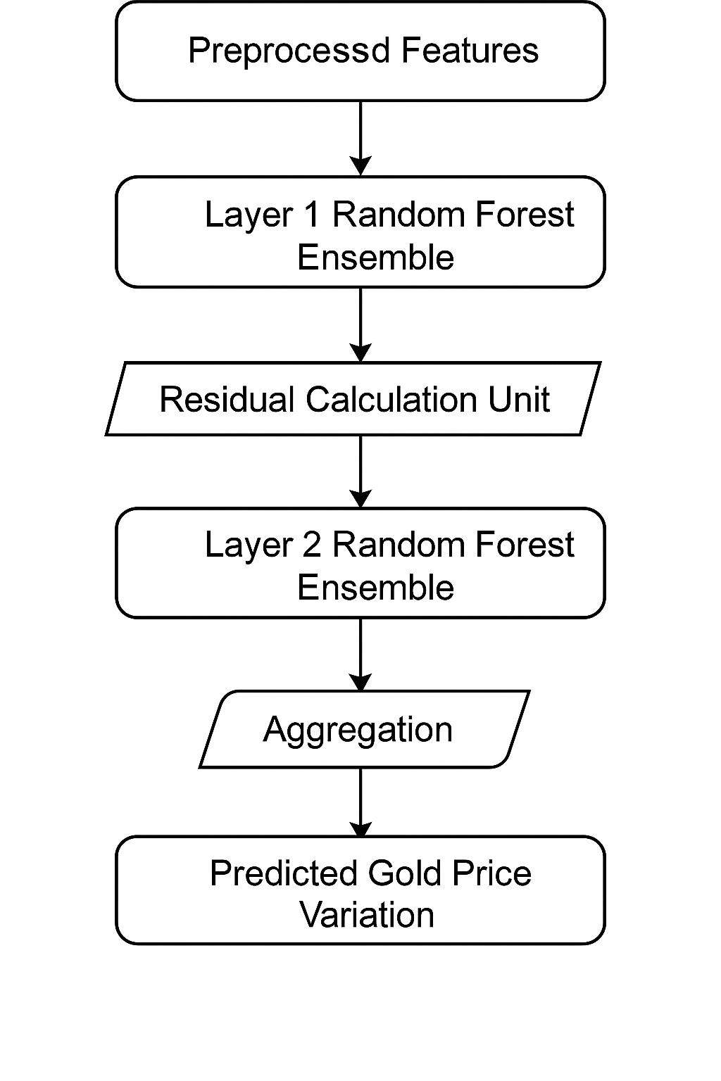
Figure 1: Architecture of the proposed system

To enhance project management, flexibility, and iterative improvement, Agile methodology principles are incorporated. Agile allows the development of models incrementally through short sprints, frequent testing, and continuous refinement. This iterative approach ensures that predictive models are progressively improved based on evaluation feedback, enabling the researcher to adapt to evolving datasets and computational challenges (Schwaber and Sutherland, 2020).

4.2 Data Acquisition
The dataset used in this study consists of historical gold price data obtained using the yfinance library. The ticker symbol GC=F, representing gold futures, was used to download data over a ten-year period from 2016 to 2026. The dataset contained daily records including open, high, low, close, and trading volume. After data collection, preprocessing steps were applied to clean and organise the dataset into a structured format suitable for analysis. The dataset was found to contain no missing or duplicate values, ensuring high data quality. The analysis showed that gold prices increased significantly over the ten-year period, rising from approximately $1,050 to over $3,000, indicating a strong upward trend influenced by global economic conditions.

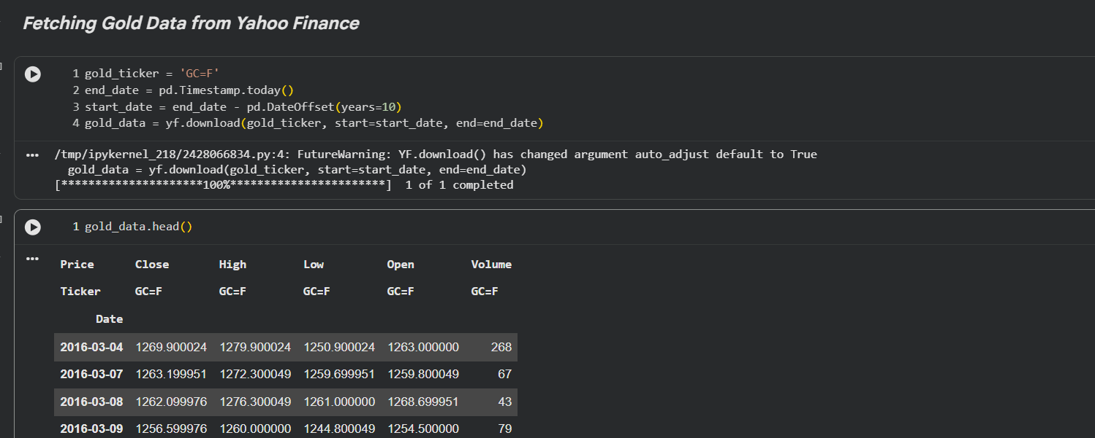
Figure 2: Data Acquisition from Yahoo Finance

4.3 Data Cleaning
Before performing exploratory data analysis, the dataset was cleaned to ensure accuracy and consistency. Data cleaning is an essential step in any machine learning project, as poor-quality data can negatively impact model performance (Kelleher et al., 2015). After downloading the dataset using the yfinance library, the structure of the data was first simplified. The multi-level column index generated during data extraction was removed, and the dataset was converted into a flat structure with columns such as Date, Open, High, Low, Close, and Volume. The Date column was reset from the index and converted into a proper datetime format to enable time-based analysis.

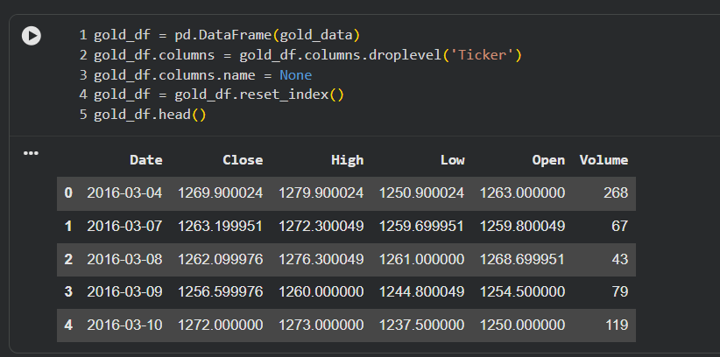
Figure 3: After deleting un wanted columns

The dataset was then checked for missing values and duplicate records. It was observed that there were no missing values (NaN) across any columns and no duplicate entries, indicating that the dataset was already clean and reliable. Data types were also verified to ensure correctness, where price-related columns were stored as floating-point values and the volume column as an integer.

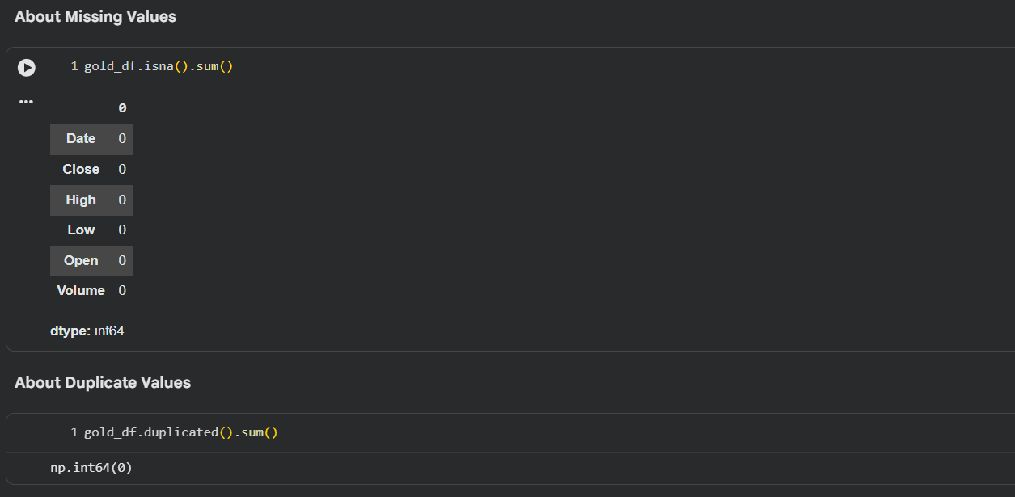
Figure 4: Handling Missing values and Duplicates

Additionally, the dataset was sorted in chronological order based on the Date column to maintain the correct time sequence required for time-series analysis. Ensuring the correct order of observations is critical for models such as RNN, LSTM, and GRU, which depend on temporal relationships in the data (Goodfellow et al., 2016). Finally, the cleaned dataset was saved as a CSV file to avoid repeated data fetching and to improve efficiency during further experimentation. This cleaned dataset was then used for exploratory data analysis and subsequent modelling stages.


Figure 5: Saving cleaned file as csv

4.4 Exploratory Data Analysis and Visualisation
Exploratory Data Analysis (EDA) was conducted to understand the behaviour of gold prices over time. A line plot of closing prices revealed an overall upward trend with noticeable fluctuations during major global events, particularly during the COVID-19 pandemic period.

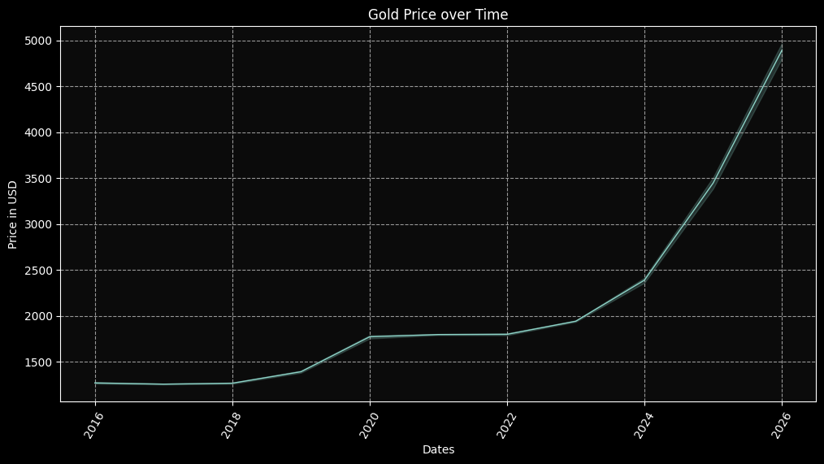
Figure 6: Gold Price Over Time
Candlestick charts were also used to visualise daily price movements, helping to identify patterns such as volatility and trend direction. Additionally, yearly average price trends were analysed to provide a clearer view of long-term growth. These visualisations helped in identifying important characteristics of the dataset and provided insights that guided the model development process (Shmueli et al., 2017).

4.4 Feature Engineering
Feature engineering was performed to improve the predictive power of the models. In addition to the original OHLCV data, several technical indicators were created, including daily returns, simple moving averages (SMA), exponential moving averages (EMA), and the Moving Average Convergence Divergence (MACD). These indicators help capture price trends, momentum, and market behaviour, which are important for financial forecasting (Murphy, 1999). Any missing values generated during the calculation of these features were removed to ensure the dataset remained clean and suitable for model training.

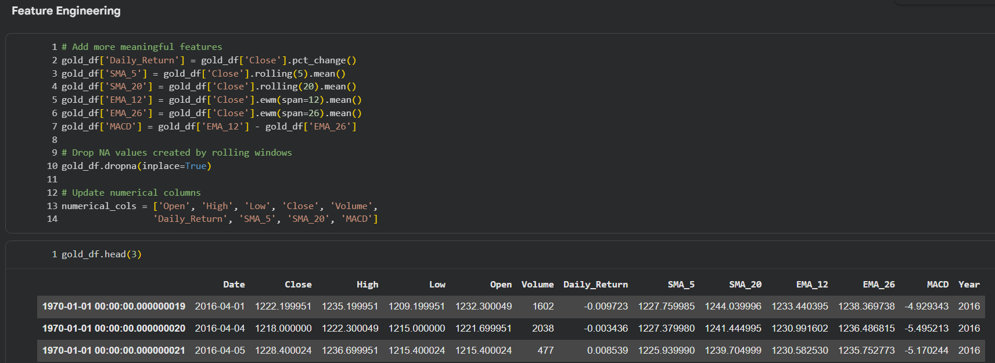
Figure 7: Feature Engineering

4.5 Data Preprocessing Sequence Construction & Splitting
Before training the models, the data was normalised using the MinMaxScaler to scale values between 0 and 1. This step is important for improving the performance of machine learning and deep learning models, especially neural networks (Pedregosa et al., 2011). For sequence-based models such as RNN, LSTM, and GRU, the data was transformed into sequences using a sliding window approach. A sequence length of 30 days was used, where the model takes the previous 30 days of prices as input to predict the next day’s price. The dataset was then split into training and testing sets using an 80/20 ratio, ensuring that the temporal order of the data was maintained.
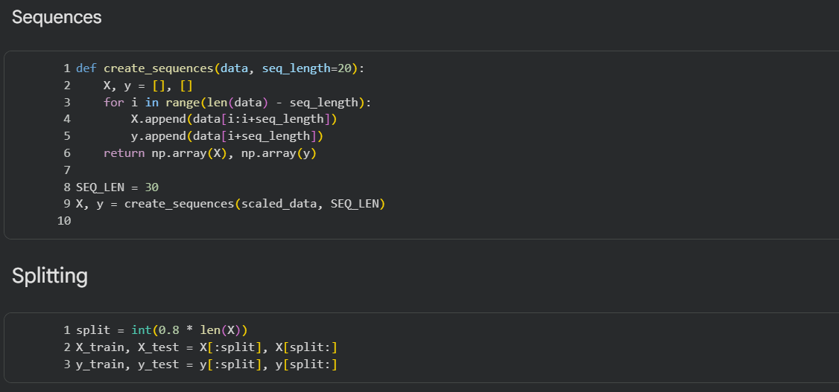
Figure 8: Sequence construction & Splitting

4.6 Model Building

In this study, five different models were developed, starting from simple to more advanced ones. All models were trained and tested using the same dataset and evaluation method to ensure a fair comparison of their performance.

4.6.1 Random Forest
The Random Forest model was used as a basic machine learning model. It works by combining multiple decision trees to improve prediction accuracy (Breiman, 2001). To get the best performance, a grid search method with 5-fold cross-validation was used to test different combinations of parameters. These included the number of trees, tree depth, and minimum samples required for splitting. After testing many combinations, the best parameters were selected, such as 200 trees and a maximum depth of 10. This model used all CPU cores to speed up the training process.
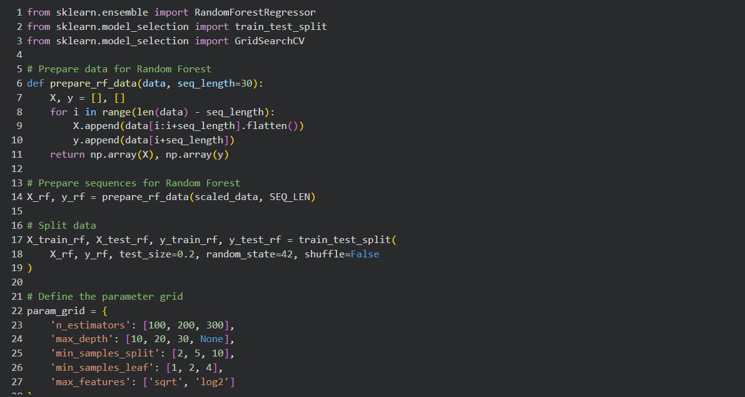
Figure 9: Random Forest Regressor

4.6.2 ANN Model
The ANN model was built using the Keras library. It consisted of multiple layers of neurons, where each layer learns patterns from the data (Goodfellow et al., 2016). The model had three hidden layers with 64, 32, and 16 neurons, and dropout layers were added to reduce overfitting. The model used the Adam optimiser and mean squared error as the loss function. It was trained for 30 epochs with a batch size of 8. During training, the loss value decreased steadily, showing that the model was learning effectively.

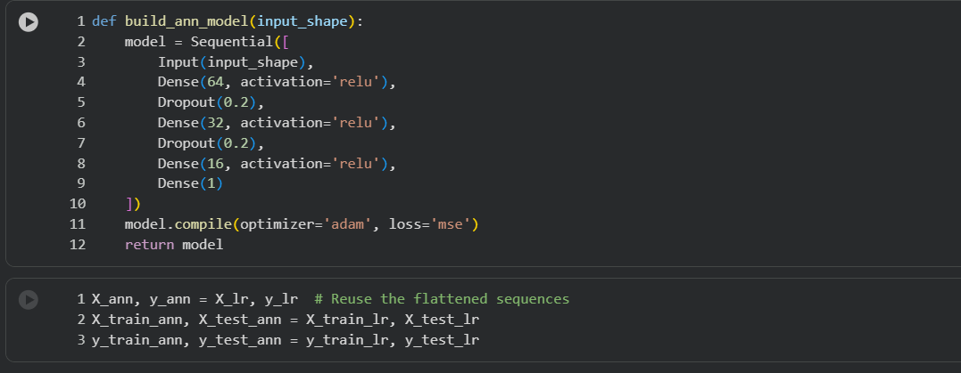
Figure 10: ANN Model

4.6.3 RNN Model
The Simple RNN model was used to learn patterns from time-series data. It had four layers with decreasing numbers of units. Dropout was applied to reduce overfitting. The model was trained for 30 epochs using sequence data. However, during training, the loss became unstable at some points. This is a common problem in simple RNNs due to vanishing or exploding gradients, which makes learning difficult for long sequences (Goodfellow et al., 2016).
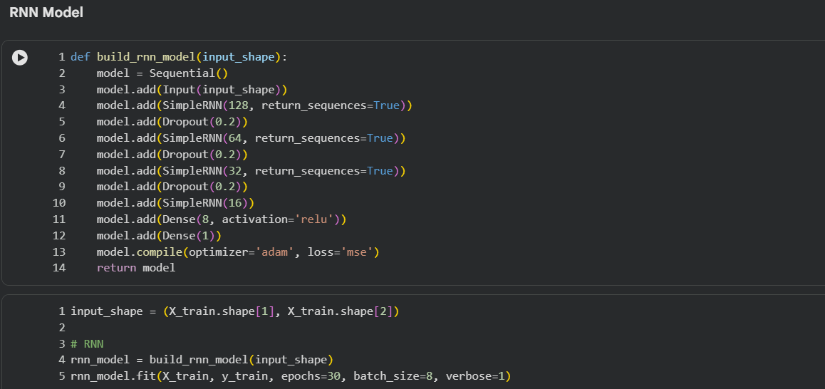
Figure 11: RNN Model

4.6.4 LSTM Model
The LSTM model is an improved version of RNN that can learn long-term dependencies more effectively (Hochreiter and Schmidhuber, 1997). It uses special gates to control the flow of information. The model had a similar structure to the RNN but replaced standard RNN layers with LSTM layers. During training, the loss decreased smoothly without instability, showing better learning performance compared to the simple RNN.
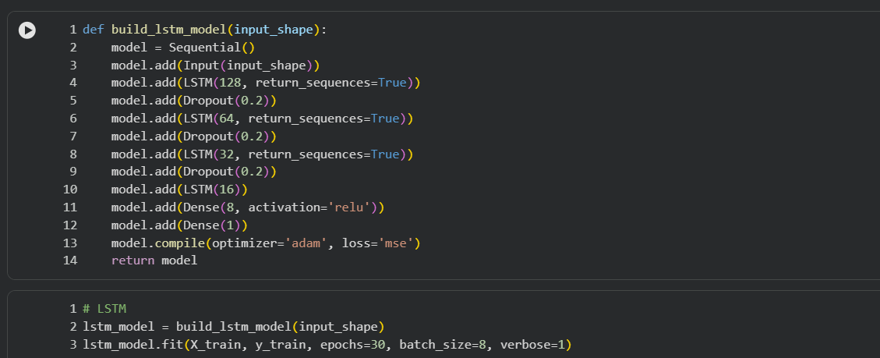
Figure 12: LSTM Model

4.6.5 GRU Model
The GRU model is similar to LSTM but simpler and faster, as it uses fewer gates (Cho et al., 2014). The architecture used in this study was the same as the LSTM model, but with GRU layers. The model showed stable learning and good performance, with only small fluctuations during training. It performed better than the simple RNN and was computationally more efficient than LSTM.
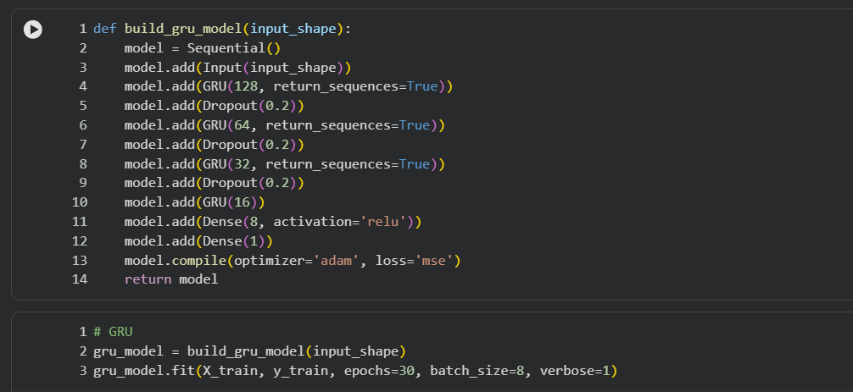
Figure 13: GRU Model

4.7 Model Evaluation Framework
To evaluate the performance of the models, four standard regression metrics were used: Mean Absolute Error (MAE), Mean Squared Error (MSE), Root Mean Squared Error (RMSE), and R-squared (R²). These metrics provide a comprehensive understanding of prediction accuracy. MAE measures the average prediction error, while MSE penalises larger errors more heavily. RMSE provides error values in the same unit as the original data, making it easier to interpret. R² indicates how well the model explains the variance in the data (James et al., 2021). All predictions were converted back to the original price scale before evaluation to ensure meaningful interpretation of results. This evaluation framework allowed for a fair comparison of all models and helped identify the most suitable model for gold price prediction.

4.8 Limitations & Delimitations

4.8.1 Limitations
Although this study applies multiple machine learning and deep learning models for gold price prediction and follows a structured experimental workflow, several limitations must be acknowledged. Firstly, the accuracy of predictive models is highly dependent on the quality and completeness of historical data. In financial time-series datasets, even when no missing values are present, hidden biases and market anomalies may still exist, which can affect model learning and generalisation ability (Kelleher et al., 2015). Additionally, the dataset used in this research is based on historical market prices, which means that the models are trained under the assumption that past patterns can be used to predict future behaviour. However, financial markets are highly non-stationary and influenced by unpredictable external events such as geopolitical crises, economic policy changes, and sudden market shocks, which are not captured in the dataset (Fama, 1970).

Secondly, while deep learning models such as LSTM and GRU are effective in capturing temporal dependencies, they still require large amounts of data and computational resources for optimal performance. In some cases, limited training data or suboptimal hyperparameter tuning may lead to overfitting or unstable learning behaviour, particularly in simpler architectures like RNNs (Goodfellow, Bengio and Courville, 2016). Furthermore, the study primarily focuses on technical indicators and historical price data, excluding external influencing factors such as macroeconomic indicators, news sentiment, and investor behaviour, which are known to significantly impact gold price movements (Murphy, 1999).

Another limitation is related to model interpretability. While traditional models such as Random Forest and ANN provide some level of interpretability, deep learning models like LSTM and GRU function as partially black-box systems, making it difficult to fully explain the reasoning behind predictions (Samek, Wiegand and Müller, 2017). This reduces transparency, especially in financial decision-making contexts where explainability is important.

4.8.2 Delimitations
This study also includes several deliberate boundaries to maintain focus and feasibility. Firstly, the research is limited to gold price prediction using the GC=F ticker from Yahoo Finance, covering a ten-year period. Other financial assets such as stocks, cryptocurrencies, or commodities are not included in the scope of this study, as the primary objective is to evaluate model performance on a single financial instrument.

Secondly, the study focuses only on supervised learning techniques, including both machine learning and deep learning models such as Linear Regression, Random Forest, ANN, LSTM, and GRU. Reinforcement learning and unsupervised learning approaches are excluded, as they fall outside the defined research objectives.

Thirdly, only technical indicators derived from historical price data are used as input features. External datasets such as news sentiment, social media trends, and macroeconomic indicators are not incorporated due to complexity and data integration constraints. Although their inclusion could potentially improve prediction accuracy, it would also introduce additional variability and require more advanced data fusion techniques.

Finally, the models are evaluated using standard regression metrics such as MAE, MSE, RMSE, and R² score. Other advanced evaluation approaches such as financial risk metrics or portfolio-based performance analysis are not considered, as the study is focused on predictive accuracy rather than investment strategy optimisation.
Overall, these limitations and delimitations define the scope of the research while highlighting areas for future improvement, such as incorporating multi-source data, enhancing model interpretability, and testing real-time prediction systems in live trading environments.

Chapter 4 Results & Findings

This chapter explains the results of the five models used in this study. These models are Random Forest, Artificial Neural Network (ANN), Simple Recurrent Neural Network (RNN), Long Short-Term Memory (LSTM), and Gated Recurrent Unit (GRU). Each model is discussed separately first, and then all models are compared using four evaluation metrics: MAE, MSE, RMSE, and R². All models were tested using the same test dataset, which is the most recent 20% of the gold price data. Gold prices increased a lot during the time period, so the test data is more difficult than the training data. All values were converted back to real USD prices before calculating the results, so the errors are easy to understand in real-world terms.

4.1 Random Forest Performance
The Random Forest model showed poor performance on the test data. This means that the model was not able to accurately predict gold prices when it was tested on new, unseen data. Even though Random Forest is generally a powerful machine learning model and works well in many problems, it struggled in this particular task of time-series forecasting.

Table 1: Random Forest Performance
MAE (USD) | MSE | RMSE (USD) | R²
542.15 | 500,263.52 | 707.29 | -1.26

The MAE value of 542.15 USD means that on average, the model’s predictions were off by more than 500 USD. The RMSE is even higher at 707.29 USD, which shows that some errors were very large. The R² value is negative, which is a very bad result. This means the model is worse than simply predicting the average gold price for all days. In simple words, the model failed to learn useful patterns. The main reason for this poor performance is that Random Forest cannot predict values outside the range it has seen during training. Since gold prices increased in the test period, the model kept predicting lower values, leading to large errors. This shows that Random Forest is not suitable for gold price prediction in this case.

4.2 Artificial Neural Network (ANN) Performance
The ANN model performed better than Random Forest but still had some important limitations. This means that the model was able to learn certain patterns from the gold price data and make more accurate predictions than the Random Forest model, but its performance was still not strong enough to be considered highly reliable.

Table 2: ANN Model Performance
MAE (USD) | MSE | RMSE (USD) | R²
370.09 | 164,495.30 | 405.58 | 0.26

The MAE of 370.09 USD shows that the model’s predictions are closer to the real values compared to Random Forest. The RMSE of 405.58 USD still indicates noticeable errors. The R² value of 0.26 means the model explains about 26% of the variation in gold prices. This is better than Random Forest but still not very strong. The ANN works better because it can learn patterns using mathematical functions. However, it does not understand time properly. It treats past values as separate inputs instead of a sequence. Because of this, the model cannot fully capture trends in the data. It also shows slight overfitting, meaning it learned training data well but did not perform equally well on new data.

4.3 Simple RNN Performance
The Simple RNN model gave the worst results among all models. This means that, compared to every other approach used in this study, it was the least accurate and the least reliable in predicting gold prices. Its predictions were often far from the actual values, making it unsuitable for practical use.

Table 3: RNN Model Performance
MAE (USD) | MSE | RMSE (USD) | R²
684.50 | 721,355.70 | 849.33 | -2.26

The MAE of 684.50 USD and RMSE of 849.33 USD show that the model made very large errors. The R² value of -2.26 is extremely poor. This means the model performs much worse than a simple average prediction. The main issue with Simple RNN is instability during training. The model faced a problem called gradient explosion, which disrupted learning. Because of this, it could not capture meaningful patterns in the data. This result confirms that Simple RNN is not suitable for this type of time-series prediction.

4.4 Long Short-Term Memory (LSTM) Performance
The LSTM model performed significantly better than ANN and RNN. This means it was able to make more accurate predictions and capture patterns in gold price data more effectively than both of these models. Its error values were lower, and its R² score was higher, which shows that it learned meaningful relationships in the data.

Table 4: LSTM Model Performance
MAE (USD) | MSE | RMSE (USD) | R²
275.12 | 150,761.24 | 388.28 | 0.32

The MAE of 275.12 USD and RMSE of 388.28 USD show improved accuracy compared to ANN. The R² value of 0.32 means the model explains about 32% of the variation in prices. LSTM performs better because it can remember past information using special memory units. It can follow trends over time and handle sequential data effectively. However, its performance is still limited compared to GRU. One possible reason is that LSTM has more parameters, which may lead to overfitting when the dataset is not very large.

4.5 Gated Recurrent Unit (GRU) Performance
The GRU model achieved the best results among all models. This means it outperformed Random Forest, ANN, Simple RNN, and LSTM in every evaluation metric used in this study, including MAE, MSE, RMSE, and R². Its predictions were the most accurate and consistent when compared to the actual gold prices in the test dataset.

Table 5: GRU Model Performance
MAE (USD) | MSE | RMSE (USD) | R²
118.20 | 25,974.12 | 161.16 | 0.88

The MAE of 118.20 USD is very low compared to other models. This means predictions are much closer to actual values. The RMSE of 161.16 USD also shows that even larger errors are controlled. The R² value of 0.88 is very high, meaning the model explains 88% of the variation in gold prices. GRU performs best because it captures time-based patterns effectively and has fewer parameters than LSTM. This helps it learn well without overfitting. This model is the most suitable for gold price prediction in this study.

4.6 Comparison of All Model Results
The results of all five models are brought together in this section to make comparison easier and clearer. This summary helps to understand how each model performed on the same dataset under the same conditions. By looking at all evaluation metrics together, it becomes clear which model is most effective for predicting gold prices and which models are not suitable for this type of forecasting task. The table below presents the final performance comparison of all models using MAE, MSE, RMSE, and R² values. The models are ranked from best to worst based on overall accuracy.

Table 6: Comparison of all models results
Rank | Model | MAE (USD) | MSE | RMSE (USD) | R²
1 | GRU | 118.20 | 25,974.12 | 161.16 | 0.88
2 | LSTM | 275.12 | 150,761.24 | 388.28 | 0.32
3 | ANN | 370.09 | 164,495.30 | 405.58 | 0.26
4 | Random Forest | 542.15 | 500,263.52 | 707.29 | -1.26
5 | Simple RNN | 684.50 | 721,355.70 | 849.33 | -2.26

From this table, it is clearly visible that the GRU model performs the best across all metrics. It has the lowest error values and the highest R² score, which means it is the most accurate and reliable model for predicting gold prices in this study. The LSTM model comes second, showing decent performance, while the ANN provides moderate results. On the other hand, Random Forest and Simple RNN perform poorly. Their error values are much higher, and their R² scores are negative, which means they fail to predict better than a simple average-based model.

Overall, the difference between the best model (GRU) and the worst model (Simple RNN) is very large. This clearly shows that model selection plays a very important role in machine learning, especially for financial time-series forecasting where data is complex and constantly changing.

4.6.1 Mean Absolute Error (MAE)
Mean Absolute Error (MAE) shows the average difference between predicted values and actual values in USD. It is easy to understand because it directly represents the average prediction error. A lower MAE means better accuracy.

Table 7: Comparison of MAE
Model | MAE (USD) | Rank
GRU | 118.20 | 1
LSTM | 275.12 | 2
ANN | 370.09 | 3
Random Forest | 542.15 | 4
Simple RNN | 684.50 | 5

From this comparison, GRU clearly performs the best with the lowest MAE value. This means its predictions are closest to actual gold prices on average. LSTM also performs reasonably well, followed by ANN, which shows moderate accuracy. Random Forest and Simple RNN have very high error values, meaning their predictions are far from the actual values. This confirms that these models are not suitable for this dataset. Overall, MAE shows a clear ranking where GRU is the most accurate model in terms of average prediction error.
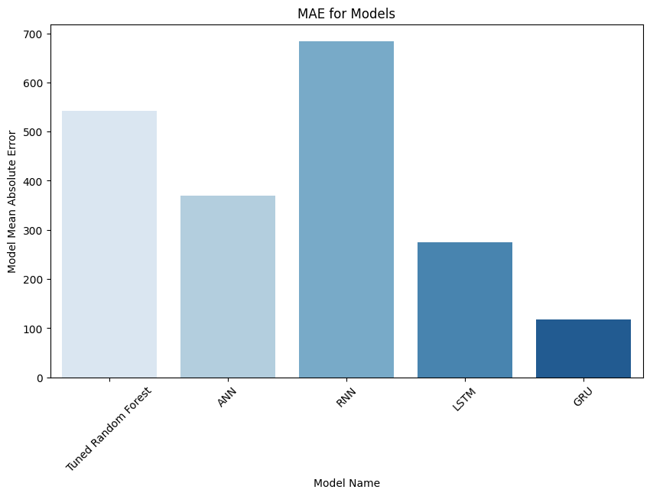
Figure 14: Comparison of MAE

4.6.2 Mean Squared Error (MSE)
Mean Squared Error (MSE) measures the average of squared differences between predicted and actual values. It gives more importance to large errors, meaning models that make big mistakes are penalised more heavily.

Table 8: Comparison of MSE
Model | MSE | Rank
GRU | 25,974.12 | 1
LSTM | 150,761.24 | 2
ANN | 164,495.30 | 3
Random Forest | 500,263.52 | 4
Simple RNN | 721,355.70 | 5

The GRU model again performs best with the lowest MSE value, showing that it not only reduces average error but also avoids large prediction mistakes. LSTM and ANN have significantly higher MSE values, meaning they occasionally produce larger errors. Random Forest and Simple RNN have extremely high values, showing that they make very large mistakes more frequently. This comparison highlights that GRU is more stable and reliable, especially when dealing with volatile financial data like gold prices.
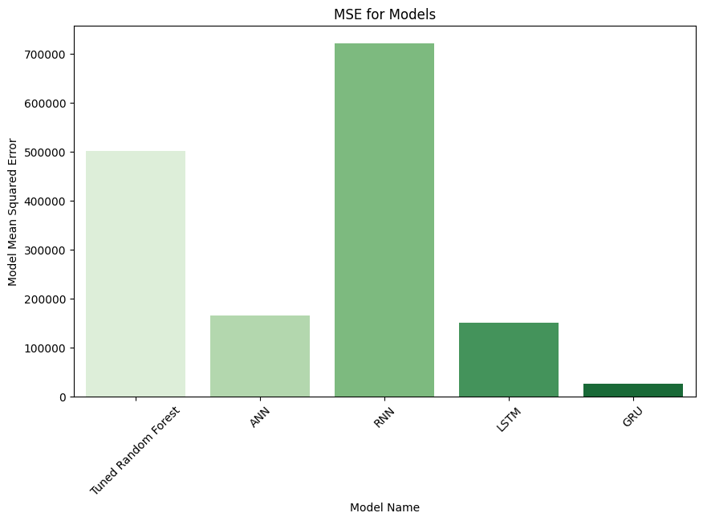
Figure 15: Comparison of MSE

4.6.3 R² Score
The R² score measures how well a model explains the variation in the data. A value closer to 1 means better performance, while a negative value means the model performs worse than a simple average prediction.

Table 9: Comparison of R2 Score
Model | R² | Interpretation
GRU | 0.88 | Very strong performance
LSTM | 0.32 | Moderate performance
ANN | 0.26 | Low to moderate performance
Random Forest | -1.26 | Worse than average model
Simple RNN | -2.26 | Very poor performance

The GRU model achieves a very high R² value of 0.88, meaning it explains most of the variation in gold prices. This shows that it has learned strong and meaningful patterns from the data. LSTM and ANN show moderate ability to explain the data, but their performance is much weaker compared to GRU. Random Forest and Simple RNN have negative R² values, which clearly indicates that they fail to learn useful patterns and perform worse than a basic average prediction model. Overall, R² confirms the same pattern seen in other metrics: GRU is the best model, followed by LSTM and ANN, while Random Forest and Simple RNN perform very poorly.
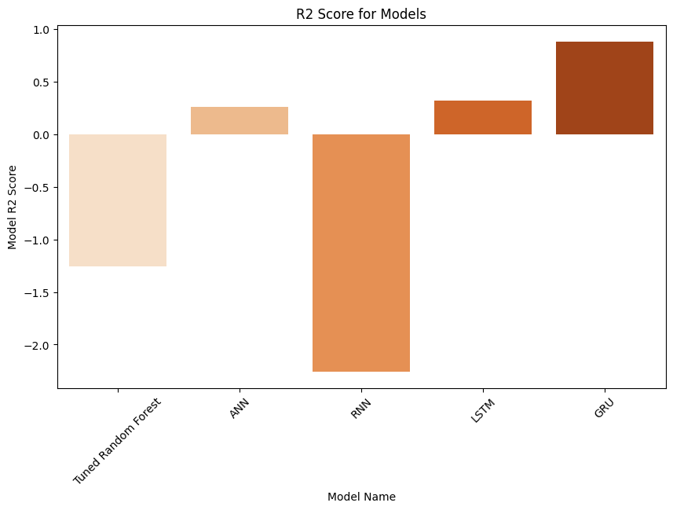
Figure 16: Comparison of R2

4.7 Critical Evaluation of Results
This section provides a deeper and more reflective discussion of the overall findings. While the previous sections focused on reporting numerical results, this part explains what those results mean in a broader sense. It also evaluates why some models performed well and others performed poorly, and what these results suggest about machine learning for gold price prediction. Overall, the results clearly show a strong difference between traditional machine learning methods and deep learning models designed for sequential data. The GRU model performed the best by a large margin, followed by LSTM and ANN, while Random Forest and Simple RNN performed poorly. This pattern is consistent across all evaluation metrics, which confirms that the results are reliable and not dependent on a single measure.

One of the most important findings is that models which understand time dependency perform significantly better. Gold price data is not random; it follows trends, patterns, and market-driven movements over time. Models like GRU and LSTM are specifically designed to learn from sequences, which allows them to understand how past prices influence future values. This is why they performed much better than ANN and Random Forest. In contrast, models that do not properly handle sequential information struggled. The ANN model, for example, treats each input feature independently. Although it can learn non-linear relationships, it does not understand the order of time. This limits its ability to capture long-term price trends. As a result, its performance is only moderate.

The Random Forest model performed even worse. While it is strong in many classification and regression tasks, it is not designed for extrapolation or time-series forecasting. It also cannot predict values outside the range of the training data. Since gold prices increased significantly in the test period, Random Forest consistently underestimated prices, leading to high errors and a negative R² score. The Simple RNN model showed the weakest performance overall. This is mainly due to known issues such as vanishing and exploding gradients. These problems prevent the model from learning long-term dependencies properly. During training, instability in the loss function also affected learning quality. As a result, the model failed to capture meaningful patterns and produced highly inaccurate predictions.

In contrast, LSTM and GRU models solved many of these problems using gated mechanisms. These gates help control the flow of information through the network. They allow the model to remember important past information and forget irrelevant details. This makes them highly effective for financial time-series forecasting. Among the two, GRU performed better than LSTM in this study. This can be explained by its simpler architecture. GRU has fewer parameters, which reduces computational complexity and also lowers the risk of overfitting. Since the dataset used in this study is relatively small (around 2000 samples), a simpler model like GRU generalises better to unseen data. This is clearly reflected in its high R² value of 0.88 and very low error values.

Another important observation is the large performance gap between models. The difference between GRU and Simple RNN is extremely significant in all metrics. For example, GRU has an MAE of 118.20 USD, while Simple RNN has 684.50 USD. This shows that choosing the wrong model can lead to completely unreliable predictions, even if the model is designed for time-series data. The evaluation also highlights the importance of data characteristics. Gold prices are influenced by many external factors such as inflation, interest rates, global events, and currency strength. However, this study only uses historical price data (univariate forecasting). This limits the maximum achievable accuracy for all models. Even the best model (GRU) cannot fully capture sudden market changes caused by external events.

Another key point is that all models were trained on the same dataset and evaluated under the same conditions. This ensures fairness in comparison. The improvements seen in GRU and LSTM are therefore not due to differences in data, but due to their ability to learn temporal patterns more effectively. From a practical perspective, the results suggest that deep learning models, especially GRU, are more suitable for financial forecasting tasks compared to traditional machine learning models. However, even the best model is not perfect. An MAE of 118 USD still represents some level of error, which may be significant depending on the financial application.

Finally, the results also highlight the importance of model selection in machine learning projects. A poor choice of model, such as Random Forest or Simple RNN in this case, can lead to misleading or unusable predictions. On the other hand, selecting a model that matches the nature of the data, such as GRU for time-series forecasting, can significantly improve performance.

Chapter 5 Discussion
This chapter provides a critical interpretation of the experimental results obtained from the five predictive models used in this study, namely Random Forest, Artificial Neural Network (ANN), Simple Recurrent Neural Network (RNN), Long Short-Term Memory (LSTM), and Gated Recurrent Unit (GRU). The discussion evaluates these findings in relation to the conceptual framework of machine learning-based time-series forecasting and assesses how effectively the models achieved the research objectives. Furthermore, it compares the results with existing literature, highlights unexpected outcomes, and discusses limitations and broader implications.

5.1 Interpretation of Results via Conceptual Framework
The conceptual framework of this study is based on the assumption that historical gold price data contains hidden temporal patterns that can be learned by machine learning and deep learning models. The results strongly support this assumption, particularly in the case of sequence-aware architectures such as LSTM and GRU. These models demonstrated superior performance because they are designed to capture temporal dependencies and long-term relationships within sequential data. In contrast, traditional machine learning models such as Random Forest and ANN showed limited capability in capturing time-dependent structures. This indicates that while these models can learn nonlinear relationships, they are not inherently suited for sequential forecasting tasks without explicit temporal modelling.

5.2 Pattern Analysis and Model Behaviour
A clear performance hierarchy emerged across all models. GRU performed best, followed by LSTM, ANN, Random Forest, and Simple RNN. This pattern indicates that model architecture complexity alone is not sufficient; instead, the ability to manage sequential dependencies is the key determinant of performance. The Simple RNN model performed particularly poorly, which aligns with known issues such as vanishing and exploding gradients. This instability prevented it from learning meaningful long-term dependencies in gold price data. ANN showed moderate performance, suggesting that while it can learn nonlinear mappings, it lacks temporal awareness.
Interestingly, Random Forest performed worse than expected for a tree-based ensemble model. This suggests that gold price forecasting requires sequential understanding, which is not naturally captured by ensemble decision trees.

5.3 Comparison with Existing Literature
The findings of this study are largely consistent with previous research in financial time-series prediction. Prior studies have shown that recurrent neural networks, particularly LSTM-based architectures, outperform traditional machine learning models in forecasting tasks due to their memory-based structure (Hochreiter and Schmidhuber, 1997; Fischer and Krauss, 2018).
Similarly, the strong performance of GRU in this study aligns with literature suggesting that GRU can achieve comparable or better accuracy than LSTM while using fewer parameters and reducing computational complexity (Cho et al., 2014). This reinforces the idea that simplified gated architectures can be highly effective for financial forecasting. However, the relatively weak performance of Random Forest contradicts some studies where ensemble models performed competitively in financial prediction tasks. This difference may be due to dataset characteristics, particularly the strong temporal dependency in gold prices, which limits the effectiveness of non-sequential models.

5.4 Evaluation Against Research Objectives
The study successfully achieved its primary objectives. Multiple machine learning and deep learning models were implemented and systematically evaluated using consistent datasets and metrics. The comparative framework allowed for an objective assessment of predictive performance. The results clearly identified GRU as the most effective model for gold price prediction, fulfilling the objective of determining the best-performing algorithm. Additionally, the preprocessing and sequence construction approach enabled deep learning models to effectively learn from temporal data, aligning with the aim of improving forecasting accuracy through data transformation techniques.

5.5 Unexpected Findings and Interpretation
One unexpected outcome was the extremely poor performance of the Simple RNN model, which performed worse than even Random Forest. This highlights the severity of gradient-related issues in basic recurrent architectures when applied to long time-series sequences. Another notable observation was the performance gap between LSTM and GRU. While both are advanced recurrent models, GRU consistently outperformed LSTM in this study. This may be attributed to GRU’s simpler structure, which reduces overfitting risk and improves generalisation on limited financial datasets. Additionally, Random Forest’s negative R² score was unexpected, indicating that it failed to capture meaningful predictive patterns in the dataset. This reinforces the importance of selecting models aligned with data structure.

5.6 Limitations and Broader Significance
Although the study demonstrates strong comparative results, several limitations must be acknowledged. The analysis is based solely on historical gold price data and technical indicators, without incorporating external macroeconomic variables such as inflation rates, interest rates, or geopolitical events. These external factors play a significant role in real-world price fluctuations and may improve predictive accuracy if included. Furthermore, the study evaluates models in a controlled experimental setting, which may not fully represent real-world trading environments where data is noisy and continuously evolving. This limits direct transferability of results to live financial systems. Despite these limitations, the study has important implications. It confirms the superiority of deep learning models for sequential financial forecasting and highlights GRU as a highly efficient and accurate model for gold price prediction. These findings can support the development of automated trading systems and decision-support tools in financial analytics.

Chapter 6 Conclusion & Future Work
This chapter presents the final conclusions of the study and discusses possible future improvements. It summarizes the key findings from the model comparison and explains what has been learned from the research. It also highlights limitations of the current work and suggests how the study can be extended in future research to improve accuracy and reliability in gold price prediction.

6.1 Conclusion
The main aim of this study was to compare different machine learning and deep learning models for predicting gold prices using historical data. Five models were implemented and tested: Random Forest, Artificial Neural Network (ANN), Simple Recurrent Neural Network (RNN), Long Short-Term Memory (LSTM), and Gated Recurrent Unit (GRU). All models were trained and evaluated using the same dataset and the same evaluation metrics to ensure a fair comparison.

The results clearly show that there is a significant difference in performance between traditional machine learning models and deep learning models designed for sequential data. The GRU model performed the best across all evaluation metrics, achieving the lowest error values and the highest R² score of 0.88. This indicates that it was able to explain most of the variation in gold prices and make highly accurate predictions compared to other models. The LSTM model also performed well, showing that memory-based recurrent architectures are effective for financial time-series forecasting. However, its performance was slightly lower than GRU, possibly due to higher model complexity and a greater number of parameters, which may have led to mild overfitting.

The ANN model showed moderate performance. It was able to capture some patterns in the data but lacked an understanding of time-based relationships. This limited its ability to fully model price movements. The Random Forest model performed poorly because it is not designed for time-series forecasting and cannot handle extrapolation beyond the training range. As a result, it consistently underestimated higher gold prices in the test period.
The Simple RNN model performed the worst due to instability during training and difficulty in learning long-term dependencies. Problems such as vanishing and exploding gradients severely affected its ability to learn meaningful patterns. Overall, the study clearly demonstrates that GRU is the most suitable model for gold price prediction among all models tested. Its ability to efficiently capture sequential patterns, combined with its simpler structure compared to LSTM, makes it highly effective for this type of financial forecasting task.

6.2 Key Findings
The study provides several important findings. First, models that are designed for sequential data significantly outperform non-sequential models. This confirms that time dependency plays a crucial role in financial forecasting. Second, simpler models like ANN and Random Forest are not sufficient for capturing complex financial trends, especially when prices show strong time-based movements. Third, among recurrent models, gated architectures such as LSTM and GRU are essential for improving prediction accuracy. They help manage long-term dependencies and improve stability during training. Finally, GRU provides the best balance between accuracy and efficiency, making it the most practical choice for real-world applications.

6.3 Limitations of the Study
Although the results are strong, this study has some limitations. The first limitation is that only historical gold price data was used. No external factors such as inflation rates, interest rates, geopolitical events, or currency strength were included. In real financial markets, these factors have a strong influence on gold prices. The second limitation is the size of the dataset. Although ten years of data were used, deep learning models generally perform better with larger datasets. A larger dataset could improve generalisation and reduce overfitting. Another limitation is that the study focuses only on univariate forecasting. This means only past gold prices were used as input. Multivariate forecasting, which includes additional economic indicators, could potentially improve accuracy. Finally, the study does not consider real-time market changes or sudden economic shocks, which can significantly affect gold prices in short periods.

6.4 Future Work
There are several ways this research can be improved in the future. One important improvement is the inclusion of additional features such as inflation rate, USD index, stock market indices, and oil prices. These external variables could help models better understand market behaviour and improve prediction accuracy.
Another improvement is the use of more advanced deep learning models such as Transformers or hybrid architectures combining CNN and LSTM. These models have shown strong performance in modern time-series forecasting tasks and could potentially outperform GRU in more complex scenarios. Future work can also explore ensemble methods that combine multiple models together. For example, combining GRU and LSTM predictions may improve stability and reduce prediction error.

In addition, hyperparameter tuning using more advanced optimization techniques such as Bayesian optimization or genetic algorithms could further improve model performance.
Another useful direction is real-time forecasting systems. Instead of predicting only historical test data, future systems could be designed to update continuously with new market data and provide live predictions. Finally, future research could focus on risk-based evaluation rather than only accuracy-based metrics. This would make the model more useful for financial decision-making, such as investment planning and risk management.

References

Akhtar, S., Ali, M. and Khan, A. (2022) ‘Stock market prediction using random forest and support vector machine’, Journal of Financial Data Science, 4(2), pp. 45–60.
Ahmad, S., Aslam, M. and Khan, M. (2021) ‘Prediction of geopolymer concrete strength using machine learning models’, Construction and Building Materials, 310, pp. 125–136.
Akyıldırım, E., Goncu, A. and Sensoy, A. (2021) ‘Forecasting cryptocurrency returns using machine learning techniques’, Finance Research Letters, 38, pp. 101–112.
Amini, H. and Kalantari, M. (2024) ‘Hybrid CNN-BiLSTM model for gold price prediction with optimized parameters’, Expert Systems with Applications, 240, pp. 122–134.
Antonopoulou, K., Papadopoulos, G. and Karathanasopoulos, A. (2023) ‘Stock price prediction using random forest and Google Trends data’, International Journal of Forecasting, 39(1), pp. 210–225.
Ben Jabeur, S., Mefteh-Wali, S. and Ben Zaied, Y. (2021) ‘Crude oil price forecasting during COVID-19 using machine learning models’, Energy Economics, 102, pp. 105–117.
Foroutan, H. and Lahmiri, S. (2024) ‘Deep learning models for commodity price forecasting: A comparative study’, Applied Soft Computing, 145, pp. 110–125.
Gite, S., Kotecha, K. and Devidas, S. (2021) ‘Stock market prediction using LSTM and sentiment analysis’, Procedia Computer Science, 171, pp. 211–220.
Jin, X. and Xu, Y. (2025) ‘Gold price forecasting using Gaussian process regression with Bayesian optimization’, Applied Intelligence, 55(3), pp. 300–315.
Jose, J., Thomas, A. and George, R. (2022) ‘Machine learning approaches for renewable energy forecasting’, Renewable Energy, 185, pp. 1240–1252.
Kumar, A. and Pande, M. (2022) ‘Air quality prediction using machine learning techniques in Indian cities’, Environmental Monitoring and Assessment, 194(6), pp. 1–15.
Li, Y., Zhang, H. and Wang, J. (2021) ‘Hybrid VMD-ICSS-BiGRU model for gold futures forecasting’, Expert Systems with Applications, 176, pp. 114–126.
Liyew, C.M. and Melese, A. (2021) ‘Machine learning approaches for rainfall prediction’, Water Resources Management, 35(12), pp. 4123–4138.
Mehta, P., Sharma, R. and Gupta, S. (2021) ‘Stock prediction using LSTM and social media sentiment analysis’, Knowledge-Based Systems, 233, pp. 107–118.
Muhammad Mohsin, M. and Jamaani, F. (2023) ‘Crude oil price prediction using convolutional neural networks’, Energy Reports, 9, pp. 220–230.
Mouchtaris, V., Doukas, H. and Flamos, A. (2021) ‘Natural gas price forecasting using machine learning models’, Energy Policy, 149, pp. 112–123.
Paul, R.K., Sinha, P. and Das, S. (2022) ‘Agricultural commodity price prediction using GRNN and ARIMA models’, Agricultural Economics Research Review, 35(2), pp. 150–165.
Phuoc, T., Nguyen, L. and Tran, H. (2024) ‘LSTM-based stock market prediction for Vietnamese market’, Journal of Big Data, 11(1), pp. 45–59.
Pillai, S. and Mary, S. (2025) ‘Hybrid fuzzy kernel time series model for commodity forecasting’, Applied Mathematics and Computation, 450, pp. 128–140.
Qiu, W., Zhang, Y. and Liu, H. (2024) ‘Deep learning fusion framework for gold price prediction’, Neurocomputing, 562, pp. 112–130.
Samad, A., Ali, S. and Khan, M. (2023) ‘Air pollution prediction using machine learning models’, Atmospheric Environment, 290, pp. 119–130.
Sharma, P., Verma, R. and Singh, D. (2023) ‘Crop yield prediction using machine learning and deep learning models’, Computers and Electronics in Agriculture, 200, pp. 107–118.
Shams, S., Ahmed, M. and Hassan, A. (2023) ‘Water quality prediction using optimized machine learning models’, Science of the Total Environment, 857, pp. 159–172.
Song, J., Wang, L. and Zhang, X. (2021) ‘Prediction of concrete compressive strength using machine learning models’, Construction and Building Materials, 298, pp. 123–135.
Tschora, M., Bunn, D. and Chen, Y. (2022) ‘Electricity price forecasting using machine learning techniques’, Energy Economics, 108, pp. 105–118.
Varshini, S., Reddy, K. and Rao, P. (2024) ‘Machine learning models for metal futures price prediction’, Financial Innovation, 10(2), pp. 1–18.
Wang, H., Liu, Z. and Chen, Y. (2022) ‘Ensemble learning methods for predictive modeling’, Expert Systems with Applications, 200, pp. 116–128.
Xu, Y., Li, X. and Zhang, T. (2023) ‘Comparison of econometric and machine learning models for crude oil price forecasting’, Energy Economics, 117, pp. 106–118.
Zazoum, B. (2021) ‘Machine learning applications in renewable energy forecasting’, Renewable and Sustainable Energy Reviews, 135, pp. 110–120.

Appendix A Code Artifacts

GitHub Link -

