**DAY-2 LAB EXPERIMENTS**

**R PROGRAMMING**

**EXPERIMENT 1:**

**The following values are the number of pencils available in the different boxes. Create a vector and find out the mean, median and mode values of set of pencils in the given data.**

**Box1 Box2 Box3 Box4 Box5 Box6 Box7 Box8 Box9 Box 10**

**9 25 23 12 11 6 7 8 9 10**

**AIM:**

To find the mean,median,mode of the given data set

**SOFTWARE REQUIRES:**

R SOFTWARE

**PROGRAM:**

pencil_counts <- c(9, 25, 23, 12, 11, 6, 7, 8, 9, 10)

mean_value <- mean(pencil_counts)

median_value <- median(pencil_counts)

mode_value <- names(table(pencil_counts))[table(pencil_counts) == max(table(pencil_counts))]

# Print results

cat("Mean:", mean_value, "\n")

cat("Median:", median_value, "\n")

cat("Mode:", mode_value, "\n")

**OUTPUT:**

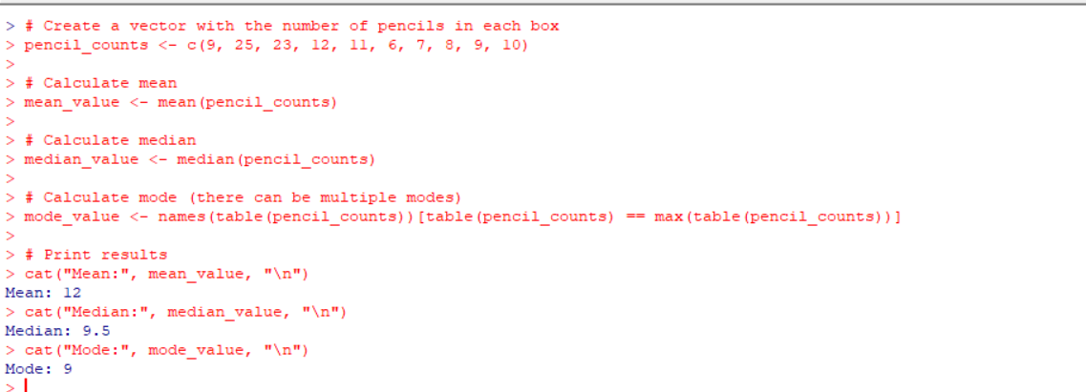

**EXPERIMENT 2:**

**the following table would be plotted as (x,y) points, with the first column being the x values as number of mobile phones sold and the second column being the y values as money. To use the scatter plot for how many mobile phones sold.**

**x :4 1 5 7 10 2 50 25 90 36**

**y :12 5 13 19 31 7 153 72 275 110**

**AIM:**

To draw the scatter plot for the mobiles phones sold in the given data

**SOFTWARE REQUIRES:**

R SOFTWARE

**PROGRAM:**

x <- c(4, 1, 5, 7, 10, 2, 50, 25, 90, 36)

y <- c(12, 5, 13, 19, 31, 7, 153, 72, 275, 110)

plot(x, y, main = "Scatter Plot of Mobile Phones Sold",

xlab = "Number of Mobile Phones Sold", ylab = "Money",

col = "blue", pch = 19)

grid()

abline(lm(y ~ x), col = "red")

**OUTPUT:**

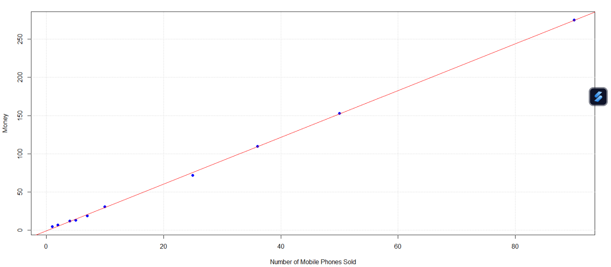

**EXPERIMENT 3:**

**. Implement of the R script using marks scored by a student in his model exam has been sorted as follows: 55, 60, 71, 63, 55, 65, 50, 55,58,59,61,63,65,67,71,72,75. Partition them into three bins by each of the following methods. Plot the data points using histogram.**

**(a) equal-frequency (equi-depth) partitioning (b) equal-width partitioning**

**AIM:**

To draw the histogram graph for the given points

**SOFTWARE REQUIRES:**

R SOFTWARE

**PROGRAM:**

marks <- c(55, 60, 71, 63, 55, 65, 50, 55, 58, 59, 61, 63, 65, 67, 71, 72, 75)

sorted_marks <- sort(marks)

# Equal-frequency partitioning (equi-depth)

bins_ef <- cut(sorted_marks, breaks = 3, labels = c("Low", "Medium", "High"), include.lowest = TRUE)

# Equal-width partitioning

min_mark <- min(sorted_marks)

max_mark <- max(sorted_marks)

width <- (max_mark - min_mark) / 3

breaks_ew <- seq(min_mark, max_mark, by = width)

bins_ew <- cut(sorted_marks, breaks = breaks_ew, labels = c("Bin1", "Bin2", "Bin3"), include.lowest = TRUE)

# Plot histograms

par(mfrow = c(1, 2)) # Set up the layout for subplots

hist(sorted_marks, breaks = breaks_ew, main = "Equal-Width Partitioning", xlab = "Marks", ylab = "Frequency", col = "lightblue")

legend("topright", legend = c("Bin1", "Bin2", "Bin3"), fill = c("lightblue", "lightgreen", "lightcoral"))

hist(sorted_marks, breaks = 3, main = "Equal-Frequency Partitioning", xlab = "Marks", ylab = "Frequency", col = "lightgreen")

legend("topright", legend = c("Low", "Medium", "High"), fill = c("lightblue", "lightgreen", "lightcoral"))

**OUTPUT:**

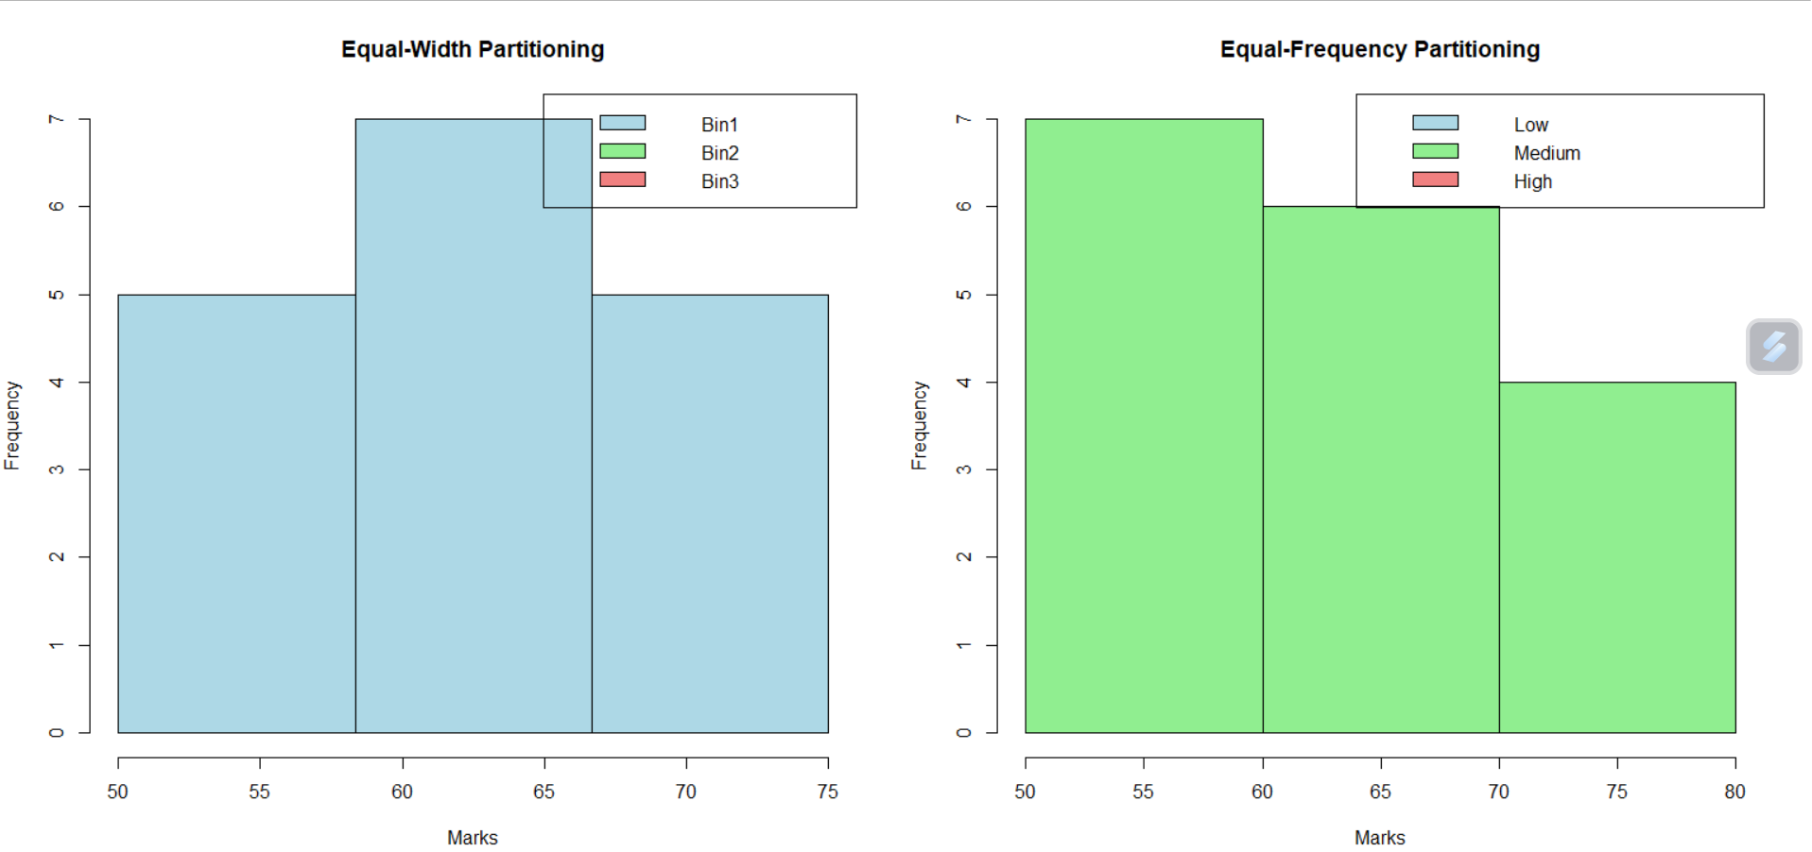

**EXPERIMENT 4:**

**Suppose that the speed car is mentioned in different driving style.**

**Regular 78.3 81.8 82 74.2 83.4 84.5 82.9 77.5 80.9 70.6 Speed**

**Calculate the Inter quantile and standard deviation of the given data.**

**AIM:**

T o find the interquartile and standard deviation of the given data

**SOFTWARE REQUIRES:**

R SOFTWARE

**PROGRAM:**

speed <- c(78.3, 81.8, 82, 74.2, 83.4, 84.5, 82.9, 77.5, 80.9, 70.6)

iqr <- IQR(speed)

std_dev <- sd(speed)

cat("Interquartile Range (IQR):", iqr, "\n")

cat("Standard Deviation:", std_dev, "\n")

**OUTPUT:**

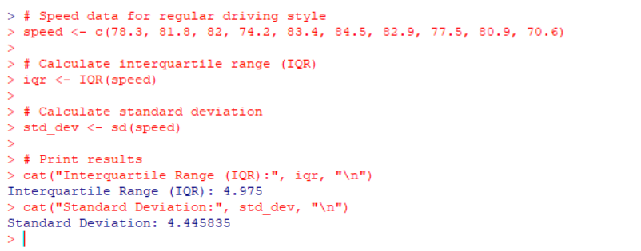

**EXPERIMENT 5:**

**Suppose that the data for analysis includes the attribute age. The age values for the data tuples are (in increasing order) 13, 15, 16, 16, 19, 20, 20, 21, 22, 22, 25, 25, 25, 25, 30, 33, 33, 35, 35, 35, 35, 36, 40, 45, 46, 52, 70.**

**Can you find (roughly) the first quartile (Q1) and the third quartile (Q3) of the data?**

**AIM:**

To find the quartiles of the given data

**SOFTWARE REQUIRES:**

R SOFTWARE

**PROGRAM:**

ages <- c(13, 15, 16, 16, 19, 20, 20, 21, 22, 22, 25, 25, 25, 25, 30, 33, 33, 35, 35, 35, 35, 36, 40, 45, 46, 52, 70)

q1 <- quantile(ages, probs = 0.25, type = 1)

q3 <- quantile(ages, probs = 0.75, type = 1)

cat("First Quartile (Q1):", q1, "\n")

cat("Third Quartile (Q3):", q3, "\n")

**OUTPUT:**

