**DAY-4 LAB EXPERIMENTS**

**R PROGRAMMING**

**EXPERIMENT 1:**

**Obtain Multiple Lines in Line Chart using a single Plot Function in R.Use attributes“mpg”and“qsec”of the dataset “mtcars”**

**AIM:**

To draw the graph using inbuilt data

**SOFTWARE REQUIRES:**

R SOFTWARE

**PROGRAM:**

data(mtcars)

plot(mtcars$mpg, type = "l", col = "blue", ylim = c(0, max(mtcars$mpg, mtcars$qsec)),

xlab = "Car Index", ylab = "Value", main = "Line Chart of mpg and qsec")

lines(mtcars$qsec, col = "red")

legend("topright", legend = c("mpg", "qsec"), col = c("blue", "red"), lty = 1)

**OUTPUT:**

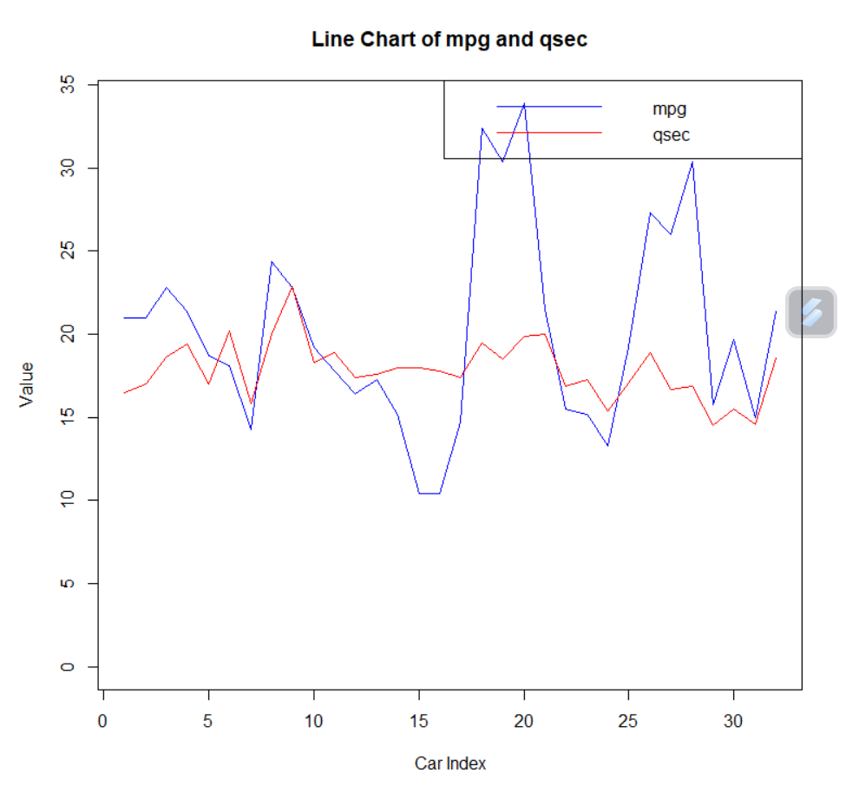

**EXPERIMENT 2:**

**Download the Dataset "water" From R dataset Link.Find out whether there is a linear relation between attributes"mortality" and"hardness" by plot function.Fit the Data into the Linear Regression model.Predict the mortality for the hardness=88.**

**AIM:**

To draw the graph

**SOFTWARE REQUIRES:**

R SOFTWARE

**PROGRAM:**

data("water")

plot(water$hardness, water$mortality,

xlab = "Hardness", ylab = "Mortality",

main = "Scatter Plot of Mortality vs Hardness")

model <- lm(mortality ~ hardness, data = water)

abline(model, col = "red")

summary(model)

hardness_new <- 88

predicted_mortality <- predict(model, data.frame(hardness = hardness_new))

cat("Predicted mortality for hardness 88:", predicted_mortality)

**OUTPUT:**

* **Download the "water" dataset.**
* **Plot the relationship between "mortality" and "hardness" to visually inspect for linearity.**
* **Fit a linear regression model to the data.**

**EXPERIMENT 3:**

**Create a Boxplot graph for the relation between "mpg"(miles per galloon) and "cyl"(number of Cylinders) for the dataset "mtcars" available in R Environment.**

**AIM:**

To draw the box plot of the given data

**MATERIAL REQUIRES:**

R SOFTWARE

**PROGRAM:**

data(mtcars)

boxplot(mpg ~ cyl, data = mtcars,

main = "Boxplot of Miles per Gallon by Number of Cylinders",

xlab = "Number of Cylinders", ylab = "Miles per Gallon")

**OUTPUT:**

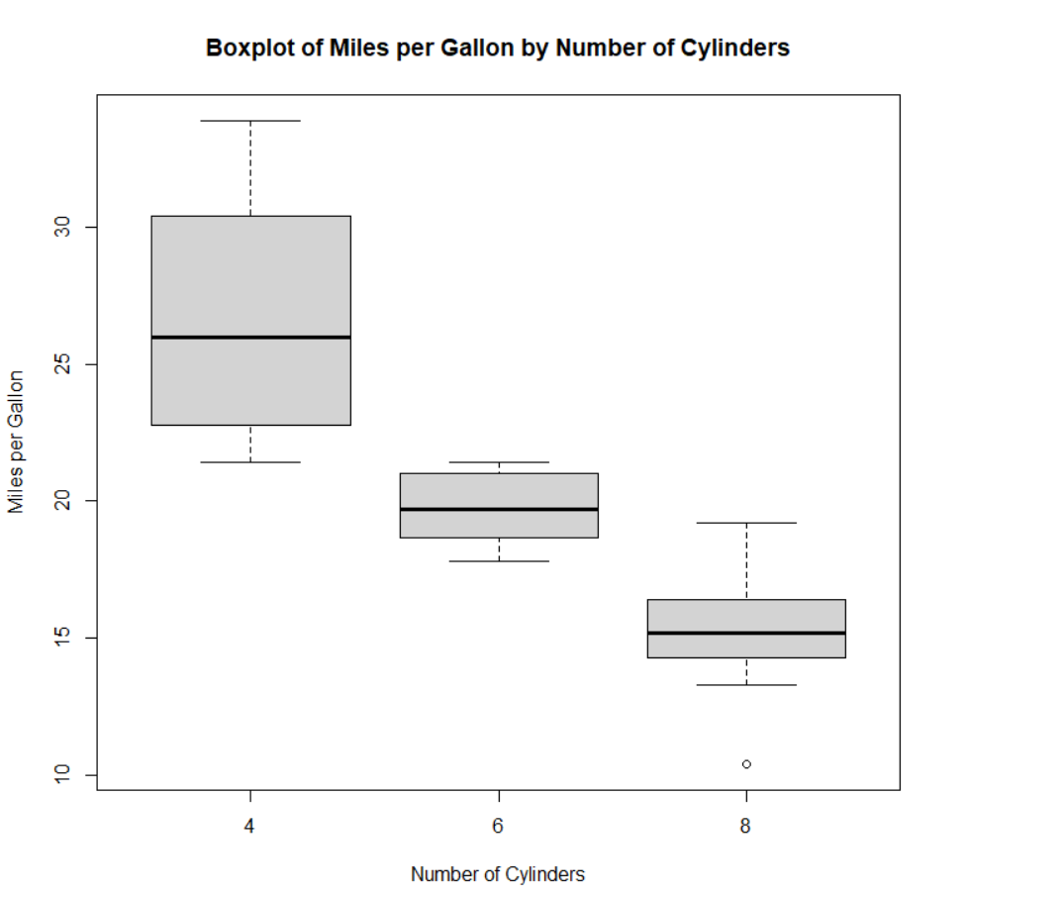

**EXPERIMENT 4:**

**Assume the Tennis coach wants to determine if any of his team players are scoring**

**outliers. To visualize the distribution of points scored by his players, then how can he**

**decide to develop the box plot? Give suitable example using Boxplot visualization**

**Technique.**

**AIM:**

To draw the graph

**SOFTWARE REQUIRES:**

R SOFTWARE

**PROGRAM:**

points <- c(20, 25, 30, 35, 40, 45, 50, 55, 60, 65, 70, 75, 80, 85, 90, 95, 100, 105, 110, 115, 120, 125, 130, 135, 140, 200)

boxplot(points, main = "Boxplot of Points Scored by Tennis Team Players",

xlab = "Players", ylab = "Points")

abline(h = median(points), col = "red", lty = 2)

text(1, median(points), paste("Median =", median(points)), pos = 4, col = "red")

**OUTPUT:**

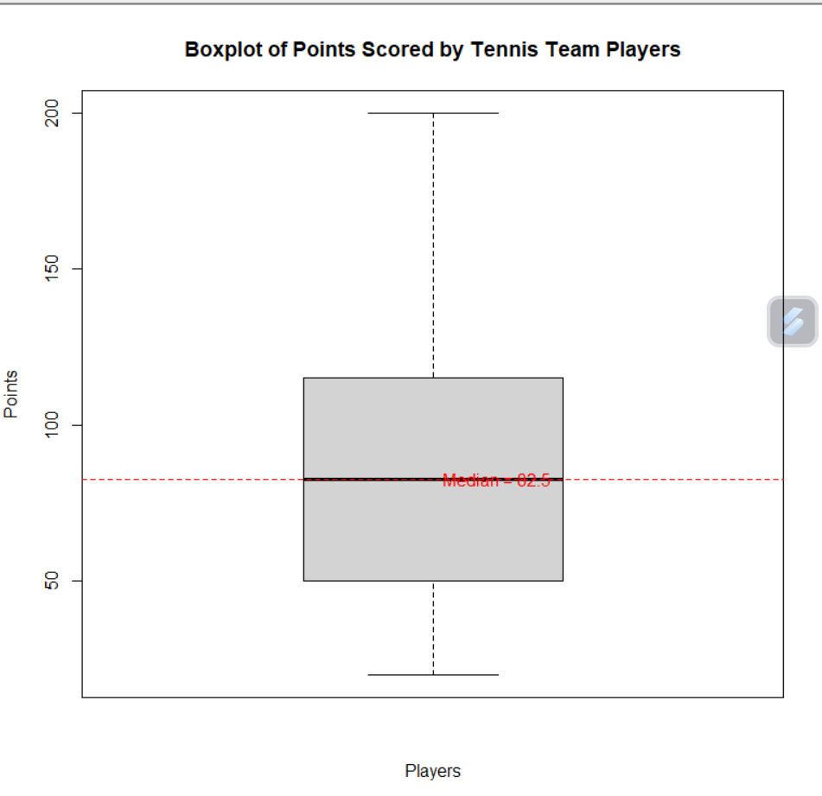

**EXPERIMENT 5:**

**. Implement using R language in which age group of people are affected byblood pressure based on the diabetes dataset show it using scatterplot and bar chart (that is BloodPressure vs Age using dataset “diabetes.csv”)**

**AIM:**

To draw the scatter plot graph

**SOFTWARE REQUIRES:**

R SOFTWARE

**PROGRAM:**

diabetes <- read.csv("diabetes.csv")

diabetes$age_group <- cut(diabetes$Age, breaks = c(0, 30, 40, 50, 60, 70, 80, 90, Inf),

labels = c("0-30", "31-40", "41-50", "51-60", "61-70", "71-80", "81-90", "90+"))

plot(diabetes$Age, diabetes$BloodPressure,

xlab = "Age", ylab = "Blood Pressure",

main = "Blood Pressure vs Age",

pch = 19, col = "blue")

avg_bp_by_age_group <- tapply(diabetes$BloodPressure, diabetes$age_group, mean)

barplot(avg_bp_by_age_group,

main = "Average Blood Pressure by Age Group",

xlab = "Age Group", ylab = "Average Blood Pressure",

col = "lightblue", ylim = c(0, max(avg_bp_by_age_group) + 10))

**OUTPUT:**

* **Download the "water" dataset.**
* **Plot the relationship between "mortality" and "hardness" to visually inspect for linearity.**
* **Fit a linear regression model to the data.**