**DAY-5 LAB EXPERIMENTS**

**R PROGRAMMING**

**EXPERIMENT 1:**

**Consider the data set and perform the Apriori Algorithm and FP algorithm support:3 and confidence=50%**

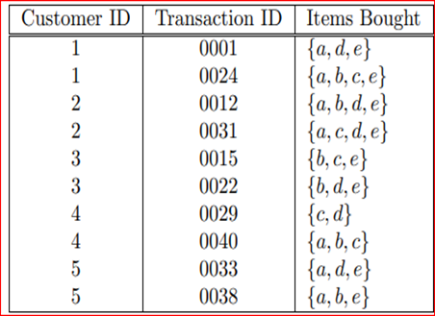

**AIM:**

To create dataset in the notepad and open the file in weka tool.

**MATERIALS REQUIRED:**

WEKA TOOL

**DATASET:**

@relation items

@attribute a{true,false}

@attribute b{true,false}

@attribute c{true,false}

@attribute d{true,false}

@attribute e{true,false}

@data

true false false true true

true true true false true

true true false true true

true false true true true

false true true false true

false true false true true

false false true true false

true true true false false

true false false true true

true true false false true

* Save this file as x.arff in the file explorer path.

**OUTPUT:**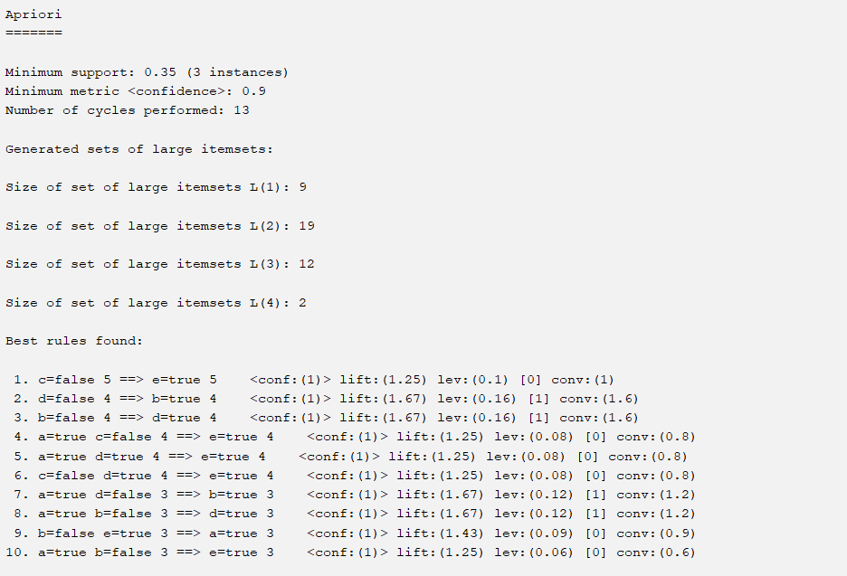

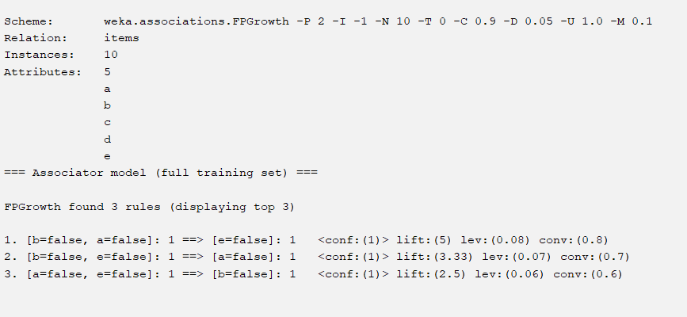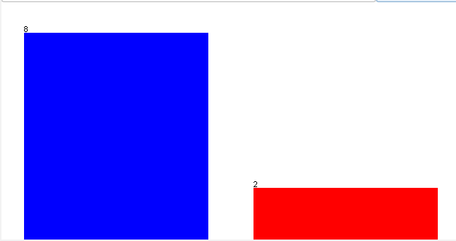

**EXPERIMENT 2:**

Consider the data set and perform the Apriori Algorithm and FP algorithm support:3 and confidence=50%

Consider the market basket transactions shown in the above table.

(a) What is the maximum number of association rules that can be extracted

from this data (including rules that have zero support)?

(b) What is the maximum size of frequent itemsets that can be extracted

(assuming minsup > 0)?

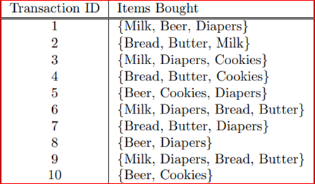

**AIM:**

To create a dataset in the notepad

**MATERIALS REQUIRED:**

WEKA TOOL

**DATASET:**

@relation transaction_data

@attribute Milk {true, false}

@attribute Bread {true, false}

@attribute Butter {true, false}

@attribute Cookies {true, false}

@attribute Beer {true, false}

@attribute Diapers {true, false}

@data

true, true, true, true, true, true

true, true, true, false, true, false

true, false, true, false, true, true

true, true, false, true, false, true

false, false, true, true, true, true

true, false, false, true, true, true

false, true, true, true, false, true

false, true, true, false, true, true

true, true, true, false, true, false

false, true, true, true, true, true

* Save this file as x.arff in the file explorer path.

**OUTPUT:**

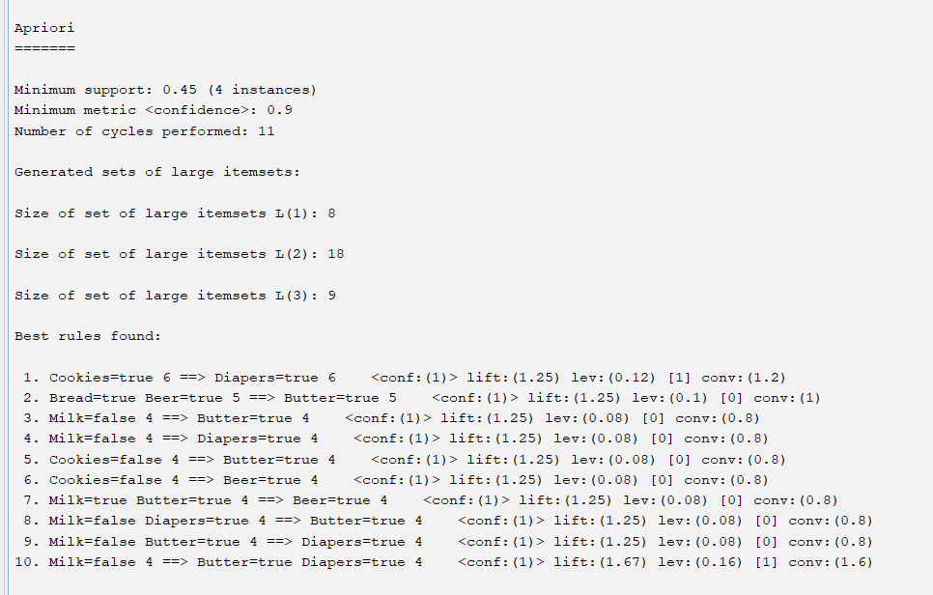

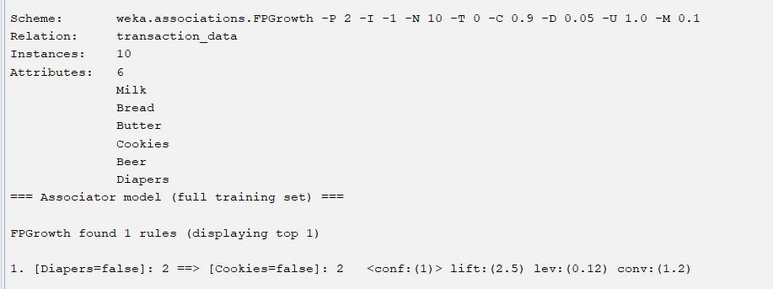

**EXPERIMENT 3:**

Bayes classification and descion tree (using training and test data)

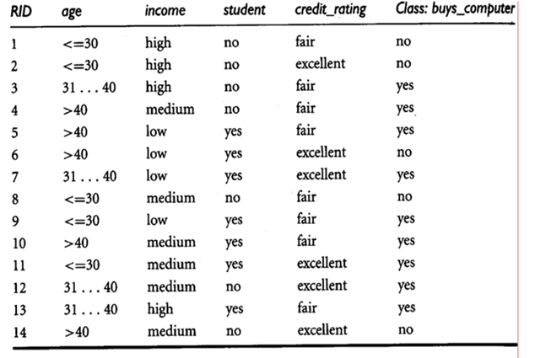

**AIM:**

To create a dataset or open the dataset in the inbuilt data

**MATERIALS REQUIRED:**

WEKA TOOL

* CREATE A DATASET IN THE EXCEL.
* AND OPEN THE DATASET IN THE WEKA

**OUTPUT:**

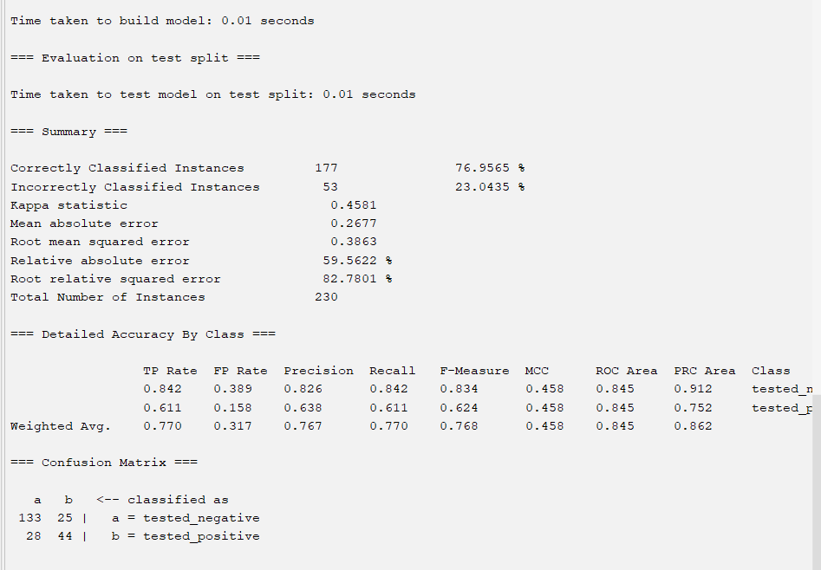

**EXPERIMENT 4:**

Implement using WEKA for the given Suppose a database has fivetransactions. Let min sup= 50%(2) and min con f = 80%.

Transactions Items

T1 (M, O, N, K, E, Y)

T2 (D, O, N, K, E, Y)

T3 (M, A, K, E)

T4 (M, U, C, K, Y)

T5 (C,O, O, K, I ,E)

• Find all frequent item sets using Apriori algorithm

• Also draw FP-Growth Tree

Prediction of Categorical Data using Decision Tree Algorithm through WEKA using any datasets. a) Tree b) Preprocess c) Logistic

**AIM:**

To create a dataset in the notepad

**MATERIALS REQUIRED:**

WEKA TOOL

**DATASET:**

@relation transaction_data

@attribute M {true, false}

@attribute O {true, false}

@attribute N {true, false}

@attribute K {true, false}

@attribute E {true, false}

@attribute Y {true, false}

@attribute D {true, false}

@attribute A {true, false}

@attribute U {true, false}

@attribute C {true, false}

@attribute I {true, false}

@data

true, true, true, true, true, true, false, false, false, false, false

false, true, true, true, true, true, true, false, false, false, false

true, false, true, false, true, false, false, true, false, false, false

true, false, false, true, true, false, false, false, true, true, false

false, true, false, true, true, true, false, false, false, true, true

* Save this file as x.arff in the file explorer path.

**OUTPUT:**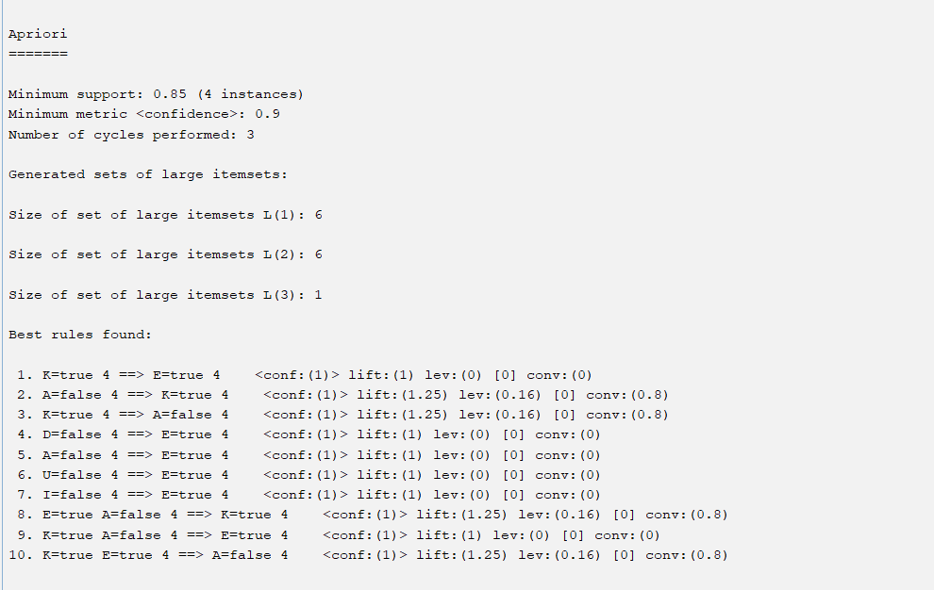

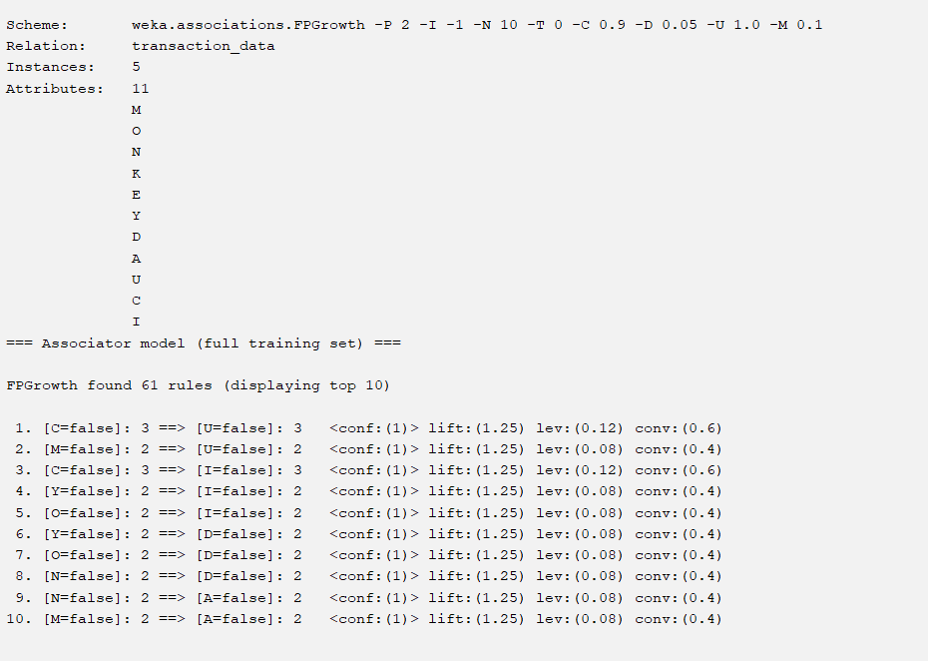

**EXPERIMENT 5:**

Prediction of Categorical Data using Decision Tree Algorithm through WEKA using any datasets. a) Tree b) Preprocess c) Logistic

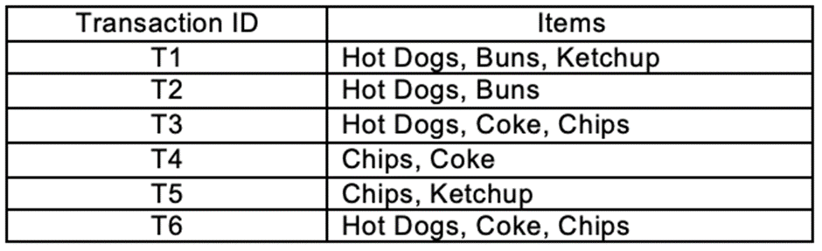

Create the dataset using ARFF file format:

a.Find the **frequent itemsets** and generate **association rules** on this. Assume that minimum support threshold (s = 33.33%) and minimum confident threshold (c = 60%).

b.List the various rule generated by apriori and FP tree algorthim ,mention wheather accepted or rejcted.

Prediction of Categorical Data using Rule base classification and decision tree classification through WEKA using any datasets. Compare the accuracy using two algorithm and plot the graph

**AIM:**

To create a data set in the notepad

**MATERIALS REQUIRED:**

WEKA TOOL

**DATASET:**

@relation transaction_data

@attribute Hot_Dogs {true, false}

@attribute Buns {true, false}

@attribute Ketchup {true, false}

@attribute Coke {true, false}

@attribute Chips {true, false}

@data

true, true, true, false, false

true, true, false, false, false

true, false, true, true, true

false, false, false, true, true

false, false, true, false, true

true, false, false, true, true

* Save this file as x.arff in the file explorer path.

**OUTPUT:**

