POLICY BRIEF
Retail Forex Trading in India: Closing the Gap Between the Rules and Practice
Bhargava C · October 2026 · Based on the author's project report “Assessing India’s Forex Trading Regulations: Challenges and the Need for Reform” (May 2025; revised October 2026)
Summary
Indian residents may trade currencies only through a narrow legal channel: exchange-traded contracts in a few currency pairs, meant mainly for hedging. Meanwhile, overseas trading apps keep advertising to Indian users. The RBI’s list of unauthorised forex entities grew from 34 names in September 2022 to 95 by November 2025, nearly tripling in about three years. Other major markets handle retail forex differently: they allow it but cap leverage and require investor protections. This brief argues that enforcement alone is unlikely to close the gap, and proposes a limited, regulated legal channel alongside stronger enforcement.
1. What the rules allow
Under the Foreign Exchange Management Act, 1999, residents may trade currency derivatives only on recognised Indian exchanges through SEBI-registered brokers. Permitted contracts are four rupee pairs (USD/INR, EUR/INR, GBP/INR and JPY/INR) and, since 2015, three cross-currency pairs (EUR/USD, GBP/USD and USD/JPY) (RBI, 2015). For rupee contracts, the RBI has stated that an underlying foreign exchange exposure is required, because these products are meant for hedging; a 2014 relaxation allows positions of up to USD 100 million without documentary proof, but not without the exposure itself (Business Standard, 2024).
What is illegal is not the overseas platforms as such, but an Indian resident using them to trade contracts that are not permitted, for example margin or CFD trading in EUR/USD or AUD/USD, and sending money abroad to fund that trading, which the Liberalised Remittance Scheme does not allow for margin payments (RBI, 2016; RBI, 2022; RBI, 2024).
2. Evidence: the Alert List keeps growing
Since September 2022 the RBI has published an Alert List of entities that are not authorised to deal in forex with Indian residents or to run forex trading platforms. I compiled each update from news reports and RBI press releases (Table 1, Figure 1).
Update | Added | Total on list | Source
2022-09-07 | 34 | 34 | Business Standard (7 Sep 2022)
2023-02-10 | 14 | 48 | Moneylife (10 Feb 2023); RBI press release 10 Feb 2023
2023-06-07 | 8 | 56 | Business Standard (7 Jun 2023)
2023-11-24 | 19 | 75 | Business Standard (24 Nov 2023)
2024-10-22 | 13 | 88 * | Business Today (22 Oct 2024)
2025-11-19 | 7 | 95 | Upstox (19 Nov 2025)
Table 1. Size of the RBI Alert List at each update. * Total calculated as 75 + 13; all other totals are stated in the source.
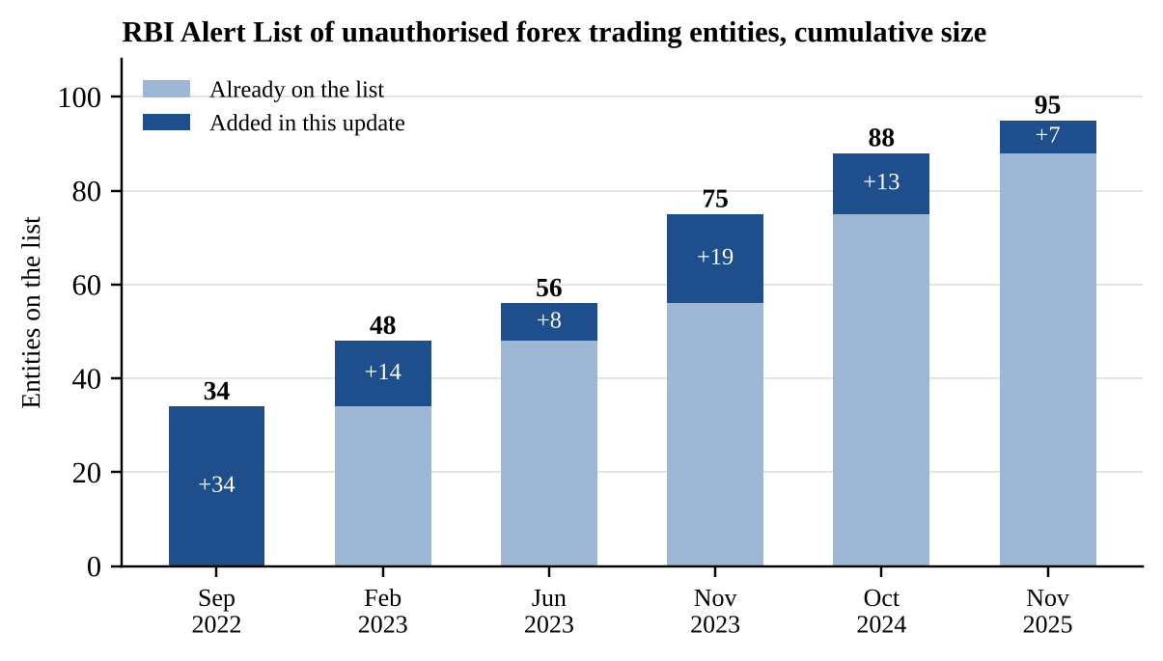
Figure 1. Author’s compilation from the sources in Table 1.
The list grew by 61 entities, or 179%, between September 2022 and November 2025. The pace was highest in 2023, when 41 entities were added across three updates, and slowed to 13 in 2024 and 7 in 2025.
How to read this: the list counts entities the RBI has identified and chosen to name. It does not measure how many Indians trade offshore or how much money is involved, and a slower pace of additions could reflect enforcement priorities rather than fewer platforms. What it does show is that, three years after the first warning, the regulator was still finding new entities targeting Indian users.
3. Evidence: how other markets regulate retail forex
 | India | United Kingdom | United States | Australia
Retail OTC forex trading | Not permitted for residents | Permitted through FCA-authorised firms | Permitted through registered dealers | Permitted through licensed providers
Where trading happens | Recognised Indian exchanges only | Off-exchange (CFDs, rolling spot) | Off-exchange (retail forex dealers) | Off-exchange (CFDs)
Leverage limit | Exchange margins; hedging purpose | Up to 30:1, lower for volatile assets | 50:1 majors, 20:1 others (2% / 5% deposit) | 30:1 on major pairs
Other protections | Underlying exposure required for INR contracts | 50% margin close-out; negative balance protection; loss-rate warning | Dealer registration and capital rules | Product intervention order
Since | Cross pairs 2015; exposure rule reaffirmed 2024 | August 2019 | October 2010 | March 2021
Source | RBI (2015); Business Standard (2024) | FCA (2019) | Morgan Lewis (2010) | ASIC (2020)
Table 2. Author’s comparison. US leverage limits are the inverse of the minimum security deposits (2% and 5%).
The comparison shows where India differs. The UK, US and Australia did not ban retail forex; they allowed it and then limited the damage through leverage caps, margin rules and disclosures. India instead offers no legal channel for retail speculation in currencies. A resident who wants to trade EUR/USD with leverage has only illegal options, which are actively marketed online.
4. Policy options
- Option A – Stronger enforcement only. Keep the current rules; expand the Alert List, block payments to listed entities and act against promoters. Benefit: no new risk to the rupee or the capital account. Cost: it treats symptoms; the list’s growth suggests demand persists.
- Option B – A narrow, regulated channel. Allow SEBI-registered brokers to offer a limited set of liquid currency pairs on Indian exchanges to retail users, with UK-style protections: low leverage caps, margin close-out, negative balance protection and published loss rates. Benefit: brings some activity under Indian oversight and tax. Cost: retail traders may still lose money, and regulators need capacity to supervise.
- Option C – Broad liberalisation. Allow residents to use foreign brokers freely. Benefit: maximum choice. Cost: inconsistent with India’s managed capital account and hard to supervise; this brief does not recommend it.
Recommendation: combine A and B. Enforcement should continue, but it is more credible when a supervised legal alternative exists. Option B should start small, for example with the three existing cross-currency pairs open to speculation under strict leverage limits, and be reviewed against data on participation and client losses.
5. Limitations
The Alert List counts are compiled from secondary reports for most updates and may miss revisions or removals. No public data exist on the number of Indian residents trading offshore or on their losses, so the size of the problem cannot be measured directly. The comparison covers headline rules only, and those rules change; each should be checked against the current regulator text before citing.
References
Australian Securities and Investments Commission. (2020, October 23). ASIC product intervention order strengthens CFD protections (Media Release 20-254MR). https://asic.gov.au/about-asic/news-centre/find-a-media-release/2020-releases/20-254mr-asic-product-intervention-order-strengthens-cfd-protections/
Business Standard. (2022, September 7). RBI releases ‘alert list’ of 34 entities barred from forex trades. https://www.business-standard.com/article/finance/rbi-releases-alert-list-of-34-entities-barred-from-forex-trades-122090701239_1.html
Business Standard. (2023, June 7). RBI updates ‘Alert List’ of entities not authorised to deal in forex trade. https://www.business-standard.com/amp/india-news/rbi-updates-alert-list-of-entities-not-authorised-to-deal-in-forex-trade-123060701017_1.html
Business Standard. (2023, November 24). Reserve Bank adds 19 unauthorised forex trading platforms in alert list. https://www.business-standard.com/industry/news/reserve-bank-adds-19-unauthorised-forex-trading-platforms-in-alert-list-123112400907_1.html
Business Standard. (2024, April 5). RBI reiterates FX exposure must for rupee exchange derivative transactions. https://www.business-standard.com/finance/news/rbi-reiterates-fx-exposure-must-for-rupee-exchange-derivative-transactions-124040500379_1.html
Business Today. (2024, October 22). RBI updates alert list of unauthorised forex trading platforms. https://www.businesstoday.in/personal-finance/investment/story/rbi-updates-alert-list-of-unauthorised-forex-trading-platforms-check-details-451015-2024-10-22
Financial Conduct Authority. (2019, July 1). PS19/18: Restricting contract for difference products sold to retail clients. https://www.fca.org.uk/publications/policy-statements/ps19-18-restricting-contract-difference-products
Government of India. (1999). The Foreign Exchange Management Act, 1999 (Act No. 42 of 1999). India Code. https://www.indiacode.nic.in/
Moneylife. (2023, February 10). 48 forex platforms are not authorised by RBI. https://moneylife.in/article/48-forex-platforms-are-not-authorised-by-rbi/69810.html
Morgan Lewis. (2010, September). CFTC issues final retail forex rules. https://www.morganlewis.com/pubs/2010/09/cftc-issues-final-retail-forex-rules
Reserve Bank of India. (2015, December 10). RBI introduces cross currency futures and exchange traded cross currency option contracts [Press release]. https://www.rbi.org.in/Scripts/BS_PressReleaseDisplay.aspx?prid=35689
Reserve Bank of India. (2016, January 1). Master Direction – Liberalised Remittance Scheme (LRS) (FED Master Direction No. 7/2015-16; updated September 6, 2024). https://www.rbi.org.in/Scripts/BS_ViewMasterDirections.aspx?id=10192
Reserve Bank of India. (2022, February 3). RBI cautions against unauthorised forex trading platforms [Press release]. https://www.rbi.org.in/commonman/Upload/English/PressRelease/PDFs/PR166003022022.pdf
Reserve Bank of India. (2023, February 10). RBI issues an updated Alert List [Press release]. https://www.rbi.org.in/SCRIPTS/BS_PressReleaseDisplay.aspx?prid=55201
Reserve Bank of India. (2024, April 24). Unauthorised foreign exchange transactions (A.P. (DIR Series) Circular No. 02). https://www.rbi.org.in/Scripts/NotificationUser.aspx?Id=12671
Upstox. (2025, November 19). RBI Alert List updated: Full list of unauthorised forex trading platforms. https://upstox.com/news/personal-finance/trading/rbi-alert-list-updated-full-list-of-unauthorised-forex-trading-platforms-and-what-happens-if-you-use-them/article-184938/

