UCBM internship Weekly Work log

GitHub Repository (with full code)

Week 1 (19th Jan – 23rd Jan)

- Introduction with Professor Scotto Di Luzio and Marco along with demonstration of ALExRS working.
- Installed and configured a Windows VM using UTM on my Mac computer to run the software.
- Transferred the Release folder to the VM along with debugging multiple errors during the process of transfer
- Tested the software from the VM (All programs run and logged apart from the ALEX GUI, highlighting the need to use a Lab Windows PC)
- Observed the Mirror experiment performed by Marco and Laura and understood the state machine and transitions.
  - 5 states: reaching, grasp, hold and lift, release, turn back.
  - Release and grasp states occur when shoulder and elbow joint velocity is 0
  - Understood by experiencing what “transparent” mode means on ALEX.
- Helped with their data collection: Performed movements of all states in sequence on the exoskeleton.
- Explored the data structures (Struct_in and struct_out) documentation written by Marco for data collection.
- Translated the 90 page user manual to English and read Section 5.
- Understanding of muscle movements and corresponding joint motions
  - Since my background in physiology is limited, I spent some time understanding Osteokinetic movements along with anatomical planes and axes. (Some of my notes are below)
  - Studied Abduction, Adduction, Flexion, Extension of shoulder and elbow.
  - Mapped these movements to the joint movements of ALExRS.

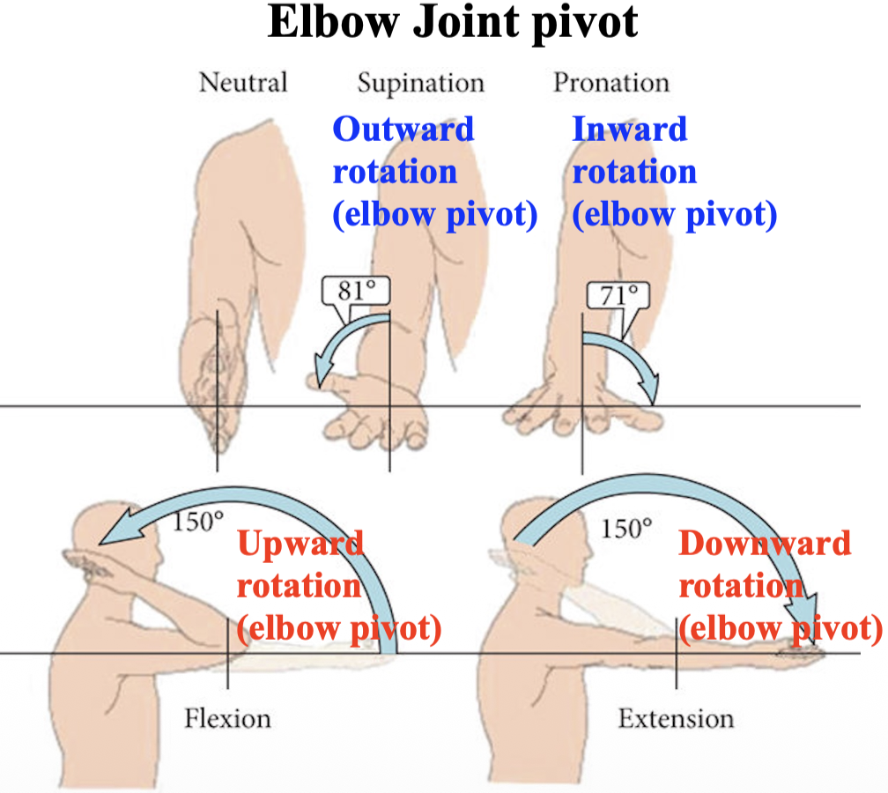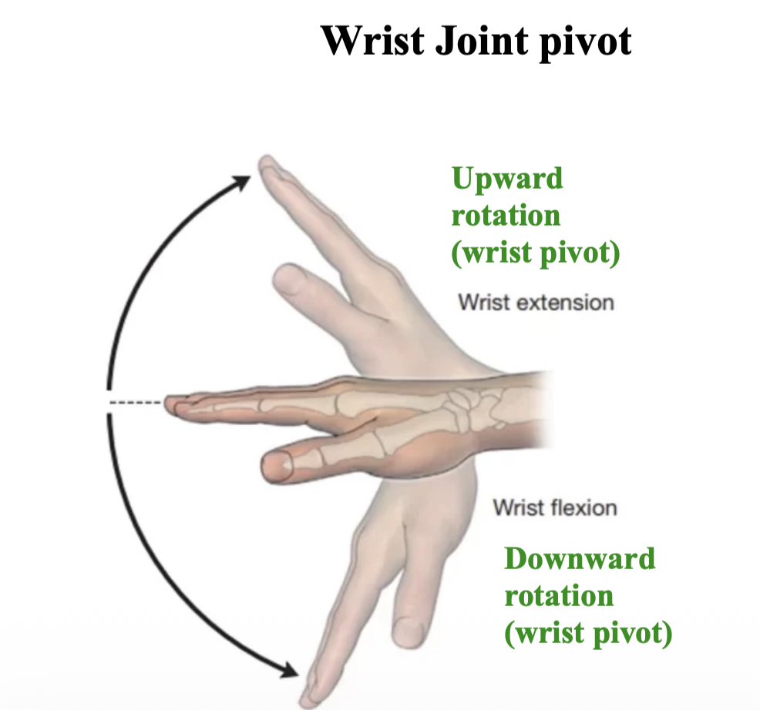

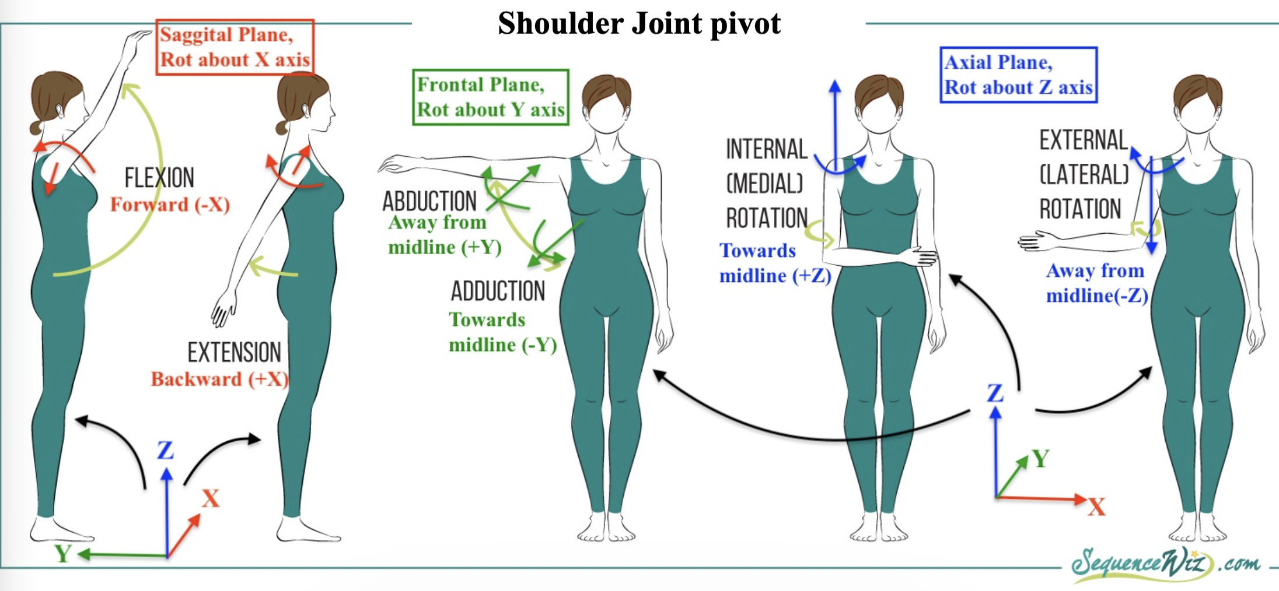

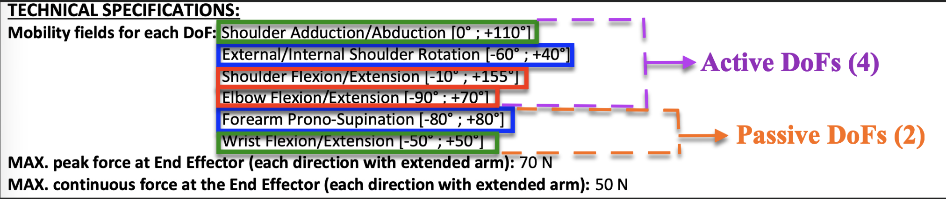

Week 2 (26th Jan – 30th Jan)

- Windows machine setup:
  - Downloading the Shared memory and ALEX_GUI classes and Release folder
  - Installation of Visual Studio and required packages.

- Assisting Marco with setup and testing the 5 Bilateral tasks on ALEx:
  - Attempting to remove the end effector (Unsuccessful as the system was over compensating for gravity due to removal of mass)
  - Re-configuring the table setup to comfortably reach each target.
  - Lifting H1 and H2 task:
Measured and tested offsets (in Z direction, craniocaudal axis). Offsets in this task determine the distance moved by the end effector at which the transition from HOLD_LIFT to RELASE states occurs.
  - Movement along a plane:
Measured and tested offsets (in Y direction, anteroposterior axis). Offsets in this task determine the Y distance moved along the plane between GRASP and RELEASE states.
  - Tested the flexion and repetitive flexion cycle experiments.
  - Testing of the electrical stimulator (in progress)

- ALEx Connection and Data Collection
  - Writing code (based on sample given by Marco) for reading from the shared memory into a csv file.

Week 3 (2nd Feb – 6th Feb)

Windows machine debugging (Problem: ALExGUI_4.0 application not loading on the PC)
- Initial launch of the GUI
  - Action: Launched the GUI through Lancia_tutto.bat and directly with ALExGUI_4.0.exe, while connected to the robot and disconnected.
  - Outcome: Unsuccessful, GUI did not open and showed up as a background task in Task manager.

- Checked the system and application architecture (x64 or x86)
  - Observation: PC is x64 (64 bit), ALExGUI prefers, but does not require x86 (32 bit)
  - Action: Used corflags to force 32 bit run of ALExGUI.
  - Outcome: Unsuccessful, same as before.

- Compared Windows Settings with Marco’s PC (Because the GUI launches on his PC)
  - Action: Turned off Virtualisation based security and changed Hyper-virtualisation settings to Match Marco’s PC settings.
  - Outcome: Unsuccessful, Event viewer showed .NET and kernel errors.

- Installed all .NET sdk packages and Visual C++ redistributables on Marco’s PC
  - Action: Installed .NET SDK 10.0.101, 9.0.305, and
Microsoft VC redistributables for x64 and x86 from 2008-2014
  - Outcome: Unsuccessful, Event viewer showed SQL server errors.

- Installed SQL servers and tools present on Marco’s PC
  - Action: Installed Microsoft SQL Server Express, Native Client, LocalDB, TransactSQL ScriptDom, Support Files.
  - Outcome: Successful launch of GUI from both Lancia_tutto.bat and ALExGUI_4.0.exe!

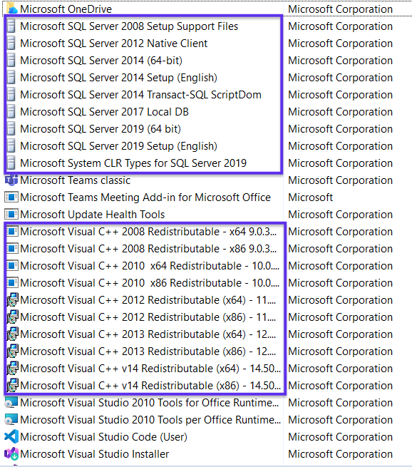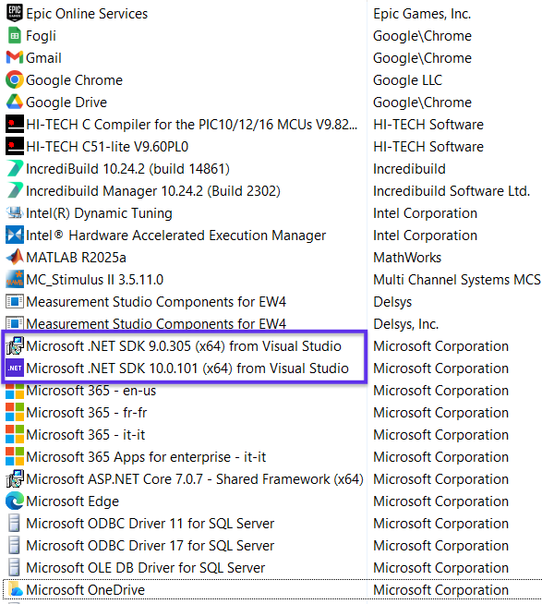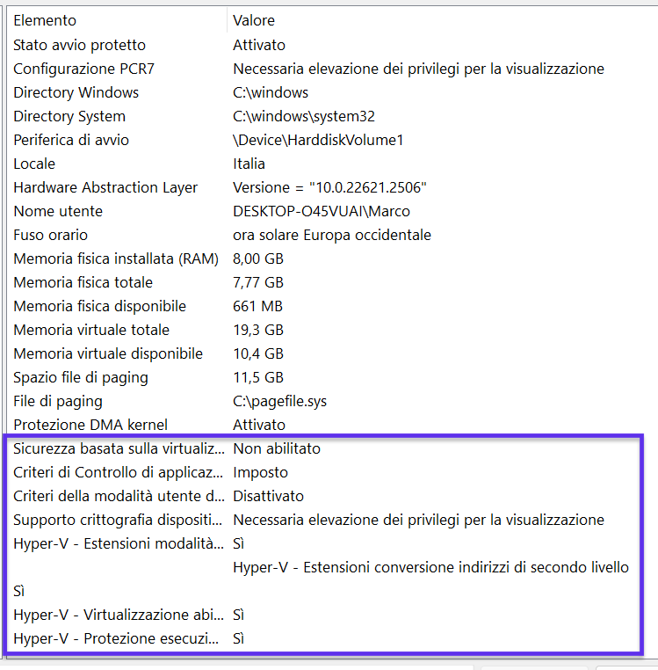
Screenshots of setting and list of applications on Marco’s PC
(In purple: packages installed and settings that were changed on my Windows PC)

Assisting Marco with testing of Functional Electrical Stimulation
- Understood the muscles stimulated for grasping and Release and their movement.

Name | Movement | Grasp / Release | Location
Flexor Digitorum Superficialis (FDS) | Finger Flexion | Grasp | Anterior and ulnar side  Between elbow and wrist
Flexor Carpi Radialis (FCR) | Wrist Flexion | Grasp | Anterior and radial side  Closer to elbow
Abductor Pollicis Brevis (APB) | Thumb opposition and abduction | Grasp | Anterior and radial side  Base of thumb and near wrist
Extensor Pollicis Longus (EPL) | Thumb extension | Release | Posterior and ulnar side  Closer to wrist
Extensor Digitorum Communis (EDC) | Finger Extension | Release | Posterior and central  Between elbow and wrist
Extensor Carpi Ulnaris (ECU) | Wrist Extension | Release | Posterior and central  Closer to elbow

- Setup of EMG sensors and stimulator electrodes:
  - Assisted with locating and positioning electrodes and sensors.
  - Left hand (master): 6 EMG sensors detecting wrist and finger flexion and extension.
  - Right hand (slave): 6 channel electrical stimulation for assistance with muscle contraction.
- Measurement of MVC (Maximum Voluntary Contraction)
  - Tested each of the 6 muscles with EMG sensors on EMGWorks.
  - MVC normalised contraction is given as the current input to the stimulator.
- Measurement of minimum and maximum current
  - Measured minimum current (I_{min}) required for the muscle to contract.
  - Measured the maximum current (I_{max}) applied before discomfort.
- Tests with the 5 Bilateral tasks
  - Assisted by controlling the flow of the experiments: starting, stopping, switching between tasks and saving the data.
  - Each task was successfully performed with the stimulation assistance for grasp and release states.
  - EMG sensors measured contraction of each muscle on left hand and normalised it by MVC.
  - The normalised values mapped between I_{min} and I_{max} control the amount of current for stimulation of right hand muscles.

Week 4 (9th Feb – 13th Feb)

Data Collection from ALEx
- Collected End Effector data by performing 3 flexion cycles of the left arm (plotted below)
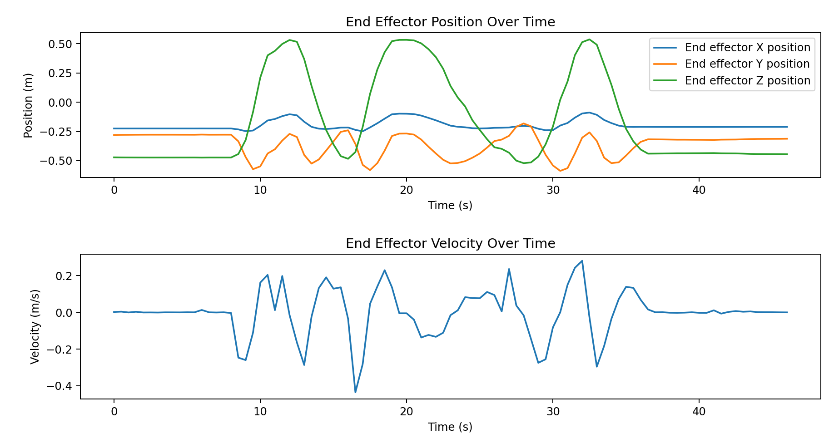

ALEx GUI Control Issue
- Issue: Fault Code 3011, GUI shows disconnected and I cannot control the robot from the GUI.
- Resolution attempt: Check the communication frequency (should be >20Hz)
- Observation: Frequency is 6-8 Hz (Too low to launch the GUI without faults)
- Possible solution: Create a custom GUI and test if robot can be controlled through shared memory.

Week 5 (16th Feb – 20th Feb)

Creating the Custom GUI
- Created a custom GUI for reading joint data and controlling the robot. (Using the assistance of claude.ai and reading the shared memory documentation)
- Features present in first version of GUI:
  - Displays left and right arm end effector positions and velocity
  - Displays frequency of communication
  - Joint data can be recorded in a csv file.
  - Buttons for changing the mode of the robot from startup to wearing to rehab.
- Additional features added
  - Positions and velocities of each joint and end effector are logged.
  - Joint data is recorded at a frequency of 50 Hz.
  - Freeze display that momentarily stops rapidly updating the display data to observe and note down joint positions and velocities at a time instant.
  - Record all data mode: Data logging of both all joint angles and positions, left and right.
  - Monolateral acquisition mode: (Designed for labelled training data collection)
    - Choice of arm (left or right) and logs data only from chosen arm.
    - Once data collection is started, the user performs the experiment and as the user reaches a change of state, they press the “Next State” button on the GUI.
    - In this way, the data records a label of the subtask and its start and end points.

Recording Data:
- Recorded 30 repetitions of a point to point task using ALExRS.
- Task:
  - Start from neutral position with hands on the side of the torso. (IDLE)
  - Move to a fixed point at a defined location forward and upward (GOING)
  - Return to neutral position (RETURNING)
- At each time step, the state (IDLE, GOING or RETURNING) is recorded in a csv file along with the joint data.
- The repetitions were time agnostic: the data contained variations in the duration of GOING and RETURNING states.
- The repetitions were path agnostic: the data contained variations in the trajectory traversed between the fixed points.

Week 5 (16th Feb – 20th Feb)

- Reading the papers provided: Summary and notes here
- Implementing PELT change point detection algorithm on python:
  - Detected duplicated and incorrect change points during the transition between ‘going’ and ‘returning’.
  - Reason: I stopped at the target for a few seconds and it detected that as a new state as the velocity changed from non zero to zero.
  - Solution: I removed consecutive zero values in going and returning states before applying CPD. This altered data is closer to a point to point task without the additional waiting or stationary state.
  - Observation: The performance improved
  - Inference: New Data should be collected without movement breaks between going and returning. Additionally, the state change signifying the end of the returning state must be recorded.
Data must have 4 states and 3 change points between them:
START, GOING, RETURNING, STOP

PLANNED TASKS
(Based on discussions with Prof. Cordella and Prof Scotto Di Luzio)
- Connect to exoskeleton, fixed IP (Done)
- Write code for storing data in a file (Done)
- Retrieve joint data and store in file (Done)
- Connect a game using visual studio
- Store the output of the game

- Choose a task: mono-lateral, point to point, time agnostic, (Done)
- Select start and final positions of subtask in a large complex task (Done)
- Data collection of multiple repetitions of a point to point task (Done)
- Reading approaches for change point detection in Papers given by Prof. Scotto
- Implementing Few shot learning, change point detection approaches for subtask detection.
- Assistance as needed. Based on velocities and torque

