#include <stdio.h>

void main(){
int ch, a, b, res=0;
printf("1. Addition\n2. Subtraction\n3. Multiplication\n4. Division\n");
printf("Enter choice : ");
scanf("%d", &ch);

switch (ch){
case 1:
printf("Enter num 1 & num 2: ");
scanf("%d %d", &a, &b);
res = a+b;
break;
case 2:
printf("Enter num 1 & num 2: ");
scanf("%d %d", &a, &b);
res = a-b;
break;
case 3:
printf("Enter num 1 & num 2: ");
scanf("%d %d", &a, &b);
res = a*b;
break;
case 4:
printf("Enter num 1 & num 2: ");
scanf("%d %d", &a, &b);
res = a/b;
break;
default:
printf("INVALID CHOICE!");
break;
}

printf("Result = %d\n", res);
}

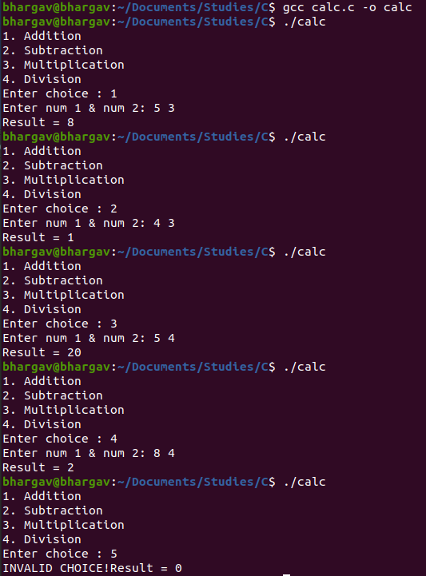

#include <stdio.h>
int a, b, res=0;
int add(){
printf("Enter num 1 & num 2: ");
scanf("%d %d", &a, &b);
return a+b;
}
int sub(){
printf("Enter num 1 & num 2: ");
scanf("%d %d", &a, &b);
return a-b;
}
int mul(){
printf("Enter num 1 & num 2: ");
scanf("%d %d", &a, &b);
return a*b;
}
int div(){
printf("Enter num 1 & num 2: ");
scanf("%d %d", &a, &b);
return a/b;
}
void main(){
int ch;
printf("1. Addition\n2. Subtraction\n3. Multiplication\n4. Division\n");
printf("Enter choice : ");
scanf("%d", &ch);
switch (ch){
case 1:
res = add();
break;
case 2:
res = sub();
break;
case 3:
res = mul();
break;
case 4:
res = div();
break;
default:
printf("Invalid choice!");
break;
}
printf("Result = %d\n", res);
}

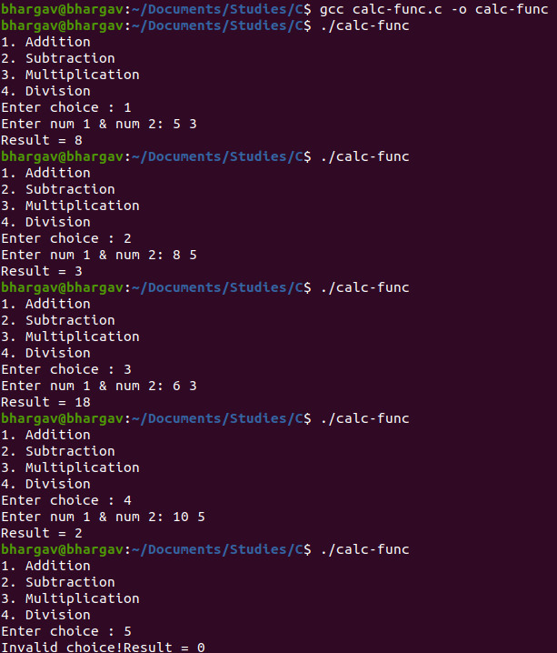

#include <stdio.h>
#include <string.h>
#define MAX_LIMIT 20
struct student {
char name[10];
char div;
int roll;
};

void main (){
struct student s1;

printf("Enter name : ");
fgets(s1.name, MAX_LIMIT, stdin);
printf("Enter division : ");
scanf("%c", &s1.div);
printf("Enter roll no : ");
scanf("%d", &s1.roll);

printf("\nHere are the details:\n");
printf("Name : %s", s1.name);
printf("Division : %c\n", s1.div);
printf("Roll no : %d\n", s1.roll);
}
