# Micro-Simulation Based Framework for Freeway Travel-Time Forecasting

Bhargava Rama Chilukuri (Corresponding author)

Email: bchilukuri3@gatech.edu

Jorge A. Laval, Ph.D.

Email: jorge.laval@ce.gatech.edu

Angshuman Guin, Ph.D.

Email: angshuman.guin@ce.gatech.edu

Georgia Institute of Technology

Department of Civil and Environmental Engineering

Atlanta, GA 30332-0355

Prepared for the Transportation Research Record Journal, 2013

Words: 4500 (excluding references)

Figures and Tables: 10 +2

Total: 4500+ 12* 250 = 7500

# Abstract

This paper presents a micro-simulation based framework to generate short-term travel-time forecasts on freeway corridors. A micro-simulation model was developed that replicated freeway capacity drop and relaxation phenomena critical for modeling non-steady state conditions. This framework was evaluated offline on a real-world freeway corridor using Georgia DOT’s video detection system data and manual counts. The travel-time forecasts were compared with the ground truth travel-time data which demonstrated the efficacy of this framework to produce realistic forecasts.

# **Introduction**

Travel-time information has attracted a lot of attention in the recent years. To the authors’ knowledge, most of the current travel-time estimation methods use data that is at least 5 minutes old. While these estimates provide knowledge about what has transpired, it provides limited information about what can be reasonably expected in the immediate future. In this context, traffic information based on forecasts rather than outdated data alone would be invaluable to users. Forecasts built into the estimation models will make the travel-time estimates more accurate by reducing the use of stale data.

Several methods and algorithms are proposed in the literature to estimate and forecast travel-time information. A summary of these methods is shown in Figure 1. The travel-time estimation methods could be broadly divided into those that measure travel-time directly (direct methods) and those that extract travel-time by indirect means (indirect methods) [1]. While the direct methods seem intuitive, they have several short comings such as sensitivity to visibility conditions, clock synchronization across check points, weather conditions, and equipment calibration [2, 3, and 4]. On the other hand, indirect methods suffer from naive assumptions such as uniform speed on segments, continuous flow-density relationship, approximate methods for modeling congested conditions, and sensitivity to detector reliability [5, 6, 7, and 8].

Travel-time forecast methods can be broadly divided into those based on statistical methods and those based on traffic dynamics. The former use statistical tools on the historic and real time data to derive models to forecast travel-time. Thus, all the statistical methods can be categorized as data driven approaches that treat traffic dynamics as ‘black boxes’ and use statistical relations to infer future travel-times [9-15].

On the other hand, traffic dynamics based models incorporate effects of lane-changings, capacity drop, merge behavior, etc. to produce realistic travel-time forecasts [16, 17]. Even though some macroscopic models [18, 19] replicate capacity drop phenomenon, these models only produces aggregate measures and do not guarantee replicating impacts of driver behavior at microscopic levels. Hu et al [20] developed a mesoscopic simulation based framework using DynaTAIWAN to forecast travel-time. While this model incorporated dynamic traffic assignment and OD estimation, it still does not replicate microscopic driver behavior during congested conditions. Moreover, long aggregation periods and use of passinger car equivalents make Hu et. al.’s study less accurate for simulating non-steady state conditions.

Several researchers used Cellular Automata (CA) based micro-simulation to estimate and forecast travel-times during normal and incident conditions [21-24]. However, CA based models have critical drawbacks: difficulty of calibration, inability to incorporate different user classes (e.g., cars and trucks), and inadequate capability of replicating detailed traffic dynamics on freeways.

Liu et al [25] developed a CORSIM based travel-time forecast framework. Unfortunately, CORSIM does not have in-built models to accurately replicate congested traffic dynamics such as capcity drop and relaxation phenomenon. Moreover, CORSIM uses turning proportions at the exits that do not allow to model congested conditions appropriately. To overcome these limitations, we propose a framework to accurately forecast travel-times during non-steady state conditions which was not possible until recently due to lack of appropriate traffic flow models. While conceptually both Liu’s research and this research developed similar frameworks, the main difference is that the former developed a turning proportions based framework and this paper proposes a origin-destination (OD) flows based framework.

Towards this end this paper developed a micro-simulation based travel-time forecast framework that includes a first of its kind micro-simulation model proven to accurately replicate traffic dynamics [26]. The objectives of this paper are to build a prediction framework able to forecast the onset and propagation of congestion across freeway corridors and demonstrate its ability to generate realistic short-term travel-time forecasts.

**Insert FIGURE 1**

The reminder of this paper is organized as follows: Section 2 describes the proposed micro-simulation based framework. The micro-simulation application and some of its new models are described in section 3. A case study to evaluate the framework is described in section 4. Finally, a discussion of the results is presented in section 5.

# **Prediction Framework:**

The prediction framework for real-time travel-time estimation and forecast is shown in Figure 2. Two main components of this framework are the freeway traffic sensor infrastructure and the micro-simulation application, called hereafter *GTsim*. The former includes field sensors that collect data such as traffic volumes, speeds, vehicle type, occupancy, etc. and store them in a database that includes filters to ensure data quality. The link volumes and speeds from the database will be used to determine the *initial* conditions on the network to be fed as input to the GTsim. The ramp flows will be used to determine the OD flows. Since OD flows are not directly observable in the field, this framework will require prior determination of dynamic historic OD flows for the network. The OD flows calculated in this framework will be validated with historic OD flows for quality control. It is desirable that this framework is initiated during free flow conditions so that the initial OD flows are less prone to errors (refer to Guin et.al [27] for the OD estimation algorithm). Otherwise, the historic OD flows may be used as the initial OD flows because travel-time between every OD pair is not accurately know under congested conditions. Once the initial conditions and OD flows are input into the GTsim, it will run in faster than real-time to generate vehicle trajectories. These vehicle trajectories serve two purposes; to help determine OD flows for the next simulation run and generate travel-time forecasts. Note that the proposed framework operates on a rolling horizon and the results from the previous simulation runs provide develop input for subsequent runs.

**Insert FIGURE 2**

This framework can be written as an algorithm as follows:

1. Estimate initial conditions for simulation run *i*.
2. Calculate OD flows using the travel-time forecasts for each OD pair from simulation run *i-*1. If *i*=0, use calculated OD flows for free flow conditions or historic OD flows otherwise.
3. Validate the calculated OD flows with historic OD flows.
4. Let the rolling horizon interval (time interval between successive simulation run initiations) be *h* and prediction horizons (how many minutes in to future forecasts are made; eg. 5, 10, 15 minutes) *r, 2r, 3r,…mr* where *h, m,* and *r* are integers. Execute simulation run *i*= *p* for sufficient duration to obtain appropriate number of vehicle trajectories to make travel-time forecasts for time *ph+r, ph+2r, ph+3r,….ph+mr* where *p* is an integer.
5. Repeat step 1 for each rolling horizon

Note that h, m, r, and p are location and time dependent policy variables. If the traffic conditions are stable, larger prediction horizon and rolling horizon interval will generally provide reliable forecasts. However, during the periods of congestion build up and dissipation, it is desirable to have small h (<<mr) to ensure reliable forecasts are made.

# **Simulation Application**

It is well known that the existing off-the-shelf traffic simulation software are deficient in simulating congested traffic dynamics on freeways. This is mainly due to insufficient inbuilt models and limited flexibility to allow users to change the models.

Georgia Tech has developed a micro-simulation application, *GTsim*, which includes the latest advancements in lane changing models that are capable of explaining congestion dynamics such as capacity drop and relaxation phenomenon [26]. Conceptually, GTsim is a variant of the widely accepted Kinematic Wave Model and therefore is simple and reliable to use. Details of GTsim architecture and its process flow can be found in [27]. GTsim was built in JAVA to perform faster than real-time simulation. For example, a 3-hour peak period simulation of a 5 mile corridor could be simulated in under 2 minutes on a 2.66 GHz processor with 2GB RAM.

It was found that the core lane-changing and car-following models [26] performed satisfactorily during unsaturated conditions. However, during congestion, these models resulted in some vehicles not able to exit appropriately (which is typically handled in commercial software by “dropping” the vehicle from the system). Moreover, it was found that exiting vehicles unrealistically (spatially) changed lanes and accumulated on one lane. It was also found that the lateral propagation of congestion across lanes was not realistic. To overcome these deficiencies, GTsim incorporated new mandatory lane-change and driver behavior models as described in Figure 3.

Insert FIGURE 3

The five new models shown in Figure 3; Threshold Model, Exit Lane Model , Exit Model, Velocity Drop Model, Friction Model are described below.

**Threshold Model**

When a vehicle intends to changes lanes to reach a destination exit, the *Threshold Model* is used. This model defines the exiting threshold location, *L,* (upstream of an exit ramp) at which a vehicle is flagged as exiting vehicle. *L* is defined based on the vehicle's lateral and longitudinal distance from its exit.

|  |  |  |
| --- | --- | --- |
|  | L = F (d, p, n,..) |  |
| Sample model: | L = d [1+p/n] |  |

where *F(.)* is a user defined function, *d* is the longitudinal distance between the vehicle and the exit ramp, and is a tunable parameter depending on the geometry of the freeway, *p* is the lane number (starting from 0 for the shoulder), and *n* is the total number of lanes on that freeway section.

Note from (2) that left lanes have higher *L* value compared to the right lanes and a lane’s *L* value changes when lanes are added (due to on-ramp) or dropped (due to exit) on the freeway. The tunable parameter (*d*) incorporates geometry sensitive driver behavior and should be calibrated for every exit ramp. For example, if there are two consecutive exits in close proximity, then the *L* for the first exit is different from the second during congested conditions because the second exit drivers tend to stay in the left lanes longer to avoid the accumulations near the first exit.

**Exit Lane Model**

When a vehicles intends to change lanes to avoid travelling in an exit-only lane, *Exit Lane Model* is used to gradually shift the vehicle to the left lanes. Similar to the previous model, the corresponding threshold location parameter in this model is the Exit lane threshold location, *L\**, that is defined as:

|  |  |  |
| --- | --- | --- |
|  | L* = G (de, N, kd...) |  |
| Sample model: | L* = de N |  |

where *G (.)* is a user defined function, *de* is similar to *d* in the previous model, kd is the downstream density in the exit-only lane(s), and *N* is the number of lane-changings a vehicle needs to make to move away from exit-only lane(s). Note from (4) that *L\** and *N* are directly proportional.

**Exit Model**

Once a vehicle is flagged as an exiting vehicle, the *Exit Model* calculates its “lane-changing urgency” (*f(t)*) as follows:

|  |  |  |
| --- | --- | --- |
|  | f(t) = K(le, L or L*,..) |  |
| Sample model: | f(t) = [1- le /[L or L*]]2 |  |

where *K(.)* is a user defined function and *le* is the vehicle’s distance from the exit. Note from (6) that *f(t)* increases significantly as the vehicle approaches close to the exit. The exit model also determines the outcome of a vehicle’s lane-changing attempt based on the magnitude of *f(t)* and density on the target lane.

**Velocity Drop Model**

A vehicle’s velocity is updated based car-following model [26] and the *Friction Model*. However, if the mandatory lane-changing attempt was unsuccessful, then a third criterion, *Velocity Drop Model* is used.

It was observed that when vehicles want to make a mandatory lane-changing, but cannot complete lane-changing due to high density on the target lane, drivers tend to slow down to ensure they have enough time and distance to safely change lanes and reach the their destination exit. This behavior is replicated by the *Velocity Drop Model* as follows:

|  |  |  |
| --- | --- | --- |
|  | Vvd(t) = H(V(t-1)-,f(t-1), V0) |  |
| Sample model: | Vvd(t) =V(t-1)- f(t-1) V0 |  |

where *H(.)* is a user defined function, *Vvd(j)* is the velocity of a vehicle at time *j*, *f(t-1)* is the “lane-changing urgency” at time *t-1* (between 0 to 1), *V0* is the tunable parameter that incorporates drivers’ deceleration characteristics. Note from (8) that if a vehicle is very close to the exit and it cannot make a lane change, it reduces its velocity more than a vehicle that was far from exit and was unsuccessful. Also, note that this model could replicate an occasional vehicle waiting (stopped) at or near the exit gore blocking the adjacent lane.

**Friction Model**

It is well known that the driver behavior in a lane are influenced by operating conditions in the adjacent lanes [28]. The drivers tend to slowdown if the adjacent lanes are congested, decreasing the capacity of their lane. *Friction Model* is used to capture this behavior, as defined below:

|  |  |  |
| --- | --- | --- |
|  | Vi fm(t) = J(Vi(t-1), Vi-1(t-1), Vi+1(t-1)) |  |
| Sample model: | Vi fm (t) = Vi(t-1)- Vdf(t-1) Vff |  |
|  | Vdf(t-1) = [Vi(t-1)- min(Vi-1(t-1), Vi+1(t-1))]/Vf |  |

where *J(.)* is the user defined function, *Vj fm* is the velocity of a vehicle in lane *j*, *Vdf* is the velocity differential (<1), *Vf* is the free flow speed, and *Vff* is a tunable parameter that incorporates the extent of influence across lanes. Note from (10) that higher velocity differential results in higher reduction in velocity. Finally, a vehicle’s velocity update is done as follows:

|  |  |  |
| --- | --- | --- |
|  | V(t) =min(Vcf(t-1), Vfm(t-1), max(0,Vvd(t-1))) |  |

where *Vcf* is the velocity update based on car-following model [26].

Note that though these models are very simple in concept, they greatly enhanced the quality of the simulation output. To quantify the effectiveness of these models, these models were tested on a test corridor (details in section 4). When the first two mandatory lane-changing models were turned off, all the lane-changings concentrated at the threshold location. When they were turned on, the lane-changings were spatially distributed realistically. When the *Velocity Drop Model* was turned off, out of the 6,304 vehicles that exited at different ramps during 1 hour of congestion period simulation, 217 vehicles were not able to exit appropriately. Even though it appears that the percentage or erroneous vehicles is small, the influence of these models is significant because vehicles slowing down (velocity drop model and friction model) replicate lateral propagation of congestion across lanes and its impacts on the freeway flow is significant. More details of these models are forthcoming in other papers currently under preparation.

# **Case Study**

The premise of this case study is to evaluate if this framework can reliably forecast travel-times for the *non-steady state conditions.* Traditional methods fail during non-steady state conditions because the traffic conditions change rapidly making the data stale for forecasting purposes.

For this study, a 10.5 km long EB/SB I-285 segment between GA-400 and I-85 was selected as shown in figure 4. The study corridor has four on-ramps; Peachtree Dunwoody Road (E1), Ashford Dunwoody Road (E2), North Peachtree Road (E3), and Peachtree Industrial Pkwy (E4). Similarly, the corridor has seven off-ramps; Ashford Dunwoody Road (X1), Chamblee Dunwoody Road (X2), SB Peachtree Industrial Pkwy (X3), NB Peachtree Industrial Pkwy (X4), Buford Hwy (X5), SB I-85 connector (X6), and NB I-85 connector (X7).

Insert FIGURE 4

Based on the congestion characteristics, this study focused on the congested evening peak period. Due to resource limitations, this study was performed in an offline fashion and historical OD flows were not estimated. During the course of the study, it was found that the quality of data from the Georgia Department of Transportation (GDOT)’s vehicle detector station system was not suitable for use in a micro-simulation based travel-time prediction framework. Therefore, GDOT’s PTZ cameras were used to record the system boundaries (13 origins/destinations) from 15:00 to 17:00 on March 7, 2012. Time-series of traffic volumes were manually extracted from the videos using the tablet based traffic counting application developed at Georgia Tech [29].

During the study period, initially the corridor was free flowing, but soon gets congested primarily due to the spillback from the NB I-85 off-ramp. Moreover, large flows destined for NB and SB I-85 exit ramps created significant weaving upstream of these ramps. The close proximity of the Buford Hwy off-ramp exacerbated the weaving upstream of the Bufford highway. When the spillback reaches the two-lane Peachtree Industrial Pkwy on-ramp, large inflows deteriorated the traffic conditions quickly propagating congestion upstream. By the end of the study duration, the congestion on the freeway encompassed all the ramps in the study corridor which can be observed from the time-space speed plot of the GDOT’s video detection system (NaviGAtor) speed data in figure 5a.

Ground truth travel-time data were collected using Bluetooth sensors from two overpasses along I-285; Perimeter Center Parkway NE, and New Peachtree Rd as shown in Figure 4. At each location, Bluetooth readers were deployed facing oncoming traffic. Figure 5b shows the travel-time data collected using Bluetooth technology. The black rectangle in figure 5a shows the boundaries of the Bluetooth data collection effort. Note that the variance in the Bluetooth data is large because throughout the study duration, the two right lanes downstream of the Bufford highway ramp were more congested than left lanes due to the spillback from the NB I-85 off-ramp.

Insert FIGURE 5

Note that the study corridor has an isolated bottleneck at NB I-85 off-ramp during the majority of the study duration. The spillback from downstream freeway onto the study corridor happened around 16:40 but did not have a significant impact on the travel-time data because the left lanes downstream of Bufford highway ramp were relatively free flowing and the spillback barely reached the Bluetooth data collection site during the study period.

A rolling horizon of 5 minutes was used in this study to account for the non-steady state conditions. The prediction horizons were decided to be 5 minutes, 10 minutes, 15, minutes, and 20 minutes into the future. For example, a simulation initiated at time t = 15:45 will give travel-time forecasts for t = 15:50, 15:55, 16:00, and 16:05. The next section will describe the parameter estimation process critical to ensure real world conditions are replicated.

## **Parameter Estimation**

Importance of calibration and validation of simulation models is widely understood. There are three categories of parameters calibrated in this study; capacity related (Free flow speed, Jam density, and Wave Speed), lane changing related (Vd, d, dll, de, tau, sd, epsilon, and zeta etc.), and driver behavior related (Vff, V0). Notice that GTsim is parsimonious in terms of number of parameters needed to be calibrated. There are a total of 13 parameters out of which 7 parameters are directly observable [26]. Therefore, only 6 parameters were required to be calibrated.

Since the validation data collected for this research was ground-truth travel-time data, the 6 mandatory lane changing and driver behavior parameters were calibrated both qualitatively and quantitatively. The calibration process was conducted with an iterative try-and-error approach based on the following criteria:

* Minimize the number of error vehicles that fail to exit appropriately
* Compliance of the driver behavior, queue length and location, bottleneck location, congestion propagation across lanes, and other traffic features observed in the video recordings and simulation animation
* Minimize the difference between the travel-time estimates from Bluetooth data and the first prediction horizon.

Based on the above criteria, the parameter values shown in Table 1 were determined. The parameter values indicate that except for one parameter all the other parameters take same value for the whole corridor.

Insert TABLE 1

To validate the model, a comparison of time-space speed plots of the observed and measured data was done as shown in Figure 6. The plot indicates that the speed measured in the simulation model comply with that observed in the field.

Since the time-space speed plot provides an aggregate measure of the performance of the calibrated modes, a finer comparison was desired. Therefore, a comparison of off-ramp flows was made as shown in Figure 7. Figure 7 shows that the off-ramp flows from the model closely match that observed in the field indicating that calibrated parameter values and OD flows adequately replicated field conditions.

Insert FIGURE 6

Insert FIGURE 7

Even though the calibrated parameter values perform well under these conditions, it does not guarantee that the simulation will be accurate for another set of conditions. Fine-tuning of the model parameters may be needed for generating accurate forecasts under a different set of conditions.

## **Results**

For each simulation run, travel-time forecasts were derived by averaging the travel-times of at least 100 vehicles. Since microsimulations have inherent stochasticity, an average of a large sample is expected to minimize the error in the forecast. If there are fewer than 100 vehicles that completed their trip during any 5 minute interval, the simulation was extended till a sufficient sample was obtained. For the test corridor used in this study, a 30 minute simulation was sufficient to obtain enough sample to produce short term forecasts such as 5 minutes and 10 minutes forecasts under both congestion build up and sustained congestion scenarios.

One should note that it is easy to induce bias in the way results may be are extracted from the simulation if the simulation duration is not sufficiently long compared to the prediction horizon. During the extraction of travel-time from simulation results, if the simulation duration is not long enough the travel-times of only the vehicles that completed their trip during the simulation will be represented in the results. It is possible that there are several vehicles that may not complete their trip during the simulation duration and are not captured in the extraction process. Thus, simulation was run for long enough duration to ensure majority of the vehicles generated during a time period completed their trip and avoid any bias in travel time calculation.

Figure 8 shows the 5-minute forecasted travel-times from simulation and the ground truth travel-times from the Bluetooth sensors. The figure also shows the bands of one standard deviation from the mean. The agreements between these results provides the evidence that the forecasts made using this model can be expected to be reliable.

Figure 9 shows the travel-time forecasts for different time horizons on the corridor. These results are extracted from the simulation by aggregating the travel-times of all the vehicles that entered the study corridor during the corresponding 5–minute time period. It can be seen that the forecasts made during each simulation run follow the pattern observed with the Bluetooth data. During congestion buildup, the forecasts show an increase in travel-time for prediction horizons. However, after the corridor gets congested, the forecasted travel-times seem to flatten out accurately forecasting traffic conditions.

Insert FIGURE 8

To compare the benefits of this framework over the traditional estimation methods, the simulation results were compared with the Instantaneous Travel-time (ITT) used by GDOT. ITT is calculated based on the speeds across the corridor at any given instant. Figure 10a shows a Y-Y plot of Bluetooth data (ATT), ITT and 5-minute prediction (1st prediction) Travel-times. The figure shows that the 1st prediction results are closer to the Y-Y line compared to the ITT values during the congestion buildup. Once the entire corridor was congested, the ITT and 1st prediction values were almost uniformly spread on either side of the Y-Y line indicating that the benefits of prediction framework during non-steady state conditions.

Insert FIGURE 9

The mean absolute error (MAE) and median of the difference of forecast and Bluetooth travel-time during the non-steady state conditions were 0.78 and 0.68 minutes. On the otherhand MAE and median of the difference of ITT and ground truth travel-time during the same time period was 1.55 and 1.65 minutes which shows that forecasted travel-times were better than ITT. Moreover, the error plot in figure 10b shows that the ITT error was much larger during the congestion buildup phase during which traditional methods fail to accurately forecast travel-times.

A direct statistical comparison of ITT and simulation based forecasts against bluetooth data could not be performed since the travel-times during each of the 5-minute intervals come from different distributions (different parameter values). Root Mean Square Error (RMSE) and Mean Absolute Percent Error (MAPE) were used to compare the error levels of the travel-time estimates from each method. Table 2 shows the RMSE and MAPE of different travel-time estimates.

Insert FIGURE 10

Insert TABLE 2

Table 2 shows that the RMSE and MAPE values for 1st and 2nd predictions are better than the ITT values. However, 3rd predictions are comparable to the ITT values. The results indicated that this framework could be successfully used to forecast short-term travel-times during non-steady state conditions. However, since the freeflow travel-time on the test corridor was less than 5 minutes (short corridor) and the congestion build up is slow (inflow into the corridor is low), the potential of the framework is not fully exploited in the case study. The real strength of this prediction framework will be highlighted in the case where the corridor length is long or during incidents when traffic conditions change frequently.

# **Discussion**

This paper described a simulation based travel-time forecast framework. As a part of the framework, GTsim, a microsimulation model was developed that incorporated several new mandatory lane changing models to replicate driver behavior during congested conditions. The ability of the framework to generate realistic travel-time forecasts was demonstrated on a test corridor. The study results show that sufficiently accurate 5-minute and 10-minute forecasts can be made using this framework, and that it outperforms the state-of-the-practice methods such as the ITT.

While this framework can be successfully used to make short term forecasts, improved calibration and acurate estimation of input values may enable making accurate long-term forecasts. Moreover, even accurate calibration around one set of conditions does not guarantee that the model will forecast accurate travel-times under a different set of conditions and therefore a methodology for automatic fine-tuning of the parameter values may be needed.

When this framework is applied for real-time prediction, new methodologies for data filtering, incident detection, data imputation, and so on will need to be developed. Also, the sensitivity of variations in OD flows on travel-time forecasts is improtant for quality control of OD flows and determine a methodology to merge historic OD flows with calculated OD flows. Efforts to incorporate uncertainty in the count data and OD estimation are currently underway and preliminary results are available in Laval and Chilukuri [30].

## **Acknowledgements**

This research was supported by the GDOT’s research project 10-01; TO 02-60:Travel-time estimation and forecasting. The authors wish to thank the GDOT for its support, in particular Binh Bui, David Jared, Mark Demidovich and W. Grant Waldrop. In addition the authors wish to thank the USDOT for the support from a companion project, provided through Tech University Transportation Center grant # DTRT07G0051.

# **References**

1. Yeon, J., Elefteriadou, L., Lawphongpanich, S., 2008. Travel-time estimation on a freeway using discrete time Markov chains. Transportation Research Part B 42 (4), 325–338.
2. Taylor, M.A.P., Bonsall, P.W. and Young, W. (2000) Data on travel-times. In, Understanding Traffic Systems: Data, Analysis and Presentation. Ashgate Publishing Ltd, 197-206.
3. B. Coifman, M. Cassidy, (2002)Vehicle reidentification and travel-time measurement on congested freeways, Transportation Research: Part A, 36 (10), pp. 899–917
4. Herrera, J.C., Work, D.B., Herring, R., Ban, X., Jacobson, Q., Bayen, A.M., (2010) Evaluation of traffic data obtained via GPS-enabled mobile phones: the Mobile Century field experiment. Transportation Research Part C. Volume 18, Issue 4, Pages 568-583
5. Dailey, D. J. (1993). Travel-time estimation using cross-correlation techniques. Transportation Research, Part B, 27B(2):97{107.
6. Petty, K., Bickel, P., Jiang, J., Ostland, M., Rice J., Ritov, Y., and Schoenberg, F. (1998). Accurate estimation of travel-times from single-loop detectors. Transp. Res. A 32(1) 1–17.
7. Yeon, J. and Elefteriadou, L. (2006) Comparison of Travel-time Estimation Using Three Previously Developed Methods to Field Data Along Freeways. 5th International Symposium on Highway Capacity and Quality of Service, pp. 229-238.
8. Van Lint J.W. C., (2010) Empirical Evaluation of New Robust Travel-time Estimation Algorithms, Transportation Research Record: Journal of the Transportation Research Board, No. 2160, Transportation Research Board of the National Academies, Washington, D.C., pp. 50–59
9. Guin A., (2006) “Travel-time Prediction Using a Seasonal Autoregressive Integrated Moving Average Time Series Model,” Proceedings of the 9th IEEE International Conference on intelligent Transportation system, pp. 493–498.
10. Min, W., Wynter, L., 2011. Real-time road trafﬁc prediction with spatio-temporal correlations. Transportation Research Part C 19 (4), 606–616.
11. Okutani, I., Stephanedes, Y.J., 1984. Dynamic prediction of trafﬁc volume through Kalman ﬁltering theory. Transportation Research Part B 18 (1), 1–11.
12. Van Lint, J.W.C., 2008. Online learning solutions for freeway travel-time prediction. IEEE Transactions on Intelligent Transportation Systems 9 (1), 38–47.
13. Vlahogianni, E.I., Karlaftis, M.G., Golias, J.C., 2005. Optimized and meta-optimized neural networks for short-term trafﬁc ﬂow prediction: a genetic approach. Transportation Research Part C 13 (3), 211–234
14. Fei, X., Lu, C.-C., Liu, K., 2011. A Bayesian dynamic linear model approach for real-time short-term freeway travel-time prediction. Transportation Research Part C 19 (6), 1306–1318.
15. Du, L., Peeta, S., Kim, Y.H., 2012. An adaptive information fusion model to predict the short-term link travel-time distribution in dynamic trafﬁc networks. Trans. Research Part B 46 (1), 235–252
16. Leclercq, L., Laval, J.A., Chiabaut, N., 2011. Capacity drops at merges: an endogenous model. Transportation Research Part B 45 (9), 1302–1313
17. Li, X., Peng, F., Ouyang, Y., 2010. Measurement and estimation of trafﬁc oscillation properties. Transportation Research Part B 44 (1), 1–14
18. Wang Y., Papageorgiou M., Messmer, A. (2006) RENAISSANCE–A unified macroscopic model-based approach to real-time freeway network traffic surveillance Transportation Research Part C: Emerging Technologies, Volume 14, Issue 3, June 2006, Pages 190-212
19. Xu, T., Hao, Y., and Sun, L. (2007) Travel-time Prediction of Urban Expressway in Unstable Traffic Flow. International Conference on Transportation Engineering 2007: pp. 2205-2210.
20. Hu, T. Y. , Tong, C. C. , Liao, T. Y. and Ho, W. M., (2013) Simulation-Assignment-Based TravelTime Prediction Model for Traffic Corridors, IEEE Transactions on Intelligent Transportation Systems, Vol. 13, No. 3, 2012, pp. 1277-1286. doi:10.1109/TITS.2012.2190061
21. S.F. Hafstein, R. Chrobok, A. Pottmeier, M. Schreckenberg, and F. Mazur. (2004) A High-Resolution Cellular Automata Traffic Simulation Model with Application in a Freeway Traffic Information System. Computer-Aided Civil and Infrastructure Engineering 19-5, pp. 338-350.
22. Dailey, D. and N. Taiyab. (2002) A Cellular Automata Model for Use with Real Freeway Data. WA-RD 537.1. Technical Report. Washington State Department of Transportation.
23. Nassab, K., Schreckenberg, M., Boulmakoul, A. and Ouaskit, S. (2006) Effect of the Lane Reduction in the Cellular Automata Models Applied to the Two-Lane Traffic. Physica A: Statistical Mechanics and its Applications, Vol. 369, No. 2, pp. 841-852.
24. Miska, Marc Philipp. 2007. Microscopic Online Simulation for Real time Traffic Management. Delft University of Technology.
25. Liu, Y., Lin, P., Lai, X., Chang, G. and Marquess, A., (2006) Developments and Applications of Simulation-Based Online Travel-time Prediction System Traveling to Ocean City, Maryland. Transportation Research Record: Journal of the Transportation Research Board, No. 1959, Transportation Research Board of the National Academies, Washington, D.C., pp. 92–104.
26. J A Laval and L Leclercq. (2008) Microscopic modeling of the relaxation phenomenon using a macroscopic lane-changing model. Transportation Research Part B, 42 (6):511-522.
27. Guin, A., Laval, J., and Chilukuri, B.R. (2013) Freeway Travel-time Estimation and Forecasting. GDOT 10-01; TO 02-60. Technical Report. Georgia Department of Transportation.
28. Guin, Angshuman; Hunter, Michael; Guensler, Randall L. Analysis of Reduction in Effective Capacities of High-Occupancy Vehicle Lanes Related to Traffic Behavior. Transportation Research Record: Journal of the Transportation Research Board, Issue 2065, 2008, pp 47-53
29. Toth C., Suh W., Elango V., Sadana R, Guin A., Hunter M., Guensler R. (2013), Tablet-Based Traffic Counting Application Designed to Minimize Human Error, Transportation Research Board.
30. Laval, J. A., Chilukuri, B. R. The Distribution of Congestion on a Class of Stochastic Kinematic Wave Model. Forthcoming in Transportation Science, 2013, <http://dx.doi.org/10.1287/trsc.2013.0462>

**List of Figures**

1. Travel-time estimation and prediction methods.
2. Travel-time estimation and prediction framework.
3. New mandatory lane-changing and driver behavior models.
4. Schematic of the test corridor.
5. a) Field measured time-space speed plot b) Travel-time data collected by Bluetooth devices.
6. a) Time-space speed plot of the measured speeds b) Time-space speed plot of the simulated data.
7. Comparison of observed and measured off-ramp flow data.
8. Simulation results vs. Bluetooth data on the corridor.
9. Travel-time predictions for different time horizons on the corridor.
10. a) Y-Y plot of 1st prediction TT and ITT against Bluetooth data b) Error plot.

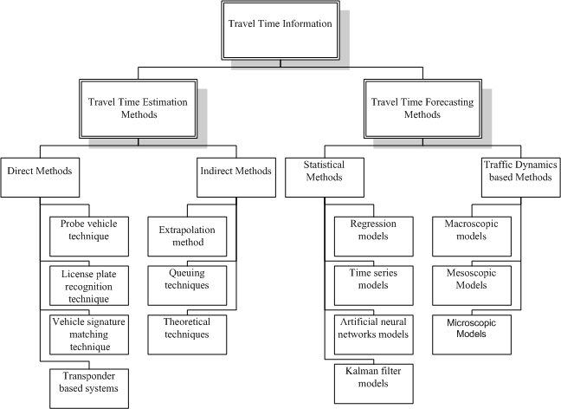

**FIGURE 1 Travel-time estimation and prediction methods.**

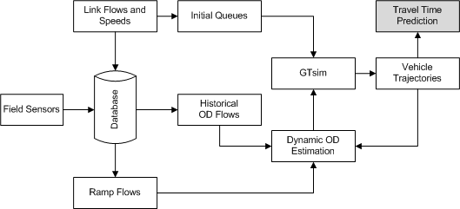

Initial Condition

**FIGURE 2 Travel-time estimation and prediction framework.**

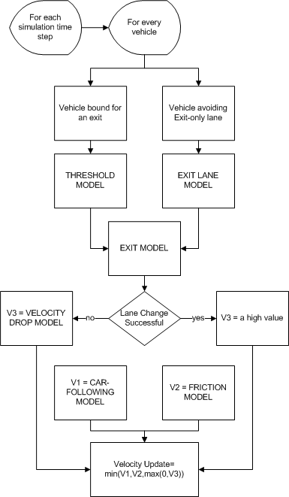

**FIGURE 3 New mandatory lane-changing and driver behavior models.**

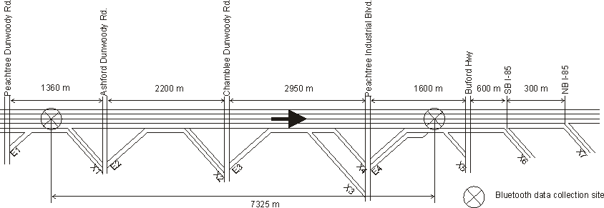

**FIGURE 4 Schematic of the test corridor.**

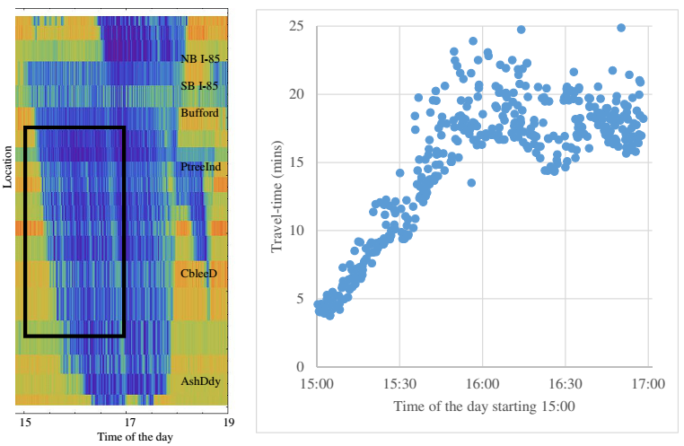

**FIGURE 5 a) Field measured time-space speed plot. b) Travel-time data collected by Bluetooth devices.**

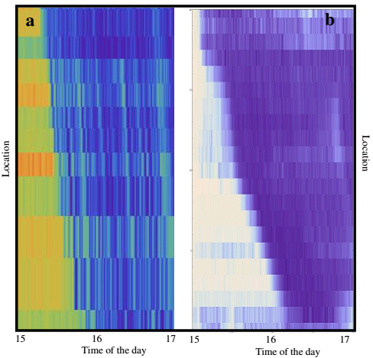

**FIGURE 6 a) Time-space speed plot of the measured speeds. b) Time-space speed plot of the simulated data.**

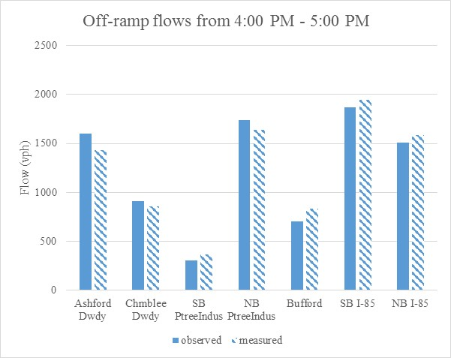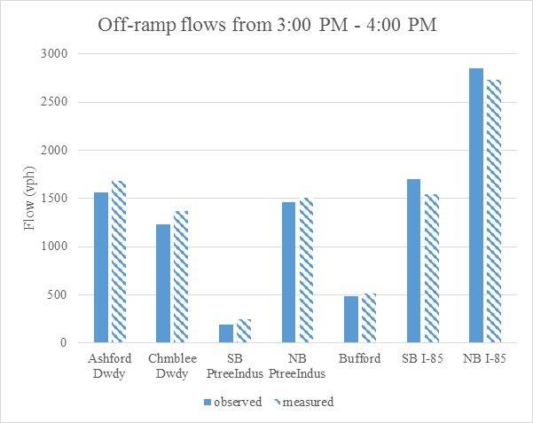

**FIGURE 7 Comparison of observed and measured off-ramp flow data.**

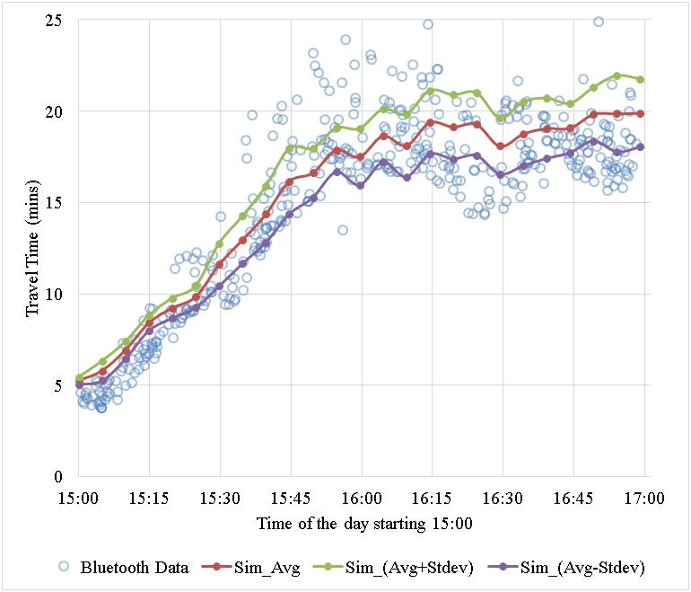

**FIGURE** **8 Simulation results vs. Bluetooth data on the corridor.**

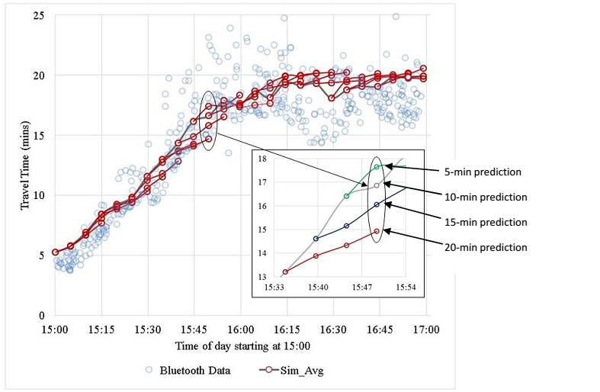

**FIGURE 9 Travel-time predictions for different time horizons on the corridor.**

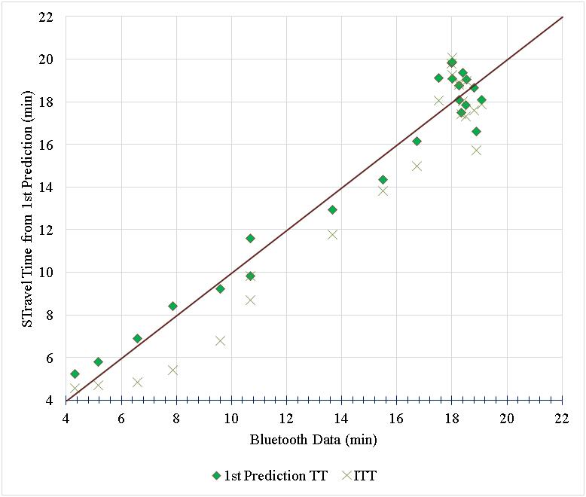

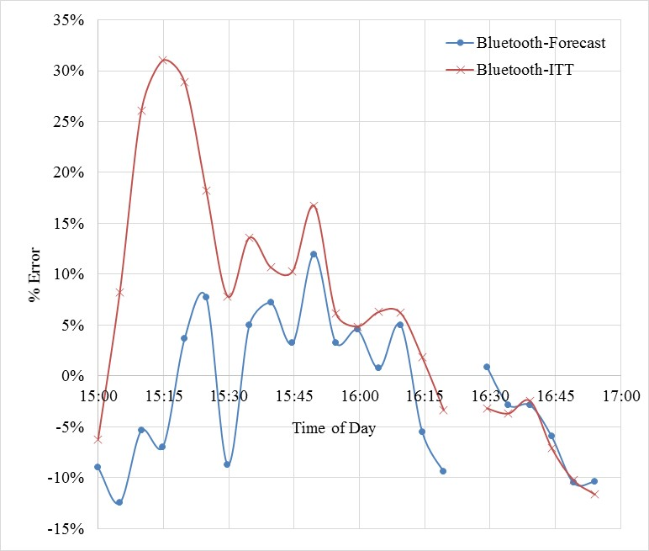

**FIGURE 10 a) Y-Y plot of 1st prediction TT and ITT against Bluetooth data. b) Error plot.**

**List of Tables**

1. Calibrated Parameters
2. RMSE and MAPE

**TABLE 1 Calibrated Parameters**

|  |  |
| --- | --- |
| **Calibrated Parameter** | **Parameter Value** |
| Free flow speed (Vf) | 100 kph |
| Jam density (kj) | 150 veh/km |
| Wave speed (w) | 20 kph |
| Vff | 20 kph |
| V0 | 10 kph |
| dll | 2 km |
| de | 1 km |
| Vd | 5 kph |
| d | 0.75* |
| Tau** | 4 seconds |
| sd** | 200 meters |
| Epsilon** | 2 |
| Zeta** | 0.5 |

* Since the NB and SB Peachtree Industrial Blvd exits are less than 200 meters apart, *d* for the NB Peachtree Industrial Blvd exit was calibrated separately ( = 0.4). ** refer to [26] for details.

**TABLE 2 RMSE and MAPE**

|  |  |  |
| --- | --- | --- |
| **Travel-time data** | **RMSE (mins)** | **MAPE (%)** |
| 1st prediction | 1.04 | 6.79% |
| 2nd prediction | 1.28 | 7.37% |
| 3rd prediction | 1.58 | 8.35% |
| ITT | 1.56 | 10.64% |