**Ceaser Cipher**

#include<stdio.h>

#include<string.h>

#include<conio.h>

#include<ctype.h>

int main()

{

char plain[10],cipher[10];

int key,i,length;

int result;

printf("\n Enter the plain text:");

scanf("%s",plain);

printf("\n Enter the key value:");

scanf("%d",key);

printf("\n \n \t PLAIN TEXT: %s",plain);

printf("\n \n \t ENCRYPTED TEXT: %s:");

length=strlen(plain);

for(i=0;i<(length);i++)

{

cipher[i]=plain[i]+key;

if(isupper(plain[i]) && (cipher[i]>'Z'))

cipher[i]=cipher[i]-26;

if(islower(plain[i]) && (cipher[i]>'z'))

cipher[i]=cipher[i]-26;

printf("%c",cipher[i]);

}

printf("\n \n \t AFTER DECRYPTION :");

for(i=0;i<length;i++)

{

plain[i]=cipher[i]-key;

if(isupper(cipher[i]) && (plain[i]<'A'))

plain[i]=plain[i]+26;

if(islower(cipher[i]) && (plain[i]<'a'))

plain[i]=plain[i]+26;

printf("%c",plain[i]);

}

return 0;

}

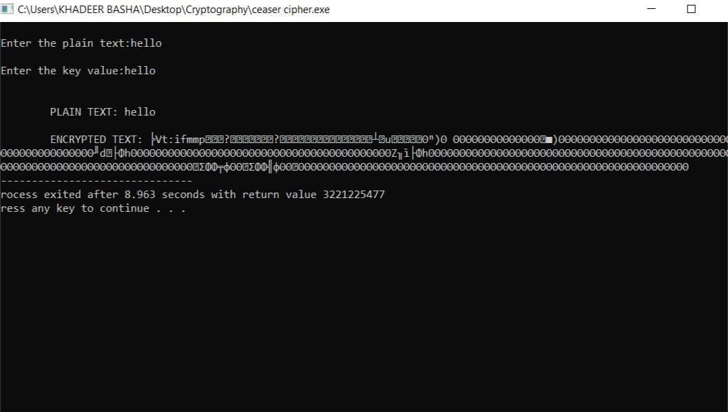

**Playfair Cipher**

#include<stdio.h>

#include<conio.h>

#include<string.h>

#include<ctype.h>

#define MX 5

void playfair(char ch1,char ch2, char key[MX][MX])

{

int i,j,w,x,y,z;

FILE *out;

if((out==fopen("cipher.txt","a+"))==NULL)

{

printf("File Currupted.");

}

for(i=0;i<MX;i++)

{

for(j=0;j<MX;j++)

{

if(ch1==key[i][j])

{

w=i;

x=j;

}

else if(ch2==key[i][j])

{

y=i;

z=j;

}

}

}

if(w==y)

{

x=(x+1)%5;z=(z+1)%5;

printf("%c%c",key[w][x],key[y][z]);

fprintf(out,"%c%c",key[w][x],key[y][z]);

}

else if(x==z)

{

w=(w+1)%5;y=(y+1)%5;

printf("%c%c",key[w][x],key[y][z]);

fprintf(out,"%c%c",key[w][x],key[y][z]);

}

else

{

printf("%c%c",key[w][z],key[y][x]);

fprintf(out,"%c%c",key[w][z],key[y][x]);

}

fclose(out);

}

int main()

{

int i,j,k=0,l,m=0,n;

char key[MX][MX],keyminus[25],keystr[10],str[25]={0};

char

alpa[26]={'A','B','C','D','E','F','G','H','J','K','L','M','N','O','P','Q','R','S','T','U','V','W','X','Y','Z'};

printf("\n Enter key:");

gets(keystr);

printf("\n Enter the plain text:");

gets(str);

n=strlen(keystr);

for(i=0;i<n;i++)

{

if(keystr[i]=='j')keystr[i]='i';

else if(keystr[i]=='J')keystr[i]='I';

keystr[i]=toupper(keystr[i]);

}

for(i=0;i<strlen(str);i++)

{

if(str[i]=='j')str[i]='i';

else if(str[i]=='J')str[i]=='I';

str[i]=toupper(str[i]);

}

j=0;

for(i=0;i<26;i++)

{

for(k=0;k<n;k++)

{

if(keystr[k]==alpa[i])

break;

else if(alpa[i]=='J')

break;

}

if(k==n)

{

keyminus[j]=alpa[i],j++;

}

}

k=0;

for(i=0;i<MX;i++)

{

for(j=0;j<MX;j++)

{

if(k<n)

{

key[i][j]=keystr[k];

k++;

}

else

{

key[i][j]=keyminus[m];

m++;

}

printf("%c ",key[i][j]);

}

printf("\n");

}

printf("\n\n Entered text: %s\nCipher Text:",str);

for(i=0;i<strlen(str);i++)

{

if(str[i]=='J')str[i]='I';

if(str[i+1]=='\0')

playfair(str[i],'X',key);

else

{

if(str[i+1]=='J')str[i+1]='I';

if(str[i]==str[i+1])

playfair(str[i],'X',key);

else

{

playfair(str[i],str[i+1],key);

i++;

}

}

}

return 0;}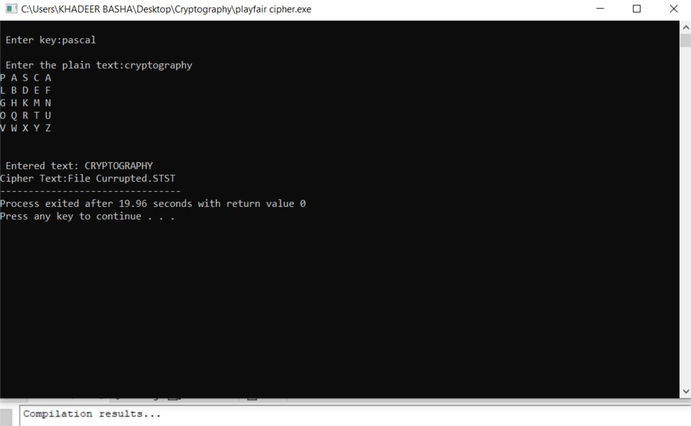

**Hill Cipher**

#include<stdio.h>

#include<conio.h>

#include<string.h>

int main()

{

unsigned int a[3][3]={{6,24,1},{13,16,10},{20,17,15}};

unsigned int b[3][3]={{8,5,10},{21,8,21},{21,12,8}};

int i,j,t=0;

unsigned int c[20],d[20];

char msg[20];

printf("Enter plain text\n");

scanf("%s",msg);

for(i=0;i<strlen(msg);i++)

{

c[i]=msg[i]-65;

printf("%d",c[i]);

}

for(i=0;i<3;i++)

{

t=0;

for(j=0;j<3;j++)

{

t=t+(a[i][j]*c[j]);

}

d[i]=t%26;

}

printf("\n Encrypted Cipher Text:");

for(i=0;i<3;i++)

printf("%c",d[i]+65);

for(i=0;i<3;i++)

{

t=0;

for(j=0;j<3;j++)

{

t=t+(b[i][j]*d[j]);

}

c[i]=t%26;

}

printf("\n Decrypted Cipher Text :");

for(i=0;i<3;i++)

printf("%c",c[i]+65);

return 0;

}

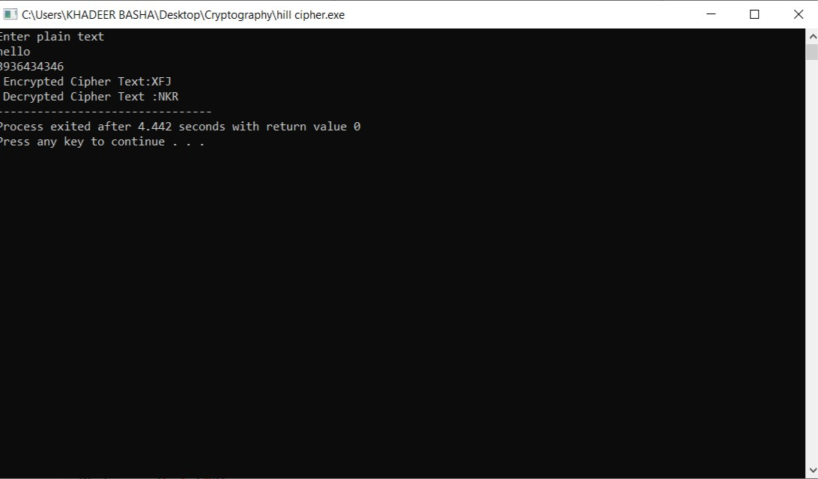

**Vigenere Cipher**

#include<stdio.h>

#include<conio.h>

#include<ctype.h>

#include<string.h>

int encipher();

int decipher();

int main()

{

int choice,exit;

while(1)

{

printf("\n1. Encrypt Text");

printf("\t2. Decrypt Text");

printf("\t3. Exit");

printf("\n\n Enter Your Choice :");

scanf("%d",&choice);

if(choice==3)

exit;

else if(choice==1)

encipher();

else if(choice==2)

decipher();

else

printf("Please Enter Valid Option");

}

}

int encipher()

{

unsigned int i,j;

char input[50],key[20];

printf("\n\n Enter Plain Text:");

scanf("%s",input);

printf("\n Resultant Cipher Text:");

for(i=0,j=0;i<strlen(input);i++,j++)

{

if(j>=strlen(key))

{

j=0;

}

printf("%c",65+(((toupper(input[i])-65)+(toupper(key[j])-65))%26));

}

}

int decipher()

{

unsigned int i,j;

char input[50],key[20];

int value;

printf("\n\nEnter Cipher Text:");

scanf("%s",input);

printf("\n\nEnter the key value:");

scanf("%s",key);

for(i=0,j=0;i<strlen(input);i++,j++)

{

if(j>=strlen(key))

{

j=0;

}

value=(toupper(input[i])-64)-(toupper(key[j])-64);

if(value<0)

{

value=value*-1;

}

printf("%c",65+(value % 26));

}

}

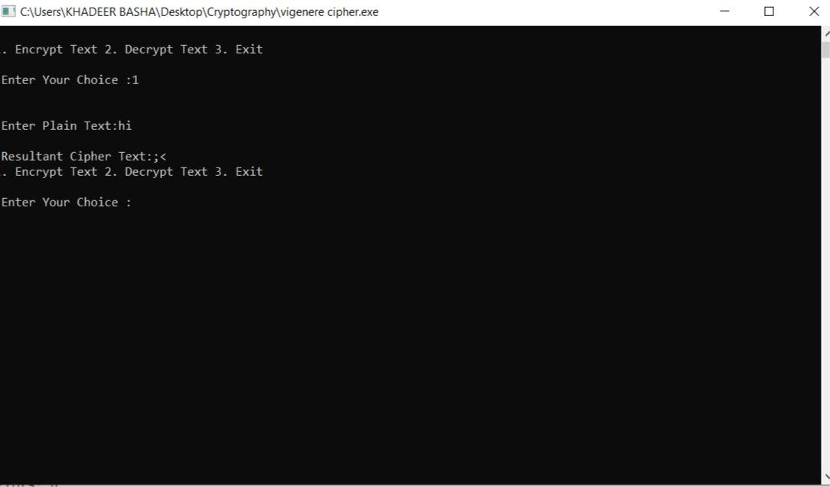

**RailFence Cipher**

#include<stdio.h>

#include<conio.h>

#include<string.h>

int main()

{

int i,j,k,l;

char a[20],c[20],d[20];

printf("\n\n\t RAIL FENCE TECHNIQUE");

printf("\n\n Enter the input string:");

gets(a);

l=strlen(a);

for(i=0,j=0;i<1;i++)

{

if(i%2==0)

c[j++]=a[i];

}

for(i=0;i<1;i++)

{

if(i%2==1)

c[j++]==a[i];

}

c[j]='\0';

printf("\n Cipher text after applying rail fence :");

printf("\n%s",c);

if(l%2==0)

k=l/2;

else

k=(l/2)+1;

for(i=0,j=0;i<k;i++)

{

d[j]=c[i];

j=j+2;

}

for(i=k,j=1;i<1;i++)

{

d[j]=c[i];

j=j+2;

}

d[1]='\0';

printf("\n Text after decryption:");

printf("%s",d);

return 0;

}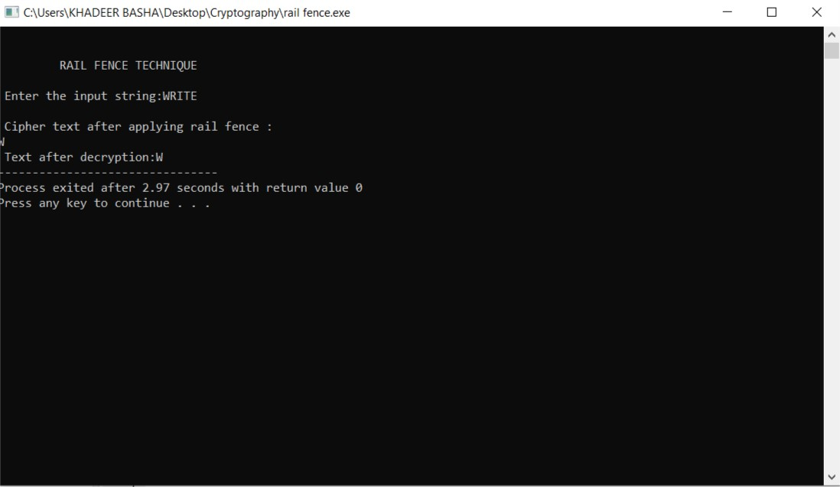

**DES Algorithm**

#include <stdio.h>

#include <string.h>

static void display(int intArray[], int length){

int i=0;

printf("Array : [");

for(i = 0; i < length; i++) {

/* display value of element at index i. */

printf(" %d ", intArray[i]);

}

printf(" ]\n ");

}

int main() {

int i = 0;

/* Declare an array */

int intArray[8];

// initialize elements of array n to 0

for ( i = 0; i < 8; i++ ) {

intArray[ i ] = 0; // set elements to default value of 0;

}

printf("Array with default data.");

/* Display elements of an array.*/

display(intArray,8);

/* Operation : Insertion

Add elements in the array */

for(i = 0; i < 8; i++) {

/* place value of i at index i. */

printf("Adding %d at index %d\n",i,i);

intArray[i] = i;

}

printf("\n");

printf("Array after adding data. ");

display(intArray,8);

/* Operation : Insertion

Element at any location can be updated directly */

int index = 5;

intArray[index] = 10;

printf("Array after updating element at index %d.\n",index);

display(intArray,8);

/* Operation : Search using index

Search an element using index.*/

printf("Data at index %d:%d\n" ,index,intArray[index]);

/* Operation : Search using value

Search an element using value.*/

int value = 4;

for(i = 0; i < 8; i++) {

if(intArray[i] == value ){

printf("value %d Found at index %d \n", intArray[i],i);

break;

}

}

return 0;

}

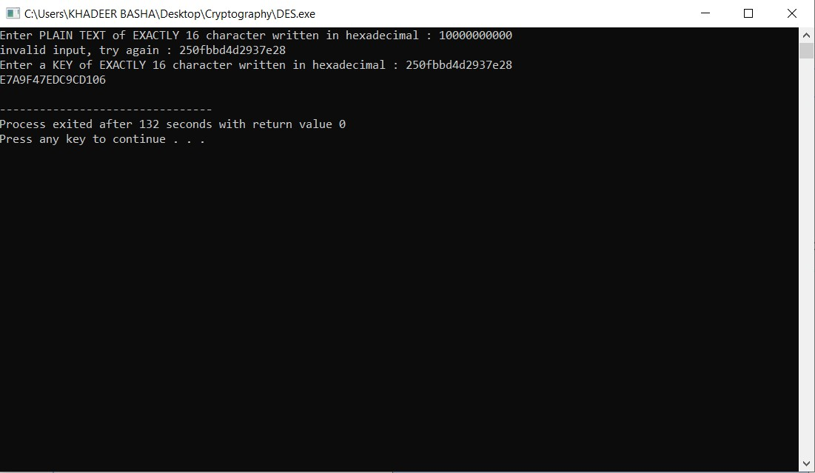

**RSA Algorithm**

#include<stdio.h>

#include<conio.h>

#include<stdlib.h>

#include<math.h>

#include<string.h>

long int

p,q,n,t,flag,e[100],d[100],temp[100],j,m[100],en[100],i;

char msg[100];

int prime(long int);

void ce();

long int cd(long int);

int encrypt();

int decrypt();

int main()

{

printf("\nENTER FIRST PRIME NUMBER\n");

scanf("%d",&p);

flag=prime(p);

if(flag==0)

{

printf("\nWRONG INPUT\n");

}

printf("\nENTER ANOTHER PRIME NUMBER\n");

scanf("%d",&q); flag=prime(q);

if(flag==0||p==q)

{

printf("\nWRONG INPUT\n");

}

printf("\nENTER MESSAGE\n");

fflush(stdin);

scanf("%s",msg);

for(i=0;msg[i]!=NULL;i++) m[i]=msg[i];

n=p*q;

t=(p-1)*(q-1);

ce();

printf("\nPOSSIBLE VALUES OF e AND d ARE\n");

for(i=0;i<j-1;i++) printf("\n%ld\t%ld",e[i],d[i]);

encrypt();

decrypt();

}

int prime(long int pr)

{

int i; j=sqrt(pr);

for(i=2;i<=j;i++)

{

if(pr%i==0) return 0;

}

return 1;

}

void ce()

{

int k; k=0;

for(i=2;i<t;i++)

{

if(t%i==0)

continue;

flag=prime(i);

if(flag==1&&i!=p&&i!=q)

{

e[k]=i;

flag=cd(e[k]);

if(flag>0)

{

d[k]=flag;

k++;

}

if(k==99) break;

}

}

}

long int cd(long int x)

{

long int k=1; while(1)

{

k=k+t;

if(k%x==0)

return(k/x);

}

}

int encrypt()

{

long int pt,ct,key=e[0],k,len;

i=0;

len=strlen(msg);

while(i!=len)

{

pt=m[i];

pt=pt-96;

k=1;

for(j=0;j<key;j++)

{

k=k*pt;

k=k%n;

}

temp[i]=k;

ct=k+96;

en[i]=ct;

i++;

}

en[i]=-1;

printf("\nTHE ENCRYPTED MESSAGE IS\n");

for(i=0;en[i]!=-1;i++)

printf("%c",en[i]);

}

int decrypt()

{

long int pt,ct,key=d[0],k;

i=0;

while(en[i]!=-1)

{

ct=temp[i];

k=1;

for(j=0;j<key;j++)

{

k=k*ct;

k=k%n;

}

pt=k+96;

m[i]=pt;

i++;

}

m[i]=-1;

printf("\nTHE DECRYPTED MESSAGE IS\n");

for(i=0;m[i]!=-1;i++)

printf("%c",m[i]);

return 0;

}

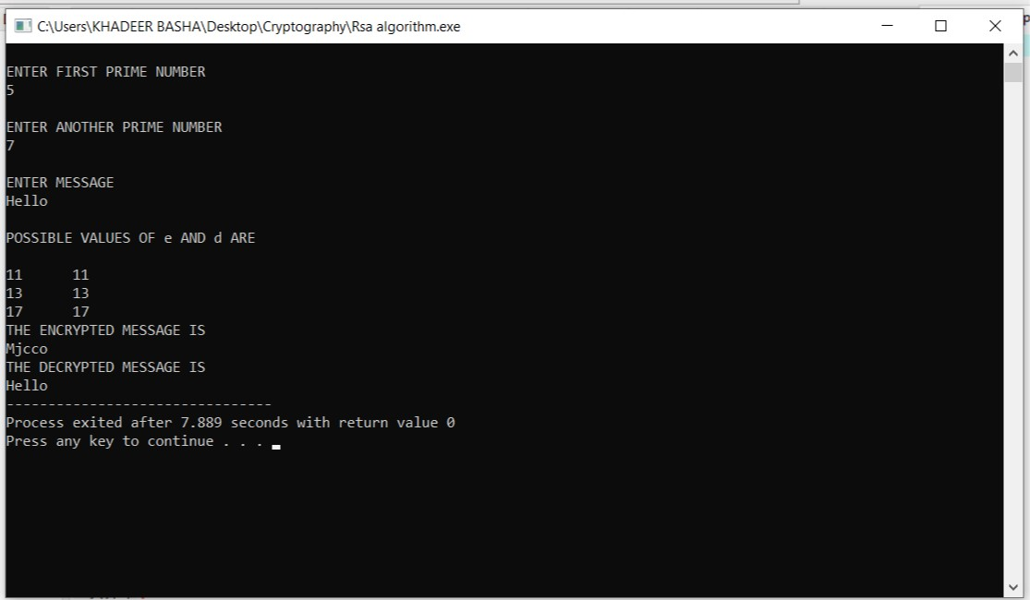

**Diffie HellMan Key Exchange**

#include<stdio.h>

#include<conio.h>

long long int power(int a, int b, int mod)

{

long long int t;

if(b==1)

return a;

t=power(a,b/2,mod);

if(b%2==0)

return (t*t)%mod;

else

return (((t*t)%mod)*a)%mod;

}

long int caluclatekey(int a,int x, int n)

{

return power(a,x,n);

}

int main()

{

int n,g,x,a,y,b;

printf("Enter the value of n and g:");

scanf("%d%d",&n,&g);

printf("Enter the value of x for the first person:");

scanf("%d",&x);

a=power(g,x,n);

printf("Enter the value of y for the second person:");

scanf("%d",&y);

b=power(g,y,n);

printf("Key for the first person is :%lld\n",power(b,x,n));

printf("Key for the second person is :%lld\n",power(a,y,n));

return 0;

}

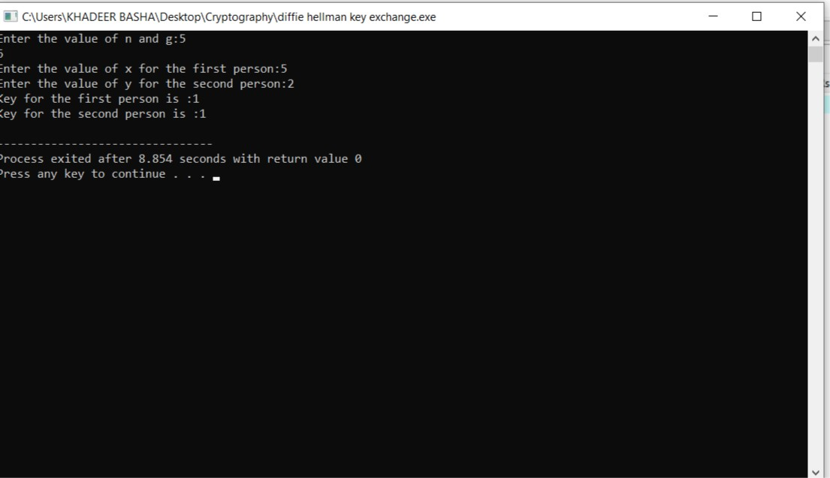

**MD5**

#include <stdlib.h>

#include <stdio.h>

#include <string.h>

#include <math.h>

#include<conio.h>

typedef union uwb

{

unsigned w;

unsigned char b[4];

}

MD5union;

typedef unsigned DigestArray[4];

unsigned func0( unsigned abcd[] )

{

return ( abcd[1] & abcd[2]) | (~abcd[1] & abcd[3]);

}

unsigned func1( unsigned abcd[] )

{

return ( abcd[3] & abcd[1]) | (~abcd[3] & abcd[2]);

}

unsigned func2( unsigned abcd[] )

{

return abcd[1] ^ abcd[2] ^ abcd[3];

}

unsigned func3( unsigned abcd[] )

{

return abcd[2] ^ (abcd[1] |~ abcd[3]);

}

typedef unsigned (*DgstFctn)(unsigned a[]);

unsigned *calctable( unsigned *k)

{

double s, pwr; int i;

pwr = pow( 2, 32);

for (i=0; i<64; i++)

{

s = fabs(sin(1+i));

k[i] = (unsigned)( s * pwr );

}

return k;

}

unsigned rol( unsigned r, short N )

{

unsigned mask1 = (1<<N) -1;

return ((r>>(32-N)) & mask1) | ((r<<N) & ~mask1);

}

unsigned *md5( const char *msg, int mlen)

{

static DigestArray h0 = { 0x67452301, 0xEFCDAB89, 0x98BADCFE, 0x10325476 };

static DgstFctn ff[] = { &func0, &func1, &func2, &func3};

static short M[] = { 1, 5, 3, 7 };

static short O[] = { 0, 1, 5, 0 };

static short rot0[] = { 7,12,17,22};

static short rot1[] = { 5, 9,14,20};

static short rot2[] = { 4,11,16,23};

static short rot3[] = { 6,10,15,21};

static short *rots[] = {rot0, rot1, rot2, rot3 };

static unsigned kspace[64];

static unsigned *k;

static DigestArray h;

DigestArray abcd;

DgstFctn fctn;

short m, o, g;

unsigned f;

short *rotn;

union

{

unsigned w[16];

char b[64];

}mm;

int os = 0;

int grp, grps, q, p;

unsigned char *msg2;

if (k==NULL) k= calctable(kspace);

for (q=0; q<4; q++) h[q] = h0[q]; // initialize

{

grps = 1 + (mlen+8)/64;

msg2 = malloc( 64* grps);

memcpy( msg2, msg, mlen);

msg2[mlen] = (unsigned char)0x80;

q = mlen + 1;

while (q < 64 *grps)

{ msg2[q] = 0;

q++;

}

{

MD5union u;

u.w = 8*mlen;

q -= 8;

memcpy(msg2+q, &u.w, 4 );

}

}

for (grp=0; grp< grps; grp++)

{

memcpy( mm.b, msg2+os, 64);

for(q=0;q<4;q++)

abcd[q] = h[q];

for (p = 0; p<4; p++)

{

fctn = ff[p];

rotn = rots[p];

m = M[p]; o= O[p];

for (q=0; q<16; q++)

{

g = (m*q + o) % 16;

f = abcd[1] + rol( abcd[0]+ fctn(abcd)+k[q+16*p]+ mm.w[g], rotn[q%4]); abcd[0] = abcd[3];

abcd[3] = abcd[2];

abcd[2] = abcd[1];

abcd[1] = f;

}

}

for (p=0; p<4; p++) h[p] += abcd[p];

os += 64;

}

return h;

}

int main()

{

int j,k;

const char *msg = "The quick brown fox jumps over the lazy dog";

unsigned *d = md5(msg, strlen(msg));

MD5union u;

printf("\t MD5 ENCRYPTION ALGORITHM IN C \n\n");

printf("Input String to be Encrypted using MD5 :\n\t%s",msg);

printf("\n\nThe MD5 code for input string is: \n");

printf("\t= 0x");

for (j=0;j<4; j++)

{

u.w = d[j];

for (k=0;k<4;k++)

printf("%02x",u.b[k]);

}

printf("\n");

printf("\n\t MD5 Encyption Successfully Completed!!!\n\n");

system("pause");

return 0;

}

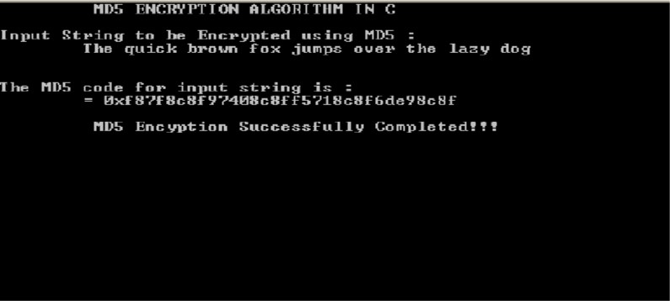

**DES**

#include <iostream>

#include <string>

#include <cmath>

using namespace std;

string Bin_to_Hex(string s);

string Hex_to_Bin(string s);

string Dec_to_Bin(int n);

class DES_Encryption

{

// constants regarding the keys

const int pc_1[56] = { 57 ,49 ,41 ,33 ,25 ,17 ,9 ,

1 ,58 ,50 ,42 ,34 ,26 ,18 ,

10 ,2 ,59 ,51 ,43 ,35 ,27 ,

19 ,11 ,3 ,60 ,52 ,44 ,36 ,

63 ,55 ,47 ,39 ,31 ,23 ,15 ,

7 ,62 ,54 ,46 ,38 ,30 ,22 ,

14 ,6 ,61 ,53 ,45 ,37 ,29 ,

21 ,13 ,5 ,28 ,20 ,12 ,4 };

int num_leftShift[16] = { 1, 1, 2, 2, 2, 2, 2, 2, 1, 2, 2, 2, 2, 2, 2, 1 }; // number of bits to shift for each iteration

const int pc_2[48] = { 14 ,17 ,11 ,24 ,1 ,5 ,

3 ,28 ,15 ,6 ,21 ,10 ,

23 ,19 ,12 ,4 ,26 ,8 ,

16 ,7 ,27 ,20 ,13 ,2 ,

41 ,52 ,31 ,37 ,47 ,55 ,

30 ,40 ,51 ,45 ,33 ,48 ,

44 ,49 ,39 ,56 ,34 ,53 ,

46 ,42 ,50 ,36 ,29 ,32 };

// constants regarding the plain text

const int IP_t[64] = { 58 ,50 ,42 ,34 ,26 ,18 ,10 ,2 , // intital permutation table

60 ,52 ,44 ,36 ,28 ,20 ,12 ,4 ,

62 ,54 ,46 ,38 ,30 ,22 ,14 ,6 ,

64 ,56 ,48 ,40 ,32 ,24 ,16 ,8 ,

57 ,49 ,41 ,33 ,25 ,17 ,9 ,1 ,

59 ,51 ,43 ,35 ,27 ,19 ,11 ,3 ,

61 ,53 ,45 ,37 ,29 ,21 ,13 ,5 ,

63 ,55 ,47 ,39 ,31 ,23 ,15 ,7 };

const int E_t[48] = { 32 ,1 ,2 ,3 ,4 ,5 , // expantion table

4 ,5 ,6 ,7 ,8 ,9 ,

8 ,9 ,10 ,11 ,12 ,13 ,

12 ,13 ,14 ,15 ,16 ,17 ,

16 ,17 ,18 ,19 ,20 ,21 ,

20 ,21 ,22 ,23 ,24 ,25 ,

24 ,25 ,26 ,27 ,28 ,29 ,

28 ,29 ,30 ,31 ,32 ,1 };

int S[8][4][16] = { // S-box

{

{ 14,4,13,1,2,15,11,8,3,10,6,12,5,9,0,7 },

{ 0,15,7,4,14,2,13,1,10,6,12,11,9,5,3,8 },

{ 4,1,14,8,13,6,2,11,15,12,9,7,3,10,5,0 },

{ 15,12,8,2,4,9,1,7,5,11,3,14,10,0,6,13 }

},

{

{ 15,1,8,14,6,11,3,4,9,7,2,13,12,0,5,10 },

{ 3,13,4,7,15,2,8,14,12,0,1,10,6,9,11,5 },

{ 0,14,7,11,10,4,13,1,5,8,12,6,9,3,2,15 },

{ 13,8,10,1,3,15,4,2,11,6,7,12,0,5,14,9 }

},

{

{ 10,0,9,14,6,3,15,5,1,13,12,7,11,4,2,8 },

{ 13,7,0,9,3,4,6,10,2,8,5,14,12,11,15,1 },

{ 13,6,4,9,8,15,3,0,11,1,2,12,5,10,14,7 },

{ 1,10,13,0,6,9,8,7,4,15,14,3,11,5,2,12 }

},

{

{ 7,13,14,3,0,6,9,10,1,2,8,5,11,12,4,15 },

{ 13,8,11,5,6,15,0,3,4,7,2,12,1,10,14,9 },

{ 10,6,9,0,12,11,7,13,15,1,3,14,5,2,8,4 },

{ 3,15,0,6,10,1,13,8,9,4,5,11,12,7,2,14 }

},

{

{ 2,12,4,1,7,10,11,6,8,5,3,15,13,0,14,9 },

{ 14,11,2,12,4,7,13,1,5,0,15,10,3,9,8,6 },

{ 4,2,1,11,10,13,7,8,15,9,12,5,6,3,0,14 },

{ 11,8,12,7,1,14,2,13,6,15,0,9,10,4,5,3 }

},

{

{ 12,1,10,15,9,2,6,8,0,13,3,4,14,7,5,11 },

{ 10,15,4,2,7,12,9,5,6,1,13,14,0,11,3,8 },

{ 9,14,15,5,2,8,12,3,7,0,4,10,1,13,11,6 },

{ 4,3,2,12,9,5,15,10,11,14,1,7,6,0,8,13 }

},

{

{ 4,11,2,14,15,0,8,13,3,12,9,7,5,10,6,1 },

{ 13,0,11,7,4,9,1,10,14,3,5,12,2,15,8,6 },

{ 1,4,11,13,12,3,7,14,10,15,6,8,0,5,9,2 },

{ 6,11,13,8,1,4,10,7,9,5,0,15,14,2,3,12 }

},

{

{ 13,2,8,4,6,15,11,1,10,9,3,14,5,0,12,7 },

{ 1,15,13,8,10,3,7,4,12,5,6,11,0,14,9,2 },

{ 7,11,4,1,9,12,14,2,0,6,10,13,15,3,5,8 },

{ 2,1,14,7,4,10,8,13,15,12,9,0,3,5,6,11 }

}

};

const int P[32] = { 16 ,7 ,20 ,21 ,

29 ,12 ,28 ,17 ,

1 ,15 ,23 ,26 ,

5 ,18 ,31 ,10 ,

2 ,8 ,24 ,14 ,

32 ,27 ,3 ,9 ,

19 ,13 ,30 ,6 ,

22 ,11 ,4 ,25 };

const int P_1[64] = { 40 ,8 ,48 ,16 ,56 ,24 ,64 ,32 ,

39 ,7 ,47 ,15 ,55 ,23 ,63 ,31 ,

38 ,6 ,46 ,14 ,54 ,22 ,62 ,30 ,

37 ,5 ,45 ,13 ,53 ,21 ,61 ,29 ,

36 ,4 ,44 ,12 ,52 ,20 ,60 ,28 ,

35 ,3 ,43 ,11 ,51 ,19 ,59 ,27 ,

34 ,2 ,42 ,10 ,50 ,18 ,58 ,26 ,

33 ,1 ,41 ,9 ,49 ,17 ,57 ,25 };

// some functions

string shift_bit(string s, int n)

{

string k = "";

for (int i = n; i < s.size(); i++)

k += s[i];

for (int i = 0; i < n; i++)

k += s[i];

return k;

}

void expand_R(string r, string r32) // expanding according to expantion table E_t

{

r = "";

for (int j = 0; j < 48; j++)

{

r += r32[E_t[j] - 1];

}

}

string xor_add(string s1, string s2)

{

string result = "";

for (int j = 0; j < s1.size(); j++) {

if (s1[j] != s2[j]) result += '1';

else result += '0';

}

return result;

}

string get_element_from_box(string s, int k)

{

int dec1 = 0, dec2 = 0, pwr = 0;

dec1 = (int)(s[0] - '0') * 2 + (int)(s[5] - '0');

for (int i = s.size() - 2; i >= 1; i--)

{

dec2 += (int)(s[i] - '0') * pow(2, pwr++);

}

return Dec_to_Bin(S[k][dec1][dec2]);

}

public:

void encrypt(const string& plain_txt, const string& key)

{

// making sub-keys

string key_64 = Hex_to_Bin(key);

string key_56 = "";

string key_firstHalf = "", key_secondHalf = "";

for (int i = 0; i < 56; i++)

key_56 += key_64[pc_1[i] - 1];

for (int i = 0; i < 28; i++)

key_firstHalf += key_56[i];

for (int i = 28; i < 56; i++) {

key_secondHalf += key_56[i];

}

string L_key[16], R_key[16];

L_key[0] = shift_bit(key_firstHalf, num_leftShift[0]); // shifting the bits according to num_leftSifht

R_key[0] = shift_bit(key_secondHalf, num_leftShift[0]);

for (int i = 1; i < 16; i++)

{

L_key[i] = shift_bit(L_key[i - 1], num_leftShift[i]);

R_key[i] = shift_bit(R_key[i - 1], num_leftShift[i]);

}

string key_48[16], keys_56[16];

for (int i = 0; i < 16; i++)

{

keys_56[i] = L_key[i] + R_key[i]; // making 56 bits keys

}

for (int i = 0; i < 16; i++)

{

key_48[i] = "";

for (int j = 0; j < 48; j++)

key_48[i] += keys_56[i][pc_2[j] - 1]; // making 48 bits keys

}

// working on the plain text

string plain_txt_64 = Hex_to_Bin(plain_txt); // transforming key from 16-bits hex to 64-bits bin

string IP = ""; // permuted key

for (int i = 0; i < 64; i++)

IP += plain_txt_64[IP_t[i] - 1];

string L = "", R = "";

for (int i = 0; i < 32; i++)

L += IP[i];

for (int i = 32; i < 64; i++)

R += IP[i];

string L_32[16], R_32[16];

string R_xor_K[16];

string R_48[16]; // making R_32 48 bits so that we can xor it with key_48 (wich is 48 bits)

string S_R[16], s[16][8];

string s_1[16];

string P_R[16];

R_48[0] = "";

for (int j = 0; j < 48; j++)

R_48[0] += R[E_t[j] - 1];

R_xor_K[0] = xor_add(R_48[0], key_48[0]); // fill the R_xor_K array

for (int j = 0; j <48; j += 6) // dividing each value of R_xor_K to 8 string contaning 6 char each

for (int k = j; k < j + 6; k++)

s[0][j / 6] += R_xor_K[0][k];

s_1[0] = "";

for (int j = 0; j < 8; j++)

s_1[0] += get_element_from_box(s[0][j], j);

for (int j = 0; j < 32; j++)

P_R[0] += s_1[0][P[j] - 1];

L_32[0] = R;

R_32[0] = "";

R_32[0] = xor_add(P_R[0], L);

for (int i = 1; i < 16; i++)

{

L_32[i] = R_32[i - 1];

R_48[i] = "";

for (int j = 0; j < 48; j++)

R_48[i] += R_32[i - 1][E_t[j] - 1];

R_xor_K[i] = xor_add(R_48[i], key_48[i]); // fill the R_xor_K

for (int j = 0; j <48; j += 6) // dividing each value of R_xor_K to 8 string contaning 6 char each

for (int k = j; k < j + 6; k++)

s[i][j / 6] += R_xor_K[i][k];

s_1[i] = "";

for (int j = 0; j < 8; j++)

s_1[i] += get_element_from_box(s[i][j], j);

for (int j = 0; j < 32; j++)

P_R[i] += s_1[i][P[j] - 1];

L_32[i] = R_32[i - 1];

R_32[i] = "";

R_32[i] = xor_add(P_R[i], L_32[i - 1]);

}

string encrypted_bin = "", RL;

RL = R_32[15] + L_32[15];

for (int i = 0; i < 64; i++)

encrypted_bin += RL[P_1[i] - 1];

cout << Bin_to_Hex(encrypted_bin) << endl;

}

};

int main()

{

DES_Encryption DES;

bool is_valid;

string plain_txt, key;

cout << "Enter PLAIN TEXT of EXACTLY 16 character written in hexadecimal : ";

do {

is_valid = true;

cin >> plain_txt;

if (plain_txt.size() != 16)

is_valid = false;

else

{

for (int i = 0; i < plain_txt.size(); i++)

if (!((plain_txt[i] <= 'f' && plain_txt[i] >= 'a') ||

(plain_txt[i] <= 'F' && plain_txt[i] >= 'A') ||

(plain_txt[i] >= '0' && plain_txt[i] <= '9')))

{

is_valid = false;

break;

}

}

if (!is_valid)

cout << "invalid input, try again : ";

} while (!is_valid);

cout << "Enter a KEY of EXACTLY 16 character written in hexadecimal : ";

do {

is_valid = true;

cin >> key;

if (key.size() != 16)

is_valid = false;

else

{

for (int i = 0; i < key.size(); i++)

if (!((key[i] <= 'f' && key[i] >= 'a') ||

(key[i] <= 'F' && key[i] >= 'A') ||

(key[i] >= '0' && key[i] <= '9')))

{

is_valid = false;

break;

}

}

if (!is_valid)

cout << "invalid input, try again : ";

} while (!is_valid);

DES.encrypt(plain_txt, key);

return 0;

}

string Bin_to_Hex(string s)

{

string hex = "";

for (int i = 0; i < s.size(); i += 4)

{

string k = "";

for (int j = i; j < i + 4; j++)

k += s[j];

if (k == "0000")

hex += '0';

else if (k == "0001")

hex += '1';

else if (k == "0010")

hex += '2';

else if (k == "0011")

hex += '3';

else if (k == "0100")

hex += '4';

else if (k == "0101")

hex += '5';

else if (k == "0110")

hex += '6';

else if (k == "0111")

hex += '7';

else if (k == "1000")

hex += '8';

else if (k == "1001")

hex += '9';

else if (k == "1010")

hex += 'A';

else if (k == "1011")

hex += 'B';

else if (k == "1100")

hex += 'C';

else if (k == "1101")

hex += 'D';

else if (k == "1110")

hex += 'E';

else if (k == "1111")

hex += 'F';

}

return hex;

}

string Hex_to_Bin(string s)

{

string bin = "";

for (int i = 0; i < s.size(); i++)

{

switch (s[i])

{

case '0': bin += "0000"; break;

case '1': bin += "0001"; break;

case '2': bin += "0010"; break;

case '3': bin += "0011"; break;

case '4': bin += "0100"; break;

case '5': bin += "0101"; break;

case '6': bin += "0110"; break;

case '7': bin += "0111"; break;

case '8': bin += "1000"; break;

case '9': bin += "1001"; break;

case 'A':

case 'a': bin += "1010"; break;

case 'B':

case 'b': bin += "1011"; break;

case 'C':

case 'c': bin += "1100"; break;

case 'D':

case 'd': bin += "1101"; break;

case 'E':

case 'e': bin += "1110"; break;

case 'F':

case 'f': bin += "1111"; break;

}

}

return bin;

}

string Dec_to_Bin(int n)

{

string bin = "";

while (n > 0)

{

bin = (char)(n % 2 + '0') + bin;

n /= 2;

}

while (bin.size() < 4)

bin = '0' + bin;

return bin;

}



Blowfish Algorithm

p = [

0x243F6A88, 0x85A308D3, 0x13198A2E, 0x03707344,

0xA4093822, 0x299F31D0, 0x082EFA98, 0xEC4E6C89,

0x452821E6, 0x38D01377, 0xBE5466CF, 0x34E90C6C,

0xC0AC29B7, 0xC97C50DD, 0x3F84D5B5, 0xB5470917,

0x9216D5D9, 0x8979FB1B

]

s = [

[

0xD1310BA6, 0x98DFB5AC, 0x2FFD72DB, 0xD01ADFB7,

0xB8E1AFED, 0x6A267E96, 0xBA7C9045, 0xF12C7F99,

0x24A19947, 0xB3916CF7, 0x0801F2E2, 0x858EFC16,

0x636920D8, 0x71574E69, 0xA458FEA3, 0xF4933D7E,

0x0D95748F, 0x728EB658, 0x718BCD58, 0x82154AEE,

0x7B54A41D, 0xC25A59B5, 0x9C30D539, 0x2AF26013,

0xC5D1B023, 0x286085F0, 0xCA417918, 0xB8DB38EF,

0x8E79DCB0, 0x603A180E, 0x6C9E0E8B, 0xB01E8A3E,

0xD71577C1, 0xBD314B27, 0x78AF2FDA, 0x55605C60,

0xE65525F3, 0xAA55AB94, 0x57489862, 0x63E81440,

0x55CA396A, 0x2AAB10B6, 0xB4CC5C34, 0x1141E8CE,

0xA15486AF, 0x7C72E993, 0xB3EE1411, 0x636FBC2A,

0x2BA9C55D, 0x741831F6, 0xCE5C3E16, 0x9B87931E,

0xAFD6BA33, 0x6C24CF5C, 0x7A325381, 0x28958677,

0x3B8F4898, 0x6B4BB9AF, 0xC4BFE81B, 0x66282193,

0x61D809CC, 0xFB21A991, 0x487CAC60, 0x5DEC8032,

0xEF845D5D, 0xE98575B1, 0xDC262302, 0xEB651B88,

0x23893E81, 0xD396ACC5, 0x0F6D6FF3, 0x83F44239,

0x2E0B4482, 0xA4842004, 0x69C8F04A, 0x9E1F9B5E,

0x21C66842, 0xF6E96C9A, 0x670C9C61, 0xABD388F0,

0x6A51A0D2, 0xD8542F68, 0x960FA728, 0xAB5133A3,

0x6EEF0B6C, 0x137A3BE4, 0xBA3BF050, 0x7EFB2A98,

0xA1F1651D, 0x39AF0176, 0x66CA593E, 0x82430E88,

0x8CEE8619, 0x456F9FB4, 0x7D84A5C3, 0x3B8B5EBE,

0xE06F75D8, 0x85C12073, 0x401A449F, 0x56C16AA6,

0x4ED3AA62, 0x363F7706, 0x1BFEDF72, 0x429B023D,

0x37D0D724, 0xD00A1248, 0xDB0FEAD3, 0x49F1C09B,

0x075372C9, 0x80991B7B, 0x25D479D8, 0xF6E8DEF7,

0xE3FE501A, 0xB6794C3B, 0x976CE0BD, 0x04C006BA,

0xC1A94FB6, 0x409F60C4, 0x5E5C9EC2, 0x196A2463,

0x68FB6FAF, 0x3E6C53B5, 0x1339B2EB, 0x3B52EC6F,

0x6DFC511F, 0x9B30952C, 0xCC814544, 0xAF5EBD09,

0xBEE3D004, 0xDE334AFD, 0x660F2807, 0x192E4BB3,

0xC0CBA857, 0x45C8740F, 0xD20B5F39, 0xB9D3FBDB,

0x5579C0BD, 0x1A60320A, 0xD6A100C6, 0x402C7279,

0x679F25FE, 0xFB1FA3CC, 0x8EA5E9F8, 0xDB3222F8,

0x3C7516DF, 0xFD616B15, 0x2F501EC8, 0xAD0552AB,

0x323DB5FA, 0xFD238760, 0x53317B48, 0x3E00DF82,

0x9E5C57BB, 0xCA6F8CA0, 0x1A87562E, 0xDF1769DB,

0xD542A8F6, 0x287EFFC3, 0xAC6732C6, 0x8C4F5573,

0x695B27B0, 0xBBCA58C8, 0xE1FFA35D, 0xB8F011A0,

0x10FA3D98, 0xFD2183B8, 0x4AFCB56C, 0x2DD1D35B,

0x9A53E479, 0xB6F84565, 0xD28E49BC, 0x4BFB9790,

0xE1DDF2DA, 0xA4CB7E33, 0x62FB1341, 0xCEE4C6E8,

0xEF20CADA, 0x36774C01, 0xD07E9EFE, 0x2BF11FB4,

0x95DBDA4D, 0xAE909198, 0xEAAD8E71, 0x6B93D5A0,

0xD08ED1D0, 0xAFC725E0, 0x8E3C5B2F, 0x8E7594B7,

0x8FF6E2FB, 0xF2122B64, 0x8888B812, 0x900DF01C,

0x4FAD5EA0, 0x688FC31C, 0xD1CFF191, 0xB3A8C1AD,

0x2F2F2218, 0xBE0E1777, 0xEA752DFE, 0x8B021FA1,

0xE5A0CC0F, 0xB56F74E8, 0x18ACF3D6, 0xCE89E299,

0xB4A84FE0, 0xFD13E0B7, 0x7CC43B81, 0xD2ADA8D9,

0x165FA266, 0x80957705, 0x93CC7314, 0x211A1477,

0xE6AD2065, 0x77B5FA86, 0xC75442F5, 0xFB9D35CF,

0xEBCDAF0C, 0x7B3E89A0, 0xD6411BD3, 0xAE1E7E49,

0x00250E2D, 0x2071B35E, 0x226800BB, 0x57B8E0AF,

0x2464369B, 0xF009B91E, 0x5563911D, 0x59DFA6AA,

0x78C14389, 0xD95A537F, 0x207D5BA2, 0x02E5B9C5,

0x83260376, 0x6295CFA9, 0x11C81968, 0x4E734A41,

0xB3472DCA, 0x7B14A94A, 0x1B510052, 0x9A532915,

0xD60F573F, 0xBC9BC6E4, 0x2B60A476, 0x81E67400,

0x08BA6FB5, 0x571BE91F, 0xF296EC6B, 0x2A0DD915,

0xB6636521, 0xE7B9F9B6, 0xFF34052E, 0xC5855664,

0x53B02D5D, 0xA99F8FA1, 0x08BA4799, 0x6E85076A

],

[

0x4B7A70E9, 0xB5B32944, 0xDB75092E, 0xC4192623,

0xAD6EA6B0, 0x49A7DF7D, 0x9CEE60B8, 0x8FEDB266,

0xECAA8C71, 0x699A17FF, 0x5664526C, 0xC2B19EE1,

0x193602A5, 0x75094C29, 0xA0591340, 0xE4183A3E,

0x3F54989A, 0x5B429D65, 0x6B8FE4D6, 0x99F73FD6,

0xA1D29C07, 0xEFE830F5, 0x4D2D38E6, 0xF0255DC1,

0x4CDD2086, 0x8470EB26, 0x6382E9C6, 0x021ECC5E,

0x09686B3F, 0x3EBAEFC9, 0x3C971814, 0x6B6A70A1,

0x687F3584, 0x52A0E286, 0xB79C5305, 0xAA500737,

0x3E07841C, 0x7FDEAE5C, 0x8E7D44EC, 0x5716F2B8,

0xB03ADA37, 0xF0500C0D, 0xF01C1F04, 0x0200B3FF,

0xAE0CF51A, 0x3CB574B2, 0x25837A58, 0xDC0921BD,

0xD19113F9, 0x7CA92FF6, 0x94324773, 0x22F54701,

0x3AE5E581, 0x37C2DADC, 0xC8B57634, 0x9AF3DDA7,

0xA9446146, 0x0FD0030E, 0xECC8C73E, 0xA4751E41,

0xE238CD99, 0x3BEA0E2F, 0x3280BBA1, 0x183EB331,

0x4E548B38, 0x4F6DB908, 0x6F420D03, 0xF60A04BF,

0x2CB81290, 0x24977C79, 0x5679B072, 0xBCAF89AF,

0xDE9A771F, 0xD9930810, 0xB38BAE12, 0xDCCF3F2E,

0x5512721F, 0x2E6B7124, 0x501ADDE6, 0x9F84CD87,

0x7A584718, 0x7408DA17, 0xBC9F9ABC, 0xE94B7D8C,

0xEC7AEC3A, 0xDB851DFA, 0x63094366, 0xC464C3D2,

0xEF1C1847, 0x3215D908, 0xDD433B37, 0x24C2BA16,

0x12A14D43, 0x2A65C451, 0x50940002, 0x133AE4DD,

0x71DFF89E, 0x10314E55, 0x81AC77D6, 0x5F11199B,

0x043556F1, 0xD7A3C76B, 0x3C11183B, 0x5924A509,

0xF28FE6ED, 0x97F1FBFA, 0x9EBABF2C, 0x1E153C6E,

0x86E34570, 0xEAE96FB1, 0x860E5E0A, 0x5A3E2AB3,

0x771FE71C, 0x4E3D06FA, 0x2965DCB9, 0x99E71D0F,

0x803E89D6, 0x5266C825, 0x2E4CC978, 0x9C10B36A,

0xC6150EBA, 0x94E2EA78, 0xA5FC3C53, 0x1E0A2DF4,

0xF2F74EA7, 0x361D2B3D, 0x1939260F, 0x19C27960,

0x5223A708, 0xF71312B6, 0xEBADFE6E, 0xEAC31F66,

0xE3BC4595, 0xA67BC883, 0xB17F37D1, 0x018CFF28,

0xC332DDEF, 0xBE6C5AA5, 0x65582185, 0x68AB9802,

0xEECEA50F, 0xDB2F953B, 0x2AEF7DAD, 0x5B6E2F84,

0x1521B628, 0x29076170, 0xECDD4775, 0x619F1510,

0x13CCA830, 0xEB61BD96, 0x0334FE1E, 0xAA0363CF,

0xB5735C90, 0x4C70A239, 0xD59E9E0B, 0xCBAADE14,

0xEECC86BC, 0x60622CA7, 0x9CAB5CAB, 0xB2F3846E,

0x648B1EAF, 0x19BDF0CA, 0xA02369B9, 0x655ABB50,

0x40685A32, 0x3C2AB4B3, 0x319EE9D5, 0xC021B8F7,

0x9B540B19, 0x875FA099, 0x95F7997E, 0x623D7DA8,

0xF837889A, 0x97E32D77, 0x11ED935F, 0x16681281,

0x0E358829, 0xC7E61FD6, 0x96DEDFA1, 0x7858BA99,

0x57F584A5, 0x1B227263, 0x9B83C3FF, 0x1AC24696,

0xCDB30AEB, 0x532E3054, 0x8FD948E4, 0x6DBC3128,

0x58EBF2EF, 0x34C6FFEA, 0xFE28ED61, 0xEE7C3C73,

0x5D4A14D9, 0xE864B7E3, 0x42105D14, 0x203E13E0,

0x45EEE2B6, 0xA3AAABEA, 0xDB6C4F15, 0xFACB4FD0,

0xC742F442, 0xEF6ABBB5, 0x654F3B1D, 0x41CD2105,

0xD81E799E, 0x86854DC7, 0xE44B476A, 0x3D816250,

0xCF62A1F2, 0x5B8D2646, 0xFC8883A0, 0xC1C7B6A3,

0x7F1524C3, 0x69CB7492, 0x47848A0B, 0x5692B285,

0x095BBF00, 0xAD19489D, 0x1462B174, 0x23820E00,

0x58428D2A, 0x0C55F5EA, 0x1DADF43E, 0x233F7061,

0x3372F092, 0x8D937E41, 0xD65FECF1, 0x6C223BDB,

0x7CDE3759, 0xCBEE7460, 0x4085F2A7, 0xCE77326E,

0xA6078084, 0x19F8509E, 0xE8EFD855, 0x61D99735,

0xA969A7AA, 0xC50C06C2, 0x5A04ABFC, 0x800BCADC,

0x9E447A2E, 0xC3453484, 0xFDD56705, 0x0E1E9EC9,

0xDB73DBD3, 0x105588CD, 0x675FDA79, 0xE3674340,

0xC5C43465, 0x713E38D8, 0x3D28F89E, 0xF16DFF20,

0x153E21E7, 0x8FB03D4A, 0xE6E39F2B, 0xDB83ADF7

],

[

0xE93D5A68, 0x948140F7, 0xF64C261C, 0x94692934,

0x411520F7, 0x7602D4F7, 0xBCF46B2E, 0xD4A20068,

0xD4082471, 0x3320F46A, 0x43B7D4B7, 0x500061AF,

0x1E39F62E, 0x97244546, 0x14214F74, 0xBF8B8840,

0x4D95FC1D, 0x96B591AF, 0x70F4DDD3, 0x66A02F45,

0xBFBC09EC, 0x03BD9785, 0x7FAC6DD0, 0x31CB8504,

0x96EB27B3, 0x55FD3941, 0xDA2547E6, 0xABCA0A9A,

0x28507825, 0x530429F4, 0x0A2C86DA, 0xE9B66DFB,

0x68DC1462, 0xD7486900, 0x680EC0A4, 0x27A18DEE,

0x4F3FFEA2, 0xE887AD8C, 0xB58CE006, 0x7AF4D6B6,

0xAACE1E7C, 0xD3375FEC, 0xCE78A399, 0x406B2A42,

0x20FE9E35, 0xD9F385B9, 0xEE39D7AB, 0x3B124E8B,

0x1DC9FAF7, 0x4B6D1856, 0x26A36631, 0xEAE397B2,

0x3A6EFA74, 0xDD5B4332, 0x6841E7F7, 0xCA7820FB,

0xFB0AF54E, 0xD8FEB397, 0x454056AC, 0xBA489527,

0x55533A3A, 0x20838D87, 0xFE6BA9B7, 0xD096954B,

0x55A867BC, 0xA1159A58, 0xCCA92963, 0x99E1DB33,

0xA62A4A56, 0x3F3125F9, 0x5EF47E1C, 0x9029317C,

0xFDF8E802, 0x04272F70, 0x80BB155C, 0x05282CE3,

0x95C11548, 0xE4C66D22, 0x48C1133F, 0xC70F86DC,

0x07F9C9EE, 0x41041F0F, 0x404779A4, 0x5D886E17,

0x325F51EB, 0xD59BC0D1, 0xF2BCC18F, 0x41113564,

0x257B7834, 0x602A9C60, 0xDFF8E8A3, 0x1F636C1B,

0x0E12B4C2, 0x02E1329E, 0xAF664FD1, 0xCAD18115,

0x6B2395E0, 0x333E92E1, 0x3B240B62, 0xEEBEB922,

0x85B2A20E, 0xE6BA0D99, 0xDE720C8C, 0x2DA2F728,

0xD0127845, 0x95B794FD, 0x647D0862, 0xE7CCF5F0,

0x5449A36F, 0x877D48FA, 0xC39DFD27, 0xF33E8D1E,

0x0A476341, 0x992EFF74, 0x3A6F6EAB, 0xF4F8FD37,

0xA812DC60, 0xA1EBDDF8, 0x991BE14C, 0xDB6E6B0D,

0xC67B5510, 0x6D672C37, 0x2765D43B, 0xDCD0E804,

0xF1290DC7, 0xCC00FFA3, 0xB5390F92, 0x690FED0B,

0x667B9FFB, 0xCEDB7D9C, 0xA091CF0B, 0xD9155EA3,

0xBB132F88, 0x515BAD24, 0x7B9479BF, 0x763BD6EB,

0x37392EB3, 0xCC115979, 0x8026E297, 0xF42E312D,

0x6842ADA7, 0xC66A2B3B, 0x12754CCC, 0x782EF11C,

0x6A124237, 0xB79251E7, 0x06A1BBE6, 0x4BFB6350,

0x1A6B1018, 0x11CAEDFA, 0x3D25BDD8, 0xE2E1C3C9,

0x44421659, 0x0A121386, 0xD90CEC6E, 0xD5ABEA2A,

0x64AF674E, 0xDA86A85F, 0xBEBFE988, 0x64E4C3FE,

0x9DBC8057, 0xF0F7C086, 0x60787BF8, 0x6003604D,

0xD1FD8346, 0xF6381FB0, 0x7745AE04, 0xD736FCCC,

0x83426B33, 0xF01EAB71, 0xB0804187, 0x3C005E5F,

0x77A057BE, 0xBDE8AE24, 0x55464299, 0xBF582E61,

0x4E58F48F, 0xF2DDFDA2, 0xF474EF38, 0x8789BDC2,

0x5366F9C3, 0xC8B38E74, 0xB475F255, 0x46FCD9B9,

0x7AEB2661, 0x8B1DDF84, 0x846A0E79, 0x915F95E2,

0x466E598E, 0x20B45770, 0x8CD55591, 0xC902DE4C,

0xB90BACE1, 0xBB8205D0, 0x11A86248, 0x7574A99E,

0xB77F19B6, 0xE0A9DC09, 0x662D09A1, 0xC4324633,

0xE85A1F02, 0x09F0BE8C, 0x4A99A025, 0x1D6EFE10,

0x1AB93D1D, 0x0BA5A4DF, 0xA186F20F, 0x2868F169,

0xDCB7DA83, 0x573906FE, 0xA1E2CE9B, 0x4FCD7F52,

0x50115E01, 0xA70683FA, 0xA002B5C4, 0x0DE6D027,

0x9AF88C27, 0x773F8641, 0xC3604C06, 0x61A806B5,

0xF0177A28, 0xC0F586E0, 0x006058AA, 0x30DC7D62,

0x11E69ED7, 0x2338EA63, 0x53C2DD94, 0xC2C21634,

0xBBCBEE56, 0x90BCB6DE, 0xEBFC7DA1, 0xCE591D76,

0x6F05E409, 0x4B7C0188, 0x39720A3D, 0x7C927C24,

0x86E3725F, 0x724D9DB9, 0x1AC15BB4, 0xD39EB8FC,

0xED545578, 0x08FCA5B5, 0xD83D7CD3, 0x4DAD0FC4,

0x1E50EF5E, 0xB161E6F8, 0xA28514D9, 0x6C51133C,

0x6FD5C7E7, 0x56E14EC4, 0x362ABFCE, 0xDDC6C837,

0xD79A3234, 0x92638212, 0x670EFA8E, 0x406000E0

],

[

0x3A39CE37, 0xD3FAF5CF, 0xABC27737, 0x5AC52D1B,

0x5CB0679E, 0x4FA33742, 0xD3822740, 0x99BC9BBE,

0xD5118E9D, 0xBF0F7315, 0xD62D1C7E, 0xC700C47B,

0xB78C1B6B, 0x21A19045, 0xB26EB1BE, 0x6A366EB4,

0x5748AB2F, 0xBC946E79, 0xC6A376D2, 0x6549C2C8,

0x530FF8EE, 0x468DDE7D, 0xD5730A1D, 0x4CD04DC6,

0x2939BBDB, 0xA9BA4650, 0xAC9526E8, 0xBE5EE304,

0xA1FAD5F0, 0x6A2D519A, 0x63EF8CE2, 0x9A86EE22,

0xC089C2B8, 0x43242EF6, 0xA51E03AA, 0x9CF2D0A4,

0x83C061BA, 0x9BE96A4D, 0x8FE51550, 0xBA645BD6,

0x2826A2F9, 0xA73A3AE1, 0x4BA99586, 0xEF5562E9,

0xC72FEFD3, 0xF752F7DA, 0x3F046F69, 0x77FA0A59,

0x80E4A915, 0x87B08601, 0x9B09E6AD, 0x3B3EE593,

0xE990FD5A, 0x9E34D797, 0x2CF0B7D9, 0x022B8B51,

0x96D5AC3A, 0x017DA67D, 0xD1CF3ED6, 0x7C7D2D28,

0x1F9F25CF, 0xADF2B89B, 0x5AD6B472, 0x5A88F54C,

0xE029AC71, 0xE019A5E6, 0x47B0ACFD, 0xED93FA9B,

0xE8D3C48D, 0x283B57CC, 0xF8D56629, 0x79132E28,

0x785F0191, 0xED756055, 0xF7960E44, 0xE3D35E8C,

0x15056DD4, 0x88F46DBA, 0x03A16125, 0x0564F0BD,

0xC3EB9E15, 0x3C9057A2, 0x97271AEC, 0xA93A072A,

0x1B3F6D9B, 0x1E6321F5, 0xF59C66FB, 0x26DCF319,

0x7533D928, 0xB155FDF5, 0x03563482, 0x8ABA3CBB,

0x28517711, 0xC20AD9F8, 0xABCC5167, 0xCCAD925F,

0x4DE81751, 0x3830DC8E, 0x379D5862, 0x9320F991,

0xEA7A90C2, 0xFB3E7BCE, 0x5121CE64, 0x774FBE32,

0xA8B6E37E, 0xC3293D46, 0x48DE5369, 0x6413E680,

0xA2AE0810, 0xDD6DB224, 0x69852DFD, 0x09072166,

0xB39A460A, 0x6445C0DD, 0x586CDECF, 0x1C20C8AE,

0x5BBEF7DD, 0x1B588D40, 0xCCD2017F, 0x6BB4E3BB,

0xDDA26A7E, 0x3A59FF45, 0x3E350A44, 0xBCB4CDD5,

0x72EACEA8, 0xFA6484BB, 0x8D6612AE, 0xBF3C6F47,

0xD29BE463, 0x542F5D9E, 0xAEC2771B, 0xF64E6370,

0x740E0D8D, 0xE75B1357, 0xF8721671, 0xAF537D5D,

0x4040CB08, 0x4EB4E2CC, 0x34D2466A, 0x0115AF84,

0xE1B00428, 0x95983A1D, 0x06B89FB4, 0xCE6EA048,

0x6F3F3B82, 0x3520AB82, 0x011A1D4B, 0x277227F8,

0x611560B1, 0xE7933FDC, 0xBB3A792B, 0x344525BD,

0xA08839E1, 0x51CE794B, 0x2F32C9B7, 0xA01FBAC9,

0xE01CC87E, 0xBCC7D1F6, 0xCF0111C3, 0xA1E8AAC7,

0x1A908749, 0xD44FBD9A, 0xD0DADECB, 0xD50ADA38,

0x0339C32A, 0xC6913667, 0x8DF9317C, 0xE0B12B4F,

0xF79E59B7, 0x43F5BB3A, 0xF2D519FF, 0x27D9459C,

0xBF97222C, 0x15E6FC2A, 0x0F91FC71, 0x9B941525,

0xFAE59361, 0xCEB69CEB, 0xC2A86459, 0x12BAA8D1,

0xB6C1075E, 0xE3056A0C, 0x10D25065, 0xCB03A442,

0xE0EC6E0E, 0x1698DB3B, 0x4C98A0BE, 0x3278E964,

0x9F1F9532, 0xE0D392DF, 0xD3A0342B, 0x8971F21E,

0x1B0A7441, 0x4BA3348C, 0xC5BE7120, 0xC37632D8,

0xDF359F8D, 0x9B992F2E, 0xE60B6F47, 0x0FE3F11D,

0xE54CDA54, 0x1EDAD891, 0xCE6279CF, 0xCD3E7E6F,

0x1618B166, 0xFD2C1D05, 0x848FD2C5, 0xF6FB2299,

0xF523F357, 0xA6327623, 0x93A83531, 0x56CCCD02,

0xACF08162, 0x5A75EBB5, 0x6E163697, 0x88D273CC,

0xDE966292, 0x81B949D0, 0x4C50901B, 0x71C65614,

0xE6C6C7BD, 0x327A140A, 0x45E1D006, 0xC3F27B9A,

0xC9AA53FD, 0x62A80F00, 0xBB25BFE2, 0x35BDD2F6,

0x71126905, 0xB2040222, 0xB6CBCF7C, 0xCD769C2B,

0x53113EC0, 0x1640E3D3, 0x38ABBD60, 0x2547ADF0,

0xBA38209C, 0xF746CE76, 0x77AFA1C5, 0x20756060,

0x85CBFE4E, 0x8AE88DD8, 0x7AAAF9B0, 0x4CF9AA7E,

0x1948C25C, 0x02FB8A8C, 0x01C36AE4, 0xD6EBE1F9,

0x90D4F869, 0xA65CDEA0, 0x3F09252D, 0xC208E69F,

0xB74E6132, 0xCE77E25B, 0x578FDFE3, 0x3AC372E6

]

]

key = [ 0x4B7A70E9, 0xB5B32944, 0xDB75092E, 0xC4192623,

0xAD6EA6B0, 0x49A7DF7D, 0x9CEE60B8, 0x8FEDB266,

0xECAA8C71, 0x699A17FF, 0x5664526C, 0xC2B19EE1,

0x193602A5, 0x75094C29]

p_new = p.copy()

def swap(a,b):

temp = a

a = b

b = temp

return a,b

def driver():

for i in range(0,18):

p[i] = p[i]^key[i%14]

k = 0

data = 0

for i in range(0,9):

temp = encryption(data)

p[k] = temp >> 32

k+=1

p[k] = temp & 0xffffffff

k+=1

data = temp

encrypt_data = int(input("Enter data to encrypt: "))

encrypted_data = encryption(encrypt_data)

print("Encrypted data : ",encrypted_data)

decrypted_data = decryption(encrypted_data)

print("Decrypted data : ",decrypted_data)

def encryption(data):

L = data>>32

R = data & 0xffffffff

for i in range(0,16):

L = p[i]^L

L1 = func(L)

R = R^func(L1)

L,R = swap(L,R)

L,R = swap(L,R)

L = L^p[17]

R = R^p[16]

encrypted = (L<<32) ^ R

return encrypted

def func(L):

temp = s[0][L >> 24]

temp = (temp + s[1][L >> 16 & 0xff]) % 2**32

temp = temp ^ s[2][L >> 8 & 0xff]

temp = (temp + s[3][L & 0xff]) % 2**32

return temp

def decryption(data):

L = data >> 32

R = data & 0xffffffff

for i in range(17, 1, -1):

L = p[i]^L

L1 = func(L)

R = R^func(L1)

L,R = swap(L,R)

L,R = swap(L,R)

L = L^p[0]

R = R^p[1]

decrypted_data1 = (L<<32) ^ R

return decrypted_data1

driver()

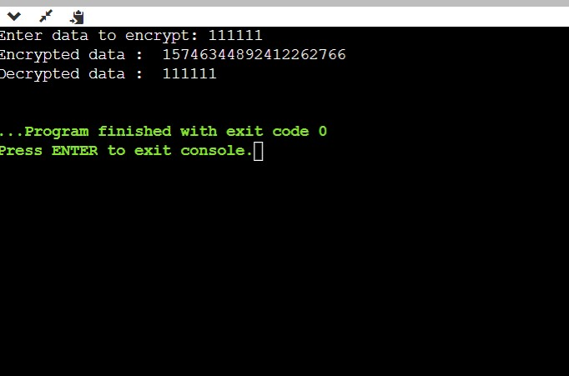

Sha Algorithm

# Python 3 code to demonstrate

# SHA hash algorithms.

import hashlib

# initializing string

str = "GeeksforGeeks"

# encoding GeeksforGeeks using encode()

# then sending to SHA256()

result = hashlib.sha256(str.encode())

# printing the equivalent hexadecimal value.

print("The hexadecimal equivalent of SHA256 is : ")

print(result.hexdigest())

print ("\r")

# initializing string

str = "GeeksforGeeks"

# encoding GeeksforGeeks using encode()

# then sending to SHA384()

result = hashlib.sha384(str.encode())

# printing the equivalent hexadecimal value.

print("The hexadecimal equivalent of SHA384 is : ")

print(result.hexdigest())

print ("\r")

# initializing string

str = "GeeksforGeeks"

# encoding GeeksforGeeks using encode()

# then sending to SHA224()

result = hashlib.sha224(str.encode())

# printing the equivalent hexadecimal value.

print("The hexadecimal equivalent of SHA224 is : ")

print(result.hexdigest())

print ("\r")

# initializing string

str = "GeeksforGeeks"

# encoding GeeksforGeeks using encode()

# then sending to SHA512()

result = hashlib.sha512(str.encode())

# printing the equivalent hexadecimal value.

print("The hexadecimal equivalent of SHA512 is : ")

print(result.hexdigest())

print ("\r")

# initializing string

str = "GeeksforGeeks"

# encoding GeeksforGeeks using encode()

# then sending to SHA1()

result = hashlib.sha1(str.encode())

# printing the equivalent hexadecimal value.

print("The hexadecimal equivalent of SHA1 is : ")

print(result.hexdigest())

