**FEASIBILITY ANALYSIS**

**OF**

**DISCUSSION PORTAL**

**DONE BY: -**

**SHRONIT BHARGAVA**

**THROUGH THE SURVEY DONE BY US IN OUR COLLEGE WE GET TO KNOW THAT: -**

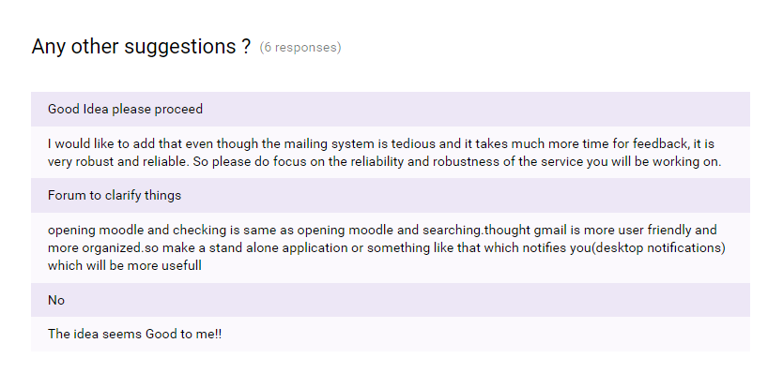

Which suggests us that:-

* Through these above given pie charts we came to know that our idea has the power of coping up with the current systems of this university.
* 84.2% of people think that the current mailing system is not up to that mark and have some problems and having a simple portal like ours is good to handle those problems.
* If this system wasn’t implemented then the reliability and usability would be degraded because mails should be sent for only official purposes, hust not for any purposes which can be, marked as spam and the reason of sending those mails are not fulfilled which is going to be completely removed after this software implementation.
* The current problem is mainly the waiting that we have to do before sharing some information (official/non-official) with all, where a student who needs to deliver an information has to first send an e-mail to the higher authorities and after their approval only the mail is sent to each and every one of us which is not that much efficient.
* This system after the Implementation will remove the above mentioned issue as the student does not have to wait for anyone’s approval. He/she just has to publish a valid post and everybody will be notified about the post and they can respond accordingly.
* Our software will have the functionality of notifying every person in this college about any possible thing so that he can know that some post has been posted.