Software Requirements Specification

for

Online Discussion Portal

Version 0.4 approved

Prepared by :-

Shronit Bhargava

18/9/16

INDEX

1. INTRODUCTION………………………………………………………….2
   1. PURPOSE…………………………………………………………………………………….2
   2. DOCUMENT CONVENTION………………………………………..……………………...2
   3. INTENDED AUDIECES AND SUGGESTED READING…………………………………2
   4. PRODUCT SCOPE…………………………………………………………………………...2
   5. REFERENCES………………………………………………………………………………..2
2. OVERALL DESCRIPTION………………………………………….........3
   1. PRODUCT PERSPECTIVE………………………………………………………………….3
   2. PRODUCT FUNCTIONS…………………………………………………………………….3
   3. USER CLASSES……………………………………………………………………………...3
   4. OPERATING ENVIRONMENT……………………………………………………………..4
   5. DESIGN CONSTRAINT……………………………………………………………………..4
   6. USER DOCUMENTATION………………………………………………………………….4
3. EXTERNAL INTERFACE REQUIREMENTS………………………….5
   1. USER INTERFACE…………………………………………………………………………..5
   2. SOFTWARE INTERFACE………………………………………………………………..…5
   3. HARDWARE INTERFACE…………………………………………………………………6
4. SYSTEM FEATURES……………………………………………………..7
5. OTHER NON FUNCTIONAL REQUIREMENTS…………………….9
   1. PERFORMANCE REQUIREMENT…………………………………………………….…9
   2. SOFTWARE QUALITY ATTRIBUTES…………………………………………………...9
   3. SAFETY REQUIREMENT…………………………………………………………………9
   4. SECURITY REQUIREMENT………………………………………………………………10

1 Introduction

* 1. Purpose

The Purpose of making this software is to reduce the time and efforts put in for doing mass mailing on some or other issues. Our product or software has very wide scope in Private / Government Colleges like ours.

* 1. Document Convention

This document is written according to the standard rules with Times New Roman Font with font size : 11 for usual text, font-size : 12 for Sub - heading and font size : 14 for Headings. In this document every requirement statement has its own priority.

* 1. Intended Audience and Reading Suggestions

This document is for all whether developer, marketing staff, project manager, user etc.

If Developer should read the document sequentially before proceeding for designing and coding.

If Project Manager should first go to Product Description then to Requirements.

If User should go for Product Description and System Features.

## Product Scope

The project is being designed in such a way that all the students and teachers inside the university can discuss about the events that are to be taken place and information is required to be spread to all the members of the university.

The further scope of this product resides in the fact that this can be used by any team or residing group where it is impossible to go and tell it to everyone in person also where emailing is not such an optimized option.

This software will give a separate platform for such discussions giving it a more of profound and optimized implementation of the concept of giving out information to a mass.

This reduces the overthrow of vast emails that one receives every day

Creating such a forum can lead to a proper implementation of issues riding inside the university where response can also be given to the authority holder.

* 1. References

The format of the SRS is based on IEEE830 document which describes about as to how a SRS document is to be prepared.

2 Overall Description

2.1 Product Perspective

This document contains the explanation of the services we are providing. This software can be a part of the “Moodle service” on going in our university, and this can work as the replacement of the email system (i.e. For any thing lost or found, for any event people have to mail to the higher authorities and then the higher authorities forward them to all)

2.2 Product Functions

* Maintain User Profile.
* Post something :-

1. Post for things lost and found.
2. Post for creation of some clubs.
3. Post for organizing some events.

* Receiving feedback on certain issues.

2.3 User Classes

Mainly the User Class of our software are the students, and it can also be used by the teachers, staff and higher authorities. And any User class should not have as such any technical expertise to use this product but the ones who are developing needs to have a Technical expertise in many fields such as :-

* Any Coding Language.
* Database Design
* Doing the front end work, etc..

2.4 Operating Environment

Our software doesn’t have as such complicacies or some special hardware and software requirements.

2.5 Design Constraints

We are making it on .net framework where our Front end work i.e. our Designing part will be based on HTML, CSS, Java script, and our Back end work i.e. coding will be done on C#. For these things we will be using Microsoft Visual Studio 2008 for our Front End and Back End work and Microsoft SQL Server Management Studio 2012 for the database work.

2.6 User Documentations

With the release of our product we will be releasing an user manual also which will help the first time user to use it properly.

2.7 Assumptions

Initially We are assuming that we will be getting access to moodle service of our university and we will be able to integrate it in moodle. But if further some issues arise we can make it an independent platform.

3 External Interface Requirements

3.1User Interface

The system shall provide a uniform look and feel between all the web pages.

The system should use of the navigation bar and icons.

* First of all our User interface would be the Login Page from where authorized person can get into our software, and if not authorized an error message would be generated inside the UI only of Unauthorized User.
* After that the User Profile page would appear where User can confirm his/her Profile and then proceed and also can update their profile and then proceed.
* After proceeding from the Profile page they would get land up on the home page where posts posted by different users will be posted would be there. Posts of some item lost would be provided by a Found button, clicking on which delete the post from our database. And also there would be tabs to navigate to the other services provided.
* Things Lost UI, where User can fill details of the item lost by them, and also possibly a picture if they have.
* Things Found UI, where a User have found something of which there is no lost post.
* Post, where User can fill the details of the post , which would be first sent to the admin of the concerned departments for validation and then only will be posted.
* For Admin also there would be login page, and a UI where he can manage the posts posted by the user.
* Admin will be given a UI to add new users.

3.2 Software Interfaces

Our product will need to have a database where we can store the post, where details of the pending dues will be stored, etc. and this database need to be connected with our product, for this we are using SQL Server Management Studio from where data can be accessed.

In our product whenever any user wishes to post anything it will be first sent to the admin/owner as in our case (Higher Authorities of university) for approval in the form of mail, for the validation so that no one can misuse our product and post some absurd things. If that post is valid by the admin/owner than only it will be posted , otherwise not.

3.3 Hardware Interfaces

Our product will work on any fully functional computer with minimal configuration and a properly working internet connection.

4 System Features

Use Case

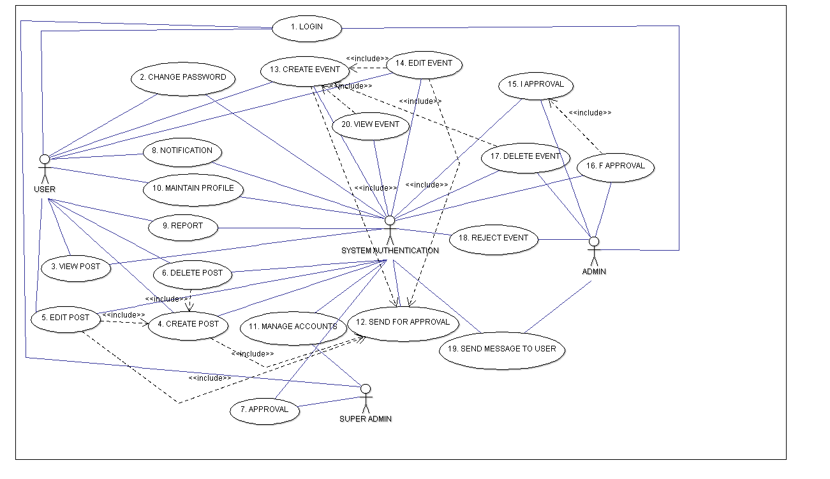

|  |  |  |
| --- | --- | --- |
| Requirement Id | Requirement Name | Description |
| R1 | Login | User, Admin needs to do login before doing anything. |
| R2 | View Post | Any User or admin can view the post about lost and found items. |
| R3 | Create Post | Any User can create a post regarding lost and found items which will be first approved by the admin and then posted. |
| R4 | Edit Post | Any User posted any post can also edit the post. |
| R5 | Delete Post | Any User posting some post can also delete that post, that post can also be deleted by admin. |
| R6 | Approve Post | Any post before posting is being approved by the admin. |
| R7 | Maintain Profile | Any User using this portal can maintain his or/her profile. |
| R8 | Manage Accounts | Admin can manage accounts of the user. |
| R9 | Add User | Admin can add new users. |
| R10 | Report User | Any abusive thing can be reported to the admin by any user. |
| R11 | Notification | Any User using this portal will be notified for the new post. |
| R12 | Create Event | Any user can create any post for organizing any event, which will include adding date for event, venue for event and concerned department. |
| R13 | I Approval | Any event created needs to undergo chain of approvals, so it is the first stage of approval. |
| R14 | F Approval | Final Stage of Approval. |
| R15 | Edit Event | Any Event created can be edited by the user. |
| R16 | Send message to User | Any admin I Approval admin or F Approval admin can send message to user for any changes in the event. |
| R17 | Reject Event | Any Admin can reject the event. |
| R18 | Delete Event | Any event posted will be deleted automatically after the event has happened. |
| R19 | Change Password/Forgot Password | Any User who wants to change their password can change it. |
| R20 | View Event | Any user can view the events posted by anyone. |

5 Other Non - Functional Requirements

5.1 Performance Requirement

Our Product should perform well in all conditions (i.e. should work on the PC with minimal configuration, should work when there is slow internet connection, our database size should be such that data don’t get overflow, our product should work well even when there is more traffic on the server instead of getting crashed.)

5.2 Software Quality Attributes

Our software must fulfill these attributes: -

* Adaptable: - Means it should adapt itself efficiently and fast to changed circumstances. It should be able to fit its behavior according to changes in environment or in parts of the system itself.
* Correctness: - Means it should always generate the correct results. There should not be any conditions which can alter the results and make them incorrect.
* Availability: - Means our product should be easily available to its customer.
* Flexibility: - Means it should have the ability to adapt according to some future requirements changes.
* Maintainability: - Means it should be maintainable i.e. in future if some changes are to be made, can be made easily, and should not change the structure or architecture of whole software.
* Testability: - Means that developers should be able to test the software easily.
* Usability: - Means that it should easy for the users to use.
  1. Safety Requirements
* The database should not be accessible for deletion and edition of data for user should only be accessible to admin.
* There should be proper management of data so data should not get lost.
* Proper Encryption of data and server should be there.
* Testing server and web for heavy traffic just to ensure that the server does not crash on heavy loads.

## Security Requirements

* The portal should be built in such a way that it provides data security.
* Encryption needs to be done in order to maintain the website secure from hackers.
* Proper Maintenance of the server is required.
* Only admin access should be encrypted.
* Privacy of data of users should be there.