**Name: Bhargava Varanasi**

**Certification Project – 1:**

* Use the Master VM for Jenkins, Ansible, GIT etc.
* Use the fresh instance for Jenkins Slave Node (Test Server)
* Change the IP address of the VMs accordingly
* Add Build Pipeline Plugin and Post-build task plugin to Jenkins on the master VM
* Install python, openssh-server and git on the slave node manually
* Use the image devopsedu/webapp and add your PHP website to it using a Dockerfile
* Push the PHP website, and the Dockerfile to a git repository

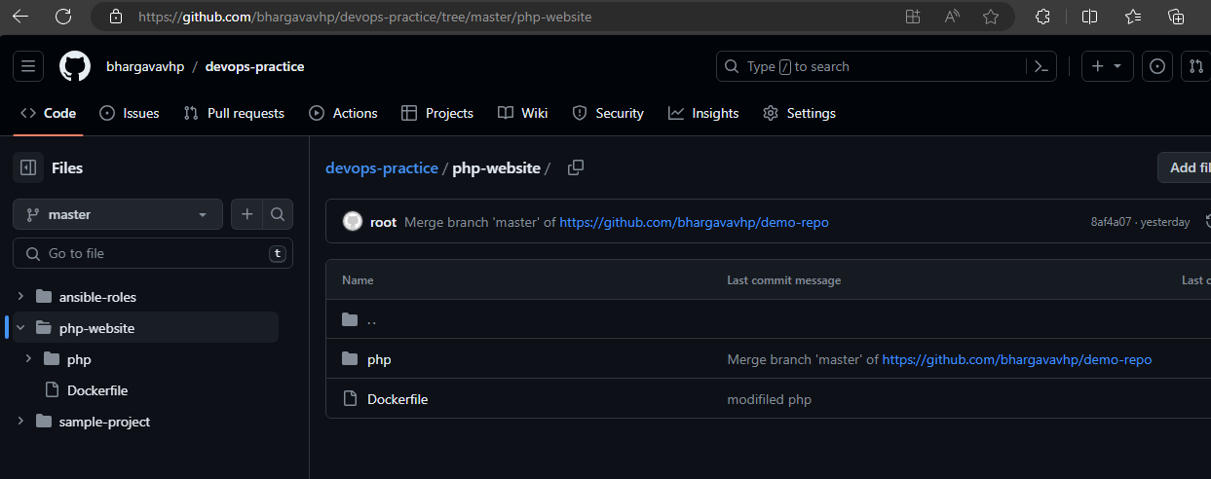

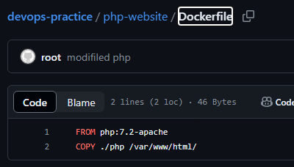

Configure github webhook for the project

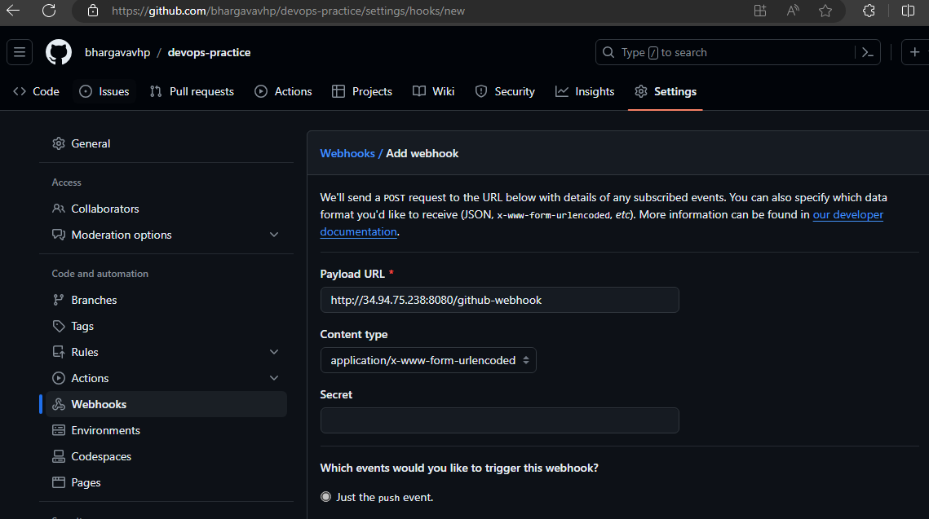

Below tasks should be automated through Jenkins by creating a pipeline:

**1.Install and configure puppet agent on the slave node (Job 1)**

Test-server Jenkins slave is added to Jenkins master, “Deploy Puppet Agent” job is created.

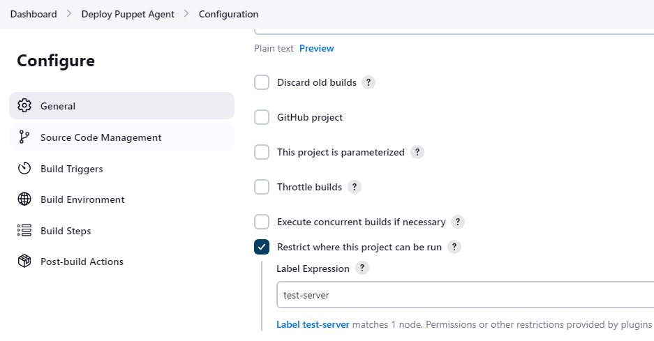

Trigger this job using github webhook

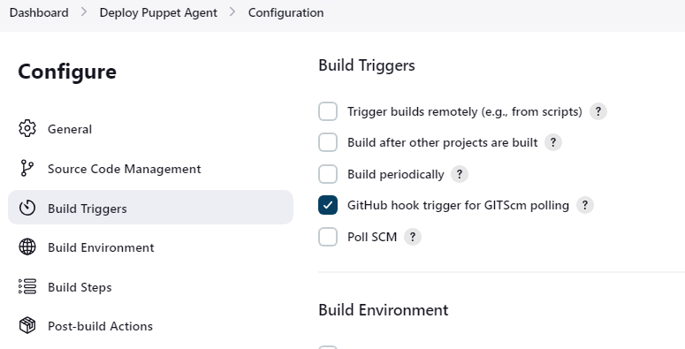

Execute commands to install puppet-agent on test-server node

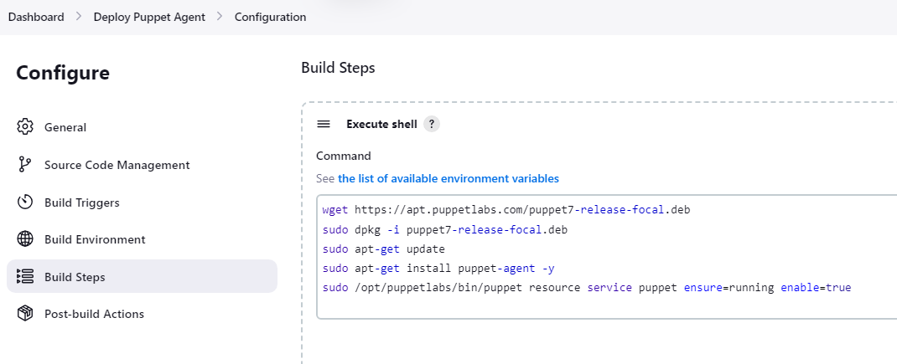

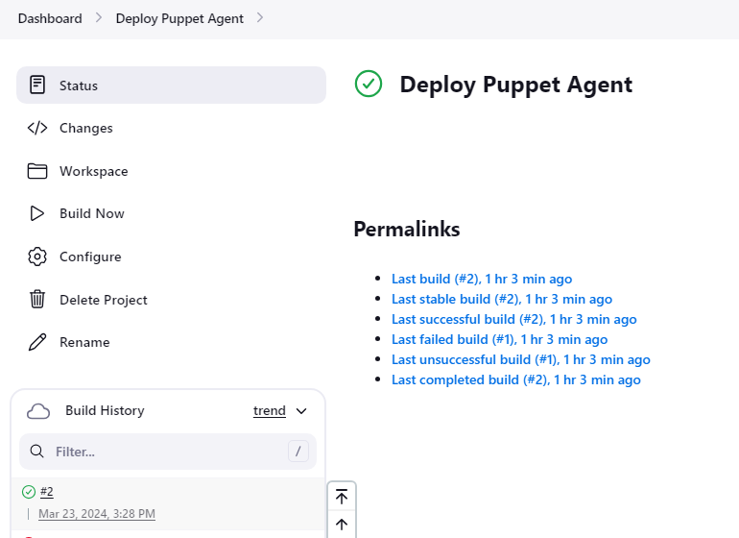

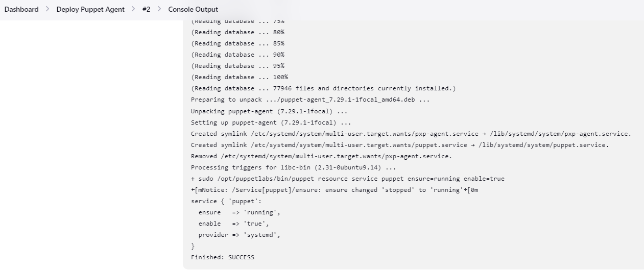

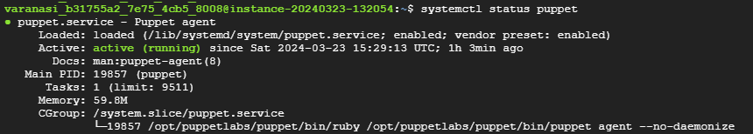

**2.Push an Ansible configuration on test server to install docker (Job 2)**

“Install Docker Using Ansible” job is created

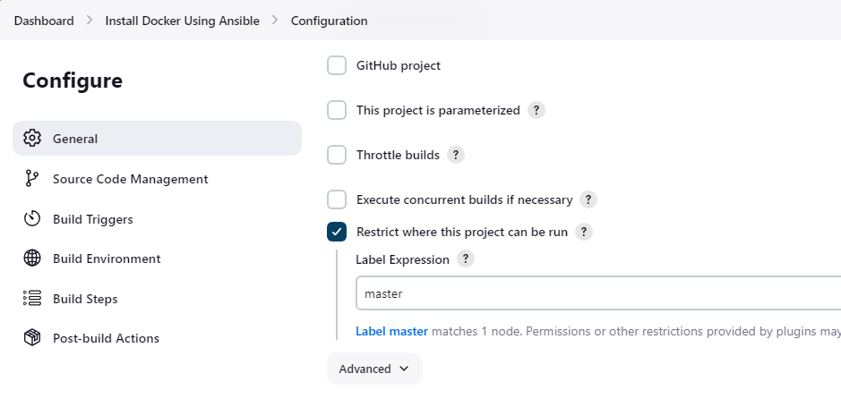

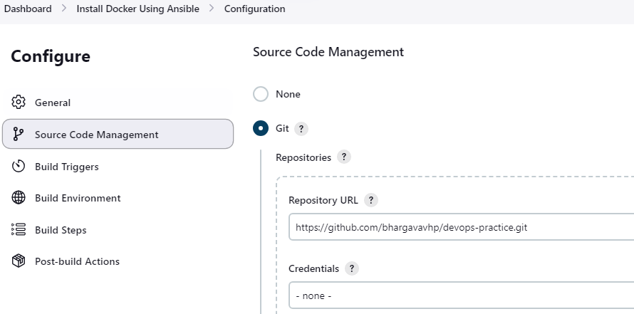

Build this job after “Deploy Puppet Agent” is successful

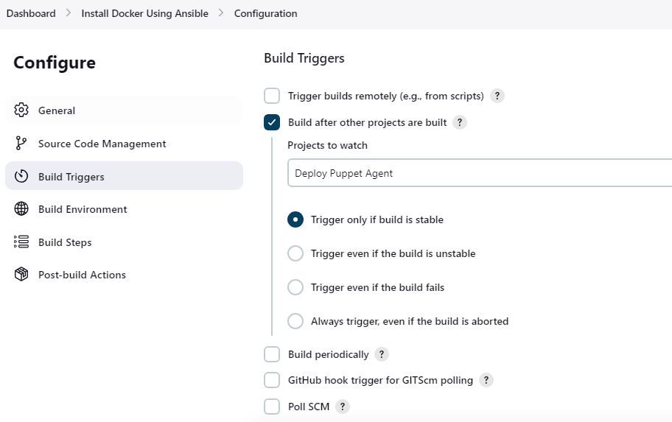

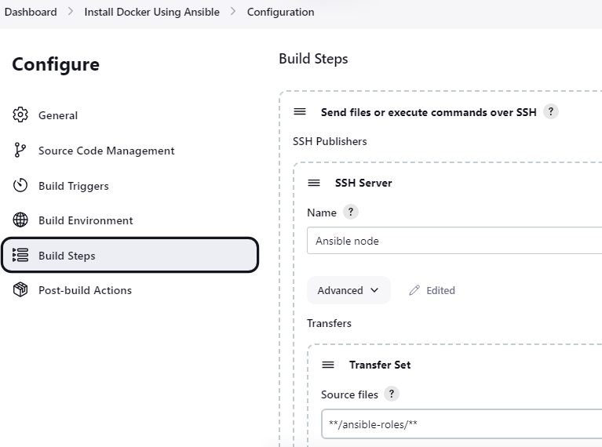

Trigger ansible playbook to deploy docker tool on test-server

Code at - [devops-practice/ansible-roles/docker/tasks/main.yml at master · bhargavavhp/devops-practice (github.com)](https://github.com/bhargavavhp/devops-practice/blob/master/ansible-roles/docker/tasks/main.yml)

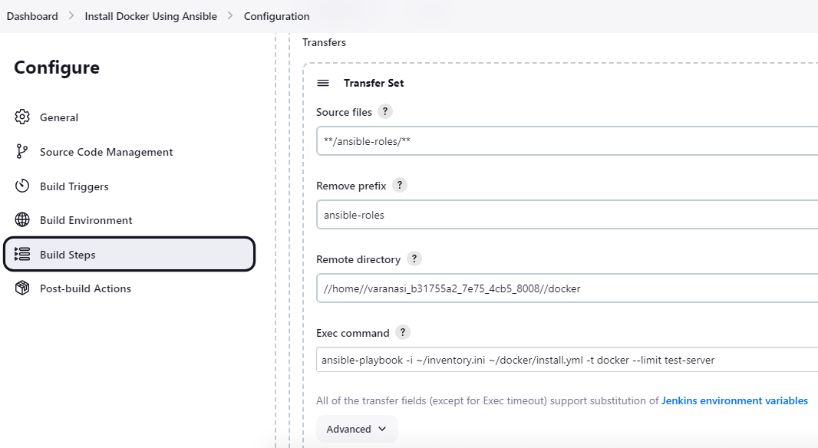

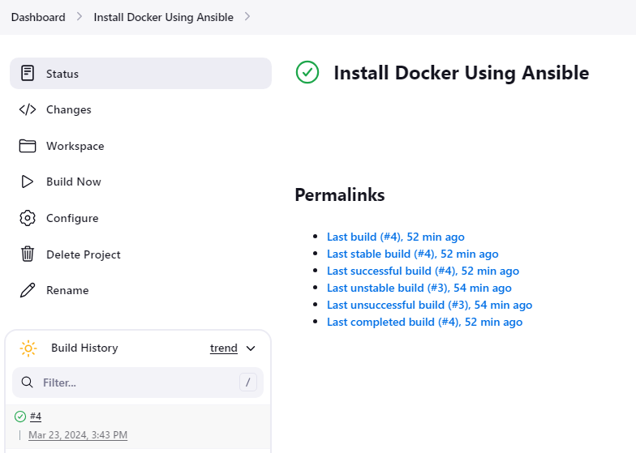

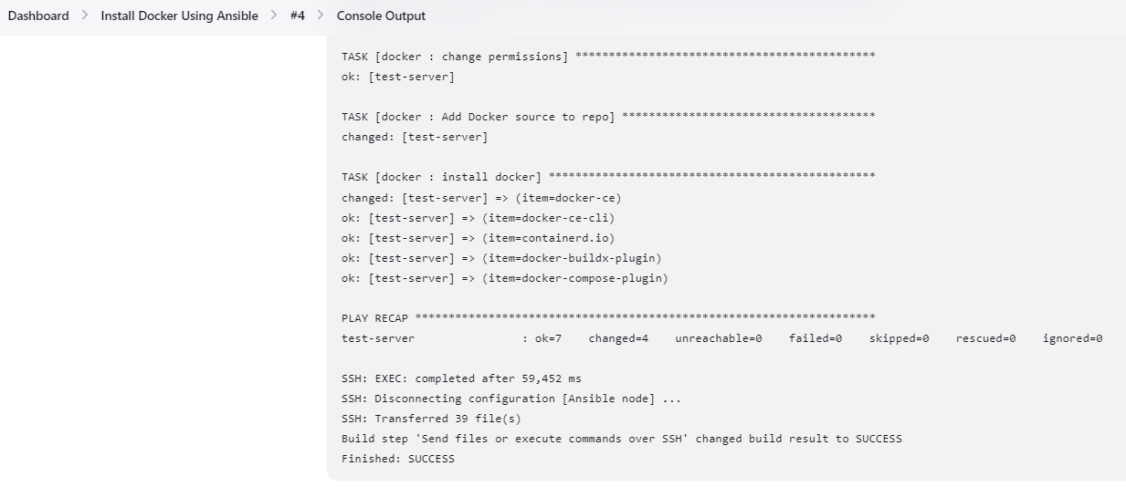



**3.Pull the PHP website, and the Dockerfile from the git repo and build and deploy your PHP docker container. After. (Job 3)**

“Deploy Application” job is created

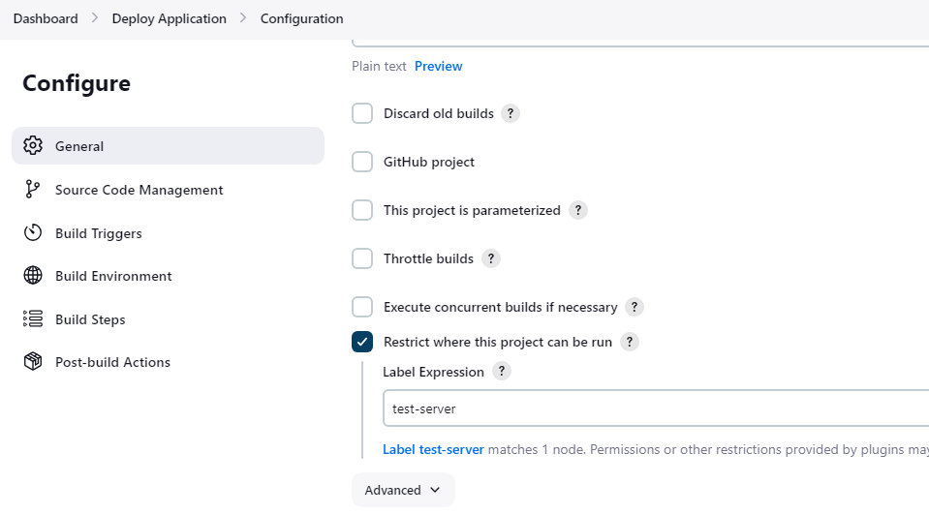

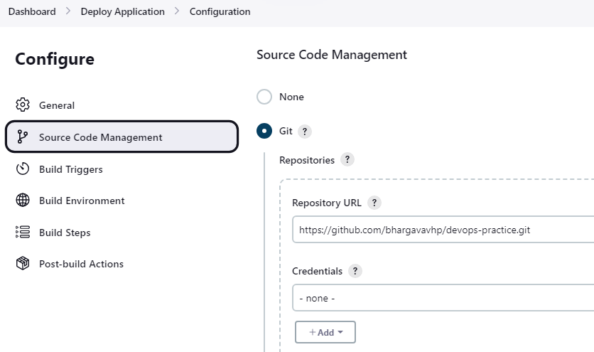

Build this after “Install Docker Using Ansible” job

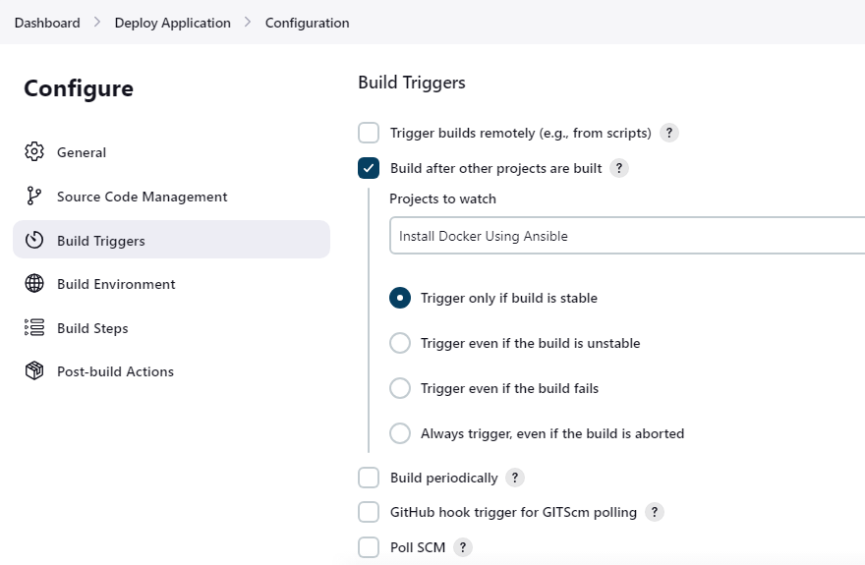

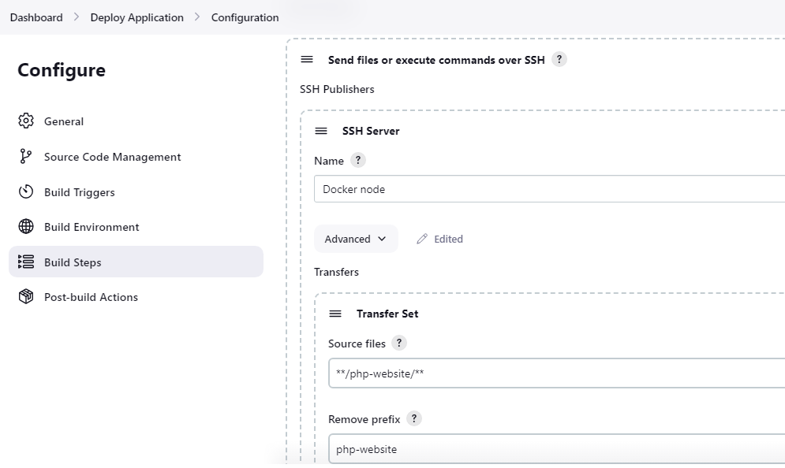

Build docker image “app”

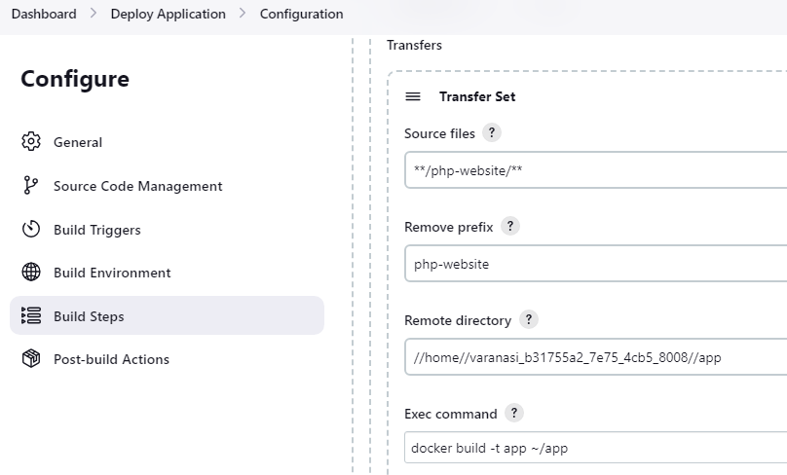

Run docker container on test-server and expose it to port 80

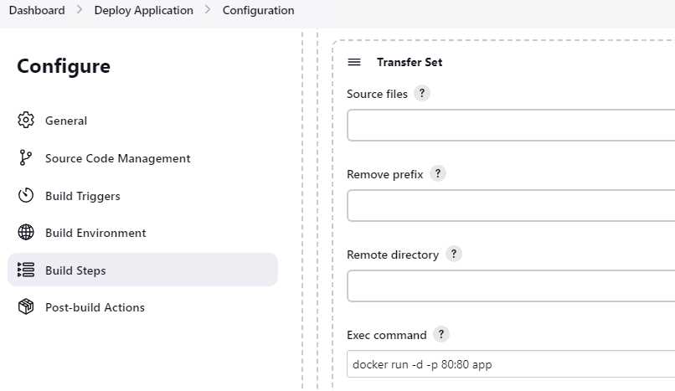

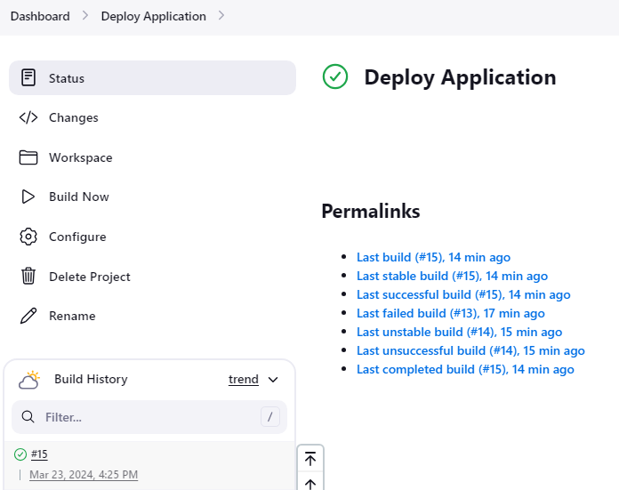

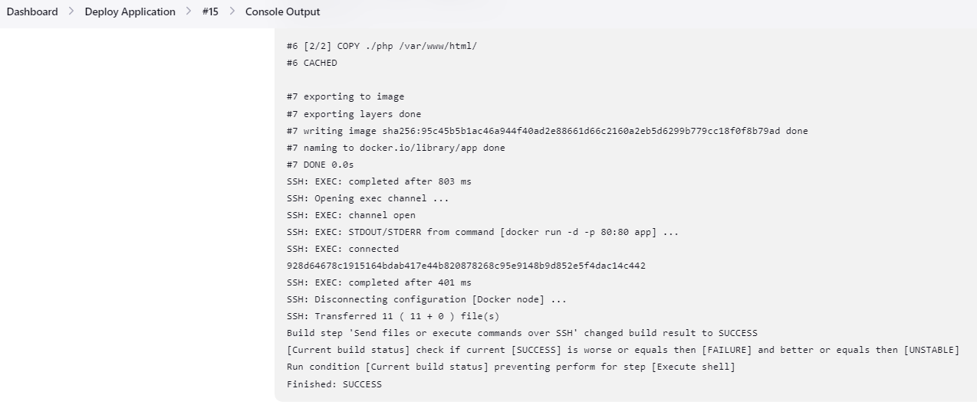



Application deployed and accessible on port 80 of test-server ip

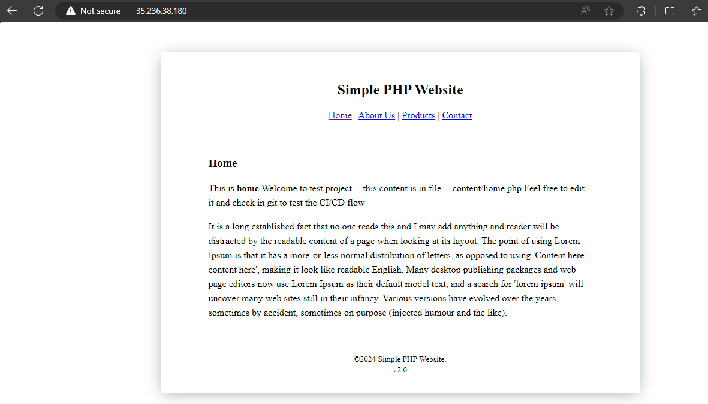

**4.If Job 3 fails, delete the running container on Test Server**

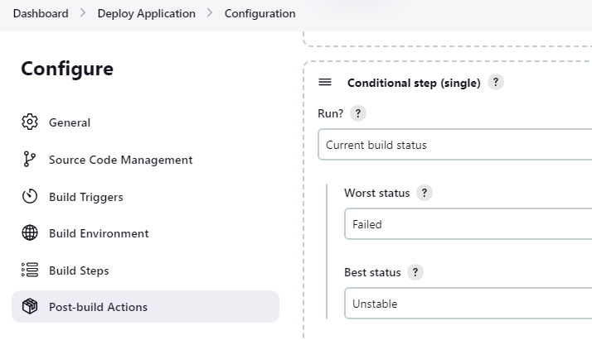

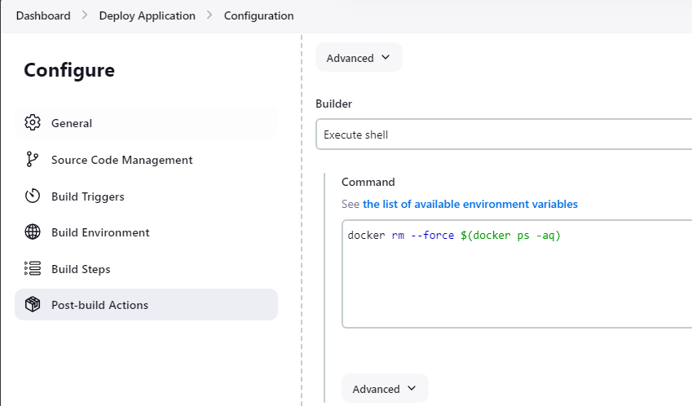

**Built a pipeline to trigger jobs automatically**

