Name: Bhargava Varanasi

Module-2: Assignment

Create a local git repository and move the entire code base to it

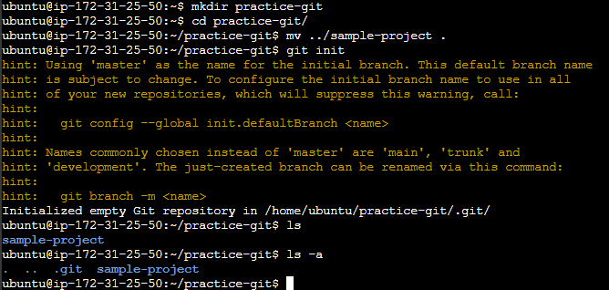

Create a new branch for a new feature you want to add to the application

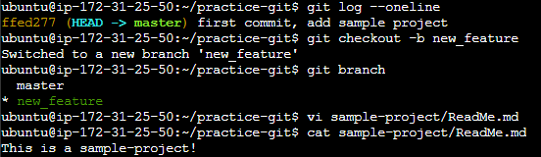

Merge back the created branch with the master branch

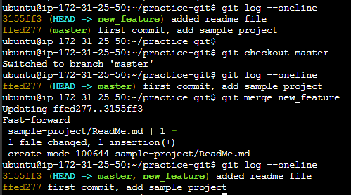

Create a remote repository

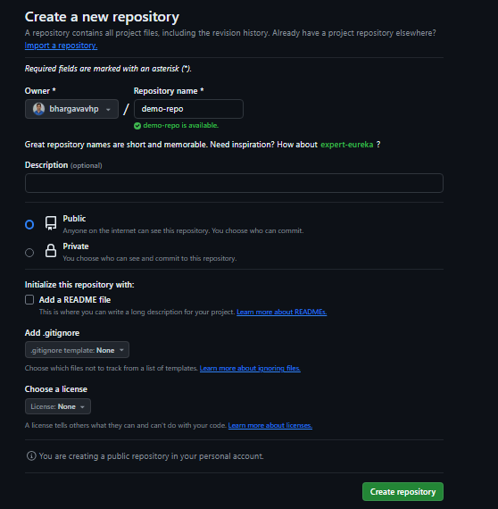

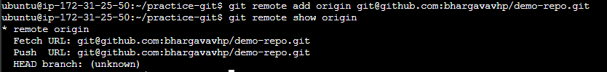

Push the local repository to company’s remote repository

