Name: Bhargava Varanasi

Module-3: Assignment-1

Create two separate branches from master

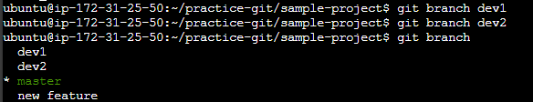

Make changes in the same function of the source code in both the branches

* dev1 branch:





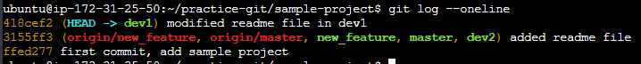

* On dev2 branch:

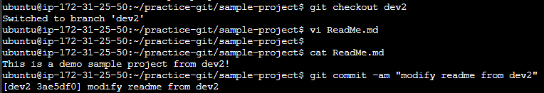



Merge branch1 into the master

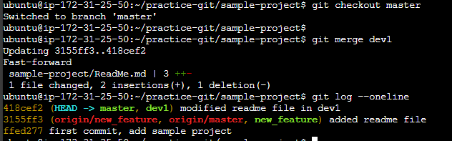

Try and merge branch2 into themaster(merge conflict should arise)

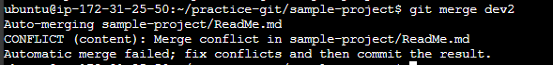

Install a merge tool of your choice and resolve the merge conflict using git mergetool command

