**Name: Bhargava Varanasi**

**Module 7: Case study – Docker**

**Objectives:**

* Download your company’s website files from the given link
* Write a docker file that will make your company’s website work out of the box with a web server (Tip -You can use httpd / apache image and build on top of it)
* Make sure that you use volumes to store the actual data of the website outside of the container
* Push the docker image to your docker hub account so that it canbe pulled later
* Create a swarm cluster
* Deploy your firm’s website on the swarm cluster and expose port 80 to access the website. Also, ensure that the volumes are configured properly so that the source of the files is the same for all the containers of the service

Application Link: https://github.com/edurekacontent/dockerContent

**SOLUTION:**

* Write a docker file that will make your company’s website work out of the box with a web server (Tip -You can use httpd / apache image and build on top of it)



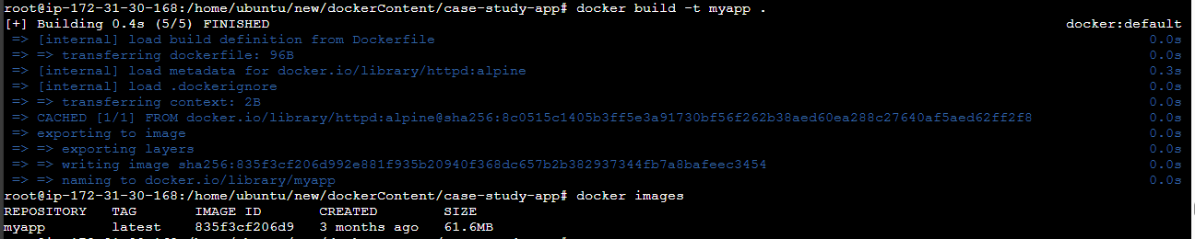

* Push the docker image to your docker hub account so that it can be pulled later

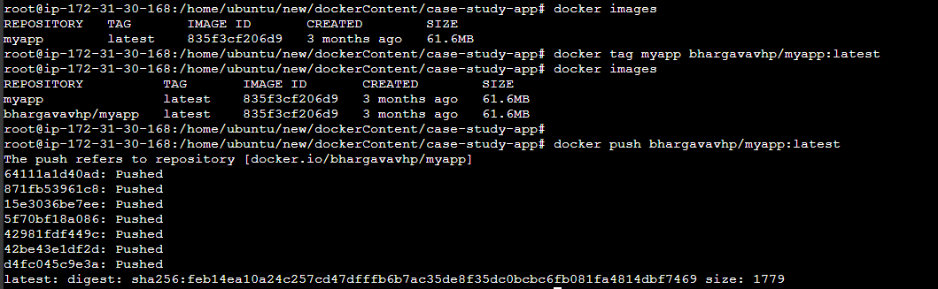

Create local mount path for volume



Copy all the data to the path



Create volume with volume mount path defined above

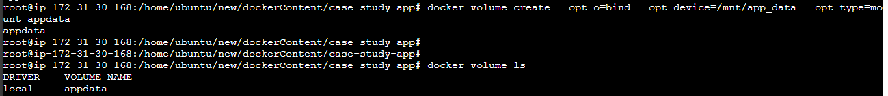

Create service with 3 replicas exposed on port 80 with volume mount “appdata”

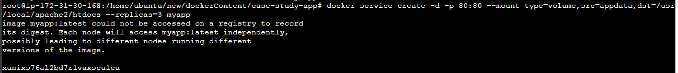

Service created with 3 replicas

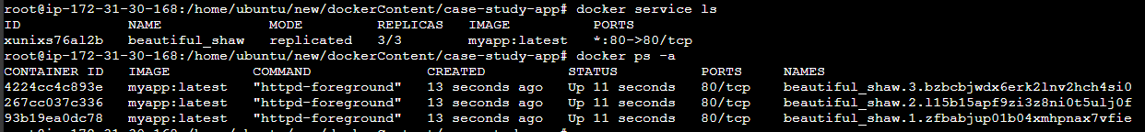

Service has the volume mount point taken from docker volume “appdata”

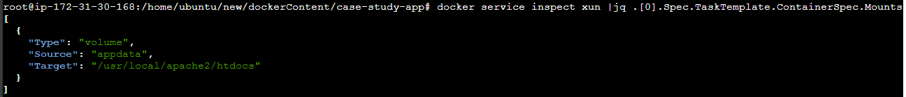

Volume mount points for docker containers

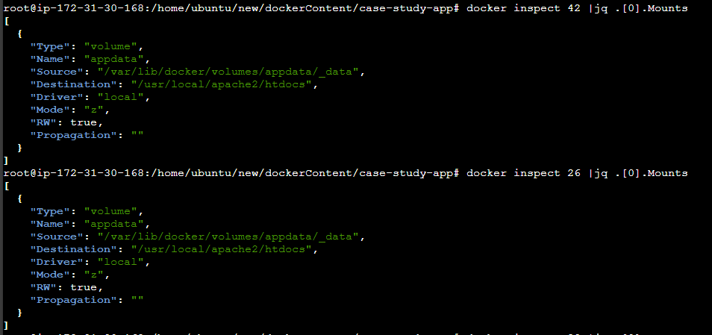

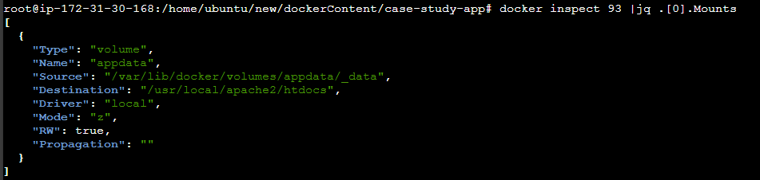

Data stored in docker volume path



Image stored in dockerhub

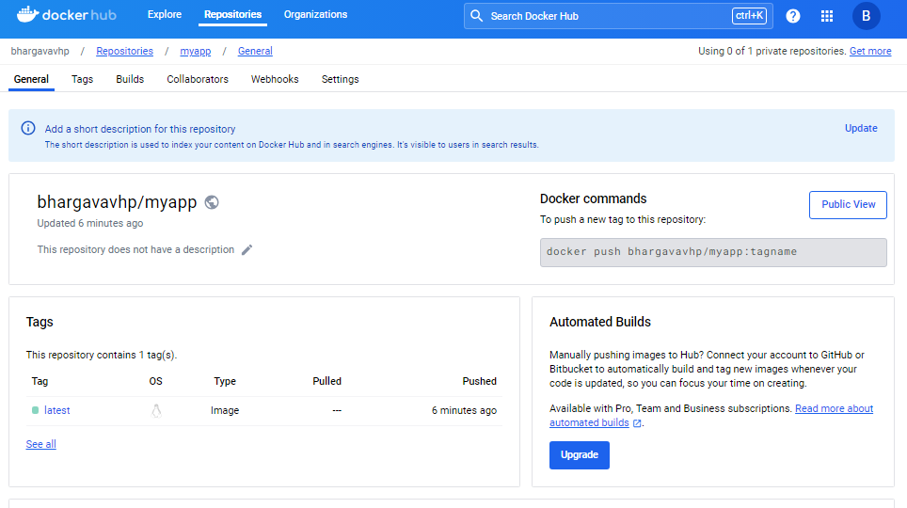

App deployed

