**TERM-2 CCNA Assignment**

**Module 7**

BHARGAV DARJI

Section 1: Multiple Choice

1. Which of the following messages in the DHCP process are broadcasted? (Choose two)

- C. Discover A. Request

2. Which command would you use to ensure that an ACL does not block web-based TCP traffic?

- B. permit tcp any any eq 80

3. Which routers will be able to form a neighbour relationship with the other routers on the LAN? 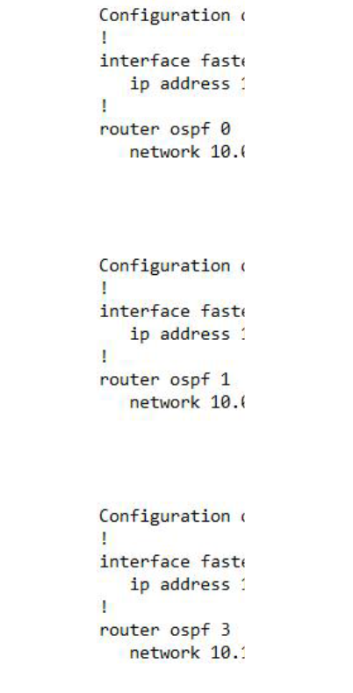

- B. R2 C.R3

4. Enable secret [password] is hashed using the _______ algorithm.

- A. MD5

5. What does the BDR mean in the status of neighbour 2.2.2.2 lists FULL/BDR?

- D. Router 2.2.2.2 is a backup designated router.

6. Which command is used to view the neighbour discovery table on a PC?

- D. netsh interface ipv6 show neighbours

7. What type of variable is being shown? Routers = [R1,R2,R3]

- A. List

8. Identify the fields in an IPv4 header. (Choose three)

- B. Time to Live

- C. Source address

- D. Destination address

9. Which part of the function is done specifically by the ACL Analysis or ACL Trace part of the APIC-EM Path Trace ACL Analysis tool?

- D. Analysis of the impact of ACLs on the packets that would flow from Host A to B

10. Which IPv6 address is the equivalent of the IPv4 interface loopback address 127.0.0.1?

- A. ::1

11. Which command is used to apply an ACL to an interface?

- B. ip access-group

12. Which command and mode will successfully configure a hostname of R1 on a Cisco IOS router?

- C. Router(config)#hostname R1

13. Which of the following reserved IPv4 addresses has binary 0s in all of the host bit positions?

- D. Network address

14. Which of the following answers describe the result of the port security configuration created with these commands? (Choose two)

- A. Prevents unknown devices with unknown MAC addresses from sending data through the switch ports.

- B. If a user connects a switch to the cable, prevents multiple devices from sending data through the port.

15. What is the Administrative Distance of internal EIGRP routes?

- B. 90

16. When a subnet mask is presented in binary, what do the binary 1s represent?

- E. The network portion of the subnet mask

17. Which switch would STP choose to become the root bridge in the selection process?

- A. 32768: 11-22-33-44-55-66 (Typically the lowest MAC address with the lowest priority)

18. Which of the following devices is used by the service provider to provide WAN services?

- D. CSU/DSU

19. Which command will display the addresses that have been handed out to clients on the LAN by a DHCP server?

- D. show ip dhcp bindings

20. Which command would you use to enable EIGRP only on those interfaces with an IP address from 10.1.1.0 through 10.1.1.63?

- A. network 10.1.1.0 0.0.0.63

21. What command could you use to have R3 advertise an OSPFv3 default route to the internal network?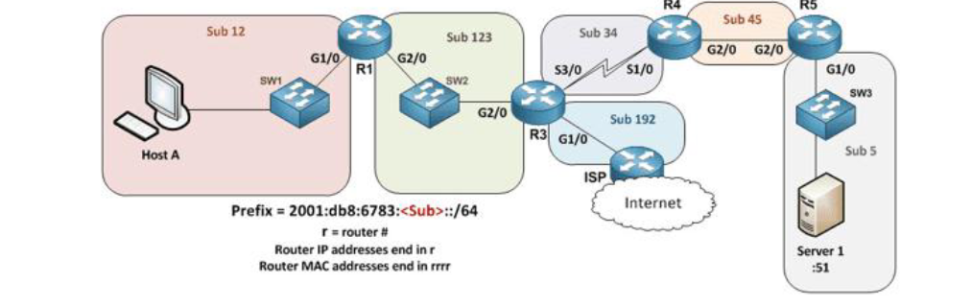

- E. Have R3 use the command default-information originate always in OSPFv3 router configuration mode.

22. Which command is used to verify the interfaces that are being used as the outside interface and the inside interface for dynamic NAT?

- F. show ip nat statistics

23. When using the “show EtherChannel summary” command, what does the “u” flag signify?

- D. Unsuitable for bundling

24. Which command could you enter to encrypt passwords?

- C. service password-encryption

25. Which command is used to identify the IPv4 addresses that will be in the DHCP pool when setting up a Cisco IOS router as a DHCP server?

- A. network

26. Which of the following statements are true regarding the processing of ACLs that have been applied to router interfaces? (Choose two)

- A. Inbound ACLs will be processed before the routing table lookup occurs

- C. Outbound ACLs will be processed after the routing table lookup has occurred

27. Which of the following answers list a condition that could keep the routers in your lab from learning all the routes to all the IPv4 routes in your small lab network? (Choose two)

- A. An ACL could be blocking router advertisements.

- C. Any physical layer problem that would prevent two neighbouring routers from being able to ping each other's IPv4 addresses in the subnet that exists between the two routers.

28. Which statements describe neighbour discovery functionality in IPv6? (Choose two)

- A. Determines the link layer address of a neighbour

- D. Queries for duplicate addresses

29. Which IPv6 prefix will the typical enterprise network receive from the service provider?

- E. /48

30. How should a switch be configured so that it could be accessed remotely?

- C. Configure a gateway for the switch

31. What conclusions can be made about the design with all hosts configured in the same VLAN?

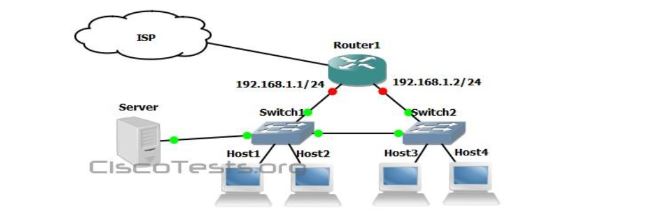

- B. Spanning-tree will need to be used.

- D. The connection between switches should be a trunk