ARMED FORCES OF iNDIA

INDIAN dEfENCE

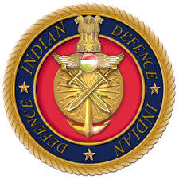

AIR FORCE:

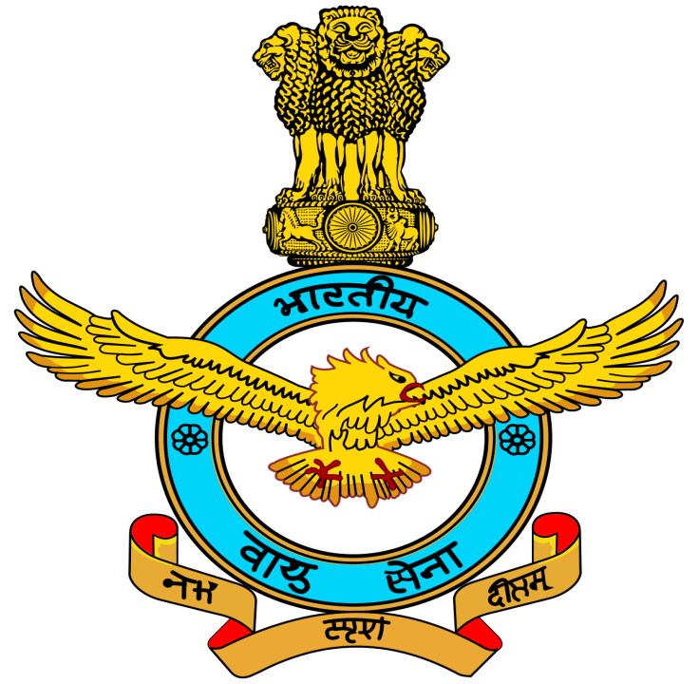

The **Indian Air Force** (**IAF**) is the [air arm](https://en.wikipedia.org/wiki/Air_force) of the [Indian Armed Forces](https://en.wikipedia.org/wiki/Indian_Armed_Forces). Its complement of personnel and aircraft assets ranks fourth amongst the air forces of the world. Its primary mission is to secure Indian [airspace](https://en.wikipedia.org/wiki/Airspace) and to conduct [aerial warfare](https://en.wikipedia.org/wiki/Aerial_warfare) during armed conflict. It was officially established on 8 October 1932 as an auxiliary air force of the [British Empire](https://en.wikipedia.org/wiki/British_Empire) which honoured India's aviation service during World War II with the prefix *Royal*. After India gained independence from the [United Kingdom](https://en.wikipedia.org/wiki/United_Kingdom) in 1947, the name Royal Indian Air Force was kept and served in the name of [Dominion of India](https://en.wikipedia.org/wiki/Dominion_of_India). With the government's transition to a Republic in 1950, the prefix *Royal* was removed.

Since 1950 the IAF has been involved in [four wars](https://en.wikipedia.org/wiki/Indo-Pakistani_Wars) with neighboring [Pakistan](https://en.wikipedia.org/wiki/Pakistan) and one with the People's Republic of China. Other major operations undertaken by the IAF include [Operation Vijay](https://en.wikipedia.org/wiki/Annexation_of_Goa), [Operation Meghdoot](https://en.wikipedia.org/wiki/Operation_Meghdoot), [Operation Cactus](https://en.wikipedia.org/wiki/Operation_Cactus) and [Operation Poomalai](https://en.wikipedia.org/wiki/Operation_Poomalai). The IAF's mission expands beyond engagement with hostile forces, with the IAF participating in [United Nations peacekeeping missions](https://en.wikipedia.org/wiki/History_of_United_Nations_peacekeeping).

The [President of India](https://en.wikipedia.org/wiki/President_of_India) holds the rank of Supreme Commander of the IAF. As of 1 July 2017, 139,576 personnel are in service with the Indian Air Force. The [Chief of Air Staff](https://en.wikipedia.org/wiki/Chief_of_Air_Staff_(India)), an [air chief marshal](https://en.wikipedia.org/wiki/Air_chief_marshal), is a [four-star](https://en.wikipedia.org/wiki/Four-star_rank) officer and is responsible for the bulk of operational command of the Air Force. There is never more than one serving ACM at any given time in the IAF. The rank of [Marshal of the Air Force](https://en.wikipedia.org/wiki/Marshal_of_the_Air_Force) has been conferred by the President of India on one occasion in history, to [Arjan Singh](https://en.wikipedia.org/wiki/Arjan_Singh). On 26 January 2002 Singh became the first and so far, only [five-star rank](https://en.wikipedia.org/wiki/Five-star_rank) officer of the IAF.

NAVY:

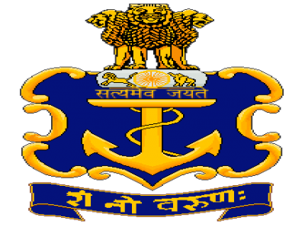

The **Indian Navy** is the [naval branch](https://en.wikipedia.org/wiki/Navy) of the [Indian Armed Forces](https://en.wikipedia.org/wiki/Indian_Armed_Forces). The [President of India](https://en.wikipedia.org/wiki/President_of_India) is the Supreme Commander of the The primary objective of the navy is to safeguard the nation's maritime borders, and in conjunction with other Armed Forces of the union, act to deter or defeat any threats or aggression against the territory, people or maritime interests of India, both in war and peace. Through joint exercises, goodwill visits and humanitarian missions, including disaster relief, Indian Navy promotes bilateral relations between nations.

As of June 2019, Indian Navy has 67,252 personnel in service and has a fleet of 137 warships and 235 aircraft. As of March 2018, the operational fleet consists of one [aircraft carrier](https://en.wikipedia.org/wiki/Aircraft_carrier), one [amphibious transport dock](https://en.wikipedia.org/wiki/Amphibious_transport_dock), eight [landing ship tanks](https://en.wikipedia.org/wiki/Landing_Ship,_Tank), eleven [destroyers](https://en.wikipedia.org/wiki/Destroyer), fourteen [frigates](https://en.wikipedia.org/wiki/Frigate), one [nuclear-powered attack submarine](https://en.wikipedia.org/wiki/SSN_(hull_classification_symbol)), one [ballistic missile submarine](https://en.wikipedia.org/wiki/Ballistic_missile_submarine), fifteen conventionally-powered attack [submarines](https://en.wikipedia.org/wiki/Submarine), twenty-two [corvettes](https://en.wikipedia.org/wiki/Corvette), one [mine countermeasure vessel](https://en.wikipedia.org/wiki/Mine_countermeasure_vessel), four [fleet tankers](https://en.wikipedia.org/wiki/Replenishment_oiler) and various other [auxiliary vessels](https://en.wikipedia.org/wiki/Auxiliary_ship).

Indian Navy. The [Chief of Naval Staff](https://en.wikipedia.org/wiki/Chief_of_the_Naval_Staff_(India)), a [four-star](https://en.wikipedia.org/wiki/Four-star_rank) [admiral](https://en.wikipedia.org/wiki/Admiral_(India)), commands the navy.

ARMY:

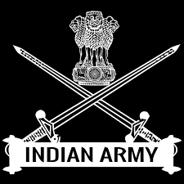

The **Indian Army** ([Hindi](https://en.wikipedia.org/wiki/Hindi): *Bhāratīya Thal Sēnā*) is the [land-based branch](https://en.wikipedia.org/wiki/Land_warfare) and the largest component of the [Indian Armed Forces](https://en.wikipedia.org/wiki/Indian_Armed_Forces). The [President of India](https://en.wikipedia.org/wiki/President_of_India) is the [Supreme Commander](https://en.wikipedia.org/wiki/Commander-in-Chief) of the Indian Army,[[4]](https://en.wikipedia.org/wiki/Indian_Army#cite_note-4) and it is commanded by the [Chief of Army Staff](https://en.wikipedia.org/wiki/Chief_of_Army_Staff_of_the_Indian_Army) (COAS), who is a [four-star](https://en.wikipedia.org/wiki/Four-star_rank) [general](https://en.wikipedia.org/wiki/General_officer). Two officers have been conferred with the rank of [field marshal](https://en.wikipedia.org/wiki/Field_marshal_(India)), a [five-star rank](https://en.wikipedia.org/wiki/Five-star_rank), which is a ceremonial position of great honour.The primary mission of the Indian Army is to ensure [national security](https://en.wikipedia.org/wiki/National_Security_Council_(India)) and national unity, [defending](https://en.wikipedia.org/wiki/Defence_(military)) the nation from external aggression and internal threats, and maintaining peace and security within [its borders](https://en.wikipedia.org/wiki/Category:Borders_of_India). It conducts humanitarian rescue operations during natural calamities and other disturbances, like [Operation Surya Hope](https://en.wikipedia.org/wiki/Operation_Surya_Hope), and can also be requisitioned by the government to cope with internal threats. It is a major component of national power alongside the [Indian Navy](https://en.wikipedia.org/wiki/Indian_Navy) and the [Indian Air Force](https://en.wikipedia.org/wiki/Indian_Air_Force). The army has been involved in four wars with neighbouring [Pakistan](https://en.wikipedia.org/wiki/Pakistan) and one with [China](https://en.wikipedia.org/wiki/China). Other major operations undertaken by the army include: [Operation Vijay](https://en.wikipedia.org/wiki/Operation_Vijay_(1961)), [Operation Meghdoot](https://en.wikipedia.org/wiki/Operation_Meghdoot) and [Operation Cactus](https://en.wikipedia.org/wiki/Operation_Cactus). Apart from conflicts, the army has conducted large peace time exercises like [Operation Brasstacks](https://en.wikipedia.org/wiki/Operation_Brasstacks) and Exercise Shoorveer, and it has also been an active participant in numerous [United Nations peacekeeping missions](https://en.wikipedia.org/wiki/Indian_Army_United_Nations_peacekeeping_missions) including those in: Cyprus, Lebanon, Congo, Angola, Cambodia, Vietnam, Namibia, El Salvador, Liberia, Mozambique, South Sudan and Somalia.

The Indian Army has a [regimental system](https://en.wikipedia.org/wiki/Regiment#Regimental_system), but is operationally and geographically divided into [seven commands](https://en.wikipedia.org/wiki/Indian_Army#Command_structure), with the basic field formation being a [division](https://en.wikipedia.org/wiki/Division_(military)). It is an [all-volunteer force](https://en.wikipedia.org/wiki/Volunteer_military) and comprises more than 80% of the country's active defence personnel. It is the [2nd largest standing army](https://en.wikipedia.org/wiki/List_of_countries_by_number_of_military_and_paramilitary_personnel) in the world, with 1,237,117 active troops and 960,000 reserve troops. The army has embarked on an infantry modernisation program known as Futuristic Infantry Soldier As a System ([F-INSAS](https://en.wikipedia.org/wiki/F-INSAS)), and is also upgrading and acquiring new assets for its armoured, artillery and aviation branches.