**Assignment -1**

* **Create three Instances**

Three Instances were created

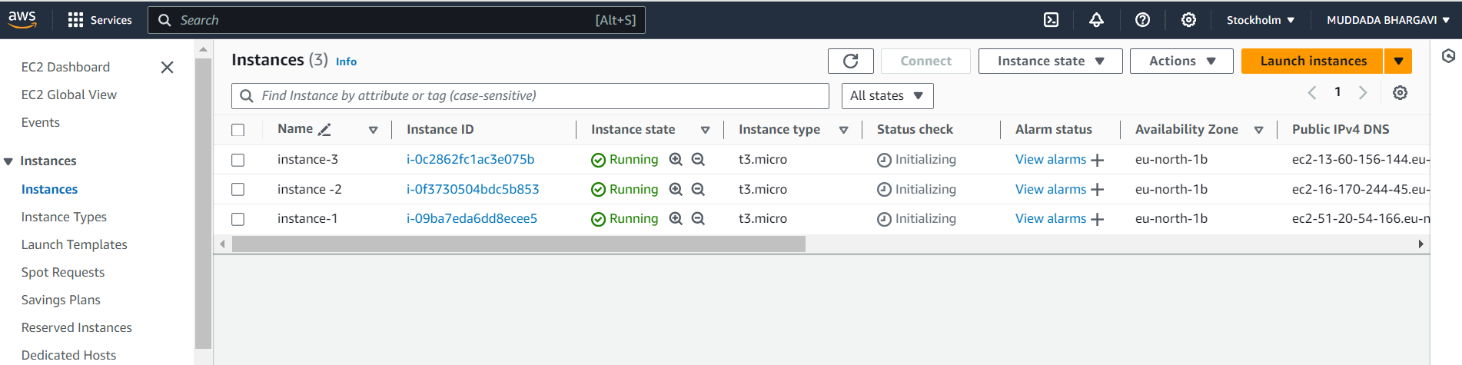

**A .Attach One EFS to Two Instances**

Creating File System

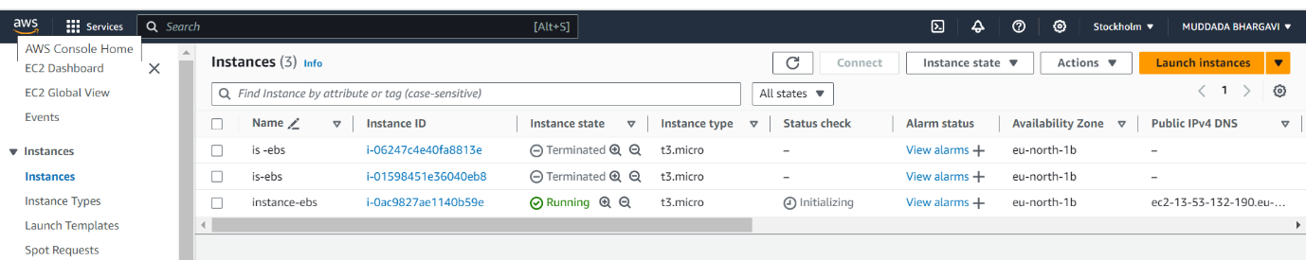

Creating two Ec2 instance and attach EFS file system to that instances which are in different availability zone

Testing of EFS by creating two different files in different servers under the command

**cd /mnt/efs/fs1** these are the results:

Server 1:

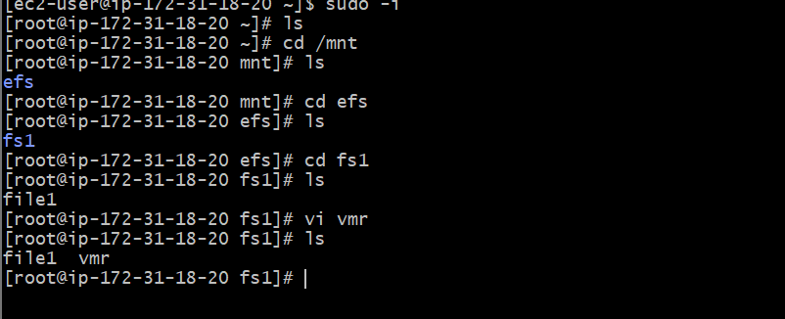

Server 2:

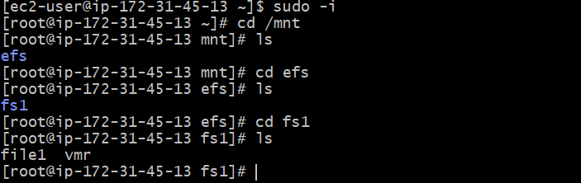

**B.Attach One EBS to Two Instances**

Here we can attach one EBS to One Instance Only

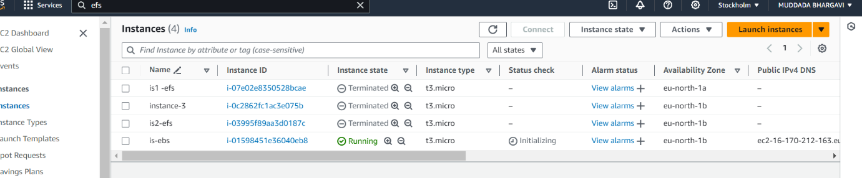 Here we can create an EC2 instance

Checking volume of the Ec2 server by using this command **df -h**

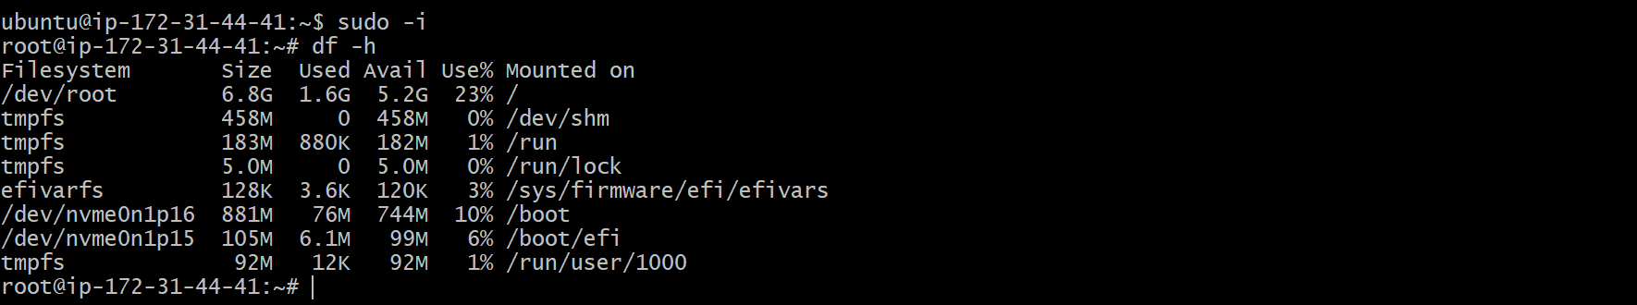

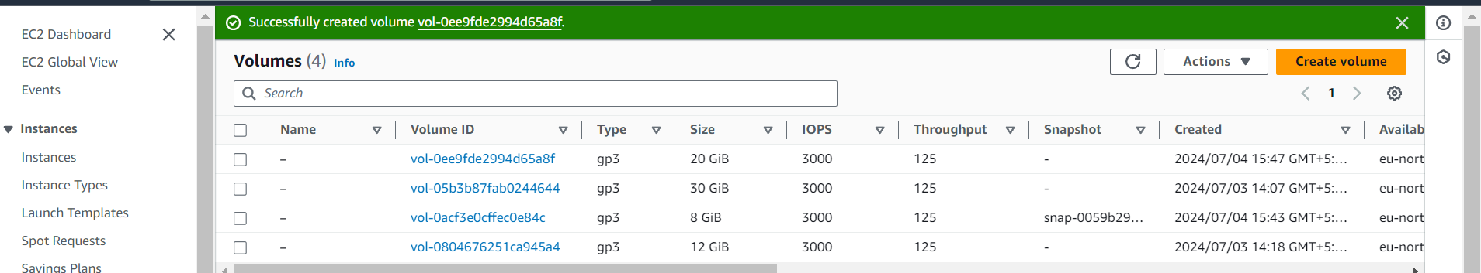Creating EBS volume of 20GB and attaching to the EC2 Server

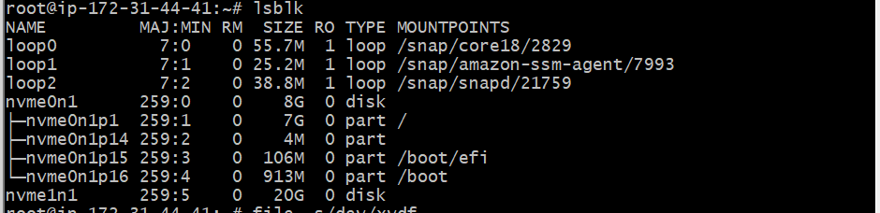



EBS volume of 20GB can be attached to bhargavi/vizag



