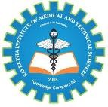

SIMATS ENGINEERING
Saveetha Institute of Medical and Technical Sciences Chennai- 602105
Student Name:B.Bhargavi
Reg. No:192311136
Course Code: CSA1711 Slot: C
Course Name: Artificial Intelligence
Course Faculty: Dr. K. Krishna Kumar
Project Title: Face Attendance System
Module Photographs: (3 photographs –Module Photo, Individual student contribution module work in
the project and presentation image)
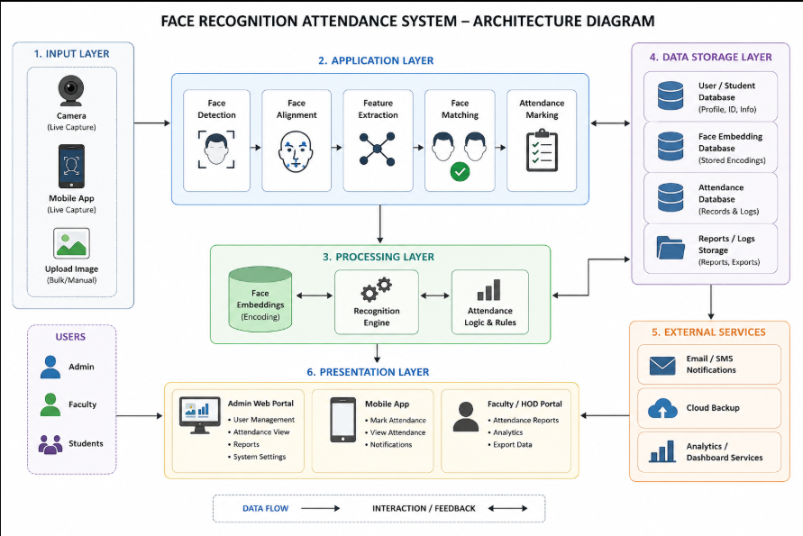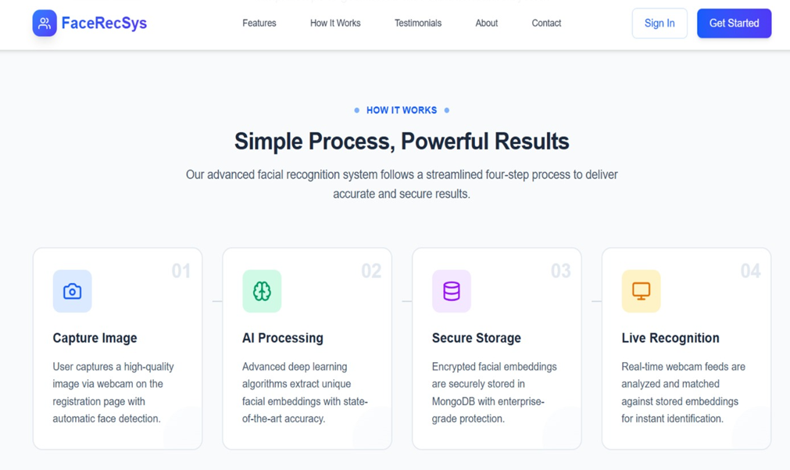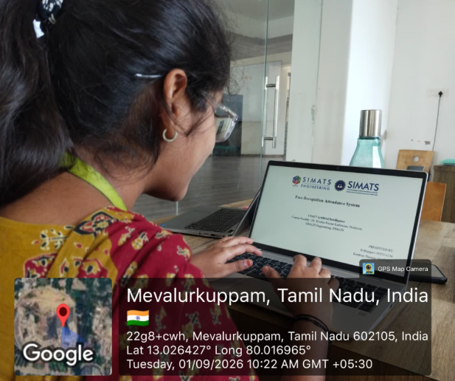

Fig 01: Project & Module Fig 02 : Individual Student Fig 03: Presentation Photo Contribution module work Image
Module Description:

The Face Attendance Recognition module is designed to automatically identify students or employees and record their attendance using facial recognition technology. The system captures the user’s face through a camera, detects and aligns the face, and extracts unique facial features for recognition. These features are compared with registered face data stored in the database to identify the person accurately. After successful recognition, the system automatically records the user’s name or ID along with the date and time of attendance. The module reduces manual effort, prevents duplicate or proxy attendance, improves accuracy, and provides a fast, contactless, and reliable attendance management solution.

Student Signature Guide Signature

