1.INTRODUCTION

1.1 PROBLEM STATEMENT

There is a need for the people to decide whether to invest in a company or not. It is very tedious task to analyze all the company’s data and decide on the company to invest. Our Project aims to develop a model which analyses the company’s datasets and predict the output.

1.2 CONTRIBUTION

The purpose of this project is to make the task of the user easy to decide where to invest and the estimated value of stock. We experimented on large data set of companies stock prices concluding where to invest and improving the accuracy by using different algorithms.

.

1

2. LITERATURE SURVEY

2.1 Introduction to Time Series

Time does play a role in normal machine learning datasets. Predictions are made for new data when the actual outcome may not be known until some future date. The future is being predicted, but all prior observations are almost always treated equally. Perhaps with some very minor temporal dynamics to overcome the idea of “concept drift” such as only using the last year of observations rather than all data available. A time series dataset is different. Time series adds an explicit order dependence between observations: a time dimension. This additional dimension is both a constraint and a structure that provides a source of additional information.

Components of Time Series

Time series analysis provides a body of techniques to better understand a dataset.Perhaps the most useful of these is the decomposition of a time series into 4 constituent parts:

1.Level: The baseline value for the series if it were a straight line.

2.Trend: The optional and often linear increasing or decreasing behavior of the series over time.

3.Seasonality: The optional repeating patterns or cycles of behavior over time.

2
4.Noise: The optional variability in the observations that cannot be explained by the model.

All time series have a level, most have noise, and the trend and seasonality are optional.

2.2 DESCRIBING VS PREDICTING

We have different goals depending on whether we are interested in understanding a dataset or making predictions. Understanding a dataset, called time series analysis, can help to make better predictions, but is not required and can result in a large technical investment in time and expertise not directly aligned with the desired outcome, which is forecasting the future. In descriptive modelling, or time series analysis, a time series is modelled to determine its components in terms of seasonal patterns, trends, relation to external factors, and the like. In contrast, time series forecasting uses the information in a time series (perhaps with additional information) to forecast future values of that series

2.3 TIME SERIES FORECASTING

Making predictions about the future is called extrapolation in the classical statistical handling of time series data. More modern fields focus on the topic and refer to it as time series forecasting. Forecasting involves taking models fit on historical data and using them to predict future observations. Descriptive models can borrow for the future (i.e. to smooth or remove noise), they only seek to best describe the data. An important distinction in forecasting is that the future is completely unavailable and must only be estimated from what has already happened. The purpose of time series analysis is generally twofold: to understand or model the stochastic mechanisms that gives rise to an observed series and to predict or forecast
3
the future values of a series based on the history of that series. The skill of a time series forecasting model is determined by its performance at predicting the future. This is often at the expense of being able to explain why a specific prediction was made, confidence intervals and even better understanding the underlying causes behind the problem.

2.3.1 CONCERNS OF FORECASTING:

When forecasting, it is important to understand your goal. Use the Socratic method and ask lots of questions to help zoom in on the specifics of your predictive modelling problem. For example:

1.How much data do you have available and are you able to gather it all together?

More data is often more helpful, offering greater opportunity for exploratory data analysis, model testing and tuning, and model fidelity.

2.What is the time horizon of predictions that is required? Short, medium or long term?

Shorter time horizons are often easier to predict with higher confidence.

3.Can forecasts be updated frequently over time or must they be made once and remain static?

Updating forecasts as new information becomes available often results in more accurate predictions.

4.At what temporal frequency are forecasts required?

Often forecasts can be made at a lower or higher frequencies, allowing you to harness down-sampling, and up-sampling of data, which in turn can offer benefits while modeling.

4
Time series data often requires cleaning, scaling, and even transformation.

For example:

Frequency: Perhaps data is provided at a frequency that is too high to model or is unevenly spaced through time requiring resampling for use in some models.

Outliers: Perhaps there are corrupt or extreme outlier values that need to be identified and handled.

Missing: Perhaps there are gaps or missing data that need to be interpolated or imputed.

Often time series problems are real-time, continually providing new opportunities for prediction. This adds an honesty to time series forecasting that quickly flushes out bad assumptions, errors in modeling and all the other ways that we may be able to fool

2.4 EXPONENTIAL SMOOTHING

2.4.1 SIMPLE EXPONENTIAL SMOOTHING:

The simplest of the exponentially smoothing methods is naturally called “simple exponential smoothing” (SES). (In some books, it is called “single exponential smoothing”.) This method is suitable for forecasting data with no trend or seasonal pattern. Forecasts are calculated using weighted averages where the weights decrease exponentially as observations come from further in the past --- the smallest weights are associated with the oldest observations: y^T+1|T=αyT+α(1−α)yT−1+α(1−α)2yT−2+⋯,

5
where 0≤α≤10≤α≤1 is the smoothing parameter. The one-step-ahead forecast for time T+1T+1 is a weighted average of all the observations in the series y1,…,yTy1,…,yT. The rate at which the weights decrease is controlled by the parameter αα.

For any αα between 0 and 1, the weights attached to the observations decrease exponentially as we go back in time, hence the name “exponential smoothing”. If αα is small (i.e., close to 0), more weight is given to observations from the more distant past. If αα is large (i.e., close to 1), more weight is given to the more recent observations

2.4.2 DOUBLE EXPONENTIAL SMOOTHING:

This is also known as holt linear trend method. Holt (1957) extended simple exponential smoothing to allow forecasting of data with a trend. This method involves a forecast equation and two smoothing equations (one for the level and one for the trend):

Forecast equation Level equation Trend equation
y^t+h|tℓtbt=ℓt+hbt=αyt+(1−α)(ℓt−1+bt−1)=β∗(ℓt−ℓt−1)+(1−β∗)bt−1
Forecast equation |  | ^t+ h|t =ℓt + hbt
Level equation | ℓt= αyt +(1−α)(ℓt−1+bt−1)
Trend equation | bt =β∗(ℓt−ℓt−1)+(1−β∗)bt−1
where ℓtℓt denotes |  | an | estimate of | the level | of | the | series | at
time tt, btbt denotes an |  |  | estimate of the trend (slope) |  |  | of the | series | at
time tt, αα is |  | the | smoothing | parameter |  | for |  | the
level, 0≤α≤10≤α≤1 and β∗β∗ is the |  |  |  | smoothing | parameter |  | for | the

trend, 0≤β∗≤10≤β∗≤1 (we denote this as β∗β∗ instead of ββ for reasons that will be explained in Section 7/7).

As with simple exponential smoothing, the level equation here shows that ℓtℓt is a weighted average of observation ytyt and the within-sample one-step-ahead forecast for time tt, here given by ℓt−1+bt−1ℓt−1+bt−1.

6
The trend equation shows that btbtis a weighted average of the estimated trend at time tt based on ℓt−ℓt−1ℓt−ℓt−1 and bt−1bt−1, the previous estimate of the trend.

The forecast function is no longer flat but trending. The hh-step-ahead forecast is equal to the last estimated level plus hh times the last estimated trend value. Hence the forecasts are a linear function of hh.

The error correction form of the level and the trend equations show the adjustments in terms of the within-sample one-step forecast errors: ℓtbt=ℓt−1+bt−1+αet=bt−1+αβ∗etℓt=ℓt−1+bt−1+αetbt=bt−1+αβ∗et where et=yt−(ℓt−1+bt−1)=yt−y^t|t−1et=yt−(ℓt−1+bt−1)=yt−y^t|t−1.

2.4.3 TRIPLE EXPONENTIAL SMOOTHING:

This is also known as exponential trend method.

A variation from Holt’s linear trend method is achieved by allowing the level and the slope to be multiplied rather than added: y^t+h|tℓtbt=ℓtbht=αyt+(1−α)(ℓt−1bt−1)=β∗ℓtℓt−1+(1−β∗)bt−1y^t+h|t=ℓ tbthℓt=αyt+(1−α)(ℓt−1bt−1)bt=β∗ℓtℓt−1+(1−β∗)bt−1

where bt represents an estimated growth rate (in relative terms rather than

absolute) which is multiplied rather than added to the estimated level. The

trend in the forecast function is now exponential rather than linear, so that

the forecasts project a constant growth rate rather than a constant slope.

The error correction form is
ℓtbt=ℓt−1bt−1+αet=bt−1+αβ∗etℓt−1ℓt=ℓt−1bt−1+αetbt=bt−1+αβ∗etℓt−

1

where et=yt−(ℓt−1bt−1)=yt−y^t|t−1et=yt−(ℓt−1bt−1)=yt−y^t|t−1.

2.5 BOX JENKINS METHOD

In time series analysis, the Box–Jenkins method,^{[1]} named after the statisticians George Box and Gwilym Jenkins, applies autoregressive

7
moving average (ARMA) or autoregressive integrated moving average (ARIMA) models to find the best fit of a time-series model to past values of a time series.

2.5.1 ARMA MODEL:

In timeseries, autoregressivemoving average (ARMA) models provide a parsimonious description of a (weakly) stationary stochastic process in terms of two polynomials, one for the autoregression and the second for the moving average. The general ARMA model was described in the 1951 thesis of Peter Whittle, Hypothesis testing in time series analysis, and it was popularized in the 1970 book by George E. P. Box and Gwilym Jenkins.

Given a time series of data X_{t} , the ARMA model is a tool for understanding and, perhaps, predicting future values in this series. The model consists of two parts, an autoregressive (AR) part and a moving average (MA) part. The AR part involves regressing the variable on its own lagged (i.e., past) values. The MA part involves modelling the error term as a linear combination of error terms occurring contemporaneously and at various times in the past.

The model is usually referred to as the ARMA(p,q) model where p is the order of the autoregressive part and q is the order of the moving average part.

2.5.2 ARIMA MODEL:

In statistics and econometrics, and in particular in time series analysis, an autoregressive integrated moving average (ARIMA) model is a generalization of an autoregressive moving average (ARMA) model. Both of these models are fitted to time series data either to better understand the data or to predict future points in the series (forecasting).

8
ARIMA models are applied in some cases where data show evidence of non-stationarity, where an initial differencing step (corresponding to the "integrated" part of the model) can be applied one or more times to eliminate the non-stationarity.

The AR part of ARIMA indicates that the evolving variable of interest is regressed on its own lagged (i.e., prior) values. The MA part indicates that the regression error is actually a linear combination of error terms whose values occurred contemporaneously and at various times in the past. The I (for "integrated") indicates that the data values have been replaced with the difference between their values and the previous values (and this differencing process may have been performed more than once). The purpose of each of these features is to make the model fit the data as well as possible.

Non-seasonal ARIMA models are generally denoted ARIMA(p,d,q) where parameters p, d, and q are non-negative integers, p is the order (number of time lags) of the autoregressive model, d is the degree of differencing (the number of times the data have had past values subtracted), and q is the order of the moving-average model. Seasonal ARIMA models are

usually denoted ARIMA(p,d,q)(P,D,Q)_{m}, where m refers to the number of periods in each season, and the uppercase P,D,Q refer to the autoregressive, differencing, and moving average terms for the seasonal part of the ARIMA model.

When two out of the three terms are zeros, the model may be referred to based on the non-zero parameter, dropping "AR", "I" or "MA" from the acronym describing the model. For example, ARIMA (1,0,0) is AR(1), ARIMA(0,1,0) is I(1), and ARIMA(0,0,1) is MA(1).

2.6 PROPHET ALGORITHM:

9
It is basically a library to build forecasting models for time series data, but instead of using the traditional way of building the model such as using ARIMA, etc., it is fitting additive regression models or known as ‘curve fitting’. They have implemented the core part of the procedure in Stan’s probabilistic programming language.

It is designed to handles typical data challenges like the followings by default.

A reasonable number of missing observations or large outliers

Historical trend changes, for instance due to product launches or logging changes

Trends that are non-linear growth curves, where a trend hits a natural limit

or saturates

ADDITIVE MODELS:

In statistics, an additive model (AM) is a nonparametric

regression method. It was suggested by Jerome H. Friedman and Werner

Stuetzle (1981) and is an essential part of the ACE algorithm. The AM uses a one-dimensional smoother to build a restricted class of nonparametric regression models. Because of this, it is less affected by the curse of dimensionality than e.g. a p-dimensional smoother.

Furthermore, the AM is more flexible than a standard linear model, while being more interpretable than a general regression surface at the cost of
approximation | errors. | Problems | with AM include model
selection, overfitting, and multicollinearity.

2.7 RECURRENT NEURAL NETWORK

A recurrent neural network (RNN) is a class of artificial neural network where connections between units form a directed graph along a sequence. This allows it to exhibit dynamic temporal behavior for a time sequence. Unlike feedforward neural networks, RNNs can use their

10
internal state (memory) to process sequences of inputs. This makes them applicable to tasks such as unsegmented, connected handwriting recognition or speech recognition.

Recurrent neural networks are used somewhat indiscriminately about two broad classes of networks with a similar general structure, where one is finite impulse and the other is infinite impulse. Both classes of networks exhibit temporal dynamic behavior. A finite impulse recurrent network is a directed acyclic graph that can be unrolled and replaced with a strictly feedforward neural network, while an infinite impulse recurrent network is a directed cyclic graph that can not be unrolled.

Both finite impulse and infinite impulse recurrent networks can have additional stored state, and the storage can be under direct control by the neural network. The storage can also be replaced by another network or graph, if that incorporates time delays or has feedback loops. Such controlled states are referred to as gated state or gated memory, and are part of Long short-term memorys (LSTM) and gated recurrent units.

RNN may come in many variants.

FULLY RECURRENT:

Basic RNNs are a network of neuron-like nodes, each with a directed (one-way) connection to every other node. Each node (neuron) has a time-varying real-valued activation. Each connection (synapse) has a modifiable real-valued weight. Nodes are either input nodes (receiving data from outside the network), output nodes (yielding results)

or hidden nodes (that modify the data on route from input to output). For supervised learning in discrete time settings, sequences of real-valued input vectors arrive at the input nodes, one vector at a time. At any given time step, each non-input unit computes its current activation (result) as a nonlinear function of the weighted sum of the activations of all units that

11
connect to it. Supervisor-given target activations can be supplied for some output units at certain time steps. For example, if the input sequence is a speech signal corresponding to a spoken digit, the final target output at the end of the sequence may be a label classifying the digit.

In reinforcement learning settings, no teacher provides target signals. Instead a fitness function or reward function is occasionally used to evaluate the RNN's performance, which influences its input stream through output units connected to actuators that affect the environment. This might be used to play a game in which progress is measured with the number of points won.

Each sequence produces an error as the sum of the deviations of all target signals from the corresponding activations computed by the network. For a training set of numerous sequences, the total error is the sum of the errors of all individual sequences.

RECURSIVE:

A recursive neural network is created by applying the same set of weights recursively over a differentiable graph-like structure by traversing the structure in topological order. Such networks are typically also trained by the reverse mode of automatic differentiation.They can process distributed representations of structure, such as logical terms. A special case of recursive neural networks is the RNN whose structure corresponds to a linear chain. Recursive neural networks have been applied to natural language processing.The Recursive Neural Tensor Network uses a tensor-based composition function for all nodes in the tree.

HOPFIELD:

The Hopfield network is an RNN in which all connections are symmetric. It requires stationary inputs and is thus not a general RNN, as it does not
12
process sequences of patterns. It guarantees that it will converge. If the connections are trained using Hebbian learning then the Hopfield network can perform as robust content-addressable memory, resistant to connection alteration.

BIDIRECTIONAL ASSOCIATE MEMORY:

Introduced by Kosko, a bidirectional associative memory (BAM) network is a variant of a Hopfield network that stores associative data as a vector. The bi-directionality comes from passing information through a matrix and its transpose. Typically, bipolar encoding is preferred to binary encoding of the associative pairs. Recently, stochastic BAM models using Markov stepping were optimized for increased network stability and relevance to real-world applications.

A BAM network has two layers, either of which can be driven as an input to recall an association and produce an output on the other layer.

13

3. SYSTEM REQUIREMENT SPECIFICATION

3.1 SOFTWARES USED IN THIS PROJECT:

Programming Language:

R Language

Operating System:

Windows, Linux

Front End:

R Shiny, HTML

Tool:

R studio

3.2 HARDWARE SPECIFICATION

Processor:

RAM:

Hard disk:

Intel Multi Core processor

512MB or above

100 GB or above

3.2.1 USER INTERFACE:

The work of the user is to give data regarding companies he wants to invest.

3.2.2 HARDWARE INTERFACE:

MONITOR: the outputs are displayed on the monitor screen.

3.2.3 SOFTWARE INTERFACE:

R is a programming language and free software environment for statistical computing and graphics that is supported by the R Foundation for Statistical Computing.

.

14

4. SOFTWARE METHODOLOGIES

4.1 INTRODUCTION TO R:

The R language is widely used among statisticians and data miners for developing statistical software and data analysis. Polls, surveys of data miners, and studies of scholarly literature databases show that R's popularity has increased substantially in recent years. As of January 2018, R ranks 13th in the TIOBE index.

R is a GNU package. The source code for the R software environment is written primarily in C, Fortran, and R. R is freely available under the GNU General Public License, and pre-compiled binary versions are provided for various operating systems. While R has a command line interface, there are several graphical front-ends available. R is an

implementation of the S programming language combined with lexical

scoping semantics | inspired by Scheme. S was | created | by John
Chambers in 1976, | while at Bell Labs. There | are some | important
differences, but much of the code written for S runs unaltered.

R was created by Ross Ihaka and Robert Gentleman at the University of Auckland, New Zealand, and is currently developed by the R Development Core Team, of which Chambers is a member. R is named partly after the first names of the first two R authors and partly as a play on the name of S. The project was conceived in 1992, with an initial version released in 1995 and a stable beta version in 2000.

15
4.1.1. STATISTICAL FEATURES:

R and its libraries implement a wide variety of statistical and graphical techniques, including linear and nonlinear modeling,

classical statistical tests, time-series analysis, classification, clustering, and others. R is easily extensible through functions and extensions, and the R community is noted for its active contributions in terms of packages. Many of R's standard functions are written in R itself, which makes it easy for users to follow the algorithmic choices made. For computationally intensive tasks, C, C++, and Fortran code can be linked and called at run time. Advanced users can write C, C++, Java, .NET or Python code to manipulate R objects directly. R is highly extensible through the use of user-submitted packages for specific functions or specific areas of study.

Due to its S heritage, R has stronger object-oriented programming facilities than most statistical computing languages. Extending R is also eased by its lexical scoping rules.

Another strength of R is static graphics, which can produce publication-quality graphs, including mathematical symbols. Dynamic and interactive graphics are available through additional packages.

R has Rd, its own LaTeX-like documentation format, which is used to supply comprehensive documentation, both on-line in a number of formats and in hard copy.

4.2 R PACKAGES:

The capabilities of R are extended through user-created packages, which allow specialized statistical techniques, graphical devices, import/export capabilities, reporting tools (knitr, Sweave), etc. These packages are developed primarily in R, and sometimes in Java, C, C++, and Fortran. The R packaging system is also used by researchers to create compendia to organise research data, code and report files in a systematic way for sharing and public archiving.

16
A core set of packages is included with the installation of R, with more than 11,000 additional packages (as of July 2017) available at the Comprehensive R Archive Network (CRAN), Bioconductor, Omegahat, GitHub, and other repositories.

The "Task Views" page (subject list) on the CRAN website lists a wide range of tasks (in fields such as Finance, Genetics, High Performance Computing, Machine Learning, Medical Imaging, Social Sciences and Spatial Statistics) to which R has been applied and for which packages are available. R has also been identified by the FDA as suitable for interpreting data from clinical research.

Other R package resources include Crantastic, a community site for rating and reviewing all CRAN packages, and R-Forge,^{[41]} a central platform for the collaborative development of R packages, R-related software, and projects. R-Forge also hosts many unpublished beta packages, and development versions of CRAN packages.

The Bioconductor project provides R packages for the analysis of genomic data, such as Affymetrix and cDNA microarray object-oriented data-handling and analysis tools, and has started to provide tools for

analysis of data from next-generation high-throughput sequencing methods.

4.3. Advantages Of R

R is the most comprehensive statistical analysis package available.It incorporates all of the standard statistical tests, models, and analyses, as well as providing a comprehensive language for managing and manipulating data. New technology and ideas often appear first in R.

- R is a programming language and environment developed for statistical analysis by practising statisticians and researchers. It

17
reflects well on a very competent community of computational statisticians. ˆ

- R is now maintained by a core team of some 19 developers, including some very senior statisticians.

➢ The graphical capabilities of R are fully programmable graphics language

outstanding,

that surpasses

providing a most other

statistical and graphical packages. ˆ

- The validity of the R software is ensured through openly validated and comprehensive governance as documented for the US Food and Drug Administration (R Foundation for Statistical Computing, 2008). Because R is open source, unlike closed source software, it has been reviewed by many internationally renowned statisticians and computational scientists.

➢ R is free and open source software, allowing anyone to use and, importantly, to modify it. R is licensed under the GNU

General Public License, with copyright held by The R Foundation for Statistical Computing.

- R has no license restrictions (other than ensuring our freedom to use it at our own discretion), and so we can run it anywhere and at any time, and even sell it under the conditions of the license.

18

- Anyone is welcome to provide bug xes, code enhancements, and new packages, and the wealth of quality packages available for R is a testament to this approach to software development and sharing.

- R has over 4800 packages available from multiple repositories specializing in topics like econometrics, data mining, spatial analysis, and bio-informatics.

- R is cross-platform. R runs on many operating systems and diff

erent hardware. It is popularly used on GNU/Linux, Macintosh, and Microsoft Windows, running on both 32 and 64 bit processors.

- R plays well with many other tools, importing data, for example, from CSV les, SAS, and SPSS, or directly from Microsoft Excel, Microsoft Access, Oracle, MySQL, and SQLite. It can also produce graphics output in PDF, JPG, PNG, and SVG formats, and table output for LATEX and HTML.

- R has active user groups where questions can be asked and are often quickly responded to, often by the very people who developed the environment|this support is second to none

19

5. PROPOSED SYSTEM

In the proposed system, we are trying to extend this work by using data mining algorithms such as recurrent neural networks, prophet to improve the accuracy of the existing project and the accuracy and be able to reach up to 80 percent.

5.1 ARCHITECTURE
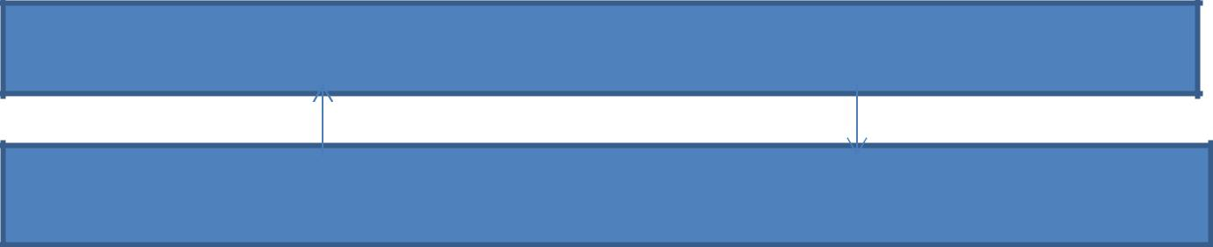

Graphical User Interface

Extracting Patterns
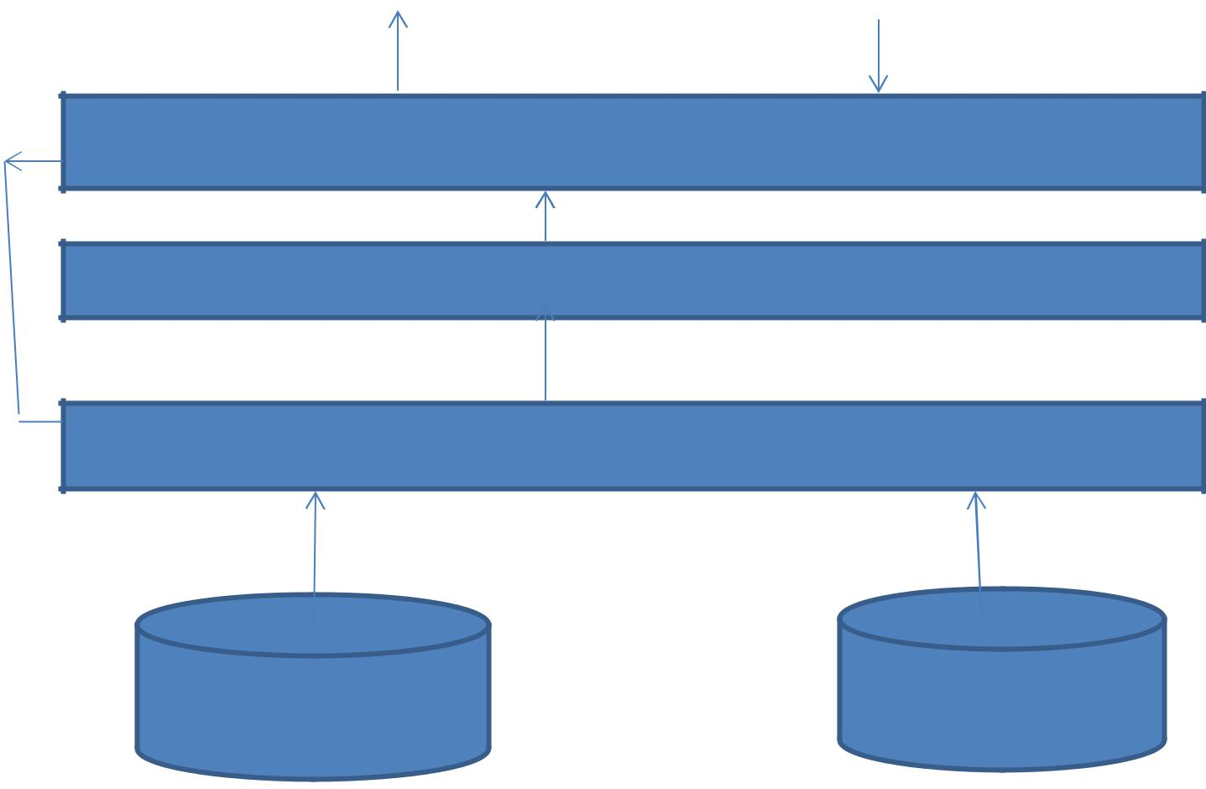

DataMining Engine(applying algorithms)

Cleaning and Smoothing data

Storing into a dataset

DATA LAKE | Other Sources
 | 20

5.2 PROCESSING STEPS

- Data of the companies you want to invest will be taken.

- First we will clean the data if there are any missing values and we then we will apply smoothing functions.

- Then the algorithms will be applied on the data.

- The results will be shown in the form of graphs,charts etc., based on our input

- They will be displayed to the user.

21
6. SYSTEM DESIGN

6.1 UML DIAGRAMS

The uml is a language. It provides vocabulary and the results for combining words in that vocabulary for the purpose of communication. A modelling language is language whose vocabulary and rules flows on the conceptual and physical representation of a system. A modelling language such as uml is a standard language for software blue prints.

The uml is a language for visualizing, specifying, constructing and documenting. The software intensive articrafts of a system.

UML diagram are classified into two categories:

- Structural or static

- Dynamic or behavioural

Structural Model contains Classes, object, use case, component and deployment.

Behavioural Model contains Collaboration, State chart and activity.

6.1.1 Sequential Diagram

Interaction diagram is called is sequence diagram. Interaction diagram describes patterns of communication among a set of interaction objects. An object interacts with another object by sending messages, arguments may be passed along with a message and they are found to be parameters of executing methods in the receiving objects.

22
In the belowDiagram, the Objects are:

1.User

2.GUI

3.DataMining Engine

4.Pattern
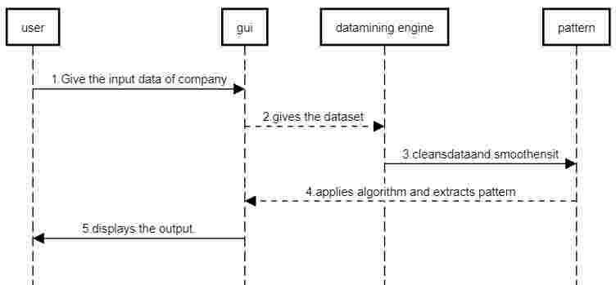

6.1.2 State Chart Diagram:

It describes the dynamic nature of the diagram how the objects changes its state. It has various States and Transitions.

23
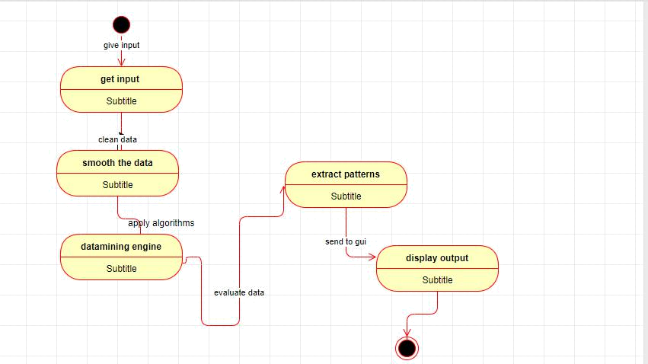

24

7. IMPLEMENTATION

USER INTERFACE

SERVER CODE:

shinyServer(function(input,output)

{options(shiny.maxRequestSize=1024*1024^2)

Data<-reactive({

Data1<-input$file;FILEPATH<-Data1$datapath; FILENAME<-Data1$name;H<-input$Header;S<-input$sep; if(is.null(input$file)){return(NULL)} if(endsWith(FILENAME,'.txt')==TRUE) {D<-read.csv(FILEPATH,header=H,sep=S); for(i in 1:ncol(D) )

{if(is.factor(D[,i]))

{ D[,i]<-as.numeric(factor(D[,i]))}} return(D)}

else if(endsWith(FILENAME,'.csv')==TRUE) {D<-read.csv(FILEPATH,header=H,sep=S);return(D)} else if(endsWith(FILENAME,'.xlsx')==TRUE) {D<-xlsx::read.xlsx(FILEPATH,1);return(D)}

else if(endsWith(FILENAME,'.xls')==TRUE) {D<-import(FILEPATH,1);return(D)}

else if(endsWith(FILENAME,'.json')==TRUE)

{D<- fromJSON(FILEPATH,header=H,sep=S);return(D)} else{print("NO FORMAT")}
})

25
accumulate_by<-function(dat,var){ var<-lazyeval::f_eval(var,dat) lvls<-plotly:::getLevels(var) dats<-lapply(seq_along(lvls),function(x){

cbind(dat[var %in% lvls[seq(1,x)],],frame=lvls[[x]])

})

dplyr::bind_rows(dats)

}

library(plotly)

fpl1<-reactive({

SES<-function(data){ets(data,alpha = 0.6)} DES<-function(data){ets(data,alpha = 0.6,beta=0.2)} TES<-function(data){ets(data,alpha = 0.6,beta=0.2,gamma = 0.2)} ARIMA<-function(data){auto.arima(data)} RNN<-function(data){nnetar(data)}

accumulate_by<-function(dat,var){ var<-lazyeval::f_eval(var,dat) lvls<-plotly:::getLevels(var) dats<-lapply(seq_along(lvls),function(x){

cbind(dat[var %in% lvls[seq(1,x)],],frame=lvls[[x]])

})

dplyr::bind_rows(dats)

}

data<-Data()

26
str(data)

sapply(data,function(x) sum(is.na(x)))

D<-strptime(data$Date,format = "%m/%d/%Y")

D1<-as.numeric(as.character(data$Close.SBI))

D2<-as.numeric(as.character(data$Close.Rcom))

D3<-as.numeric(as.character(data$Close.kcp))

D4<-as.numeric(as.character(data$Close.HDFC))

D5<-as.numeric(as.character(data$Close.HATH))

Data1<-data.frame(D,D1,D2,D3,D4,D5)

#Data1<-Data1[-1,]

names(Data1)<-

c("timeStamp","close.SBI","close.Rcom","close.kcp","close.HDFC","cl

ose.HATH")

#Data1$timeStamp

TS1<-ts(Data1$close.SBI)

TS2<-ts(Data1$close.Rcom)

TS3<-ts(Data1$close.kcp)

TS4<-ts(Data1$close.HDFC)

TS5<-ts(Data1$close.HATH)

library(forecast)

fore1<-do.call(input$Models,list(TS1))

fore2<-do.call(input$Models,list(TS2))

fore3<-do.call(input$Models,list(TS3))

fore4<-do.call(input$Models,list(TS4))

fore5<-do.call(input$Models,list(TS5))

27
PR1<-forecast(fore1,h=31)

PR2<-forecast(fore2,h=31)

PR3<-forecast(fore3,h=31)

PR4<-forecast(fore4,h=31)

PR5<-forecast(fore5,h=31)

A<-

cbind(unclass(PR1$mean),unclass(PR2$mean),unclass(PR3$mean),uncl ass(PR4$mean),unclass(PR5$mean))
head(A)

change<-NULL

change1<-NULL

for(i in 1:ncol(A)){

for(j in 1:(nrow(A)-1)){

change<-paste(round((((A[j+1,i]-A[j,i])/A[j,i])*100),digits = 2),"%")

change1<-rbind(change1,change)

}

}

ind<-1:(nrow(change1)/ncol(A))

changeSBI<-change1[ind]

changeRcom<-change1[ind+30]

changekcp<-change1[ind+60]

changeHDFC<-change1[ind+90]

changeHATH<-change1[ind+120]

library(prophet)

Pr1<-Data1[,c(1,2)]

names(Pr1)<-c("ds","y")

prop<-prophet(df=Pr1)

28
B<-make_future_dataframe(prop,periods = 31)

Dtabel<-

data.frame(as.Date(B[250:279,1]),changeSBI,changeRcom,changekcp,c

hangeHDFC,changeHATH)

names(Dtabel)<-c("Date","SBI","Rcom","kcp","HDFC","HATH")

#View(t(Dtabel))

Finaldata<<-t(Dtabel)

Finaldata1<<-data.frame(Company=rownames(Finaldata),Finaldata)

V1<-append(unclass(TS1),unclass(PR1$mean))

V2<-append(unclass(TS2),unclass(PR2$mean))

V3<-append(unclass(TS3),unclass(PR3$mean))

V4<-append(unclass(TS4),unclass(PR4$mean))

V5<-append(unclass(TS5),unclass(PR5$mean))

class<-c(rep(1,length(TS1)),rep(2,length(PR1$mean)))

B<-as.Date(B[,1])

Ap1<-rep(1:length(V1),5)

Ap2<-c(rep(1,280),rep(2,280),rep(3,280),rep(4,280),rep(5,280))

class1<-

c(c(rep(1,length(TS1)),rep(2,length(PR1$mean))),c(rep(1,length(TS1)),r ep(2,length(PR1$mean))),

c(rep(1,length(TS1)),rep(2,length(PR1$mean))),c(rep(1,length(TS1)),re p(2,length(PR1$mean))),

c(rep(1,length(TS1)),rep(2,length(PR1$mean))))

VV<-c(V1,V2,V3,V4,V5)

29
plt1<-

data.frame(ds=Ap1,ds1=as.character(Ap2),Price=VV,frame=(1:length(

Ap1)),class=class1)

d<-plt1%>%

accumulate_by(~ds)

fp1<-d %>%

plot_ly(

x=~ds,

y=~Price,

color=~class,

frame=~frame,

split=~ds1,

type="scatter",

mode="lines",

#hoverinfo=text,

#text=~paste("Date:",TS,"<br>","Price: Rs",PriceSBI,"<br>"), line=list(simplyfy=F))%>%

layout(title="Plots of All Companies")%>% animation_opts(

frame=100,

transition=10,

redraw=FALSE

)%>%

animation_slider(hide=F

)%>%

animation_button(

x=1,xanchor="right",y=0,yanchor="bottom")

return(fp1)

30
})

pl1<-reactive({

SES<<-function(data){ets(data,alpha = 0.6)} DES<<-function(data){ets(data,alpha = 0.6,beta=0.2)} TES<<-function(data){ets(data,alpha = 0.6,beta=0.2,gamma = 0.2)} ARIMA<<-function(data){auto.arima(data)} RNN<<-function(data){nnetar(data)}

accumulate_by<-function(dat,var){ var<-lazyeval::f_eval(var,dat) lvls<-plotly:::getLevels(var) dats<-lapply(seq_along(lvls),function(x){

cbind(dat[var %in% lvls[seq(1,x)],],frame=lvls[[x]])

})

dplyr::bind_rows(dats)

}

data<-Data()

str(data)

sapply(data,function(x) sum(is.na(x)))

D<-strptime(data$Date,format = "%m/%d/%Y")

D1<-as.numeric(as.character(data$Close.SBI))

D2<-as.numeric(as.character(data$Close.Rcom))

D3<-as.numeric(as.character(data$Close.kcp))

D4<-as.numeric(as.character(data$Close.HDFC))

D5<-as.numeric(as.character(data$Close.HATH))

31

Data1<-data.frame(D,D1,D2,D3,D4,D5)

#Data1<-Data1[-1,]

names(Data1)<-

c("timeStamp","close.SBI","close.Rcom","close.kcp","close.HDFC","cl

ose.HATH")

#Data1$timeStamp

TS1<-ts(Data1$close.SBI)

TS2<-ts(Data1$close.Rcom)

TS3<-ts(Data1$close.kcp)

TS4<-ts(Data1$close.HDFC)

TS5<-ts(Data1$close.HATH)

library(forecast)

fore1<-do.call(input$Models,list(TS1))

fore2<-do.call(input$Models,list(TS2))

fore3<-do.call(input$Models,list(TS3))

fore4<-do.call(input$Models,list(TS4))

fore5<-do.call(input$Models,list(TS5))

PR1<-forecast(fore1,h=31)

PR2<-forecast(fore2,h=31)

PR3<-forecast(fore3,h=31)

PR4<-forecast(fore4,h=31)

PR5<-forecast(fore5,h=31)

32
A<-

cbind(unclass(PR1$mean),unclass(PR2$mean),unclass(PR3$mean),uncl

ass(PR4$mean),unclass(PR5$mean))

head(A)

change<-NULL

change1<-NULL

for(i in 1:ncol(A)){

for(j in 1:(nrow(A)-1)){

change<-paste(round((((A[j+1,i]-A[j,i])/A[j,i])*100),digits = 2),"%")

change1<-rbind(change1,change)

}

}

ind<-1:(nrow(change1)/ncol(A))

changeSBI<-change1[ind]

changeRcom<-change1[ind+30]

changekcp<-change1[ind+60]

changeHDFC<-change1[ind+90]

changeHATH<-change1[ind+120]

library(prophet)

Pr1<-Data1[,c(1,2)]

names(Pr1)<-c("ds","y")

prop<-prophet(df=Pr1)

B<-make_future_dataframe(prop,periods = 31)

Dtabel<-

data.frame(as.Date(B[250:279,1]),changeSBI,changeRcom,changekcp,c

hangeHDFC,changeHATH)

names(Dtabel)<-c("Date","SBI","Rcom","kcp","HDFC","HATH")

33
#View(t(Dtabel))

Finaldata<<-t(Dtabel)

Finaldata1<<-data.frame(Company=rownames(Finaldata),Finaldata)

V1<-append(unclass(TS1),unclass(PR1$mean))

V2<-append(unclass(TS2),unclass(PR2$mean))

V3<-append(unclass(TS3),unclass(PR3$mean))

V4<-append(unclass(TS4),unclass(PR4$mean))

V5<-append(unclass(TS5),unclass(PR5$mean))

class<-c(rep(1,length(TS1)),rep(2,length(PR1$mean)))

B<-as.Date(B[,1])

Ap1<-rep(1:length(V1),5)

Ap2<-c(rep(1,280),rep(2,280),rep(3,280),rep(4,280),rep(5,280))

class1<-

c(c(rep(1,length(TS1)),rep(2,length(PR1$mean))),c(rep(1,length(TS1)),r ep(2,length(PR1$mean))),

c(rep(1,length(TS1)),rep(2,length(PR1$mean))),c(rep(1,length(TS1)),re p(2,length(PR1$mean))),

c(rep(1,length(TS1)),rep(2,length(PR1$mean))))

VV<-c(V1,V2,V3,V4,V5)

plt1<-

data.frame(ds=Ap1,ds1=as.character(Ap2),Price=VV,frame=(1:length(

Ap1)),class=class1)

plt<-data.frame(ds=1:length(V1),TS=as.character(B),

34
PriceSBI=V1,

PriceRcom=V2,

PriceKcp=V3,

PriceHDFC=V4,

PriceHath=V5,

class=class,frame=(1:length(V1)),

changeSBI=append(rep(0,250),changeSBI),

changeRcom=append(rep(0,250),changeRcom),

changekcp=append(rep(0,250),changekcp),

changeHDFC=append(rep(0,250),changeHDFC),

changeHATH=append(rep(0,250),changeHATH)

)

plt$TS<-as.character(plt$TS)

library(plotly)

d<-plt%>%

accumulate_by(~ds)

p1<-d %>%

plot_ly(

x=~ds,

y=~PriceSBI,

frame=~frame,

color=~class,

#type="scatter",

mode="lines",

hoverinfo=text,

text=~paste("Date:",TS,"<br>","Price:

Rs",PriceSBI,"<br>","Change in %",changeSBI),

line=list(simplyfy=F))%>%

35
layout(title="SBI Stock Prices")%>%

animation_opts(

frame=100,

transition=10,

redraw=FALSE

)%>%

animation_slider(hide=F

)%>%

animation_button(

x=1,xanchor="right",y=0,yanchor="top")

return(p1)

})

pl2<-reactive({

SES<<-function(data){ets(data,alpha = 0.6)} DES<<-function(data){ets(data,alpha = 0.6,beta=0.2)} TES<<-function(data){ets(data,alpha = 0.6,beta=0.2,gamma = 0.2)}

accumulate_by<-function(dat,var){ var<-lazyeval::f_eval(var,dat) lvls<-plotly:::getLevels(var) dats<-lapply(seq_along(lvls),function(x){

cbind(dat[var %in% lvls[seq(1,x)],],frame=lvls[[x]])

})

dplyr::bind_rows(dats)

}

36
data<-Data()

str(data)

sapply(data,function(x) sum(is.na(x)))

D<-strptime(data$Date,format = "%m/%d/%Y")

D1<-as.numeric(as.character(data$Close.SBI))

D2<-as.numeric(as.character(data$Close.Rcom))

D3<-as.numeric(as.character(data$Close.kcp))

D4<-as.numeric(as.character(data$Close.HDFC))

D5<-as.numeric(as.character(data$Close.HATH))

Data1<-data.frame(D,D1,D2,D3,D4,D5)

#Data1<-Data1[-1,]

names(Data1)<-

c("timeStamp","close.SBI","close.Rcom","close.kcp","close.HDFC","cl

ose.HATH")

#Data1$timeStamp

TS1<-ts(Data1$close.SBI)

TS2<-ts(Data1$close.Rcom)

TS3<-ts(Data1$close.kcp)

TS4<-ts(Data1$close.HDFC)

TS5<-ts(Data1$close.HATH)

library(forecast)

fore1<-do.call(input$Models,list(TS1))

fore2<-do.call(input$Models,list(TS2))

fore3<-do.call(input$Models,list(TS3))

fore4<-do.call(input$Models,list(TS4))

37
fore5<-do.call(input$Models,list(TS5))

PR1<-forecast(fore1,h=31)

PR2<-forecast(fore2,h=31)

PR3<-forecast(fore3,h=31)

PR4<-forecast(fore4,h=31)

PR5<-forecast(fore5,h=31)

A<-

cbind(unclass(PR1$mean),unclass(PR2$mean),unclass(PR3$mean),uncl

ass(PR4$mean),unclass(PR5$mean))

head(A)

change<-NULL

change1<-NULL

for(i in 1:ncol(A)){

for(j in 1:(nrow(A)-1)){

change<-paste(round((((A[j+1,i]-A[j,i])/A[j,i])*100),digits = 2),"%")

change1<-rbind(change1,change)

}

}

ind<-1:(nrow(change1)/ncol(A))

changeSBI<-change1[ind]

changeRcom<-change1[ind+30]

changekcp<-change1[ind+60]

changeHDFC<-change1[ind+90]

changeHATH<-change1[ind+120]

library(prophet)

38
Pr1<-Data1[,c(1,2)]

names(Pr1)<-c("ds","y")

prop<-prophet(df=Pr1)

B<-make_future_dataframe(prop,periods = 31)

Dtabel<-

data.frame(as.Date(B[250:279,1]),changeSBI,changeRcom,changekcp,c

hangeHDFC,changeHATH)

names(Dtabel)<-c("Date","SBI","Rcom","kcp","HDFC","HATH")

#View(t(Dtabel))

Finaldata<<-t(Dtabel)

Finaldata1<<-data.frame(Company=rownames(Finaldata),Finaldata)

V1<-append(unclass(TS1),unclass(PR1$mean))

V2<-append(unclass(TS2),unclass(PR2$mean))

V3<-append(unclass(TS3),unclass(PR3$mean))

V4<-append(unclass(TS4),unclass(PR4$mean))

V5<-append(unclass(TS5),unclass(PR5$mean))

class<-c(rep(1,length(TS1)),rep(2,length(PR1$mean)))

B<-as.Date(B[,1])

Ap1<-rep(1:length(V1),5)

Ap2<-c(rep(1,280),rep(2,280),rep(3,280),rep(4,280),rep(5,280))

class1<-

c(c(rep(1,length(TS1)),rep(2,length(PR1$mean))),c(rep(1,length(TS1)),r ep(2,length(PR1$mean))),

c(rep(1,length(TS1)),rep(2,length(PR1$mean))),c(rep(1,length(TS1)),re p(2,length(PR1$mean))),

c(rep(1,length(TS1)),rep(2,length(PR1$mean))))

39
8.RESULTS

DATA SET
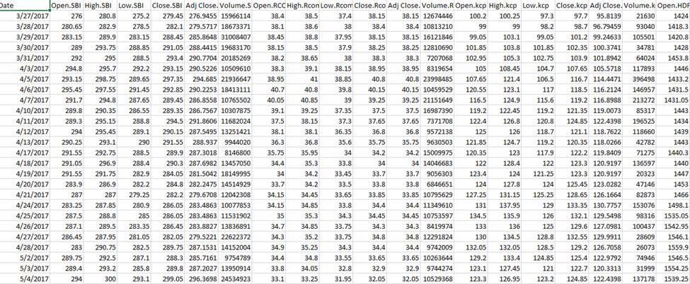

SIMPLE EXPONENTIAL SMOOTHING METHOD:
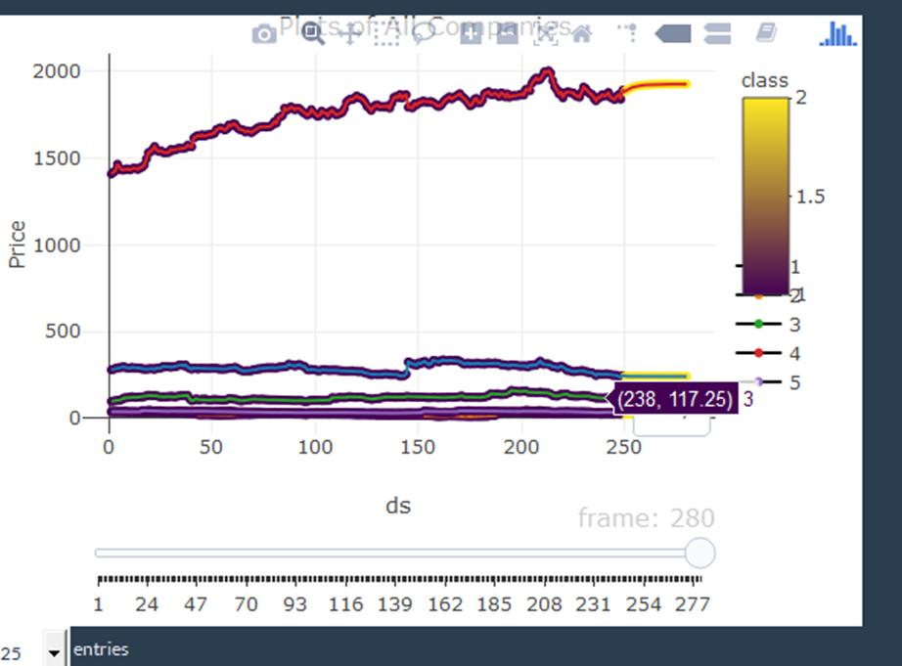

40
DOUBLE EXPONENTIAL SMOOTHNING METHOD
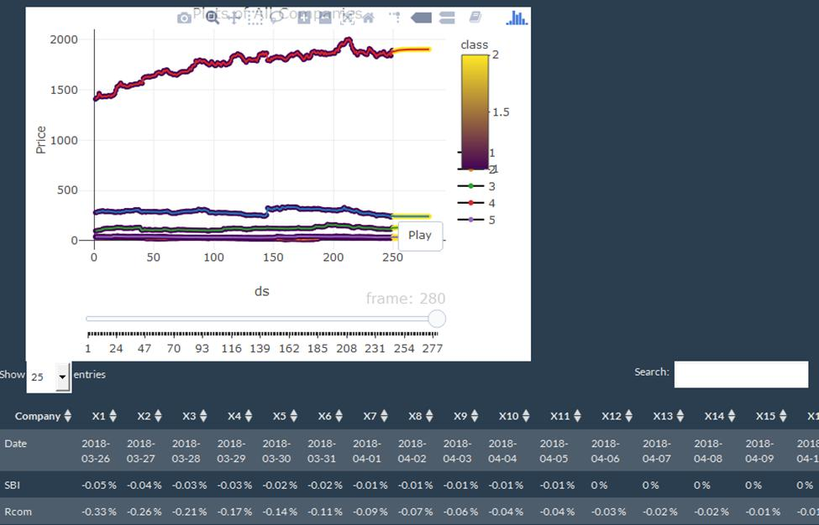

TRIPLE EXPONENTIAL SMOOTHNING METHOD
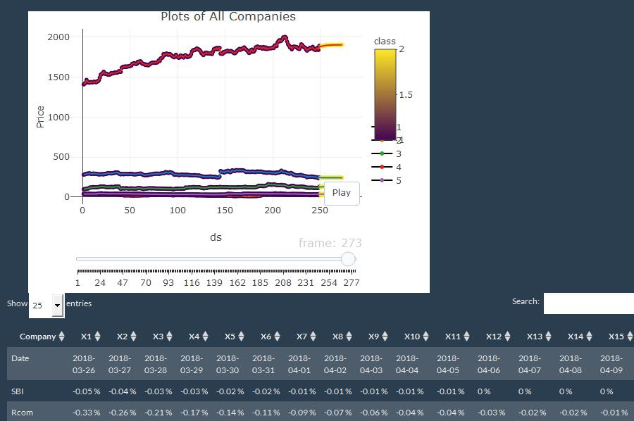

41
ARIMA
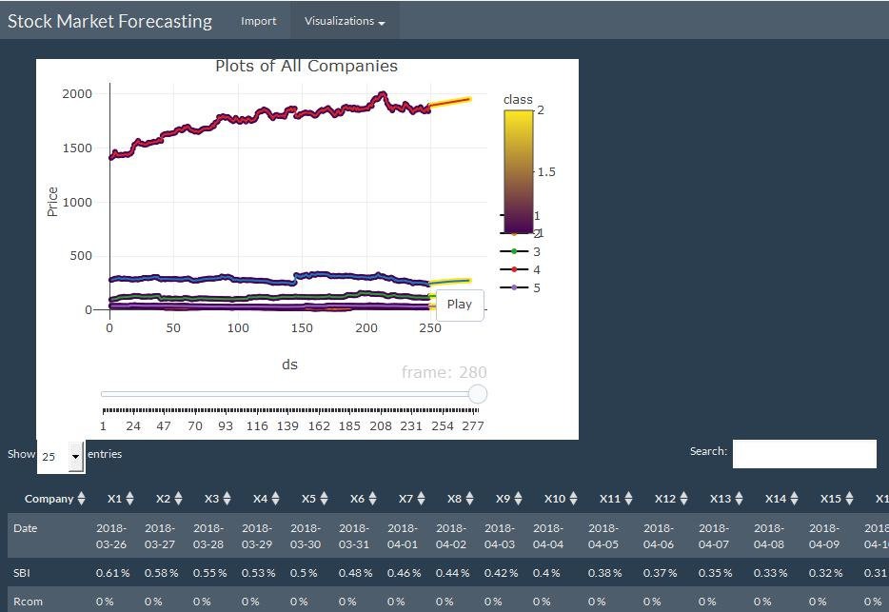

RECURRENT NEURAL NETWORKS
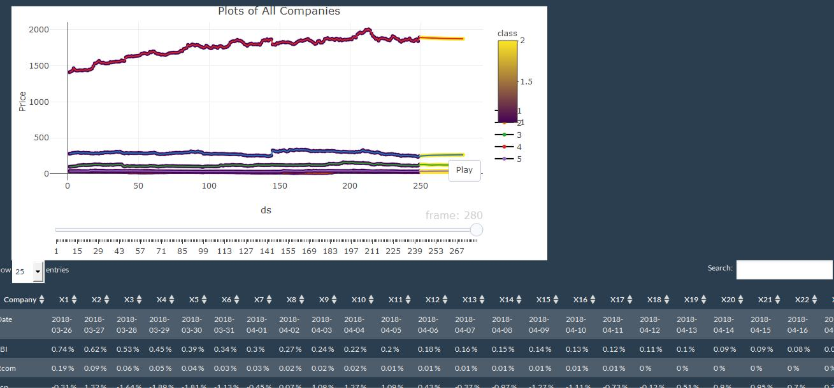

42

9. TESTING

The purpose of testing is to discover errors. Testing is the process of

trying to discover every conceivable fault or weakness in a work product. It provides a way to check the functionality of components, subassemblies, assemblies and or/a finished product. It is the process of exercising software with the intent of ensuring that the software system meets its requirements and user expectations does not fail in unacceptable manner. There are various types of test. Each test type addresses a specific requirement.

9.1 TYPES OF TESTS

UNIT TESTING

Unit testing involves the design of test cases that validate the internal program logic is functioning properly, and that program inputs procedure valid outputs. All decision branches and internal code flow should be validated. It is the testing of individual software units of the application. It is done after the completion o an individual unit before integration. This is structural testing, that relies on knowledge of its construction and is invasive. Unit test perform basic test at component level and and test a specific business process, application ,and/or system configuration .Unit test ensures that each unique path of a business process performs accurately to the documented specifications and contains clearly defined inputs and expected results.

43
INTEGRATION TESTING

Integration tests are designed to test integrated software components to determine if they actually run as one program. Testing is event driven and is more concerened with thebasic outcome o screens or fields. Integration tests demonstrate that although the components were individually satisfaction, as shown successfully by unit testing ,the combination of components is correct and consistent. Integration testing is specifically aimed at exposing the problems that arise from the combination of components.

FUNCTIONAL TEST

Functional tests provide systematic demonstrations that function tests are available as specified by the business and technical requirements, system documentation, and user manuals.

Functional testing is centred on the following items:

Valid Input : identified classes of valid input must be accepted

Invalid Input :identified classes of invalid input must be rejected

Functions :identified function must be exercised

Output : identified classes of application outputs must be exercised

Procedures : interfacing systems or procedures must be invoked

Organization and preparation of function tests is focused on requirements, key functions or special test cases. In addition, systematic coverage pertaining to identify business process flow; data fields, predefined process, and successive process must be considered for testing. Before functional testing is complete, additional tests are identified and the effective value of current test is determined.

System Test

System testing ensures that the entire integrated software system meets requirements. It tests a configuration to ensure known and

44
predictable results. An example of system testing is configuration oriented system integration test.

White Box Testing

White Box Testing is a testing in which the software tester has and of the inner workings, structure and language of the software ,or at least its purpose. It is used to test areas that cannot be reached from a black box level.

Black Box Testing

Black Box Testing is testing the software without any knowledge of the inner workings, structure or language of the module being tested. Black box tests, as most other kind of tests, must be written from a definitive source document, such as specification or requirements document. It is a testing in which the software under test is treated, as black box you cannot “see” into it. The test provides inputs and responds to outputs without considering how the software works.

45
10.CONCLUSION

To maintain the economy of a company the stock exchange has to be performing. In order to predict the changes in the stock we are performing the above-mentioned algorithms. we observed that from the first to last at each we are finding more accuracy than the previous one. Hence, we conclude that from the above algorithms recurrent neural networks is providing more accurate predictions.

46
11.REFERENCES

WEB REFERENCES:

- https://www.nltk.org/

- https://www.r.org/

- https://www.analyticsvidhya.com/

47

