ASSIGNMENT-7.1
NAME:P.BHARGAVI
BATCH:44
2303A52391
Task Description #1 (Syntax Errors – Missing Parentheses in Print Statement)
Task: Provide a Python snippet with a missing parenthesis in a print
statement (e.g., print "Hello"). Use AI to detect and fix the syntax
error.
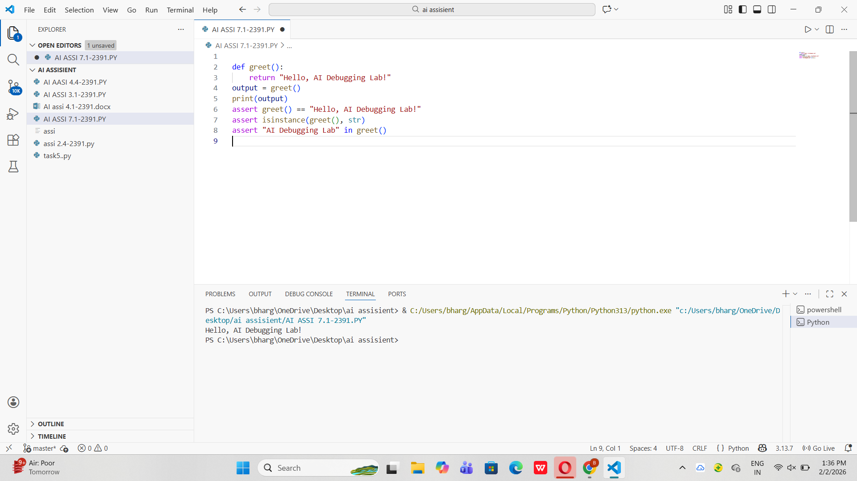

Task Description #2 (Incorrect condition in an If Statement)
Task: Supply a function where an if-condition mistakenly uses = instead of ==. Let AI identify and fix the issue.

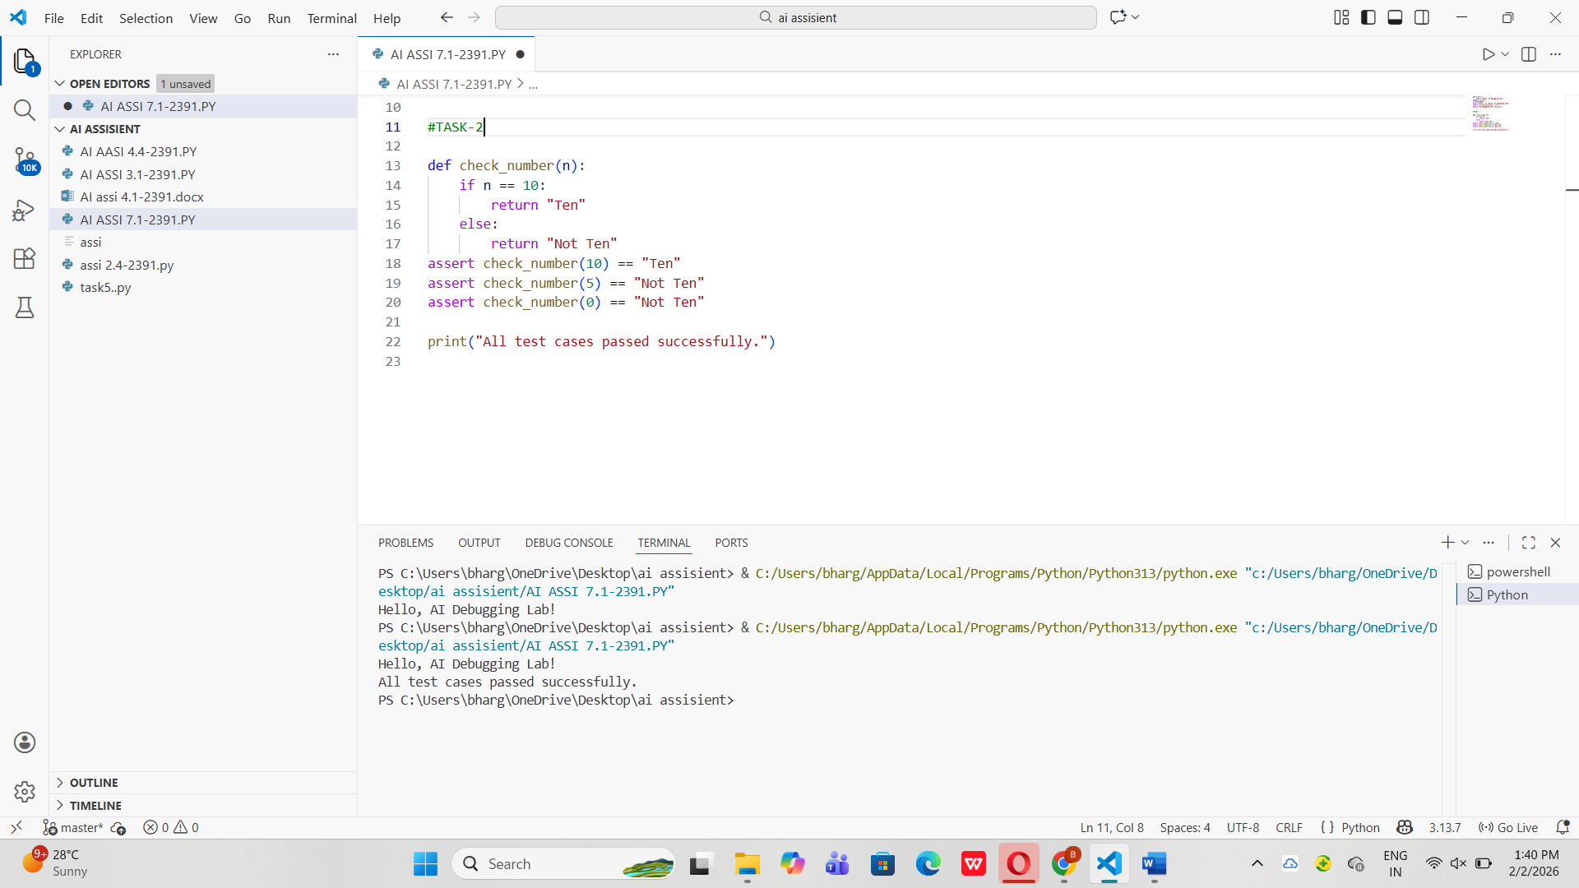

Task Description #3 (Runtime Error – File Not Found)
Task: Provide code that attempts to open a non-existent file and
crashes. Use AI to apply safe error handling.

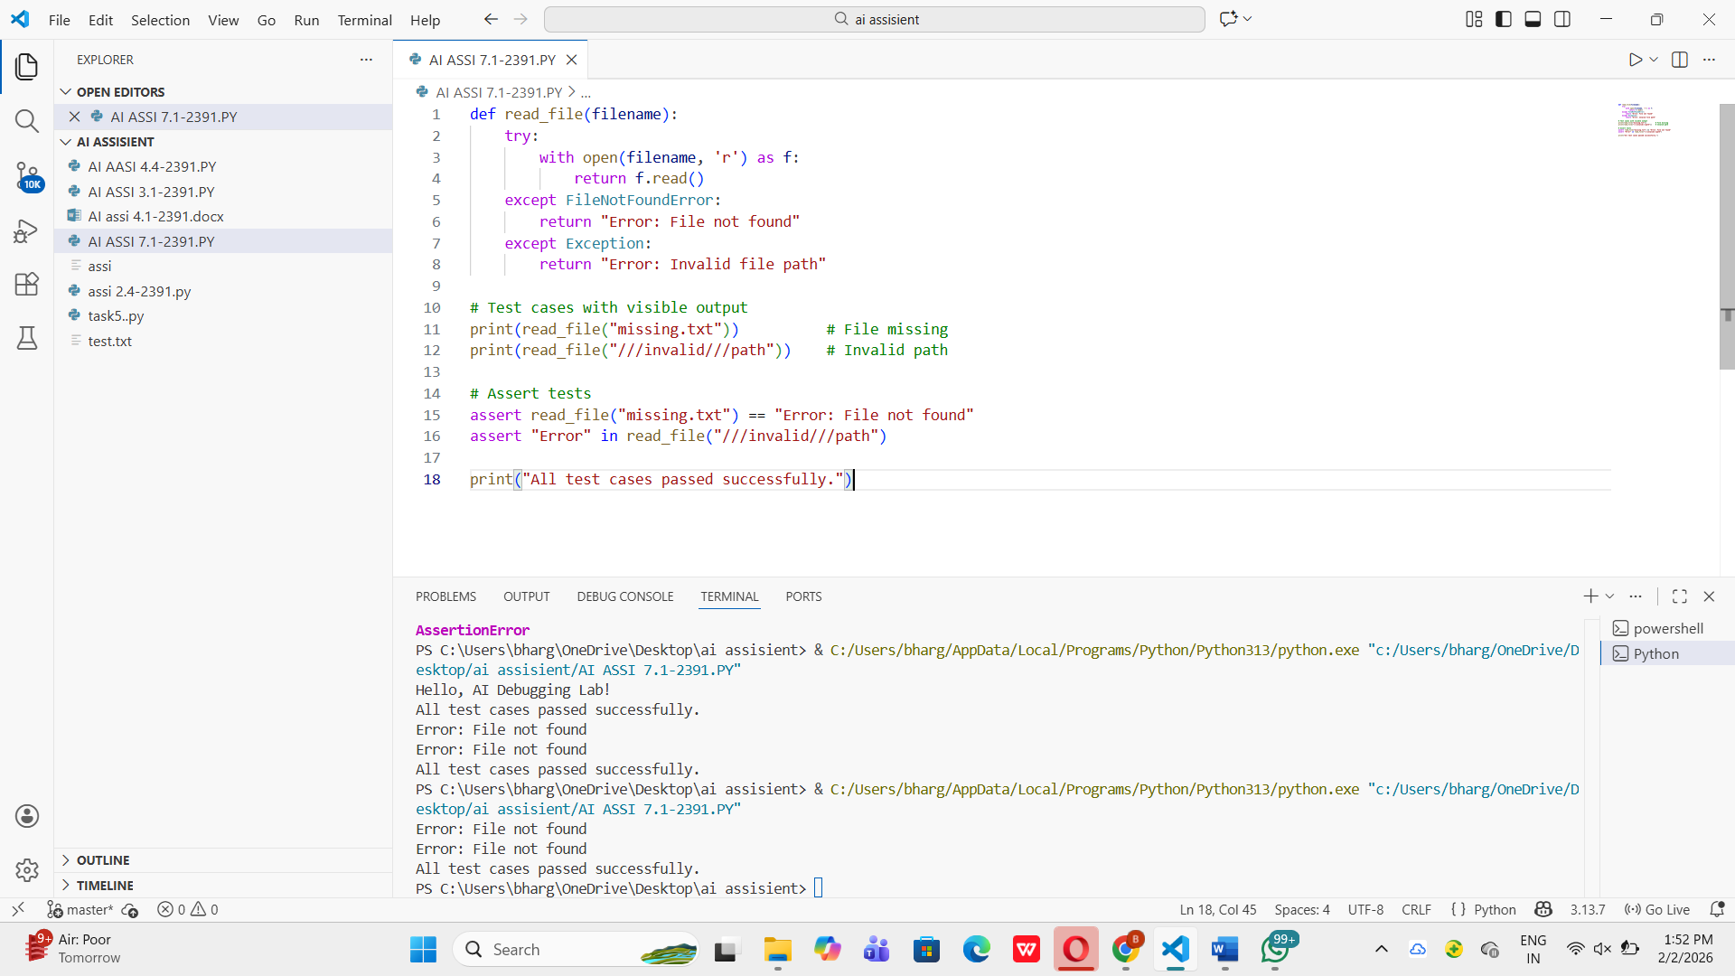

Task Description #4 (Calling a Non-Existent Method)
Task: Give a class where a non-existent method is called (e.g.,
obj.undefined_method()). Use AI to debug and fix.

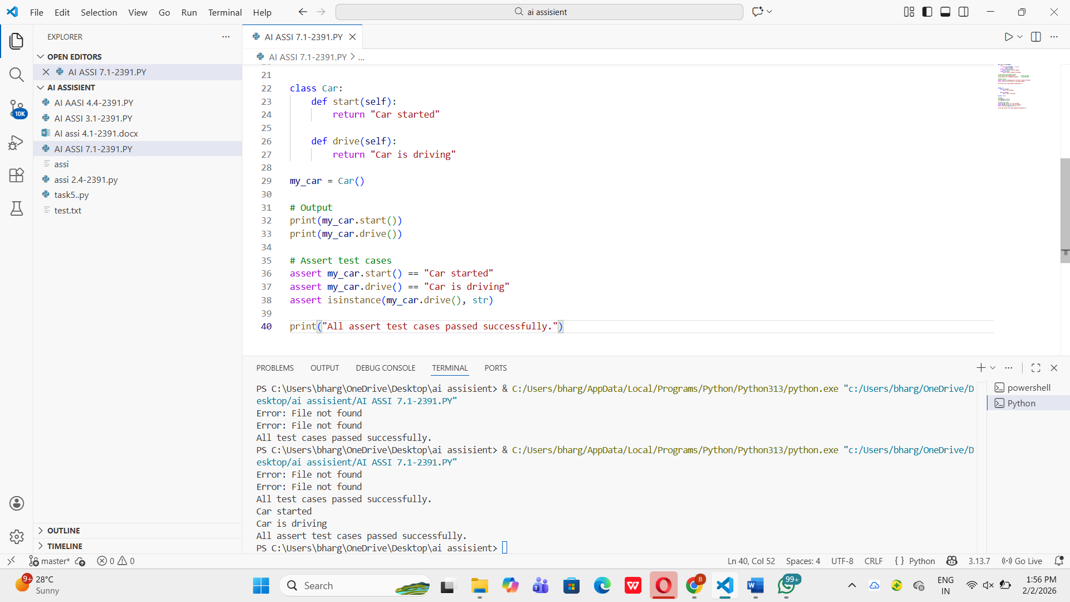

Task Description #5 (TypeError – Mixing Strings and Integers inAddition)
Task: Provide code that adds an integer and string ("5" + 2) causing
a TypeError. Use AI to resolve the bug.
