PERSONAL EXPENSE TRACKING SYSTEM
A Web Application using Python, Flask, MySQL, Pandas, NumPy and Matplotlib
Mini Project Report
Bachelor of Technology in Computer Science and Engineering
Mohan Babu University
Submitted by: [Your name] Roll number: [Your roll number]
Guide: [Guide name] Academic year: [Year]

1. Abstract
The Personal Expense Tracking System is a web application that helps a user record daily expenses, organise them into categories, filter them by date and category, and understand spending through totals, percentages and charts. The back end is written in Python with the Flask framework and stores data in a MySQL database. Pandas and NumPy are used for calculations and Matplotlib draws the charts. The project includes input validation, error handling, a database diagnostic tool, automated tests and step-by-step installation instructions for Windows.

2. Introduction
Many students and families do not know exactly where their money goes each month. Notes on paper or in a phone are easy to lose and cannot quickly answer questions such as "How much did I spend on food in September?". A small database-backed application solves this by keeping every expense in one place and calculating summaries automatically.

2.1 Objectives
- Record expenses with a title, amount, date, category and optional notes.
- Reject invalid data, especially amounts that are zero or negative.
- Manage categories and protect categories that are still in use.
- Filter expenses by date range, by category, or by both together.
- Show totals, averages, category shares and monthly trends with charts.
- Run on a normal Windows computer with simple, documented setup steps.

3. Technology Stack
Technology | Purpose in this project
Python 3 | Application logic
Flask | Web server, routing and HTML templates (Jinja2)
MySQL 8 with PyMySQL | Permanent storage; every query is parameterized
Pandas and NumPy | Totals, average, median, standard deviation, category percentages, monthly grouping
Matplotlib | Pie chart (by category) and bar chart (by month) produced as PNG images
HTML, CSS, JavaScript | User interface, responsive layout, confirmation dialogs, basic form checks
unittest | Automated tests

4. System Design

4.1 Architecture
The browser sends a request to a Flask route in app.py. The route validates the input (validators.py), reads or writes data through the repository (repository.py), which runs parameterized SQL through the database helper (db.py). For the dashboard and reports, the rows are converted to a Pandas DataFrame and processed by the analysis package (stats.py, charts.py, reports.py). The result is rendered by an HTML template or returned as a PNG chart or CSV file.

4.2 Database design
The database expense_tracker has two InnoDB tables with a one-to-many relationship: one category has many expenses.
Table | Columns | Rules
categories | id, name, description, created_at | name is unique and required
expenses | id, title, amount, expense_date, category_id, notes, created_at | amount DECIMAL(10,2) with CHECK amount > 0; category_id is a foreign key with ON DELETE RESTRICT; indexes on expense_date and category_id

4.3 Modules
File / folder | Responsibility
app.py | Routes: dashboard, expenses (list, add, edit, delete), categories, reports, CSV export, chart images, health check, error pages
config.py, .env.example | Settings read from environment variables; no passwords in the code
db.py | Opens and closes a connection for every query; converts database errors into clear messages
repository.py | All SQL statements
validators.py | Amount, date, title, category, filter and month validation
analysis/ | stats.py (Pandas, NumPy), charts.py (Matplotlib), reports.py (monthly report, CSV)
init_db.py, diagnose.py | Create the database and sample data; check packages, settings and connection
templates/, static/ | HTML pages, CSS and JavaScript
tests/ | Automated tests

5. Implementation Highlights
- Validation: the amount must be a number greater than zero with at most two decimal places; dates must be real, not in the future and not before 2000; the category must exist. Messages are shown next to the form fields and the entered values are kept.
- Filters: date range and category are optional and combine with AND. Invalid filter values are ignored with a warning instead of causing an error.
- Dashboard: totals come from the same filtered rows that are listed, so the numbers always match the database. A test compares the Pandas total with the SQL SUM.
- Empty data: NumPy and Pandas calculations return zeros and empty lists when there are no rows; charts show a "No data" image.
- Charts: Matplotlib Figure objects are created per request and released afterwards, so no figures accumulate in memory.
- Security: parameterized SQL, escaped HTML, CSRF tokens on all forms, spreadsheet-formula protection in CSV export, server bound to 127.0.0.1.
- Error handling: missing or wrong .env values, MySQL not running, missing tables, 404 and unexpected errors each produce a readable page.

6. Testing
The project contains 83 automated tests written with unittest. In the standard setup 78 run and 5 are skipped because they need a real MySQL test database. The standard tests run against a temporary SQLite database with an identical table structure, so real data is never modified. The optional MySQL tests reuse the same test cases on a separate database whose name must end in _test.
Area | Examples
Expenses | create, list, edit, delete, positive amount, required fields, invalid dates and categories, SQL-injection text, HTML escaping
Categories | add, rename, duplicate names (case-insensitive), delete protection
Filters and analysis | date only, category only, combined, inclusive bounds, monthly totals, category totals and percentages, dashboard total equals SQL SUM, empty data
Charts and export | valid PNG output, no figure leak, CSV content and formula protection
Errors and configuration | missing settings, placeholder password, 404, CSRF, database failure page
Static review | every file compiles, every import resolves, every template and url_for target exists, forms post to POST routes, schema files match, sample data loads

Limitation: the standard tests do not execute SQL on MySQL itself. MySQL-specific behaviour is verified only when the optional integration tests are run on a computer that has MySQL.

7. Results
With the supplied sample data (34 fictional expenses from July to October 2026) the dashboard shows total spending, the number of expenses, the average and highest expense, this month's total, category shares with a pie chart and monthly totals with a bar chart. The monthly report page shows the total, average, median, standard deviation, category breakdown and the five largest expenses of the selected month.
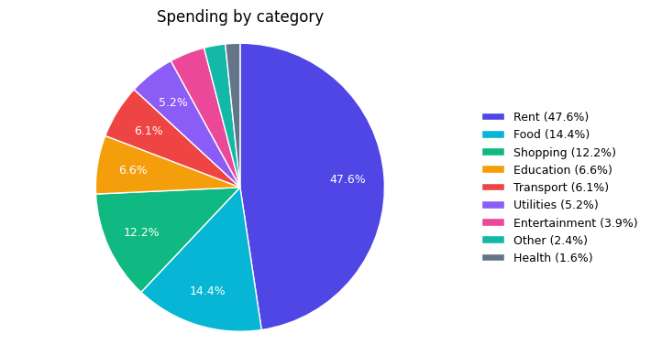
Figure 1: Spending by category (sample data)
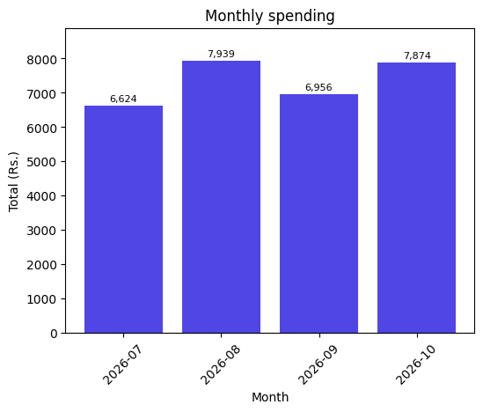
Figure 2: Monthly spending (sample data)

8. Limitations and Future Scope

8.1 Limitations
- Single user; there is no login.
- Designed for local demonstration, not for deployment on the internet.
- One currency; no budgets or recurring expenses.

8.2 Future scope
- User accounts with separate data for each user.
- Monthly budgets with warnings when a budget is exceeded.
- Recurring expenses and reminders.
- Import from bank statements and export to PDF.
- A mobile-friendly progressive web app.

9. Conclusion
The Personal Expense Tracking System meets its objectives: it records expenses safely, keeps them organised, answers date and category questions and presents spending clearly. The code is divided into small modules, validated by automated tests, and documented so that a beginner can install and run it on Windows by following the README.

Appendix: How to run
Install Python 3.10+ and MySQL 8, extract the ZIP, create a virtual environment, run pip install -r requirements.txt, copy .env.example to .env and enter the MySQL password, run python init_db.py --sample, then python app.py and open http://127.0.0.1:5000. The full commands are in README.md.

