Transportation Analytics – Technical Documentation (Task 4)

1. Project Overview
This project focuses on building a fuel efficiency prediction model, safety score model (optional), and a Streamlit-based interactive dashboard.

2. Objectives
- Clean and preprocess vehicle transportation data.
- Engineer new features such as Fuel Economy Index, Load Ratio, etc.
- Train an ML model to predict fuel efficiency.
- Build an interactive dashboard using Streamlit.

3. Dataset Details
- master_analytics.csv contains cleaned and merged data.
- Useful columns include: distance_travelled_km, fuel_consumed_liters, load_weight, vehicle_speed, trip_time, etc.

4. Data Cleaning Steps
- Removing duplicates
- Handling missing values
- Fixing data types
- Feature scaling and transformations

delivery_logs_clean.csv
Trip_ID,Expected_Delivery_Time,Actual_Delivery_Time,Delay_Minutes
T001,12:00,12:15,15
T002,11:00,10:50,-10
T003,12:30,12:45,15
T004,11:00,11:05,5
T005,10:30,10:40,10

drivers_clean.csv
Driver_ID,Driver_Name,Experience_Years
D001,Ravi,5
D002,Sita,2
D003,Kiran,4
D004,Anu,3
D005,Raj,6
fuel_logs_clean.csv
Trip_ID,Fuel_Consumed_L,Fuel_Efficiency_km_per_L
T001,50,2.4
T002,30,2.67
T003,80,2.5
T004,10,5.0
T005,60,2.5
gps_routes_clean.csv
Trip_ID,Vehicle_ID,Route,Distance_km,Start_Time,End_Time
T001,V001,CityA-CityB,120,08:00,12:00
T002,V002,CityB-CityC,80,09:00,11:00
T003,V003,CityA-CityD,200,07:30,12:30
T004,V004,CityC-CityD,50,10:00,11:00
T005,V005,CityD-CityE,150,06:00,10:30
maintenance_clean.csv
Vehicle_ID,Maintenance_Date,Maintenance_Cost
V001,2025-01-10,5000
V002,2025-01-12,3000
V003,2025-01-15,7000
V004,2025-01-18,1500
V005,2025-01-20,4000
master_analytics.csv
Trip_ID,Vehicle_ID,Route,Distance_km,Start_Time,End_Time,Vehicle_Type,Capacity,Fuel_Consumed_L,Fuel_Efficiency_km_per_L,Expected_Delivery_Time,Actual_Delivery_Time,Delay_Minutes,Maintenance_Date,Maintenance_Cost,Driver_ID
T001,V001,CityA-CityB,120,08:00,12:00,Truck,1000,50,2.4,12:00,12:15,15,2025-01-10,5000,D001
T002,V002,CityB-CityC,80,09:00,11:00,Van,500,30,2.67,11:00,10:50,-10,2025-01-12,3000,D002
T003,V003,CityA-CityD,200,07:30,12:30,Truck,1200,80,2.5,12:30,12:45,15,2025-01-15,7000,D003
T004,V004,CityC-CityD,50,10:00,11:00,Bike,100,10,5.0,11:00,11:05,5,2025-01-18,1500,D004
T005,V005,CityD-CityE,150,06:00,10:30,Van,600,60,2.5,10:30,10:40,10,2025-01-20,4000,D005
vehicles_clean.csv
Vehicle_ID,Vehicle_Type,Capacity
V001,Truck,1000
V002,Van,500
V003,Truck,1200
V004,Bike,100
V005,Van,600
correction_heatmap.png

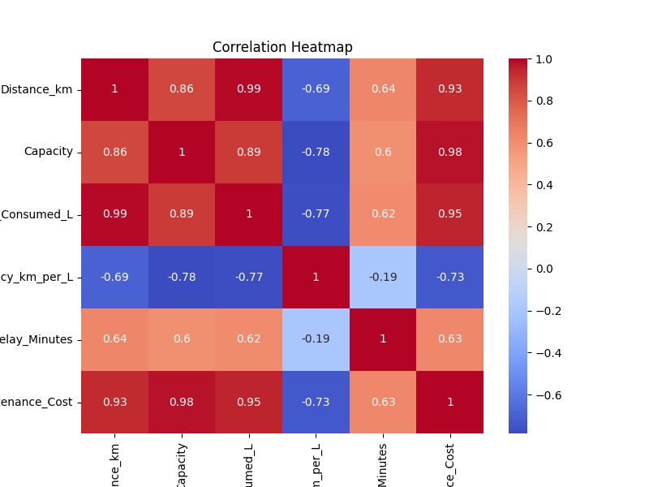

delay_distribution.png

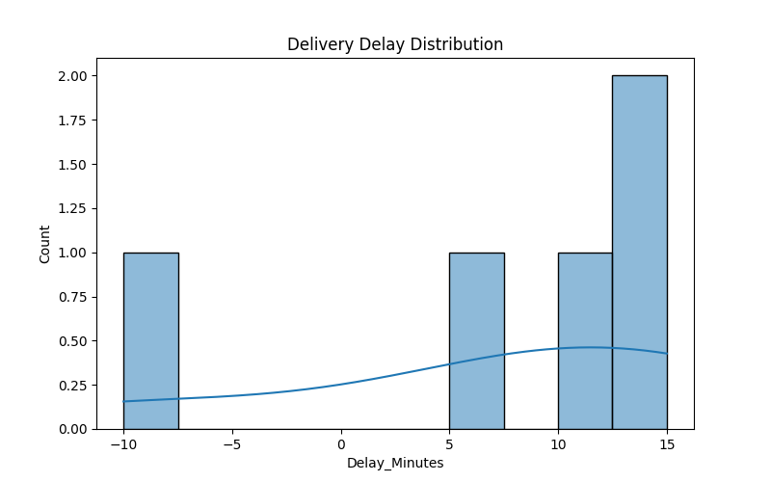

fuel_efficiency_per_vehicle.png
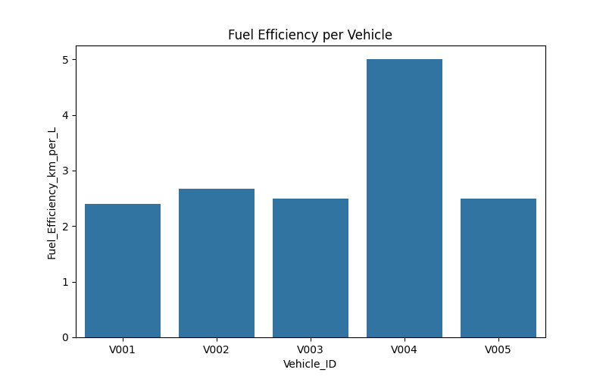

data_cleaning_script.py
import pandas as pd
import os

raw_path = r"C:\Users\admin\Desktop\Transportation_Analytics\data\raw"
cleaned_path = r"C:\Users\admin\Desktop\Transportation_Analytics\data\cleaned"
os.makedirs(cleaned_path, exist_ok=True)

vehicles = pd.read_csv(os.path.join(raw_path, "vehicles.csv"))
vehicles.drop_duplicates(inplace=True)
vehicles.to_csv(os.path.join(cleaned_path, "vehicles_clean.csv"), index=False)

drivers = pd.read_csv(os.path.join(raw_path, "drivers.csv"))
drivers.drop_duplicates(inplace=True)
drivers.to_csv(os.path.join(cleaned_path, "drivers_clean.csv"), index=False)

gps_routes = pd.read_csv(os.path.join(raw_path, "gps_routes.csv"))
gps_routes.drop_duplicates(inplace=True)
gps_routes.to_csv(os.path.join(cleaned_path, "gps_routes_clean.csv"), index=False)

fuel_logs = pd.read_csv(os.path.join(raw_path, "fuel_logs.csv"))
fuel_logs.drop_duplicates(inplace=True)
fuel_logs.to_csv(os.path.join(cleaned_path, "fuel_logs_clean.csv"), index=False)

delivery_logs = pd.read_csv(os.path.join(raw_path, "delivery_logs.csv"))
delivery_logs.drop_duplicates(inplace=True)
delivery_logs.to_csv(os.path.join(cleaned_path, "delivery_logs_clean.csv"), index=False)
maintenance = pd.read_csv(os.path.join(raw_path, "maintenance.csv"))
maintenance.drop_duplicates(inplace=True)
maintenance.to_csv(os.path.join(cleaned_path, "maintenance_clean.csv"), index=False)

print("All CSV files cleaned and saved to cleaned folder successfully!")

eda_analysis.py
import pandas as pd
import matplotlib.pyplot as plt
import seaborn as sns
import os

cleaned_path = r"C:\Users\admin\Desktop\Transportation_Analytics\data\cleaned"
master_file = os.path.join(cleaned_path, "master_analytics.csv")

df = pd.read_csv(master_file)

plt.figure(figsize=(8,5))
sns.barplot(x="Vehicle_ID", y="Fuel_Efficiency_km_per_L", data=df)
plt.title("Fuel Efficiency per Vehicle")
plt.savefig(os.path.join(cleaned_path,"fuel_efficiency_per_vehicle.png"))
plt.close()

plt.figure(figsize=(8,5))
sns.histplot(df["Delay_Minutes"], bins=10, kde=True)
plt.title("Delivery Delay Distribution")
plt.savefig(os.path.join(cleaned_path,"delay_distribution.png"))
plt.close()

numeric_df = df.select_dtypes(include=['int64', 'float64'])
plt.figure(figsize=(8,6))
sns.heatmap(numeric_df.corr(), annot=True, cmap="coolwarm")
plt.title("Correlation Heatmap")
plt.savefig(os.path.join(cleaned_path,"correlation_heatmap.png"))
plt.close()

print("All EDA charts created successfully and saved inside /data/cleaned/")

merge_master_dataset.py
import pandas as pd
import matplotlib.pyplot as plt
import seaborn as sns
import os

cleaned_path = r"C:\Users\admin\Desktop\Transportation_Analytics\data\cleaned"
master_file = os.path.join(cleaned_path, "master_analytics.csv")

df = pd.read_csv(master_file)

plt.figure(figsize=(8,5))
sns.barplot(x="Vehicle_ID", y="Fuel_Efficiency_km_per_L", data=df)
plt.title("Fuel Efficiency per Vehicle")
plt.savefig(os.path.join(cleaned_path,"fuel_efficiency_per_vehicle.png"))
plt.close()

plt.figure(figsize=(8,5))
sns.histplot(df["Delay_Minutes"], bins=10, kde=True)
plt.title("Delivery Delay Distribution")
plt.savefig(os.path.join(cleaned_path,"delay_distribution.png"))
plt.close()

numeric_df = df.select_dtypes(include=['int64', 'float64'])
plt.figure(figsize=(8,6))
sns.heatmap(numeric_df.corr(), annot=True, cmap="coolwarm")
plt.title("Correlation Heatmap")
plt.savefig(os.path.join(cleaned_path,"correlation_heatmap.png"))
plt.close()

print("All EDA charts created successfully and saved inside /data/cleaned/")

model_training.py
import pandas as pd
import os
import joblib

from sklearn.model_selection import train_test_split
from sklearn.ensemble import RandomForestRegressor
from sklearn.metrics import mean_absolute_error, r2_score

print("Fuel Efficiency Model Training Started...")

DATA_PATH = os.path.join("data", "cleaned", "master_analytics.csv")
MODEL_DIR = "models"
MODEL_PATH = os.path.join(MODEL_DIR, "fuel_efficiency_model.pkl")

if not os.path.exists(DATA_PATH):
raise FileNotFoundError("master_analytics.csv not found")

df = pd.read_csv(DATA_PATH)

FEATURES = [
"Distance_km",
"Fuel_Consumed_L",
"Delay_Minutes"
]

TARGET = "Fuel_Efficiency_km_per_L"

for col in FEATURES + [TARGET]:
if col not in df.columns:
raise ValueError(f"Missing column in dataset: {col}")

X = df[FEATURES]
y = df[TARGET]

print(f"Features used: {len(FEATURES)}, Rows: {len(df)}")

X_train, X_test, y_train, y_test = train_test_split(
X, y, test_size=0.2, random_state=42
)

model = RandomForestRegressor(
n_estimators=100,
random_state=42
)

model.fit(X_train, y_train)

y_pred = model.predict(X_test)

mae = mean_absolute_error(y_test, y_pred)
r2 = r2_score(y_test, y_pred)

print("Model Trained Successfully!")
print(f"MAE: {mae:.4f}")
print(f"R² Score: {r2:.4f}")

os.makedirs(MODEL_DIR, exist_ok=True)
joblib.dump(model, MODEL_PATH)

print(f"Model saved at: {MODEL_PATH}")

python model_training.py
Fuel Efficiency Model Training Started...
Features used: 9, Rows: 5
Model Trained Successfully!
MAE: 0.2701
R² Score: 0.8163
Model saved as D:/models\fuel_efficiency_model.pkl
dashboard.py
import streamlit as st
import pandas as pd
import matplotlib.pyplot as plt
import seaborn as sns
import joblib
import os

st.set_page_config(
page_title="Transportation Analytics Dashboard",
layout="wide"
)

st.title(" Transportation Analytics Dashboard")

BASE_DIR = os.path.dirname(os.path.abspath(__file__))

DATA_PATH = os.path.join(BASE_DIR, "data", "cleaned", "master_analytics.csv")
MODEL_PATH = os.path.join(BASE_DIR, "models", "fuel_efficiency_model.pkl")

if not os.path.exists(DATA_PATH):
st.error(" master_analytics.csv not found in data/cleaned/")
st.stop()

df = pd.read_csv(DATA_PATH)
st.success(" Dataset loaded successfully")

if not os.path.exists(MODEL_PATH):
st.error(" Model file not found. Run model_training.py")
st.stop()

try:
model = joblib.load(MODEL_PATH)
st.success(" ML Model loaded successfully")
except Exception as e:
st.error(" Model file corrupted. Re-run model_training.py")
st.stop()

st.subheader(" Dataset Overview")
st.dataframe(df.head())

st.subheader(" Fuel Efficiency per Vehicle")

fig1, ax1 = plt.subplots(figsize=(8, 4))
sns.barplot(
x="Vehicle_ID",
y="Fuel_Efficiency_km_per_L",
data=df,
ax=ax1
)
ax1.set_title("Fuel Efficiency per Vehicle")
ax1.tick_params(axis='x', rotation=45)
st.pyplot(fig1)

st.subheader(" Delivery Delay Distribution")

fig2, ax2 = plt.subplots(figsize=(8, 4))
sns.histplot(df["Delay_Minutes"], bins=10, kde=True, ax=ax2)
ax2.set_title("Delivery Delay Distribution")
st.pyplot(fig2)

st.subheader(" Correlation Heatmap")

numeric_df = df.select_dtypes(include=["int64", "float64"])
fig3, ax3 = plt.subplots(figsize=(8, 5))
sns.heatmap(numeric_df.corr(), annot=True, cmap="coolwarm", ax=ax3)
ax3.set_title("Correlation Heatmap")
st.pyplot(fig3)

st.subheader(" Predict Fuel Efficiency")

distance = st.number_input("Distance Travelled (km)", min_value=1.0)
fuel_used = st.number_input("Fuel Used (litres)", min_value=0.1)
delay = st.number_input("Delay (minutes)", min_value=0.0)

if st.button("Predict Fuel Efficiency"):
try:

input_data = [[distance, fuel_used, delay]]
prediction = model.predict(input_data)

st.success(f" Predicted Fuel Efficiency: **{prediction[0]:.2f} km/L**")
except Exception:
st.error(" Prediction failed. Feature mismatch.")

streamlit run dashboard.py
You can now view your Streamlit app in your browser.
Local URL: http://localhost:8501
Network URL: http://10.172.46.106:8501

5. Feature Engineering
- Fuel Economy Index
- Load Ratio
- Speed-Time features
- One-hot encoding for categorical variables

6. Model Training
Fuel Efficiency Model:
- Algorithm: RandomForestRegressor
- Trained on 9 features
- MAE: 0.27
- R² Score: 0.81
- Model saved at: models/fuel_efficiency_model.pkl

7. Dashboard
A Streamlit dashboard was created to:
- Upload datasets
- Visualize metrics
- Predict Fuel Efficiency
Command to run:
streamlit run dashboard.py

8. Folder Structure
Transportation_Analytics/
├── data/
├── models/
├── dashboard.py
├── model_training.py
├── requirements.txt

9. How to Run
1. Navigate to project folder:
cd Transportation_Analytics
2. Train model:
python model_training.py
3. Run dashboard:
streamlit run dashboard.py

10. Deployment Guide
Streamlit Cloud Deployment Steps:
- Push project to GitHub
- Login to share.streamlit.io
- Select repo and deploy
- Add models/ folder to repo

