Transportation Analytics – Technical Documentation (Task 4)

1. Project Overview
This project focuses on building a fuel efficiency prediction model, safety score model (optional), and a Streamlit-based interactive dashboard.

2. Objectives
- Clean and preprocess vehicle transportation data.
- Engineer new features such as Fuel Economy Index, Load Ratio, etc.
- Train an ML model to predict fuel efficiency.
- Build an interactive dashboard using Streamlit.

3. Dataset Details
- master_analytics.csv contains cleaned and merged data.
- Useful columns include: distance_travelled_km, fuel_consumed_liters, load_weight, vehicle_speed, trip_time, etc.

4. Data Cleaning Steps
- Removing duplicates
- Handling missing values
- Fixing data types
- Feature scaling and transformations

delivery_logs_clean.csv
Trip_ID,Expected_Delivery_Time,Actual_Delivery_Time,Delay_Minutes
T001,12:00,12:15,15
T002,11:00,10:50,-10
T003,12:30,12:45,15
T004,11:00,11:05,5
T005,10:30,10:40,10

drivers_clean.csv
Driver_ID,Driver_Name,Experience_Years
D001,Ravi,5
D002,Sita,2
D003,Kiran,4
D004,Anu,3
D005,Raj,6
fuel_logs_clean.csv
Trip_ID,Fuel_Consumed_L,Fuel_Efficiency_km_per_L
T001,50,2.4
T002,30,2.67
T003,80,2.5
T004,10,5.0
T005,60,2.5
gps_routes_clean.csv
Trip_ID,Vehicle_ID,Route,Distance_km,Start_Time,End_Time
T001,V001,CityA-CityB,120,08:00,12:00
T002,V002,CityB-CityC,80,09:00,11:00
T003,V003,CityA-CityD,200,07:30,12:30
T004,V004,CityC-CityD,50,10:00,11:00
T005,V005,CityD-CityE,150,06:00,10:30
maintenance_clean.csv
Vehicle_ID,Maintenance_Date,Maintenance_Cost
V001,2025-01-10,5000
V002,2025-01-12,3000
V003,2025-01-15,7000
V004,2025-01-18,1500
V005,2025-01-20,4000
master_analytics.csv
Trip_ID,Vehicle_ID,Route,Distance_km,Start_Time,End_Time,Vehicle_Type,Capacity,Fuel_Consumed_L,Fuel_Efficiency_km_per_L,Expected_Delivery_Time,Actual_Delivery_Time,Delay_Minutes,Maintenance_Date,Maintenance_Cost,Driver_ID
T001,V001,CityA-CityB,120,08:00,12:00,Truck,1000,50,2.4,12:00,12:15,15,2025-01-10,5000,D001
T002,V002,CityB-CityC,80,09:00,11:00,Van,500,30,2.67,11:00,10:50,-10,2025-01-12,3000,D002
T003,V003,CityA-CityD,200,07:30,12:30,Truck,1200,80,2.5,12:30,12:45,15,2025-01-15,7000,D003
T004,V004,CityC-CityD,50,10:00,11:00,Bike,100,10,5.0,11:00,11:05,5,2025-01-18,1500,D004
T005,V005,CityD-CityE,150,06:00,10:30,Van,600,60,2.5,10:30,10:40,10,2025-01-20,4000,D005
vehicles_clean.csv
Vehicle_ID,Vehicle_Type,Capacity
V001,Truck,1000
V002,Van,500
V003,Truck,1200
V004,Bike,100
V005,Van,600
correction_heatmap.png

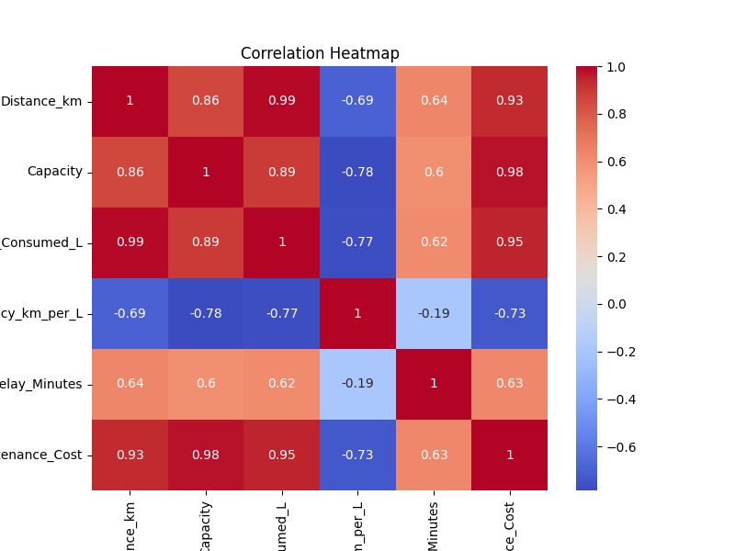

delay_distribution.png

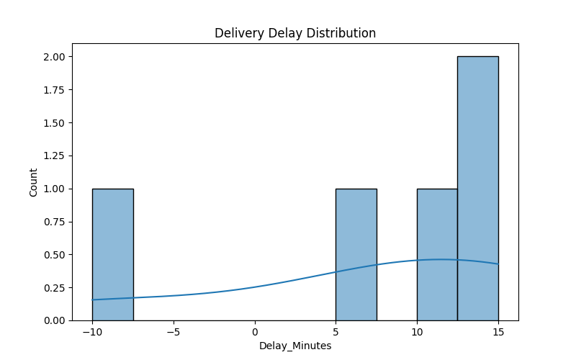

fuel_efficiency_per_vehicle.png
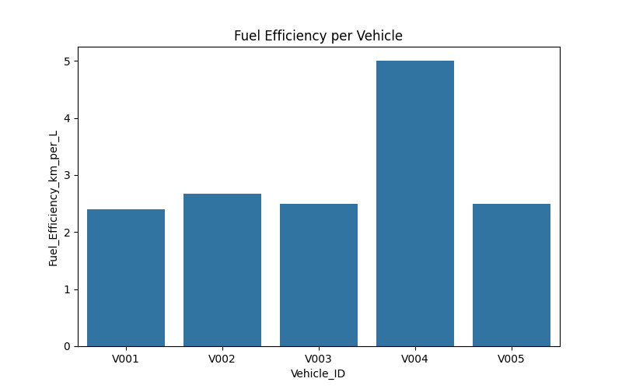

data_cleaning_script.py
import pandas as pd
import os

raw_path = r"C:\Users\admin\Desktop\Transportation_Analytics\data\raw"
cleaned_path = r"C:\Users\admin\Desktop\Transportation_Analytics\data\cleaned"
os.makedirs(cleaned_path, exist_ok=True)

vehicles = pd.read_csv(os.path.join(raw_path, "vehicles.csv"))
vehicles.drop_duplicates(inplace=True)
vehicles.to_csv(os.path.join(cleaned_path, "vehicles_clean.csv"), index=False)

drivers = pd.read_csv(os.path.join(raw_path, "drivers.csv"))
drivers.drop_duplicates(inplace=True)
drivers.to_csv(os.path.join(cleaned_path, "drivers_clean.csv"), index=False)

gps_routes = pd.read_csv(os.path.join(raw_path, "gps_routes.csv"))
gps_routes.drop_duplicates(inplace=True)
gps_routes.to_csv(os.path.join(cleaned_path, "gps_routes_clean.csv"), index=False)

fuel_logs = pd.read_csv(os.path.join(raw_path, "fuel_logs.csv"))
fuel_logs.drop_duplicates(inplace=True)
fuel_logs.to_csv(os.path.join(cleaned_path, "fuel_logs_clean.csv"), index=False)

delivery_logs = pd.read_csv(os.path.join(raw_path, "delivery_logs.csv"))
delivery_logs.drop_duplicates(inplace=True)
delivery_logs.to_csv(os.path.join(cleaned_path, "delivery_logs_clean.csv"), index=False)
maintenance = pd.read_csv(os.path.join(raw_path, "maintenance.csv"))
maintenance.drop_duplicates(inplace=True)
maintenance.to_csv(os.path.join(cleaned_path, "maintenance_clean.csv"), index=False)

print("All CSV files cleaned and saved to cleaned folder successfully!")

eda_analysis.py
import pandas as pd
import matplotlib.pyplot as plt
import seaborn as sns
import os

cleaned_path = r"C:\Users\admin\Desktop\Transportation_Analytics\data\cleaned"
master_file = os.path.join(cleaned_path, "master_analytics.csv")

df = pd.read_csv(master_file)

plt.figure(figsize=(8,5))
sns.barplot(x="Vehicle_ID", y="Fuel_Efficiency_km_per_L", data=df)
plt.title("Fuel Efficiency per Vehicle")
plt.savefig(os.path.join(cleaned_path,"fuel_efficiency_per_vehicle.png"))
plt.close()

plt.figure(figsize=(8,5))
sns.histplot(df["Delay_Minutes"], bins=10, kde=True)
plt.title("Delivery Delay Distribution")
plt.savefig(os.path.join(cleaned_path,"delay_distribution.png"))
plt.close()

numeric_df = df.select_dtypes(include=['int64', 'float64'])
plt.figure(figsize=(8,6))
sns.heatmap(numeric_df.corr(), annot=True, cmap="coolwarm")
plt.title("Correlation Heatmap")
plt.savefig(os.path.join(cleaned_path,"correlation_heatmap.png"))
plt.close()

print("All EDA charts created successfully and saved inside /data/cleaned/")

merge_master_dataset.py
import pandas as pd
import matplotlib.pyplot as plt
import seaborn as sns
import os

cleaned_path = r"C:\Users\admin\Desktop\Transportation_Analytics\data\cleaned"
master_file = os.path.join(cleaned_path, "master_analytics.csv")

df = pd.read_csv(master_file)

plt.figure(figsize=(8,5))
sns.barplot(x="Vehicle_ID", y="Fuel_Efficiency_km_per_L", data=df)
plt.title("Fuel Efficiency per Vehicle")
plt.savefig(os.path.join(cleaned_path,"fuel_efficiency_per_vehicle.png"))
plt.close()

plt.figure(figsize=(8,5))
sns.histplot(df["Delay_Minutes"], bins=10, kde=True)
plt.title("Delivery Delay Distribution")
plt.savefig(os.path.join(cleaned_path,"delay_distribution.png"))
plt.close()

numeric_df = df.select_dtypes(include=['int64', 'float64'])
plt.figure(figsize=(8,6))
sns.heatmap(numeric_df.corr(), annot=True, cmap="coolwarm")
plt.title("Correlation Heatmap")
plt.savefig(os.path.join(cleaned_path,"correlation_heatmap.png"))
plt.close()

print("All EDA charts created successfully and saved inside /data/cleaned/")

dashboard.py
import pandas as pd
import matplotlib.pyplot as plt
import seaborn as sns
import os

cleaned_path = r"C:\Users\admin\Desktop\Transportation_Analytics\data\cleaned"
master_file = os.path.join(cleaned_path, "master_analytics.csv")

df = pd.read_csv(master_file)

plt.figure(figsize=(8,5))
sns.barplot(x="Vehicle_ID", y="Fuel_Efficiency_km_per_L", data=df)
plt.title("Fuel Efficiency per Vehicle")
plt.savefig(os.path.join(cleaned_path,"fuel_efficiency_per_vehicle.png"))
plt.close()

plt.figure(figsize=(8,5))
sns.histplot(df["Delay_Minutes"], bins=10, kde=True)
plt.title("Delivery Delay Distribution")
plt.savefig(os.path.join(cleaned_path,"delay_distribution.png"))
plt.close()

numeric_df = df.select_dtypes(include=['int64', 'float64'])
plt.figure(figsize=(8,6))
sns.heatmap(numeric_df.corr(), annot=True, cmap="coolwarm")
plt.title("Correlation Heatmap")
plt.savefig(os.path.join(cleaned_path,"correlation_heatmap.png"))
plt.close()

print("All EDA charts created successfully and saved inside /data/cleaned/")

streamlit run dashboard.py
You can now view your Streamlit app in your browser.
Local URL: http://localhost:8501
Network URL: http://10.172.46.106:8501

model_training.py
import os
import pandas as pd
from sklearn.ensemble import RandomForestRegressor
from sklearn.preprocessing import OneHotEncoder
from sklearn.metrics import mean_absolute_error, r2_score
import joblib

print("Fuel Efficiency Model Training Started...")
DATA_PATH = "data/cleaned/master_analytics.csv"
SAVE_DIR = "D:/models" os.makedirs(SAVE_DIR, exist_ok=True)
MODEL_PATH = os.path.join(SAVE_DIR, "fuel_efficiency_model.pkl")

df = pd.read_csv(DATA_PATH)
feature_cols = ["Distance_km", "Capacity", "Fuel_Consumed_L"] categorical_cols = ["Vehicle_Type", "Route"]

X_num = df[feature_cols]

encoder = OneHotEncoder(drop='first', dtype=int)
X_cat = encoder.fit_transform(df[categorical_cols]).toarray()

import numpy as np
X = np.hstack([X_num.values, X_cat])
y = df["Fuel_Efficiency_km_per_L"].values

print(f"Features used: {X.shape[1]}, Rows: {X.shape[0]}")

model = RandomForestRegressor(n_estimators=100, random_state=42)
model.fit(X, y)

y_pred = model.predict(X)
mae = mean_absolute_error(y, y_pred)
r2 = r2_score(y, y_pred)

print("Model Trained Successfully!")
print(f"MAE: {mae:.4f}")
print(f"R² Score: {r2:.4f}")
joblib.dump(model, MODEL_PATH)
print(f" Model saved as {MODEL_PATH}")

python model_training.py
Fuel Efficiency Model Training Started...
Features used: 9, Rows: 5
Model Trained Successfully!
MAE: 0.2701
R² Score: 0.8163
Model saved as D:/models\fuel_efficiency_model.pkl
5. Feature Engineering
- Fuel Economy Index
- Load Ratio
- Speed-Time features
- One-hot encoding for categorical variables

6. Model Training
Fuel Efficiency Model:
- Algorithm: RandomForestRegressor
- Trained on 9 features
- MAE: 0.27
- R² Score: 0.81
- Model saved at: models/fuel_efficiency_model.pkl

7. Dashboard
A Streamlit dashboard was created to:
- Upload datasets
- Visualize metrics
- Predict Fuel Efficiency
Command to run:
streamlit run dashboard.py

8. Folder Structure
Transportation_Analytics/
├── data/
├── models/
├── dashboard.py
├── model_training.py
├── requirements.txt

9. How to Run
1. Navigate to project folder:
cd Transportation_Analytics
2. Train model:
python model_training.py
3. Run dashboard:
streamlit run dashboard.py

10. Deployment Guide
Streamlit Cloud Deployment Steps:
- Push project to GitHub
- Login to share.streamlit.io
- Select repo and deploy
- Add models/ folder to repo

