1.No of consonants and vowels

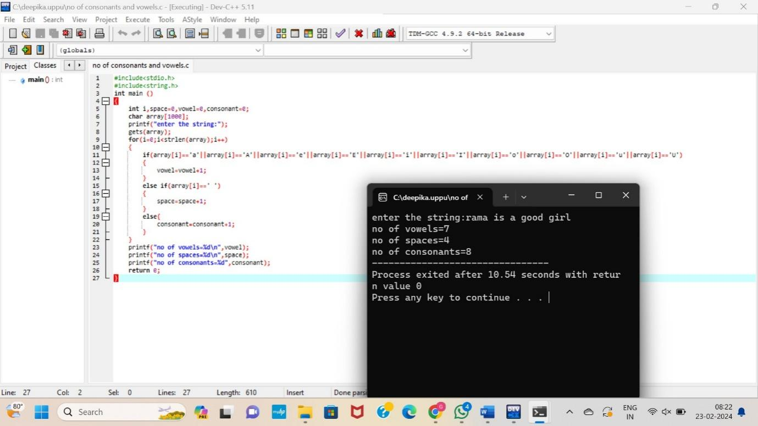

2. Accept the Height of a Person & Categorize as Taller, Dwarf & Average

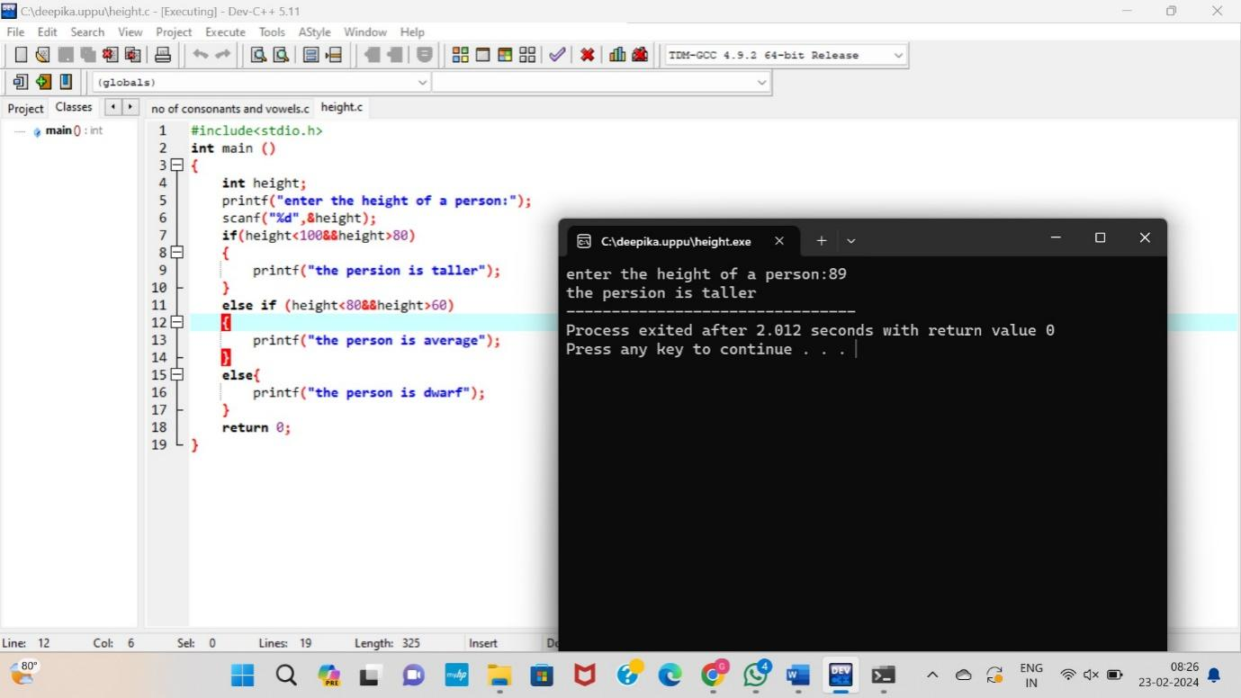

1. Prime Number

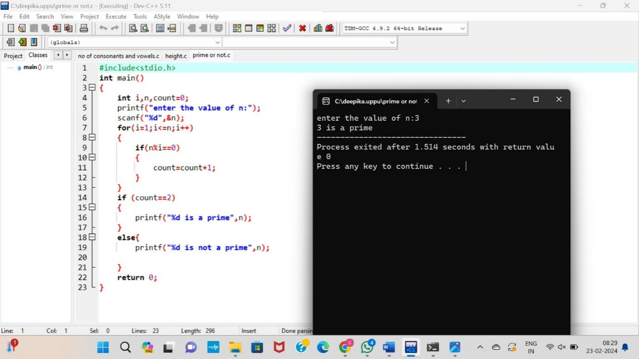

4. Check Whether a Given Number is Perfect Number

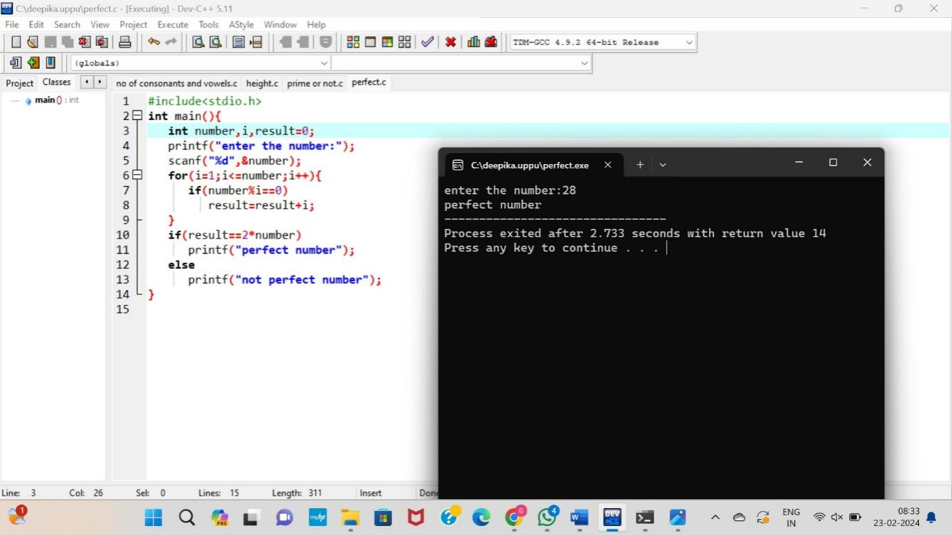

5. Check Armstrong Number

