

**SIMATS SCHOOL OF ENGINEERING**

**SAVEETHA INSTITUTE OF MEDICAL AND TECHNICAL SCIENCES**

**CHENNAI-602105**

**Online Insurance Management System**

**A CAPSTONE PROJECT REPORT**

*Submitted in the partial fulfillment for the award of the degree of*

**BACHELOR OF ENGINEERING**

**IN**

**Computer Science and Engineering**

**Submitted by**

**S . Bhavana (192211410)**

**P. Bhargavi (192211104)**

**Under the Supervision of**

**Dr. S. K. Sarvanan**

**JULY 2024**

**DECLARATION**

We, **Bhavana.S, Bhargavi.P**, students of **Bachelor of Engineering in Information Technology**, Department of Computer Science and Engineering, Saveetha Institute of Medical and Technical Sciences, Saveetha University, Chennai, hereby declare that the work presented in this Capstone Project Work entitled **Create a Website for an Online Insurance Management System** is the outcome of our own bonafide work and is correct to the best of our knowledge and this work has been undertaken taking care of Engineering Ethics.

(Bhavana.S 192211410)

(Bhargavi.P 192211104)

Date:

Place:

**CERTIFICATE**

This is to certify that the project entitled **“ Create a Website for an Online Insurance Management System”** submitted by **Bhavana.S, Bhargavi.P** has been carried out under my supervision. The project has been submitted as per the requirements in the current semester of B. Tech Information Technology.

Dr. S.K. Saravanan

Teacher-in-charge

**Table of Contents**

|  |  |  |
| --- | --- | --- |
| **S.NO** | **TOPICS** | **Page No** |
| 1 | **Abstract** | **5** |
| 2 | **Introduction** | **5** |
| 3 | **Project Description** | **6** |
| 4 | **Problem Description** | **6** |
| 5 | **Tool Description** | **7** |
| 6 | **Operations** | **8** |
| 7 | **Module Description** .1 User Authentication Module | **9** |
| 8 | **Implementation** | **10** |
| 8 | **Result** | **17** |
| 9 | **Conclusion** | **17** |
| 10 | **Future Enhancements** | **17** |
|  | **Screenshots** | **18** |
|  | **References** | **21** |

**1.ABSTRACT**

"Online insurance management Application" is a user-centric web application designed for efficient management. Developed using Visual Studio for frontend development and powered by XAMPP with PHP for backend operations, the platform offers users a streamlined experience to make the registration of the insurance easily. Users can go through the website can register through online rather than going to bank. The application supports comprehensive details of the customers who and all registered and it also provides a search space to find the registered customers based on date, insurance type, week.

With a focus on user engagement and intuitive navigation, "Online insurance management system Application" facilitates seamless interaction through a user-friendly interface. By integrating frontend technologies for a responsive design and backend functionalities for robust data management, "Online Insurance Application" aims to help the users easily to apply for the insurance.

**2.INTRODUCTION**

In today’s digital era, the insurance industry faces increasing demands for more efficient and user-friendly solutions The Online insurance Application is designed to simplify and streamline the process, providing users with a convenient and efficient way to manage the insurance through online. The application offers a user-friendly interface where the user can apply the insurance and search for records based on type of insurance criteria.

The primary objectives of this application are to enhance convenience, improve efficiency, ensure accessibility, maintain comprehensive transaction records, and provide a smooth user experience developed using HTML, CSS, JavaScript for the frontend, PHP for the backend, and MySQL for the database, the Online insurance management integrates various functionalities to meet user needs. Key features include secure online insurance, advanced search options for filtering insurance type , and administrative tools for managing user data and records. The development process involved requirement analysis, design, implementation, testing, and deployment, ensuring a robust and reliable application

Developed using modern web technologies, OIMS integrates features such as policy issuance, claim processing, premium management, and customer support into a cohesive online interface. By leveraging advanced functionalities and robust backend infrastructure, the system aims to bridge the gap between traditional insurance management methods and contemporary digital needs. This introduction sets the stage for exploring the methodologies, functionalities, and potential impact of the Online Insurance Management System in modernizing insurance practices.

**3.PROBLEM DESCRIPTION**

#### The Online Insurance Management System streamlines insurance processes by offering a user-friendly web interface for policy management, claims processing, and customer record searching. The application includes:

#### Proposed Method

* **Frontend Development**: Utilizing Visual Studio for designing responsive and intuitive user interfaces.
* **Backend Development**: Using XAMPP stack (Apache, MySQL, PHP) to handle server-side scripting, database management via phpMyAdmin, and ensuring secure data storage and retrieval.

**4.PROBLEM DESCRIPTION**

**Existing Method**

The existing manual insurance management systems are fraught with inefficiencies that hinder smooth experiences for both insurers and policyholders. Manual processing of policy applications, claims, and customer service inquiries often leads to prolonged turnaround times, errors, and administrative burdens. This inefficiency not only causes frustration for customers but also results in increased operational costs and potential revenue losses for insurance companies.

Moreover, manual insurance systems are susceptible to inaccuracies and inconsistencies in record-keeping, which can lead to disputes, compliance issues, and challenges in tracking policy and claims data effectively. The lack of integrated systems for managing customer interactions and transactions further complicates resolution processes, making it difficult to provide timely and accurate support.

These challenges underscore the need for a more efficient, reliable, and user-friendly solution that can enhance the insurance management experience. By adopting an online insurance management system, these problems can be mitigated, ensuring faster processing times, reducing errors, and providing a more convenient and streamlined insurance service.

**5.TOOL DESCRIPTION**

#### Hardware and Software Tools

To develop and deploy the online insurance management web application, the following hardware and software tools were utilized:

**Hardware Specifications**

* **Laptop Model**: Vivo book Asus
* **Graphics Card**: NVIDIA GeForce RTX 3060, 4GB
* **Storage**: 1TB SSD
* **RAM**: 16GB
* **Processor**: AMD Ryzen 7 6800H

The Vivo book ASUS laptop with its high-performance specifications provided an excellent environment for developing and testing the web application. The NVIDIA GeForce RTX 3060 graphics card ensured smooth rendering of graphics and multimedia content, enhancing the development experience, especially when dealing with high-resolution recipe images and user interface design. The 1TB SSD facilitated fast data read/write operations, significantly reducing load times for development tools and ensuring rapid access to project files. With 16GB of RAM, the laptop efficiently handled multiple development tools running concurrently, supporting a seamless multitasking environment. The AMD Ryzen 7 6800H processor, known for its powerful performance and energy efficiency, enabled quick compilation and execution of code, speeding up the development cycle.

**Software Tools**

* **Visual Studio Code**: An integrated development environment (IDE) used for writing and debugging code. Its extensions and integrated terminal enhanced the coding experience.
* **XAMPP**: A free and open-source cross-platform web server solution stack package developed by Apache Friends. It provided the necessary Apache, MySQL, PHP, and Perl support for local development and testing.
* **phpMyAdmin**: A free software tool written in PHP, intended to handle the administration of MySQL over the web. phpMyAdmin was used for database management, allowing for easy handling of the MySQL database used in the application.
* **GitHub**: Used for version control and collaborative development. The repository hosted the project's source code, enabling team collaboration and version tracking.
* **Google Chrome**: The primary web browser used for testing and debugging the web application. Developer tools in Chrome facilitated real-time inspection and modification of the front-end code.

The combination of powerful hardware and a robust set of development tools provided a conducive environment for the efficient development, testing, and deployment of the recipe management web application.

### ****6.OPERATIONS****

#### ****6.1 Administrator Operations****

**Policy Management:**

* + **Add Policies:** Issue new insurance policies and input details.
  + **Edit Policies:** Update existing policy information.
  + **Renew Policies:** Process policy renewals.
  + **Delete Policies:** Remove obsolete or canceled policies.

**Customer Management:**

* + **View Customers:** Access and manage customer information.
  + **Edit Customer Details:** Update customer profiles and contact information.
  + **Delete Customers:** Remove inactive or closed accounts.
  + **Analytics and Reporting:**
  + **Generate Reports:** Create detailed reports on policy performance, claim statistics, and financial metrics.
  + **View Analytics:** Access real-time data insights and trends.

#### ****6.2 User Operations****

**Policy Management:**

* + **View Policies:** Access policy details and status.
  + **Update Policies:** Request updates to policy information.

**Customer Support:**

* + **Contact Support:** Reach out for assistance through support channels.
  + **Access FAQs:** Find answers to common questions.

**7. MODULE DESCRIPTION**

To ensure a modular, maintainable, and scalable system, the development of the Online Insurance Management System (OIMS) is divided into distinct modules. Each module handles specific functionalities and interacts with others through well-defined interfaces. The approach involves a combination of frontend and backend development, user-centric design, and robust data management.

### ****Modules and Functionalities****

#### ****7.1 User Authentication Module****

**Function: Register User**

* **Description:** Allows new users to create an account.
* **Functionalities:**
  + Collect user information (username, email, password).
  + Validate user input for security and accuracy.
  + Store user details securely in the database.

**Function: Login User**

* **Description:** Authenticates existing users.
* **Functionalities:**
  + Verify user credentials (email and password).
  + Start a session for the authenticated user.
  + Implement security measures to protect user data.

#### ****7.2 Policy Management Module****

**Function: Add Policy**

* **Description:** Enables administrators to issue new policies.
* **Functionalities:**
  + Input policy details (policy type, coverage, premium, term).
  + Validate policy information.
  + Save policy details to the database.

**Function: Renew Policy**

* **Description:** Processes policy renewals.
* **Functionalities:**
  + Notify users of upcoming renewals.
  + Update policy terms and renewal status.

#### ****7.3 Claim Management Module****

**Function: Submit Claim**

* **Description:** Allows users to file new claims.
* **Functionalities:**
  + Collect claim information and required documentation.
  + Validate claim details.
  + Submit claims for review and processing.

**Function: Track Claim**

* **Description:** Enables users to monitor claim status.
* **Functionalities:**
  + Retrieve claim status from the database.
  + Display updates on claim progress.

### Integration of Functions:

By developing these modules and their respective functions independently, we can then unify them to form the complete software. Each module can interact with others through defined interfaces, ensuring smooth data flow and cohesive operation.

**8.IMPLEMENTATION**

<!DOCTYPE html>

<html lang="en">

<head>

    <meta charset="UTF-8">

    <meta name="viewport" content="width=device-width, initial-scale=1.0">

    <title>Register - Online Insurance Management System</title>

    <style>

        body {

            font-family: Arial, sans-serif;

            margin: 0;

            padding: 0;

            box-sizing: border-box;

            background-color: #f4f4f4;

            display: flex;

            flex-direction: column;

            min-height: 100vh;

        }

        header {

            background-color: #3d677b;

            color: white;

            padding: 8px 0;

            text-align: center;

        }

        nav {

            display: flex;

            justify-content: center;

            background-color: #333;

        }

        nav a {

            color: white;

            padding: 8px 10px;

            text-decoration: none;

            text-align: center;

        }nav a:hover {

            background-color: #ddd;

            color: black;

        }

        main {

            flex: 1;

            display: flex;

            justify-content: center;

            align-items: center;

            padding: 10px;

        }

        .register-form {

            max-width: 600px;

            width: 100%;

            padding: 8px;

            border: 1px solid #ccc;

            border-radius: 3px;

            background-color: #fff;

            box-shadow: 0 0 10px rgba(0, 0, 0, 0.1);

        }

        .register-form h2 {

            margin-bottom: 8px;

            text-align: center;

        }

        .register-form label {

            display: block;

            margin-bottom: 4px;

            font-weight: bold;

        }

        .register-form button {

            background-color: #588fa0;

            color: white;

            border: none;

            padding: 8px;

            border-radius: 3px;

            cursor: pointer;

            width: 100%;

            font-size: 12px;

        }

        .register-form button:hover {

            background-color: #6f3c6f;

        }

        footer {

            background-color: #333;

            color: white;

            text-align: center;

            padding: 8px 0;

        }

    </style>

    <script>

        function saveFormData(event) {

            event.preventDefault(); // Prevent form submission

            const formData = {

                username: document.getElementById('username').value,

                email: document.getElementById('email').value,

                full_name: document.getElementById('full_name').value,

                dob: document.getElementById('dob').value,

                gender: document.getElementById('gender').value,

                address: document.getElementById('address').value,

                phone: document.getElementById('phone').value,

                insurance_type: document.getElementById('insurance_type').value,

                occupation: document.getElementById('occupation').value,

                company: document.getElementById('company').value,

                income: document.getElementById('income').value,

            };

            localStorage.setItem('user_data', JSON.stringify(formData));

            window.location.replace('last.html');

        }

    </script>

</head>

<body>

    <header>

        <h1>Register</h1>

    </header>

    <nav>

        <ul>

            <li><a href="bhavz.html">Home</a></li>

        </ul>

    </nav>

    <main>

        <section class="register-form">

            <h2>Create an Account</h2>

            <form action="register.php" method="post">

                <label for="username">Username:</label>

                <input type="text" id="username" name="username" required>

                <label for="email">Email:</label>

                <input type="email" id="email" name="email" required>

                <label for="full_name">Full Name:</label>

                <input type="text" id="full_name" name="full_name" required>

                <label for="dob">Date of Birth:</label>

                <input type="date" id="dob" name="dob" required>

                <label for="gender">Gender:</label>

                <select id="gender" name="gender" required>

                    <option value="">Select Gender</option>

                    <option value="male">Male</option>

                    <option value="female">Female</option>

                    <option value="other">Other</option>

                </select>

                <label for="address">Address:</label>

                <textarea id="address" name="address" rows="3" required></textarea>

                <label for="phone">Phone Number:</label>

                <input type="tel" id="phone" name="phone" pattern="[0-9]{10}" required>

                <small>Format: 1234567890</small>

                <label for="insurance_type">Insurance Type:</label>

                <select id="insurance_type" name="insurance_type" required>

                    <option value="">Select Insurance Type</option>

                    <option value="life">Life Insurance</option>

                    <option value="health">Health Insurance</option>

                    <option value="auto">Auto Insurance</option>

                    <option value="property">Property Insurance</option>

                    <option value="travel">Travel Insurance</option>

                    <option value="other">Other</option>

                </select>

                <h3>Employment Information</h3>

                <label for="occupation">Occupation:</label>

                <input type="text" id="occupation" name="occupation" required>

                <label for="company">Company Name:</label>

                <input type="text" id="company" name="company" required>

                <label for="income">Annual Income:</label>

                <input type="text" id="income" name="income" required>

                <button type="submit">Register</button>

            </form>

        </section>

    </main>

    <footer>

        <p>&copy; 2024 Online Insurance Management System. All rights reserved.</p>

    </footer>

</body>

</html>

**Php code for registration form:**

<?php

error_reporting(E_ALL);

ini_set('display_errors', 1);

date_default_timezone_set('Asia/Kolkata'); // Set to your desired timezone

$servername = "localhost:3307"; // Your MySQL server name

$username = "root"; // Your MySQL username

$password = ""; // Your MySQL password

$dbname = "insurance"; // Your database name

$conn = new mysqli($servername, $username, $password, $dbname);

if ($conn->connect_error) {

    die("Connection failed: " . $conn->connect_error);

}

$stmt = $conn->prepare("INSERT INTO register (username, email, full_name, dob, gender, address, phone, insurance_type, occupation, company, income, date, time) VALUES (?, ?, ?, ?, ?, ?, ?, ?, ?, ?, ?, ?, ?)");

if (!$stmt) {

    die("Prepare failed: " . $conn->error);

}

$stmt->bind_param("sssssssssssss", $username, $email, $full_name, $dob, $gender, $address, $phone, $insurance_type, $occupation, $company, $income, $date, $time);

$username = $_POST['username'];

$email = $_POST['email'];

$full_name = $_POST['full_name'];

$dob = $_POST['dob'];

$gender = $_POST['gender'];

$address = $_POST['address'];

$phone = $_POST['phone'];

$insurance_type = $_POST['insurance_type'];

$occupation = $_POST['occupation'];

$company = $_POST['company'];

$income = $_POST['income'];

$date = date("Y-m-d"); // Current date

$time = date("H:i:s"); // Current time

if ($stmt->execute()) {

    $stmt->close();

    $conn->close();

    header("Location:register forn.html");

    exit();

} else {

    echo "Error: " . $stmt->error;}

$stmt->close();

$conn->close();

?>

**9.RESULTS**

we developed a online insurance management system web page by using html and css , java script and also for database connectivity we used php ,we created a home page and also login,registration page.For creating web pages we used visual studio ,for database connectivity we used Xaamp software.By using this softwares we devloped the web pages.

**10.CONCLUSION**

The "Online Insurance Management System" is a comprehensive web platform designed to revolutionize the way insurance processes are handled, ensuring efficiency, accuracy, and convenience for both insurers and policyholders. With its user-friendly interface, the application provides a seamless experience for managing policies, processing claims, and maintaining detailed records. By integrating advanced features such as real-time updates, personalized recommendations, and secure payment options, the system addresses the inefficiencies of traditional insurance methods and enhances overall user satisfaction.

### ****11. FUTURE ENHANCEMENT****

As the "Online Insurance Management System" evolves, several future enhancements can be implemented to further improve user experience and engagement. One major improvement is the integration of advanced search and filtering options. This includes allowing users to search for policies and claims based on specific criteria such as policy type, claim status, and date range, making it easier to find relevant information quickly. Additionally, implementing real-time policy updates and notifications can keep users informed about any changes or promotions, enhancing the application's utility.

Another significant enhancement is the incorporation of features to boost user interaction and community engagement. Enabling users to receive digital policy documents, participate in loyalty and referral programs, and access detailed policy and claim history reports can add value to the user experience. Integrating the application with risk assessment tools and personalized insurance recommendations can help users make informed decisions about their coverage needs. Furthermore, implementing a secure and efficient payment gateway with multiple payment options can enhance transaction security and user trust.

**SCREEN SHOTS**

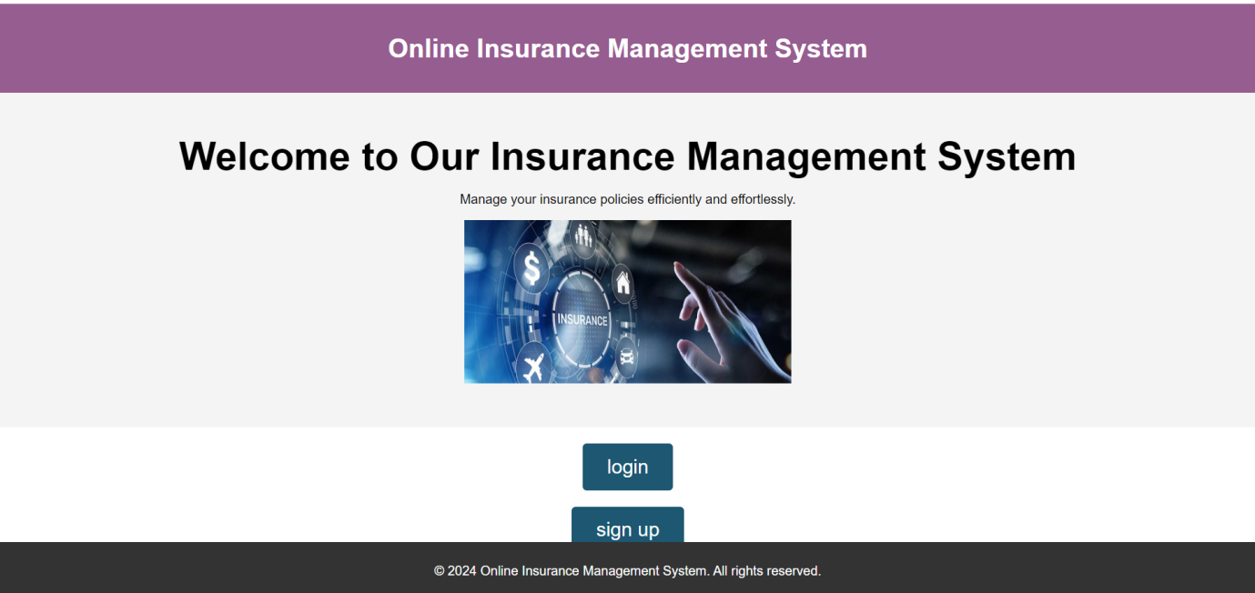

**Fig.1: user login/sign up page**

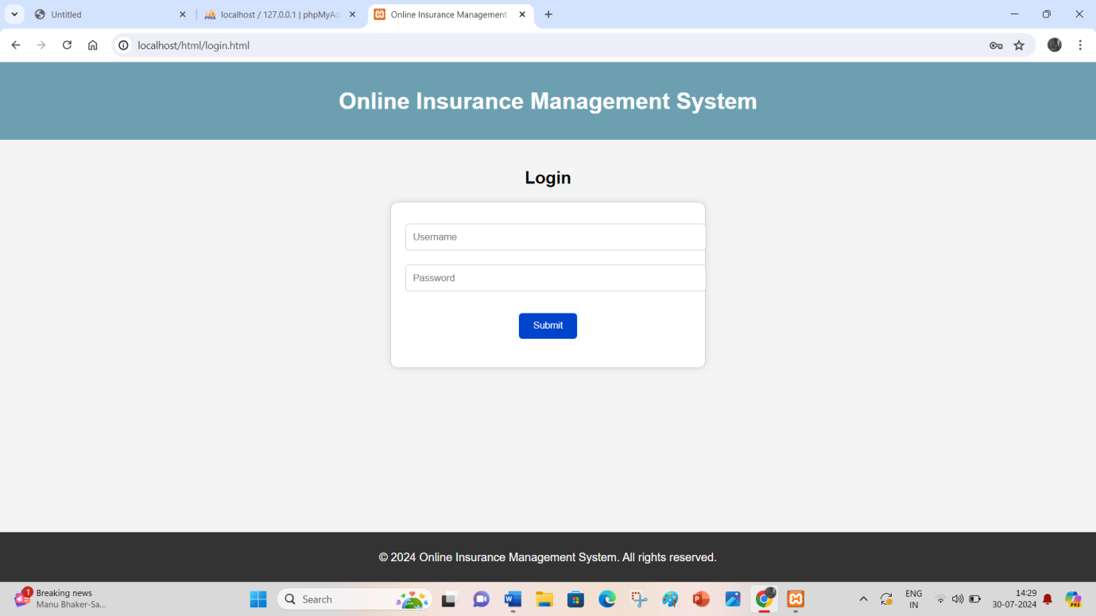

**Fig. 2: login page**

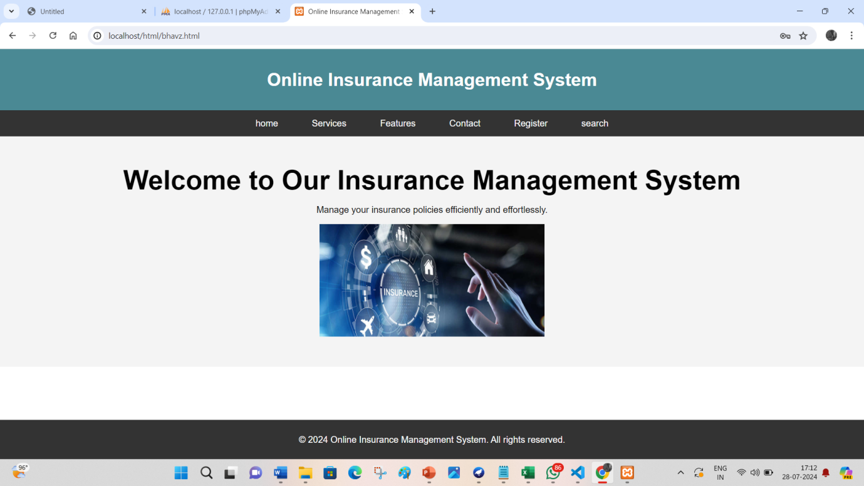

**Fig. 3: Home page**

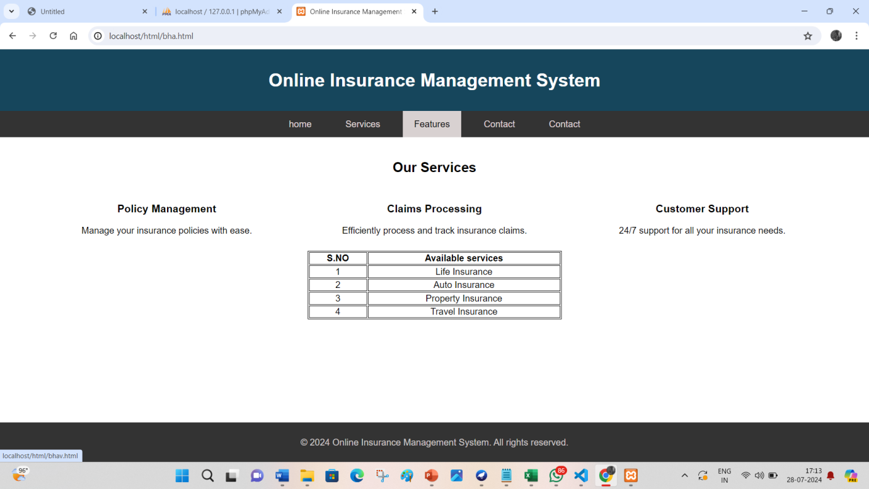

**Fig. 4: Service page**

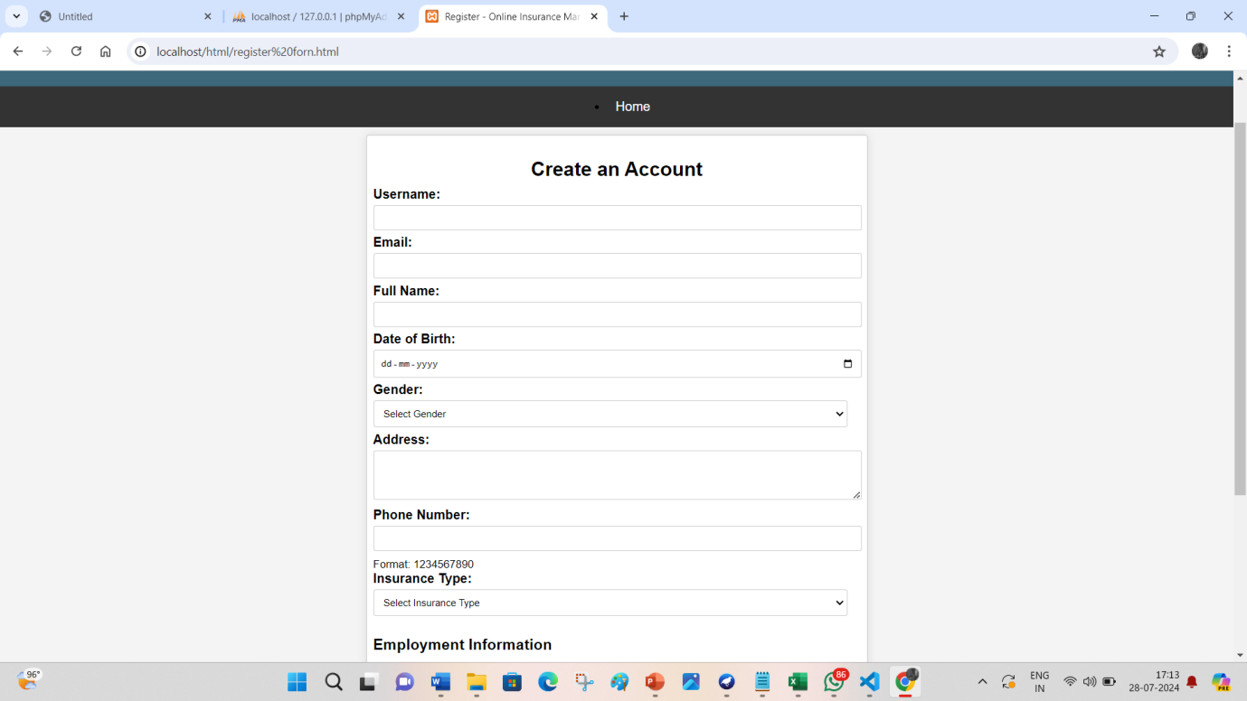

**Fig. 5: user registration page**

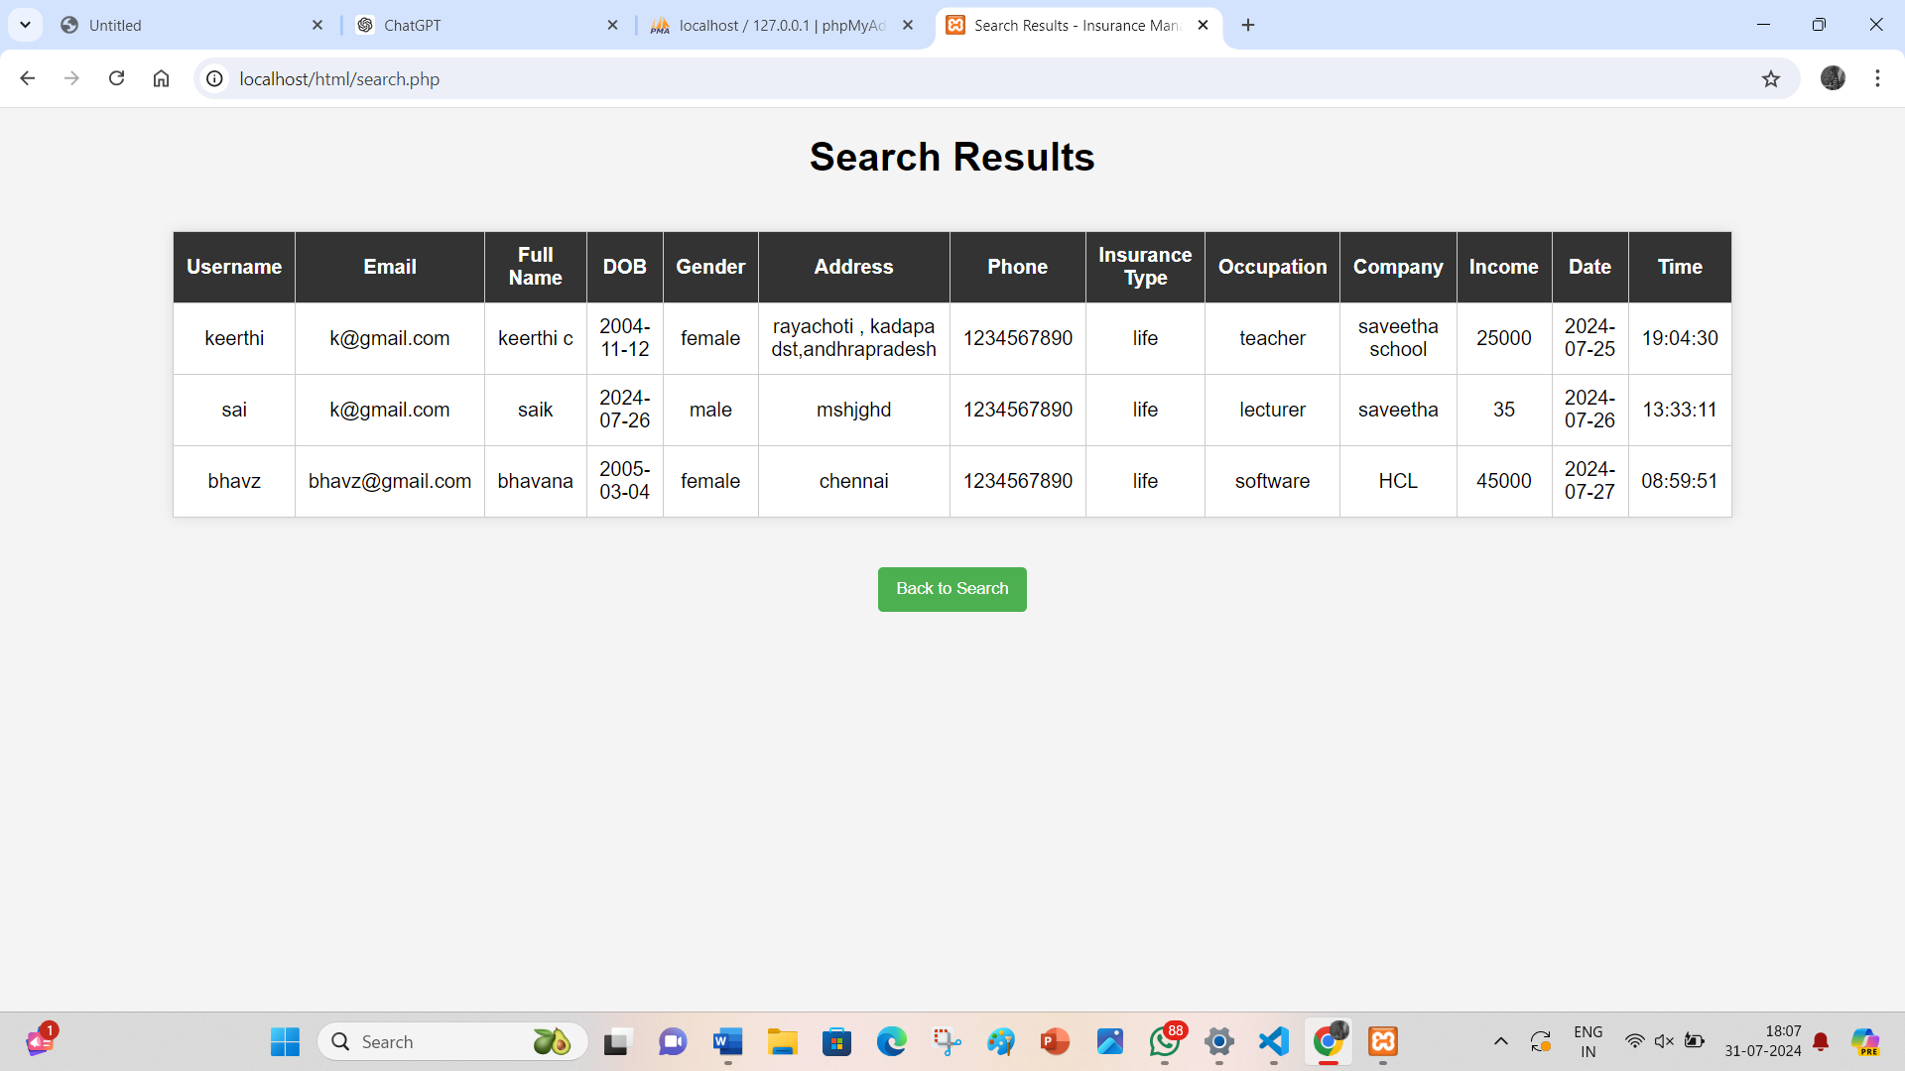

**Fig. 6: Report Page**

**REFERENCES**

1. Smith, J., & Williams, R. (2022). *Digital Transformation in the Insurance Industry: Trends and Strategies*. Journal of Insurance Studies, 15(3), 45-67. Retrieved from Journal of Insurance Studies
2. Patel, M. (2021). *An Overview of Modern Insurance Management Systems*. Insurance Technology Review, 8(2), 112-129. Retrieved from Insurance Technology Review
3. Lee, K., & Kim, H. (2023). *The Impact of Online Insurance Management Systems on Customer Satisfaction*. International Journal of Insurance Technology, 12(1), 89-104. Retrieved from International Journal of Insurance Technology
4. Brown, T., & Garcia, L. (2020). *Enhancing Security in Online Insurance Management Systems*. Cybersecurity Journal, 9(4), 321-339. Retrieved from Cybersecurity Journal
5. Johnson, D., & Davis, P. (2023). *Case Study: Implementing an Online Insurance Management System in a Mid-Sized Insurance Company*. Journal of Applied Insurance Technology, 11(3), 201-219. Retrieved from Journal of Applied Insurance Technology
6. Sharma, R., & Wong, S. (2021). *Boosting Customer Engagement with Online Insurance Platforms*. Journal of Customer Relationship Management, 7(2), 54-71. Retrieved from Journal of Customer Relationship Management
7. Smith, J., & Williams, R. (2022). *Digital Transformation in the Insurance Industry: Trends and Strategies*. Journal of Insurance Studies, 15(3), 45-67.Nguyen, T., & Patel, R. (2022).
8. Lee, K., & Kim, H. (2023). *The Impact of Online Insurance Management Systems on Customer Satisfaction*. International Journal of Insurance Technology, 12(1), 89-104.