SIMATS ENGINEERING
ASSESSMENT TOOL 2

COURSE NAME: INTERNET PROGRAMMING
COURSE CODE: CSA43
NAME: BHARGAVI. N
REG. NO: 192411144

COURSE OUTCOME COVERED

CO 5: Construct interoperable web services by leveraging JAX-RPC, WSDL, SOAP, and XML Schema for seamless data exchange across distributed systems.(L4,L5)

Assessment Tool : Alternative Solution Design
Weightage: 20%

QUESTIONS: Total Marks: 25

1. REST vs SOAP – Web Service Selection
Analysis:
- REST uses HTTP methods such as GET, POST, PUT, and DELETE.
- It commonly uses lightweight JSON data, making communication faster.
- REST is stateless and supports horizontal scaling easily.
- SOAP is an XML-based protocol with strict standards and built-in features such as WS-Security.
- SOAP provides strong reliability and transaction support but has greater processing overhead.
Selected Approach: REST
Design:
Mobile / Web Client
↓
HTTPS Request
↓
REST API
↓
Authentication
↓
Business Logic
↓
Database
↓
JSON Response
Justification:
REST is suitable because mobile and web applications require fast response, low bandwidth usage, and easy scalability. JSON is smaller and easier to process than SOAP XML. HTTPS, OAuth 2.0/JWT, input validation, and rate limiting can provide strong security.
Alternative: SOAP can be selected when strict security, transactions, and enterprise-level reliability are more important than lightweight communication.
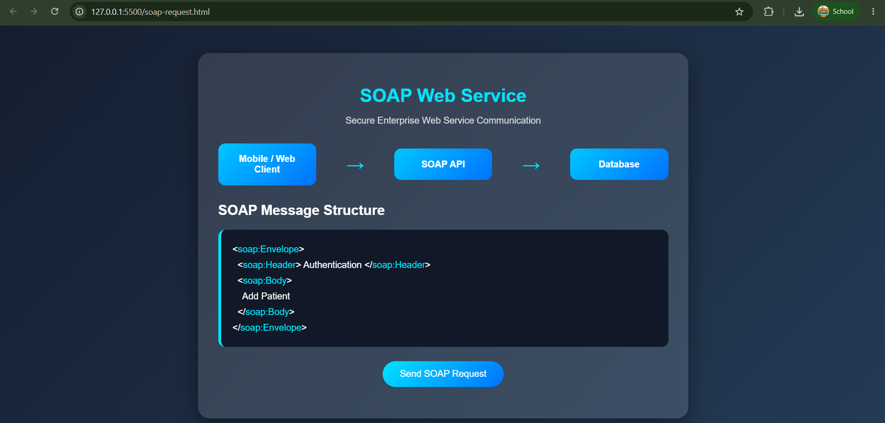

2. Scalable Service Architecture
Basic Architecture:
Users
↓
Mobile / Web Clients
↓
Load Balancer
↓
Application Server
↓
API
↓
Business Services
↓
Database
Working:
- Clients send requests to the API.
- A load balancer distributes requests among multiple servers.
- Application servers process business logic.
- The database stores and retrieves information.
- The response is returned to the client.
Alternative Scalable Design:
Clients
↓
API Gateway
↓
Load Balancer
↓
┌────────┬────────┬────────┐
Service 1 Service 2 Service 3
↓ ↓ ↓
Cache Queue Database
Justification:
A microservices-based architecture improves scalability because individual services can be scaled independently. Caching reduces database load, while message queues handle large numbers of asynchronous requests. Database replication and sharding can further improve performance.
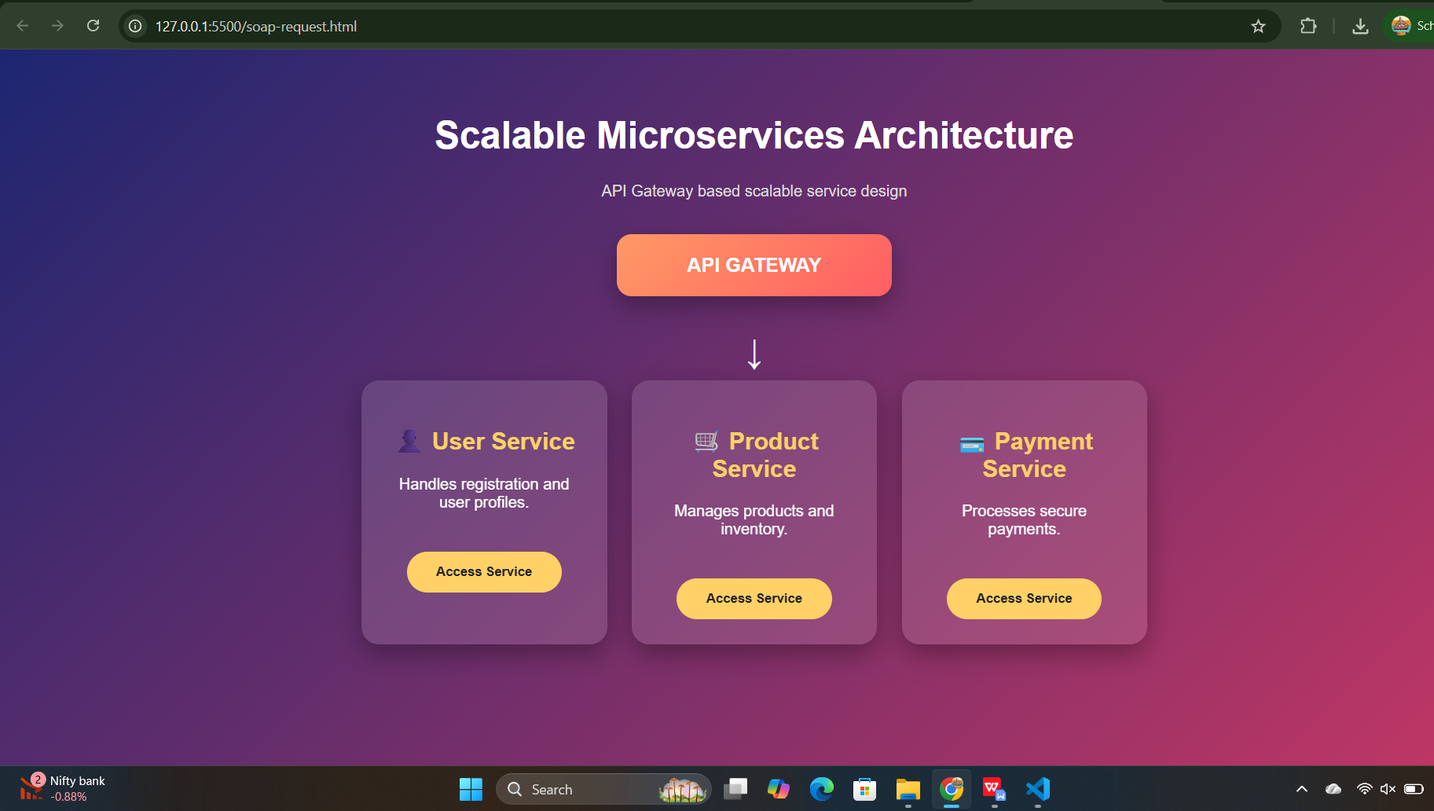

3. Secure Communication for Banking Application
Protocol Analysis:
Protocol | Security | Reliability | Performance
HTTP | Low | Medium | High
HTTPS | High | High | High
FTP | Low/Medium | High | Medium
SSH | Very High | High | Medium
TLS | Very High | High | High
Selected Protocol: HTTPS with TLS
Architecture:
Banking Client
↓
HTTPS
↓
TLS Layer
↓
Authentication
↓
Banking Server
↓
Database
Justification:
HTTPS uses TLS encryption to protect sensitive banking information during transmission. It provides confidentiality, integrity, and server authentication. Modern TLS also provides good performance with low communication overhead.
Additional security mechanisms include:
- Multi-factor authentication
- JWT/session security
- Certificate validation
- Encryption of sensitive data
- API rate limiting
- Transaction monitoring
Alternative: Mutual TLS (mTLS) can be used for highly sensitive server-to-server banking communication because both sides authenticate each other.
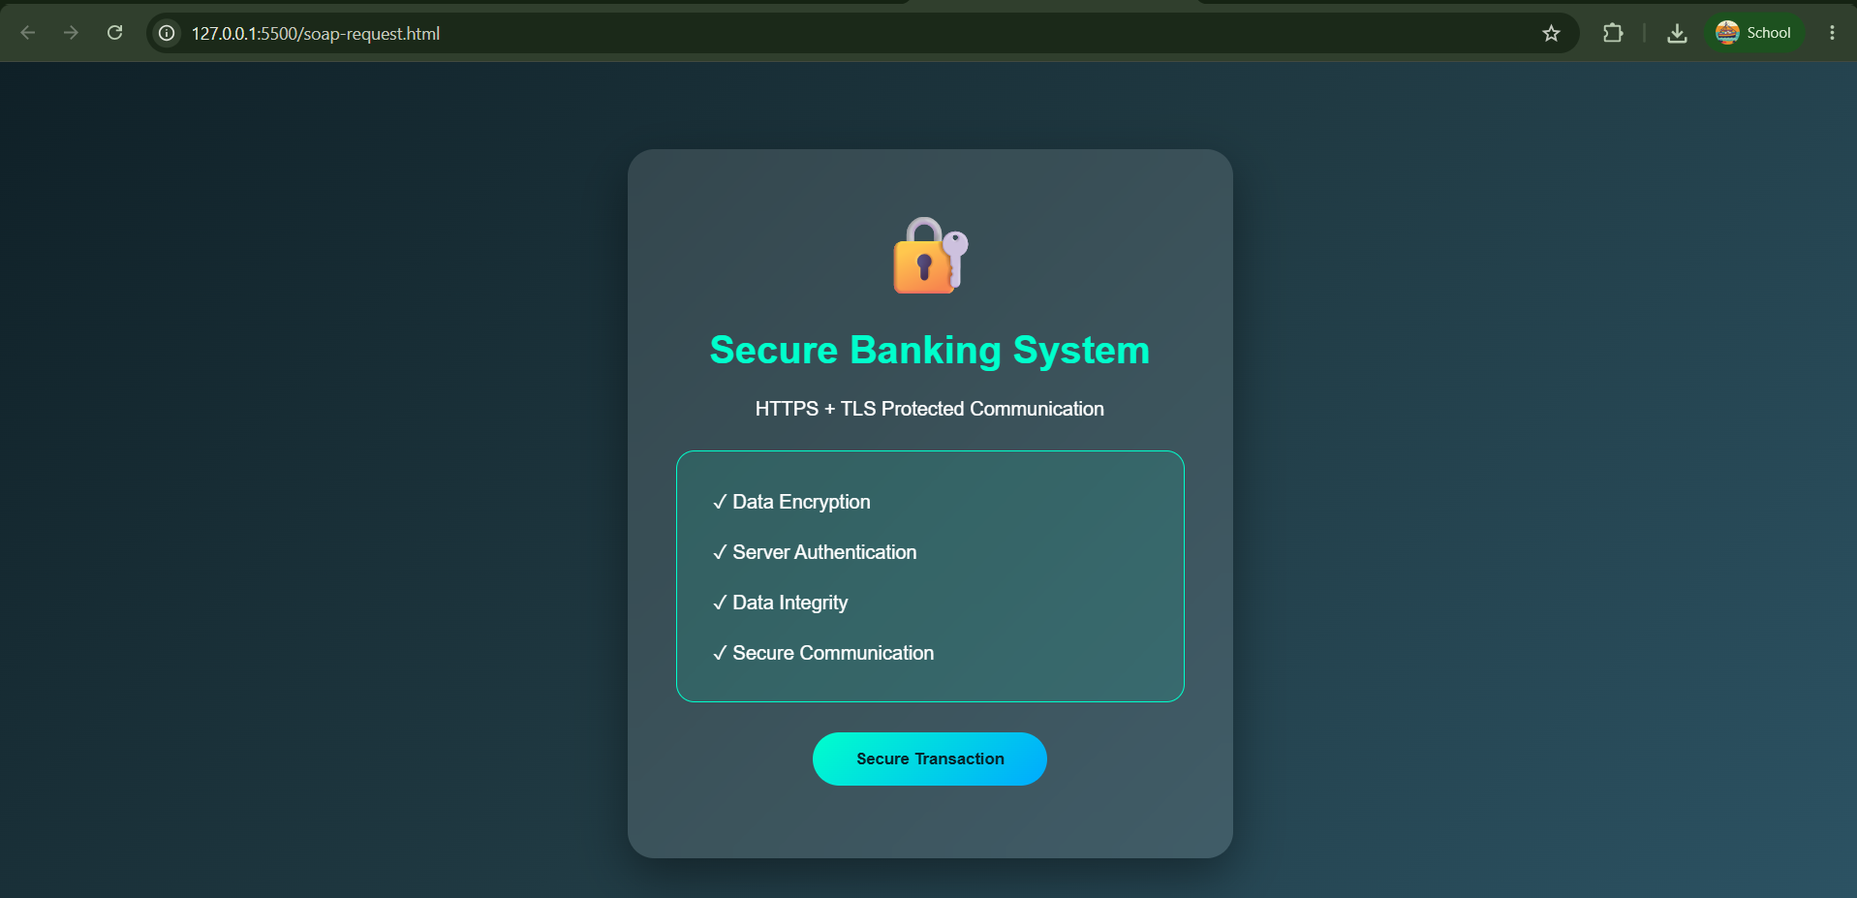

4. Third-Party API Integration Strategy
Example: Payment Gateway
User
↓
Web/Mobile Application
↓
Application Server
↓
API Integration Layer
↓
Authentication
↓
Payment Gateway
↓
Payment Response
↓
Application Server
↓
User
Request Handling:
- The application receives the user's request.
- The server validates the request.
- The integration layer creates the third-party API request.
- Authentication credentials/API keys or OAuth tokens are added.
- The request is sent using HTTPS.
- The response is validated and processed.
- The application updates its database and returns the result.
Security:
Use HTTPS.
- Store API keys in environment variables/secrets management.
- Use OAuth 2.0 where supported.
- Validate third-party responses.
- Never expose secret keys to the client.
Alternative Approach:
Use an API gateway or asynchronous message queue between the application and third-party service.
Application
↓
API Gateway
↓
Message Queue
↓
Third-Party Service
This reduces direct dependency on the third-party service and allows retries when temporary failures occur.
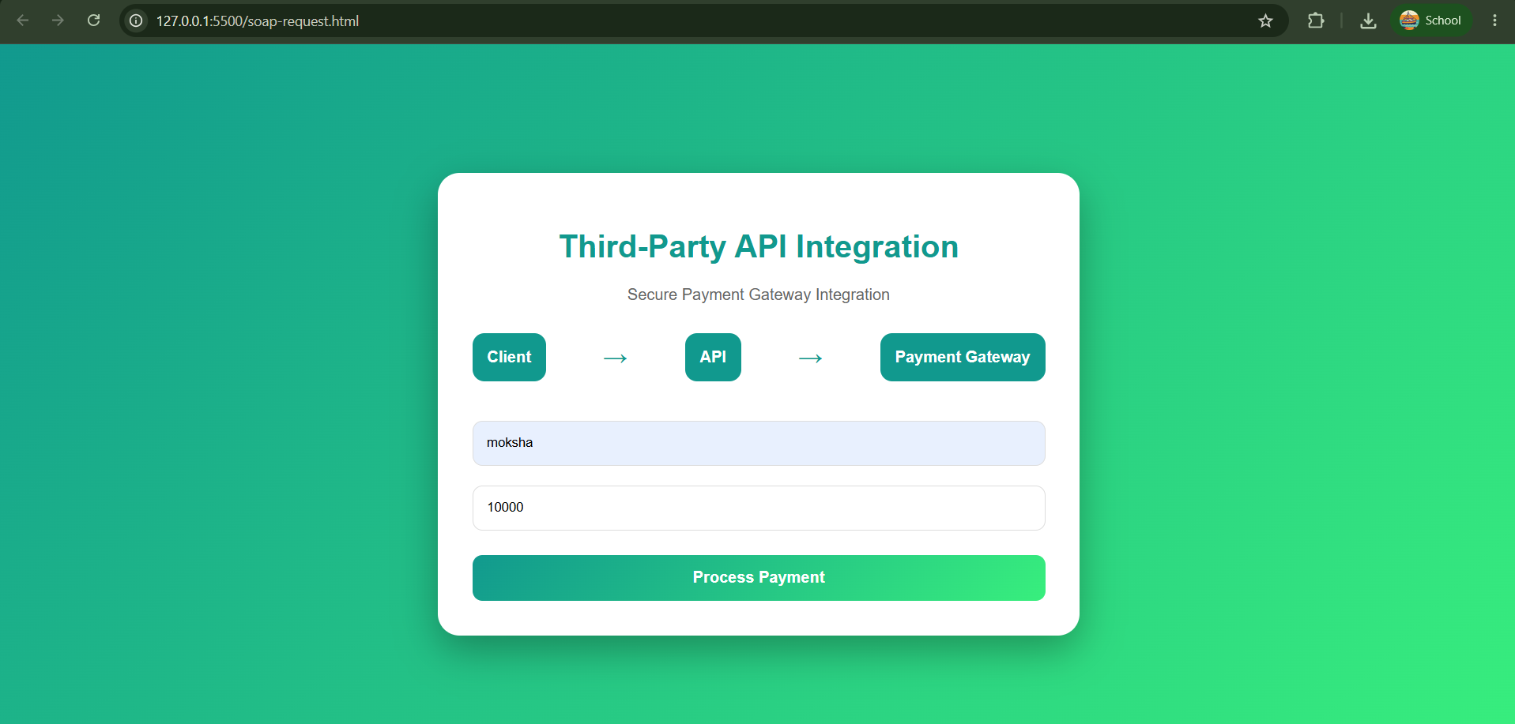

Code of Conduct:

I BHARGAVI. N(192411144) (Name / Reg No) certify that this submission is my original work and that I have adhered to the guidelines specified for this assessment.
I understand that any violation of academic integrity rules will result in disciplinary action.

Signature of the student: Bhargavi. N

RUBRICS FOR CALCULATION:

Criteria | Weightage (%) | Level 4 (Exemplary) | Level 3 (Proficient) | Level 2 (Developing) | Level 1 (Beginning)
Problem Understanding | 20% | Clearly defines problem, objectives, and all requirements accurately | Understands problem with minor gaps | Partial understanding; misses key requirements | Misinterprets or fails to understand problem
Generation of Solutions | 25% | Develops multiple innovative and feasible alternatives with clear differentiation | Generates relevant alternatives with minor limitations | Limited or repetitive alternatives | Fails to generate meaningful alternatives
Evaluation of Alternatives | 25% | Critically compares alternatives using appropriate criteria and metrics | Compares alternatives with some justification | Basic or superficial comparison | No proper comparison conducted
Solution Selection | 20% | Selects best solution with strong justification and decision rationale | Selects suitable solution with moderate justification | Selection is weakly justified | No clear or justified selection
Feasibility | 10% | Applies relevant concepts ensuring high feasibility and practicality | Applies concepts with minor issues | Limited feasibility or incorrect application | Solution is impractical or conceptually incorrect

