SIMATS ENGINEERING
ASSESSMENT TOOL 1

COURSE NAME: INTERNET PROGRAMMING
COURSE CODE: CSA4303
NAME: BHARGAVI. N
REG. NO: 19241144

COURSE OUTCOME COVERED

CO 3: Implement dynamic web applications by utilizing DOM-based client-side scripting and employing Java Servlets for server-side request processing and response handling. (L3)

Assessment Tool : Scenario-Based Assessment

Weightage: 40%

QUESTIONS: Total Marks: 30

Question 1
Suppose that a college wants to develop an online student registration system where students submit their details through a web form, and the data is processed using a Java Servlet.
Explain the architecture of a servlet-based application. Design and implement a servlet to handle form data using both GET and POST methods. Describe the servlet life cycle (init, service, destroy)and justify which method is more appropriate for handling sensitive data

.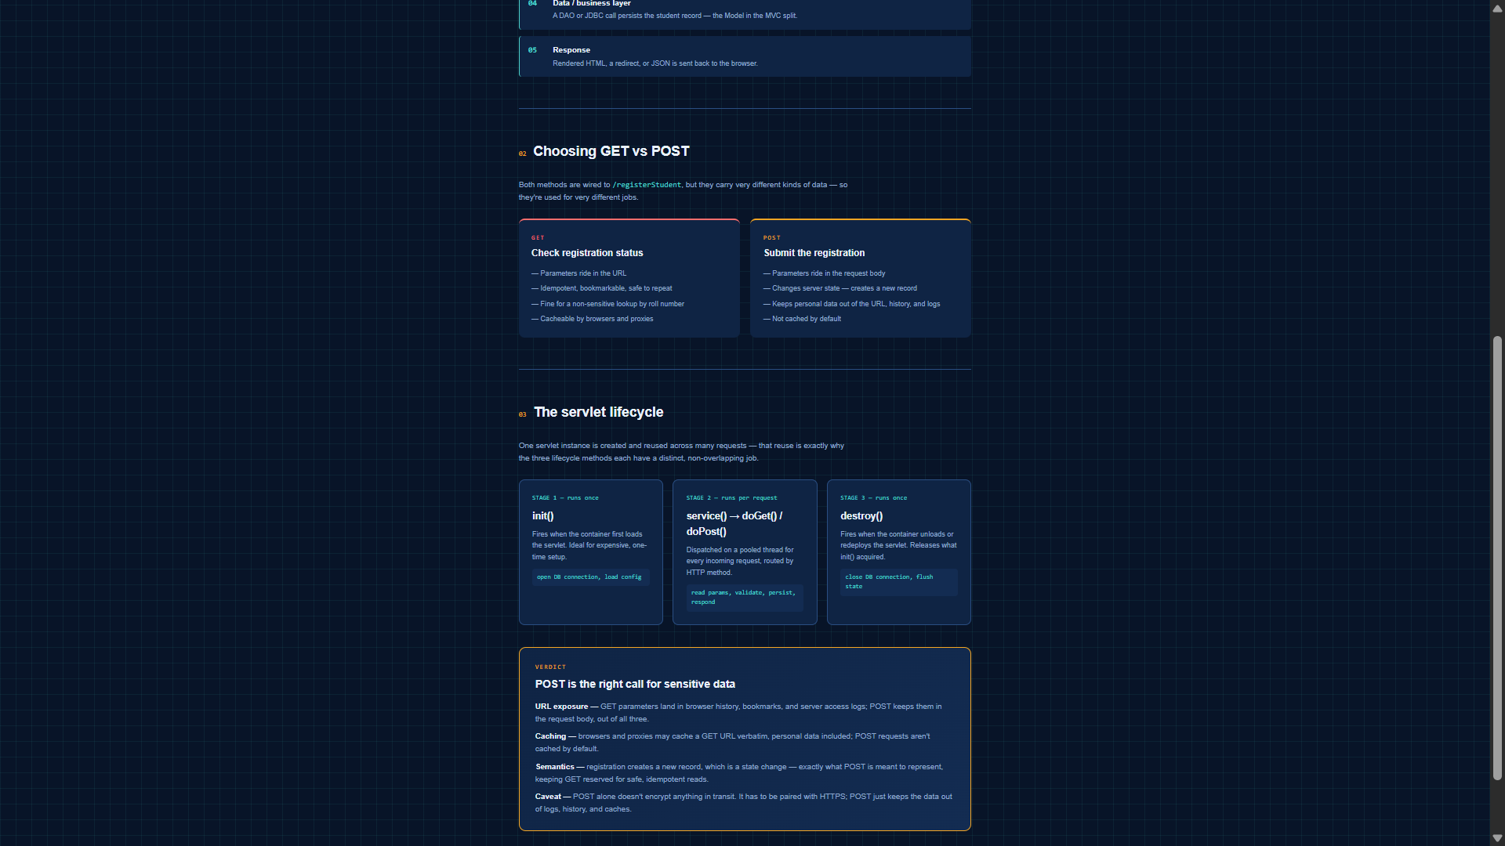

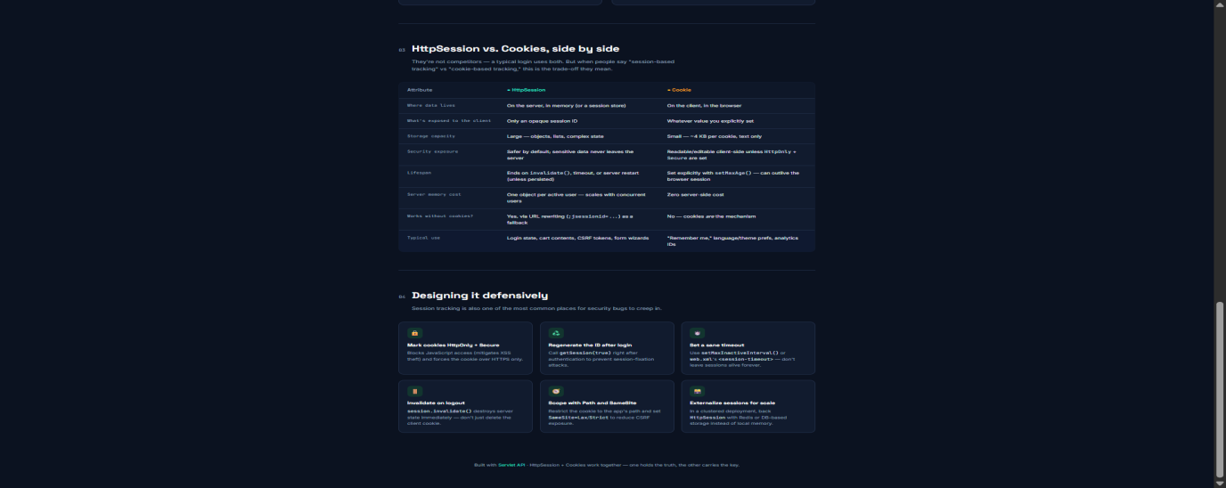
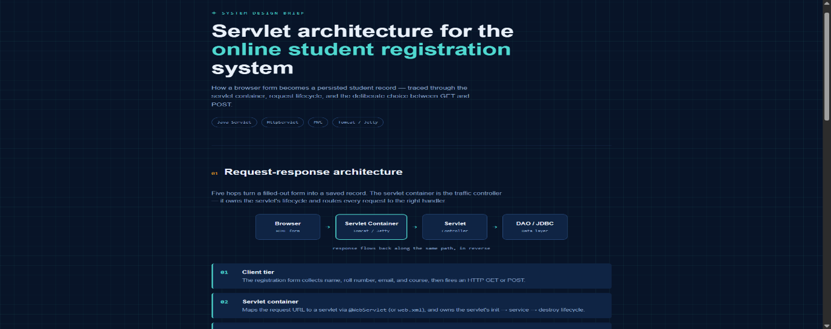
Question 2
Suppose that a website requires users to log in and maintain their session across multiple pages after authentication.
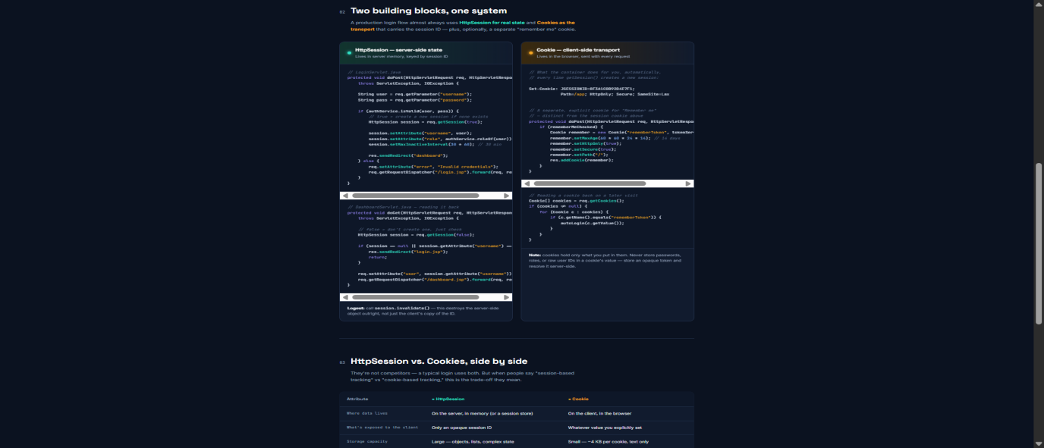
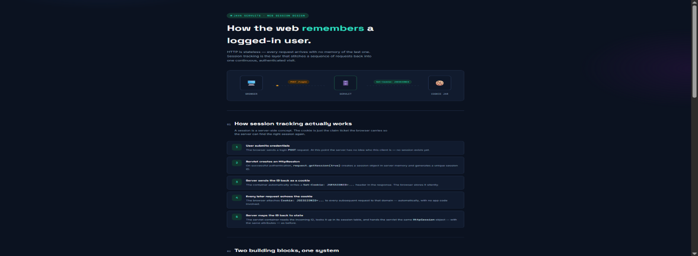
Design a session management system using HttpSession and Cookies in Servlets. Explain how session tracking works in web applications and compare session-based tracking with cookies.

Question 3
Suppose that an e-commerce platform needs to store and retrieve product details from a database using a Java-based web application.
Design a JDBC-based application to connect to a database, insert product data, and retrieve it using SQL queries. Explain the JDBC architecture and describe the steps involved in database connectivity along with proper exception handling.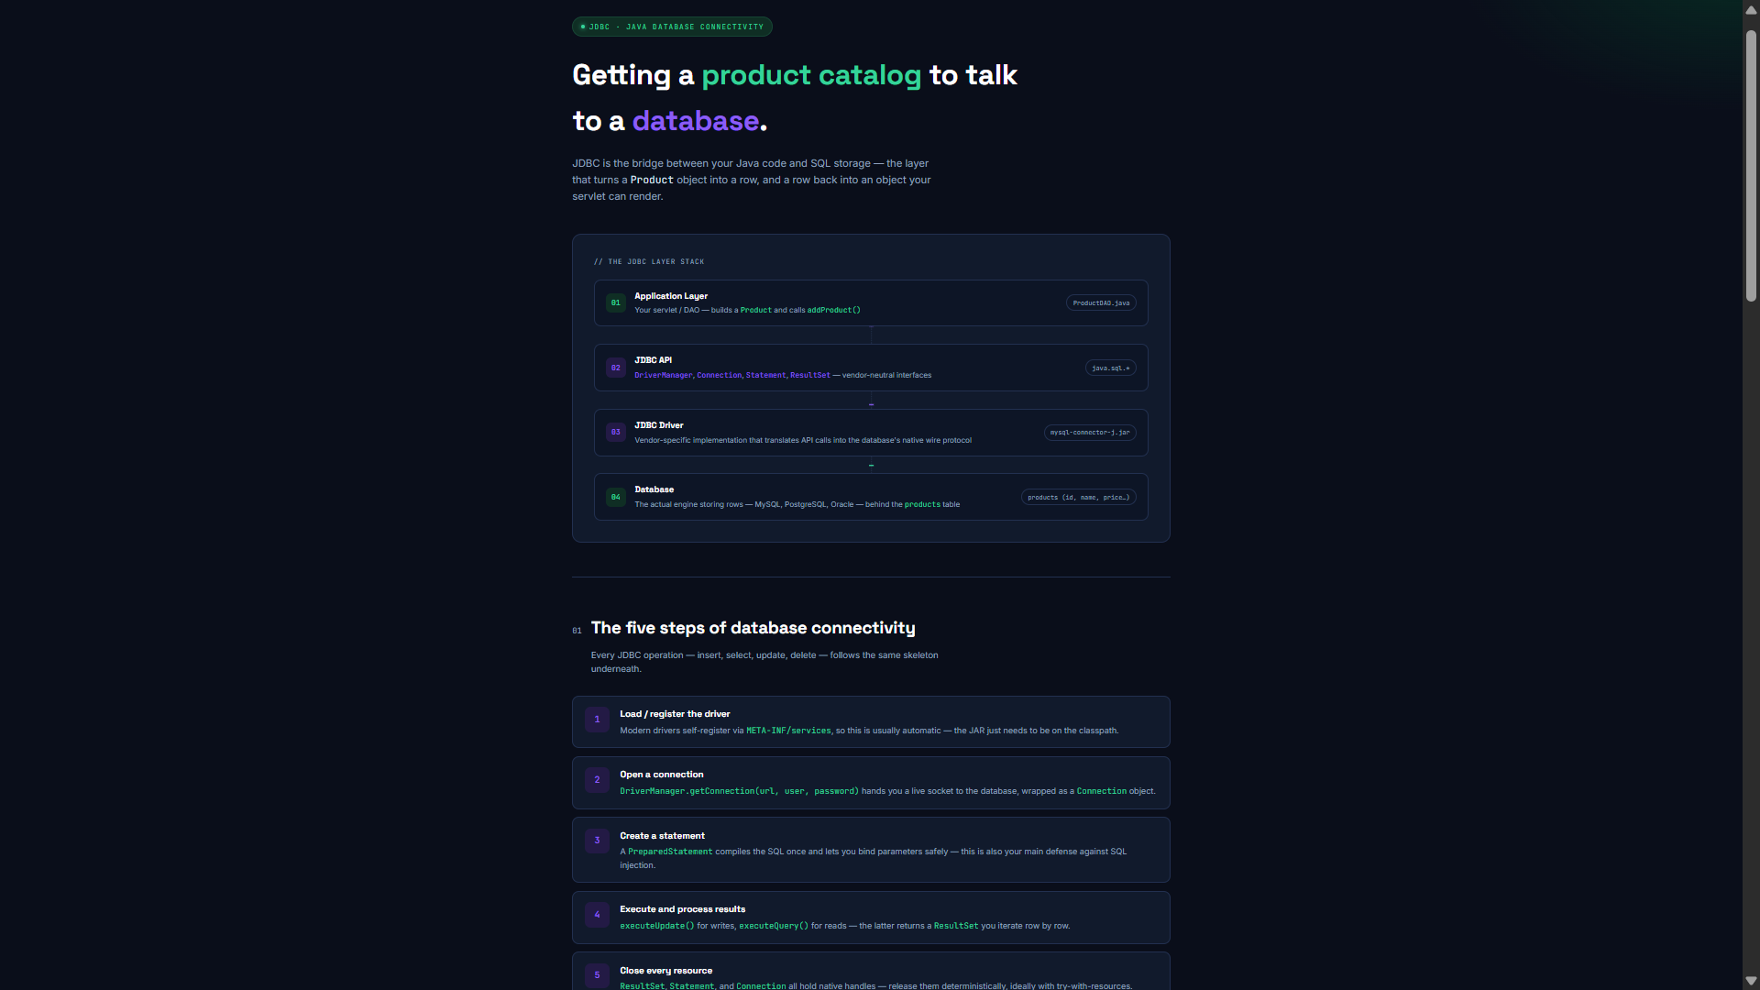
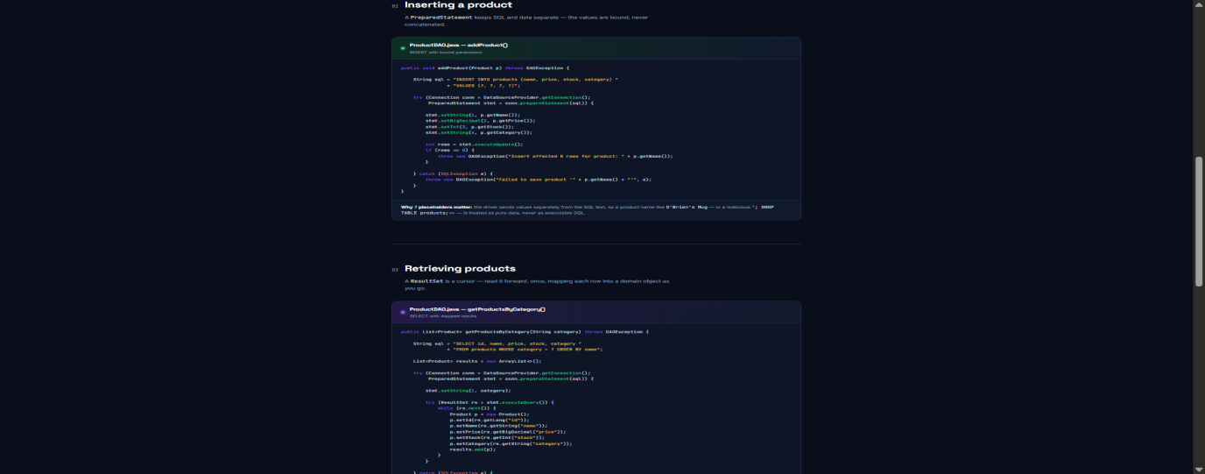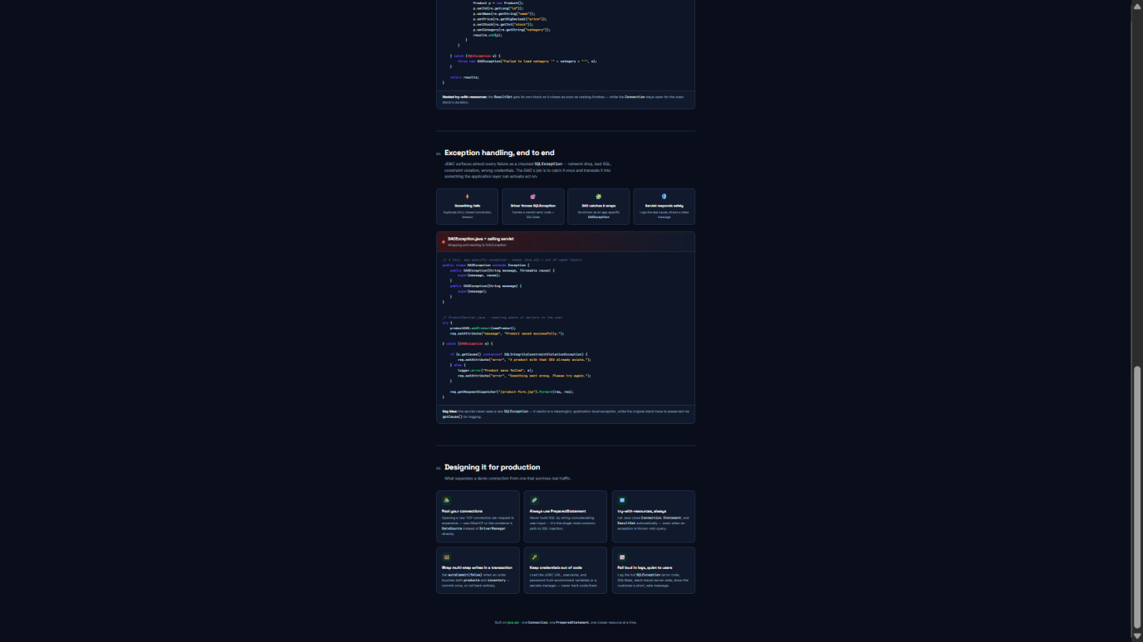

Code of Conduct:

I BHARGAVI. N (192411144) (Name / Reg No) certify that this submission is my original work and that I have adhered to the guidelines specified for this assessment.
I understand that any violation of academic integrity rules will result in disciplinary action.

Signature of the student: Bhargavi. N

RUBRICS FOR CALCULATION:

Criteria | Weightage (%) | Level 4 (Exemplary) | Level 3 (Proficient) | Level 2 (Developing) | Level 1 (Beginning)
Understanding of Scenario | 20% | Demonstrates clear and complete understanding of the scenario and context | Shows good understanding with minor gaps | Partial understanding; misses key aspects | Misinterprets or fails to understand the scenario
Identification of Key Issues | 20% | Accurately identifies all relevant issues and factors involved | Identifies most key issues with minor omissions | Identifies limited issues; some irrelevant points | Unable to identify key issues
Application of Concepts | 25% | Applies appropriate concepts effectively to address the scenario | Applies concepts with minor errors | Limited or partially correct application | Unable to apply relevant concepts
Decision Making | 20% | Makes well-reasoned, logical decisions with strong rationale | Makes reasonable decisions with some justification | Makes weak decisions with limited justification | No clear decisions made or rationale provided
Clarity of Response | 15% | Response is clear, structured, and logically presented | Generally clear with minor issues | Somewhat unclear or poorly structured | Disorganized and difficult to understand

