MEDHADRISHTI – YUGMA TECHFEST 2.0
National-Level AI Hackathon · JNNCE Shivamogga
GF-QFDet
Gated Cross-Modal Fusion for Quality-Aware
RGB–Thermal Pedestrian Detection
Track: AI for Multimodal RGB-Thermal Pedestrian Detection through Efficient Fusion Strategies
Baseline: QFDet · Framework: MMDetection / OpenMMLab · Dataset: VTUAV-det (curated subset)
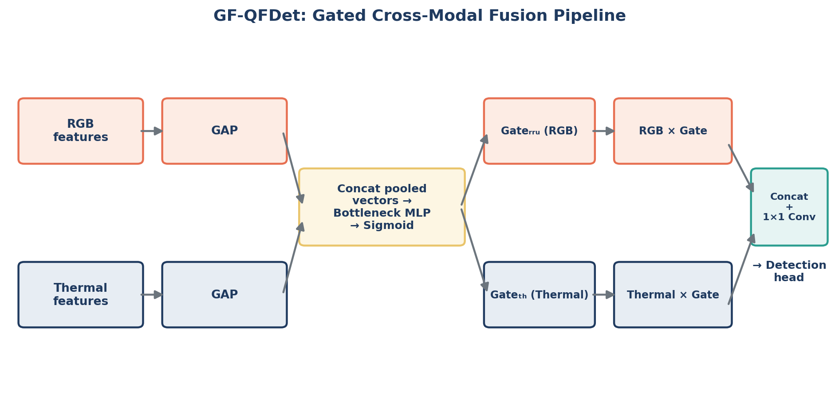
Figure 0 — GF-QFDet pipeline: per-channel gated trust between RGB and thermal features.

1. Objectives
This project targets the MedhaDrishti hackathon's core challenge: detecting pedestrians reliably across the full range of real-world illumination, using paired RGB and thermal drone imagery from the VTUAV-det dataset. Working from the provided pretrained QFDet baseline, our objectives were:
▸ Explore and characterise the dataset — scale distribution, illumination extremes, and class balance — to ground every later design decision in evidence rather than assumption.
▸ Reproduce and benchmark the QFDet baseline across three settings (RGB-only, Thermal-only, Fusion) to quantify exactly what each modality contributes.
▸ Design a novel, lightweight fusion strategy that improves on the baseline's simple concatenation, specifically targeting the small-object / low-illumination weaknesses surfaced during exploration.
▸ Fine-tune (never train from scratch) the improved model on the provided VTUAV-det subset only, and rigorously evaluate it against the baseline on the held-out test set.
▸ Diagnose and iterate — treat an unexpected result as a hypothesis to test, not a dead end — and document every decision for the final technical report.

2. Dataset at a Glance
The curated VTUAV-det subset consists of 1,200 training, 300 validation and 200 test RGB–thermal image pairs (1920×1080, COCO-format annotations, single class: pedestrian). A key finding motivating this entire project: some frames are captured under near-zero visible-light illumination (as low as 3.6/255 average RGB brightness) where pedestrians are essentially invisible in RGB but remain clearly visible in the paired thermal channel.
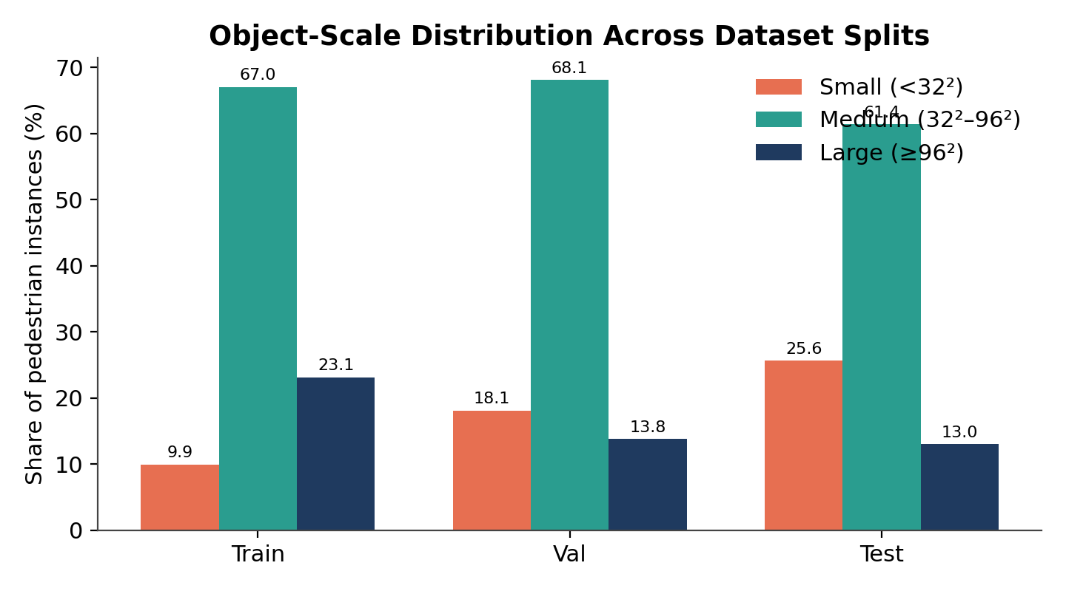
Figure 1 — Pedestrian scale distribution by split. The test set skews notably smaller (25.6% small objects) than train (9.9%), meaning the model must generalise beyond the training distribution.

3. Baseline Benchmarking
Before designing any improvement, we benchmarked all three input configurations on the real test set to isolate exactly where fusion helps and by how much.
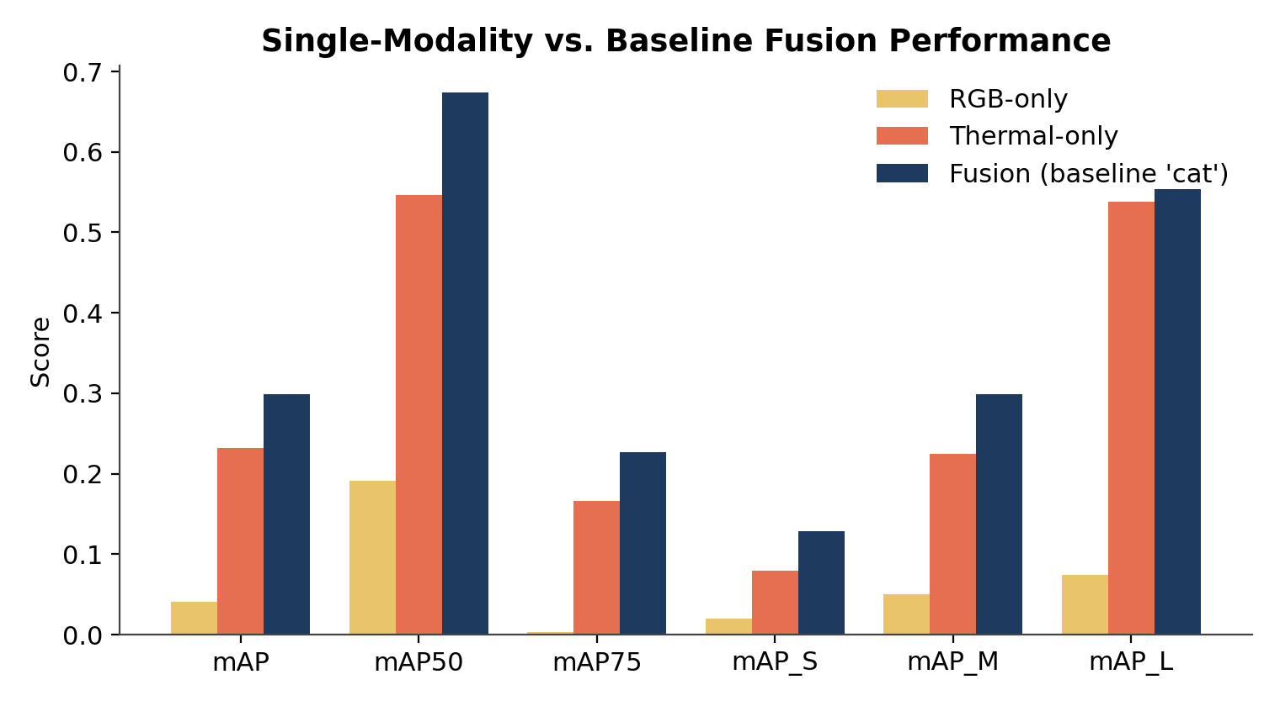
Figure 2 — RGB-only collapses at strict IoU (mAP75 = 0.003); Thermal-only is the dominant single modality; Fusion beats both everywhere.
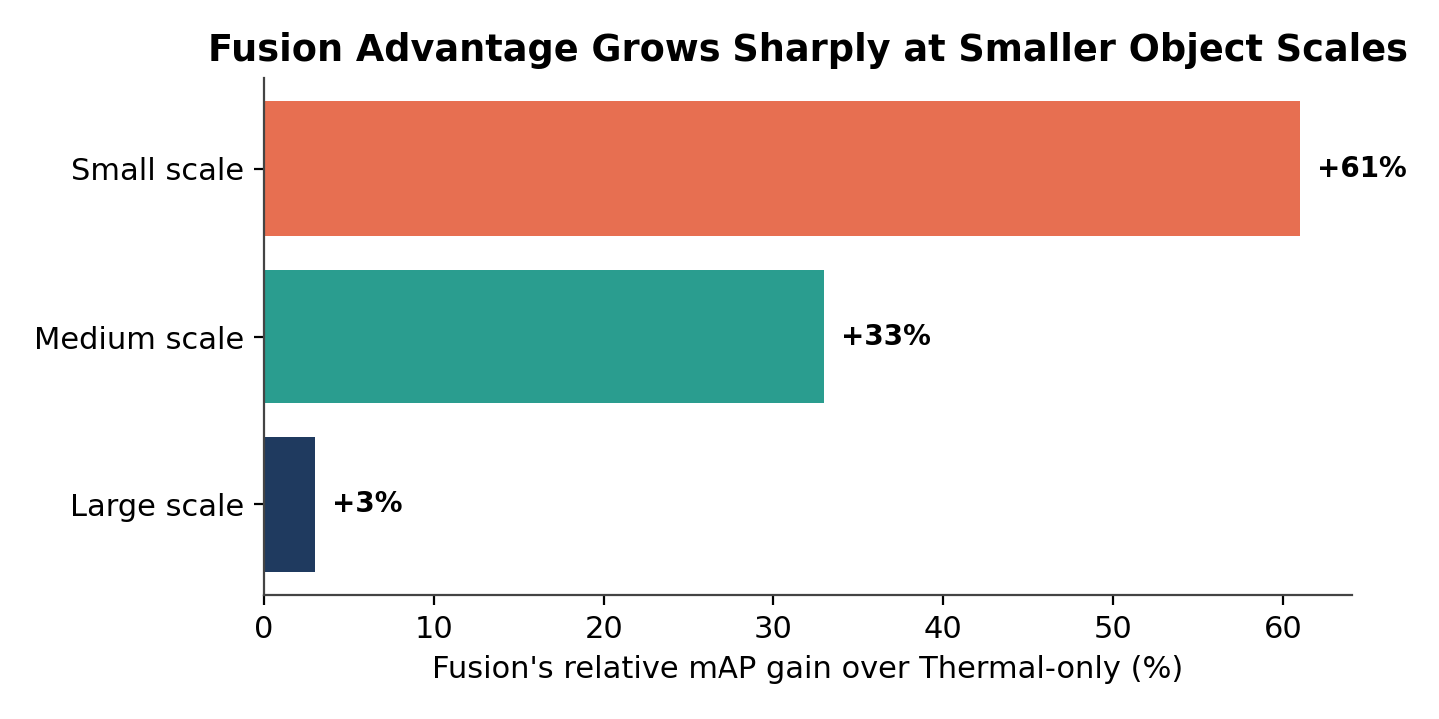
Figure 3 — Fusion's advantage over Thermal-only is small at large scale (+3% relative) but grows to +61% relative at small scale — exactly where a new fusion design should focus.
Baseline fusion (QFDet, concatenation-based) requires two backbones — 60.63M parameters, 122.14 GFLOPs @ 640×384, running at 14.39 FPS (69.5 ms/pair) on a T4 GPU.

4. Proposed Model — GF-QFDet
Named GF-QFDet (Gated-Fusion QFDet), our improvement replaces the baseline's Fusion-CAT block (concatenate, then 1×1 conv) with a lightweight gated cross-modal attention module, inserted downstream of QFDet's existing quality-attention mechanism so the two complement rather than duplicate each other.

Figure 4 — GF-QFDet gating module. Each modality is globally pooled, passed through a shared bottleneck MLP + sigmoid, and used to scale that modality's own feature channels before concatenation — letting the network learn, per channel, how much to trust RGB vs. thermal in a given scene.
▸ Squeeze: global-average-pool RGB and thermal feature maps independently.
▸ Excite: concatenate the pooled vectors → bottleneck MLP → sigmoid → per-channel gates for each modality.
▸ Scale & fuse: multiply each modality by its own gate, concatenate, compress with a 1×1 conv to the original channel count.

5. Training Strategy & Iteration
Fine-tuning only (per hackathon rules) — all runs continue from the provided pretrained QFDet checkpoint.
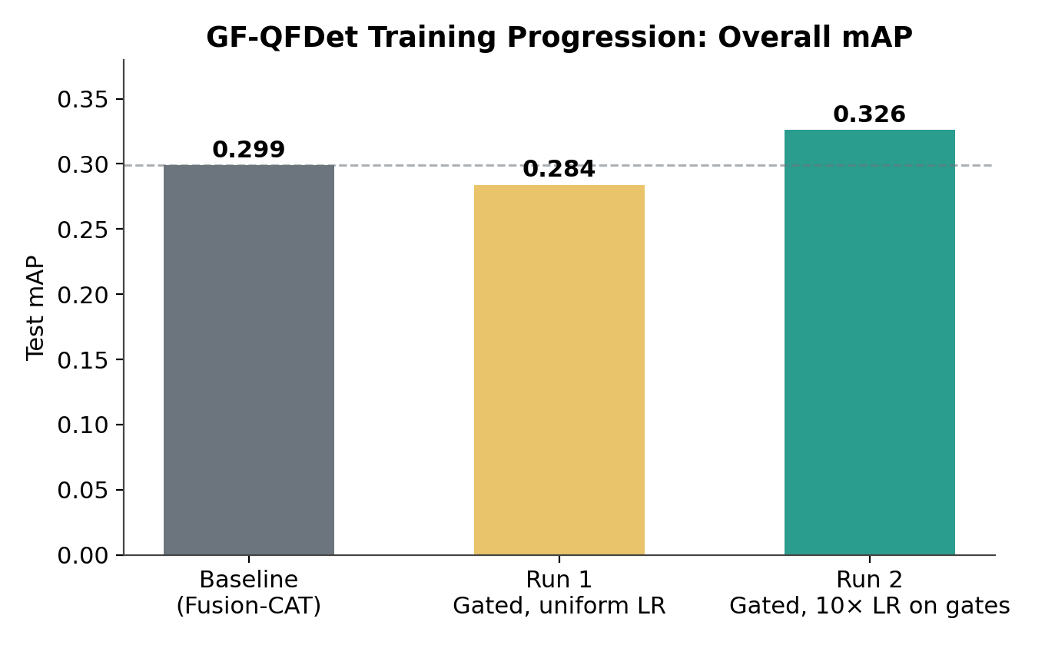
Figure 5 — Run 1 (uniform learning rate for all parameters, 4 epochs) underperformed the baseline. Diagnosis: the newly-added, randomly-initialised gating layers were undertrained relative to the already-pretrained backbone within the limited epoch budget.
Fix: Run 2 applied a 10× learning-rate multiplier to only the new gating parameters, continuing from Run 1's best checkpoint for 4 further epochs — a direct, controlled test of the undertraining hypothesis.

6. Results
Run 2 confirms the diagnosis: GF-QFDet now beats the baseline on every single metric, including every object scale.
Model | mAP | mAP50 | mAP75 | mAP_S | mAP_M | mAP_L
RGB-only | 0.041 | 0.191 | 0.003 | 0.020 | 0.050 | 0.074
Thermal-only | 0.232 | 0.547 | 0.166 | 0.080 | 0.225 | 0.538
Baseline Fusion (Cat) | 0.299 | 0.674 | 0.227 | 0.129 | 0.299 | 0.554
GF-QFDet – Run 2 (best) | 0.326 | 0.712 | 0.251 | 0.130 | 0.311 | 0.572

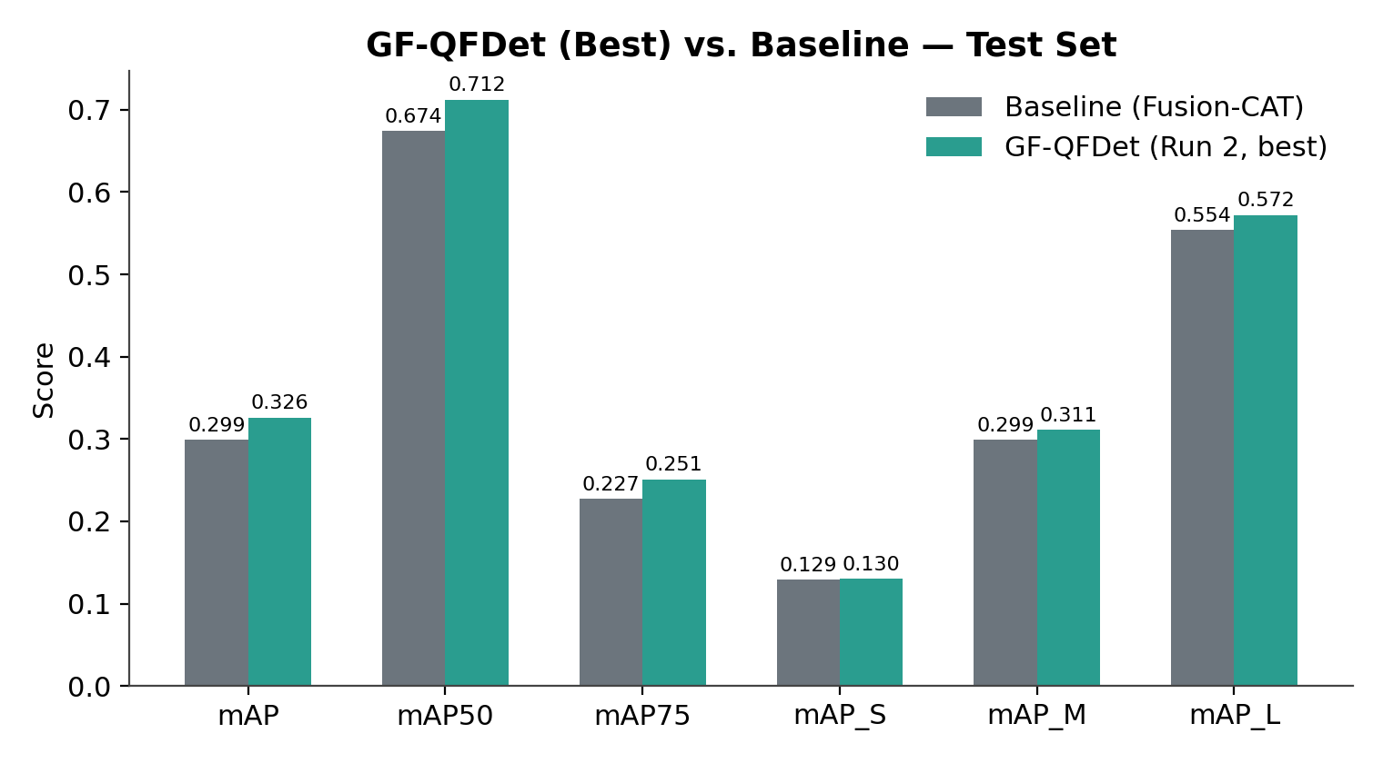
Figure 6 — GF-QFDet (Run 2) vs. baseline across all metrics. Largest relative gains appear at mAP75 (+10.6%) and mAP_M (+4.0%), confirming the gating mechanism sharpens localisation precision, not just recall.

