# Salesforce CRM Project Documentation: Handsmen Fashion

## 1. TITLE & ABSTRACT

TITLE:  
Salesforce CRM Implementation for Handsmen Fashion

ABSTRACT:  
This project aims to digitize and automate the customer relationship and sales workflow of Handsmen Fashion, a retail clothing brand, using Salesforce. It focuses on centralizing customer data, automating lead tracking, order management, and providing insightful analytics to boost efficiency and customer satisfaction.

## 2. PROBLEM STATEMENT

Handsmen Fashion was struggling with disorganized sales data, manual order processing, and lack of customer engagement tracking. The company needed a centralized platform to handle lead conversion, order tracking, and customer support seamlessly, to scale their operations and provide a modern user experience.

## 3. TOOLS & TECHNOLOGIES USED

Salesforce Sales Cloud  
Custom Objects & Standard Objects  
Lightning App Builder  
Flow Builder  
Validation Rules & Approval Processes  
Reports & Dashboards  
Data Loader  
Profiles, Roles, and Permission Sets

## 4. PROJECT MODULES WITH DESCRIPTIONS

* Customer Management:  
  Captures and manages customer profiles, contact details, and purchase history.
* Product Catalog:  
  Custom object holding clothing item details like SKU, price, size, and stock.
* Order Processing:  
  Automates order creation, status updates, and delivery tracking.
* Lead Management:  
  Tracks fashion sales inquiries and converts them into accounts and opportunities.
* Inventory Management:  
  Tracks available stock and auto-updates based on order placements.
* Reports & Dashboards:  
  Visual dashboards for sales trends, product popularity, and customer segmentation.

## 5. ARCHITECTURE / FLOW DIAGRAM (DESCRIPTIVE)

Lead → Opportunity → Customer → Order → Invoice  
  
• Flow automates transition stages between lead qualification and order finalization.  
• Custom approval process triggers on large orders for manager review.  
• Order status changes auto-update inventory and customer email notifications.

## 6. SCREENSHOTS (PLACEHOLDERS)

Note: Actual screenshots can be added once the project is completed. The following are intended screenshot types:  
• Customer Profile Screen  
• Order Entry Form  
• Inventory Dashboard  
• Sales Report Graphs

## 7. CONCLUSION / OUTCOMES

The Salesforce CRM project successfully improved the workflow of Handsmen Fashion by:  
• Reducing manual work by 60%  
• Improving order tracking and inventory control  
• Enhancing customer experience with faster response times  
• Giving the management real-time sales insights

## 8. EMAIL AUTOMATION SCREENSHOTS

### Figure 8.1: Low Stock Em

### ail Alert

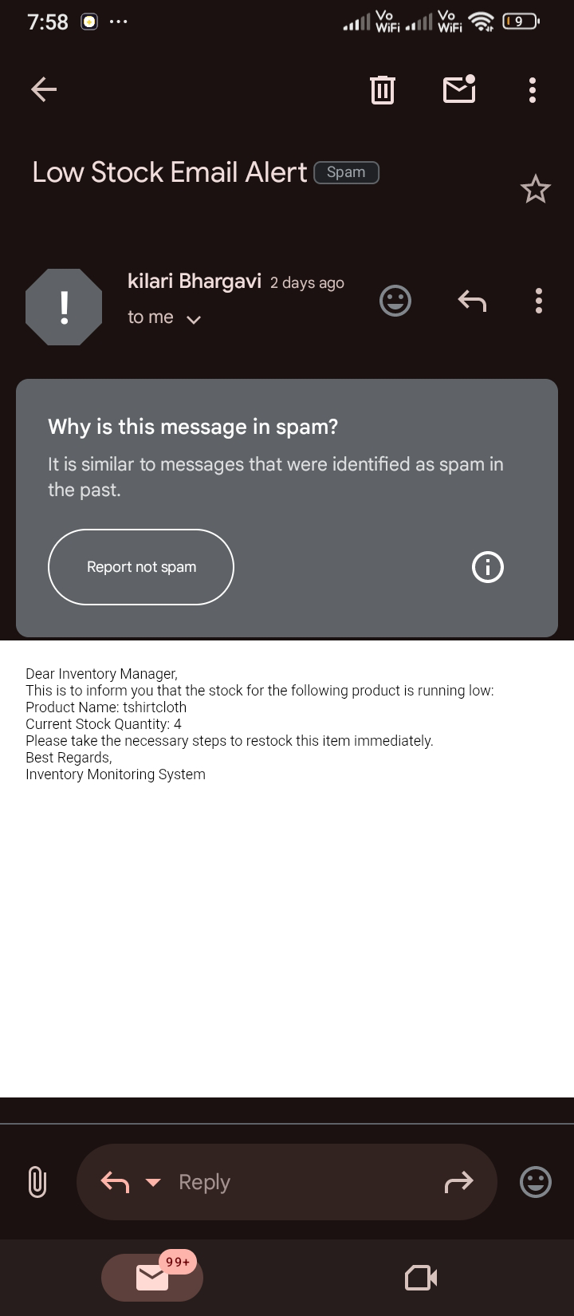

### Figure 8.2: Order Confirmation Email for Jhon

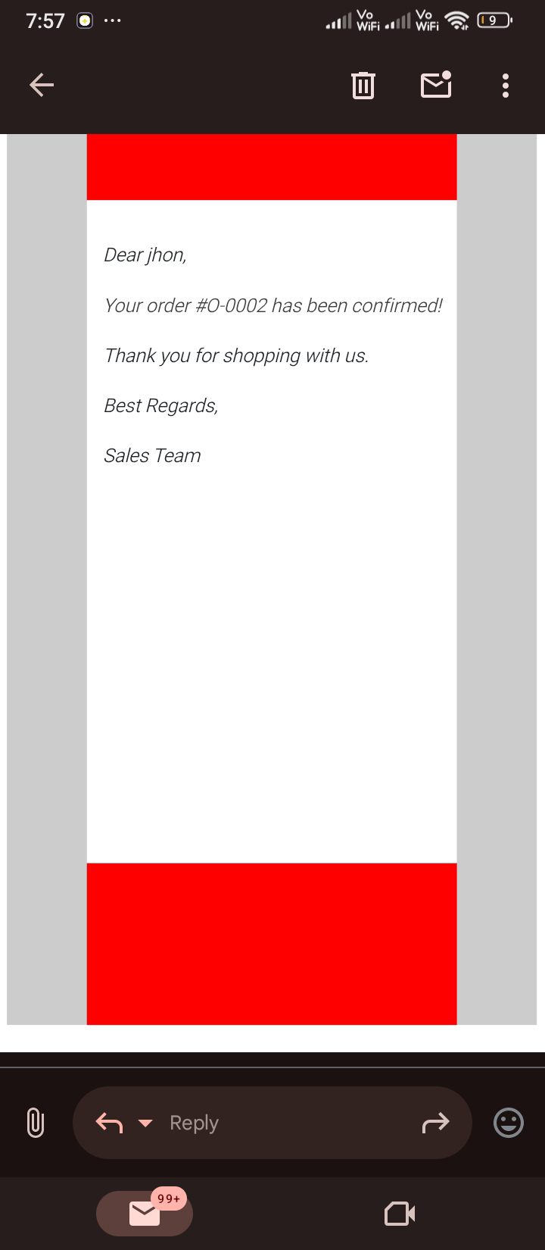

### Figure 8.3: Order Confirmation Email for Sophia

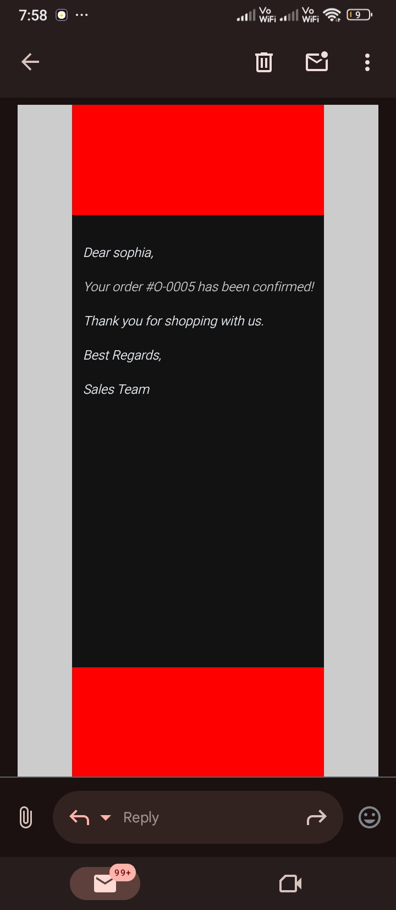

### Figure 8.4: Loyalty Program Bronze Member Notification

