**8.)** Table 4-4 shows a relation called GRADE REPORT for a university. Your assignment is as follows:

a. Draw a relational schema and diagram the functional dependencies in the relation.

b. In what normal form is this relation?

c. Decompose GRADE REPORT into a set of 3NF relations.

d. Draw a relational schema for your 3NF relations and show the referential integrity constraints.

e. Draw your answer to part d using Microsoft Visio (or any other tool specified by your instructor).

**Ans.)**

**a.)**

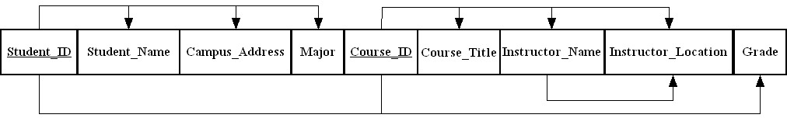

**b.)** 1NF.

**c.)**

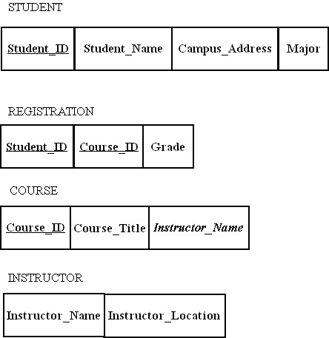

**d.)**

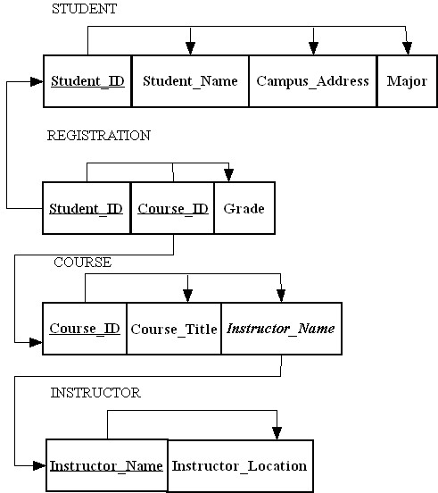

**11.)** For your answers to the following Problems and Exercises from prior chapters, transform the EER diagrams into a set of relational schemas, diagram the ftmctional dependencies, and convert all the relations to third normal form.

1. Chapter 3, Problem and Exercise 15

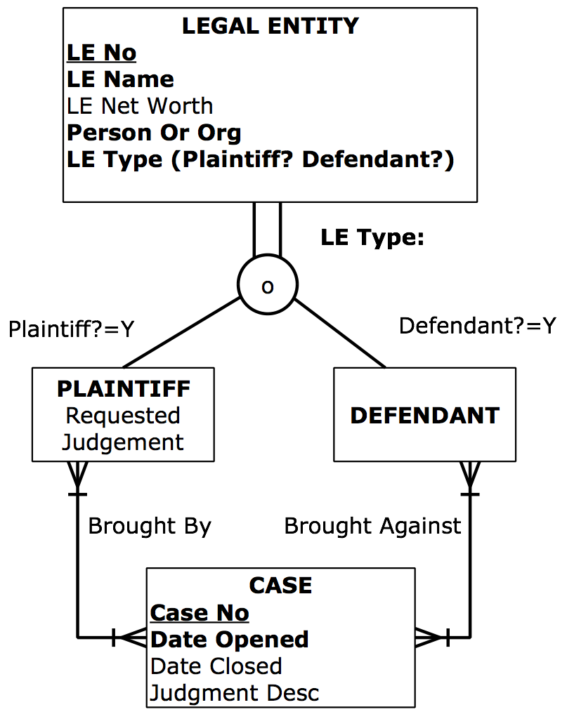

**Ans.)**

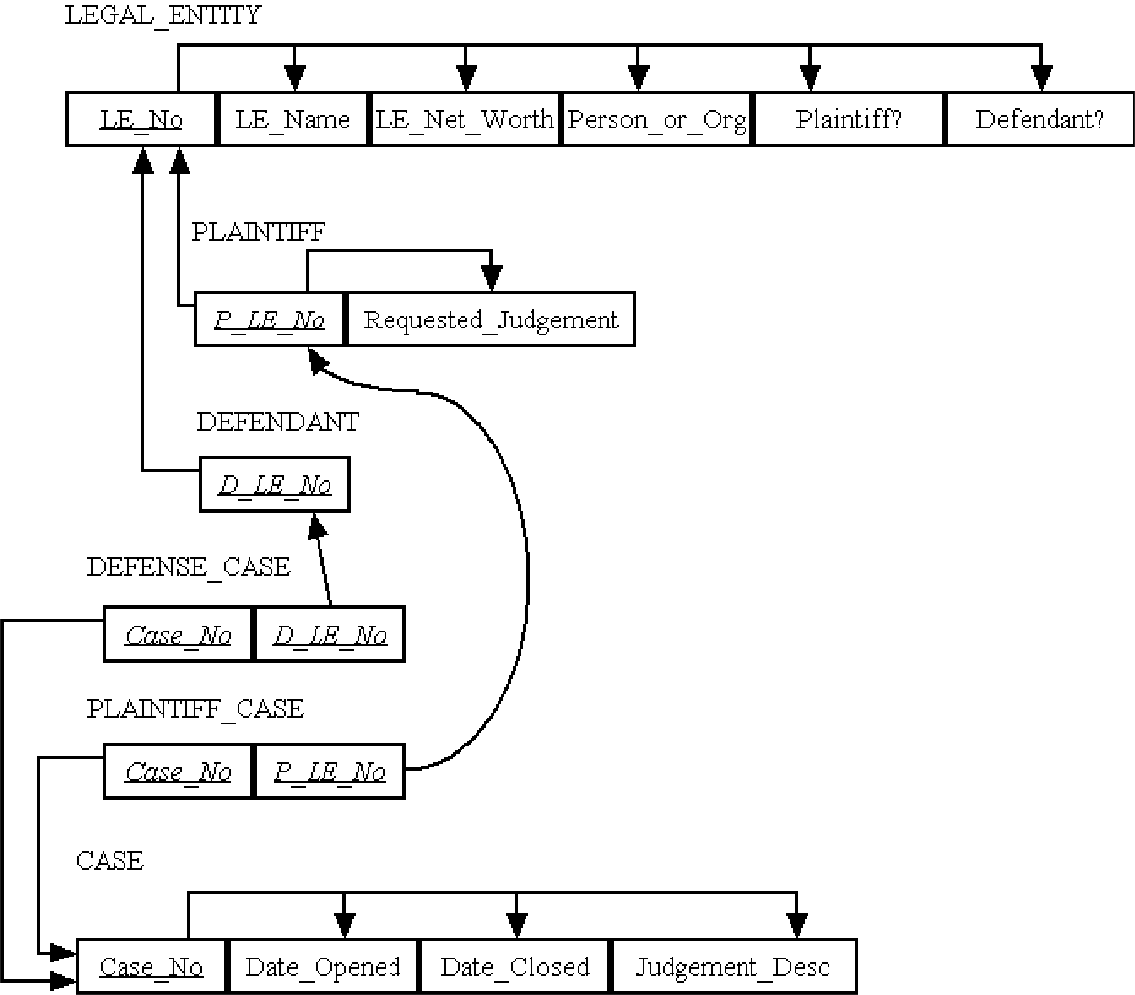

**16.)** Figure 4-34 shows an EER diagram for Vacation Property Rentals. This organization rents preferred properties in several states. As shown :in the figure, there are *tvvo* basic types of properties: beach properties and mountain properties.

a. Transform the EER diagram to a set of relations and develop a relational schema.

b. Diagram the functional dependencies and determine the normal form for each relation.

c. Convert all relations to third normal form, if necessary, and draw a revised relational schema.

d. Suggest an integrity constraint that would ensure that no property is rented twice during the same time interval.

**Ans.)**

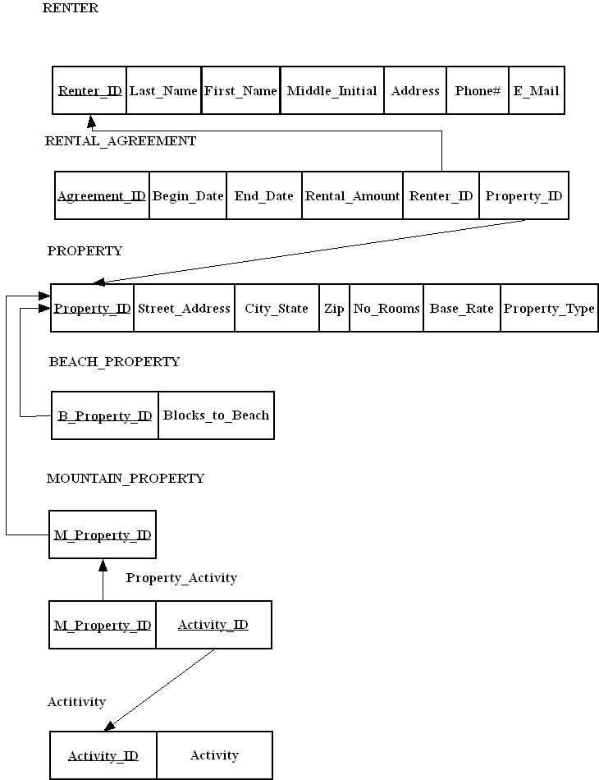

b.)

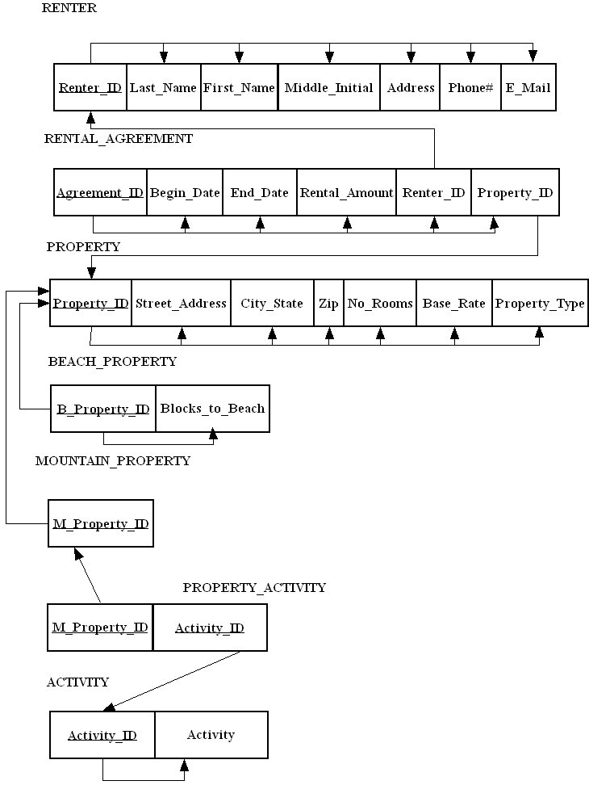

1. All relations are in third normal form.
2. An action assertion could be used such as:

A property shall have one and only one rental agreement in force at one time, where “in force” means that a given date falls between Begin_Date and End_Date.

**18.)** Figure 4-35 includes an EER diagram describing a car racing league. Transform the diagram into a relational schema that shows referential integrity constraints (see Figure 4-5 for an example of such a schema). In addition, verify that the resulting

relations are in 3NF.

**Ans.)** 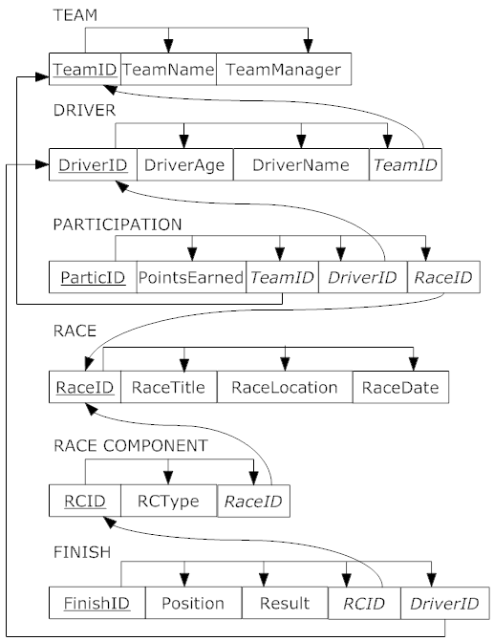

**20.)** Examine the set of relations in Figure 4-37. What normal form are these in? How do you know this? lf they are in 3NF, convert the relations into an EER diagram. What assumptions

did you have to make to answer these questions?

**Ans.)** For this situation, we assume that Client information is stored even if there is not a corresponding instance of Retention with an Attorney and a Case. We also assume that Attorney information is stored even if there is not a corresponding instance of Retention with a Client and a Case.

All relations are in 3NF since there are no partial functional dependencies or transitive dependencies. It could be argued that zip code is determined by city and state (also by address with 9-digit zip codes). This could be a good point to discuss in class.

