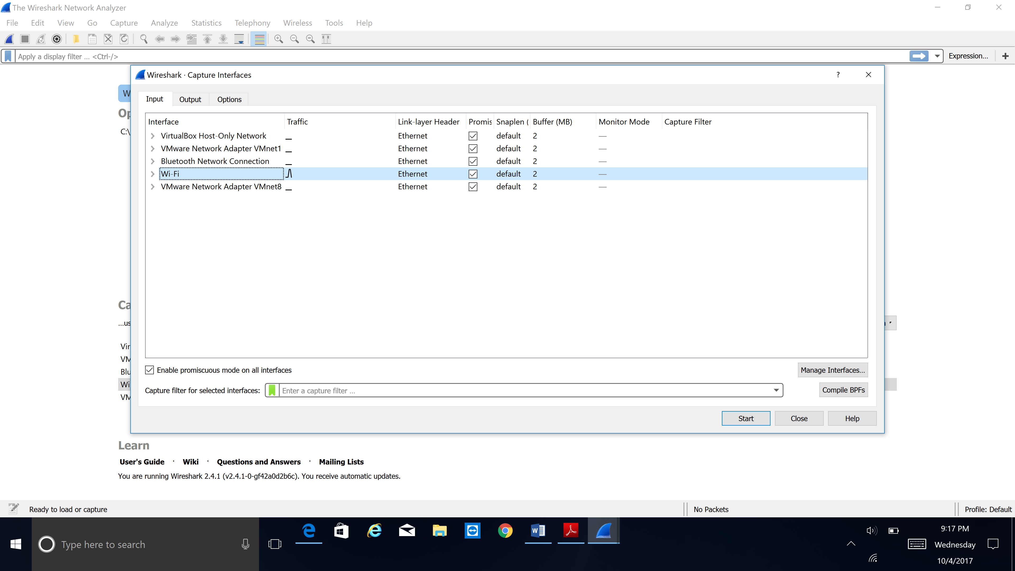

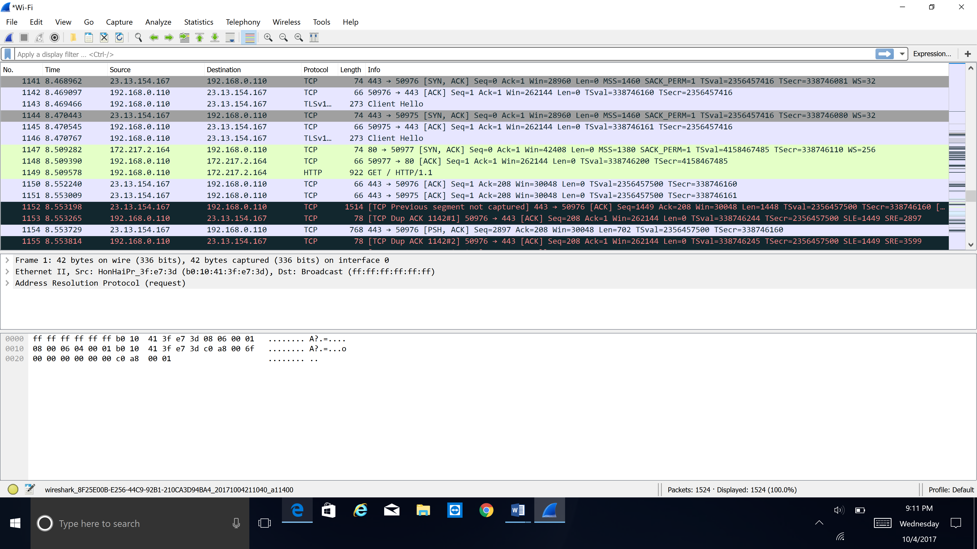

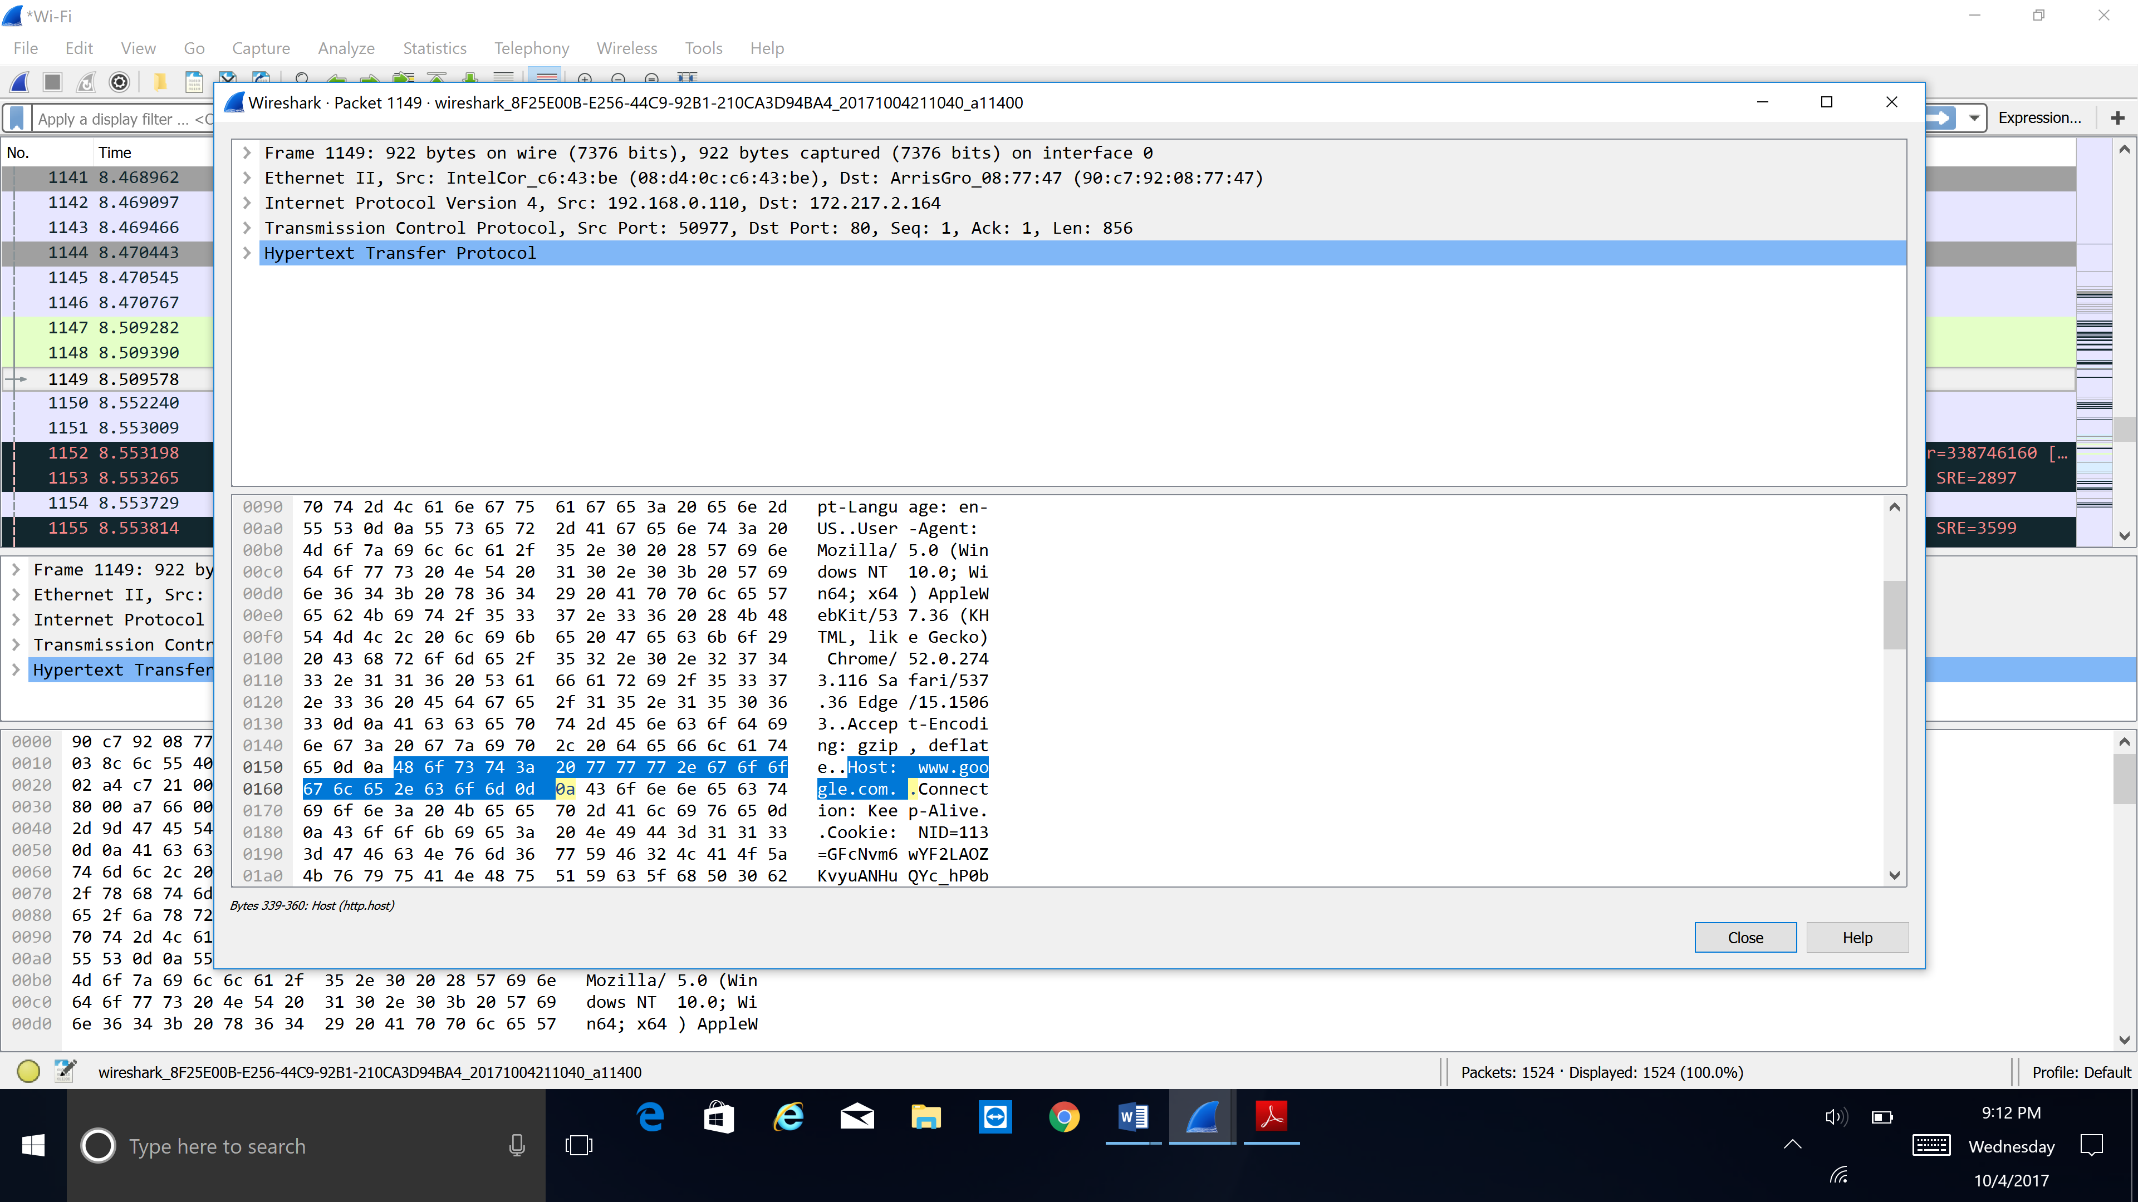

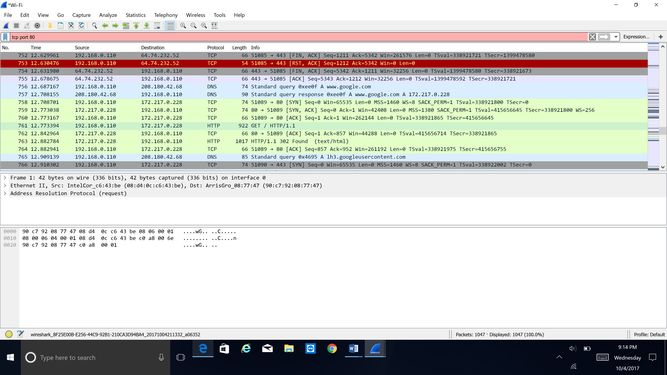

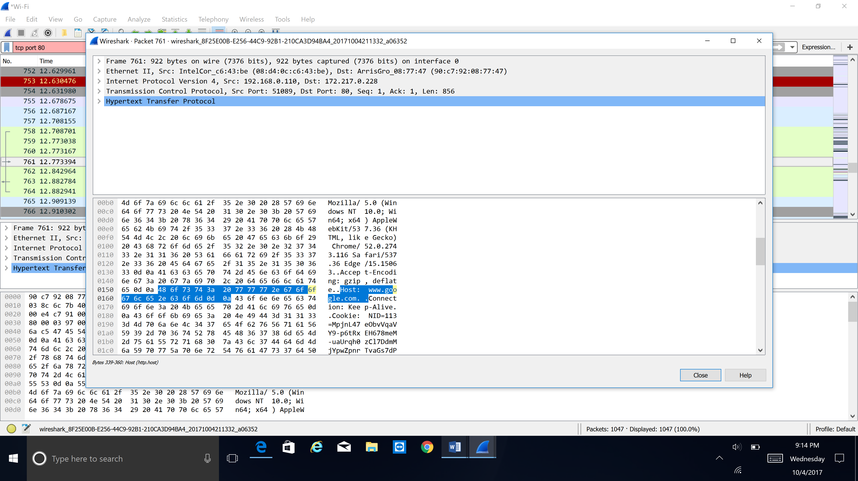

**a.** computer sends a lot of smaller packets for different kinds of reasons. we have lot of advantages to send smaller packets than big packet, it can move fast and the process will be easier and it reduce the chance of getting bottlenecks.

**b**. The following packets are used in the TCP/IP connection. They stand for

SYN: synchronize 🡪 initiates a connection

ACK: acknowledgement 🡪 acknowledges received data

FIN: final 🡪 cleanly terminates a connection

GET: get 🡪get or page request

**c**. Each and every packet can be routed individually, sequence numbers do allow our computer to reassemble packets in the correct way, So that packets need sequence numbers.

**d**. most of the packets are ACK packets, that will acknowledge the receipt of data from the Web server.

**e.** Different kinds of color codes helps the end user to identify the particular types of packets. Color coding helps you to reduce the time.

**f**. if the packets are at our local network, we can capture the any kind of packets in promiscuous mode.