ASSIGNMENT-2
SUPERMARKET SALES DATA ANALYSIS
(TEAM LEADER)

- DONUT CHART
- Purpose: This donut chart represents the percentage contribution of each product category to the total supermarket sales. It helps in identifying which product line generates the highest revenue and which contributes the least. This visualization supports business decision-making by clearly showing category-wise performance in a simple and attractive format.

- Step-by-Step Process:
- Open Tableau Public/Desktop.
- Load the supermarket_sales.csv dataset.
- Click on New Worksheet.
- Change the Marks type to Pie.
- Drag Product Line → to Color.
- Drag Product Line → to Label.
- Drag Total → to Angle.
- Drag Total again → to Label.
- Click on Label → Show Percentage of Total.
- Drag Total to Rows twice.
- Right-click on the second axis → Select Dual Axis.
- Click on the second Marks card.
- Change mark type to Circle.
- Reduce the size of the second circle.
- Change the color to White to create the donut hole.
- Remove extra headers if visible.
- Edit the title as:SALES BREAKDOWN ACROSS CATEGORY
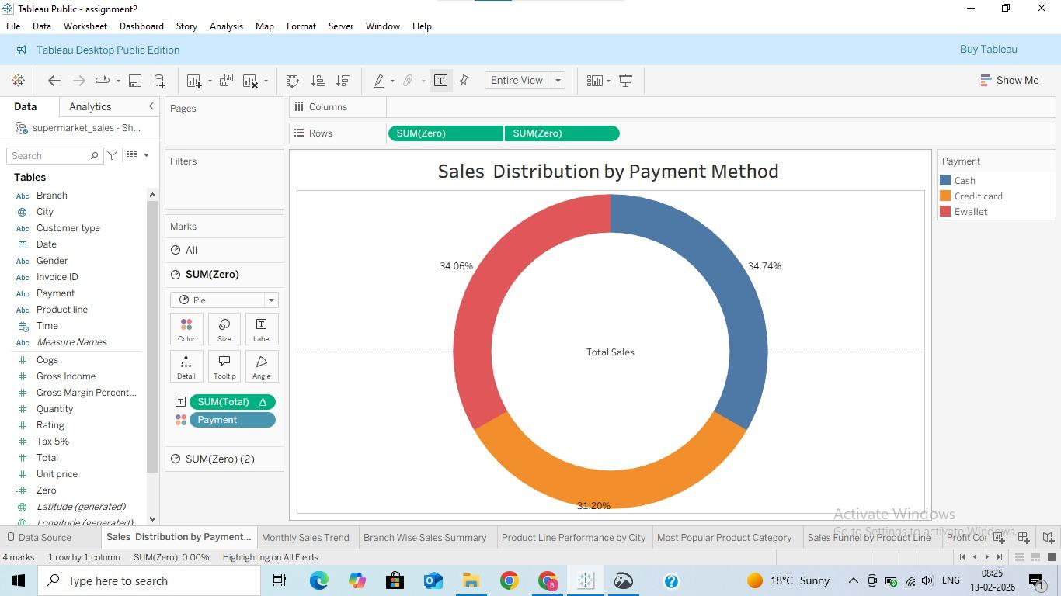

- AREA CHART
- Purpose: To analyze monthly sales trend for each city (Jan–Mar 2019).

- Step-by-Step Process:
- Drag Date → Columns
- Change to Month
- Drag Total → Rows
- Drag City → Color
- Change Marks → Area
- Edit Title as : “Monthly Sales Trend by City (Jan–Mar 2019)”
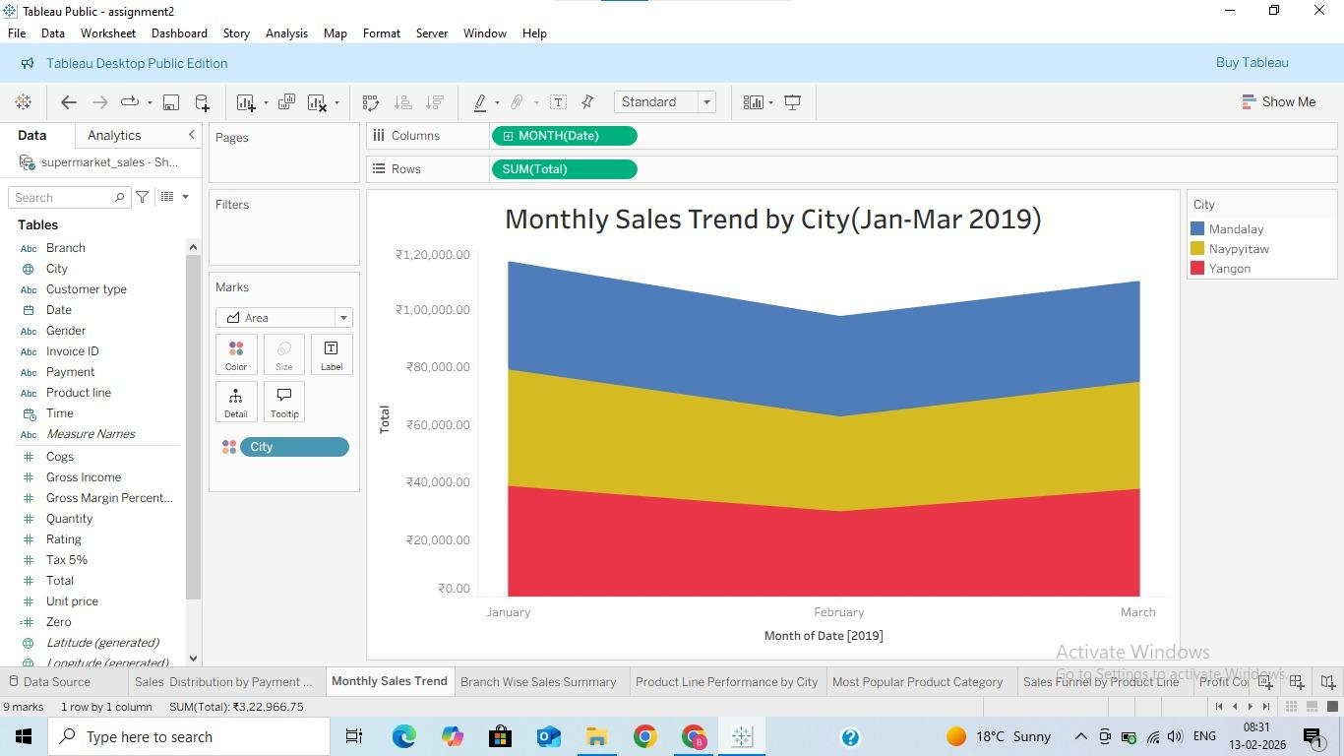

- TEXT TABLE
- Purpose: To show complete summary per branch:
Gross Income
- Quantity
- Total Sales
- Used for management reporting.

- Step-by-Step Process:
- Drag Branch → Rows
- Drag Measure Names → Columns
- Drag Measure Values → Text
- In Measure Values, keep:
- Gross Income
- Quantity
- Total
- Format currency & alignment
- Edit Title as : “Branch Wise Sales Summary”
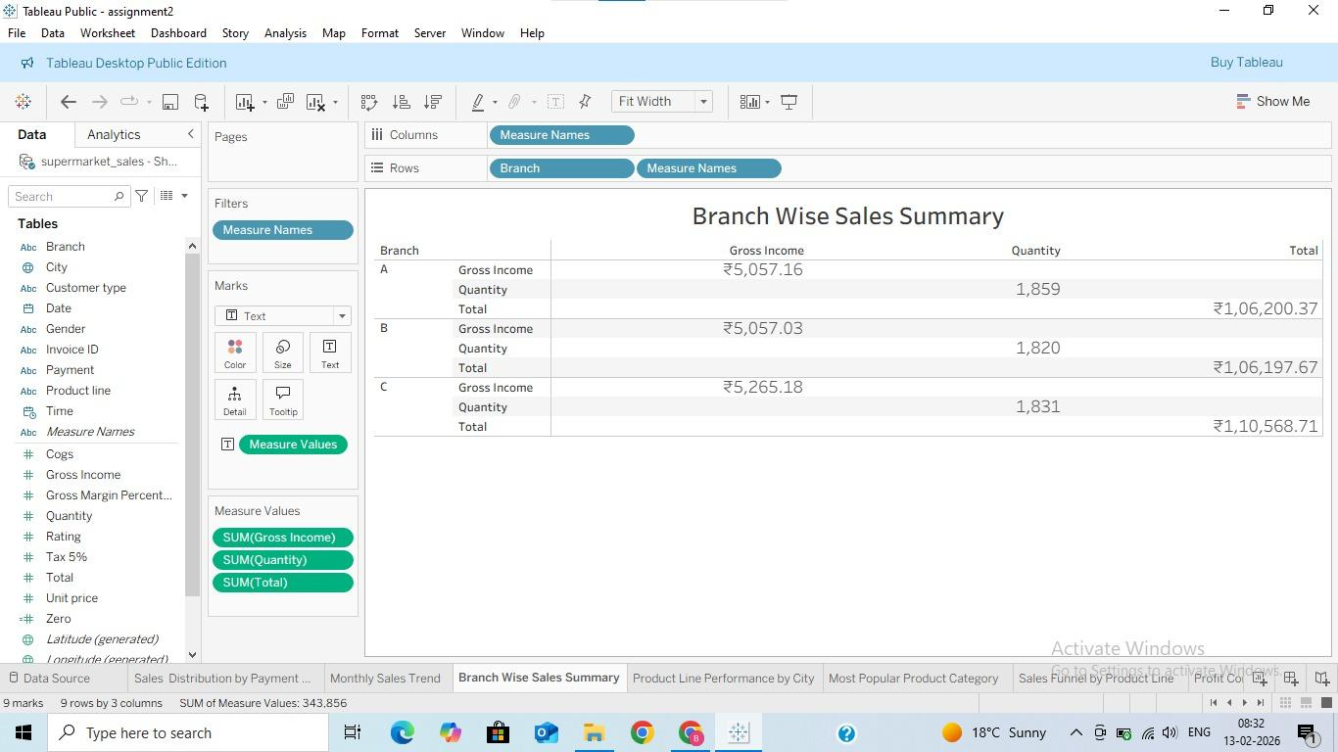

- Heat Map
- Purpose: To compare sales (Total) of each product line across different cities.

- Step-by-Step Process:
- Drag City → Rows
- Drag Product line → Columns
- Drag Total → Color
- Drag Total → Label
- Change Marks type → Square
- Adjust color intensity
- Edit Title as : “Product Line Performance by City”
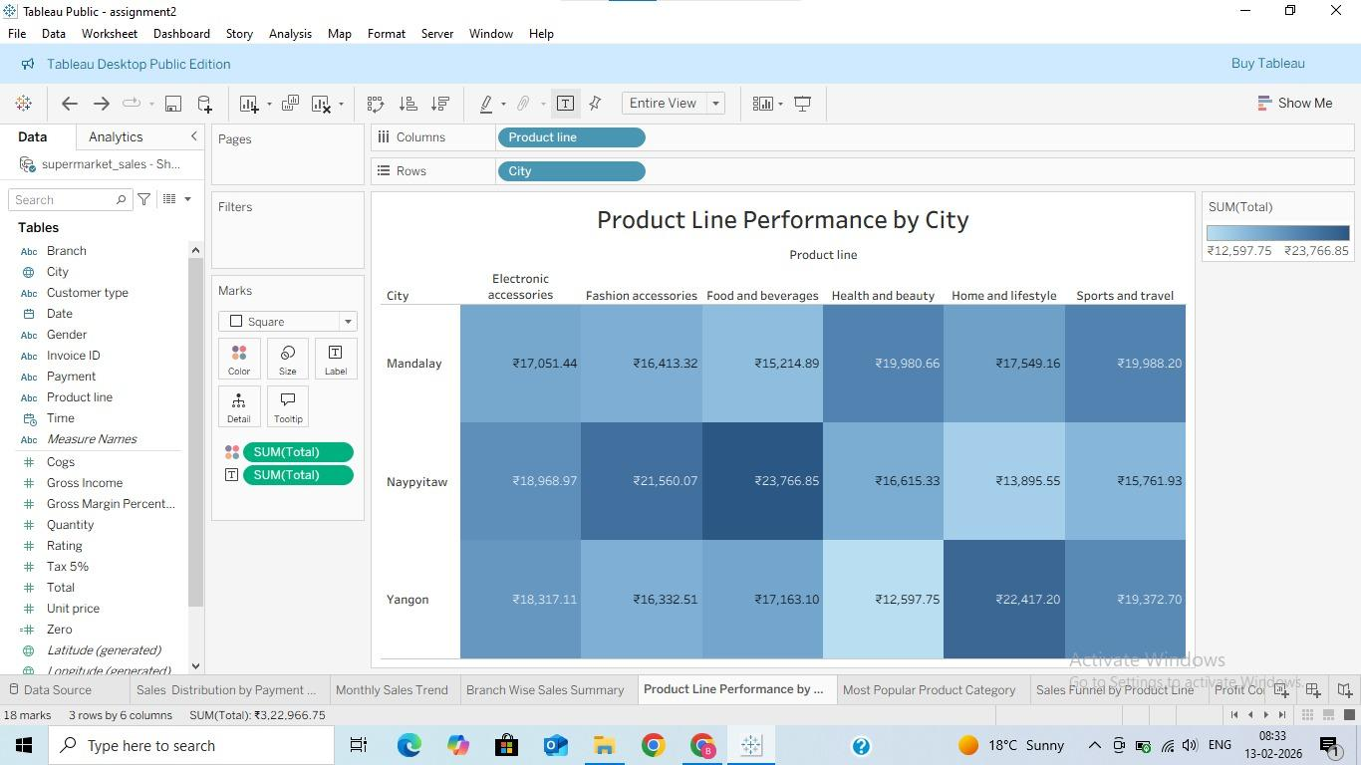

- WORD CLOUD
- Purpose: To show which product category sold the most based on Quantity.
Bigger word = higher sales volume.

- Step-by-Step Process:
- Drag Product line → Text
- Drag Quantity → Size
- Drag Quantity → Color
- Change Marks type → Text
- Increase font size
- Edit Title as : “Most Popular Product Category”
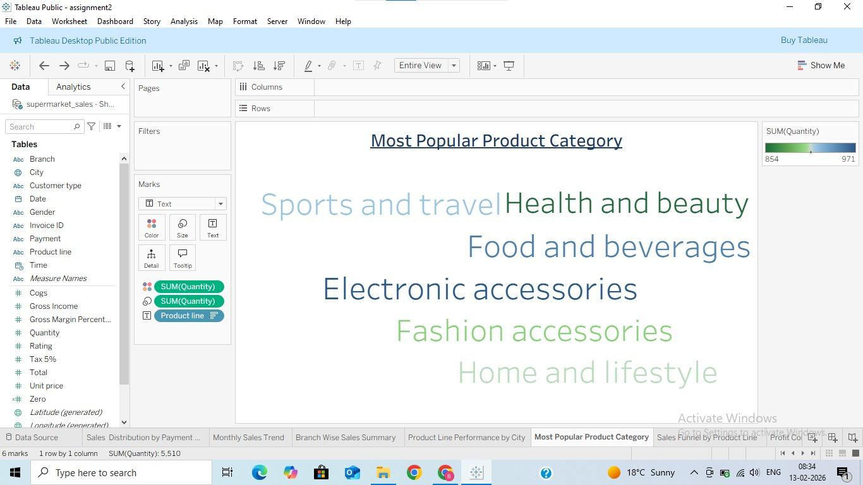

- HORIZONTAL BAR CHART
- Purpose: To rank product lines based on total sales.

- Step-by-Step Process:
- Drag Product line → Rows
- Drag Total → Columns
- Change Marks → Bar
- Click Sort Descending
- Add labels if needed
- Edit Title as : “Sales Funnel by Product Line”
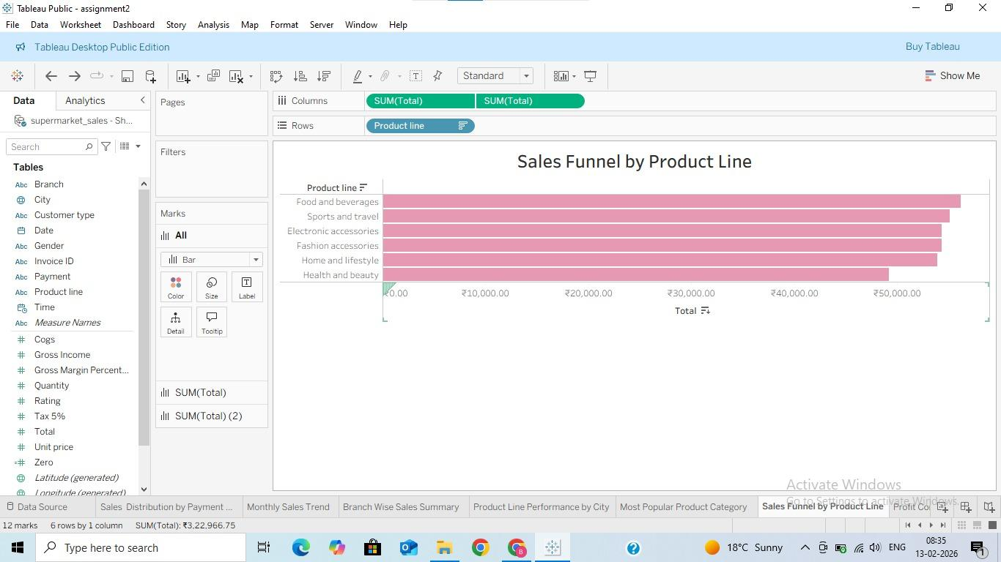

- WATERFALL CHART
- Purpose: To show how each product line contributes to total profit (Gross Income) and how the cumulative profit builds step by step.

- Step-by-Step Process:
- Drag Product line → Columns
- Drag Gross Income → Rows
- Right-click SUM(Gross Income)
- ➜ Quick Table Calculation → Running Total
- Change Marks type to Gantt Bar
- Drag SUM(Gross Income) again to Size
- Edit Title as → “Profit Contribution by Product Line”
