Nalla Bhargavi

  Submission date:16/02/25

**AWS S3 Data Backup and Restore**

# Introduction

Objective & Importance:

* Data Redundancy & Protection: Ensures that critical data is backed up in case of accidentaldeletion, corruption, or system failures.
* Disaster Recovery: Enables quick restoration of lost data from the backup bucket.
* Version Control: Keeps previous file versions available for rollback if needed.
* Cost Optimization: Lifecycle policies automatically delete old backups to optimize storage costs.

# Configuration and Setup

**Step 1: Creating S3 Buckets**

1. Log in to AWS Management Console.
2. Navigate to Amazon S3.
3. Click 'Create Bucket' and name the first bucket (e.g., my-live-data-bucket).
4. Choose a region and enable Versioning.
5. Repeat for the second bucket (e.g., my-backup-data-bucket) in a different AWS region.

aws s3api put-bucket-versioning --bucket my-live-data-bucket --versioning-configuration Status=Enabled

aws s3api put-bucket-versioning --bucket my-backup-data-bucket

--versioning-configuration Status=Enabled

**Step 3: Setting Up Cross-Region Replication (CRR)**

1. Navigate to 'my-live-data-bucket' > Management > Replication rules.
2. Click 'Create replication rule' and select 'Destination bucket' as my-backup-data-bucket.
3. Create an IAM Role with replication permissions and save the rule.

# Restore Procedure

1. Identify the file to restore in 'my-backup-data-bucket'.
2. Use the AWS CLI to copy it back to the live bucket.aws s3 cp s3://my-backup-data-bucket/myfile.txt s3://my-live-data-bucket/

# Monitoring

1. Open AWS CloudWatch.
2. Navigate to Metrics > S3 Buckets.
3. Create an Alarm for replication failures and configure SNS Notifications.

# Optimization and Best Practices

* Lifecycle Policies reduce storage costs by automatically deleting old backups.
* Cross-Region Replication (CRR) ensures data availability even if a region fails.
* Versioning enables recovery of previous versions in case of accidental changes.

# Conclusion

The AWS S3 Data Backup and Restore implementation ensures secure, reliable, and cost-effective data protection. By setting up Cross-Region Replication (CRR), Lifecycle Policies, and Versioning, we ensure that data remains available and recoverable in case of failures.

**Screenshots:**

**These are the created buckets**

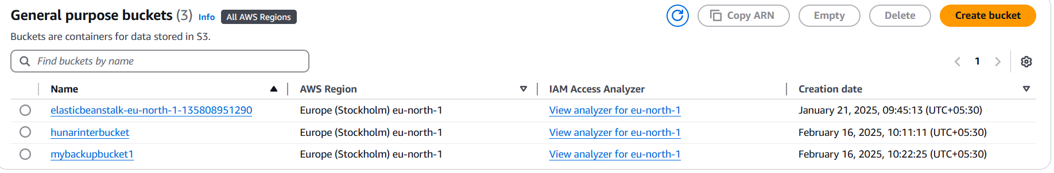

**In this Hunarinternbucket is my live bucket and mybackupbucket1 is backup bucket**

**File inserted in live bucket:**

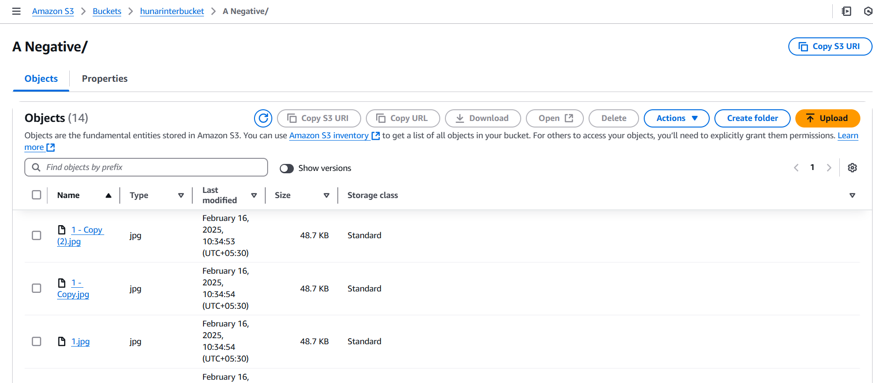

**Same file has been copied in my backup bucket:**

