NAME:- 1)BHARGAVI PODILE ROLL NUM:- 16

NAME:- 2)VYSHNAVI PERLA ROLL NUM:-15

The below is the home page for the course registration which has options like select your level of education option for selecting which semester you are and option for selecting the career.

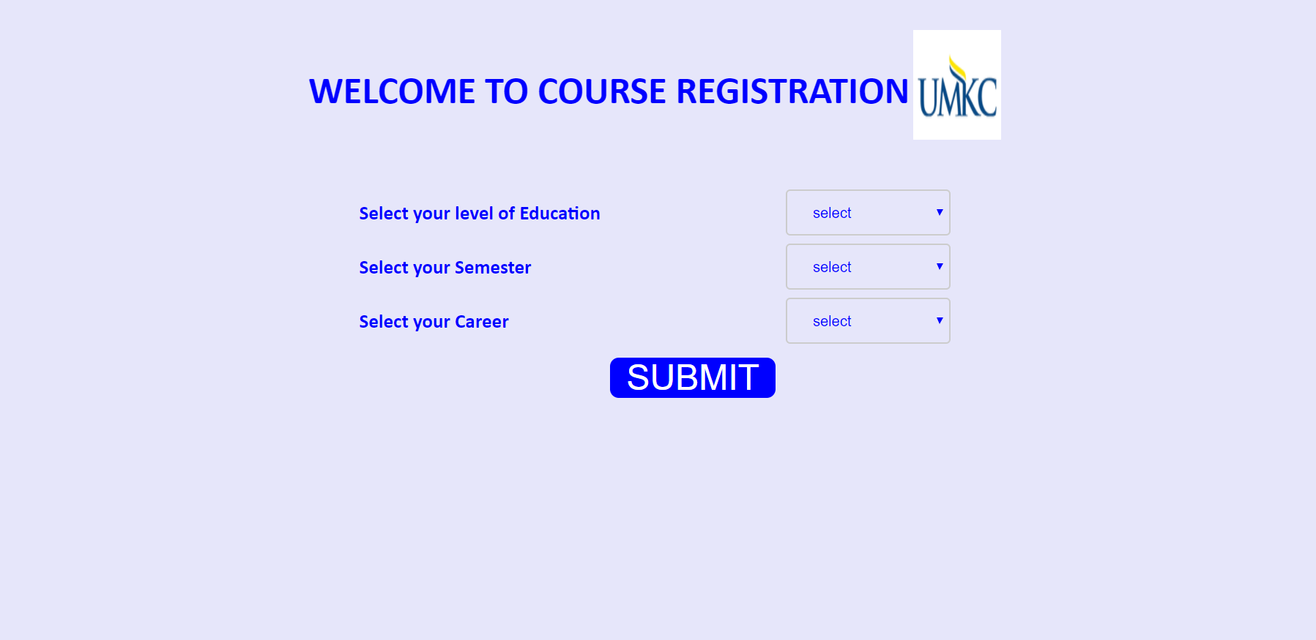

Below is the sample selection part for the given options.



Here from below we will be selecting the courses .if we press the view button we will be getting an option for enrolling.

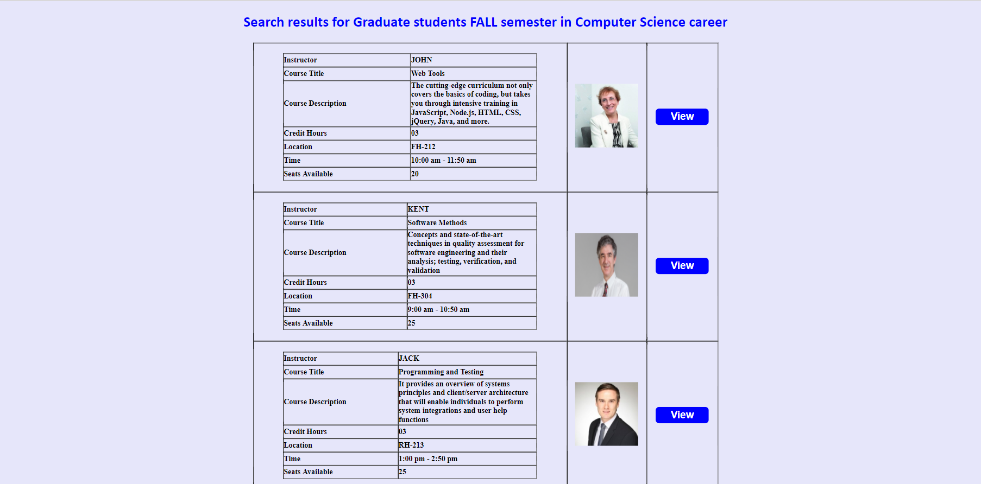

\* Another combination

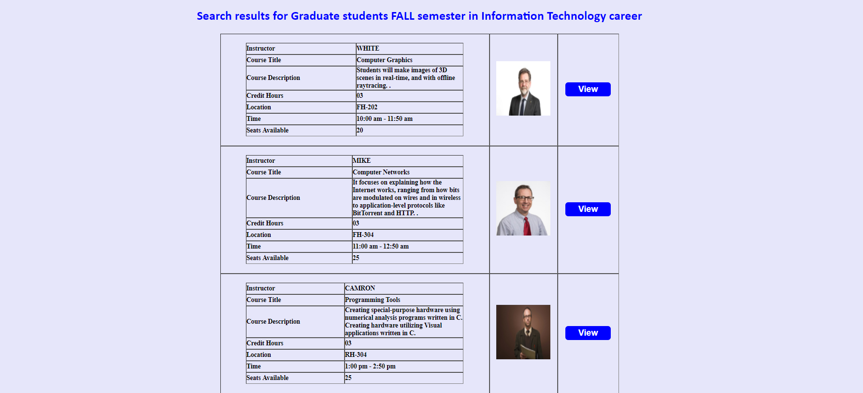

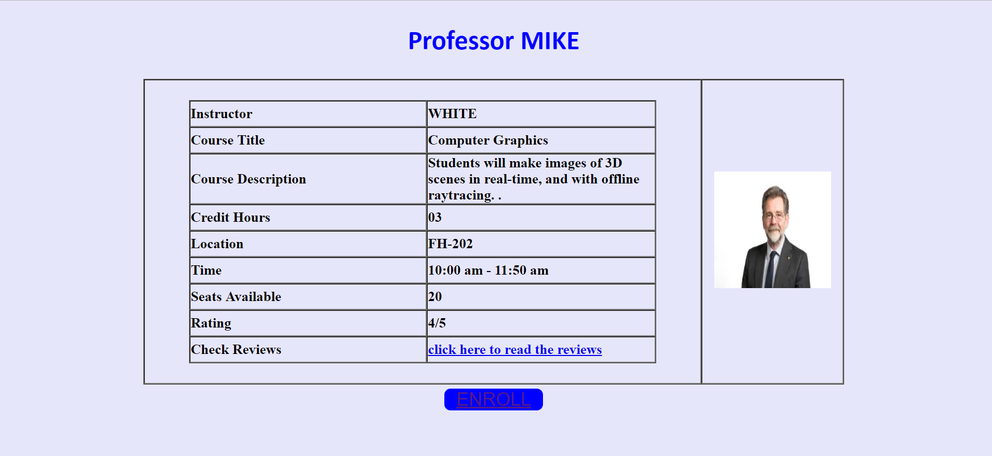

Updated version for career options

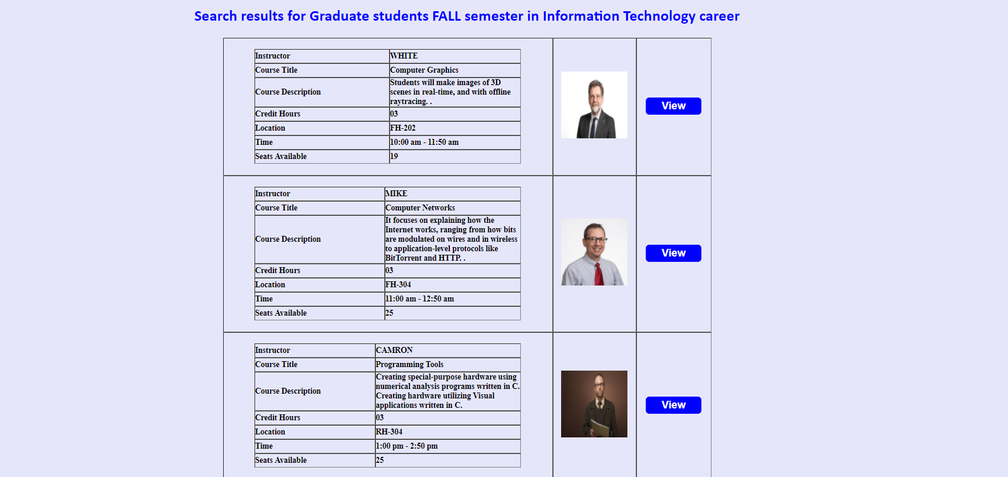



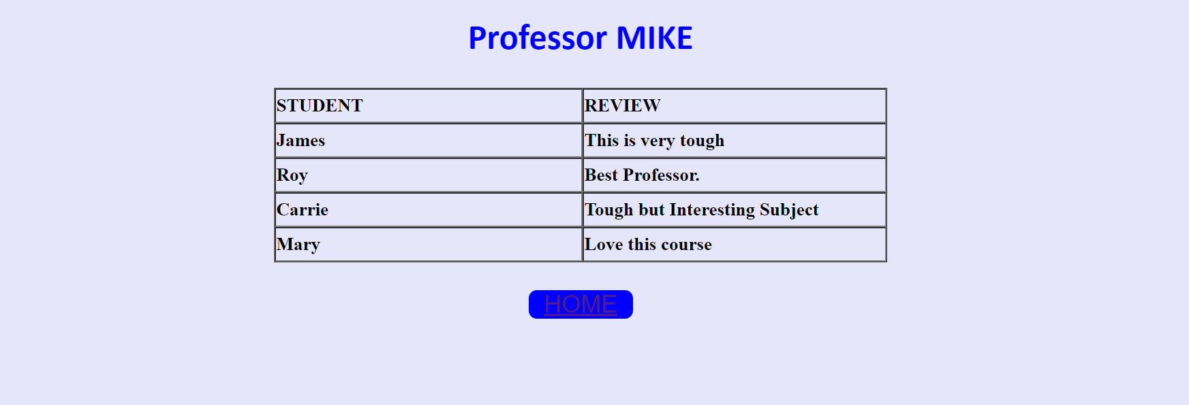

* Used Java script, HTML, CSS for designing web pages.