NAME-LAKSHMI PERLA(15)

NAME-BHARGAVI PODILE(16)

**HOME PAGE**

A screen shot of a video game

Description generated with high confidence

A picture containing electronics

Description generated with very high confidence

Here we can signup if we don’t have an already registered account or twitter account.

The below image shows the sign up process, we have registered with a gmail id.

Before and after filling the details

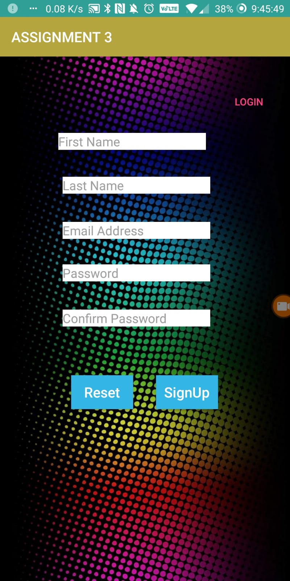

**Home PAGE**

Here after entering our id and password we will be redirected to our task page where we have two options for taking a picture and getting news.

A screenshot of a cell phone

Description generated with very high confidence

**MACHINE LEARNING WITH CAMERA**

**A screenshot of a cell phone

Description generated with very high confidenceA screenshot of a cell phone

Description generated with very high confidence**

**NEWS API**

**A screenshot of a cell phone

Description generated with very high confidence**

**A screenshot of a cell phone

Description generated with very high confidenceA screenshot of a cell phone

Description generated with very high confidence**

**Twitter login**

**A screenshot of a cell phone

Description generated with very high confidence**