$lookup
$lookup allows you to perform joins on collections in the same database.
$lookup works by returning documents from a "joined" collection as a sub-array of the original collection.

populate()
Population is the process of automatically replacing the specified paths in the document with document(s) from other collection(s). We may populate a single document, multiple documents, a plain object, multiple plain objects, or all objects returned from a query.

Aggreagate()
https://www.geeksforgeeks.org/aggregation-in-mongodb/
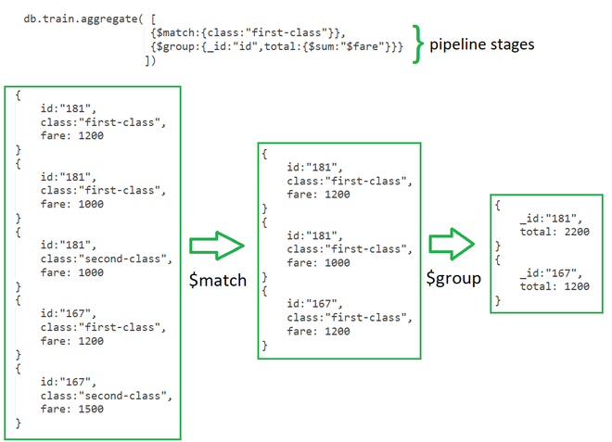
an aggregation framework query is an array of stages. A stage is an object description of how MongoDB should transform any document coming into the stage. The first stage feeds documents into the second stage, and so on, so you can compose transformations using stages. The array of stages you pass to the aggregate() function is called an aggregation pipeline.

MongoDB provides three ways to perform aggregation
- Aggregation pipeline
- Map-reduce function
- Single-purpose aggregation

Using query operations, such as the find() method, you can perform the following actions:

Select which documents to return.
Select which fields to return.
Sort the results.

Using aggregation operations, you can perform the following actions:

Perform all query operations.
Rename fields.
Calculate fields.
Summarize data.
Group values.

Stages:Each stage starts from stage operators which are:
- $match:It is used for filtering the documents can reduce the amount of documents that are given as input to the next stage.
- $project:It is used to select some specific fields from a collection.
- $group:It is used to group documents based on some value.
- $sort:It is used to sort the document that is rearranging them
- $skip:It is used to skip n number of documents an d passes the remaining documents
- $limit:It is used to pass first n number of documents thus limiting them.
- $unwind:It is used to unwind documents that are using arrays i.e. it deconstructs an array field in the documents to return documents for each element.
- $out:It is used to write resulting documents to a new collection

Expressions:It refers to the name of the field in input documents for e.g. { $group : { _id : “$id“, total:{$sum:”$fare“}}} here $id and $fare are expressions.
Accumulators:These are basically used in the group stage
- sum:It sums numeric values for the documents in each group
- count:It counts total numbers of documents
- avg:It calculates the average of all given values from all documents
- min:It gets the minimum value from all the documents
- max:It gets the maximum value from all the documents
- first:It gets the first document from the grouping
- last:It gets the last document from the grouping

$lookup | populate()
- can only be used with aggregate  - can only be used to pull in referenced documents from unsharded collections  - can pull in referenced documents by any field  - generally more performant as it's a server-side operation  - requires MongoDB 3.2+ | - can be used with find and aggregate  - can be used to to pull in referenced documents from both sharded and unsharded collections  - can only pull in referenced documents by _id  - no MongoDB version requirement

