LinkedIn jobs web scraper API using Python, Beautiful Soup and Flask with SQLite database
Summary:
This report presents the details about the project “LinkedIn jobs web scraper API” with proper description from defining the use case to implementation includes business logic development to scrape the data, Feature extraction, Data transformations, SQLite database to dump the transformed data, building pipeline to call all the main methods from these classes to utilize in API endpoints. Finally, API endpoints internally call pipeline methods or interaction with database directly to post and fetch the data.
- Use case: Scrape particular role/company type jobs in a country or any preferred location from LinkedIn portal.
- API Features Covered:
- Extract LinkedIn jobs by keywords (role/company/any job type) and location
- Store jobs in SQLite database
- Filter and search jobs by multiple criteria (Company name, Employment type, Salary range (min/max), Programming languages and Technologies)
- Automatic feature extraction from job descriptions
- Data cleaning and normalization
3. API Endpoints:
-Health & Status: GET http://localhost:5000/health - API health check
-Job Extraction
- GET http://localhost:5000/jobs/extract?keywords=Python&location=Ireland&refresh_data=true
- Extracts fresh jobs from LinkedIn
- refresh_data=true - Replace all data
- refresh_data=false - Append new data (default)
-Job Retrieval
- GET http://localhost:5000/jobs - Get all jobs
- GET http://localhost:5000/jobs?company=Google - Filter by company
- GET http://localhost:5000/jobs?employment_type=Full-time - Filter by employment type
- GET http://localhost:5000/jobs?salary_min=100000&salary_max=200000 - Filter by salary
- GET http://localhost:5000/jobs?programming_language=Python - Filter by language
- GET http://localhost:5000/jobs?technology=Docker - Filter by technology
- GET http://localhost:5000/jobs/1 - Get specific job by ID

4. Technical Considerations:
- Python: Core programming language
- BeautifulSoup4: HTML parsing and data extraction from static content
- Requests: HTTP Client library for sending web requests
- Pandas: Data Manipulation and analysis
- Flask framework: python-based framework for building API end points
- re: Regex expressions
- asyncio and aiohttp: Libraries for async processing of requests
- urllib parse: Encoding library for query parameters
- SQlite3: Database to store the data
5. Implementation Details:
5.1. Code structure:
- Initialization module: Import necessary libraries
- LinkedinJobScraper class to hold business logic to make HTTP requests to scrap the data(Jobs and details) and return in structured format.
- FeatureExtraction class to extract new features based on the scraped data. For instance programming languages, technologies, salary ranges(max and min) and key skills for filtering purpose.
- DataTransformer class to clean and transform the uneven data into consistent across all columns by removing duplicates, whitespaces, normalize lists and extract salary max and min from range.
- DatabaseManager class to store or dump the structured and transformed data into sqlite database.
- LinkedinJobsPipeline to streamline the execution flow of jobs extraction by calling methods from above mentioned class.
- Flask API endpoints including Jobs extraction, Job by Id, Jobs by various criteria.
5.2. Execution Flow:
- Execution starts when an API endpoint hit or invoked.
- API endpoint either interacts with database directly or call main method from LinkedinJobs Pipeline to extract jobs.
- The main method in pipeline continues the execution by passing keywords and location to LinkedinJobsScraper class to retrieve the data.
- Then pass those retrieved data into FeatureExtraction class to extract additional features.
- Once feature extraction completes, then the data passes to DataTransformer to clean and transform the data into structured format so that the uniform data can be dumped into database.
- After data transformation, data dumps into database by creating table if required and dumping the data without deleting existing data if the query parameter has refresh_data as false otherwise the new data will be inserted by deleting existing data.
- Finally the inserted data is retrieved from the data base and returned in Json format.
6. Results and Output:
The data extracted successfully through API endpoints and the sample API response format for list of jobs below.
{
"message": "Successfully extracted 25 jobs",
"jobs_count": 25,
"jobs": [
{
"id": 1,
"title": "Senior Software Engineer",
"company": "Google",
"location": "San Francisco, CA",
"employment_type": "Full-time",
"seniority_level": "Senior",
"salary": "180k-220k USD",
"salary_min": 180000,
"salary_max": 220000,
"job_description": "We are looking for...",
"job_function": "Engineering",
"industries": "Information Technology",
"programming_languages": "Python, Go, Java",
"technologies": "Kubernetes, Docker, AWS",
"key_skills": "Leadership, System Design",
"posted_date": "2025-12-03T10:30:00",
"job_link": "https://linkedin.com/jobs/..."
}
]
}

Sample pipeline data format
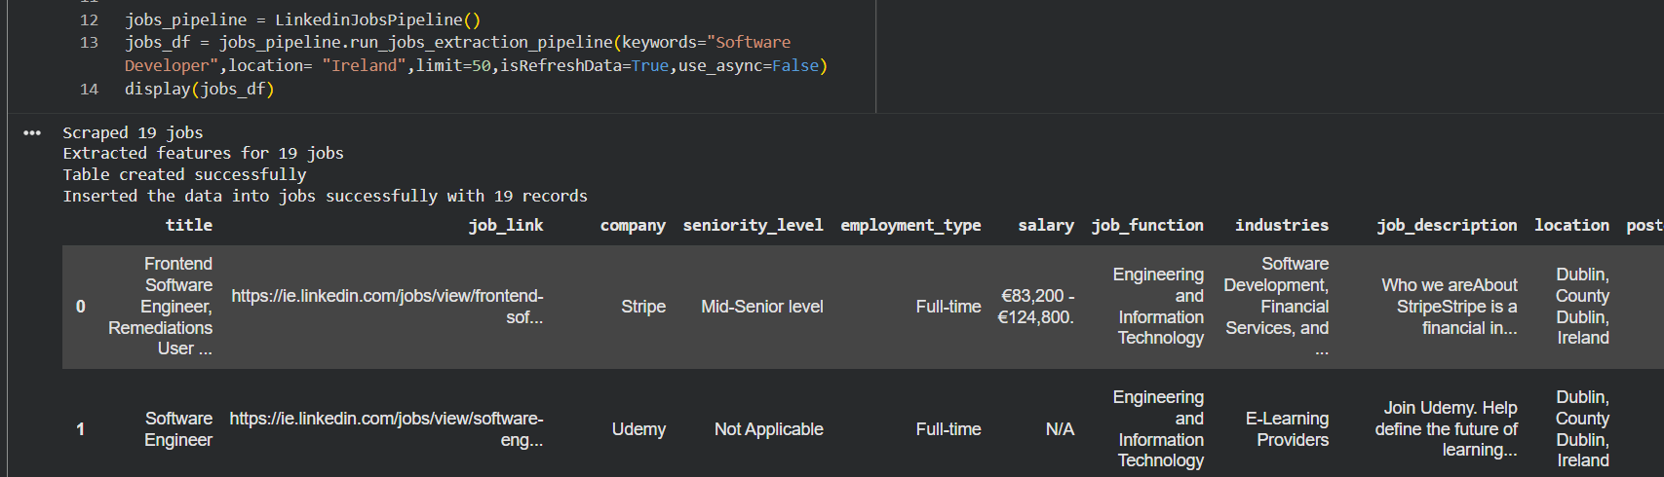
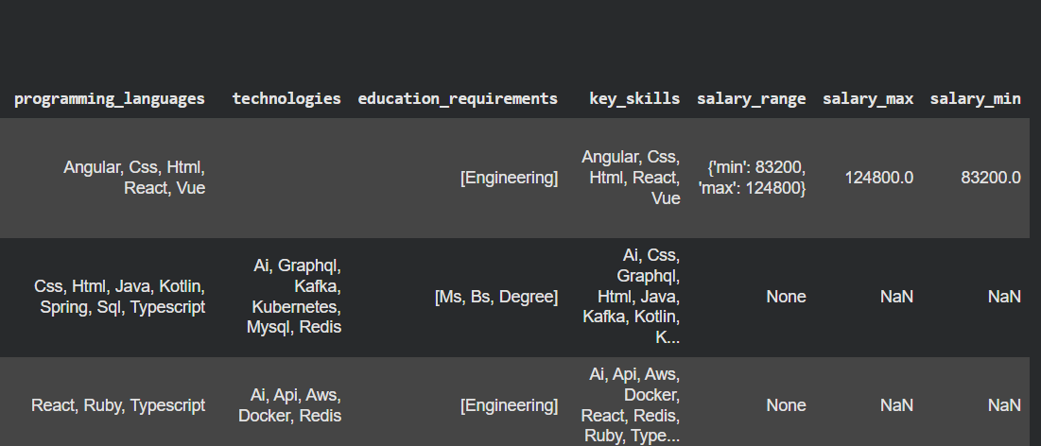
7. Challenges and solutions:
There are several key challenges preventing this solution to scalable for real world use.
- LinkedIn does not allow to make requests after certain number of requests within a limited time. For instance, in this solution, it is not allowing to extract job details after particular number of records: Including headless mechanisms like Selenium/Playwright frameworks to replicate user interactions, Rate limiting and Anti bot detection by adding reasonable delays between the requests to make it realistic.
- HTML structure challenges: Adding fallback methods if structure changes
- Session management: session persistence across multiple requests
- Asynchronous processing for performance optimization: caching and batch processing is not implemented in this solution but it is preferrable to include as the application grows.
8. Future Enhancements:
- Real time scheduling with periodic data updates
- Include few more portals like Irish jobs and Indeed
- Replace normal request processing with headless browsers to make it realistic and receiving the proper real time data without blockage from sources.
- ML Integration for jobs classification
- Host API endpoints for real time usage
9. Conclusion:
This solution successfully demonstrates effective data collection from LinkedIn through web scraping and also modular architecture followed to extensible feature development, easier maintenance and future enhancements.
10. References:
- Challenges and Solutions reference(https://scrapfly.io/blog/posts/how-to-scrape-linkedin)

