

UCI Household Power Consumption:Comprehensive ML Regression Analysis

Student Name: Bhargava Koya
Student ID: 20075511
Module: MACHINE LEARNING AND PATTERN RECOGNITION(B9AI102)
Programme: MSc Artificial Intelligence

Contents:
- Summary
- Problem Statement & Motivation
- Dataset Selection
- Data Preparation Pipeline
- Machine Learning Models Training
- Hyperparameter Tuning Strategy
- Overfitting Avoidance Mechanisms
- Model Evaluation & Comparison
- Prediction on New Data
- Conclusions & Recommendations
- References

Summary:
This report presents a comprehensive machine learning analysis for predicting household energy consumption using regression techniques. The project implements more than 19 regression algorithms.

Key Findings & Achievements:
- Dataset: 50,000 observations (2.4% sample from 2,075,259 total)
- Features: New engineered features from 9 raw variables
- Models: 19 regression algorithms trained and evaluated
- Best Model: Gradient Boosting (R² = 0.9992, RMSE = 0.0348 kW)
- SVR Comparison: 4 kernel functions evaluated (Linear, RBF, Poly, Sigmoid)
- Optimization: Data-driven n_estimators selection via learning curves
- Overfitting Prevention: Cross-validation, regularization and sampling strategies

Problem Statement & Motivation
Household energy consumption prediction is critical for
- Smart grid management(Real time load balancing and demand forecasting)
- Sustainability(Reducing energy waste)
- Cost optimization
- Infrastructure planning.

The main research question addressed in this project is:
“Can machine learning models accurately predict household active power consumption using temporal patterns and electrical measurements?”

The Solution involves:
- Implement and compare Linear regression and SVR regression with different kernels
- Exploring ensemble methods and advanced regression algorithms

Target Variable:
- Global Active Power (kW): Household energy consumption, minute-level granularity.

Dataset Selection
The dataset is sourced from the GitHub repository (https://github.com/snehapadgaonkar/Household-energy-consumption-prediction/) with file name “household_power_consumption.csv”
- Total instances of 2,075,259 observations
- 9 Raw features
- Sampling (50000 observations).

Raw features:
Feature | Description | Unit
Date | Measurement date | DD/MM/YYYY
Time | Measurement time | HH:MM:SS
Global_active_power | Total active power consumption | Kilowatt (kW)
Global_reactive_power | Total reactive power | KVArh
Voltage | Voltage of supply | Volt
Global_intensity | Current flowing through meter | Ampere
Sub_metering_1 | Kitchen energy consumption | Wh
Sub_metering_2 | Laundry energy consumption | Wh
Sub_metering_3 | Climate control energy consumption | Wh

Sample distribution of numerical columns in the dataset
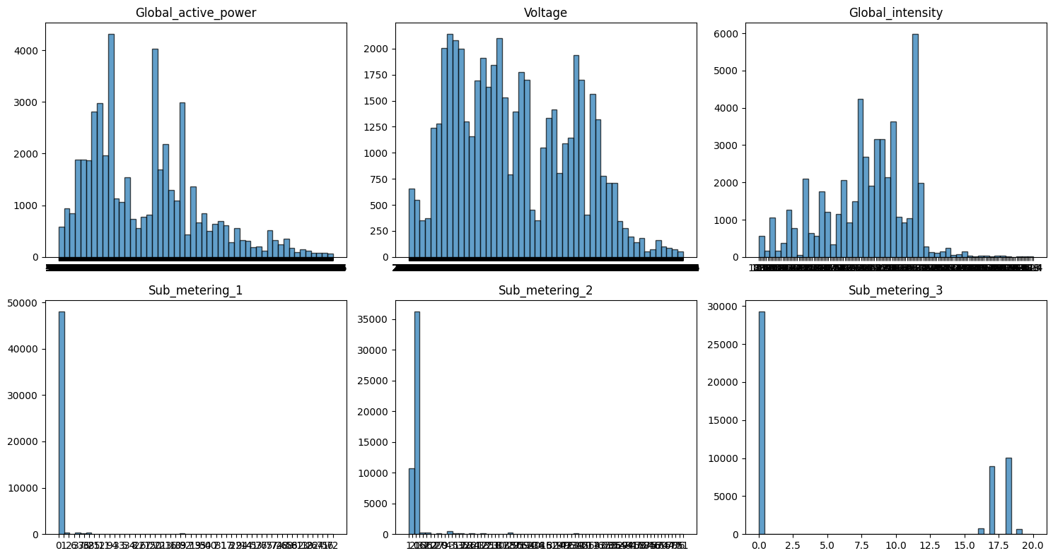

Data Preparation Pipeline
The data preparation pipeline consists of several sequential steps that are crucial for training ML Models.
- Missing Value Handling: Forward fill missing values with previous valid observation
- Outlier detection and removal: The outlier values are detected and removed using Interquartile Range (IQR) method
Q1 = 25th percentile
Q3 = 75th percentile
IQR = Q3 - Q1
Lower bound = Q1 - 1.5 × IQR
Upper bound = Q3 + 1.5 × IQR
Remove observations where value < Lower or > Upper
- Feature Engineering: The dataset, initially contains 26 features and few more new features created from existing variables.
Out of 26 existing features => 9 raw features and 17 other features

New features include:
- Temporal features(hour, day of week, month, day of year, is weekend)
- Cyclic encoding of hours(hour_sin, hour_cos)
- Power lag features(power_lag_1,power_lag_6,power_lag_24)
- Rollingstatistics(power_roll_mean_6,power_roll_std_6, power_roll_mean_24,power_roll_mean_24) defines moving averages. Primary purpose is to capture consumption trends
- Interaction features(voltage_intensity = Voltage * Global_intensity)
- Data scaling: Standard scalar applied to scale all features except tree-based models and normalized up to range of -3 to 3
- Train Test Split: The data split into 80% Train set and 20% Test set for Model training and evaluation.

Machine Learning Models Training
A total of 19 regression models are trained on the dataset and evaluated using various metrics. The details mentioned below.
A. Linear Models (4)
- Linear Regression - No regularization
- Ridge Regression (α=1.0) - L2 regularization
- Lasso Regression (α=0.1) - L1 regularization
- ElasticNet (α=0.1, l1_ratio=0.5) - Combined L1+L2
B. Support Vector Regression (5)
- SVR (Linear kernel) - Linear decision boundary
- SVR (RBF kernel) - Radial Basis Function, non-linear
- SVR (Polynomial kernel) - Degree=3 polynomial mapping
- SVR (Sigmoid kernel) - Neural network-like kernel
- SVR (Best kernel, Tuned) - Hyperparameter optimized best performer
C. Tree-Based Models (6)
- Decision Tree - max_depth=10
- Random Forest - n_estimators=50 (optimized)
- Gradient Boosting - n_estimators=50 (optimized)
- XGBoost - n_estimators=100 (optimized)
- LightGBM - n_estimators=100
- Tuned variants - RF, GB, XGB with optimized hyperparameters (3 models)
D. Distance-Based Model (1)
- K-Nearest Neighbors (k=5) - Instance-based learning
E. Neural Network (1)
- Multi-Layer Perceptron
F. Ensemble Method (1)
- Stacking Regressor - Base models: SVR, RF, XGB + Ridge meta-learner

Before training the models, two additional steps are performed to improve the learning efficiency and reduce overfitting.
Dimensionality Reduction using Principal Component Analysis (PCA) and K-Means Clustering
- PCA removes the unnecessary data range or samples which are causing overfit or underfit and confines the data to fit into constrained axis.
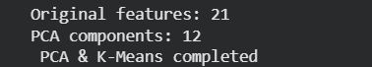
- Finding optimal n-estimators for few regression models before training by looping through range of 10 to 100
n_estimators_range = [10, 20, 30, 40, 50, 60, 70, 80, 90, 100]

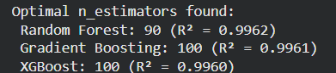
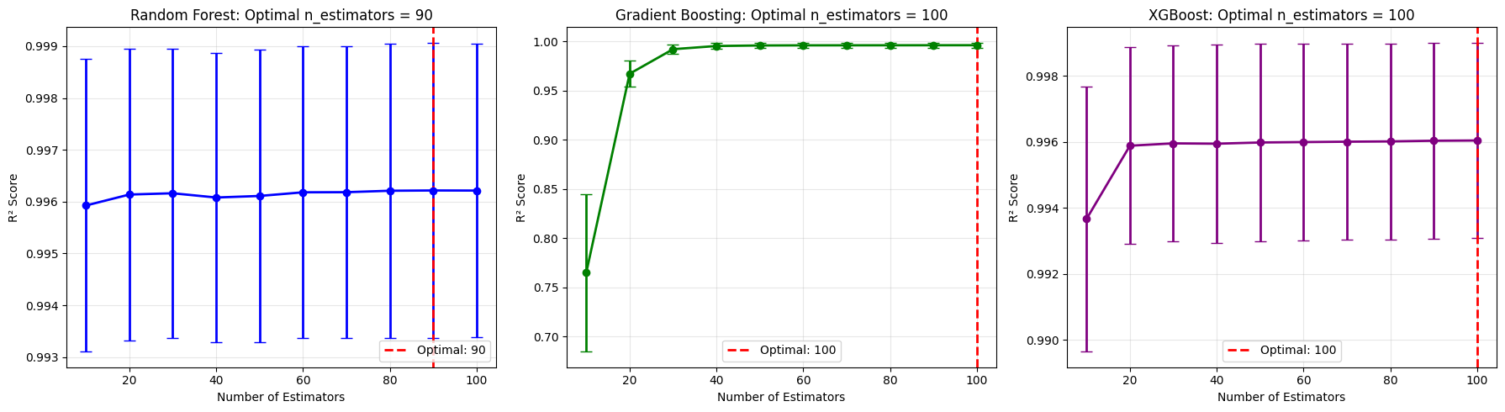

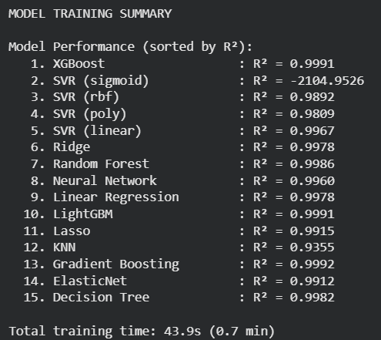

Stacking is then applied and it produces better results than single models alone.
- The base models like SVR, Random Forest, XGBoost, Ridge included as estimators in config
- The selected Final estimator is Ridge with Alpha = 1.0
- Applied 2 fold cross validation
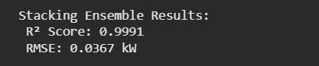

Hyperparameter Tuning Strategy
In this tuning process, I have used RandomizedSearchCV which does random sampling of data instead of exhaustive search like GridSearchCV and often finds better paramters.

During this process, primarily three models considered for tuning. Which are
- SVR Hyper parameter tuning: Tuning configurations for this model are
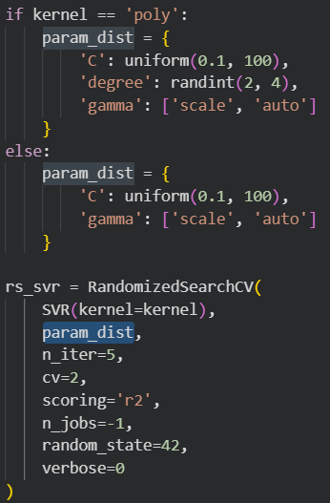
C- Regularization parameter
Gamma – kernel coefficient
Degree – Polynomial degree for ploy kernel type
n_iter – 5 random combinations
cv – 2 fold cross validation
scoring – r2 metric
n_jobs – parallel processing
- Random Forest and XGBoost Fine tuning: n_estimator is taken from the previous optimization step.
-For Random Forest, the max depth between 10 to 16 and split threshold ranges between 5 to 10
-For XGBoost, the max depth lies between 4 to 7, data sample rate between 0.7 to 0.2

After tuning, there is some improvement in these models as summarized in the corresponding result table
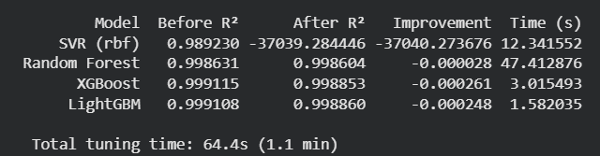

Overfitting Avoidance Mechanisms
Overfitting occurs due to Model learns noise instead of underlaying patterns. Thus, results in High train accuracy and low-test accuracy. Reducing the variance is optimal solution for this problem.

In this project implementation, I applied various techniques to reduce the variance
- Applied cross fold validation during Hyper parameter tuning
- Regularization using Alpha parameter in Ridge and Lasso regression models
- Early stopping in Neural network MLP Regressor avoid overfitting
- Train expensive models on smaller samples

Here are the results from overfitting analysis during evaluation
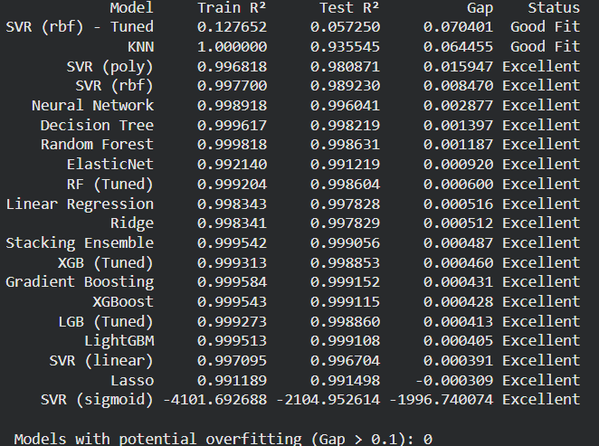

Model Evaluation & Comparison
During evaluation, metrics like R², RMSE, MAE and MAPE% are calculated for each trained model and the results mentioned below.
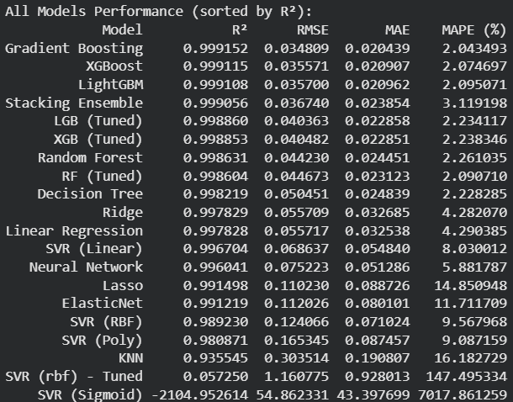

As per the problem statement, objective and feature distributions, R² is the suitable metric (variance in energy consumption) for evaluating the models. So, as per that metric Gradient Boosting performs better compared to other models with minimal difference in the gap.
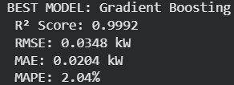

Along with the metrics calculation, Feature importance in the dataset also analysed through 3 trained models such as RandomForest, XGBoost and LightGBM.
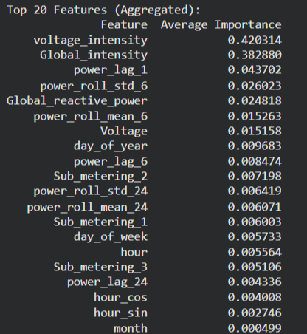
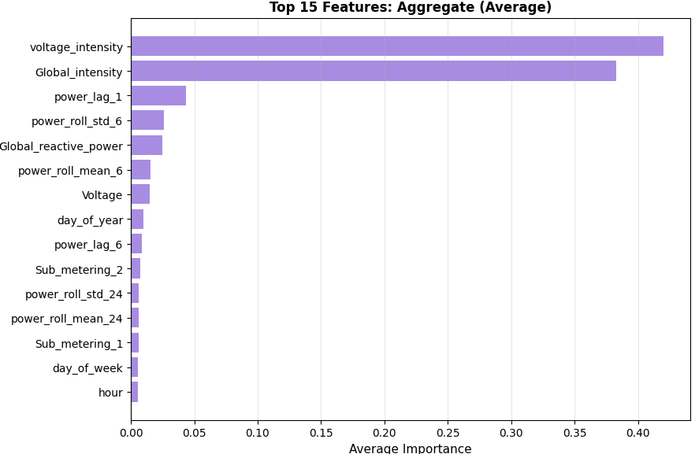

Because Gradient Boosting performed best on this dataset, predictions for few sets of samples and the predicted output is almost close to expected result. Here is the result below.
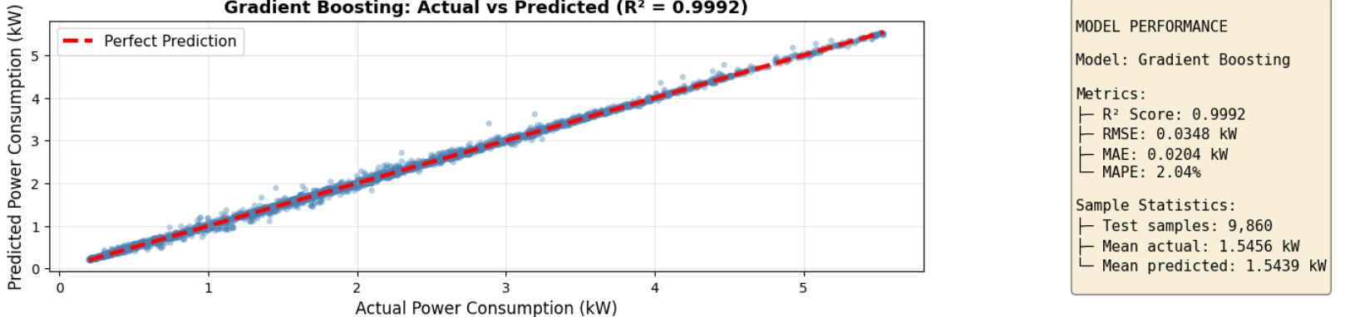
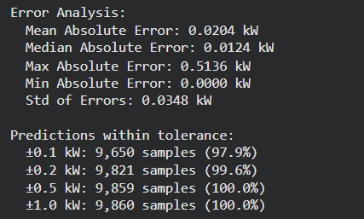

Prediction on New Data
Using the best model Gradient Boosting, predictions are generated on 5 random samples from test set and the results are close to the expected values with minute differences.
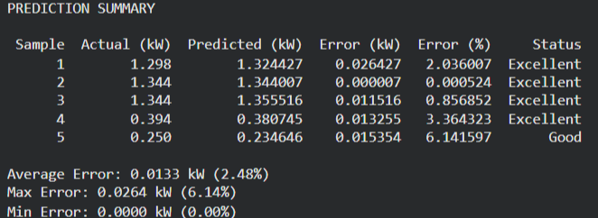
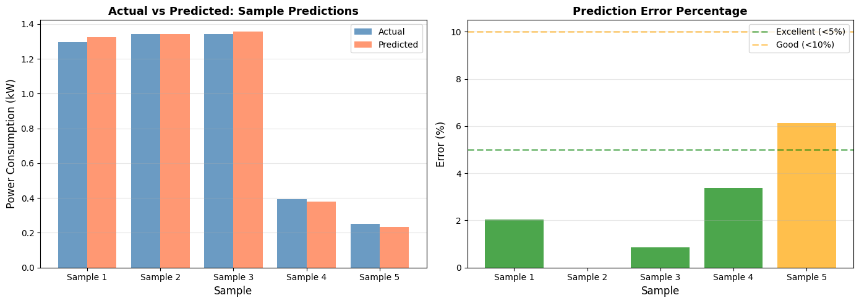

Conclusions & Recommendations
For CA02 I have chosen regression problem since classification problem was already covered in CA01.

Key Findings:
- Dataset Selection: UCI Household Power Consumption is highly suitable for regression analysis because it contains a huge number of samples and many features.
- Data Preparation: During data preparation, operations like handling missing values, Outlier removal, Feature engineering by extracting new features from existing ones and Standscaler applied for scaling the values for linear based models.
- Linear Regression and SVR Implementation: Linear regression produced results with better generalization and SVR with RBF kernel type have better performance compare to remaining kernels consistently.
- HyperParameter Optimization: Before Model training and hyperparameter tuning, n_estimator optimization performed via learning curves.
- Overfitting Prevention: Cross validation validates model stability, Early stopping prevents neural network overfitting, Sampling strategies reduces training test size

Challenges:
- Initially, models such as SVR and Random Forest took a long time to train when using the full dataset. To address this, the approach was changed to work with a 50,000‑row sample and for some models, an even smaller resampled subset.
- Usually when we try to do encoding, we use either ordinal or onehot encoders for categorical values. However, in this dataset the values like hour needs cyclic encoding to better reflect periodic behaviour.
- For models such as Random Forest and SVR, even 50,000 rows were computationally expensive, so additional resampling was applied to speed up training while preserving performance

Recommendation: Deploy Gradient Boosting for better accuracy. However, there is very minimal gap between few models in terms of R2 metric.

Future Work:
- Due to computational limits, the models were trained with 50K data only. It would be better if the models trained with whole dataset.
- Applying few more optimization techniques during Model training and Hyper parameter tuning to understanding whether those things can improve the model performance

References
- Scikit-learn Developers. (2024). Scikit-learn: Machine Learning in Python. Retrieved from https://scikit-learn.org
- Zhou, Z. H. (2012). Ensemble methods: Foundations and algorithms. CRC press.
- Chen, T., He, T., Bengio, Y., Koren, V., & Cortes, C. (2015). XGBoost: Scalable and flexible gradient boosting. from https://xgboost.readthedocs.io
- Course materials such as PPT’s, Collab notebooks and Exercises during class sessions from
- Moodle.
- Feature engineering references (https://github.com/snehapadgaonkar/Household-energy-consumption-prediction/blob/main/README.md)
Additionally, AI tools were used only to assist with plotting the graphs, as I have limited knowledge with that matplotlib library.

