Bhargav Limbani 92301733029

Take Home Test-3
Sr. No. | Section | Task Description | CO Mapped
1 | Database (MongoDB) with Backend | Design and implement Mongoose schemas in infrastructure layer for Book (title, author, ISBN, totalCopies, availableCopies), User (name, email, password, role, studentId), and Transaction (bookId ref, userId ref, issueDate, dueDate, returnDate, status, fine) supporting NoSQL flexible documents and relationships. | 1
2 | Database (MongoDB) with Backend | Establish MongoDB connection via Mongoose in infrastructure/config, integrate with clean architecture (injectable), handle connection errors/success with Winston logging, and use .env for DB URI and options. | 1, 2
3 | Database (MongoDB) with Backend | Implement Repository pattern: create domain repository interfaces (BookRepository, UserRepository, TransactionRepository), then concrete MongoDB implementations with full CRUD NoSQL operations (find, create, update, delete, aggregate) following clean architecture dependency inversion. | 1, 2
4 | Database (MongoDB) with Backend | Enhance repositories with transaction-specific NoSQL queries: checkBookAvailability, updateBookStockOnIssue/Return, findOverdueTransactions (using MongoDB $gt for dueDate + aggregation), and support for renew logic. | 1
5 | Database (MongoDB) with Backend | Add database optimizations and integrity: schema-level validations, unique indexes (email, ISBN), compound indexes for frequent queries (userId + status), and timestamps for audit trails. | 1
6 | Database (MongoDB) with Backend | Integrate MongoDB repositories into existing backend use-cases (replace any mocks): update application layer dependency injection, ensure all DB operations are wrapped with Winston logging for traceability and error tracking.

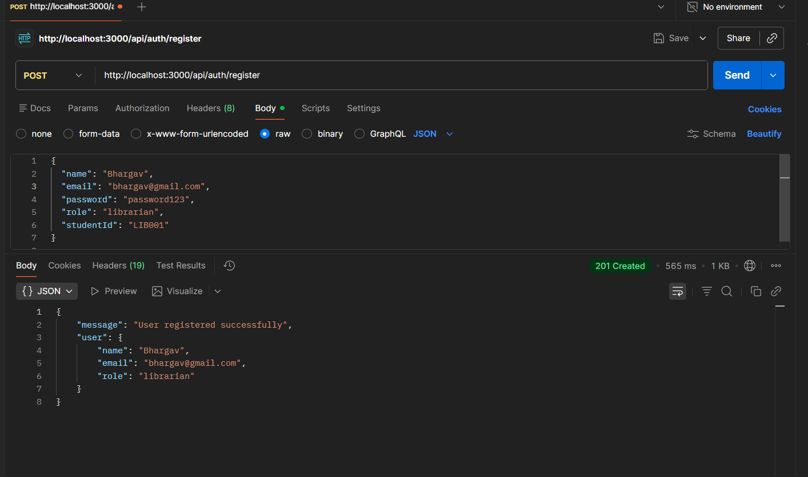
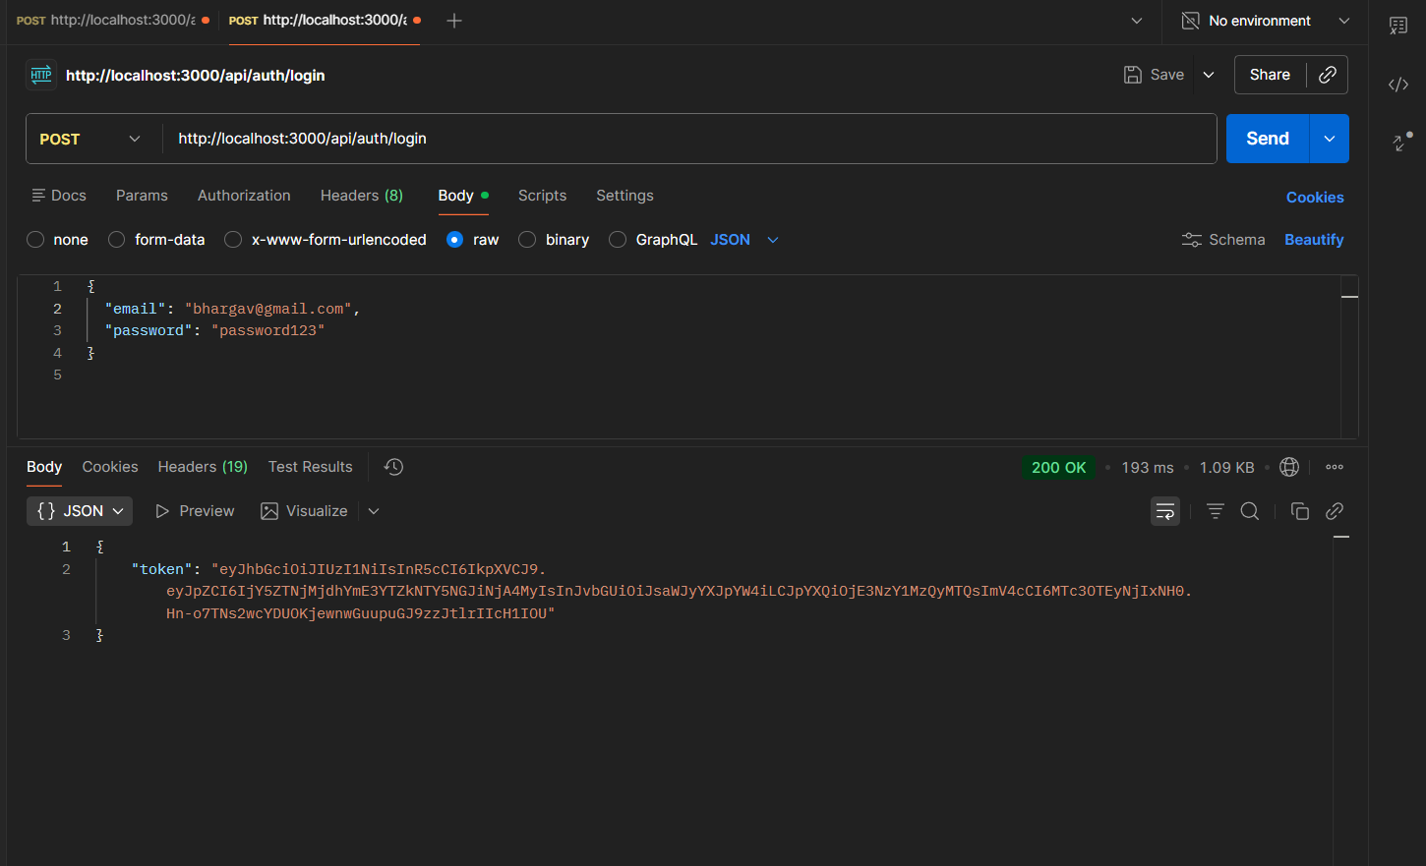

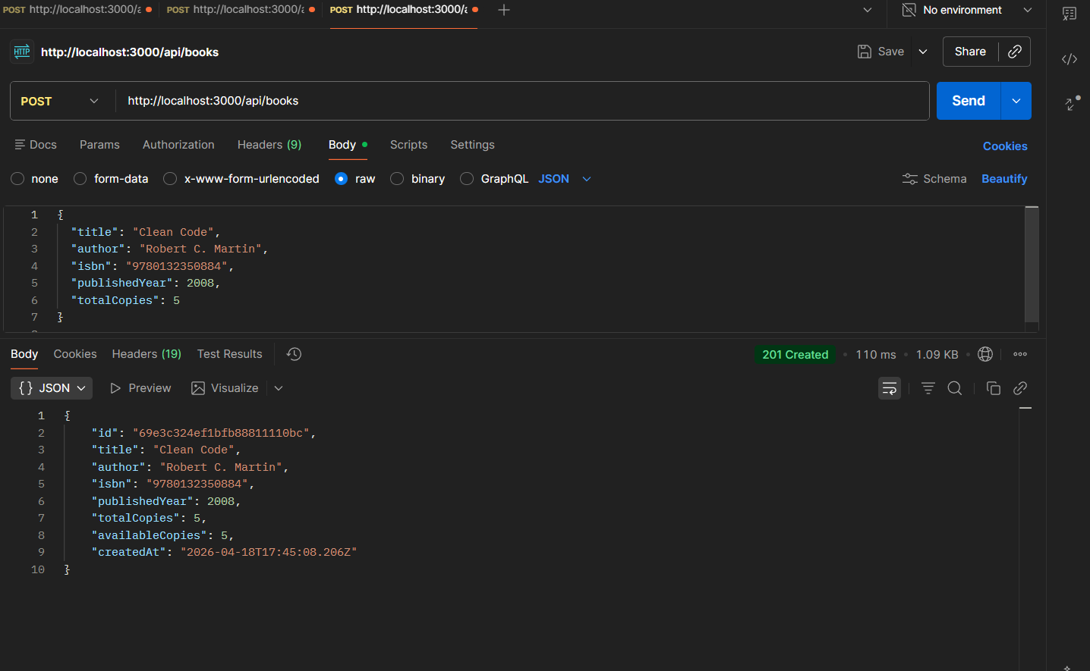

Log file
{"level":"info","message":"MongoDB Connected: 127.0.0.1","service":"library-management-api","timestamp":"2026-04-18 23:05:50"}
{"level":"info","message":"Server is running on port 3000","service":"library-management-api","timestamp":"2026-04-18 23:05:50"}
{"level":"info","message":"MongoDB Connected: 127.0.0.1","service":"library-management-api","timestamp":"2026-04-18 23:12:15"}
{"level":"info","message":"Server is running on port 3000","service":"library-management-api","timestamp":"2026-04-18 23:12:15"}
{"level":"info","message":"POST /api/auth/register","service":"library-management-api","timestamp":"2026-04-18 23:12:17"}
{"level":"info","message":"New user registered: bhargav@gmail.com (Role: librarian)","service":"library-management-api","timestamp":"2026-04-18 23:12:18"}
{"level":"info","message":"POST /api/auth/login","service":"library-management-api","timestamp":"2026-04-18 23:13:34"}
{"level":"info","message":"User logged in: bhargav@gmail.com","service":"library-management-api","timestamp":"2026-04-18 23:13:34"}
{"level":"info","message":"MongoDB Connected: 127.0.0.1","service":"library-management-api","timestamp":"2026-04-18 23:13:57"}
{"level":"info","message":"Server is running on port 3000","service":"library-management-api","timestamp":"2026-04-18 23:13:57"}
{"level":"info","message":"POST /api/books","service":"library-management-api","timestamp":"2026-04-18 23:14:31"}
{"level":"warn","message":"Unauthorized access attempt: No token provided","service":"library-management-api","timestamp":"2026-04-18 23:14:31"}
{"level":"info","message":"POST /api/books","service":"library-management-api","timestamp":"2026-04-18 23:15:08"}
{"level":"info","message":"Book created by Librarian bhargav@gmail.com: Clean Code","service":"library-management-api","timestamp":"2026-04-18 23:15:08"}
{"level":"info","message":"GET /api/books","service":"library-management-api","timestamp":"2026-04-18 23:15:39"}
{"level":"warn","message":"Unauthorized access attempt: No token provided","service":"library-management-api","timestamp":"2026-04-18 23:15:39"}

