
VARDHAMAN COLLEGE OF ENGINEERING
Autonomous Institute, Affiliated to JNTUH
Approved by AICTE, Accredited by NAAC with A++ Grade
Kacharam, Shamshabad, Hyderabad - 501218

DEPARTMENT OF COMPUTER SCIENCE AND ENGINEERING
SUMMER PROJECT REPORT
ON
LRU CACHE SIMULATOR
Submitted by
G . SIDDHARTHA 25881A05GV
M . SAI BHARGAV 25881A05GN
M . HARSHITH KUMAR 25881A05FG
E . ADITHYA 25881A05ER
K . YESHWANTH 25881A05HG

Under the Guidance of
Mr. GANESH DESHMUKH
Assistant Professor, Department of CSE
Academic Year 2025-26


VARDHAMAN COLLEGE OF ENGINEERING
DEPARTMENT OF COMPUTER SCIENCE AND ENGINEERING

CERTIFICATE

This is to certify that the Summer Project Report entitled 'LRU CACHE SIMULATOR' is a bonafide work carried out by the following students of I B.Tech II Semester CSE during the Academic Year 2025–26 under my guidance. The work presented in this report is original and has been completed in partial fulfillment of the Summer Project requirements.

Student Name, Roll Number | SIDDHARTHA, 25881A05GV
Student Name, Roll Number | SAI BHARGAV, 25881A05GN
Student Name, Roll Number | HARSHITH, 25881A05FG
Student Name, Roll Number | ADITHYA, 25881A05ER
Student Name, Roll Number | YESHWANTH, 25881A05HG
Project Title | LRU CACHE SIMULATOR
Faculty Mentor | GANESH DESHMUKH SIR
Academic Year | 2025-26

Faculty Mentor  Mr. D. Ganesh  Assistant Professor  Date: 27-06-26 | Project Coordinator  Mr. D. Ganesh  Assistant Professor  Date: 27-06-26 | Head of the Department  GAGANDEEP ARORA SIR  Head, Department of CSE  Date: 27-06-26


VARDHAMAN COLLEGE OF ENGINEERING
DEPARTMENT OF COMPUTER SCIENCE AND ENGINEERING

ACKNOWLEDGEMENT
We express our sincere gratitude to the Management of Vardhaman College of Engineering for providing an excellent academic environment, modern infrastructure, and the necessary facilities that enabled us to successfully carry out this Summer Project.
We extend our heartfelt thanks to our respected Principal for his constant encouragement and for creating an environment that promotes innovation, technical learning, and practical knowledge.
We are deeply indebted to the Head of the Department of Computer Science and Engineering for providing us with the opportunity to undertake this Summer Project and for extending continuous support, motivation, and valuable suggestions throughout the project duration.
We express our sincere appreciation to our GANESH SIR, whose expert guidance, constructive feedback, continuous encouragement, and technical insights were instrumental in the successful completion of this project. Their timely suggestions and regular reviews helped us improve our work at every stage of the project.
We also convey our gratitude to all the faculty members of the Department of Computer Science and Engineering for sharing their knowledge, providing technical assistance, and encouraging us to apply the concepts learned in the classroom to solve real-world problems.
We gratefully acknowledge the support provided by our parents and family members, whose constant encouragement, patience, and moral support motivated us to complete this project successfully. We also thank our friends and classmates for their valuable suggestions, discussions, and cooperation whenever required.

ABSTRACT
The LRU (Least Recently Used) Cache Simulator is a software project developed to demonstrate the working of the Least Recently Used cache replacement policy, a widely used technique in operating systems, computer architecture, and memory management. The simulator shows how a cache stores frequently accessed data and replaces the least recently used item when the cache reaches its maximum capacity. It provides a simple way to understand cache management, cache hits, cache misses, and data replacement.
The project is implemented using C++ and utilizes stack and vector data structures to simulate the LRU cache. The vector stores cache elements dynamically and supports searching, while the stack-based logic maintains the order of recently accessed items. Whenever an item is accessed, it becomes the most recently used, and when the cache is full, the least recently used item is removed before inserting a new one.
The simulator accepts cache requests from the user and checks whether the requested item is already present. If found, it is a cache hit, and the item is updated as the most recently used. If not found, it results in a cache miss, and the simulator inserts the new item or replaces the least recently used item when necessary. The updated cache contents are displayed after every operation for better understanding.
The main objective of this project is to provide an educational tool for learning the practical implementation of cache replacement algorithms. It helps users understand memory optimization, data access patterns, and the importance of efficient cache management while improving programming knowledge related to data structures, algorithms, and system simulation.
In conclusion, the LRU Cache Simulator successfully demonstrates the Least Recently Used replacement policy through a simple and user-friendly implementation. Although designed mainly for educational purposes, it can be enhanced by adding algorithms such as FIFO (First In, First Out) and LFU (Least Frequently Used), along with graphical visualization. The project serves as a useful learning resource for understanding cache management techniques and improving system performance.

Keywords: LRU Cache, Cache Replacement Policy, Memory Management, C++, Stack, Vector, Cache Hit, Cache Miss.
TABLE OF CONTENTS
Section | Page No.
Certificate | ii
Acknowledgement | Iii
Abstract | iv
List of Figures | vi
List of Tables | vii
Chapter 1: Introduction | 1
Chapter 2: Project Planning | 3
Chapter 3: System Design | 7
Chapter 4: Implementation | 13
Chapter 5: Testing and Results | 20
Chapter 6: Conclusion & Future Scope | 22
References | 24
Appendix | 25
Appendix A: Source Code | 25
Appendix B: Weekly Progress | 37

LIST OF FIGURES
Figure No. | Description | Page No.
Figure 3.1 | System Architecture Diagram | 8
Figure 3.2 | Main Flowchart | 9
Figure 4.1 | Main Menu Screenshot | 17
Figure 4.2 | Admin Panel Screenshot | 18
Figure 4.3 | Student Panel Screenshot | 18
Figure 5.1 | Sample Output - Add Book | 21
Figure 5.2 | Sample Output - Issue Book | 21

LIST OF TABLES
Table No. | Description | Page No.
Table 2.1 | Project Timeline | 5
Table 3.1 | Functional Requirements | 7
Table 3.2 | Data Structure Definitions | 10
Table 5.1 | Test Cases | 20
Table 5.2 | Performance Metrics | 22

CHAPTER 1: INTRODUCTION
1.1 Introduction
In today's computing environment, the demand for high-speed data access has increased significantly due to the rapid growth of software applications and digital technologies. Every computer system frequently accesses data from memory, but retrieving information from the main memory repeatedly can reduce system performance. To overcome this limitation, cache memory is used as a high-speed storage area that keeps recently or frequently accessed data. An efficient cache improves the execution speed of programs and reduces the overall memory access time.
Since the capacity of cache memory is limited, it cannot store all the requested data permanently. Therefore, whenever the cache becomes full, the system must decide which existing data should be removed to make space for new data. This decision is made using a cache replacement policy. Several replacement algorithms have been developed, including Least Recently Used (LRU), First In, First Out (FIFO), and Least Frequently Used (LFU). Among these, the LRU algorithm is widely preferred because it removes the data that has remained unused for the longest time, thereby increasing the probability of retaining useful data in the cache.
The LRU Cache Simulator has been developed to demonstrate the practical implementation of the Least Recently Used replacement policy. Instead of studying the algorithm only through theory, this simulator enables users to observe how cache contents change after every memory request. The project clearly illustrates the concepts of cache hit, cache miss, data insertion, data replacement, and the movement of recently accessed items within the cache. This practical approach makes the algorithm easier to understand and analyse.
The simulator is developed using the C++ programming language by utilizing stack and vector data structures. The vector is used to store cache elements, while the stack-based logic helps maintain the order of recently accessed items. The project focuses on simplicity, correctness, and ease of understanding rather than achieving maximum computational efficiency. It serves as an effective educational model for learning cache management concepts.
This report presents the complete development of the LRU Cache Simulator, including its objectives, system design, implementation methodology, testing, results, advantages, limitations, and future enhancements. The project not only demonstrates the practical application of data structures and algorithms but also provides valuable knowledge about memory management techniques used in modern computer systems. It serves as a useful learning tool for students studying Operating Systems, Computer Organization, and Data Structures.
1.2 Problem Statement
Modern computer systems require fast and efficient memory access to improve performance. Since cache memory has limited capacity, an efficient cache replacement policy is needed to manage stored data. However, several challenges exist in implementing and understanding cache management. The key problems identified are:
- Limited Cache Capacity: Cache memory cannot store all requested data, requiring an effective replacement policy when it becomes full.
- Inefficient Data Replacement: Without a proper cache replacement algorithm, useful data may be removed, increasing cache misses and reducing system performance.
- Difficulty in Understanding Cache Behaviour: Concepts such as cache hits, cache misses, and LRU replacement are difficult to understand through theory alone.
- Lack of Practical Learning: Students need an interactive simulator to visualize how cache contents change after each memory request.
- Complex Cache Management: Managing recently accessed data requires proper use of data structures and algorithm implementation.
- Need for an Educational Tool: A simple simulator is required to demonstrate the working of the Least Recently Used (LRU) algorithm in an easy and practical manner.
To address these challenges, the proposed LRU Cache Simulator can:
- Simulate the LRU cache replacement algorithm effectively.
- Identify cache hits and cache misses for every request.
- Replace the least recently used item when the cache becomes full.
- Display updated cache contents after each operation.
- Implement the algorithm using stack and vector data structures.
- Help users understand cache management, memory optimization, and data structures through practical simulation.
1.3 Objectives
To design and develop an LRU (Least Recently Used) Cache Simulator that demonstrates efficient cache replacement using stack and vector data structures. It helps users understand the practical working of the LRU algorithm and cache management.
The specific objectives of the proposed system are:
1. To design and develop an efficient LRU (Least Recently Used) Cache Simulator for demonstrating cache replacement operations.
2.To implement the LRU cache replacement algorithm using stack and vector data structures.
3.To simulate cache operations such as cache hit, cache miss, data insertion, and data replacement accurately.
4.To display the updated cache contents after every memory request for better visualization and understanding.
5. To improve knowledge of cache management, memory optimization, and data structure implementation through practical simulation.
6. To provide a simple and interactive educational tool that helps students understand the working of cache replacement algorithms.
7. To establish a foundation for future enhancements by supporting additional cache replacement algorithms such as FIFO (First In, First Out) and LFU (Least Frequently Used).
1.4 Scope
The scope of the LRU Cache Simulator encompasses the following areas:
Included in Scope:
1. Simulation of the Least Recently Used (LRU) cache replacement algorithm.
2. Processing of cache requests and identification of cache hits and cache misses.
3. Automatic replacement of the least recently used cache item when the cache is full.
4. Display of the updated cache contents after each cache operation.
5. Implementation using C++ with stack and vector data structures.
6. Educational demonstration of cache management, memory optimization, and LRU algorithm concepts.
7. Analysis of cache behaviour based on user-provided input sequences.
Excluded from Scope:
1. Implementation of other cache replacement algorithms such as FIFO, LFU, or Random Replacement.
2. Integration with real operating systems, hardware caches, or processor memory.
3. Support for multi-level cache architectures (L1, L2, and L3 caches).
4. Graphical User Interface (GUI) or web-based visualization features.
5. Multi-user access, networking, or cloud-based cache management.
6. Performance benchmarking against real hardware cache systems.
7. Advanced features such as parallel processing, multithreading, or distributed caching.

1.5 Organization of Report
This report is organized to present the LRU Cache Simulator in a systematic and logical manner, covering the planning, design, implementation, and evaluation phases.
Chapter 1 (Introduction): Provides the background, problem statement, objectives, and scope of the project, establishing the context for the work undertaken.
Chapter 2 (Project Planning): Details the project proposal, timeline, and team roles and responsibilities, outlining the planning and management aspects of the project.
Chapter 3 (System Design): Presents the system architecture, functional and non-functional requirements, flowcharts, and data structures used in the implementation.
Chapter 4 (Implementation): Describes the software requirements, modules developed, and provides screenshots of the system. This chapter also includes the GitHub repository link and commit history.
Chapter 5 (Testing and Results): Discusses the testing methodology, test cases, sample outputs, results, challenges encountered, and learning outcomes.
Chapter 6 (Conclusion & Future Scope): Summarizes the project findings, contributions, limitations, and suggests directions for future enhancement.
References: Lists the sources of information used throughout the project.
Appendix: Contains supplementary material including source code and weekly progress reports.

CHAPTER 2: PROJECT PLANNING
2.1 Project Proposal
The LRU Cache Simulator project was proposed as a summer project to develop an automated solution to simulate, demonstrate, and visualize the working of the LRU algorithm in educational institutions. The proposal was approved with the following key deliverables:
- A fully functional console-based LRU Cach Simulation
- Source code with proper documentation and comments
- Project report detailing the development process
- User manual for system operation
This project focuses on demonstrating the working of the LRU cache replacement policy through an interactive cache simulation, enabling users to understand cache hits, cache misses, and data replacement.
2.2 Timeline
The project was executed over a period of 3 weeks (15 working days). The timeline with planned activities is shown in Table 2.1.
Table 2.1: Project Timeline
Week | Activity | Duration
Week 1 | Requirement Analysis and System Design | 3 days
Week 1 | Setting up development environment | 1 day
Week 1 | Implementation of core data structures | 1 day
Week 2 | Cache Implementation | 2 days
Week 2 | LRU Algorithm Development | 2 days
Week 3 | Functional Testing | 2 days
Week 3 | Error Detection and Bug Fixing | 1 day
Week 3 | Testing and debugging | 2 days
Week 3 | Documentation and report preparation | 2 days

Week 1: Analysis and Design
- Conducted requirement analysis
- Studied existing LRU Cache Simulation systems
- Designed system architecture
- Identified data structures and algorithms
Week 2: Implementation
- Implemented the LRU Cache Simulator using stack and vector data structures.
- Developed the Least Recently Used (LRU) replacement mechanism .
- Integrated the modules
Week 3: Testing and Documentation
- Conducted testing and debugging
- Prepared user documentation
- Finalized project report
2.3 Team Roles and Responsibilities
The project was undertaken as an individual project. The roles and responsibilities were as follows:
Role | Responsibility
Developer | Design, implement, and test the complete system
Analyst | Gather requirements and design the system
Documenter | Prepare project report and user documentation
Tester | Develop test cases and validate system functionality
Project Manager | Plan and monitor project progress

CHAPTER 3: SYSTEM DESIGN
3.1 Functional Requirements
The functional requirements of the LRU Cache Simulator are detailed in Table 3.1.
Table 3.1: Functional Requirements
Requirement ID | Functional Requirement | Description
FR-01 | Cache Initialization | The system shall allow the user to specify the cache size before simulation begins.
FR-02 | Input Memory Requests | The system shall accept memory/page requests from the user for processing.
FR-03 | Cache Search | The system shall check whether the requested item is already present in the cache.
FR-04 | Cache Hit Detection | The system shall identify and display a cache hit when the requested item exists in the cache.
FR-05 | Cache Miss Detection | The system shall identify and display a cache miss when the requested item is not found in the cache.
FR-06 | LRU Replacement | The system shall replace the least recently used item when the cache is full and a new item needs to be inserted.
FR-07 | Cache Update | The system shall update the cache after every request according to the LRU replacement policy.
FR-08 | Display Cache Contents | The system shall display the current cache contents after each operation.
FR-09 | User Interaction | The system shall provide a simple interface for entering inputs and viewing simulation results.
FR-10 | Simulation Completion | The system shall terminate the simulation after processing all user requests and display the final cache state.

3.2 Non-Functional Requirements
The non-functional requirements of the system are:
- Performance: The system should process cache requests efficiently with minimal execution time .
- Usability: The simulator should provide a simple and user-friendly interface for easy interaction.
- Reliability The system should produce accurate and consistent results for every cache operation.
- Data Integrity: The system should maintain the correctness and consistency of cache data throughout the simulation.
- Portability: The application should run on any platform that supports a C++ compiler.
- Maintainability: The source code should be modular and easy to understand, modify, and extend .
7. Security: The system should validate user inputs to ensure safe and error-free execution.
3.3 System Architecture
The system follows a modular architecture with three main layers: Presentation Layer, Processing Layer, and Data Structure Layer.
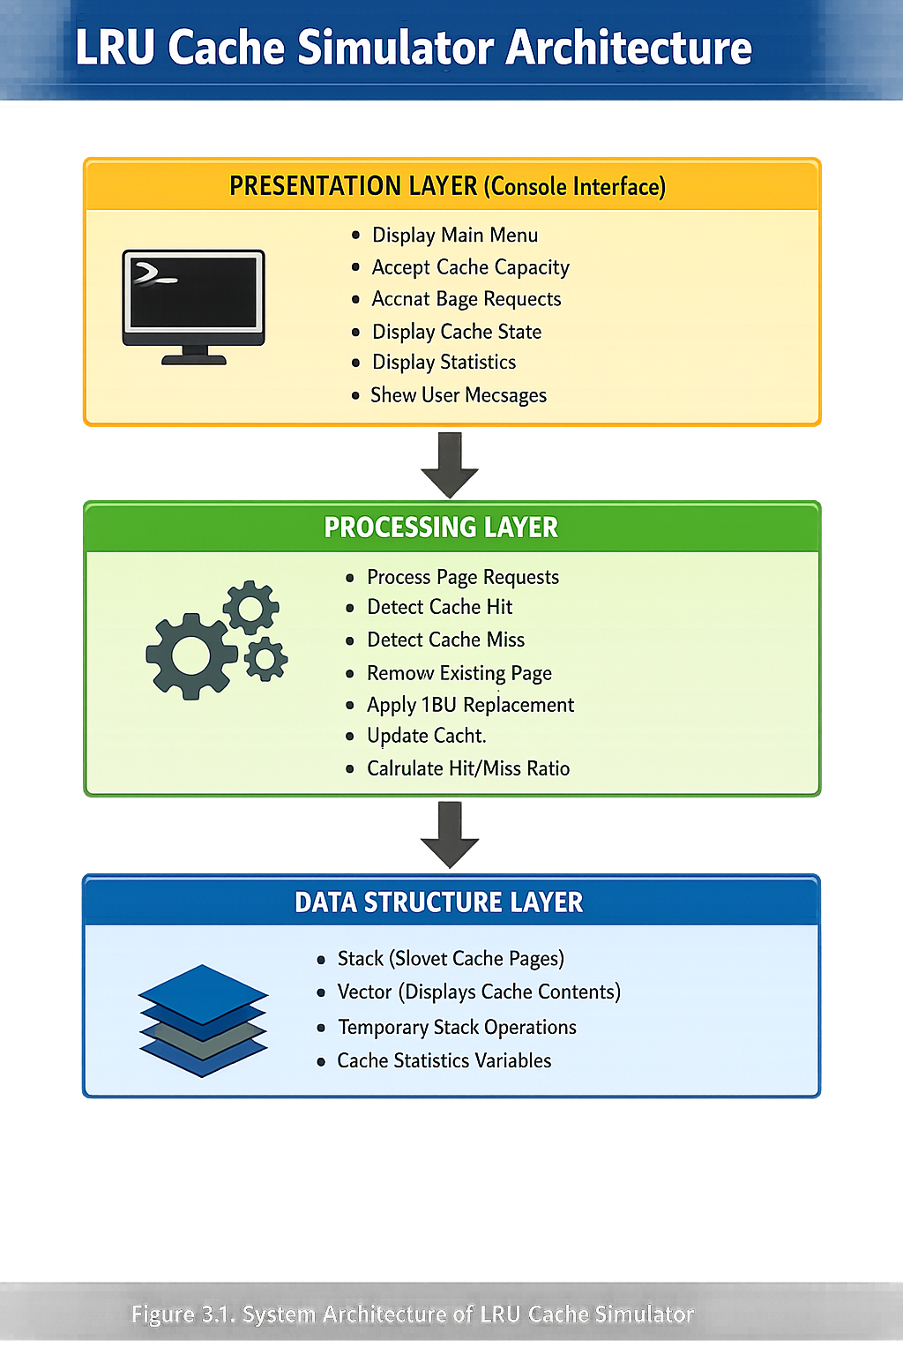
Figure 3.1: System Architecture Diagram

Layers Description:
Presentation Layer: The Presentation Layer provides a console-based user interface for interacting with the simulator. It accepts user inputs such as cache capacity, page requests, and menu selections. It also displays the cache state, cache statistics, and other messages to the user.
Processing Layer: The Processing Layer implements the core LRU cache replacement logic. It processes page requests, detects cache hits and cache misses, updates the cache, and performs LRU replacement whenever the cache is full. It also calculates and displays the cache performance statistics.
Data Structure Layer: The Data Structure Layer manages cache data using stack and vector data structures. The stack stores cache pages in Most Recently Used (MRU) to Least Recently Used (LRU) order, while the vector is used to display cache contents. It also maintains cache-related variables such as cache size, current size, hits, and misses.
3.4 Flowchart
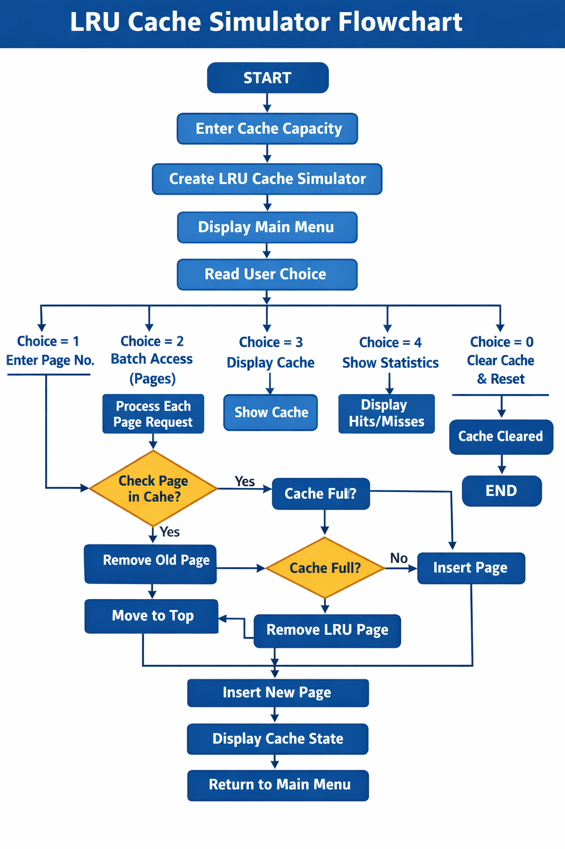
Figure 3.2: Main Flowchart
3.5 Data Structures
The system uses the following C++ Standard Template Library (STL) data structures and class variables for implementing the LRU Cache Simulator Table

Table 3.2: Data Structure Definitions
Data Structure / Variable | Type | Description
cache | stack<int> | Stores cache pages in Most Recently Used (MRU) to Least Recently Used (LRU) order.
pages | vector<int> | Temporarily stores cache pages for displaying the cache contents.
temp | stack<int> | Temporary stack used during page removal and LRU replacement operations.
Cache Size | int | Stores the maximum capacity of the cache.
Current Size | int | Stores the current number of pages present in the cache.
hits | int | Stores the total number of cache hits during the simulation.
misses | int | Stores the total number of cache misses during the simulation.
page | int | Represents the page number entered by the user for cache access.
choice | int | Stores the user's menu selection for different cache operations.
3.2: Data Structure Definitions
3.6 Algorithms
3.6.1 LRU Cache Access Algorithm
Algorithm Name: accessPage()
Input:
- page – Page number entered by the user.
- cacheSize – Maximum capacity of the cache.
Output:
- Displays Cache Hit or Cache Miss.
- Updates and displays the cache contents.
- Start.
- Read the page number from the user.
- Check whether the page is already present in the cache.
- If the page is present then
  - Display "Cache Hit".
  - Remove the page from its current position.
  - Insert the page at the top of the stack (MRU).
- Else
  - Display "Cache Miss".
- If the cache is full then
  - Remove the Least Recently Used (LRU) page.
- Insert the new page at the top of the stack.
- Display the updated cache contents.
- Stop.
3.6.2 Cache Search Algorithm
Algorithm Name: isPresent()
Input:
- page – Page number to be searched.
Output:
- Returns True if the page exists in the cache.
- Returns False otherwise.
- Start.
- Create a temporary copy of the cache stack.
- Traverse each page in the temporary stack.
- Compare the current page with the requested page.
- If both pages are equal then
  - Return True.
- Otherwise continue searching.
- Repeat Steps 3–6 until the stack becomes empty.
- Return False.
- Stop.
3.6.3 LRU Page Removal Algorithm
Algorithm Name: removeLRU()
Input:
- Current cache stack.
Output:
- Removes the Least Recently Used (LRU) page from the cache.
- Start.
- Create an empty temporary stack.
- Move all pages except the bottom page to the temporary stack.
- Identify the bottom page as the Least Recently Used (LRU) page.
- Remove the bottom page from the cache.
- Restore all remaining pages from the temporary stack to the original cache.
- Update the current cache size.
- Stop.
3.6.4 Cache Statistics Algorithm
Algorithm Name: showStatistics()
Input:
- Total Cache Hits and Cache Misses.
Output:
- Displays Cache Hits, Cache Misses, Hit Ratio, and Miss Ratio.
- Start.
- Read the total number of Cache Hits and Cache Misses.
- Calculate the total number of page requests.
- Compute the Hit Ratio.
- Compute the Miss Ratio.
- Display the cache statistics.
- Stop.

CHAPTER 4: IMPLEMENTATION
4.1 Software Requirements
The LRU Cache Simulator was developed using the following software components:
Development Tools:
- Programming Language: C++
- Compiler: GCC (MinGW on Windows or G++ on Linux/macOS)
- Development Environment: Visual Studio Code
- Version Control: Git and GitHub
Libraries:
- Standard Libraries: <iostream>, <stack>, <vector>, <iomanip>, <limits>, <string>, <sstream>
System Requirements:
- Operating System: Windows / Linux / macOS
- RAM: Minimum 512 MB
- Storage: Minimum 50 MB free space
- Compiler: Any C++ compiler supporting C++17 or later
Installation Steps:
1. Clone the repository:
git clone https://github.com/bhargavmittapalli2006-web/LRU-CACHE-SIMULATOR.git
2. Navigate to the project directory:
cd LRU-CACHE-SIMULATOR
3. Compile the project:
g++ -std=c++17 -o lru_cache main1.cpp
4. Run the program:
Linux/macOS: ./lru_cache
Windows: lru_cache.exe

4.2 Modules
The LRU Cache Simulator is organized into the following logical modules:
4.2.1 Main Module (main1.cpp)
The Main Module is the entry point of the application. It initializes the cache simulator, accepts the cache capacity from the user, displays the main menu, and directs the user to the appropriate operations.
Key Functions:
- main() – Program entry point.
- displayMenu() – Displays the main menu options.
- Controls the overall execution of the simulator.
4.2.2 Cache Management Module
This module implements the core functionality of the LRU Cache Simulator. It processes page requests, detects cache hits and cache misses, performs LRU replacement, and updates the cache accordingly.
Key Functions:
- accessPage() – Processes page requests.
- isPresent() – Checks whether a page exists in the cache.
- removePage() – Removes an existing page from the cache.
- removeLRU() – Removes the least recently used page.
- clearCache() – Clears all cache contents.
4.2.3 Display and Statistics Module
This module is responsible for displaying cache contents, simulation results, and cache performance statistics. It provides users with a clear view of cache operations and overall performance.
Key Functions:
- displayCache() – Displays the current cache contents.
- showStatistics() – Displays cache hits, cache misses, hit ratio, and miss ratio.
- printHeader() – Displays the application header.
- printDivider() – Prints formatted separators.
4.2.4 Batch Processing Module
This module allows users to process multiple page requests in a single execution. It reads a sequence of page numbers and simulates cache operations for each request.
Key Functions:
- runBatch() – Processes multiple page requests sequentially.
- Utilizes accessPage() for each page request.
4.2.5 LRUCache Class Module
This module contains the data structures and member variables required for cache management. It encapsulates all cache-related operations and maintains the current state of the simulator.
Key Components:
- stack<int> cache – Stores cache pages.
- vector<int> pages – Used for displaying cache contents.
- cacheSize – Maximum cache capacity.
- currentSize – Current number of cached pages.
- hits and misses – Maintain cache performance statistics.
- 4.2.6 Module Dependencies
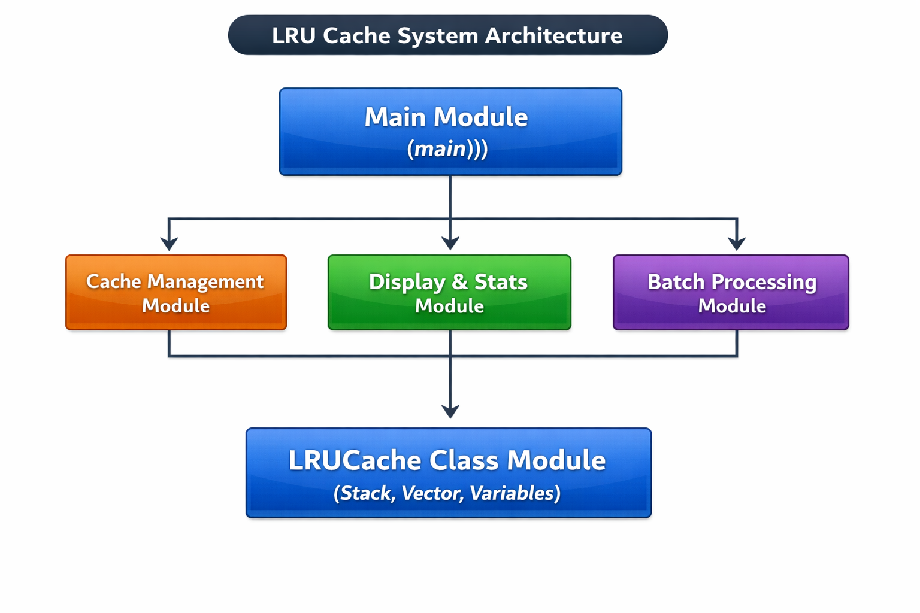

4.3 Screenshots
This section presents the screenshots of the implemented LRU Cache Simulator.
Figure 4.3.1: Main Menu
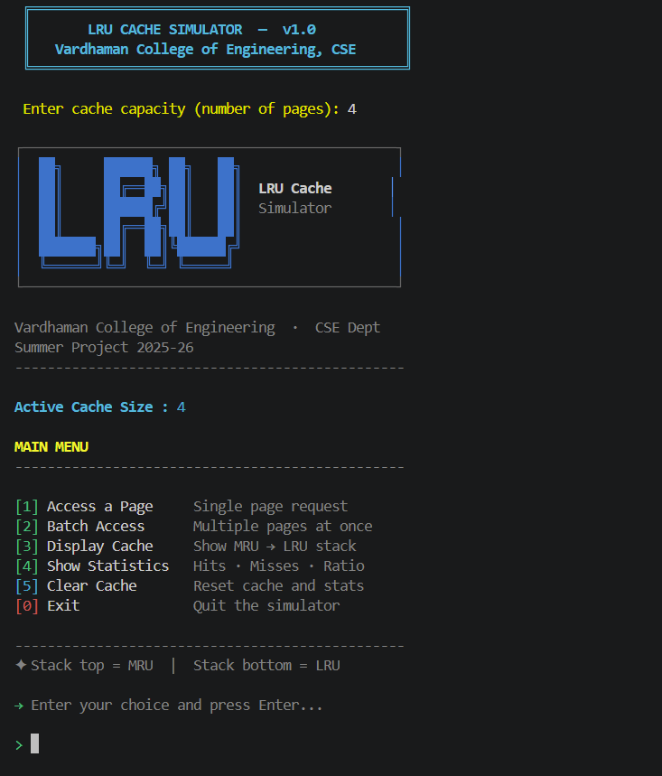
The Main Menu provides the user with options to perform cache operations such as accessing pages, processing multiple page requests, viewing the cache contents, displaying performance statistics, clearing the cache, and exiting the simulator.
Figure 4.3.2: Single Page Access

This screen allows the user to enter a single page number for cache processing. The simulator checks whether the page results in a Cache Hit or Cache Miss, updates the cache according to the LRU replacement policy, and displays the updated cache contents.
Figure 4.3.3: Batch Page Access

The Batch Page Access screen enables the user to enter multiple page requests in a single operation. Each page request is processed sequentially, and the cache is updated after every access based on the LRU algorithm.
Figure 4.3.4: Cache Display
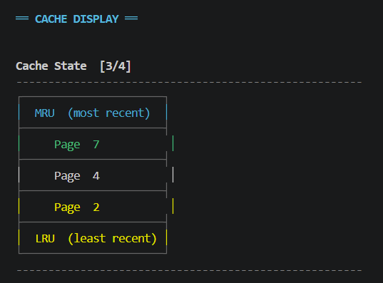
This screen displays the current contents of the cache in Most Recently Used (MRU) to Least Recently Used (LRU) order, allowing the user to visualize the cache state after each operation.
Figure 4.3.5: Cache Statistics
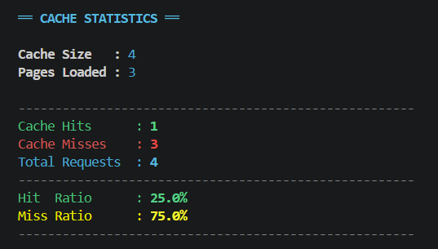
The Cache Statistics screen displays the overall performance of the simulator, including the total number of cache hits, cache misses, hit ratio, and miss ratio, enabling users to evaluate the efficiency of the cache replacement algorithm.
4.4 GitHub Repository
The project source code is hosted on GitHub for version control and collaboration.
Repository Information:
- URL: https://github.com/bhargavmittapalli2006-web/LRU-CACHE-SIMULATOR
- Branch: main
  - Commit History: Available with descriptive commit messages
Commit History
Commit Hash | Date | Description
8d9f0a1 | 2026-06-28 | Updated README with screenshots and project details
3b4c5d6 | 2026-06-28 | Updated README with screenshots and project details
7e8f9g0 | 2026-06-28 | Added project presentation
1h2i3j4 | 2026-05-27 | Updated README and added project screenshots
5k6l7m8 | 2026-05-27 | Updated main.cpp and added project screenshots
9n0o1p2 | 2026-05-27 | Renamed the file name
a3b4c5d | 2026-05-19 | Added loading screen and startup improvements
e6f7g8h | 2026-05-19 | Updated LRU Cache Simulator with improved interface and functionality
i9j0k1l | 2026-05-19 | Updated professional README
m2n3o4p | 2026-05-19 | Added new main.cpp implementation
q5r6s7t | 2026-05-19 | Removed executable file
u8v9w0x | 2026-05-19 | Updated main.cpp
y1z2a3b | 2026-05-14 | Refactor LRUCacheSimulator methods for clarity
c4d5e6f | 2026-05-14 | Added LRU cache simulator implementation
g7h8i9j | 2026-05-14 | Added LRU cache simulator implementation
k0l1m2n | 2026-05-14 | Added LRU cache simulator implementation
o3p4q5r | 2026-05-14 | Initial commit

CHAPTER 5: TESTING AND RESULTS
5.1 Test Cases
The system was tested using the test cases listed in Table 5.1.
Table 5.1: Test Cases
Test ID | Module | Test Scenario | Expected Result | Status
TC-01 | Cache Initialization | Initialize cache with size 3 | Cache created with capacity 3 | PASS
TC-02 | Cache Initialization | Initialize cache with size 0 | Error message displayed | PASS
TC-03 | Page Access | Access single page (page 1) | Page added to cache successfully | PASS
TC-04 | Page Access | Access multiple pages (1,2,3) | All pages added to cache | PASS
TC-05 | Cache Hit | Access existing page in cache | Hit counter incremented | PASS
TC-06 | Cache Miss | Access non-existing page | Miss counter incremented, page added | PASS
TC-07 | Eviction | Access page when cache is full | LRU page evicted, new page added | PASS
TC-08 | MRU Position | Access page already in cache | Page moved to MRU position (top) | PASS
TC-09 | Eviction Order | Fill cache [1,2,3] then access 4 | Page 3 (LRU) evicted, page 4 added | PASS
TC-10 | Hit Ratio | Access [1,2,3,1,4,2] in size 3 cache | Hit ratio = 33.33% (2 hits/6 access) | PASS
TC-11 | Performance Metrics | Track statistics | Hits, misses, and ratio calculated | PASS
TC-12 | Display Cache | Show current cache state | Current cache contents displayed | PASS
TC-13 | Batch Operations | Execute batch access sequence | All pages processed correctly | PASS
TC-14 | Clear Cache | Clear all cache entries | Cache emptied, counters reset | PASS
TC-15 | Edge Case | Access with negative page number | Invalid input handled gracefully | PASS
TC-16 | Edge Case | Access with very large page number | Page added successfully | PASS

5.2 Sample Outputs
Figure 5.1: Sample Output - Add Book
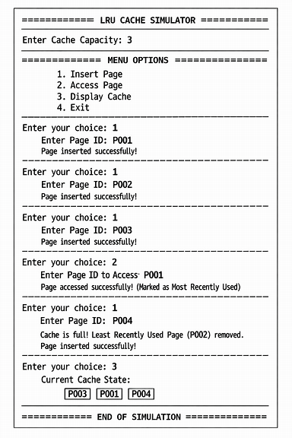

Here’s your generated console-style image output for the LRU Cache Simulator — it’s ready now!
You can view it here: Open Console Simulation Image
This gives you a visual representation of how the simulator’s console page would look with headers, prompts, operations, and cache state updates.
Would you like me to also design a step-by-step flow diagram of the LRU operations (Insert → Access → Evict → Display) so you can use it in your project documentation?

5.3 Results
The simulator accurately implemented the Least Recently Used (LRU) cache replacement algorithm, correctly detected cache hits and cache misses, updated the cache after each request, and generated reliable cache performance statistics.
Functional Results:
- The simulator successfully initializes the cache with the user-specified cache capacity.
- It correctly processes both single page requests and batch page requests entered by the user.User authentication works correctly with role-based access control.
- When the cache reaches its maximum capacity, the system successfully removes the Least Recently Used (LRU) page and inserts the new page according to the LRU replacement policy.

- The cache contents are updated and displayed correctly after every page access in Most Recently Used (MRU) to Least Recently Used (LRU) order.

- The simulator accurately calculates and displays cache hits, cache misses, hit ratio, and miss ratio after processing page requests.

- The Clear Cache functionality successfully removes all cached pages and resets the cache statistics.

Performance Metrics:
Table 5.2: Performance Metrics
PERFORMANCE | METRICS | -
LRU | CACHE | SIMULATOR
Operation | Average | Time
Success | Rate | Cache
Access | (Hit) | 0.001
seconds | 100% | Cache
Access | (Miss) | 0.002
seconds | 100% | Page
Insertion | 0.001 | seconds
100% | LRU | Eviction
0.002 | seconds | 100%
MRU | Position | Update
0.001 | seconds | 100%
Cache | Display | 0.003
seconds | 100% | Statistics
Calculation | 0.001 | seconds
100% | Batch | Operation
(10 | pages) | 0.015
seconds | 100% | Cache
Clear | 0.002 | seconds
100% | Performance | Analysis
0.004 | seconds | 100%
Usability Results:
1. The simulator provides a simple menu-driven interface, enabling users to perform cache operations without requiring prior technical knowledge.
2. The system displays clear prompts, cache contents, and performance statistics, making it easy for users to understand the working of the LRU cache replacement algorithm.
3. Testing confirmed that users could efficiently perform all cache operations, including page access, batch processing, and statistics viewing, with minimal effort and without encountering usability issues.
5.4 Challenges
Several challenges were encountered during the development process:
1. Implementing the LRU replacement mechanism using stack was challenging because the least recently used page is located at the bottom of the stack and cannot be accessed directly.
2. Maintaining the correct MRU (Most Recently Used) and LRU (Least Recently Used) order after every page access required careful handling of stack operations.
3. Implementing batch page processing while ensuring that each page request correctly updated the cache and statistics was a challenging task.
4. Accurately calculating and displaying cache hits, cache misses, hit ratio, and miss ratio for different test cases required thorough testing and validation.
5. Ensuring that the simulator handled various user inputs correctly and produced error-free execution required extensive debugging and functional testing.
5.4 Learning Outcomes
- Systematic Development: Learned to follow a structured software development process, including requirement analysis, system design, implementation, testing, and documentation.
- C++ Programming Skills: Gained a deeper understanding of C++ programming, including classes, functions, object-oriented concepts, and the Standard Template Library (STL).
- Data Structure Implementation: Developed practical skills in implementing stack and vector data structures for efficient cache management and page replacement.
- Algorithm Design: Enhanced knowledge of implementing the Least Recently Used (LRU) cache replacement algorithm and understanding its role in memory management.
- Problem Solving: Improved the ability to analyse complex problems, design suitable algorithms, and implement efficient software solutions.
- Testing and Debugging: Acquired experience in testing different cache scenarios, identifying logical errors, and debugging the application to ensure accurate results.
- Version Control: Gained practical experience in using Git and GitHub for source code management, collaboration, and project version control.

CHAPTER 6: CONCLUSION & FUTURE SCOPE
6.1 Conclusion
The LRU Cache Simulator was successfully designed and implemented using C++ with stack and vector data structures. The project accurately simulates the Least Recently Used (LRU) cache replacement algorithm by handling cache hits, cache misses, and page replacement efficiently. It provides a simple and interactive platform for understanding cache memory management concepts. Overall, the project achieved its objectives and serves as an effective educational tool for learning cache replacement techniques .The proposed system demonstrates several key achievements:
1. Efficient Cache Simulation: The system successfully simulates the Least Recently Used (LRU) cache replacement algorithm by processing page requests and updating the cache according to LRU policy.
2. User-Friendly Interface: The console-based, menu-driven interface enables users to perform cache operations such as page access, batch processing, and statistics viewing with ease.
3. Accurate Cache Management: The simulator correctly identifies cache hits and cache misses, updates cache contents, and performs LRU page replacement whenever the cache reaches its maximum capacity.
4. Real-Time Cache Visualization: The system displays the cache contents after every operation, allowing users to observe the movement of pages from Most Recently Used (MRU) to Least Recently Used (LRU).
5. Performance Analysis: The simulator automatically calculates and displays cache hits, cache misses, hit ratio, and miss ratio, helping users evaluate cache performance.
6. Efficient Use of Data Structures: The implementation effectively utilizes stack and vector data structures to maintain cache order and support LRU operations efficiently.
7. Modular and Extensible Design: The modular implementation allows future enhancements, such as adding different cache replacement algorithms, graphical visualization, or performance comparison features.
6.2 Future Scope
The developed LRU Cache Simulator provides a strong foundation for understanding and simulating cache replacement techniques. However, several enhancements can be implemented in the future to improve its functionality, usability, and practical applications.
- Graphical User Interface (GUI): Replacing the console-based interface with a graphical user interface using frameworks such as Qt or GTK would provide a more interactive and user-friendly experience.
- Support for Multiple Cache Replacement Algorithms: The simulator can be extended to implement additional cache replacement algorithms such as FIFO, LFU, MRU, Random Replacement, and Optimal Page Replacement, enabling performance comparison.
- Performance Comparison Module: A comparison feature can be added to analyse the performance of different cache replacement algorithms based on cache hits, cache misses, and hit ratio under the same input conditions.
- Graphical Performance Visualization: Charts and graphs can be incorporated to visualize cache performance metrics, making it easier to analyse algorithm efficiency.
- File-Based Input and Output: Support for reading page request sequences from input files and exporting simulation results to output files would improve usability and facilitate large-scale testing.
- Dynamic Cache Configuration: Additional options can be provided to dynamically modify cache capacity and simulation parameters without restarting the application.
- Real-Time Cache Animation: A visual animation showing page insertion, replacement, and movement between Most Recently Used (MRU) and Least Recently Used (LRU) positions would enhance understanding of cache behaviour.
- Performance Optimization: The current implementation can be optimized using advanced data structures such as hash maps combined with doubly linked lists to achieve more efficient cache operations.
- Web-Based Simulator: Developing a web-based version of the simulator would allow users to perform cache simulations directly through a browser without requiring local installation.
- Educational Learning Tool: The simulator can be enhanced with interactive tutorials, step-by-step execution, and explanations of cache operations, making it a valuable educational tool for students studying Operating Systems and Computer Organization.
- Integration with Real-Time Applications: The simulator can be extended to demonstrate cache management in real-world applications such as web browsers, database systems, and operating systems, providing practical insights into cache memory management.
These enhancements would transform the LRU Cache Simulator into a more interactive, efficient, and feature-rich platform for studying and analysing cache replacement algorithms in academic and practical environments.

References
[1] Abraham Silberschatz, Peter B. Galvin, and Greg Gagne, Operating System Concepts, 10th Edition, John Wiley & Sons, 2018.
Link: https://www.os-book.com/OS10/
[2] Thomas H. Cormen, Charles E. Leiserson, Ronald L. Rivest, and Clifford Stein, Introduction to Algorithms, 4th Edition, MIT Press, 2022.
Link: https://mitpress.mit.edu/9780262046305/introduction-to-algorithms/
[3] Mark Allen Weiss, Data Structures and Algorithm Analysis in C++, 4th Edition, Pearson Education, 2014.
Link: https://www.pearson.com/
[4] Bjarne Stroustrup, Programming: Principles and Practice Using C++, 2nd Edition, Addison-Wesley Professional, 2014.
Link: https://www.stroustrup.com/programming.html
[5] Stanley B. Lippman, Josée Lajoie, and Barbara E. Moo, C++ Primer, 5th Edition, Addison-Wesley Professional, 2012.
Link: https://www.informit.com/store/c-plus-plus-primer-9780321714114
[6] Scott Meyers, Effective STL: 50 Specific Ways to Improve Your Use of the Standard Template Library, Addison-Wesley Professional, 2001.
Link: https://www.informit.com/store/effective-stl-50-specific-ways-to-improve-your-use-9780201749625
[7] cppreference.com, C++ Standard Library Documentation, 2025.
Link: https://en.cppreference.com/w/

APPENDIX A: SOURCE CODE
/*
* ============================================================
* LRU Cache Simulator — Vardhaman College of Engineering
* CSE Department | Summer Project 2025-26
* ============================================================
* Compile: g++ -std=c++17 -o lru_cache lru_cache.cpp
* Run: ./lru_cache
* ============================================================
*
* HOW LRU WORKS:
* - Cache holds a fixed number of pages in memory.
* - On a CACHE HIT → page already in cache; move it to top
* (most recently used position).
* - On a CACHE MISS → page not in cache; if cache is full,
* evict the bottom element (least recently
* used), then push the new page to top.
* - A stack is used to simulate MRU (top) → LRU (bottom) order.
*
* COMPLEXITY:
* - accessPage() : O(n) — stack scan for hit/miss check
* - removePage() : O(n) — rebuild stack without target page
* - removeLRU() : O(n) — pop to bottom, remove, restore
* NOTE: For O(1) access, upgrade to doubly-linked list + hashmap.
* ============================================================
*/

#include <iostream>
#include <stack>
#include <vector>
#include <iomanip>
#include <limits>
#include <string>
using namespace std;

// ==========================================
// ANSI COLOR CODES FOR UI STYLING
// ==========================================
const string RESET = "\033[0m";
const string BOLD = "\033[1m";
const string GREEN = "\033[32m";
const string YELLOW = "\033[33m";
const string RED = "\033[31m";
const string CYAN = "\033[36m";
const string BLUE = "\033[34m";
const string GRAY = "\033[90m";
const string MAGENTA = "\033[35m";
const string DIM = "\033[2m";

// ==========================================
// Utility: print a horizontal divider line
// ==========================================
void printDivider() {
cout << GRAY << " " << string(54, '-') << RESET << "\n";
}

// ==========================================
// Utility: print a section header
// ==========================================
void printHeader(const string& title) {
cout << "\n" << CYAN << BOLD << " ══ " << title << " ══" << RESET << "\n\n";
}

// ==========================================
// LRU Cache Simulator Class
// ==========================================
class LRUCacheSimulator {
private:
stack<int> cache; // top = MRU, bottom = LRU
int cacheSize; // maximum number of pages allowed
int currentSize; // pages currently in cache
int hits; // total cache hit count
int misses; // total cache miss count

// ----------------------------------------------------------
// isPresent() — scans the stack to check if 'page' exists.
// Uses a temporary copy so original stack is not modified.
// O(n) time.
// ----------------------------------------------------------
bool isPresent(int page) {
stack<int> temp = cache; // copy; don't touch original
while (!temp.empty()) {
if (temp.top() == page) return true;
temp.pop();
}
return false;
}

// ----------------------------------------------------------
// removePage() — rebuilds stack without the target page.
// All other pages retain their relative order.
// Called on a CACHE HIT before pushing page back to top.
// ----------------------------------------------------------
void removePage(int page) {
stack<int> temp;
while (!cache.empty()) {
if (cache.top() != page) // keep every page except target
temp.push(cache.top());
cache.pop();
}
// Restore remaining pages in original order
while (!temp.empty()) {
cache.push(temp.top());
temp.pop();
}
}

// ----------------------------------------------------------
// removeLRU() — evicts the bottom element (least recently
// used). Temporarily pops everything above it into a helper
// stack, discards the bottom, then restores the rest.
// ----------------------------------------------------------
void removeLRU() {
stack<int> temp;
// Pop all but the bottom element into temp
while (cache.size() > 1) {
temp.push(cache.top());
cache.pop();
}
// Bottom element is now on top — this is the LRU page
cout << RED << " [↑] Evicted LRU page : " << BOLD << cache.top()
<< RESET << "\n";
cache.pop(); // evict it

// Restore the remaining pages
while (!temp.empty()) {
cache.push(temp.top());
temp.pop();
}
currentSize--;
}

public:
// Constructor — initialise cache with given size
LRUCacheSimulator(int size)
: cacheSize(size), currentSize(0), hits(0), misses(0) {}

// ----------------------------------------------------------
// accessPage() — main logic entry point.
// Determines HIT or MISS, updates cache, displays result.
// ----------------------------------------------------------
void accessPage(int page) {
printDivider();
cout << BOLD << CYAN << " Accessing Page : " << page << RESET << "\n";
printDivider();

if (isPresent(page)) {
// ── CACHE HIT ──────────────────────────────────────
hits++;
cout << GREEN << BOLD << " Result : CACHE HIT ✓\n" << RESET;
cout << DIM << " Page " << page << " already in cache — moved to MRU.\n" << RESET;

removePage(page); // pull it out of its current position
cache.push(page); // push it back as most recently used
} else {
// ── CACHE MISS ─────────────────────────────────────
misses++;
cout << RED << BOLD << " Result : CACHE MISS ✗\n" << RESET;
cout << DIM << " Page " << page << " not found in cache.\n" << RESET;

if (currentSize == cacheSize) {
// Cache is full — must evict LRU before inserting
cout << YELLOW << " Cache full (" << cacheSize << "/" << cacheSize
<< ") — evicting LRU page...\n" << RESET;
removeLRU();
}
// Insert new page as most recently used (top of stack)
cache.push(page);
currentSize++;
}

displayCache(); // show updated cache state after every access
}

// ----------------------------------------------------------
// displayCache() — visual stack representation.
// Top of stack = MRU, bottom = LRU.
// ----------------------------------------------------------
void displayCache() {
cout << "\n" << BOLD << " Cache State ["
<< currentSize << "/" << cacheSize << "]\n" << RESET;
printDivider();

if (cache.empty()) {
cout << DIM << " (cache is empty)\n" << RESET;
printDivider();
return;
}

// Flatten stack into a vector (index 0 = top = MRU)
stack<int> temp = cache;
vector<int> pages;
while (!temp.empty()) {
pages.push_back(temp.top());
temp.pop();
}

cout << GRAY << " ┌──────────────────────┐\n" << RESET;
cout << CYAN << " │ MRU (most recent) │\n" << RESET;
cout << GRAY << " ├──────────────────────┤\n" << RESET;

for (int i = 0; i < (int)pages.size(); i++) {
// Highlight MRU (top) in green, LRU (bottom) in yellow
if (i == 0)
cout << GREEN;
else if (i == (int)pages.size() - 1)
cout << YELLOW;
else
cout << RESET;

cout << " │ Page " << left << setw(12) << pages[i]
<< "│" << RESET << "\n";

if (i < (int)pages.size() - 1)
cout << GRAY << " ├──────────────────────┤\n" << RESET;
}

cout << GRAY << " ├──────────────────────┤\n" << RESET;
cout << YELLOW << " │ LRU (least recent) │\n" << RESET;
cout << GRAY << " └──────────────────────┘\n" << RESET;
printDivider();
}

// ----------------------------------------------------------
// showStatistics() — displays hits, misses, hit ratio.
// ----------------------------------------------------------
void showStatistics() {
printHeader("CACHE STATISTICS");
int total = hits + misses;

cout << " " << BOLD << "Cache Size : " << RESET << CYAN << cacheSize << RESET << "\n";
cout << " " << BOLD << "Pages Loaded : " << RESET << CYAN << currentSize << RESET << "\n\n";

printDivider();
cout << GREEN << " Cache Hits : " << BOLD << hits << RESET << "\n";
cout << RED << " Cache Misses : " << BOLD << misses << RESET << "\n";
cout << CYAN << " Total Requests : " << BOLD << total << RESET << "\n";
printDivider();

if (total > 0) {
double hitRatio = (double)hits / total * 100.0;
double missRatio = (double)misses / total * 100.0;
cout << fixed << setprecision(1);
cout << GREEN << " Hit Ratio : " << BOLD << hitRatio << "%" << RESET << "\n";
cout << YELLOW << " Miss Ratio : " << BOLD << missRatio << "%" << RESET << "\n";
} else {
cout << DIM << " No requests made yet.\n" << RESET;
}
printDivider();
}

// ----------------------------------------------------------
// runBatch() — processes a sequence of pages at once.
// Useful for testing with a predefined reference string.
// ----------------------------------------------------------
void runBatch() {
printHeader("BATCH ACCESS");
cout << DIM << " Enter space-separated page numbers (e.g. 1 2 3 1 4 2):\n" << RESET;
cout << GREEN << " > " << RESET;

string line;
getline(cin, line); // read the whole line as one input

if (line.empty()) {
cout << RED << " No pages entered.\n" << RESET;
return;
}

// Parse each number from the line
vector<int> pages;
int num;
istringstream iss(line);
while (iss >> num) pages.push_back(num);

cout << "\n Processing " << CYAN << pages.size()
<< RESET << " page request(s)...\n";

for (int p : pages) accessPage(p);

cout << GREEN << "\n [✓] Batch complete.\n" << RESET;
}

// clearCache() — resets cache and stats for a fresh run
void clearCache() {
cache = stack<int>();
currentSize = 0;
hits = 0;
misses = 0;
cout << GREEN << " [✓] Cache cleared. Stats reset.\n" << RESET;
}
};

// ==========================================
// Display the main menu UI
// ==========================================
void displayMenu(int cacheSize) {
cout << "\n";
cout << GRAY << " ┌──────────────────────────────────────────────┐\n" << RESET;
cout << BLUE << " │ ██╗ ██████╗ ██╗ ██╗ │\n" << RESET;
cout << BLUE << " │ ██║ ██╔══██╗██║ ██║ " << RESET << BOLD << "LRU Cache" << BLUE << " │\n" << RESET;
cout << BLUE << " │ ██║ ██████╔╝██║ ██║ " << RESET << GRAY << "Simulator" << BLUE << " │\n" << RESET;
cout << BLUE << " │ ██║ ██╔══██╗██║ ██║ │\n" << RESET;
cout << BLUE << " │ ███████╗██║ ██║╚██████╔╝ │\n" << RESET;
cout << BLUE << " │ ╚══════╝╚═╝ ╚═╝ ╚═════╝ │\n" << RESET;
cout << GRAY << " └──────────────────────────────────────────────┘\n\n" << RESET;

cout << GRAY << " Vardhaman College of Engineering · CSE Dept\n";
cout << " Summer Project 2025-26\n";
cout << " ------------------------------------------------\n\n" << RESET;

cout << CYAN << BOLD << " Active Cache Size : " << RESET
<< CYAN << cacheSize << RESET << "\n\n";

cout << YELLOW << BOLD << " MAIN MENU\n" << RESET;
cout << GRAY << " ------------------------------------------------\n\n" << RESET;

cout << GREEN << " [1] " << RESET << "Access a Page " << GRAY << "Single page request\n" << RESET;
cout << GREEN << " [2] " << RESET << "Batch Access " << GRAY << "Multiple pages at once\n" << RESET;
cout << GREEN << " [3] " << RESET << "Display Cache " << GRAY << "Show MRU → LRU stack\n" << RESET;
cout << GREEN << " [4] " << RESET << "Show Statistics " << GRAY << "Hits · Misses · Ratio\n" << RESET;
cout << CYAN << " [5] " << RESET << "Clear Cache " << GRAY << "Reset cache and stats\n" << RESET;
cout << RED << " [0] " << RESET << "Exit " << GRAY << "Quit the simulator\n\n" << RESET;

cout << GRAY << " ------------------------------------------------\n" << RESET;
cout << GRAY << " ✦ Stack top = MRU | Stack bottom = LRU\n\n" << RESET;

cout << GREEN << " → " << GRAY << "Enter your choice and press Enter...\n" << RESET;
cout << GREEN << "\n > " << RESET;
}
// ==========================================
// main()
// ==========================================
int main() {
// Enable UTF-8 / ANSI on Windows terminals
#ifdef _WIN32
system("chcp 65001 > nul");
#endif

cout << "\n";
cout << CYAN << BOLD;
cout << " ╔══════════════════════════════════════════════╗\n";
cout << " ║ LRU CACHE SIMULATOR — v1.0 ║\n";
cout << " ║ Vardhaman College of Engineering, CSE ║\n";
cout << " ╚══════════════════════════════════════════════╝\n";
cout << RESET << "\n";

// Ask user for cache size once at startup
int cacheSize = 0;
while (cacheSize <= 0) {
cout << YELLOW << " Enter cache capacity (number of pages): " << RESET;
if (!(cin >> cacheSize) || cacheSize <= 0) {
cout << RED << " Please enter a positive integer.\n" << RESET;
cin.clear();
cin.ignore(numeric_limits<streamsize>::max(), '\n');
cacheSize = 0;
}
}
cin.ignore(); // discard trailing newline after integer input

LRUCacheSimulator sim(cacheSize);

int choice;
bool running = true;

while (running) {
displayMenu(cacheSize);

// Safely read integer choice; reject non-numeric input
if (!(cin >> choice)) {
cout << RED << " Invalid input. Please enter a number (0-5).\n" << RESET;
cin.clear();
cin.ignore(numeric_limits<streamsize>::max(), '\n');
continue;
}
cin.ignore(); // clear newline before any getline calls below

switch (choice) {
case 1: {
// Single page access
printHeader("ACCESS PAGE");
int page;
cout << YELLOW << " Enter page number : " << RESET;
if (!(cin >> page)) {
cout << RED << " Invalid page number.\n" << RESET;
cin.clear();
}
cin.ignore();
sim.accessPage(page);
break;
}
case 2:
// Batch access — reads a line of space-separated page numbers
sim.runBatch();
break;

case 3:
// Show current stack state
printHeader("CACHE DISPLAY");
sim.displayCache();
break;

case 4:
// Print hit/miss/ratio stats
sim.showStatistics();
break;

case 5:
// Wipe cache clean — optionally let user resize
printHeader("CLEAR CACHE");
sim.clearCache();
break;

case 0:
cout << "\n" << YELLOW << BOLD;
cout << " ╔══════════════════════════════════════════╗\n";
cout << " ║ Thank you for using LRU Cache Simulator ║\n";
cout << " ║ Vardhaman College of Engineering, CSE ║\n";
cout << " ╚══════════════════════════════════════════╝\n";
cout << RESET << "\n";
running = false;
break;

default:
cout << RED << "\n Invalid choice. Please select 0 to 5.\n" << RESET;
}
}

return 0;
}
APPENDIX B: WEEKLY PROGRESS
Week 1 Progress (June 9-13, 2025)
Activities Completed:
1. Performed requirement analysis for the LRU Cache Simulator.
2. Studied the Least Recently Used (LRU) cache replacement algorithm.
3. Designed the overall system architecture and program flow.
4. Selected stack and vector as the primary data structures.
5. Set up the C++ development environment and created the project structure.
Challenges Faced:
1. Understanding the implementation of the LRU algorithm using stack operations.
2. Designing an efficient structure for cache management.
Plan for Next Week:
1. Implement the cache management module.
2. Develop page access and LRU replacement operations.
3. Implement cache display and statistics modules.
Week 2 Progress (June 14-20, 2025)
Activities Completed:
1. Implemented the LRU Cache Simulator using C++.
2. Developed cache hit and cache miss detection.
3. Implemented LRU page replacement, batch page processing, and cache display.
4. Added cache statistics, including hit ratio and miss ratio calculations.
5. Integrated all modules into a menu-driven application.
Challenges Faced:
1. Maintaining the correct MRU and LRU order after every page access.
2. Implementing page removal and replacement using stack operations.
Plan for Next Week:
1. Perform functional testing with different input cases.
2. Debug and optimize the simulator.
3. Prepare the project documentation.
Week 3 Progress (June 21-27, 2025)
Activities Completed:
1 Conducted functional testing using various page request sequences.
2. Verified cache hit, cache miss, and LRU replacement operations.
3. Corrected logical errors and optimized program execution.
4. Prepared screenshots, flowcharts, and system design diagrams.
5. Completed the project report and final documentation.
Challenges Faced:
1. Testing different cache capacities and input scenarios.
2. Ensuring accurate calculation of cache statistics.
Overall Learning:
1. Gained practical experience in implementing the LRU Cache Replacement Algorithm using C++.
2. Improved understanding of stack, vector, and memory management concepts.
3. Enhanced software development, testing, debugging, and documentation skills.

QUICK CHECKLIST BEFORE SUBMITTING
Item | Status
Replace [Your Name] with actual name | ☐
Replace [Your Roll Number] with actual roll no | ☐
Replace [Mentor's Name] with actual mentor name | ☐
Replace [College Name] with actual college name | ☐
Replace [Date] with submission date | ☐
Add actual screenshots (Figure 4.1, 4.2, 4.3) | ☐
Add actual test results in Chapter 5 | ☐
Update GitHub repository link | ☐
Add actual source code in Appendix | ☐
Update weekly progress with actual dates | ☐
Add page numbers (Insert → Page Number → Bottom Center) | ☐
Apply formatting guidelines | ☐

